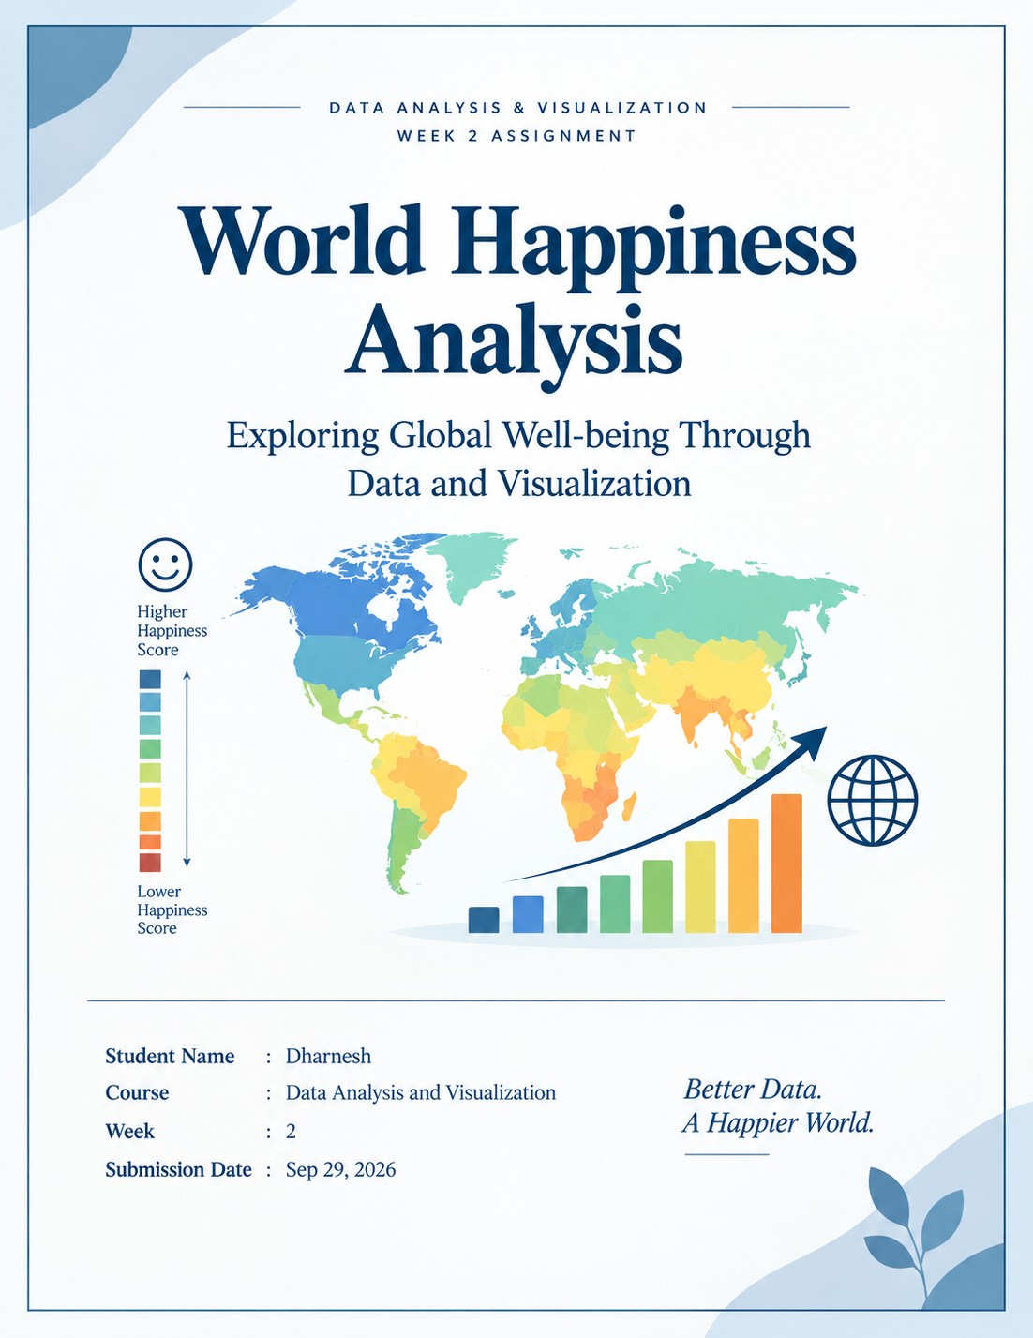

Contents
1. Executive Summary
2. Dataset Overview
3. Tools and Methodology
4. Data Preparation and Quality Checks
5. Visualization 1 - Top 10 Countries by Life Evaluation
6. Visualization 2 - Distribution of Life Evaluation Scores
7. Visualization 3 - GDP and Life Evaluation
8. Visualization 4 - Average Life Evaluation Over Time
9. Visualization 5 - Life Evaluation Across GDP Groups
10. Key Insights
11. Conclusion
12. Submission Description
13. Reproducibility and GitHub
Appendix A - Complete R Code
References

1. Executive Summary
This report presents a data visualization and insight-communication analysis of the World Happiness Report Figure 2.1 dataset using R and ggplot2. The analysis focuses on life evaluation, a 0-to-10 measure of how respondents assess their lives, and examines how the measure varies across countries, across the distribution of observations, over time, and in relation to the explanatory contribution of log GDP per capita.
The supplied dataset contains 2,116 country-year observations and 13 variables, covering 14 observed years between 2011 and 2025 and 168 countries or territories. Across all observations, the mean life evaluation is 5.466, the median is 5.480, and the observed range is 1.364 to 7.856.
For 2025, the ten highest life-evaluation observations range from 7.018 to 7.764, with Finland at the top of the supplied dataset at 7.764. The time-series view shows an increase in the country-average of the available observations from 5.392 in 2011 to 5.650 in 2025, a change of 0.258 points.
The scatter plot uses 1,019 complete observations with non-missing GDP and life-evaluation values. The Pearson correlation is 0.68, indicating a moderately strong positive association in this dataset. This relationship should be interpreted as an association rather than proof that GDP alone causes higher life evaluation.

Key message
The visualizations show that life evaluation differs substantially across countries and observations, varies over time, and tends to be higher in observations with greater GDP-per-capita contribution. The report uses charts to communicate these patterns to a non-technical audience without treating correlation as causation.

2. Dataset Overview
The analysis uses the file WHR26_Data_Figure_2.1.xlsx, supplied for this assignment. The file corresponds to the World Happiness Report 2026 Figure 2.1 data. The World Happiness Report states that Figure 2.1 data include three-year averages of life evaluation, 95% confidence intervals, and contributions from six explanatory factors. The report's 2026 ranking uses life evaluations averaged over 2023-2025.
Dataset characteristic | Value
Rows / observations | 2,116
Variables | 13
Unique countries / territories | 168
Observed years | 2011, 2012, 2014, 2015, 2016, 2017, 2018, 2019, 2020, 2021, 2022, 2023, 2024, 2025
Missing 2013 | 2013 is not present in the supplied file
Life evaluation mean | 5.466
Life evaluation median | 5.480
Life evaluation minimum | 1.364 (Afghanistan, 2024)
Life evaluation maximum | 7.856 (Denmark, 2011)
Complete GDP-life observations | 1,019

Variables used in the visualizations
- Life evaluation (3-year average): the primary wellbeing outcome used across the five visualizations.
- Country name: the country/territory label used for the 2025 ranking chart.
- Year: the time field used to compute annual average life evaluation.
- Explained by: Log GDP per capita: the GDP-related explanatory contribution used for the scatter plot and GDP quartile grouping.

3. Tools and Methodology
The analysis was designed for an audience that may not have a technical background. The workflow follows a simple sequence: import the public dataset, inspect and clean the relevant fields, construct five complementary visualizations, save high-resolution chart images, and interpret each chart in plain language.
Tool | Purpose
R | Data preparation, calculation, visualization, and reproducibility
RStudio | Development environment for the analysis
readxl | Reading the supplied Excel workbook
tidyverse / ggplot2 | Data transformation and visualization
Microsoft Word / DOCX | Communication of results in a report format

4. Data Preparation and Quality Checks
The raw Excel workbook was imported into R with readxl. Rows without a country name or a life-evaluation value were removed for the main analysis. The life-evaluation field was checked before plotting; its observed range is 1.364 to 7.856, confirming that the field is on the expected 0-to-10 life-evaluation scale.
A data-quality check found 1,097 missing values in the GDP contribution field. As a result, the GDP-versus-life scatter plot and the GDP-group box plot are based on the 1,019 observations that have both GDP and life-evaluation values.
The line chart uses all available life-evaluation observations by year. The supplied file contains observations for 2011, 2012, and 2014 through 2025; 2013 is absent, so the time series should be read as a sequence of observed years rather than a complete annual series.

5. Visualization 1 - Top 10 Countries by Life Evaluation
The ranking chart uses the latest year in the workbook (2025) so that repeated country-year observations from earlier years do not compete with the latest values.
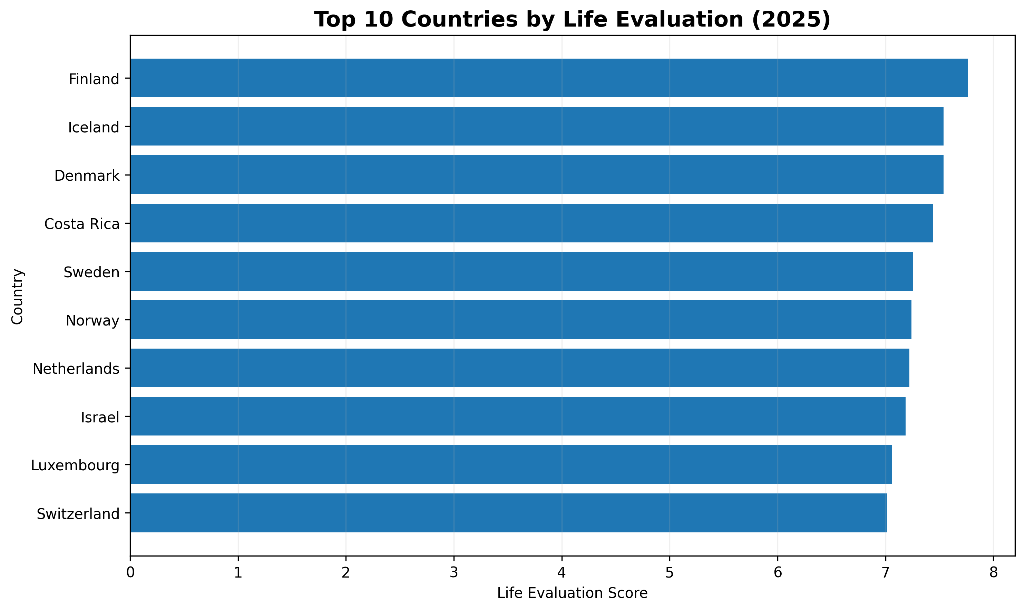
Figure 1. Top 10 countries by life evaluation in the latest observed year (2025).

What the chart shows
The chart ranks the ten highest 2025 life-evaluation observations in the supplied dataset. Finland has the highest value at 7.764. The tenth country in this top-ten group is Switzerland at 7.018.

Insight for a non-technical audience
The top ten values are all above 7.0. The difference between the highest and tenth-ranked observations is 0.746 points, showing that the leading group is relatively clustered at the high end of the scale.

6. Visualization 2 - Distribution of Life Evaluation Scores
This visualization uses the complete life-evaluation field after removing rows with missing country or life-evaluation values.
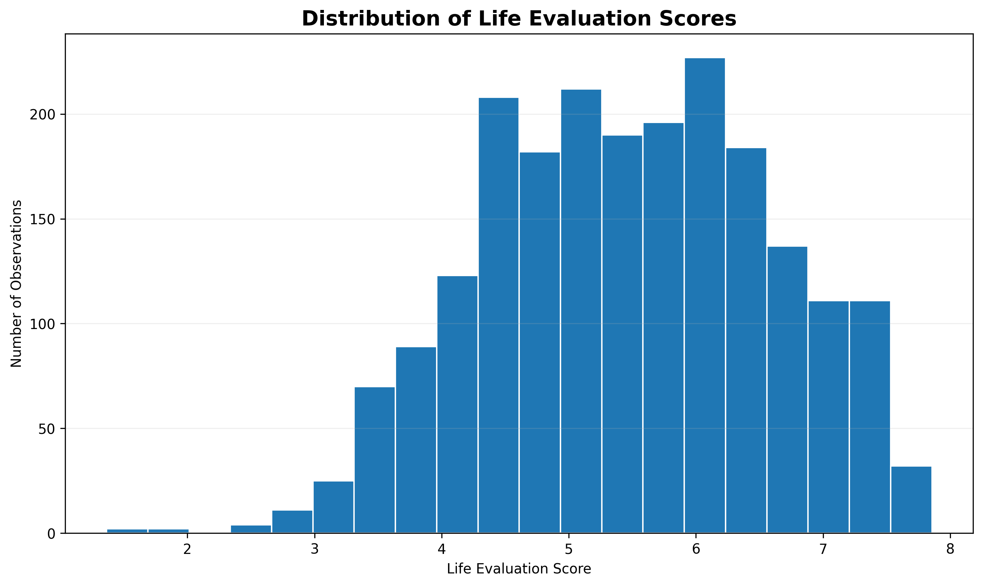
Figure 2. Distribution of life-evaluation scores across all 2,116 observations.

What the chart shows
The histogram groups the 2,116 life-evaluation observations into 20 intervals. The largest bin is approximately 5.91 to 6.23, containing about 227 observations.

Insight for a non-technical audience
Most observations fall in the middle portion of the scale rather than at the very bottom or very top. This indicates that extremely low and extremely high life evaluations are less common than mid-range values in the supplied dataset.

7. Visualization 3 - GDP and Life Evaluation
The chart uses only rows with non-missing GDP contribution and life-evaluation values, leaving 1,019 complete cases from the 2,116 original observations.
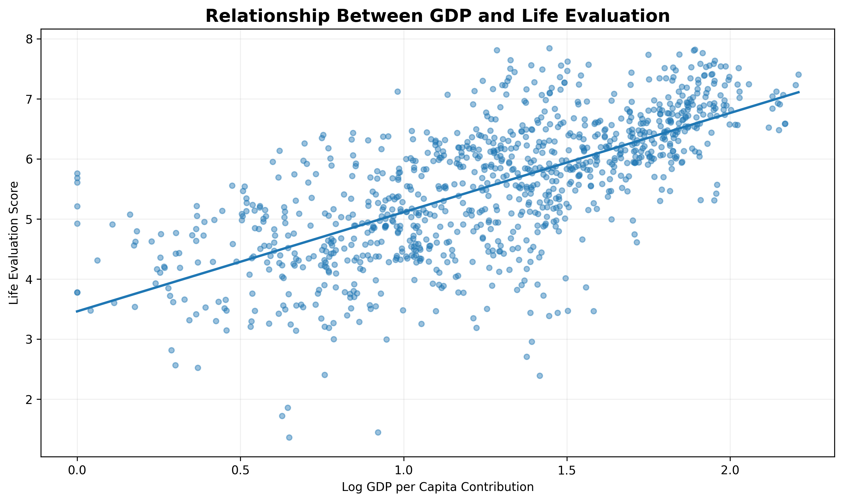
Figure 3. Relationship between log GDP-per-capita contribution and life evaluation (1,019 complete observations).

What the chart shows
The scatter plot places GDP-related contribution on the horizontal axis and life evaluation on the vertical axis. The fitted line slopes upward, and the Pearson correlation is 0.68.

Insight for a non-technical audience
Observations with larger GDP-per-capita contribution generally also show higher life-evaluation scores. The relationship is meaningful in this dataset, but it is not evidence that GDP by itself causes higher wellbeing; social support, health, freedom, generosity, corruption perceptions, and other factors also differ across observations.

8. Visualization 4 - Average Life Evaluation Over Time
The average is calculated across all available country-year rows for each observed year; missing 2013 is not imputed.
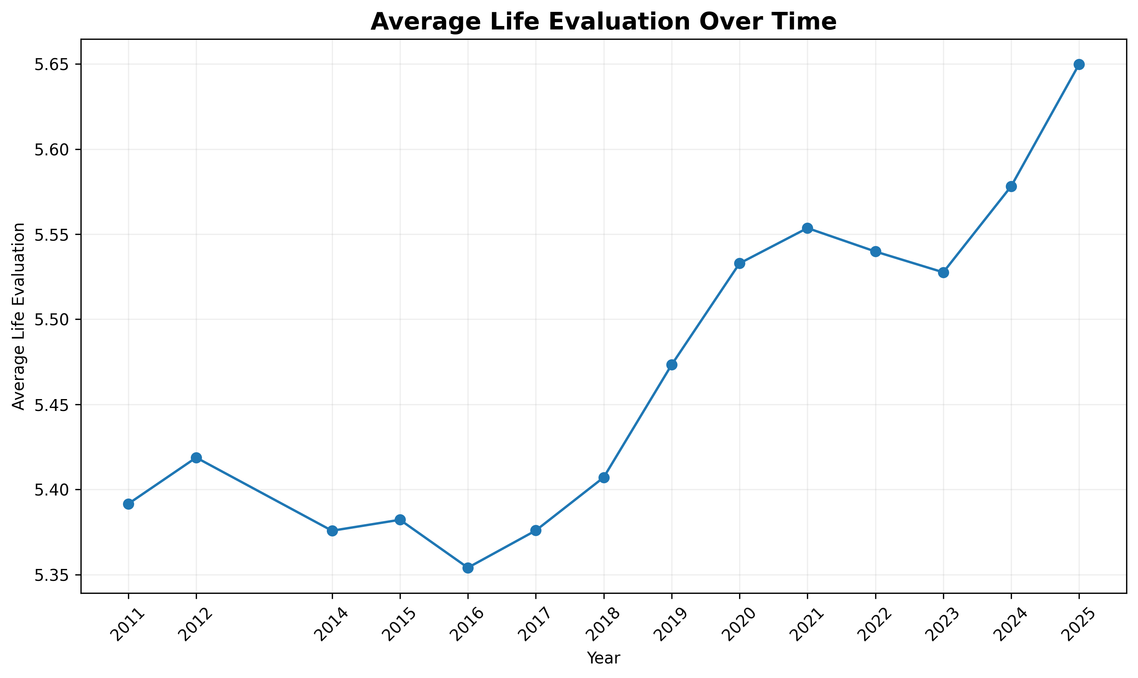
Figure 4. Average life evaluation of the available country-year observations by year.

What the chart shows
The line chart shows the mean life evaluation for the observations available in each year. The annual average is 5.392 in 2011 and 5.650 in 2025, a net increase of 0.258 points. The highest observed annual average is 5.650 in 2025.

Insight for a non-technical audience
The long-run pattern in the supplied observations is upward overall, although it is not perfectly smooth. The annual means rise through the later part of the period, with some year-to-year movement.

9. Visualization 5 - Life Evaluation Across GDP Groups
The four groups are created with R's ntile() approach so that the observations are split into approximately equal-sized quartiles.
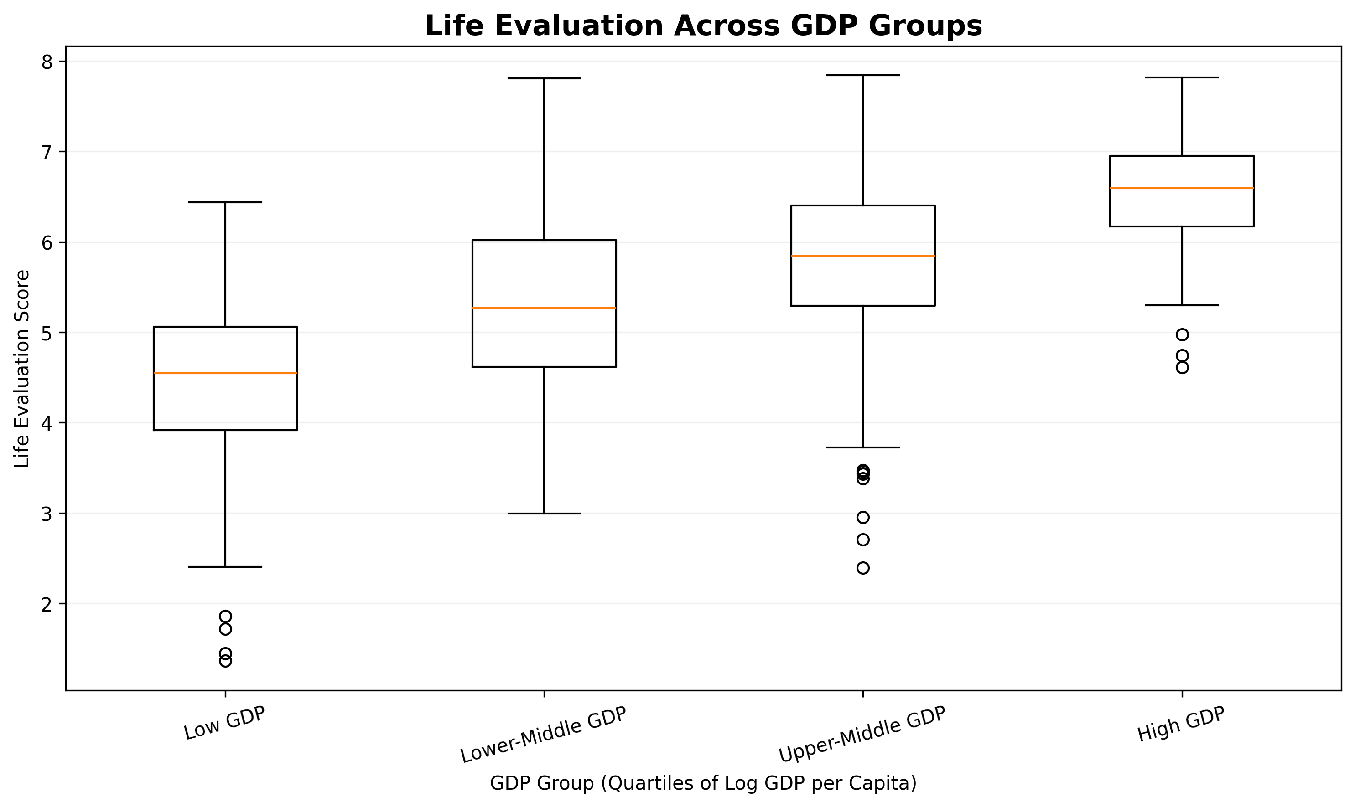
Figure 5. Life-evaluation distribution across four quartile groups of GDP-per-capita contribution.

What the chart shows
The box plot divides the 1,019 complete GDP-life observations into four groups with similar numbers of observations. Median life evaluation rises from 4.548 in the low-GDP group to 6.594 in the high-GDP group.

Insight for a non-technical audience
The typical life-evaluation score is higher in the higher GDP groups. The boxes also show variation within each group, meaning GDP contribution alone does not explain every country-year observation.

10. Key Insights
1. The overall life-evaluation level is centered around the middle of the 0-to-10 scale, with a mean of 5.466 and a median of 5.480.
2. The latest observed year has a clear high-performing group: the 2025 top ten range from 7.018 to 7.764.
3. The distribution is concentrated in the middle, rather than being dominated by very low or very high scores.
4. GDP contribution and life evaluation have a positive association (r = 0.68) among the 1,019 complete observations used in the scatter analysis.
5. The annual average rises from 5.392 in 2011 to 5.650 in 2025, although the series includes year-to-year variation and does not contain 2013.
6. The GDP-group box plot shows a step-up in typical life evaluation across GDP quartiles: median values increase from 4.548 to 6.594.
7. Missing explanatory-factor values are an important data-quality consideration; the GDP-based views use complete cases rather than imputing missing GDP contributions.

11. Conclusion
This analysis demonstrates how a public wellbeing dataset can be turned into a clear visual story using R. The five charts answer different but connected questions: who has the highest life-evaluation scores in the latest year, how scores are distributed overall, how GDP contribution relates to life evaluation, how average scores change over time, and how the distribution changes across GDP groups.
The results support a consistent descriptive message: life evaluation varies widely across observations, higher GDP-per-capita contribution is associated with higher life evaluation, and the average of the available observations is higher in 2025 than in 2011. At the same time, the analysis does not treat any single explanatory factor as a complete explanation of wellbeing. The report therefore combines quantitative evidence with careful interpretation and explicitly distinguishes association from causation.

12. Submission Description
This Week 2 assignment applies R-based data visualization techniques to the World Happiness Report Figure 2.1 dataset. The objective was to transform a public dataset into clear visual evidence that can be understood by both technical and non-technical audiences. The analysis began by importing the Excel workbook into R using readxl and checking the structure, dimensions, variable names, missing values, and life-evaluation range. After removing rows without country or life-evaluation information, five visualizations were developed with ggplot2: a bar chart for the top ten countries in the latest observed year, a histogram showing the distribution of life-evaluation scores, a scatter plot examining the relationship between log GDP-per-capita contribution and life evaluation, a line chart showing annual average life evaluation, and a box plot comparing life evaluation across GDP groups. Each visualization was selected to communicate a different analytical question. The bar chart supports comparison, the histogram supports distributional understanding, the scatter plot supports relationship analysis, the line chart supports trend communication, and the box plot supports comparison of variability across groups. The dataset contains 2,116 observations and 168 countries or territories. The analysis found a positive association between GDP contribution and life evaluation and an overall upward change in annual average life evaluation between the earliest and latest observed years. The report also documents an important limitation: many explanatory-factor fields are missing for part of the dataset, so GDP-based charts use complete observations only. Overall, the project demonstrates how data cleaning, visualization, statistical interpretation, and report writing can be combined to communicate meaningful insights from public data.

13. Reproducibility and GitHub
The analysis is reproducible because the R script contains the data import, cleaning, calculations, chart construction, and image export steps. The recommended project structure is:
Week 2 Assignment/
data/WHR26_Data_Figure_2.1.xlsx
graphs/
R_code/happiness_analysis.R
report/

GitHub Repository
Repository URL: [Add your GitHub repository URL here]
Before submission, upload the R script, generated graph images, and report to the repository if required by the assignment. The public World Happiness Report dataset may be referenced as the source data; do not add private credentials or unrelated personal files.

Appendix A - Complete R Code
# ============================================
# World Happiness Analysis
# Week 2 Assignment - R Data Visualization
# ============================================
library(tidyverse)
library(readxl)
# Load dataset
happiness <- read_excel("data/WHR26_Data_Figure_2.1.xlsx")
# Check the dataset
head(happiness)
dim(happiness)
names(happiness)
str(happiness)
colSums(is.na(happiness))
summary(happiness)
# Clean data
happiness_clean <- happiness %>%
filter(
!is.na(`Country name`),
!is.na(`Life evaluation (3-year average)`)
)
# --------------------------------------------
# Visualization 1 - Top 10 Countries
# --------------------------------------------
top10_2025 <- happiness_clean %>%
filter(Year == max(Year, na.rm = TRUE)) %>%
arrange(desc(`Life evaluation (3-year average)`)) %>%
slice_head(n = 10)
ggplot(
top10_2025,
aes(
x = reorder(
`Country name`,
`Life evaluation (3-year average)`
),
y = `Life evaluation (3-year average)`
)
) +
geom_col() +
coord_flip() +
labs(
title = "Top 10 Countries by Life Evaluation",
subtitle = "Latest Year in the Dataset",
x = "Country",
y = "Life Evaluation Score"
) +
theme_minimal()
ggsave(
"graphs/top10_happiness.png",
width = 10,
height = 6,
dpi = 300
)
# --------------------------------------------
# Visualization 2 - Histogram
# --------------------------------------------
ggplot(
happiness_clean,
aes(x = `Life evaluation (3-year average)`)
) +
geom_histogram(bins = 20) +
labs(
title = "Distribution of Life Evaluation Scores",
x = "Life Evaluation Score",
y = "Number of Observations"
) +
theme_minimal()
ggsave(
"graphs/happiness_histogram.png",
width = 10,
height = 6,
dpi = 300
)
# --------------------------------------------
# Visualization 3 - Scatter Plot
# --------------------------------------------
ggplot(
happiness_clean,
aes(
x = `Explained by: Log GDP per capita`,
y = `Life evaluation (3-year average)`
)
) +
geom_point() +
geom_smooth(method = "lm") +
labs(
title = "Relationship Between GDP and Life Evaluation",
x = "Log GDP per Capita",
y = "Life Evaluation Score"
) +
theme_minimal()
ggsave(
"graphs/gdp_happiness_scatter.png",
width = 10,
height = 6,
dpi = 300
)
# --------------------------------------------
# Visualization 4 - Line Chart
# --------------------------------------------
yearly_happiness <- happiness_clean %>%
group_by(Year) %>%
summarise(
Average_Happiness = mean(
`Life evaluation (3-year average)`,
na.rm = TRUE
)
)
ggplot(
yearly_happiness,
aes(
x = Year,
y = Average_Happiness
)
) +
geom_line() +
geom_point() +
labs(
title = "Average Life Evaluation Over Time",
x = "Year",
y = "Average Life Evaluation"
) +
theme_minimal()
ggsave(
"graphs/happiness_trend.png",
width = 10,
height = 6,
dpi = 300
)
# --------------------------------------------
# Visualization 5 - Box Plot
# --------------------------------------------
happiness_clean <- happiness_clean %>%
mutate(
GDP_Group = ntile(
`Explained by: Log GDP per capita`,
4
)
)
happiness_clean <- happiness_clean %>%
mutate(
GDP_Group = factor(
GDP_Group,
levels = c(1, 2, 3, 4),
labels = c(
"Low GDP",
"Lower-Middle GDP",
"Upper-Middle GDP",
"High GDP"
)
)
)
ggplot(
happiness_clean,
aes(
x = GDP_Group,
y = `Life evaluation (3-year average)`
)
) +
geom_boxplot() +
labs(
title = "Life Evaluation Across GDP Groups",
x = "GDP Group",
y = "Life Evaluation"
) +
theme_minimal()
ggsave(
"graphs/happiness_boxplot.png",
width = 10,
height = 6,
dpi = 300
)
# Final file check
list.files("graphs")

References
World Happiness Report. (2026). World Happiness Report 2026. Wellbeing Research Centre, University of Oxford. https://www.worldhappiness.report/ed/2026/
World Happiness Report. (2026). Data Sharing. https://www.worldhappiness.report/data-sharing/
World Happiness Report. (2026). Figure 2.1 data: Country rankings by life evaluations, Gallup World Poll (2023-2025).
Wickham, H., et al. (2019). Welcome to the tidyverse. Journal of Open Source Software, 4(43), 1686.
Data source note: The numerical results and charts in this report were generated from the user-supplied WHR26_Data_Figure_2.1.xlsx workbook.

