A report on

Iron content management

by

2016103022 | Dharni S S

Submitted for the course

CS7411- Database Management Systems Laboratory

Abstract

Many people in our country are suffering from anaemic. Reason behind this is they failed to consume the iron required for them. The main aim of this application to keep track of daily consumed iron and intimating them their status of consumption. Simply its iron requirement tracker. By using this application they can know about their daily iron consumption.

Front End: java swing

Back End: oracle 11g

Salient Features of the System

* Calculates the per day iron requirement of a person
* Calculate the bmi of a person
* Calculate the total iron consumption of a day based on their food intake
* Intimating their status of consumption
* Tracker which shows their progress, it intimates them when they consume less iron for more than one day
* Remainds them if they didnt login for more than one day

ER Diagram

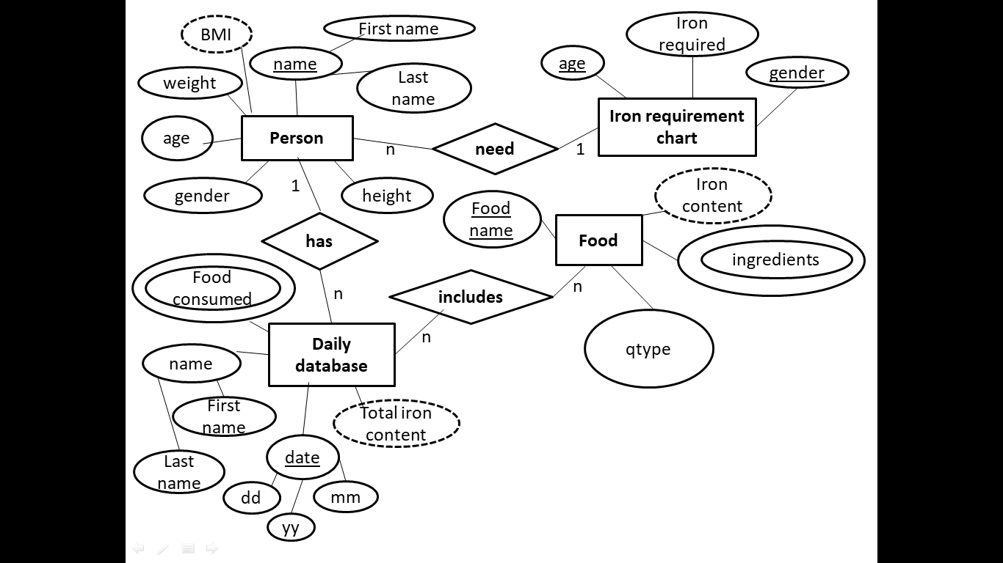

DB Schema

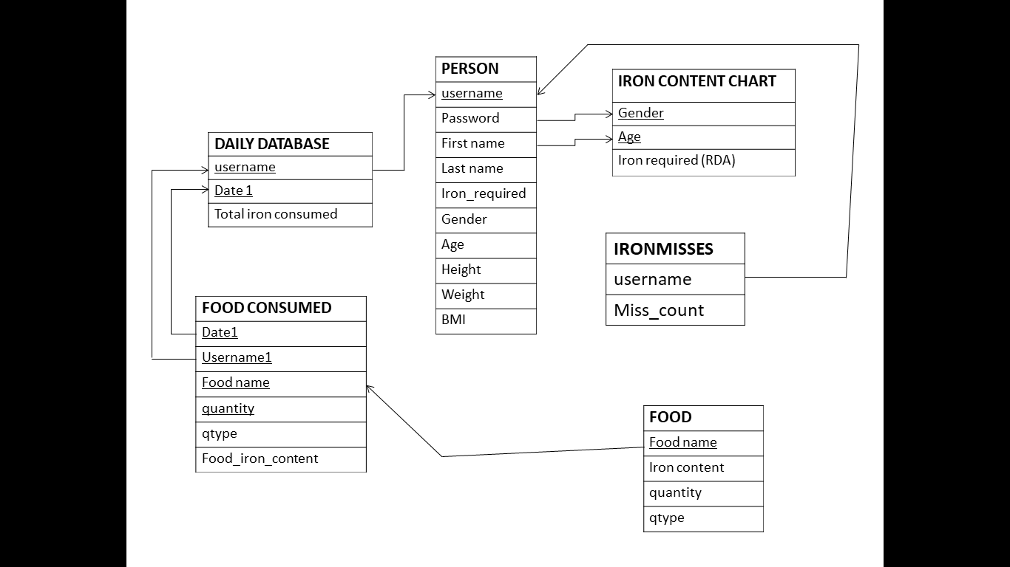

Instances of each Relation (Snapshot)

Iron_requirement_chart

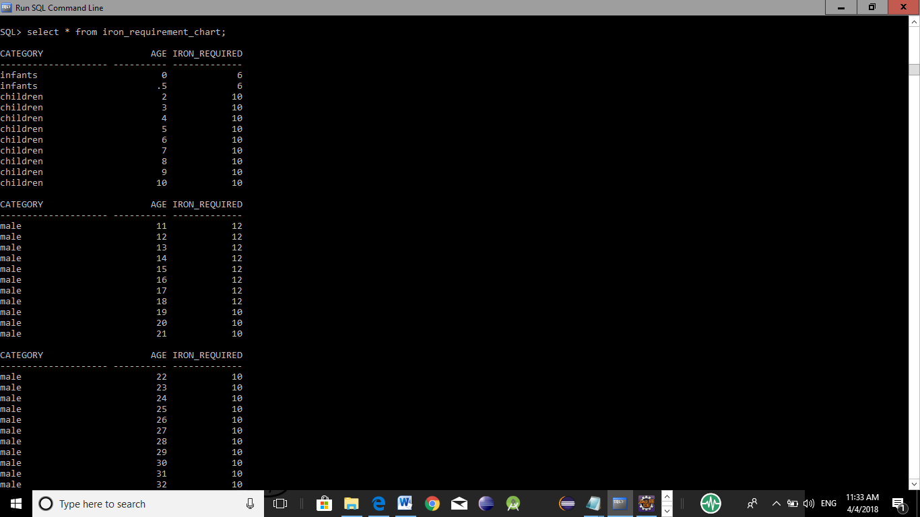

**Person**

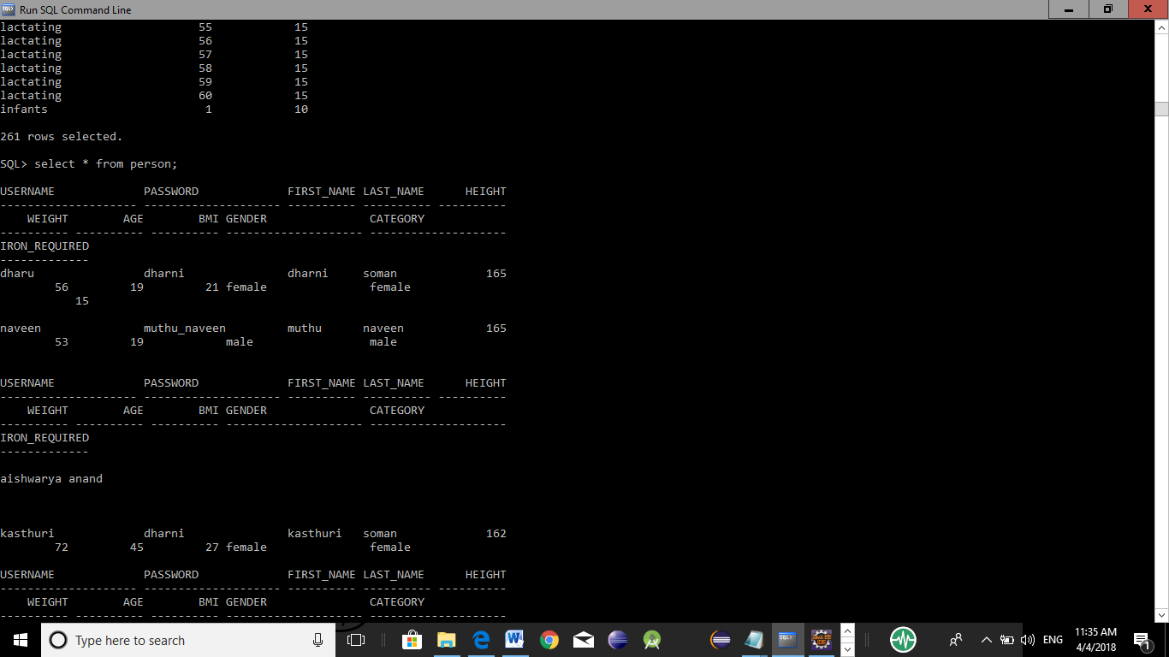

**Daily_database:**

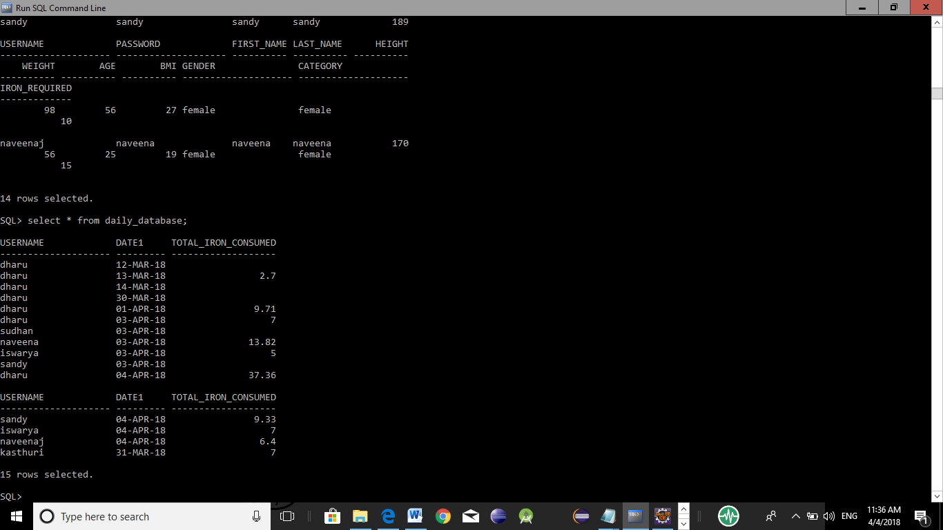

Food:

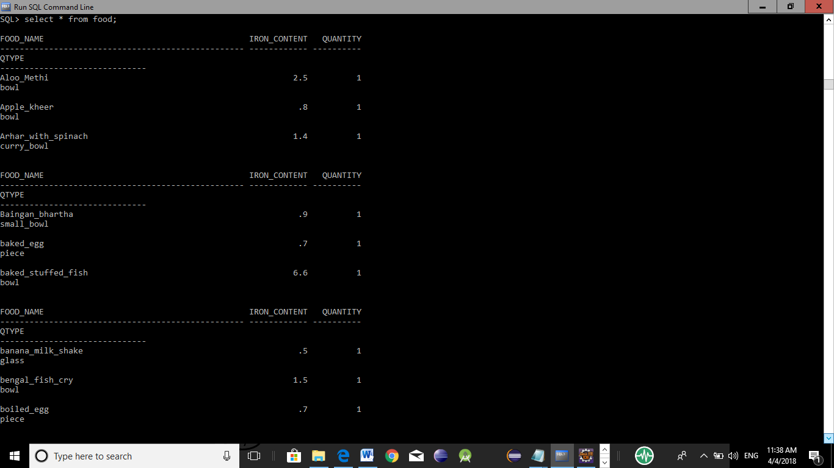

Food consumed:

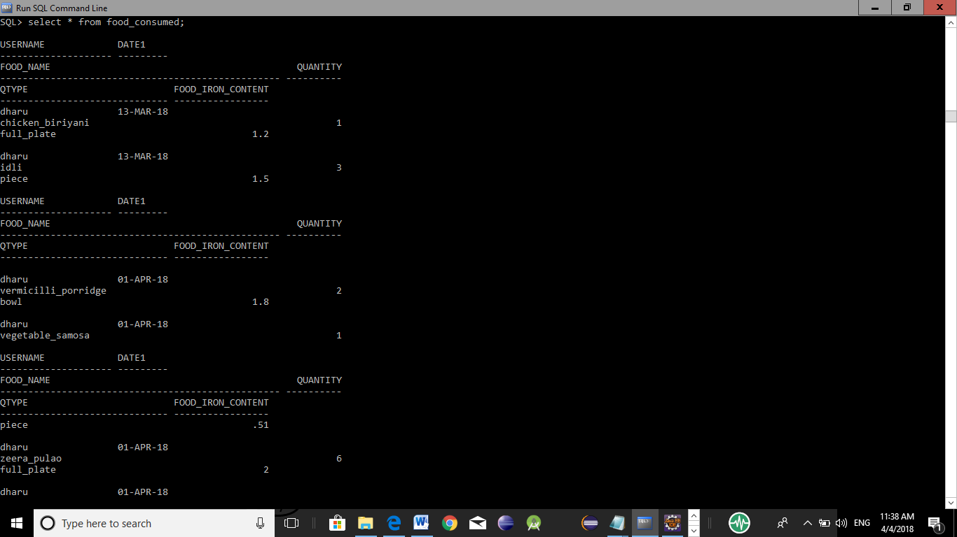

Ironmisses:

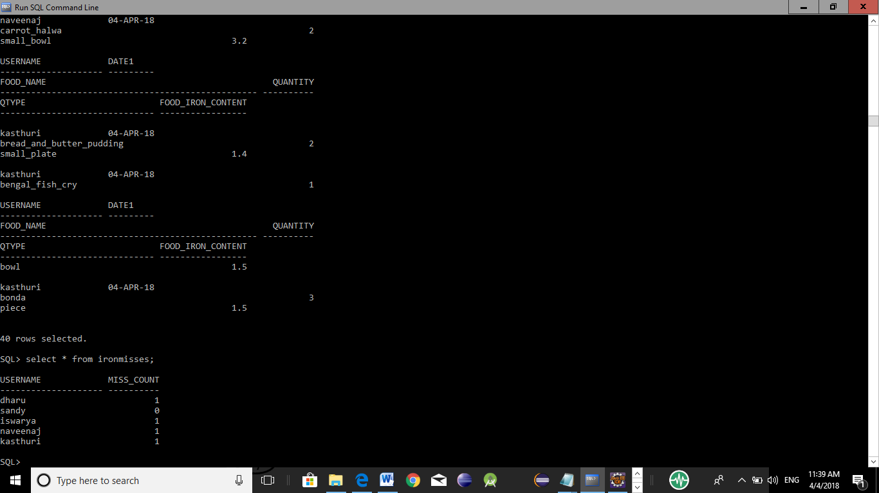

Views

|  |  |  |  |  |
| --- | --- | --- | --- | --- |
| # | Name | Tables Involved | Description | Output |
| 1 | View1 | person | To extract the details of a person leaving password for security purpose | All the fields of person table except password |

Procedures

|  |  |  |  |  |
| --- | --- | --- | --- | --- |
| # | Name & Description | Tables Involved | IN & OUT Parameter(s) | Output |
| 1 | **Signup**  A procedure to calculate bmi and iron_required and insert the values into table  Person. | Person,  iron_requirement_chart | Username, password, firstname, lastname, gender, age, weight, height, category | Values inserted into table |
| Nil |
| 2 | **insert_food**  a procedure to insert the food with its calculated iron content into food consumed table | Food_consumed,  food | Username,  food, quantity | Values inserted into food consumed table |
| 3 | **Detailsdis**  It returns the details of a person with out parameter | person | **IN:** username  **OUT:** firtname, lastname, gender, height, weight, bmi, iron_required, age | Change the values of the variables |

Functions

|  |  |  |  |  |  |
| --- | --- | --- | --- | --- | --- |
| # | Name & Description | Tables Involved | Parameter(s) | Return Type | Output |
| 1 | **check_signup**  a function to check whether username exist or not | person | username | number | 0 or 1 |
| 2 | **Login**  A function checks password match | person | Username,  password | number | 0 or 1 |
| 3 | **Date_fun**  a function which returns login delay and insert new value to daily_database | Daily_database | username | number | Date delay |
| 4 | **total_iron**  a function to return total iron consumption of the day | Food_consumed | username | number | Tota_iron_  consumed |
| 5. | **insert_totaliron**  a function to update the total iron consumed of a person | Food_consumed,  Daily_database | username | number | Total_iron  _consumed |
| 6 | **Missfun**  to calculate the consecutive days for less iron consumption | Daily_database | username | number | Count of consecutive days failed to achieve the target |
| 7 | **Missesret**  a function to return total no of target failed | ironmisses | username | number | count |
| 8 | **Ironret**  A function to return iron requirement of a particular person | person | username | number | Iron_required |
| 9 | **Bmiret**  a function to return bmi of a particular person | person | username | number | bmi |
| 10 | **Ironcons**  A function to return total iron consumption of today | Daily_data_base | username | number | Total_iron_  consumed |

Triggers

|  |  |  |  |  |
| --- | --- | --- | --- | --- |
| # | Name & Description | Trigger Type | Tables Involved | Output |
| 1 | **Ironmiss**  If the total_iron_consumed is less than iron_required it adds count in the table ironmisses | After update or insert | Daily_database,  Person,  ironmisses | Count updation in ironmisses |