Downloading Git
https://git-scm.com/downloads

After choosing your OS as Windows Simply run the Wizard until the Git gets installed.

Configure Git for the first time.
Do the following steps :
Suppose I want to register a user whose user name is "GitClass" and email address is "GitClass@xyz", then it will be done as follows:
To register a username, run the below command:
$ git config --global user.name "GitClass"

To register an email address for the given author, run the below command:

$ git config --global user.email "GitClass@xyz"

It's important to understand that the git config tool works on a user according to the user.
For example, if we have a user "john" registered on Git. Then there can be another user "Mike" on the same machine registered on Git.
To do this, Mike must run the same command from his user account. The commits made by both the users will be done under their details in Git.

To check whether username and email configure are correct .
$ git config –list : Run the following command :

You will have the output as shown below displaying user.name & user.email
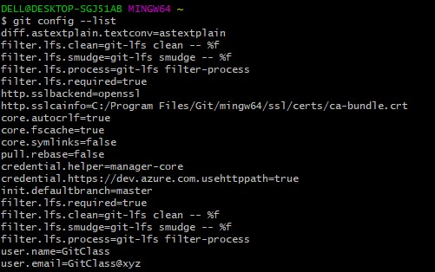

Alternatively you can also execute the following commands for checking username and password :
$ git config user.name

Output :
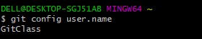

$ git config user.email

OutPut :

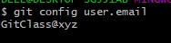

Git command line

There are many different ways to use Git.
Git supports many command-line tools and graphical user interfaces.
The Git command line is the only place where you can run all the Git commands.

Basic Git Commands :
Here is a list of most essential Git commands that are used daily.

Git Config command :
$ git config --global user.name "ImDwivedi1"
$ git config --global user.email Himanshudubey481@gmail.com

mkdir git-project : creates a directory by the name of git-project
ls : list all the commands
cd git-project/ : Changing the directory
nano index.html : Nano is an editor used for writing html codes

In order to save file in Nano Editior we need to press CTRL + O
In order to exit file in Nano Editior we need to press CTRL + X

Git init : Informs about that current directory needs to be transformed into a repository and the same needs to be started from tracking perspective as well.

Git add [filename]: This command adds a file to the staging area.

Git Status : When you’re feeling a bit lost with what’s happened in your repo (yes, it can happen) the Git Status command can tell you all the information you’ll need to know.

Git Status can give you information such as:

Your current branch
Whether your current branch is up to date
If there’s anything in the branch that needs to be committed, pushed, or pulled.
If you have any files that are either staged or not staged.
And if you have any files that are created, modified, or deleted.

=====================================

Git Commit : Think of Git Commit command like a checkpoint in your development process.

It’s commonly used to save your changes.

Every time you commit your code changes, you’ll also include a message to briefly describe the changes you made.

This helps other team members quickly understand what was added, changed, or removed.

Using Git Commit Command : $ Git commit -a

This will commit all the changes in the directory you’re working in.

Once this command is run, you’ll be prompted to enter a commit message.

Alternatively, you can enter the commit message in the command itself and skip the additional step where you’ll be prompted to enter the commit message.

To do this, run the following git command:

$ git commit -am “<commit-message>”

Changes made are saved on our local systems

e.g : git commit -m "Added index.html"

=====================================
Git remote : git remote add [variable name] [Remote Server Link]
This command is used to connect your local repository to the remote server ( e.g Github )
e.g : git remote add origin https://github.com/dharniv/first-repository.git | we are declaring our origin destination and that too remotely

========================================
Git Push : To make all your committed changes available to your teammates, you’ll have to push them to the remote origin.
Using Git Push Command
$ git push <remote> <branch-name> : we want to push our changes to remote from branch name
It’s important to remember that git push command will upload only the changes you’ve committed.
e.g : git push origin master (code from master branch is being pushed at origin location defined earlier )

=======================================

Executing Git Push Command
run
nano index.html
make some changes in the file
then check the git status
adding the file to staging area by running the following command git add index.html
git commit -m "changed Hi to How are"
git push origin master
You will now see 2 commits in the GitHub | latest message for commit have also got changed from Hi to Hi How are
=================================
clear : command will clear the entire screen
=================================
cd : Running this command will take you to old directory
===============================
mkdir temp : creating a new temp directory
============================
cd temp/ : we are assuming this directory is on some another system
=====================
clear
=====================

Git clone https://github.com/dharniv/first-repository.git

Git Clone commands helps to copy any code sitting on gitlab to another developer system .

Once the code gets updated on GitHub another developer can download the same and get moving.
=========================
Once this has been done .
Just run the following command : ls
and you would be able to see the same repository into a new directory ( temp )

=========================
cd first-repository/
========================

Git Push / Pull Request
The term pull is used to receive data from GitHub. It fetches and merges changes from the remote server to your working directory. The git pull command is used to pull a repository.
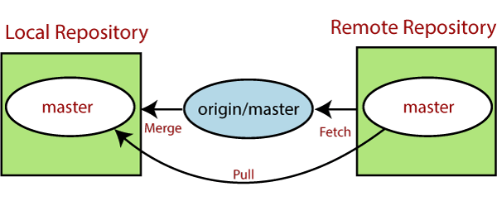

Git Branch

A branch is a version of the repository that diverges from the main working project. It is a feature available in most modern version control systems.

A Git project can have more than one branch. These branches are a pointer to a snapshot of your changes

When you want to add a new feature or fix a bug, you spawn a new branch to summarize your changes.

So, it is complex to merge the unstable code with the main code base and also facilitates you to clean up your future history before merging with the main branch.

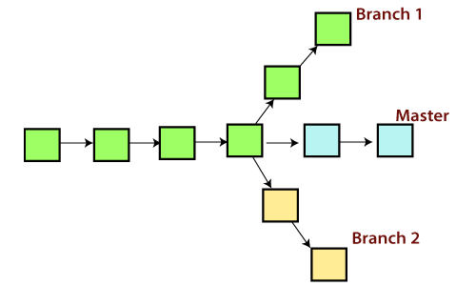

To check your current branch run the following command:

Input : Git branch

Output : *indicates the current branch. By default this is the main or master branch

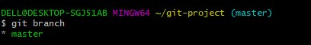

Adding a new branch .

Input : git branch new branch

Output :

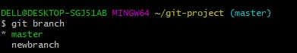

Switching the branch ( old to new )

Input : git checkout newbranch

Output :

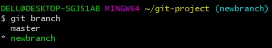

Input : ls

Whenever we create a new branch and switch it to new branch . Existing code from the main branch gets copied to new branch automatically

Output :

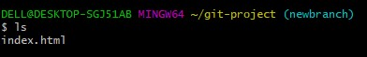

Deleting a branch :

Command : Git branch –d newbranch

Looking to list down all the branches :

Git branch –a

Git Log command : Informs about the history of commits made till date

Git Master Branch

The master branch is a default branch in Git. It is instantiated when first commit made on the project. When you make the first commit, you're given a master branch to the starting commit point. When you start making a commit, then master branch pointer automatically moves forward. A repository can have only one master branch.

Master branch is the branch in which all the changes eventually get merged back. It can be called as an official working version of your project.

Operations on Branches

We can perform various operations on Git branches. The git branch command allows you to create, list, rename and delete branches. Many operations on branches are applied by git checkout and git merge command. So, the git branch is tightly integrated with the git checkout and git merge commands.

Git Merge and Merge Conflict

In Git, the merging is a procedure to connect the forked history. It joins two or more development history together. The git merge command facilitates you to take the data created by git branch and integrate them into a single branch. Git merge will associate a series of commits into one unified history. Generally, git merge is used to combine two branches.

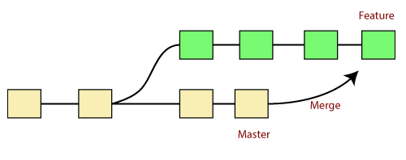

It is used to maintain distinct lines of development; at some stage, you want to merge the changes in one branch. It is essential to understand how merging works in Git.

In the above figure, there are two branches master and feature. We can see that we made some commits in both functionality and master branch, and merge them. It works as a pointer. It will find a common base commit between branches. Once Git finds a shared base commit, it will create a new "merge commit." It combines the changes of each queued merge commit sequence.

Adding a sub – branch to a master branch

Git checkout master

Git merge (newbranch : branch name that needs to be added to master branch)

Git log

The "git merge" command

The git merge command is used to merge the branches.

The syntax for the git merge command is as:
- $ git merge <query>
It can be used in various context. Some are as follows:
Scenario1: To merge the specified commit to currently active branch:
Use the below command to merge the specified commit to currently active branch.
- $ git merge <commit>
The above command will merge the specified commit to the currently active branch. You can also merge the specified commit to a specified branch by passing in the branch name in <commit>. Let's see how to commit to a currently active branch.

Scenario2: To merge commits into the master branch:
To merge a specified commit into master, first discover its commit id. Use the log command to find the particular commit id.
- $git log

To merge the commits into the master branch, switch over to the master branch.
- $ git checkout master
Now, Switch to branch 'master' to perform merging operation on a commit. Use the git merge command along with master branch name. The syntax for this is as follows:

$ git merge master

