David Haro

CSC Java 18C

Professor Paul Conrad

2016 March 3

Assignment #1: Implementation of resizing array within a Bag.

This method was fairly simple to implement. It made sense to make it part of the add() method. This was made so because instead of throwing an error indicative of a full array and returning false, better to just increase the size of the array and carry on.

Here is a screen capture of the newly implemented resizing of the array within the add() method:

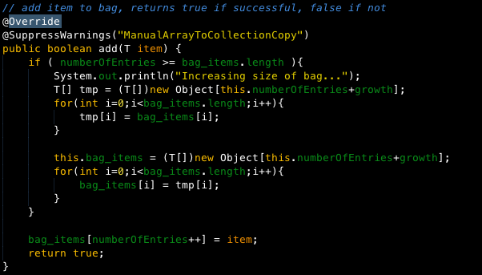

Added suppress warnings because I wanted to show manual copy of an array.

In the first if-statement, before it would compare the number of entries with the length of the bag, and return false if the two values were equal or if the numberOfentries exceeded bag_items.length.

The new if-statement makes changes to the bag length when this flag is true. When TRUE, the if-statement displays a message to the user indicating that the bag will be re-sized, then, like a tailor, a temp bag is created with the number of elements in the original bag PLUS an addition called “growth”. Growth is used to add length to the bag. In this scenario, the bag is increased by 5

Once all values are copied from original bag to temporary bag, bag_items is re-initialized to be the same size as the temporary bag and once again, all the items are copied from the temp bag to the newly re-sized bag_items.

The final statement is unchanged and adds the item to the bag because it now fits. This returns true and continues to work until bag needs to be resized.