DELIVERY ORDER TRACKING SYSTEM

1. INTRODUCTION
The Delivery Order Tracking System is an automated application designed to help users efficiently manage and track their product deliveries. Traditionally, tracking delivery orders involves manual checking, phone calls, and lack of real-time updates, which can lead to delays and confusion. This project eliminates these challenges by providing a Graphical User Interface (GUI) through which users can log in, view their order details, check delivery statuses, and search for specific orders instantly.
The system ensures smooth interaction between the user interface and the backend database, maintaining accurate order information and status updates in real time. It uses Java Swing for the GUI and MySQL for backend data management, ensuring a user-friendly, secure, and scalable solution.
2. OBJECTIVES
- To provide an intuitive and user-friendly interface for customers to view and track their delivery orders.
- To allow users to register, log in securely, and access their personalized dashboard.
- To display all delivery orders with their respective statuses such as Pending, Shipped, and Delivered.
- To enable quick search and filtering of orders using the order number.
- To store and manage user and order data efficiently in a MySQL database.
- To minimize manual tracking efforts and enhance the accuracy of delivery information.
- To ensure easy scalability for adding more users and orders in the future.
3. SYSTEM REQUIREMENTS AND SETUP

Software Requirements
• RAM: Minimum 4 GB
• Processor: Intel Core i3 or higher
• Hard Disk Space: Minimum 100 MB of free space
• Operating System: Windows 10 or above
• Java Development Kit (JDK): Version 1.8 or above
• Database Server: MySQL 8.0 or above
• Integrated Development Environment (IDE): Eclipse IDE
• Libraries Required: MySQL Connector/J (mysql-connector-java.jar)

Hardware Requirements
• Processor: Intel i3 / AMD Ryzen 3 or higher
• Memory: 4 GB RAM (Recommended 8 GB for smooth execution)
• Storage: Minimum 500 MB available for project files and database storage
• Display: 1024×768 resolution or higher for GUI display
• Network: Localhost connectivity for database communication

Setup Instructions
- Create MySQL Database:
CREATE DATABASE delivery_tracking_db;
USE delivery_tracking_db;
- Create Tables:
CREATE TABLE IF NOT EXISTS users (
id INT AUTO_INCREMENT PRIMARY KEY,
username VARCHAR(50) NOT NULL UNIQUE,
password VARCHAR(100) NOT NULL,
email VARCHAR(100),
phone VARCHAR(15),
address VARCHAR(255)
);

CREATE TABLE IF NOT EXISTS orders (
id INT AUTO_INCREMENT PRIMARY KEY,
user_id INT NOT NULL,
order_number VARCHAR(50) NOT NULL,
product_name VARCHAR(100) NOT NULL,
status VARCHAR(50) NOT NULL,
delivery_date DATE NOT NULL,
address VARCHAR(255),
FOREIGN KEY (user_id) REFERENCES users(id)
);
- Import the table structure
Import the provided SQL script (delivery_tracking_db.sql) in MySQL Workbench
- Add the JDBC Connector:
Add mysql-connector-java.jar to the Project Libraries in Eclipse.
(Right-click Project → Build Path → Configure Build Path → Add External JARs → Select the connector file)
- Run the Application:
Open the project in Eclipse.
Start MySQL Server.
Run Main.java to launch the Login Window.
- User Login:
Existing users can log in using their username and password.
New users can register using the Sign-Up option.
- Track Orders:
After logging in, users can view, search, and track their delivery orders.
- Admin Access (Optional):
Admins can log in with admin credentials to view all orders and manage user data.

4.PROCEDURE

1. User Login and Registration:
- Open the User Login GUI.
- Enter username and password to log in.
- If you are a new user, click Register and fill in details such as name, email, phone, and address.
- On successful login, the user dashboard appears.

2. Viewing and Tracking Orders:
- After logging in, the user can view a list of all their orders.
- Each order displays the Order Number, Product Name, Status, Delivery Date, and Address.
- The order status is:
  - Delivered – Successfully completed.
  - Shipped – Currently in transit.
  - Pending – Yet to be dispatched.

3. Database and Server Interaction:
- The application connects to MySQL using JDBC (mysql-connector-java.jar).
- All login credentials, user data, and order details are securely stored in the database.
- When users perform actions like login or search, SQL queries are executed in real-time.
- The system ensures data integrity and automatic refresh of order status updates.
5. SYSTEM ARCHITECTURE
5.1 Architectural Layers
- Presentation Layer (Client GUI):
- Collects product details and displays wishlist data.
- Developed using Java Swing.
- Communicates with the server via TCP sockets.
- Application Layer (Server):
- Receives client requests, processes them, and executes database operations.
- Uses ServerSocket for communication and JDBC for SQL execution.
- Data Layer (MySQL Database):
- Stores product information in a persistent table.
- Executes INSERT, DELETE, and SELECT queries.
- Communication Layer:
  - Establishes real-time connectivity between client and server through sockets.
  - Ensures reliable data transfer and response handling.

5.2 ARCHITECTURE DIAGRAM
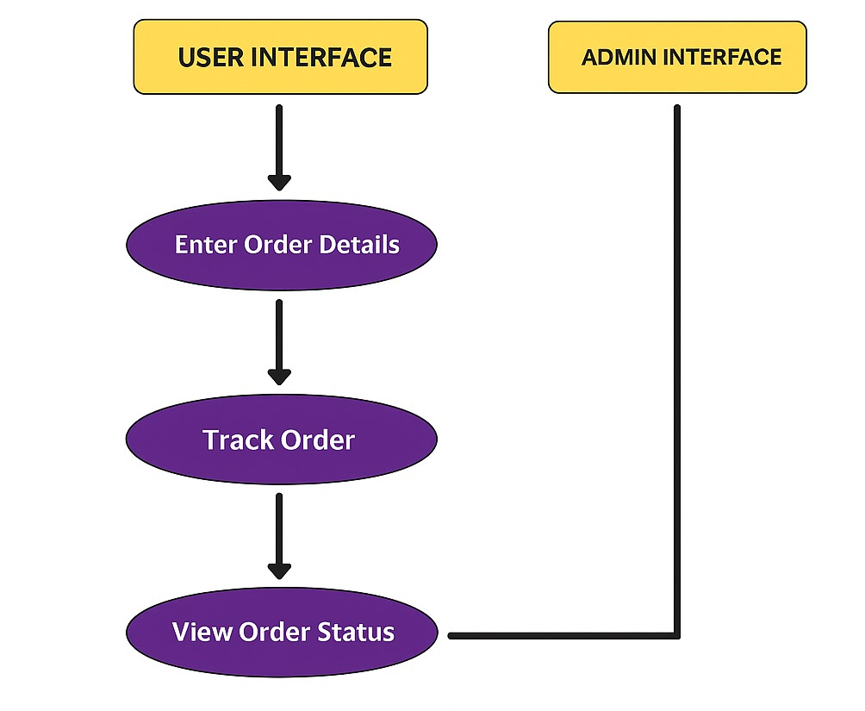
6. MODULE DESCRIPTION

Module 1: Order.java
- Defines the blueprint of an order with attributes like orderId, customerName, productName, quantity, price, and status.
- Implements encapsulation and provides getter and setter methods for each attribute.
- Represents each delivery order as an object for easier manipulation and tracking.
ORDER PROGRAM:
public class Order implements java.io.Serializable {
private int orderId;
private String customerName;
private String productName;
private int quantity;
private double price;
private String status;

public Order(int orderId, String customerName, String productName, int quantity, double price, String status) {
this.orderId = orderId;
this.customerName = customerName;
this.productName = productName;
this.quantity = quantity;
this.price = price;
this.status = status;
}

public int getOrderId() { return orderId; }
public String getCustomerName() { return customerName; }
public String getProductName() { return productName; }
public int getQuantity() { return quantity; }
public double getPrice() { return price; }
public String getStatus() { return status; }

@Override
public String toString() {
return String.format("OrderID: %d | Customer: %s | Product: %s | Qty: %d | Price: %.2f | Status: %s",
orderId, customerName, productName, quantity, price, status);
}
}

Module 2: DBConnection.java
- Establishes a connection between the Java application and the MySQL database using JDBC.
- Contains a reusable getConnection() method to access the database securely.
DBCONNECTION PROGRAM:
import java.sql.Connection;
import java.sql.DriverManager;
import java.sql.SQLException;

public class DBConnection {
private static final String URL = "jdbc:mysql://localhost:3306/deliverydb";
private static final String USER = "root";
private static final String PASSWORD = "yourpassword"; // change this

public static Connection getConnection() throws SQLException {
return DriverManager.getConnection(URL, USER, PASSWORD);
}
}

Module 3: Protocol.java
- Defines constants for standardized communication between client and server.
- Commands include operations like ADD_ORDER, VIEW_ORDERS, UPDATE_STATUS, and EXIT.
PROTOCOL PROGRAM:
public class Protocol {
public static final String ADD_ORDER = "ADD_ORDER";
public static final String VIEW_ORDERS = "VIEW_ORDERS";
public static final String UPDATE_STATUS = "UPDATE_STATUS";
public static final String EXIT = "EXIT";
}

Module 4: DeliveryServer.java
- Implements the main server which listens on a specific port (e.g., 6000).
- Receives client requests, performs database operations, and sends responses back to the client.
DELIVERYSERVER PROGRAM:
import java.io.*;
import java.net.*;
import java.sql.*;

public class DeliveryServer {
public static void main(String[] args) {
try (ServerSocket serverSocket = new ServerSocket(6000)) {
System.out.println("Server running... Waiting for clients.");
while (true) {
Socket socket = serverSocket.accept();
new ClientHandler(socket).start();
}
} catch (IOException e) {
e.printStackTrace();
}
}
}

class ClientHandler extends Thread {
private Socket socket;

public ClientHandler(Socket socket) {
this.socket = socket;
}

public void run() {
try (
ObjectInputStream in = new ObjectInputStream(socket.getInputStream());
ObjectOutputStream out = new ObjectOutputStream(socket.getOutputStream())
) {
while (true) {
String command = (String) in.readObject();
if (Protocol.ADD_ORDER.equals(command)) {
Order order = (Order) in.readObject();
addOrderToDB(order);
out.writeObject("Order added successfully!");
} else if (Protocol.VIEW_ORDERS.equals(command)) {
out.writeObject(viewOrders());
} else if (Protocol.UPDATE_STATUS.equals(command)) {
int orderId = (int) in.readObject();
String status = (String) in.readObject();
updateOrderStatus(orderId, status);
out.writeObject("Order status updated!");
} else if (Protocol.EXIT.equals(command)) {
break;
}
}
} catch (Exception e) {
e.printStackTrace();
}
}

private void addOrderToDB(Order order) throws SQLException {
try (Connection con = DBConnection.getConnection();
PreparedStatement ps = con.prepareStatement("INSERT INTO orders VALUES (?, ?, ?, ?, ?, ?)")) {
ps.setInt(1, order.getOrderId());
ps.setString(2, order.getCustomerName());
ps.setString(3, order.getProductName());
ps.setInt(4, order.getQuantity());
ps.setDouble(5, order.getPrice());
ps.setString(6, order.getStatus());
ps.executeUpdate();
}
}

private String viewOrders() throws SQLException {
StringBuilder sb = new StringBuilder();
try (Connection con = DBConnection.getConnection();
Statement st = con.createStatement();
ResultSet rs = st.executeQuery("SELECT * FROM orders")) {
while (rs.next()) {
sb.append(String.format("OrderID: %d | Customer: %s | Product: %s | Qty: %d | Price: %.2f | Status: %s\n",
rs.getInt(1), rs.getString(2), rs.getString(3),
rs.getInt(4), rs.getDouble(5), rs.getString(6)));
}
}
return sb.length() == 0 ? "No orders found!" : sb.toString();
}

private void updateOrderStatus(int orderId, String status) throws SQLException {
try (Connection con = DBConnection.getConnection();
PreparedStatement ps = con.prepareStatement("UPDATE orders SET status = ? WHERE orderId = ?")) {
ps.setString(1, status);
ps.setInt(2, orderId);
ps.executeUpdate();
}
}
}

Module 5: DeliveryClient.java
- Provides a GUI interface for customers/admin to manage delivery orders.
- Allows users to add orders, view order lists, and update delivery status.
DELIVERYCLIENT PROGRAM:
import javax.swing.*;
import java.awt.*;
import java.io.*;
import java.net.*;

public class DeliveryClient extends JFrame {
private Socket socket;
private ObjectOutputStream out;
private ObjectInputStream in;
private JTextArea outputArea;

public DeliveryClient() {
setTitle("Delivery Order Tracking System");
setSize(500, 400);
setDefaultCloseOperation(EXIT_ON_CLOSE);
setLayout(new BorderLayout());

JButton addButton = new JButton("Add Order");
JButton viewButton = new JButton("View Orders");
JButton updateButton = new JButton("Update Status");

JPanel panel = new JPanel();
panel.add(addButton);
panel.add(viewButton);
panel.add(updateButton);
add(panel, BorderLayout.NORTH);

outputArea = new JTextArea();
add(new JScrollPane(outputArea), BorderLayout.CENTER);

connectToServer();

addButton.addActionListener(e -> addOrder());
viewButton.addActionListener(e -> viewOrders());
updateButton.addActionListener(e -> updateStatus());
}

private void connectToServer() {
try {
socket = new Socket("localhost", 6000);
out = new ObjectOutputStream(socket.getOutputStream());
in = new ObjectInputStream(socket.getInputStream());
} catch (Exception e) {
JOptionPane.showMessageDialog(this, "Server not available!", "Error", JOptionPane.ERROR_MESSAGE);
}
}

private void addOrder() {
JTextField idField = new JTextField();
JTextField nameField = new JTextField();
JTextField productField = new JTextField();
JTextField qtyField = new JTextField();
JTextField priceField = new JTextField();
JTextField statusField = new JTextField("Pending");

Object[] message = {
"Order ID:", idField,
"Customer Name:", nameField,
"Product Name:", productField,
"Quantity:", qtyField,
"Price:", priceField,
"Status:", statusField
};

int option = JOptionPane.showConfirmDialog(this, message, "Add Order", JOptionPane.OK_CANCEL_OPTION);
if (option == JOptionPane.OK_OPTION) {
try {
Order order = new Order(
Integer.parseInt(idField.getText()),
nameField.getText(),
productField.getText(),
Integer.parseInt(qtyField.getText()),
Double.parseDouble(priceField.getText()),
statusField.getText()
);
out.writeObject(Protocol.ADD_ORDER);
out.writeObject(order);
out.flush();
outputArea.setText((String) in.readObject());
} catch (Exception e) {
JOptionPane.showMessageDialog(this, "Error adding order!");
}
}
}

private void viewOrders() {
try {
out.writeObject(Protocol.VIEW_ORDERS);
out.flush();
outputArea.setText((String) in.readObject());
} catch (Exception e) {
JOptionPane.showMessageDialog(this, "Error viewing orders!");
}
}

private void updateStatus() {
try {
int id = Integer.parseInt(JOptionPane.showInputDialog(this, "Enter Order ID:"));
String status = JOptionPane.showInputDialog(this, "Enter New Status:");
out.writeObject(Protocol.UPDATE_STATUS);
out.writeObject(id);
out.writeObject(status);
out.flush();
outputArea.setText((String) in.readObject());
} catch (Exception e) {
JOptionPane.showMessageDialog(this, "Error updating status!");
}
}

public static void main(String[] args) {
SwingUtilities.invokeLater(() -> new DeliveryClient().setVisible(true));
}
}

Module 6: Database Module
- Uses MySQL with JDBC for data storage and retrieval.
- Performs Add, View, and Update operations on the orders table.
- Ensures data persistence, security, and real-time synchronization with the server.
SQL QUERIES:
CREATE DATABASE deliverydb;
USE deliverydb;

CREATE TABLE orders (
orderId INT PRIMARY KEY,
customerName VARCHAR(100),
productName VARCHAR(100),
quantity INT,
price DOUBLE,
status VARCHAR(50)
);

SCREENSHOTS
LOGIN PAGE
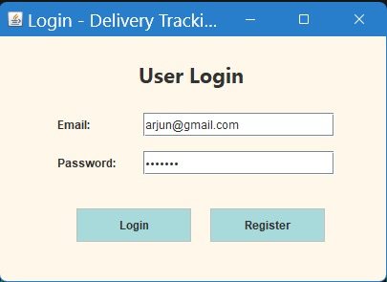
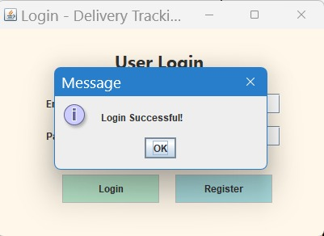
REGISTRATION PAGE
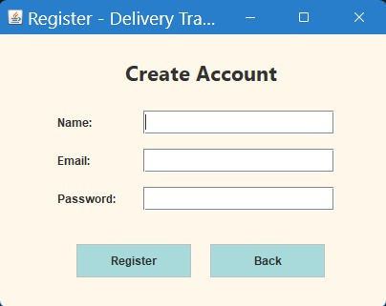
USER DASHBOARD PAGE
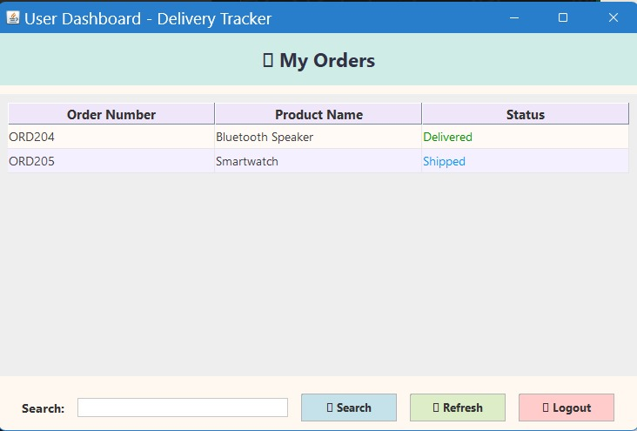
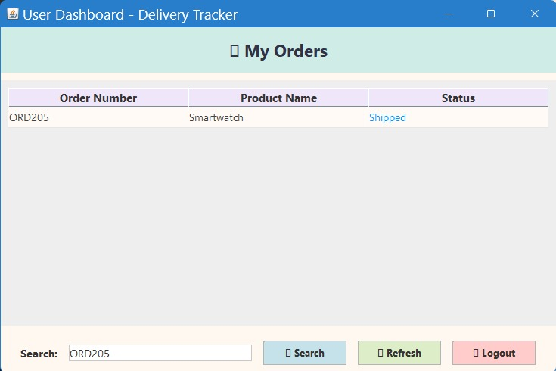
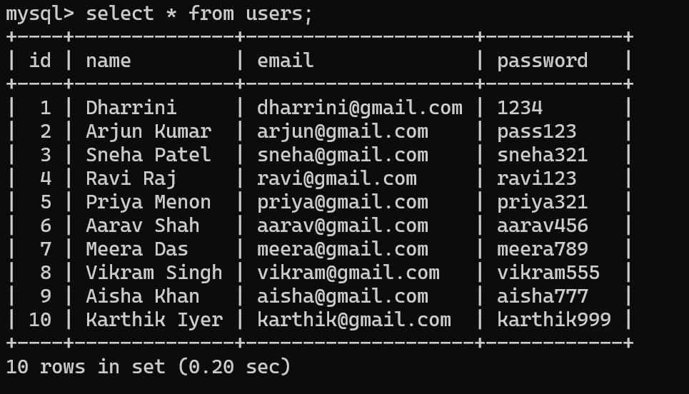
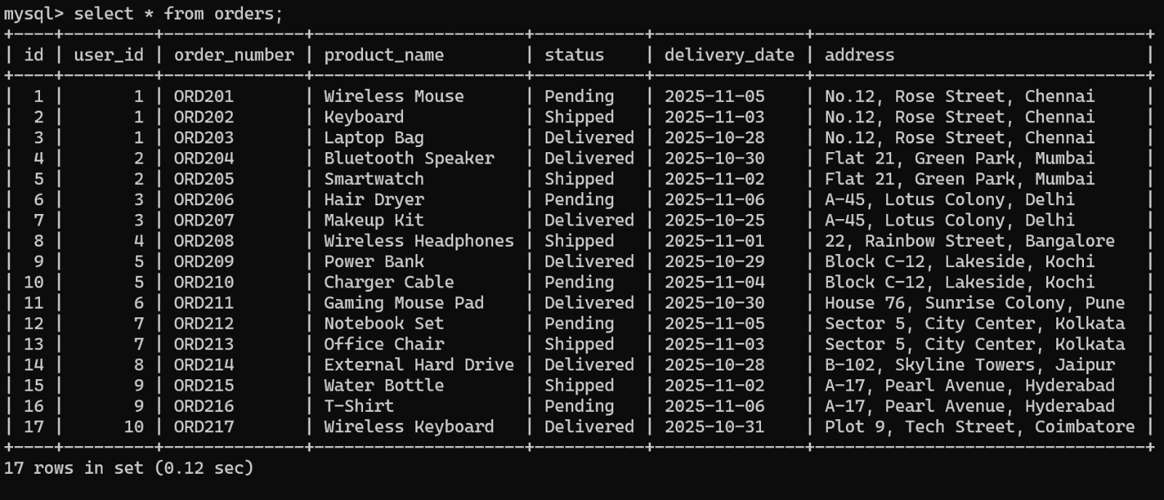

8. Conclusion
The Delivery Order Booking System successfully combines the core concepts of Object-Oriented Programming (OOP), Graphical User Interface (GUI) design, Socket Programming, and Database Management into an efficient and well-organized application.
The system enables users to conveniently place, track, and manage their delivery orders through an intuitive Java Swing interface, while the admin can monitor and update order statuses in real time.By implementing a client–server architecture, the project ensures seamless communication between the user interface and the backend server. All order details are securely stored in a MySQL database using JDBC connectivity, providing both reliability and data persistence.The modular design of the system enhances scalability, maintainability, and ease of future development. The use of prepared statements and structured SQL queries ensures data integrity and security during all transactions.
Through this project, essential programming skills such as network communication, event-driven programming, and database integration have been effectively applied.
Overall, the system achieves its primary objective of delivering a robust, reliable, and user-friendly platform for managing delivery orders, serving as a solid foundation for further enhancements and real-world deployment.

9. Future Work
The Delivery Order Booking System can be further enhanced to improve efficiency, scalability, and adaptability for real-world logistics and e-commerce applications. The following improvements can be implemented in future versions:
- User Authentication and Role Management:
Introduce a secure login system with distinct roles for customers, delivery agents, and administrators. This ensures secure access control, personalized order history, and data privacy.
- Real-Time Order Tracking and Notifications:
Integrate GPS-based real-time tracking to monitor delivery status. Add automated email or SMS notifications to inform customers about order confirmation, dispatch, and delivery updates.
- Web and Mobile Platform Integration:
Extend the system into a web-based or mobile application using frameworks like Spring Boot, React, or Flutter. This allows users to place and track orders anytime, from any device.
- Advanced Analytics and Reporting:
Incorporate analytics dashboards to display metrics such as delivery times, most-ordered items, and customer satisfaction. Enable admins to generate PDF or Excel reports for performance evaluation.
- Payment Gateway and Invoice Management:
Integrate secure online payment options and generate digital invoices automatically for each order to streamline the transaction process.
- Cloud and API Integration:
Host the system on cloud services like AWS or Google Cloud for better scalability and reliability. Expose APIs to connect with third-party logistics or inventory systems.
With these enhancements, the Delivery Order Booking System can evolve from a basic desktop-based prototype into a fully featured, cloud-integrated delivery management platform, suitable for real-world business applications in logistics, e-commerce, and supply chain management.
GITHUB REFERENCE
https://github.com/dharrini06/DHARRINI-SELVI-R--DELIVERY-ORDER-TRACKING-SYSTEM

PO–PSO Mapping and Justification

PO–PSO Mapping Table
PO1 | PO2 | PO3 | PO4 | PO5 | PO6 | PO7 | PO8 | PO9 | PO10 | PO11 | PO12 | PSO1 | PSO2 | PSO3
3 | 3 | 3 | 2 | 2 | 1 | - | 3 | 2 | 2 | 2 | 3 | 3 | 2 | 1

PSO Justification

PSO | Relevance | Justification
PSO1 – Apply fundamental computing knowledge | 3 | Uses Java fundamentals, database connectivity, and socket programming to create a reliable tracking system.
PSO2 – Design and implement solutions | 2 | Integrates software design and modular programming to provide an efficient, maintainable delivery tracking solution.
PSO3 – Use modern tools and technologies | 1 | Utilizes MySQL, Eclipse IDE, and JDBC for developing and managing the client–server communication and data storage.

PO Justification

PO | Relevance | Justification
PO1 – Engineering Knowledge | 3 | Applies core Java, socket programming, and database integration to develop a complete client–server system.
PO2 – Problem Analysis | 3 | Identifies and resolves issues in order tracking, client–server communication, and database management.
PO3 – Design/Development of Solutions | 3 | Designs a real-time delivery order tracking system integrating GUI, server logic, and MySQL database.
PO4 – Conduct Investigations of Complex Problems | 2 | Tests and evaluates multiple client connections, ensuring performance and consistency in tracking.
PO5 – Modern Tool Usage | 2 | Employs modern tools such as Eclipse IDE, MySQL, and JDBC for building, testing, and deploying the system.
PO6 – The Engineer and Society | 1 | Promotes real-world applicability by improving order tracking efficiency for delivery-based businesses.
PO8 – Ethics | 3 | Ensures secure handling of user data and responsible network communication using encrypted connections.
PO9 – Individual and Team Work | 2 | Can be implemented collaboratively with clear modular division between client, server, and database development.
PO10 – Communication | 2 | Demonstrates effective communication through GUI interactions and structured socket message protocols.
PO11 – Project Management and Finance | 2 | Applies project management principles for coordinating modules and optimizing system efficiency.
PO12 – Life-long Learning | 3 | Encourages continuous learning of Java networking, DB connectivity, and scalable application design.

