Index.html
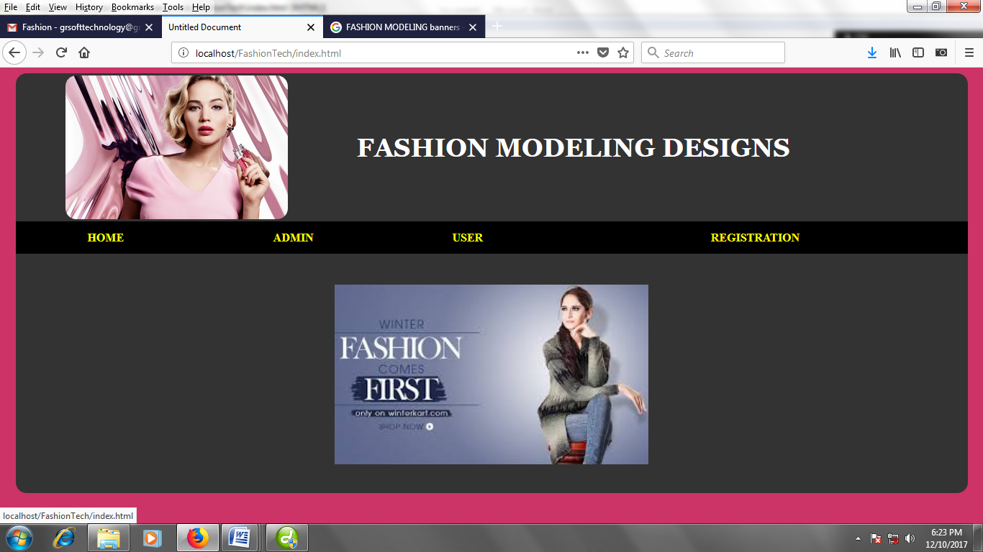
<!DOCTYPE html PUBLIC "-//W3C//DTD XHTML 1.0 Transitional//EN" "http://www.w3.org/TR/xhtml1/DTD/xhtml1-transitional.dtd">
<html xmlns="http://www.w3.org/1999/xhtml">
<head>
<meta http-equiv="Content-Type" content="text/html; charset=iso-8859-1" />
<title>Untitled Document</title>
<style type="text/css">
<!--
.style1 {
font-family: Georgia, "Times New Roman", Times, serif;
font-weight: bold;
font-size: 36px;
color: #FFFFFF;
text-transform:uppercase;
}
.style2 {
color: #FFFF00;
font-weight: bold;
text-decoration:none;
}

.style6 {color: #FFFFFF;font-size: 25px; }
-->
</style>
</head>

<body bgcolor="#CC3366">
<center>
<table width="98%" border="0" cellpadding="0" cellspacing="0" bgcolor="#333333"s style="border-radius:15px">
<!--DWLayoutTable-->
<tr>
<td width="100%" height="111" valign="top">
<center>
<table width="90%" border="0">
<tr>
<td><img src="1.jpg" height="200px" style="border-radius:15px"/></td>
<td> <p class="style1"> FASHION MODELING DESIGNS</p></td>
</tr>
</table>

</td>
</tr>
<tr>
<td height="48" valign="top"><table width="100%" height="45" border="0" bgcolor="#000000">
<tr>
<td><div align="center"><a href="index.html" class="style2">HOME</a></div></td>
<td><div align="center"><a href="login.html" class="style2">ADMIN</a></div></td>
<td><div align="center"><a href="userlogin.html" class="style2">USER</a></div></td>
<td><div align="center"><a href="reg.html" class="style2">REGISTRATION</a></div></td>
</tr>
</table></td>
</tr>
<tr>
<td height="330" valign="top">
<br /><br />
<centeR>
<img src="2.jpg" height="250px" /></centeR>

</td>
</tr>
</table>
</center>
</body>
</html>
Login.html
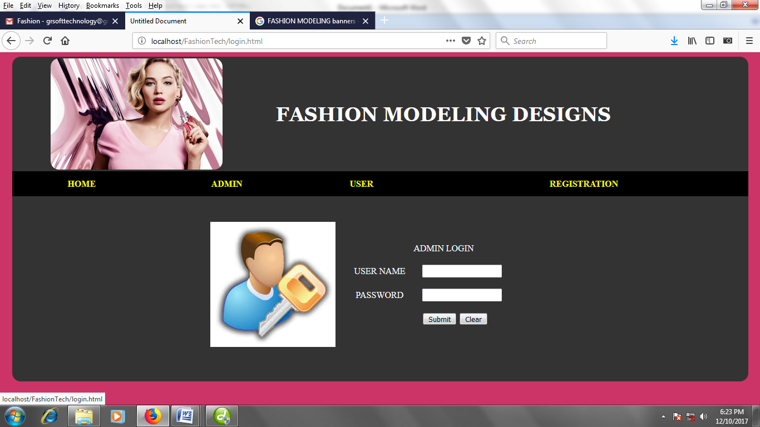
<!DOCTYPE html PUBLIC "-//W3C//DTD XHTML 1.0 Transitional//EN" "http://www.w3.org/TR/xhtml1/DTD/xhtml1-transitional.dtd">
<html xmlns="http://www.w3.org/1999/xhtml">
<head>
<meta http-equiv="Content-Type" content="text/html; charset=iso-8859-1" />
<title>Untitled Document</title>
<style type="text/css">
<!--
.style1 {
font-family: Georgia, "Times New Roman", Times, serif;
font-weight: bold;
font-size: 36px;
color: #FFFFFF;
}
.style2 {
color: #FFFF00;
font-weight: bold;
text-decoration:none;
}
.style7 {color: #FFFFFF}
-->
</style>
</head>

<body bgcolor="#CC3366">
<center>
<table width="98%" border="0" cellpadding="0" cellspacing="0" bgcolor="#333333"s style="border-radius:15px">
<!--DWLayoutTable-->
<tr>
<td width="100%" height="111" valign="top">
<center>
<table width="90%" border="0">
<tr>
<td><img src="1.jpg" height="200px" style="border-radius:15px"/></td>
<td> <p class="style1"> FASHION MODELING DESIGNS</p></td>
</tr>
</table>

</td>
</tr>
<tr>
<td height="48" valign="top"><table width="100%" height="45" border="0" bgcolor="#000000">
<tr>
<td><div align="center"><a href="index.html" class="style2">HOME</a></div></td>
<td><div align="center"><a href="login.html" class="style2">ADMIN</a></div></td>
<td><div align="center"><a href="userlogin.html" class="style2">USER</a></div></td>
<td><div align="center"><a href="reg.html" class="style2">REGISTRATION</a></div></td>
</tr>
</table></td>
</tr>
<tr>
<td height="330" valign="top">
<br /><br />
<center>
<table width="200" border="0">
<tr>
<td><img src="12.jpg" width="225" height="225" /></td>
<td>

<table width="382" height="170" border="0" align="center">
<tr>
<td colspan="2"><div align="center" class="style7"><span class="style3">ADMIN LOGIN </span></div></td>
</tr>
<tr>
<td><div align="center" class="style7"><span class="style3">USER NAME </span></div></td>
<td>
<input name="textfield" type="text" /> </td>
</tr>
<tr>
<td><div align="center" class="style7"><span class="style3">PASSWORD</span></div></td>
<td>
<input name="textfield2" type="text" /> </td>
</tr>
<tr>
<td>&nbsp;</td>
<td><label>
<input type="submit" name="Submit" value="Submit" />
<input type="submit" name="Submit" value="Clear" />
</label></td>
</tr>
</table>

</td>
</tr>
</table>
<center>

</td>
</tr>
</table>
</center>
</body>
</html>
Reg.html
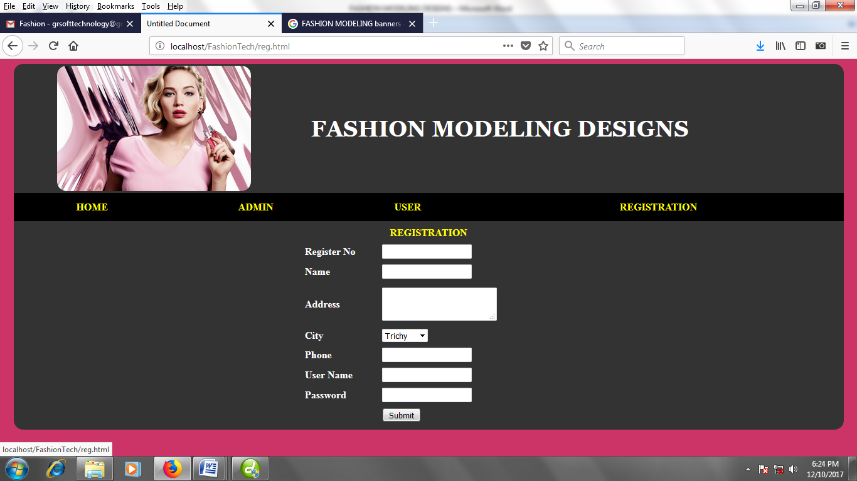
<!DOCTYPE html PUBLIC "-//W3C//DTD XHTML 1.0 Transitional//EN" "http://www.w3.org/TR/xhtml1/DTD/xhtml1-transitional.dtd">
<html xmlns="http://www.w3.org/1999/xhtml">
<head>
<meta http-equiv="Content-Type" content="text/html; charset=iso-8859-1" />
<title>Untitled Document</title>
<style type="text/css">
<!--
.style1 {
font-family: Georgia, "Times New Roman", Times, serif;
font-weight: bold;
font-size: 36px;
color: #FFFFFF;
text-transform:uppercase;
}
.style2 {
color: #FFFF00;
font-weight: bold;
text-decoration:none;
}

.style8 {color:#FFFFFF;
font-weight: bold;
text-decoration:none; }
-->
</style>
</head>

<body bgcolor="#CC3366">
<center>
<table width="98%" border="0" cellpadding="0" cellspacing="0" bgcolor="#333333"s style="border-radius:15px">
<!--DWLayoutTable-->
<tr>
<td width="100%" height="111" valign="top">
<center>
<table width="90%" border="0">
<tr>
<td><img src="1.jpg" height="200px" style="border-radius:15px"/></td>
<td> <p class="style1"> FASHION MODELING DESIGNS</p></td>
</tr>
</table>

</td>
</tr>
<tr>
<td height="48" valign="top"><table width="100%" height="45" border="0" bgcolor="#000000"> <tr>
<td><div align="center"><a href="index.html" class="style2">HOME</a></div></td>
<td><div align="center"><a href="login.html" class="style2">ADMIN</a></div></td>
<td><div align="center"><a href="userlogin.html" class="style2">USER</a></div></td>
<td><div align="center"><a href="reg.html" class="style2">REGISTRATION</a></div></td>
</tr>
</table></td>
</tr>
<tr>
<td height="330" valign="top">
<table width="400" height="324" border="0" align="center">
<tr>
<td colspan="2"><div align="center"><span class="style2">REGISTRATION </span></div></td>
</tr>
<tr>
<td><span class="style8">Register No </span></td>
<td>
<input type="text" name="textfield" />
</td>
</tr>
<tr>
<td><span class="style8">Name</span></td>
<td>
<input type="text" name="textfield2" />
</td>
</tr>

<tr>
<td><span class="style8">Address</span></td>
<td><span class="style8">
<label>
<textarea name="textarea"></textarea>
</label>
</span></td>
</tr>
<tr>
<td><span class="style8">City</span></td>
<td><span class="style8">
<label>
<select name="select">
<option>Trichy</option>
<option>Chennai</option>
</select>
</label>
</span></td>
</tr>
<tr>
<td><span class="style8">Phone</span></td>
<td><span class="style8">
<label>
<input type="text" name="textfield3" />
</label>
</span></td>
</tr>
<tr>
<td><span class="style8">User Name</span></td>
<td><span class="style8">
<label>
<input type="text" name="textfield3" />
</label>
</span></td>
</tr>
<tr>
<td><span class="style8">Password</span></td>
<td><span class="style8">
<label>
<input type="text" name="textfield3" />
</label>
</span></td>
</tr>

<tr>
<td>&nbsp;</td>
<td><label>
<input type="submit" name="Submit" value="Submit" />
</label></td>
</tr>
</table></td>
</tr>
</table>

</td>
</tr>
</table>
</center>
</body>
</html>

