PROJECT DOCUMENTATION
AUTO TICKET
CLASSIFICATION
USING FLOW DESIGNER
A rule-driven workflow automation for IT service desk incidents
Team ID | : | SWTID-2026-3996
Team Size | : | 4
Team Leader | : | Dharsan A N S
Team Member | : | Aravindha Kumar M
Team Member | : | Dinesh Kumar T
Team Member | : | Manojpandi S

TABLE OF CONTENTS
S.No | Contents | Page No.
- | List of Figures | 5
1 | Abstract | 6
2 | Problem Statement | 7
2.1 | Background | 7
2.2 | Problem Statement | 7
2.3 | Challenges in Manual Ticket Classification | 7
2.4 | Need for Automation | 8
2.5 | Objectives of the Project | 8
3 | Introduction | 9
3.1 | IT Service Management and Ticketing | 9
3.2 | ServiceNow Platform | 9
3.3 | Flow Designer | 9
3.4 | Scope of the Project | 9
3.5 | Organisation of the Report | 10
3.6 | Basic Terminology | 10
4 | Existing and Proposed System | 12
4.1 | Existing System | 12
4.2 | Proposed System | 12
4.3 | Comparison of Existing and Proposed System | 13
4.4 | Feasibility Study | 13
5 | Software Requirements | 14
5.1 | Functional Requirements | 14
5.2 | Non-Functional Requirements | 14
5.3 | Software Requirement Specification | 15
5.4 | Description of the Software Used | 15
6 | Hardware Requirements | 17
6.1 | Development Machine | 17
6.2 | End User Device | 17
6.3 | Server Requirements for Deployment | 17
6.4 | Justification | 18
7 | System Design | 19
7.1 | System Architecture | 19
7.2 | Module Description | 19
7.3 | Classification Algorithm and Flow Chart | 21
7.4 | Sequence Diagram | 22
7.5 | Data Design | 22
7.6 | Flow Designer Flow Design | 24
7.7 | User Interface Design | 24
7.8 | Use Case Description | 26
8 | Implementation | 27
8.1 | Technology and Project Structure | 27
8.2 | Classification Engine | 27
8.3 | REST API | 28
8.4 | ServiceNow Integration | 28
8.5 | Front-end Implementation | 29
8.6 | Flow Designer Implementation Steps | 29
8.7 | Script Include | 30
8.8 | Running the Application | 30
8.9 | Security Considerations | 31
8.10 | Sample Data | 31
9 | Testing | 33
9.1 | Testing Strategy | 33
9.2 | Test Environment | 33
9.3 | Classification Test Cases | 33
9.4 | API and Validation Test Cases | 34
9.5 | User Interface Test Cases | 35
9.6 | Test Results and Observations | 35
10 | Output Screens | 36
10.1 | Raise Ticket Page | 37
10.2 | Live Routing Slip | 38
10.3 | Ticket Submitted | 39
10.4 | Manual Review Routing | 40
10.5 | Tickets List | 41
10.6 | Dashboard | 42
10.7 | Rules Manager | 43
10.8 | Adding a Rule | 44
10.9 | Mobile View | 45
11 | Future Implementation | 46
11.1 | Machine-Learning Classification | 46
11.2 | Natural Language Understanding and Multilingual Support | 46
11.3 | Knowledge Suggestions and Automatic Resolution | 46
11.4 | Priority from Impact and SLA Prediction | 46
11.5 | More Ways to Raise Tickets | 46
11.6 | Authentication and Role-Based Access | 47
11.7 | Database, Deployment and Notifications | 47
11.8 | Advanced Analytics | 47
12 | Conclusion | 48
12.1 | Summary | 48
12.2 | Objectives and Outcome | 48
12.3 | Limitations | 48
12.4 | Learning Outcomes and Final Remarks | 49
13 | References | 50
LIST OF FIGURES
Figure | Title | Page No.
7.1 | System architecture | 19
7.2 | Flow chart of ticket classification | 21
7.3 | Sequence diagram for raising a ticket | 22
7.4 | Data model | 22
7.5 | Flow Designer flow | 24
10.1 | Raise ticket page | 37
10.2 | Routing slip updating while the user types | 38
10.3 | Confirmation message after submitting a ticket | 39
10.4 | Ticket with no matching rule | 40
10.5 | Tickets page | 41
10.6 | Dashboard with statistics and charts | 42
10.7 | Classification rules page | 43
10.8 | Rule form filled in | 44
10.9 | Rules table after the new rule is added | 44
10.10 | Raise ticket page on a 390 px wide screen | 45

1. ABSTRACT
Every organisation that provides IT services receives a continuous stream of support tickets: login failures, network problems, printer faults, software installation requests, security incidents and many more. When these tickets arrive, someone must read each one, decide what kind of problem it is, decide how urgent it is and forward it to the team that can solve it. In most service desks this triage step is still done by hand. It is slow, it depends on the experience of the person on duty, and it produces inconsistent results, so tickets are often routed to the wrong team, wait in a general queue or breach their service targets.
This project, Auto Ticket Classification using Flow Designer, removes the manual triage step. The system reads the short description and the detailed description written by the user, matches the text against a table of classification rules, and automatically assigns the category, subcategory, priority and assignment group. If no rule matches, the ticket is not lost: it is sent to the Service Desk and marked for manual review. The urgency selected by the user can raise the priority by one level so that critical issues are never under-rated.
The solution has three connected parts. The first is a web front end with four pages: Raise Ticket, Tickets, Dashboard and Rules. While the user is typing, a live "routing slip" shows which category, team and priority the ticket will receive before it is submitted. The second is a Node.js backend that exposes a REST API, runs the classification engine and stores tickets and rules. The third is the ServiceNow integration: the backend can create a real Incident through the ServiceNow Table API, and a Flow Designer flow named Auto Ticket Classification performs the same rule-based classification inside the ServiceNow platform using a custom rules table and a Script Include.
Because the rules are stored as data and not written into the program, administrators can add, switch off or delete a rule from the Rules page and the change applies immediately without any code change. The dashboard reports the number of tickets, the percentage classified automatically, the tickets sent for manual review, tickets by category and priority, and the most frequently matched keywords.
The application runs on any computer with Node.js and needs no external libraries. Testing with sample tickets showed that tickets are classified correctly, unmatched tickets are safely routed for manual review and the user interface updates in real time. The project demonstrates how low-code workflow automation can reduce triage effort, improve routing accuracy and shorten the time taken to reach the right support team.
Keywords: ServiceNow, Flow Designer, Ticket Classification, IT Service Management, Workflow Automation, Incident Management, REST API, Node.js.

2. PROBLEM STATEMENT

2.1 Background
IT Service Management (ITSM) is the discipline of designing, delivering and supporting IT services for the users of an organisation. The most visible part of ITSM is incident management: when something stops working, the user raises a ticket and the support organisation works to restore the service. In a company of a few hundred employees a service desk can easily receive hundreds of tickets a day, and in large enterprises the figure runs into thousands.
Each ticket is written in free text by a person who is usually not an IT expert. One user writes "VPN not working", another writes "cannot connect from home", and a third writes "remote access timeout"; all three describe the same problem. The service desk agent has to interpret each message, choose a category, estimate the priority and select the correct resolver group. This activity is called ticket triage or ticket classification, and it is the first and most important step in the life of an incident.

2.2 Problem Statement
Manual classification of support tickets is slow, inconsistent and error-prone. Agents spend a large part of their time reading and routing tickets instead of solving them. Different agents classify the same problem in different ways, urgent issues are sometimes left in a general queue, and tickets bounce between teams before they reach the right one. As the number of tickets grows, the delay in triage grows with it and the quality of service falls.
The problem addressed by this project is therefore: how can incoming support tickets be classified and routed automatically, using rules that business users can maintain, so that every ticket receives the correct category, priority and assignment group within seconds of being raised, and so that tickets which cannot be classified are safely handed to a human?

2.3 Challenges in Manual Ticket Classification
Challenge | Impact on the service desk
Free-text descriptions | The same problem is described in many different ways, so agents must interpret every message.
Dependence on agent experience | New agents classify slowly and make more mistakes than experienced ones.
Inconsistent categories | Reports and dashboards become unreliable because similar tickets carry different categories.
Wrong or delayed routing | Tickets are passed between teams, increasing resolution time and user frustration.
Priority under-rating | Critical issues such as security incidents may wait in a normal queue.
Peak-time overload | During outages the number of tickets rises sharply and triage becomes a bottleneck.
No audit of the decision | It is difficult to explain why a ticket was given a particular category or team.

2.4 Need for Automation
Automation of ticket classification is needed because the decision is repetitive and can be described by clear rules. Words such as VPN, password, printer, database or phishing are strong signals of the category and the responsible team. A system that applies these rules consistently can handle the large majority of tickets instantly and leave only the unusual tickets to the agents. The result is faster response, fewer routing errors, a more reliable data set for reporting and more time for the agents to solve real problems.

2.5 Objectives of the Project
- To classify every new ticket automatically into a category, subcategory, priority and assignment group.
- To store the classification rules as data so that they can be maintained without changing program code.
- To give users instant feedback by showing the expected routing while the ticket is being written.
- To route unmatched tickets to the Service Desk and mark them for manual review so that no ticket is lost.
- To integrate with ServiceNow so that the same logic runs inside the Flow Designer.
- To provide a dashboard that measures the percentage of automatic classification and the distribution of tickets.
- To build a clean, responsive and easy-to-use interface that works as a real application and not as a demonstration.

3. INTRODUCTION

3.1 IT Service Management and Ticketing
A ticketing system is the central record of all requests and problems reported to the IT department. Every ticket carries a unique number, the name of the caller, a short description, a detailed description, a category, a priority, a state and the team that is working on it. The quality of these fields decides how quickly the ticket is solved. If the category is wrong, the ticket reaches the wrong team; if the priority is wrong, a critical outage may wait behind a routine request.
Most ticketing tools allow users to choose the category themselves, but users rarely know the correct category and often leave the field at its default value. For this reason many service desks employ first-level agents whose only task is to read new tickets and correct these fields. This project automates that first-level work.

3.2 ServiceNow Platform
ServiceNow is a cloud platform for digital workflows. Its IT Service Management application provides incident, problem, change and request management, and its low-code tools allow organisations to automate processes without writing large amounts of program code. Every record in ServiceNow is stored in a table; the Incident table holds support tickets, the Group table holds the resolver teams, and custom tables can be created for any new need. ServiceNow also offers a REST Table API through which external applications can create and read records, and it provides free Personal Developer Instances (PDI) for learning and development.

3.3 Flow Designer
Flow Designer is the ServiceNow tool for building automations visually. A flow consists of a trigger, which starts the flow when something happens (for example when a record is created), and a sequence of actions, such as looking up records, updating a record, adding a note or sending a notification. Conditions, loops and branches allow the flow to make decisions. Flow Designer also supports custom actions that run a script, and every execution is recorded so that the developer can see what each step did. These features make it the natural place to implement automatic ticket classification inside ServiceNow.

3.4 Scope of the Project
The project covers the complete path of a ticket from creation to classification and reporting. It includes the user interface for raising and viewing tickets, the rule engine, the rules administration page, the dashboard, the REST backend, and the optional connection to a ServiceNow instance together with the design of the Flow Designer flow. The classification is keyword based; the use of machine learning is described as a future enhancement in Chapter 11.

3.5 Organisation of the Report
Chapter | Title | Description
1 | Abstract | Summary of the project and its results
2 | Problem Statement | Background, problem, challenges and objectives
3 | Introduction | ITSM, ServiceNow, Flow Designer and scope
4 | Existing and Proposed System | Comparison, advantages and feasibility
5 | Software Requirements | Functional, non-functional and tool requirements
6 | Hardware Requirements | Development, user and server hardware
7 | System Design | Architecture, modules, flow charts, data design
8 | Implementation | Technology, code, API and Flow Designer set-up
9 | Testing | Test strategy, test cases and results
10 | Output Screens | Screenshots of the working application
11 | Future Implementation | Planned enhancements
12 | Conclusion | Summary and learning
13 | References | Sources used

3.6 Basic Terminology
The following terms are used throughout this report. Readers who are new to IT service management and ServiceNow can use the table as a quick reference.
Term | Meaning
Incident | An unplanned interruption or reduction in the quality of an IT service, for example "VPN not working".
Ticket | The record that stores an incident or request together with its details and history. In ServiceNow it is a row of the Incident table.
Triage / classification | Reading a new ticket and deciding its category, priority and the team that must handle it.
Category and subcategory | Two-level label that describes the kind of problem, for example Network and VPN.
Urgency | How quickly the user needs the problem solved. Chosen by the user: Low, Medium or High.
Priority | The order in which tickets are handled, from P1 (most critical) to P4. Calculated by the system.
Assignment group | The resolver team that owns the ticket, such as Network Team or IAM Team.
Service Desk | The first-line team that receives tickets which cannot be routed automatically.
SLA | Service Level Agreement: the promised time within which a ticket will be answered or solved.
Flow / Trigger / Action | A flow is an automation in Flow Designer; the trigger starts it; actions are the steps it performs.
Script Include | Reusable server-side JavaScript class stored in ServiceNow and callable from flows and scripts.
Table API | The ServiceNow REST interface used to create, read and update records in any table.
PDI | Personal Developer Instance: a free ServiceNow instance for learning and testing.

Priority levels used in the project
Level | Meaning | Typical examples
P1 | Critical: service is down or security is at risk | Server down, phishing, virus
P2 | High: many users or an important service affected | VPN failure, account lockout, database issue
P3 | Moderate: one user affected, workaround exists | Password reset, Wi-Fi, laptop, Outlook
P4 | Low: minor inconvenience or request | Printer, keyboard, software installation

4. EXISTING AND PROPOSED SYSTEM

4.1 Existing System
In the existing way of working, a user submits a ticket through a portal, an e-mail or a telephone call. The ticket lands in a common queue. A first-level agent opens it, reads the text, selects the category and subcategory, sets the priority, assigns it to a resolver group and only then does the real work begin. When the agent is not sure, the ticket is forwarded to a colleague, and sometimes it is reassigned several times.

Limitations of the existing system
- Every ticket needs a human to read and route it, so the first response is delayed.
- Classification quality depends on the knowledge and mood of the agent.
- Rules are in the heads of experienced agents and are not documented.
- Reports on categories and teams contain errors because the fields are filled inconsistently.
- Critical tickets can remain unnoticed in a long queue.
- Cost grows in direct proportion to the number of tickets.

4.2 Proposed System
The proposed system performs triage automatically at the moment the ticket is created. The text is compared with a set of active rules; the best match decides the category, subcategory, priority and assignment group. The user sees the expected routing while typing, the ticket is saved with the classification and an audit trail of the matched keywords, and, if ServiceNow is connected, an Incident is created and the Flow Designer flow applies the same classification inside the platform. Tickets with no matching rule go to the Service Desk with a manual review flag.

Advantages of the proposed system
- Classification takes milliseconds and requires no agent.
- The same text always receives the same result, which makes reports reliable.
- Rules are data: administrators add, switch off or delete them from a web page.
- Each ticket stores the keywords that caused the decision, so the result can be explained.
- Unmatched tickets are never lost; they are flagged for a human.
- The dashboard shows how much work is automated and which keywords occur most often.
- The application needs only Node.js and a browser; no database server or external library is required.

4.3 Comparison of Existing and Proposed System
Aspect | Existing system | Proposed system
Triage performed by | Service desk agent | Rule engine / Flow Designer
Time to classify | Minutes to hours | Under one second
Consistency | Varies between agents | Same input gives same output
Maintenance of rules | Informal knowledge | Rules table edited from the UI
Explanation of decision | Not recorded | Matched keywords stored
Unclassifiable tickets | Wait in queue | Service Desk + manual review flag
Reporting | Manual and error-prone | Live dashboard
Scalability | More agents needed | Handles volume without extra staff

4.4 Feasibility Study

Technical feasibility
All technologies used are mature and freely available. Node.js runs on Windows, Linux and macOS; the front end uses standard HTML, CSS and JavaScript supported by every modern browser; ServiceNow offers a free developer instance and a documented REST API. No special skills beyond web development and basic ServiceNow administration are needed.

Economic feasibility
The project needs no paid software or licences. The development was carried out on ordinary student computers using free tools. In a production environment the saving in agent time spent on triage would far exceed the small cost of maintaining the rules.

Operational feasibility
The interface is simple: a user describes the problem in plain language and presses one button. Administrators maintain rules in a table with add, switch-off and delete actions. No training beyond a short demonstration is needed, and the manual review path keeps the human in control whenever the system is unsure.

5. SOFTWARE REQUIREMENTS

5.1 Functional Requirements
ID | Requirement
FR-01 | The user shall be able to raise a ticket by entering name, short description, details and urgency.
FR-02 | The system shall classify the ticket into category, subcategory, priority and assignment group using active rules.
FR-03 | The system shall show a live preview of the classification while the user types.
FR-04 | The system shall raise the priority by one level when the urgency is High (never above P1).
FR-05 | A ticket matching no rule shall be assigned to the Service Desk and marked for manual review.
FR-06 | The system shall generate a unique ticket number and store the ticket with the matched keywords.
FR-07 | The system shall list all tickets with category, team, priority and creation time.
FR-08 | The administrator shall be able to add, switch on/off and delete classification rules.
FR-09 | The dashboard shall show total tickets, automatic classification rate, manual review count and distributions.
FR-10 | When ServiceNow credentials are configured, the system shall create an Incident through the Table API.

5.2 Non-Functional Requirements
Attribute | Requirement
Performance | Classification and API responses within one second for normal load.
Usability | Clear labels, plain-language messages, keyboard-friendly forms and visible focus.
Responsiveness | The layout adapts to desktop, tablet and mobile screens.
Reliability | Invalid input is rejected with a clear message; the server does not stop on errors.
Security | All user text is escaped before display; static file access is restricted to the front-end folder; credentials are kept in an environment file and not in source code.
Portability | Runs on Windows, Linux and macOS with Node.js 18 or newer.
Maintainability | Rules are stored as data; the code base has no external dependencies.
Accessibility | Light and dark colour schemes, sufficient contrast and reduced-motion support.

5.3 Software Requirement Specification
Component | Specification
Operating system | Windows 10 / 11, Ubuntu 20.04 or later, macOS 12 or later
Runtime | Node.js 18 LTS or newer (npm is not required to install packages)
Front-end technologies | HTML5, CSS3, JavaScript (ES2020), Fetch API
Back-end technologies | Node.js built-in modules: http, https, fs, path
Data storage | JSON files (rules.json and tickets.json)
Enterprise platform | ServiceNow Personal Developer Instance (Washington DC release or later)
Workflow tool | ServiceNow Flow Designer, Script Include
Code editor | Visual Studio Code
Web browser | Google Chrome, Microsoft Edge, Mozilla Firefox (latest versions)
API testing (optional) | Postman or curl
Documentation | Microsoft Word

5.4 Description of the Software Used

Node.js
Node.js is a JavaScript runtime built on the V8 engine. It allows JavaScript to run on the server. The backend uses only the built-in http module to serve the API and the front-end files, https to call ServiceNow, and fs to read and write the JSON data files, which keeps the project free of dependencies.

HTML, CSS and JavaScript
The user interface is written in plain HTML, CSS and JavaScript without any framework. CSS custom properties define the colour system and automatically switch to a dark theme when the operating system uses one. JavaScript communicates with the backend through the Fetch API and updates the page without reloading it.

ServiceNow Personal Developer Instance
A PDI is a free, fully functional ServiceNow instance for learning. It contains the Incident table, assignment groups and the Flow Designer. The backend connects to it using basic authentication over HTTPS and the Table API endpoint /api/now/table/incident.

Flow Designer and Script Include
The flow Auto Ticket Classification is triggered when an Incident is created. It calls a Script Include named ClassificationEngine, which reads the active rules from the custom table u_classification_rule and returns the best match. The flow then updates the incident and adds a work note.

Visual Studio Code
Visual Studio Code was used to write and run the code, with its integrated terminal used to start the server using the command npm start.

6. HARDWARE REQUIREMENTS

6.1 Development Machine
The following configuration is required to develop and test the application. The project is lightweight; the figures below give comfortable performance while running the editor, browser and server together.
Component | Minimum | Recommended
Processor | Dual-core 2.0 GHz | Intel Core i5 / AMD Ryzen 5 or better
Memory (RAM) | 4 GB | 8 GB or more
Storage | 500 MB free | 2 GB free (SSD)
Display | 1366 x 768 | 1920 x 1080
Network | Broadband for ServiceNow access | Stable broadband connection
Input devices | Keyboard and mouse / touchpad | Keyboard and mouse

6.2 End User Device
The end user needs only a device with a modern web browser. Because the layout is responsive, the application can be used from a desktop, laptop, tablet or smartphone.
Component | Requirement
Device | Desktop, laptop, tablet or smartphone
Browser | Chrome, Edge, Firefox or Safari (latest two versions)
Screen width | From 360 px (mobile) upwards
Network | Access to the server over LAN or the Internet

6.3 Server Requirements for Deployment
Component | Small deployment (up to 50 users) | Larger deployment
Processor | 1 vCPU | 2 to 4 vCPU
Memory | 1 GB RAM | 4 GB RAM
Storage | 5 GB | 20 GB (more if a database replaces the JSON files)
Operating system | Linux server or Windows Server | Linux server with a process manager
Network | Open TCP port 3000 (configurable) | Reverse proxy with HTTPS

6.4 Justification
The classification algorithm performs a simple text search over a small number of rules, so it needs very little processor time or memory. Data are stored in small JSON files, so no database server is required for the demonstration. The only demanding component is the ServiceNow instance, which runs in the cloud and therefore adds no hardware requirement to the local machine. The result is that the project can be run on almost any computer available to a student or a small organisation.

7. SYSTEM DESIGN

7.1 System Architecture
The system follows a three-layer architecture. The presentation layer is the web browser, which shows the pages and talks to the backend using JSON over HTTP. The application layer is the Node.js server, which contains the REST API, the classification engine and the data stores. The ServiceNow layer is optional: when credentials are provided, the application layer creates incidents through the Table API and the Flow Designer flow classifies them inside the platform.
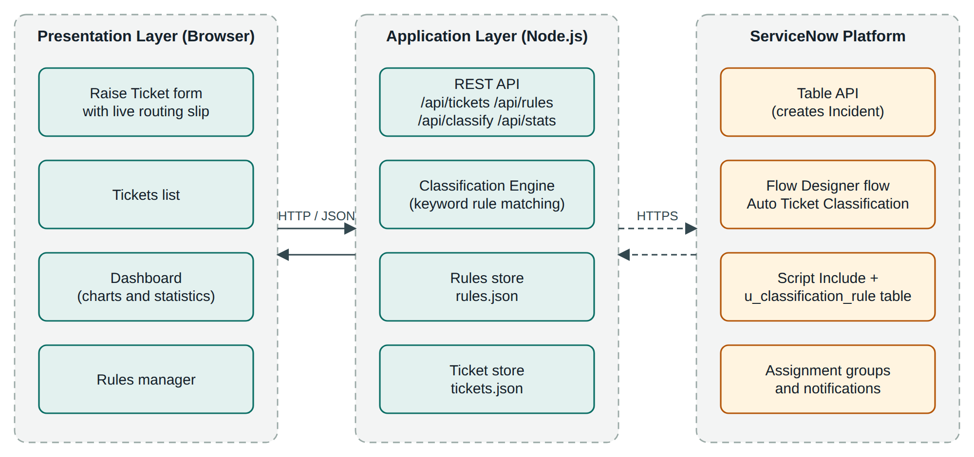
Figure 7.1: System architecture
Separating the layers has three benefits. The interface can be changed without touching the logic, the classification engine can be tested on its own, and the ServiceNow connection can be switched on or off by editing a single configuration file without any change in the code.

7.2 Module Description
Module | Responsibility
Raise Ticket | Collects name, issue, details and urgency; calls the classification API while the user types; shows the routing slip; submits the ticket.
Classification Engine | Combines the text, searches it for active rule keywords, selects the best rule, applies the urgency adjustment and returns category, subcategory, priority, team and matched keywords.
Ticket Management | Creates the ticket number, stores the ticket, returns the list of tickets and supplies data to the dashboard.
Rules Manager | Lists, adds, switches on or off and deletes classification rules; changes apply immediately.
Dashboard | Calculates and displays total tickets, automatic classification rate, manual review count, tickets by category, tickets by priority and top keywords.
ServiceNow Integration | Creates an Incident through the Table API and records the returned number and sys_id; reports an error without stopping the application if the call fails.

Rule selection logic
When several rules match the same ticket, the engine chooses the rule with the lowest priority number, that is, the most critical one. If two rules have the same priority, the one with the longer keyword is preferred because it is more specific. For example, the text "VPN password expired" matches both vpn (priority 2) and password (priority 3); the VPN rule wins and the ticket goes to the Network Team.

7.3 Classification Algorithm and Flow Chart
The algorithm is shown in Figure 7.2. It is deterministic and has no hidden state: the same text, urgency and rule set always produce the same result.
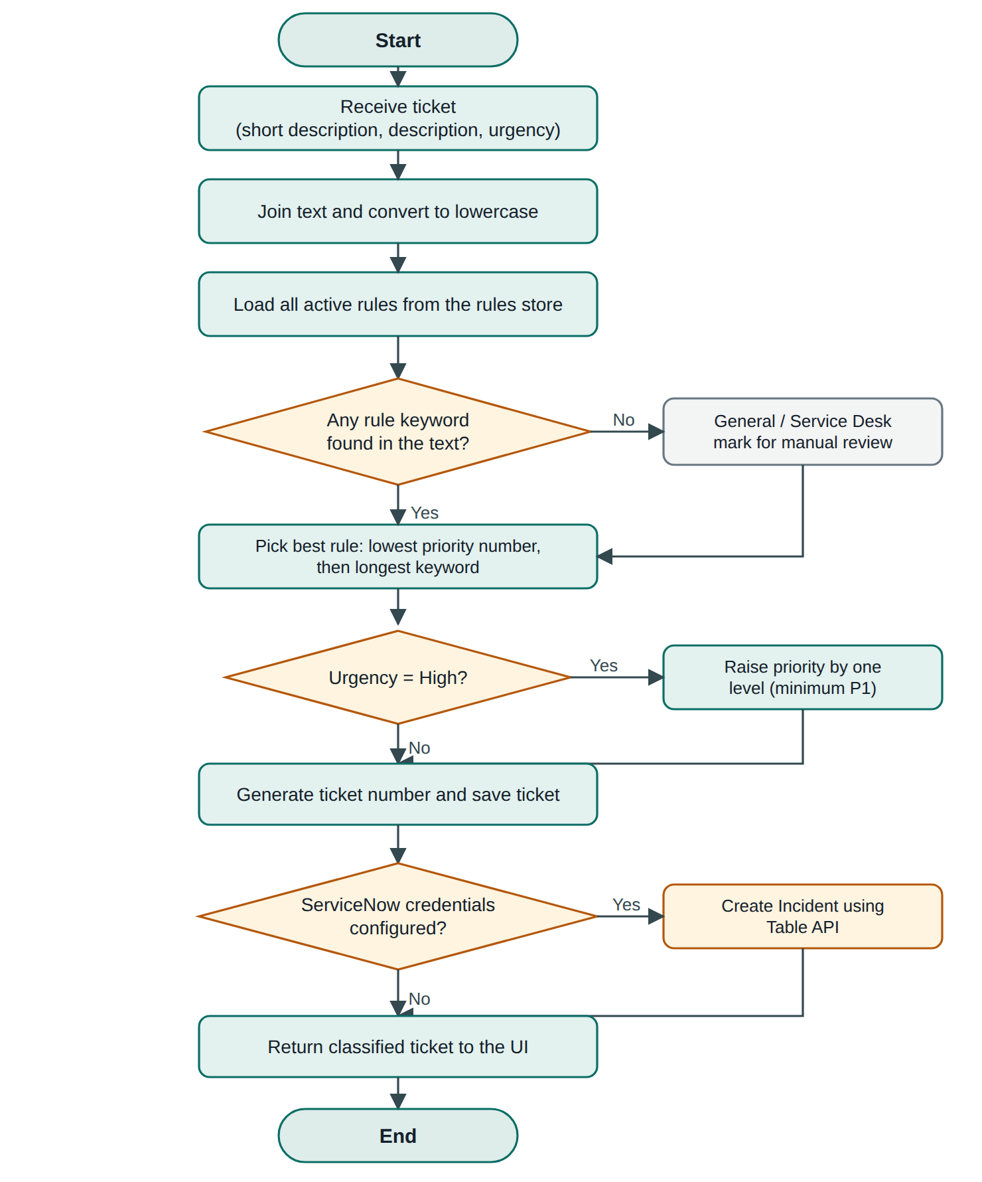
Figure 7.2: Flow chart of ticket classification

7.4 Sequence Diagram
Figure 7.3 shows the messages exchanged while a user raises a ticket. Steps 1 to 5 happen while the user is still typing, so the user sees the expected routing before submitting. Steps 6 to 12 show submission, the optional ServiceNow call and the confirmation.
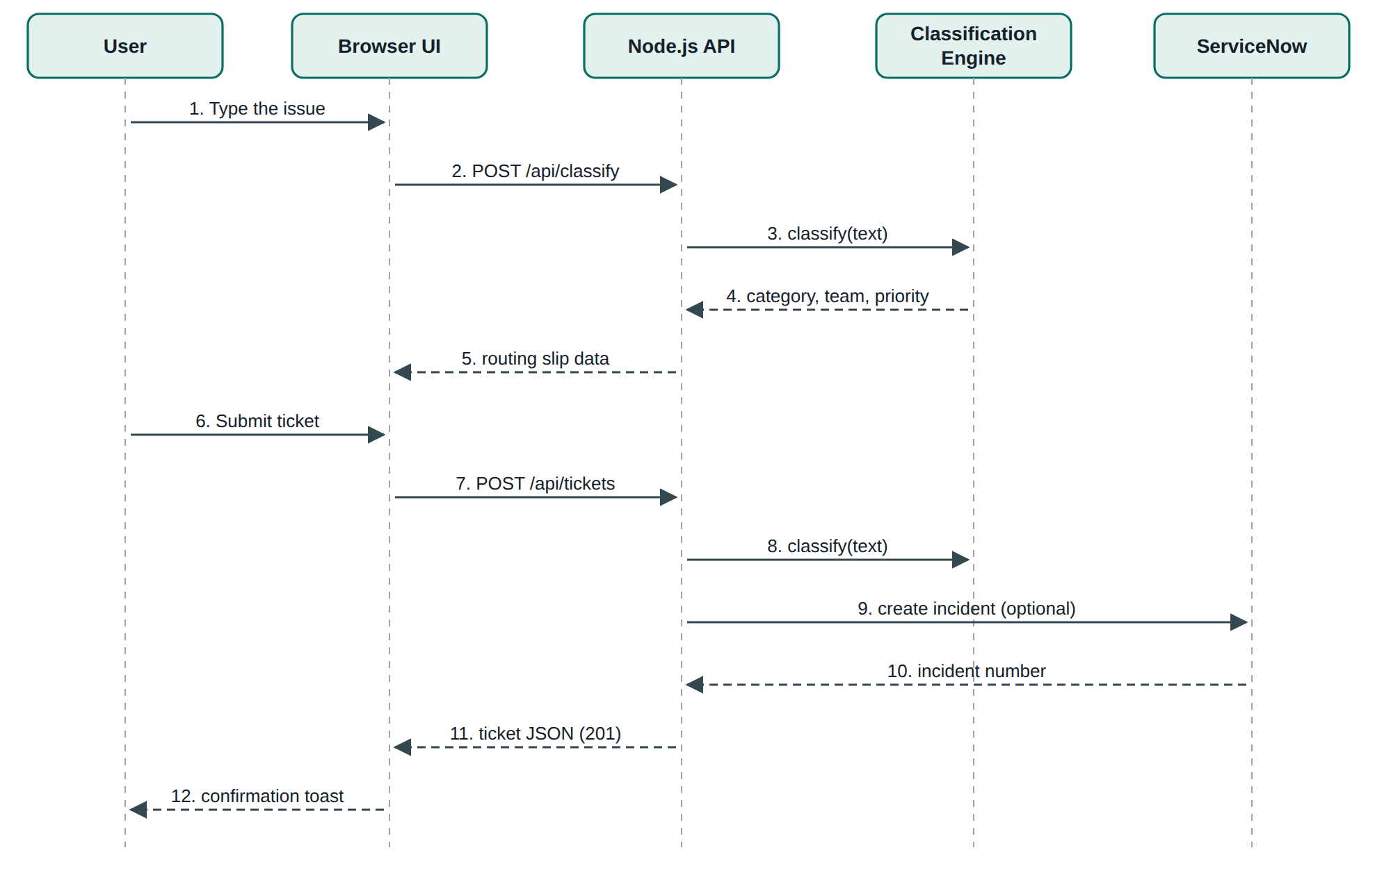
Figure 7.3: Sequence diagram for raising a ticket

7.5 Data Design
The application uses two JSON data stores, which map directly to the ServiceNow design: the rules store corresponds to the custom table u_classification_rule, and a ticket corresponds to an Incident record. Figure 7.4 shows the entities and their relationship.
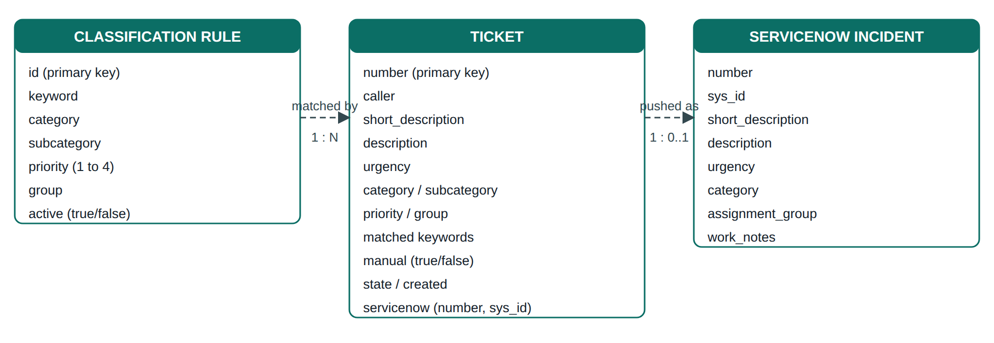
Figure 7.4: Data model

Data dictionary: Classification Rule
Field | Type | Description
id | Integer | Unique number of the rule, generated automatically
keyword | Text | Word or phrase searched for in the ticket text (not case sensitive)
category | Text | Category assigned when the rule matches
subcategory | Text | Subcategory assigned when the rule matches
priority | Integer 1 to 4 | 1 is the most critical; 4 is the lowest
group | Text | Name of the assignment group
active | Boolean | Only active rules are used

Data dictionary: Ticket
Field | Type | Description
number | Text | Ticket number in the form INC0001001
caller, short_description, description | Text | Entered by the user
urgency | low / medium / high | Selected by the user
category, subcategory, group | Text | Assigned by the engine
priority | Integer 1 to 4 | Rule priority after urgency adjustment
matched | List of text | Keywords that caused the decision (audit trail)
manual | Boolean | True when no rule matched
state, created | Text / date-time | Initial state New and creation time
servicenow | Object | Incident number and sys_id, or an error message

7.6 Flow Designer Flow Design
Inside ServiceNow the same logic is implemented as the flow Auto Ticket Classification, shown in Figure 7.5. The flow starts when an incident is created with an empty category, calls the Script Include to find the best rule, and then either applies the rule or routes the incident to the Service Desk.
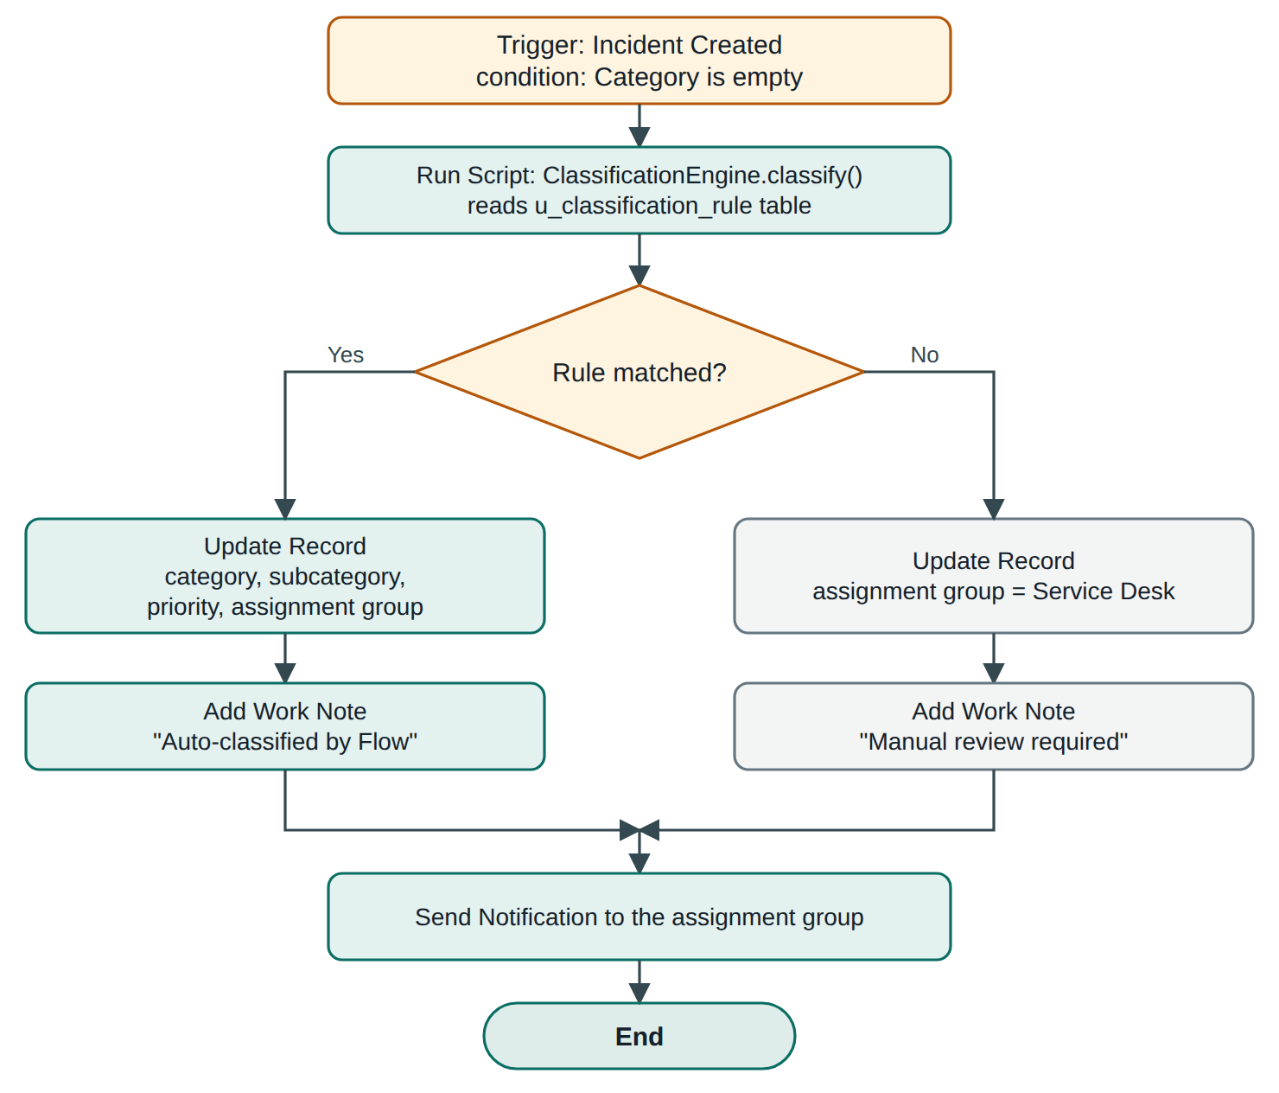
Figure 7.5: Flow Designer flow
Flow element | Type | Purpose
Incident Created | Trigger | Starts the flow for new incidents whose Category is empty
Run Script | Action | Calls ClassificationEngine.classify() with the short description and description
Rule matched? | If condition | Branches on whether a rule was returned
Update Record | Action | Sets category, subcategory, priority and assignment group (or Service Desk)
Add Work Note | Action | Records "Auto-classified by Flow" or "Manual review required"
Send Notification | Action | Informs the assignment group about the new incident

7.7 User Interface Design
The interface was designed for a service desk setting where users are often stressed and in a hurry. The design therefore keeps every screen quiet and focuses attention on one memorable element: the routing slip, a ticket-shaped card that appears next to the form and shows where the ticket will go. Everything else is deliberately plain.
- Colour: a calm teal accent on a neutral background, with separate light and dark palettes selected automatically from the system setting.
- Typography: one clean sans-serif family with a clear size scale; short line lengths for readability.
- Language: plain wording written from the user's point of view, for example "Tell us what's wrong" and "How urgent is it?".
- Feedback: the routing slip updates 250 ms after the user stops typing; a confirmation message shows the ticket number and the team.
- Empty and error states: an empty page explains what to do next; errors say what is wrong and how to fix it.
- Responsive layout: the two-column form collapses to one column on small screens and tables scroll sideways inside their own container.
- Accessibility: visible keyboard focus, adequate contrast, reduced-motion support and escaped text output.

7.8 Use Case Description
The system has three human actors and one system actor. The user raises and views tickets. The administrator maintains the classification rules and monitors the dashboard. The service desk agent handles tickets that were flagged for manual review. The ServiceNow flow acts automatically when an incident is created.
ID | Use case | Actor | Description and result
UC-01 | Raise a ticket | User | The user enters the issue and urgency; the routing slip previews the result; submission stores the ticket with its classification.
UC-02 | View tickets | User, Agent | The ticket list shows every ticket with category, team, priority and time.
UC-03 | Manage rules | Administrator | Rules are added, switched on or off, or deleted; the next ticket uses the new rule set.
UC-04 | Monitor dashboard | Administrator | Totals, automation rate and distributions are shown for decision making.
UC-05 | Review unmatched ticket | Agent | Tickets flagged for manual review are classified by a person; the agent may ask the administrator to add a new rule.
UC-06 | Classify incident in ServiceNow | Flow Designer | When an incident is created with an empty category the flow applies the matching rule or the Service Desk fallback.

8. IMPLEMENTATION

8.1 Technology and Project Structure
The project is delivered as a single folder that can be unzipped and started with one command. The back end and front end are in separate folders and the ServiceNow artefacts are kept apart from them.
auto-ticket-classification/
|-- backend/
| |-- server.js REST API, classifier, static files, ServiceNow
| `-- data/
| |-- rules.json 15 starter classification rules
| `-- tickets.json created automatically with the first ticket
|-- frontend/
| |-- index.html page structure (4 tabs)
| |-- style.css design system and responsive layout
| `-- app.js API calls, live slip, tables, charts
|-- servicenow/
| `-- ClassificationEngine.js Script Include for Flow Designer
|-- .env.example ServiceNow connection settings
|-- package.json start script (npm start)
`-- README.md run instructions

8.2 Classification Engine
The engine is a single function. It lowercases the text, filters the active rules whose keyword appears in the text, sorts the matches by priority and keyword length and returns the best one. If nothing matches it returns the Service Desk values with the manual flag set.
function classify(text) {
text = (text || '').toLowerCase();
const hits = read('rules.json', [])
.filter(r => r.active && text.includes(r.keyword.toLowerCase()));
if (!hits.length)
return { matched: [], category: 'General', subcategory: 'Other',
priority: 4, group: 'Service Desk', manual: true };
hits.sort((a, b) => a.priority - b.priority
|| b.keyword.length - a.keyword.length);
const t = hits[0];
return { matched: hits.map(h => h.keyword), category: t.category,
subcategory: t.subcategory, priority: t.priority,
group: t.group, manual: false };
}

Because the rules are read from the file on every call, a rule added or switched off on the Rules page affects the very next ticket without restarting the server.

8.3 REST API
Method | Endpoint | Purpose | Success / error
POST | /api/classify | Preview classification of the typed text | 200
GET | /api/tickets | List tickets, newest first | 200
POST | /api/tickets | Create and classify a ticket | 201 / 400 if short description is empty
GET | /api/rules | List all rules | 200
POST | /api/rules | Add a rule | 201 / 400 if keyword, category or group is missing
PUT | /api/rules/:id | Switch a rule on or off | 200 / 404
DELETE | /api/rules/:id | Delete a rule | 200
GET | /api/stats | Dashboard figures | 200

Ticket creation validates the input, classifies the text, applies the urgency adjustment, calls ServiceNow if configured, and saves the ticket:
const c = classify(`${b.short_description} ${b.description || ''}`);
const urgency = ['low','medium','high'].includes(b.urgency)
? b.urgency : 'medium';
if (urgency === 'high') c.priority = Math.max(1, c.priority - 1);
const t = { number: 'INC' + String(1001 + tickets.length).padStart(7,'0'),
caller: (b.caller || 'Anonymous').trim(),
short_description: b.short_description.trim(),
description: (b.description || '').trim(),
urgency, ...c, state: 'New',
created: new Date().toISOString() };
t.servicenow = await snPush(t);
tickets.push(t); save('tickets.json', tickets);

8.4 ServiceNow Integration
The function snPush sends the ticket to the Table API of the instance configured in the .env file. Basic authentication is used over HTTPS. If SN_PUSH_CLASSIFIED is false only the text is sent, so that the Flow Designer flow performs the classification itself. Any network error is caught and stored with the ticket so that the user is never blocked.
const body = { short_description: t.short_description,
description: t.description,
urgency: { high: 1, medium: 2, low: 3 }[t.urgency] || 3 };
if (process.env.SN_PUSH_CLASSIFIED !== 'false') {
body.category = t.category.toLowerCase();
body.assignment_group = t.group;
body.work_notes = 'Auto-classified: ' + t.category + ' / '
+ t.subcategory;
}
https.request({ host: inst, method: 'POST',
path: '/api/now/table/incident?sysparm_input_display_value=true',
headers: { 'Content-Type': 'application/json',
Authorization: 'Basic ' + Buffer.from(user+':'+pass)
.toString('base64') } }, ...);

8.5 Front-end Implementation
The live routing slip is implemented with a debounce: each keystroke restarts a 250 millisecond timer, and when the user pauses the page asks the API to classify the current text and redraws the slip. All text coming from the server is passed through an escape function before it is placed in the page, which prevents script injection.
let timer;
f.addEventListener('input', () => {
clearTimeout(timer);
timer = setTimeout(async () => {
if (!f.short_description.value.trim()
&& !f.description.value.trim()) return emptySlip();
showSlip(await api('/classify', 'POST', {
short_description: f.short_description.value,
description: f.description.value }), f.urgency.value);
}, 250);
});

const esc = s => String(s ?? '').replace(/[&<>"']/g,
c => ({'&':'&amp;','<':'&lt;','>':'&gt;','"':'&quot;',"'":'&#39;'}[c]));

The dashboard is drawn with plain HTML elements: each bar is a block whose width is the value divided by the largest value in the group, so no charting library is needed.

8.6 Flow Designer Implementation Steps
- Open the ServiceNow Personal Developer Instance and create the custom table u_classification_rule with the fields u_keyword, u_category, u_subcategory, u_priority, u_assignment_group (reference to the Group table) and active.
- Enter the starter rules from the rules file into the table.
- Create the Script Include ClassificationEngine using the code given in Section 8.7.
- Open Flow Designer and create a new flow named Auto Ticket Classification.
- Set the trigger to Created on the Incident table with the condition "Category is empty".
- Add a Run Script step that calls new ClassificationEngine().classify(short_description, description).
- Add an If step that checks whether a rule was returned. In the true branch add Update Record to set category, subcategory, priority and assignment group, followed by Add Work Note.
- In the false branch update the incident with the Service Desk group and add the work note "Manual review required".
- Add Send Notification to the assignment group and activate the flow.
- Run the backend with SN_PUSH_CLASSIFIED=false, raise a ticket and confirm the execution under Flow Designer, Executions.

8.7 Script Include
var ClassificationEngine = Class.create();
ClassificationEngine.prototype = {
initialize: function () {},
classify: function (shortDesc, desc) {
var text = ((shortDesc || '') + ' ' + (desc || '')).toLowerCase();
var gr = new GlideRecord('u_classification_rule');
gr.addActiveQuery();
gr.orderBy('u_priority');
gr.query();
while (gr.next()) {
var kw = (gr.getValue('u_keyword') || '').toLowerCase();
if (kw && text.indexOf(kw) > -1) {
return { keyword: kw,
category: gr.getValue('u_category'),
subcategory: gr.getValue('u_subcategory'),
priority: gr.getValue('u_priority'),
group: gr.getValue('u_assignment_group') };
}
}
return null; // no match: flow assigns the Service Desk
},
type: 'ClassificationEngine'
};

8.8 Running the Application
- Install Node.js 18 or newer from nodejs.org.
- Extract the project zip file completely; open the inner folder that contains package.json.
- Open a terminal in that folder and run npm start.
- Wait for the message "AutoTicket running" and open http://localhost:3000 in a browser.
- Optional: copy .env.example to .env, enter the ServiceNow instance, user and password, and restart the server. The header badge changes from Standalone mode to ServiceNow connected.

8.9 Security Considerations
- User text is escaped before display, so a ticket containing script tags is shown as plain text.
- The static file server resolves each path and refuses any file outside the front-end folder, so requests that try to climb out of it return 404.
- ServiceNow credentials are read from environment variables and never written to the data files.
- Input is validated on the server: an empty short description or an incomplete rule is rejected with HTTP 400.
- The ServiceNow call has a 15 second timeout, so a slow instance cannot block the server.

8.10 Sample Data
The rules file is a list of objects. The first three of the fifteen starter rules are shown below.
[
{"id":1,"keyword":"vpn","category":"Network","subcategory":"VPN",
"priority":2,"group":"Network Team","active":true},
{"id":2,"keyword":"wifi","category":"Network","subcategory":"Wi-Fi",
"priority":3,"group":"Network Team","active":true},
{"id":3,"keyword":"internet","category":"Network",
"subcategory":"Connectivity","priority":3,
"group":"Network Team","active":true}
]

A ticket created with the text "VPN keeps disconnecting" and urgency High is stored as follows. The field matched records which keyword caused the decision, and servicenow is null because the application ran in standalone mode.
{
"number": "INC0001001",
"caller": "Test",
"short_description": "VPN keeps disconnecting",
"description": "",
"urgency": "high",
"matched": ["vpn"],
"category": "Network",
"subcategory": "VPN",
"priority": 1,
"group": "Network Team",
"manual": false,
"state": "New",
"created": "2026-10-07T18:54:43.932Z",
"servicenow": null
}

9. TESTING

9.1 Testing Strategy
Testing was carried out at four levels. Unit testing checked the classification function with a variety of ticket texts and urgency values. API testing called every endpoint with valid and invalid input using curl. User interface testing exercised each page in a browser on desktop and mobile widths. Integration testing verified that the front end, back end and data files work together, and that a failure of the ServiceNow call is handled correctly.

9.2 Test Environment
Item | Details
Operating system | Ubuntu Linux (the code uses no operating-system specific features; Windows 10 / 11 supported)
Runtime | Node.js 18 or newer
Browsers | Chromium-based browser (Google Chrome / Microsoft Edge compatible)
Rules | 15 starter rules supplied with the project
Tools | Visual Studio Code, browser developer tools, curl

9.3 Classification Test Cases
Each test case supplies a ticket text and an urgency; the expected category, team and priority were decided in advance from the rules, and the actual result is the output of the classification function.
ID | Input (urgency) | Expected | Actual | Status
TC-01 | "VPN keeps disconnecting" (medium) | Network / Network Team / P2 | Network / Network Team / P2 | Pass
TC-02 | "Cannot connect to office wifi" (medium) | Network / Network Team / P3 | Network / Network Team / P3 | Pass
TC-03 | "I forgot my password" (low) | Access / IAM Team / P3 | Access / IAM Team / P3 | Pass
TC-04 | "Locked out of my account" (medium) | Access / IAM Team / P2 | Access / IAM Team / P2 | Pass
TC-05 | "Printer is not working" (low) | Hardware / Desktop Support / P4 | Hardware / Desktop Support / P4 | Pass
TC-06 | "Laptop battery drains fast" (medium) | Hardware / Desktop Support / P3 | Hardware / Desktop Support / P3 | Pass
TC-07 | "Outlook keeps crashing" (medium) | Software / Application Support / P3 | Software / Application Support / P3 | Pass
TC-08 | "Please install Python" (low) | Software / Application Support / P4 | Software / Application Support / P4 | Pass
TC-09 | "Production server down" (medium) | Infrastructure / Infrastructure Team / P1 | Infrastructure / Infrastructure Team / P1 | Pass
TC-10 | "Database connection timeout" (medium) | Infrastructure / DBA Team / P2 | Infrastructure / DBA Team / P2 | Pass
TC-11 | "Got a phishing email" (medium) | Security / Security Team / P1 | Security / Security Team / P1 | Pass
TC-12 | "Virus detected on my PC" (low) | Security / Security Team / P1 | Security / Security Team / P1 | Pass
TC-13 | "Coffee machine is noisy" (medium) | General / Service Desk / P4 | General / Service Desk / P4 | Pass
TC-14 | "VPN keeps disconnecting" (high) | Network / Network Team / P1 | Network / Network Team / P1 | Pass
TC-15 | "Printer is not working" (high) | Hardware / Desktop Support / P3 | Hardware / Desktop Support / P3 | Pass
TC-16 | "Phishing email received" (high) | Security / Security Team / P1 | Security / Security Team / P1 | Pass
TC-17 | "VPN password expired" (medium) | Network / Network Team / P2 | Network / Network Team / P2 | Pass
TC-18 | "VPN DOWN (capital letters)" (low) | Network / Network Team / P2 | Network / Network Team / P2 | Pass

All 18 classification test cases passed.

9.4 API and Validation Test Cases
ID | Test | Expected result | Status
API-01 | POST /api/tickets with an empty short description | HTTP 400 and message "Short description is required." | Pass
API-02 | POST /api/rules without a keyword | HTTP 400 and message "Keyword, category and group are required." | Pass
API-03 | GET /api/rules | List containing the 15 starter rules | Pass
API-04 | PUT /api/rules/1 (switch VPN rule off) then classify "vpn down" | Rule inactive; ticket goes to General / Service Desk for manual review | Pass
API-05 | Request /../backend/server.js (path traversal) | HTTP 404; file is not served | Pass
API-06 | Request an unknown endpoint /api/nothing | HTTP 404 with an error message | Pass
API-07 | Create a ticket whose text contains a script tag | Ticket is stored as plain text (the front end escapes it before display) | Pass
API-08 | Start the server without ServiceNow settings | Standalone mode; ticket saved with servicenow set to null | Pass

9.5 User Interface Test Cases
ID | Test | Expected result | Status
UI-01 | Type "VPN keeps disconnecting" in the issue field | Routing slip shows Network - VPN, Network Team, matched keyword vpn | Pass
UI-02 | Change urgency to High | Priority chip on the slip changes from P2 to P1 | Pass
UI-03 | Type text matching no rule | Slip shows "Needs a human look" and Service Desk | Pass
UI-04 | Submit a valid ticket | Message shows the ticket number and team; form and slip reset | Pass
UI-05 | Open the Tickets page after several tickets exist | Table lists tickets with category, team, priority and time | Pass
UI-06 | Open the Dashboard after several tickets | Totals, percentage and three bar charts are drawn | Pass
UI-07 | Add the rule "firewall" from the Rules form | Rule appears in the rules table and the message "Rule added" is shown | Pass
UI-08 | View the application at 390 px width | Layout collapses to a single column | Pass

9.6 Test Results and Observations
The 18 classification tests, 8 API tests and 8 interface tests all produced the expected results. The tests confirmed that rules of different priority are resolved correctly, that urgency never raises a priority above P1, that unmatched tickets are flagged for manual review and that input validation protects the server. When the ServiceNow settings are absent the application runs in standalone mode and is fully functional.
The main limitation observed is that the classifier depends on keywords: a ticket that describes a problem without using any rule keyword is sent to the Service Desk. This is the intended safe behaviour and is addressed further by adding rules, or by the machine-learning enhancement proposed in Chapter 11.

10. OUTPUT SCREENS
This chapter presents the screens of the working application, captured with sample data. The same screens are produced when the application is started with the command npm start and opened at http://localhost:3000. Each screen is explained below its title.
Section | Screen | Purpose
10.1 | Raise ticket (empty) | Starting point for the user
10.2 | Live routing slip | Shows classification while typing
10.3 | Ticket submitted | Confirmation with ticket number
10.4 | Manual review | Behaviour when no rule matches
10.5 | Tickets list | All tickets with classification
10.6 | Dashboard | Statistics and charts
10.7 | Rules manager | Rules table
10.8 | Adding a rule | Rule form and result
10.9 | Mobile view | Responsive layout

10.1 Raise Ticket Page
This is the first page a user sees. The heading "Tell us what's wrong" and the single sentence under it explain the purpose of the page. The form asks only four things: the name of the user, a short description of the issue, optional details and how urgent the problem is. The header shows the four pages of the application and a badge that tells whether the application is in Standalone mode or connected to ServiceNow.
On the right is the routing slip. Before the user types anything it shows a short hint that explains what will appear there. The Submit ticket button is the only primary action on the page.
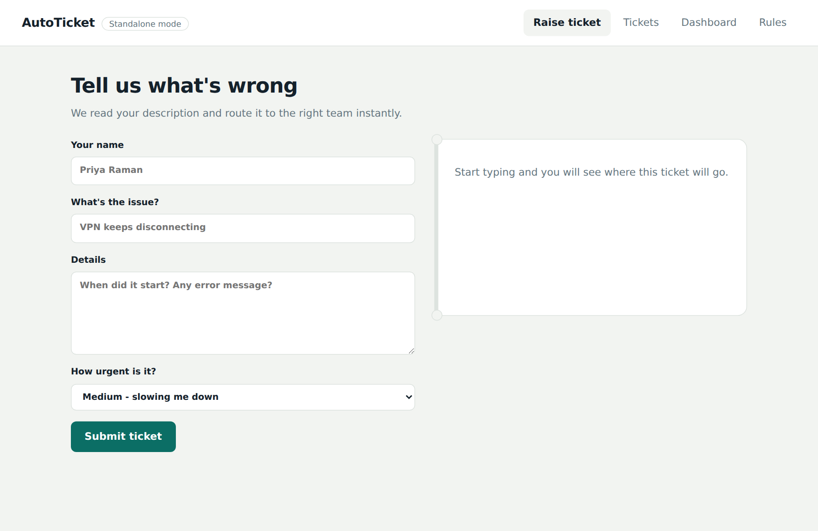
Figure 10.1: Raise ticket page

10.2 Live Routing Slip
As soon as the user types the issue, the slip on the right changes to show where the ticket will go. In this example the text "VPN keeps disconnecting" matches the keyword vpn, so the slip shows the category and subcategory (Network - VPN), the team (Network Team), the matched keyword and the priority.
The urgency chosen was High, so the priority is shown as P1: the VPN rule has priority P2 and the high urgency raises it by one level. The user can therefore see the effect of every choice before submitting.
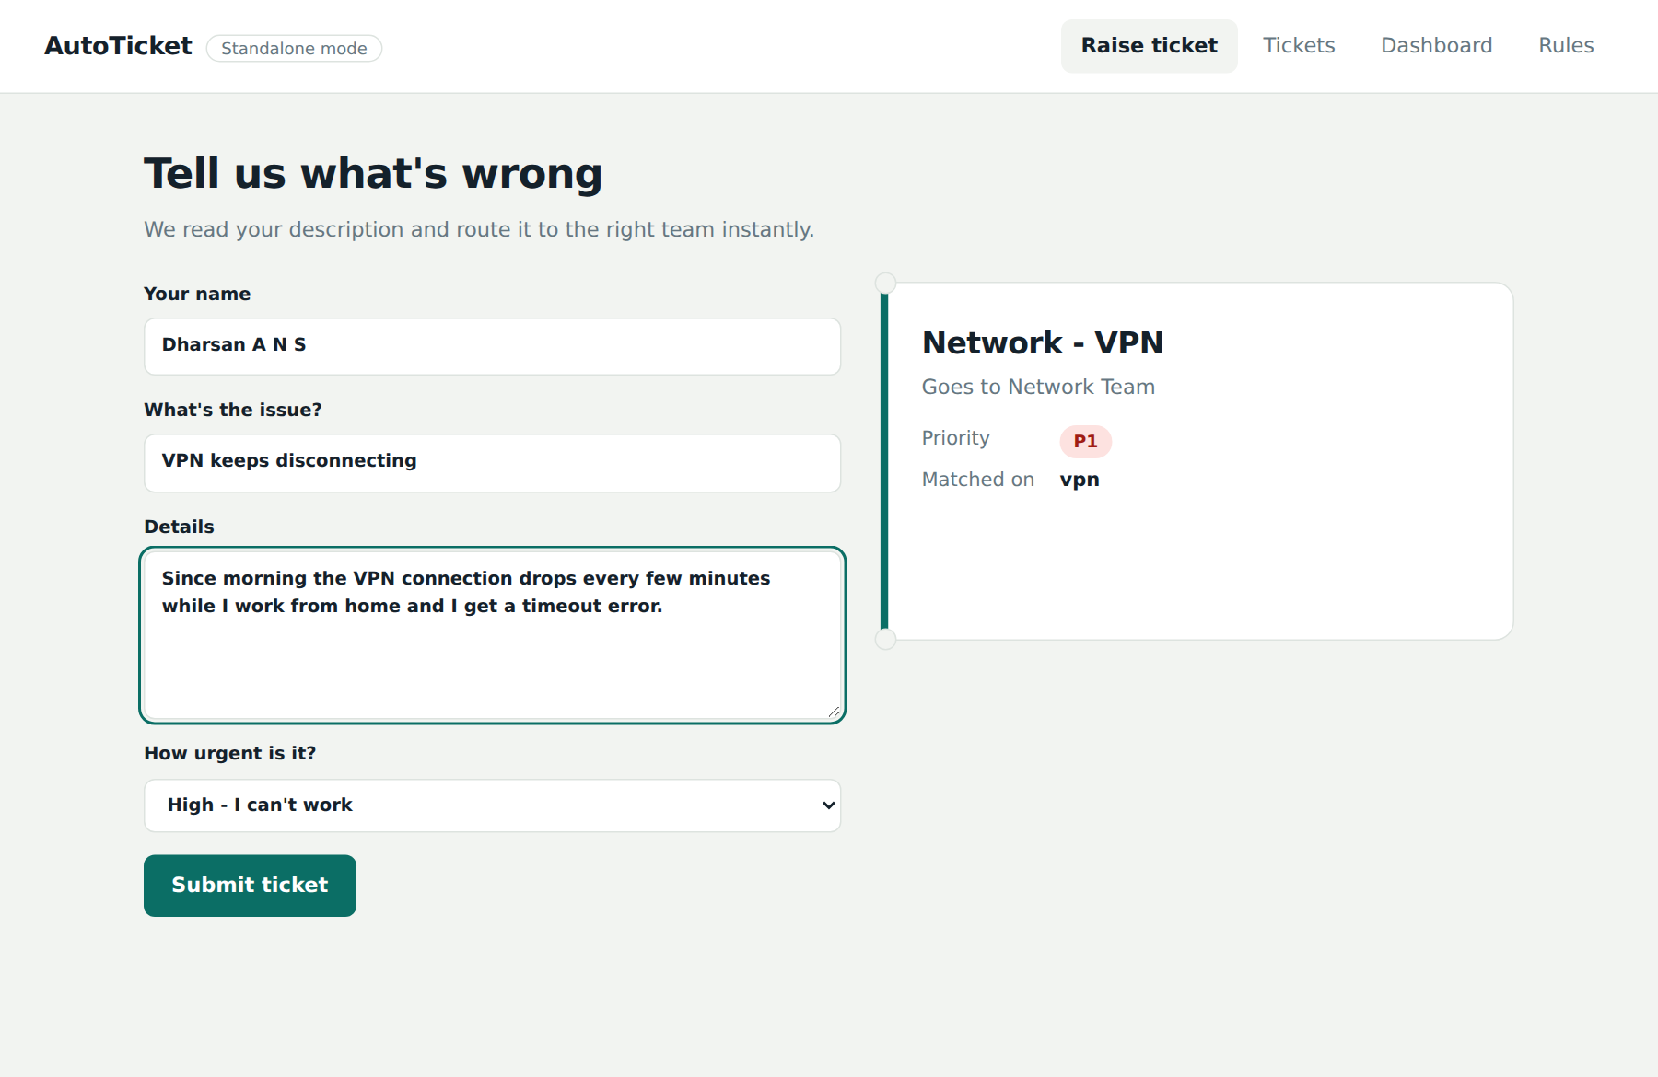
Figure 10.2: Routing slip updating while the user types

10.3 Ticket Submitted
After the user presses Submit ticket, the ticket is classified, saved and, if ServiceNow is configured, created as an Incident. A confirmation message appears at the bottom of the screen with the new ticket number and the team that will handle it. The form and the routing slip are cleared so that another ticket can be raised immediately.
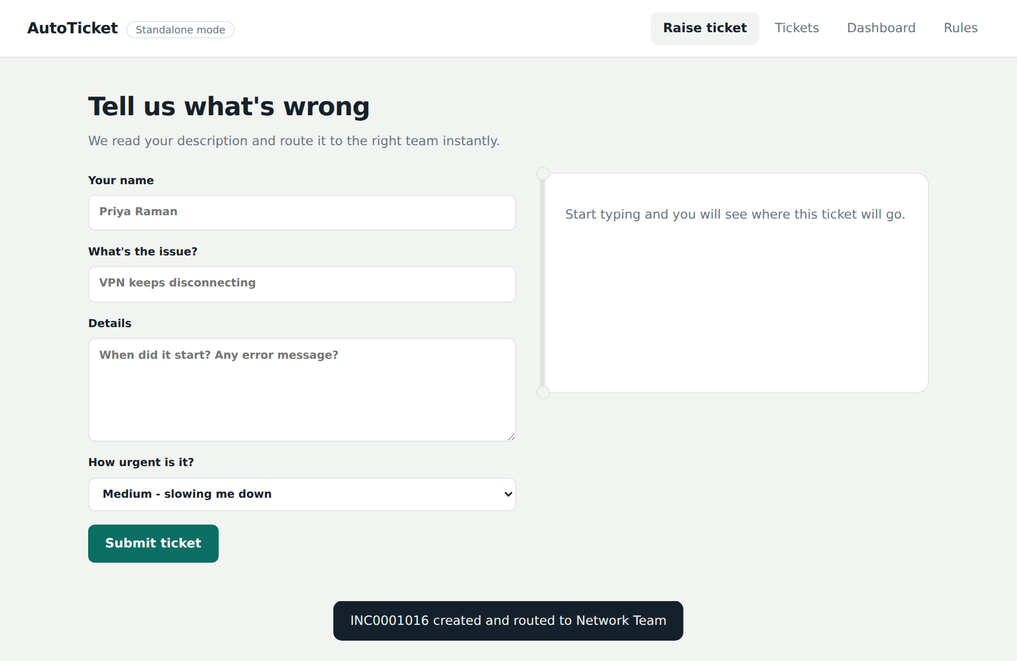
Figure 10.3: Confirmation message after submitting a ticket

10.4 Manual Review Routing
When the text does not contain any rule keyword, the slip changes to "Needs a human look". The ticket will go to the Service Desk and is flagged for manual review. The slip uses an amber edge instead of the teal edge so that this case is visible at a glance. In this example the text "Coffee machine making noise in pantry" is not an IT problem covered by any rule.
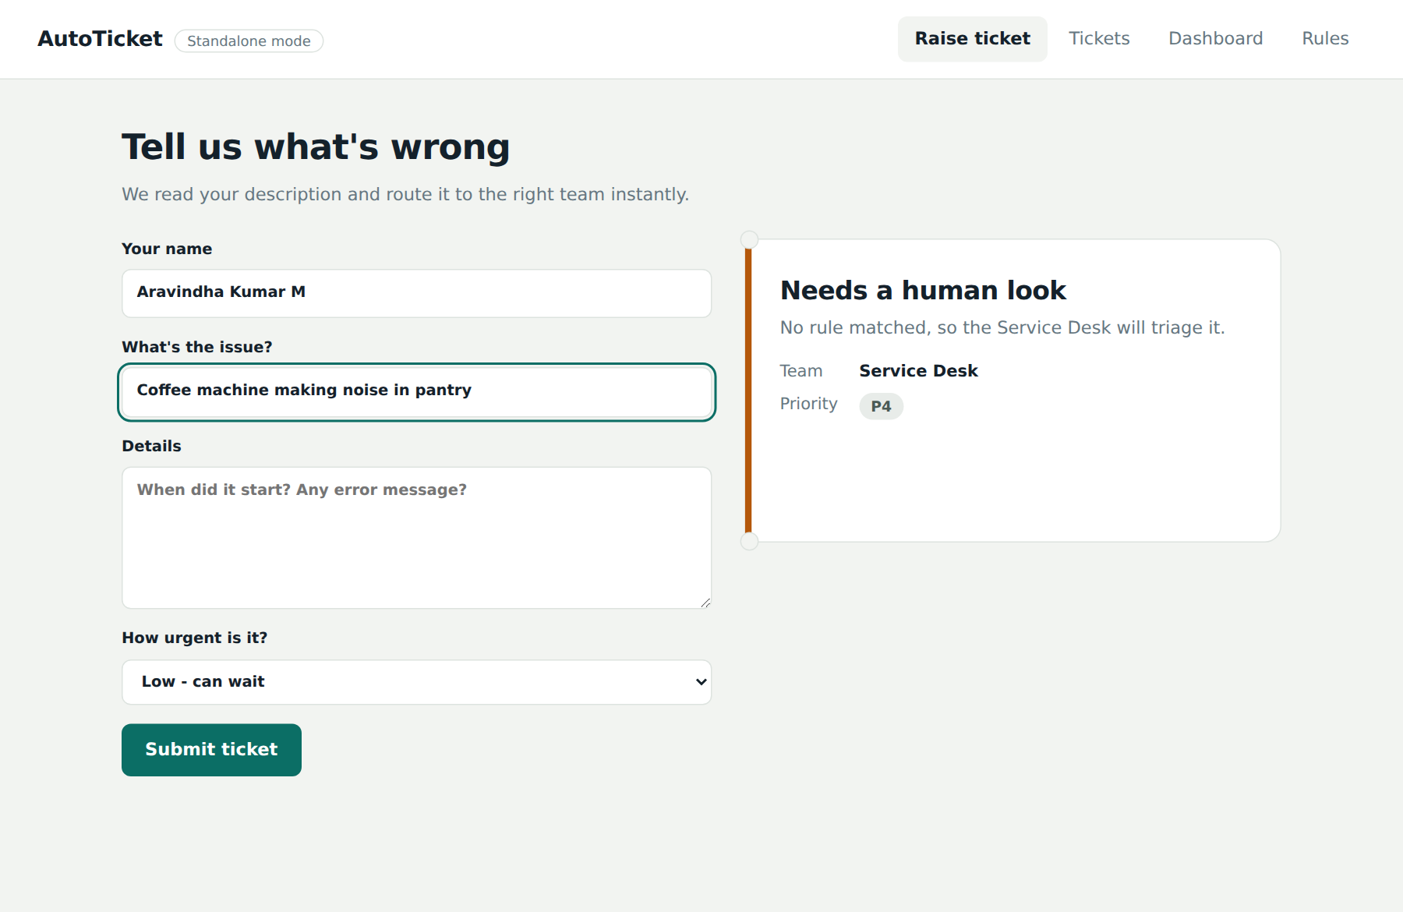
Figure 10.4: Ticket with no matching rule

10.5 Tickets List
The Tickets page lists every ticket, newest first. For each ticket it shows the number, the issue and the name of the caller, the category and subcategory, the assigned team, a priority chip coloured from critical to low, and the creation time. Tickets that were not matched by any rule carry the note "needs manual review". When ServiceNow is connected, the Incident number is shown under the ticket number.
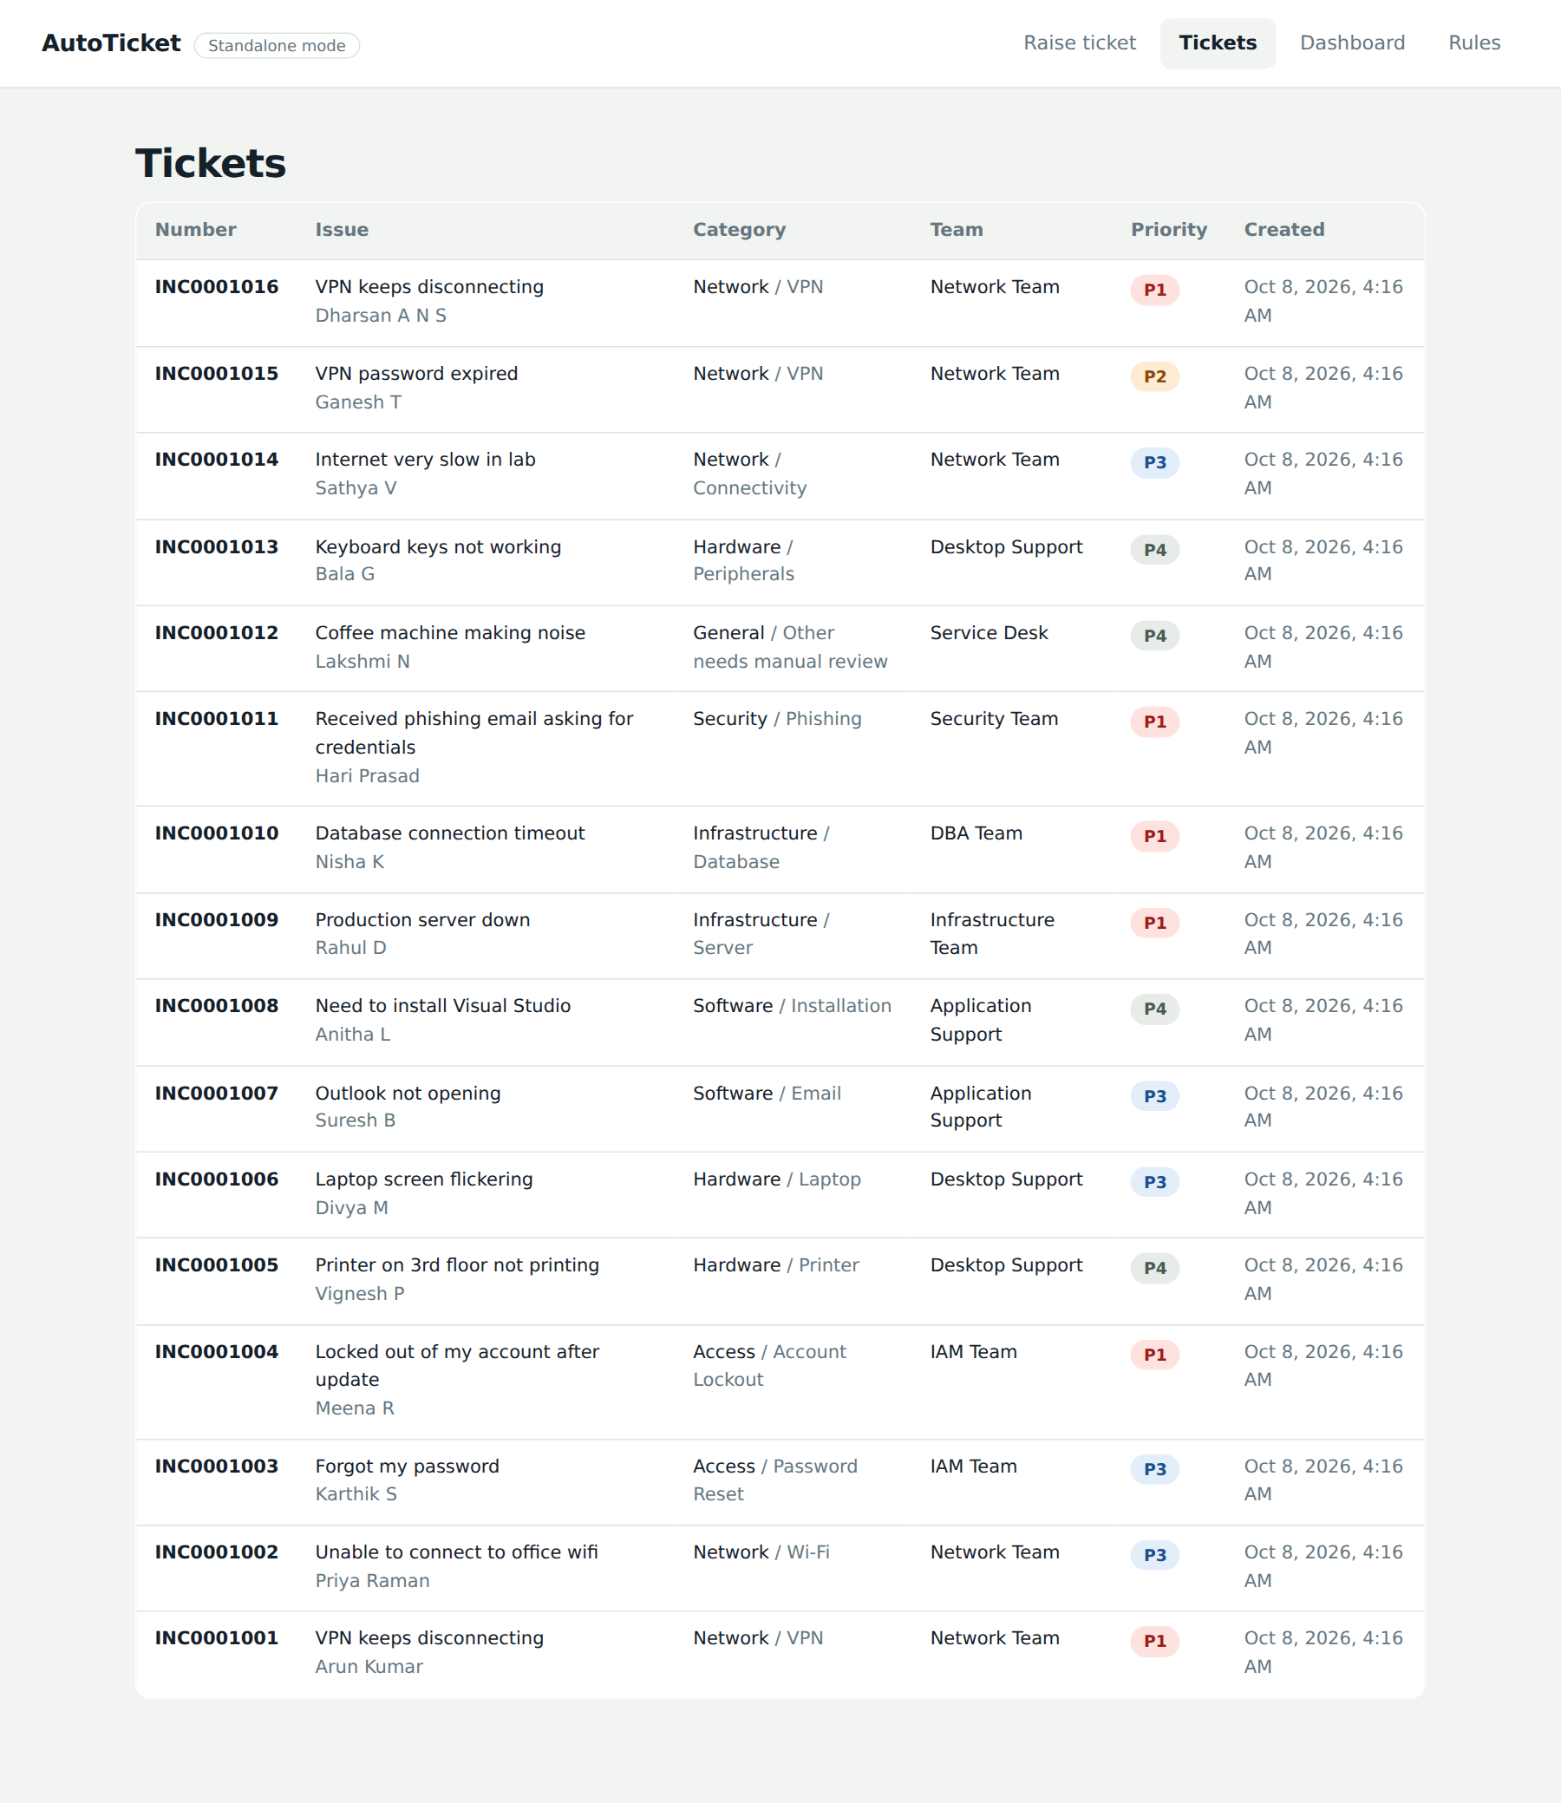
Figure 10.5: Tickets page

10.6 Dashboard
The dashboard gives the service desk manager a quick view of the work. The cards at the top show the number of tickets raised, the percentage classified automatically and the number sent for manual review. Below them three bar charts show the tickets by category, the tickets by priority and the most frequently matched keywords.
These figures are calculated from the stored tickets each time the page is opened, so they are always current. The keyword chart helps administrators decide which rules are most valuable and where new rules are needed.
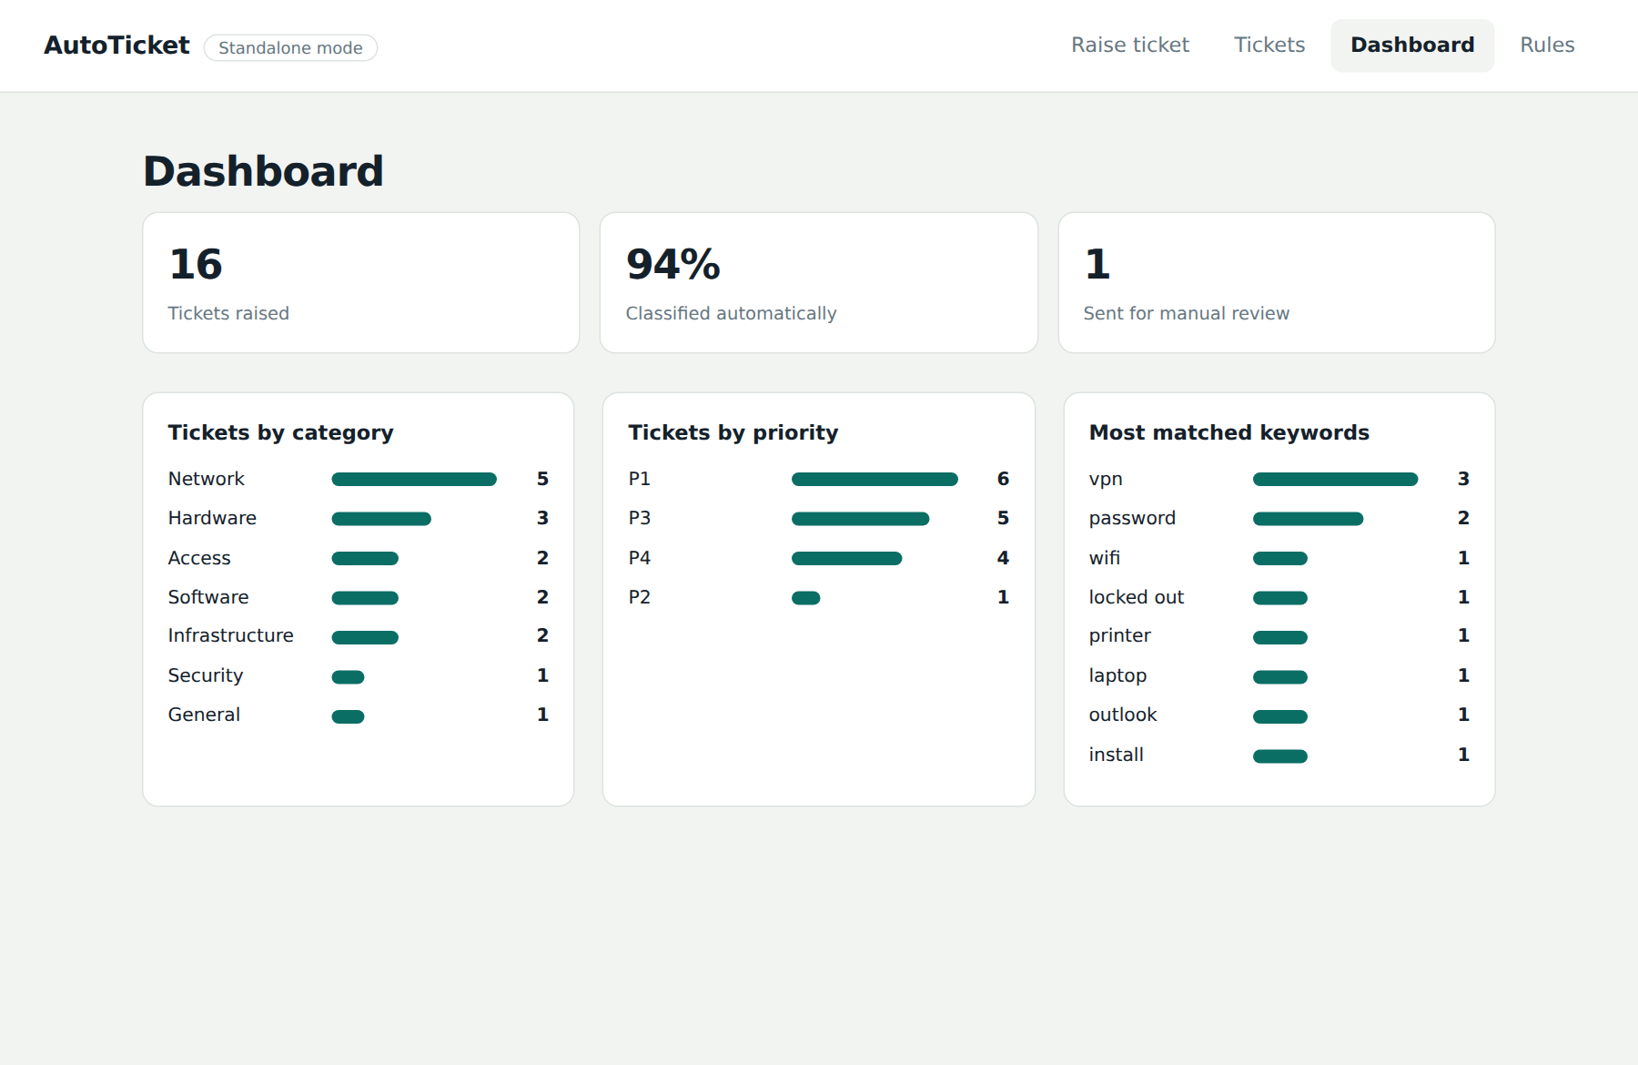
Figure 10.6: Dashboard with statistics and charts

10.7 Rules Manager
The Rules page is where administrators maintain the knowledge of the system. Every rule shows its keyword, category, subcategory, team and priority. The links at the end of each row switch a rule off or on, or delete it. A switched-off rule is shown faded and is ignored by the classifier. Changes apply to the next ticket without restarting the server.
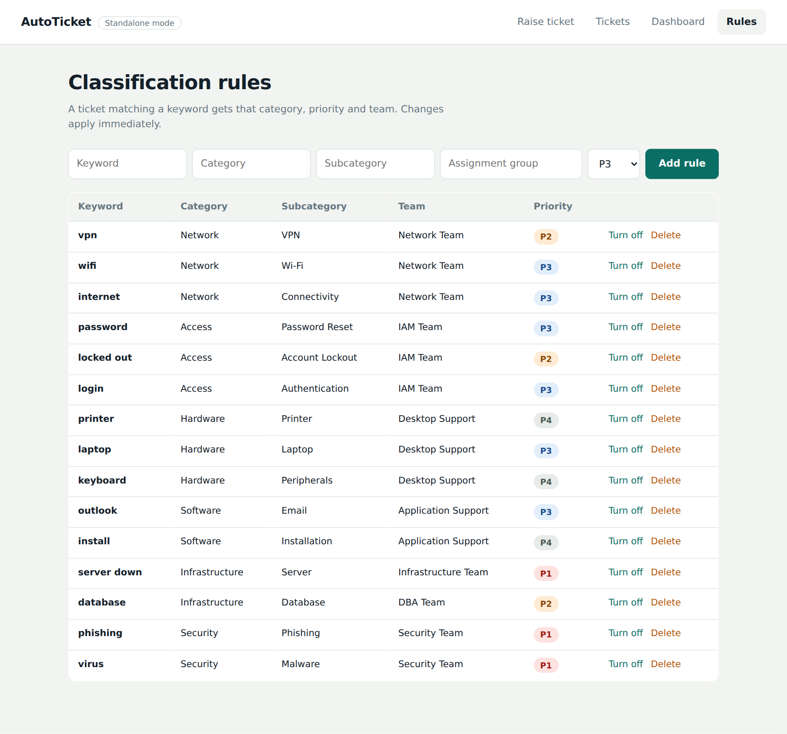
Figure 10.7: Classification rules page

10.8 Adding a Rule
The form at the top of the Rules page adds a new rule. In Figure 10.8 the administrator has entered the keyword firewall, the category Network, the subcategory Firewall, the team Network Team and the priority P2. After pressing Add rule, the message "Rule added" appears and the new rule is shown in the table (Figure 10.9).
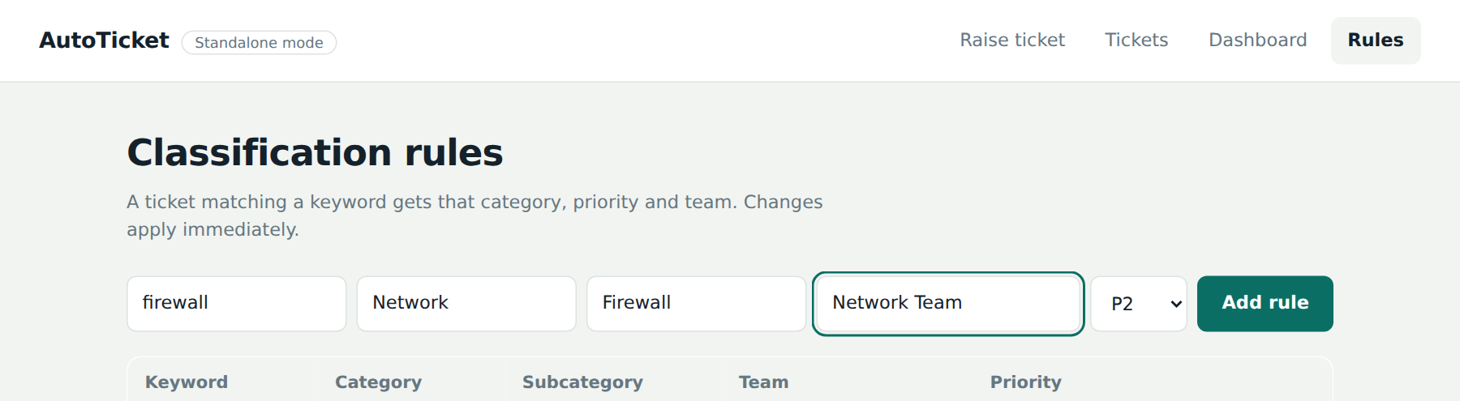
Figure 10.8: Rule form filled in
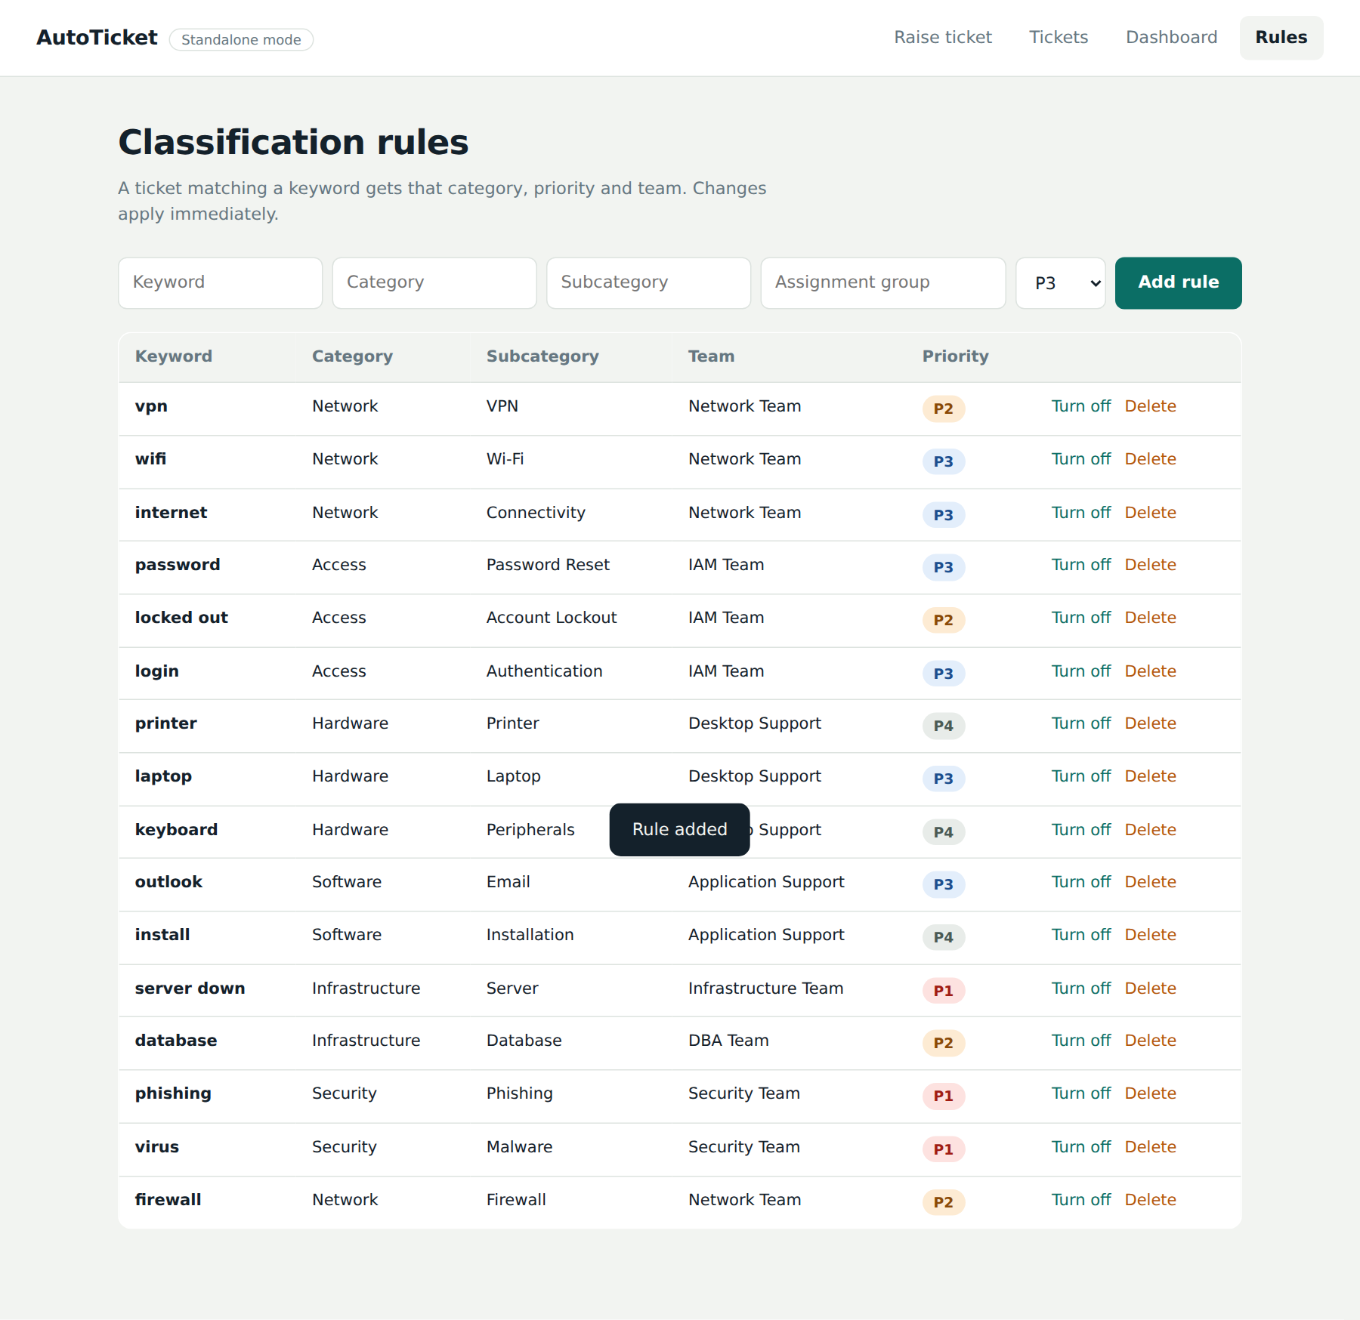
Figure 10.9: Rules table after the new rule is added

10.9 Mobile View
On a phone the two-column layout becomes one column: the form comes first and the routing slip appears below it. The navigation wraps under the brand name, buttons keep a comfortable touch size and the text remains readable without zooming. The same behaviour applies to the other pages, where tables scroll sideways inside their own container.
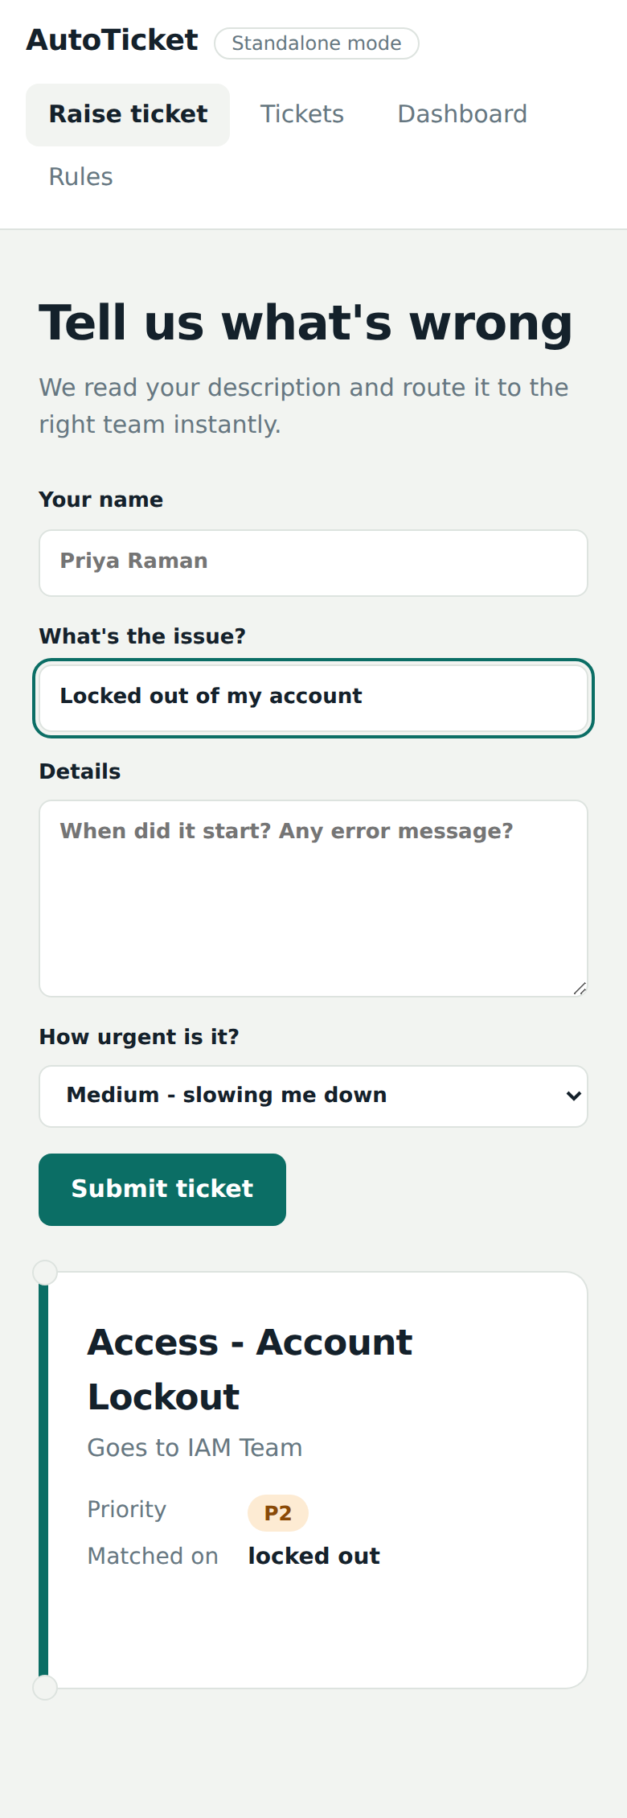
Figure 10.10: Raise ticket page on a 390 px wide screen

11. FUTURE IMPLEMENTATION
The present system classifies tickets with keyword rules. This is transparent, easy to maintain and effective for common issues, and it provides a solid base for the following enhancements.

11.1 Machine-Learning Classification
Keyword rules cannot recognise a problem that is described in unexpected words. ServiceNow Predictive Intelligence can train a classification model on the history of resolved incidents and predict category and assignment group from the text. A hybrid approach is proposed: use the model when its confidence is high, use the rules as a fallback, and send low-confidence tickets to manual review. Corrections made by agents can be fed back as new training data so that accuracy improves over time.

11.2 Natural Language Understanding and Multilingual Support
Users often write tickets in their own language or mix languages. Adding language detection and translation, and extending the rules with keywords in Tamil, Hindi and other languages, would allow the system to serve a wider group of users. Synonym lists and spelling correction would also help to match "wi-fi", "wifi" and "wireless" with a single rule.

11.3 Knowledge Suggestions and Automatic Resolution
For common requests such as a password reset the system could suggest a knowledge article to the user before the ticket is created, or even resolve the request automatically through an approved workflow. This would reduce the number of tickets and give users an immediate answer.

11.4 Priority from Impact and SLA Prediction
Priority could be calculated from both urgency and impact, as in the ITIL priority matrix, using the number of affected users or the business service involved. The system could also predict which tickets are likely to breach their service level agreement and warn the team lead before the deadline.

11.5 More Ways to Raise Tickets
Tickets could be created from e-mail, from a chatbot such as the ServiceNow Virtual Agent, or from Microsoft Teams and Slack. Each channel would use the same classification service, so that the user receives the same quality of routing wherever the problem is reported.

11.6 Authentication and Role-Based Access
A login page with roles would let ordinary users see only their own tickets, agents see their team queue and administrators manage the rules. Single sign-on with the organisation directory would remove the need to type a name when raising a ticket.

11.7 Database, Deployment and Notifications
The JSON files can be replaced by a database such as PostgreSQL or MongoDB for larger volumes, and the application can be packaged in a Docker container for easy deployment behind an HTTPS reverse proxy. E-mail, SMS or push notifications could inform the user when the status of a ticket changes.

11.8 Advanced Analytics
The dashboard can be extended with trends over time, average time to resolution per category, the busiest hours and a list of tickets that were frequently corrected by agents. The last item would automatically suggest new rules to the administrator and close the loop between operations and rule maintenance.

12. CONCLUSION

12.1 Summary
The project Auto Ticket Classification using Flow Designer shows that the first and most repetitive step of incident management can be automated with a small, understandable set of rules. A ticket written in free text is read, matched against active rules and receives a category, subcategory, priority and assignment group within a fraction of a second. The user sees the result while still typing, unmatched tickets are safely passed to a human, and every decision is recorded with the keywords that caused it.
The work delivered a complete, running application: a responsive web interface, a dependency-free Node.js backend with a REST API, a rules administration page, a dashboard, an optional ServiceNow integration through the Table API, and the design of the Flow Designer flow with its custom rules table and Script Include. The application can be started with one command and used immediately.

12.2 Objectives and Outcome
Objective | Outcome
Classify every new ticket automatically | Achieved: category, subcategory, priority and team are assigned for every ticket
Keep rules as data | Achieved: rules are stored in a table and managed from the Rules page
Instant feedback to the user | Achieved: live routing slip updates while typing
Safe handling of unmatched tickets | Achieved: Service Desk assignment with manual review flag
Integration with ServiceNow | Achieved by design and code: Table API push and Flow Designer flow with Script Include
Dashboard for measurement | Achieved: totals, automation rate, categories, priorities and keywords
Clean, responsive, real application | Achieved: tested at desktop and mobile widths with live data

12.3 Limitations
The classifier is keyword based, so it cannot understand the meaning of a sentence and depends on the quality of the rule set. Data are stored in JSON files, which is suitable for a demonstration and small teams but not for very large volumes. The application does not yet have user authentication. These limitations are addressed in the future enhancements of Chapter 11.

12.4 Learning Outcomes and Final Remarks
During the project the team learned the structure of ITSM processes, the way ServiceNow tables, flows and Script Includes work together, the design of a REST API, and the practice of building an interface that is both attractive and accessible. The project also showed the value of designing a safe fallback: an automation is only trusted when it knows when to ask a human for help.
In conclusion, the system reduces manual triage effort, improves the consistency of routing and gives managers reliable data, and it provides a practical foundation on which machine-learning and multi-channel features can be added.

13. REFERENCES
- ServiceNow Developer Program, "Personal Developer Instance and developer documentation", https://developer.servicenow.com
- ServiceNow Product Documentation, "Flow Designer", https://docs.servicenow.com
- ServiceNow Product Documentation, "Table API (REST)", https://docs.servicenow.com
- ServiceNow Product Documentation, "Predictive Intelligence", https://docs.servicenow.com
- Node.js Foundation, "Node.js Documentation: http, https and fs modules", https://nodejs.org/docs
- Mozilla Developer Network, "Fetch API" and "Using CSS custom properties", https://developer.mozilla.org
- AXELOS, "ITIL 4 Foundation: IT Service Management", Incident Management practice
- World Wide Web Consortium, "Web Content Accessibility Guidelines (WCAG) 2.1", https://www.w3.org/TR/WCAG21/
- OWASP, "Cross Site Scripting Prevention Cheat Sheet", https://cheatsheetseries.owasp.org

