**HR MANAGER/HIRING MANAGER/HR TEAM/RECRUITEE USER STORIES**

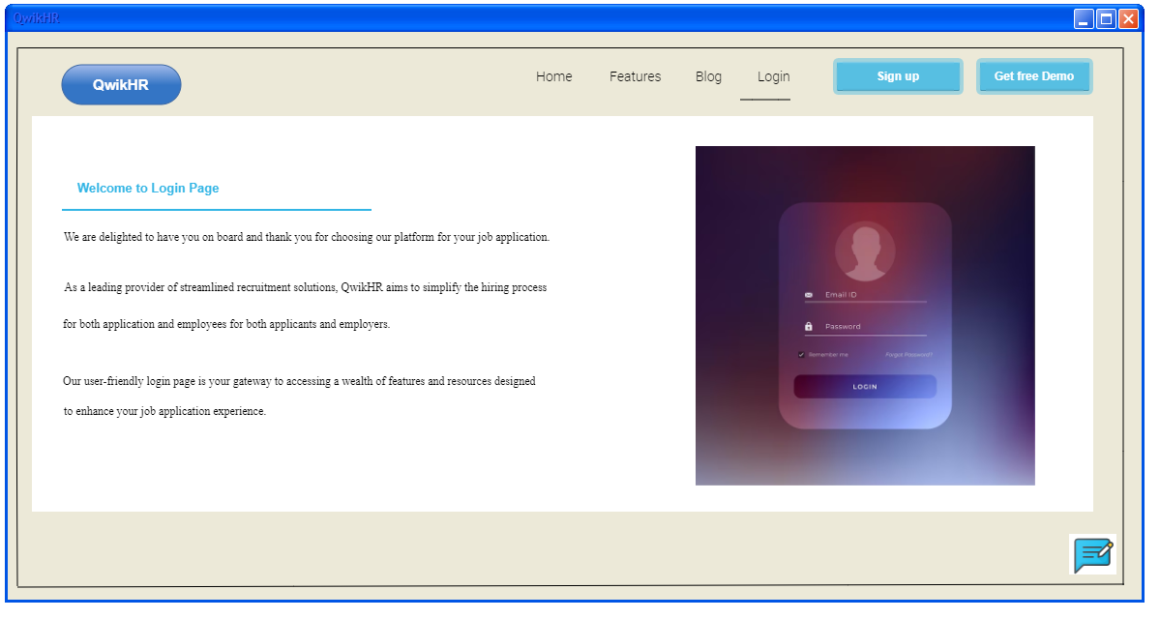

|  |
| --- |
| **Title**  Login |
| **User Story:**  **As a** Hr Manager or HR Team or candidate  **I want** to login using my username and password  **So that** I can access the QwikHR application |
| **Acceptance Criteria:**   1. Display keypad when the user clicks inside the mail ID and password textbox 2. The Login button is highlighted when the user starts typing. 3. Login button should be inactive when no input is typed. 4. Choose the option whether login as candidate, Recruiter, HR Manager, Hiring Manager. 5. User can click on button after giving input. 6. Display home page after clicking the Login button if the credentials are correct. 7. Display the message “Invalid username/password” if the credentials are wrong and remove the input in the textboxes. |

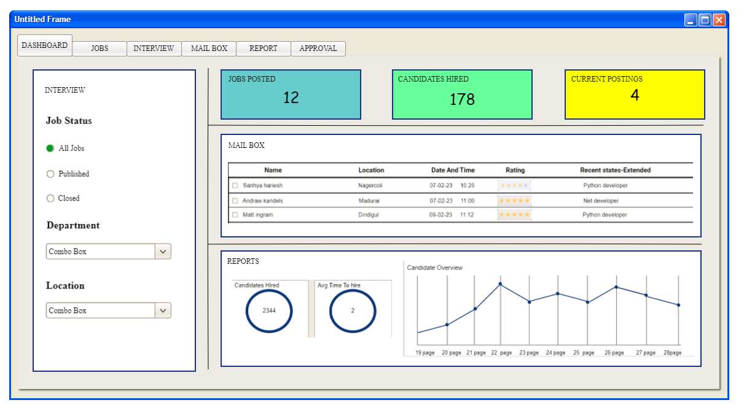

|  |
| --- |
| **Title**  Dashboard |
| **User Story:**  **As a** Hr Manager or HR Team  **I want** to view features of Dashboard to proceed further  **So that** I can hire the candidates to my company. |
| **Acceptance Criteria:**   1. After login the page takes to dashboard where all the features of panel will be displayed. 2. It is possible to click the various panel or those features will be displayed in dashboard which are very important. |

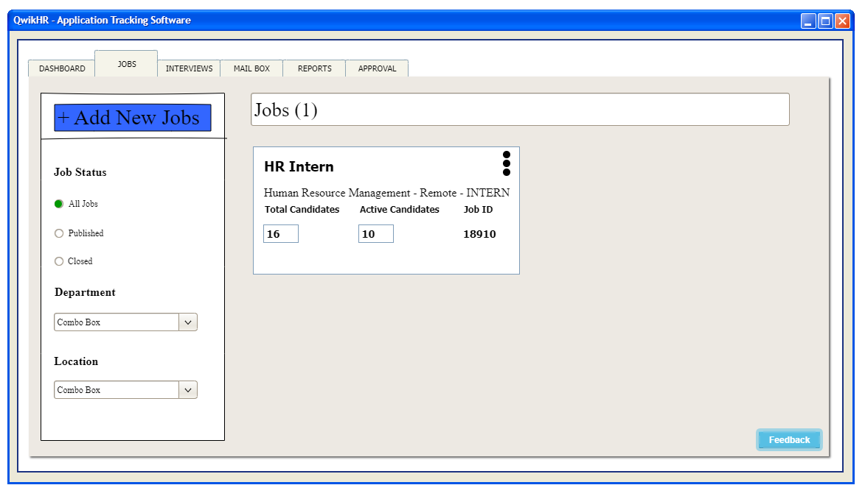

|  |
| --- |
| **Title**  Jobs |
| **User Story:**  **As a** Hr Manager or HR Team  **I want** to create jobs to publish in various boards  **So that** I can hire the candidates to my company. |
| **Acceptance Criteria:**   1. In Jobs panel there will be options to add new job, publish jobs. 2. Further, it is also possible to Search and filter jobs that has been posted. 3. It is possible to search jobs posted department and location wise by choosing the appropriate option from the combo box/ 4. From the feedback option it is possible to provide feedback for the appropriate page. |

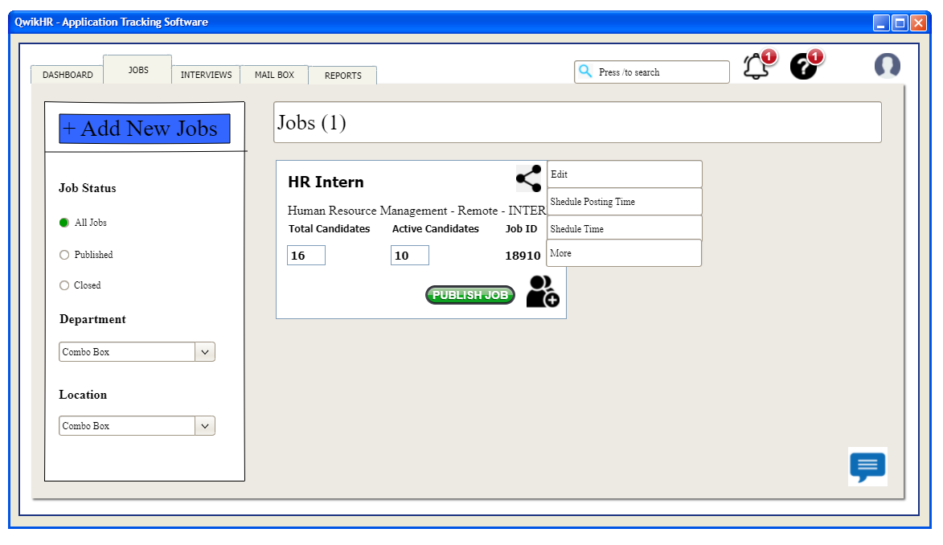

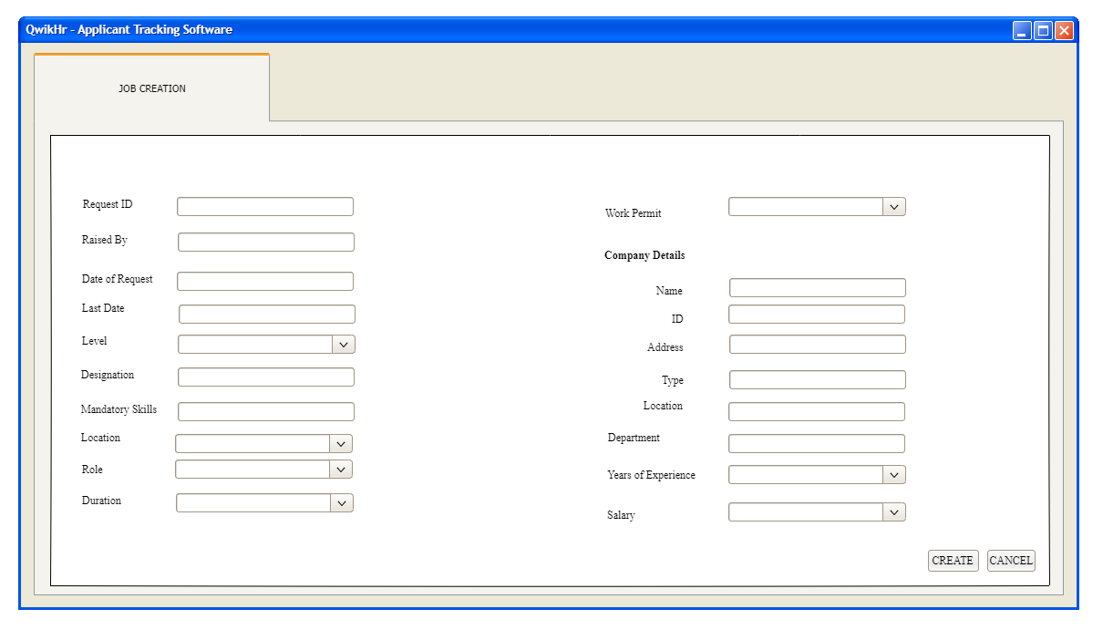

|  |
| --- |
| **Title**  Create Jobs |
| **User Story:**  **As a** Hr Manager or HR Team  **I want** to create jobs to publish in various boards  **So that** I can hire the candidates to my company. |
| **Acceptance Criteria:**   1. Go to Jobs Panel 2. Click on Add New Jobs Button 3. Enter the job details manually and then click create button to create the jobs. 4. The created job will be appeared in jobs panel. 5. To edit, publish go to the jobs panel |



|  |
| --- |
| **Title**  Press/to search |
| **User Story:**  **As a** Hr Manager or HR Team or candidate  **I want** to search jobs to publish in various that us been applied  **So that** I can view and hire candidates. |
| **Acceptance Criteria:**   1. Go to Jobs Panel 2. Click on Search panel 3. Enter the job name you want to search. 4. The searched job will be displayed. |

|  |
| --- |
| **Title**  Job Approval |
| **User Story:**  **As a** Hr Manager or HR Team  **I want** to create jobs to publish in various boards  **So that** I can hire the candidates to my company. |
| **Acceptance Criteria:**   1. The job that is created be HR Team will undergone by HR Manager where if satisfied it is published. 2. Else it is been not published. |

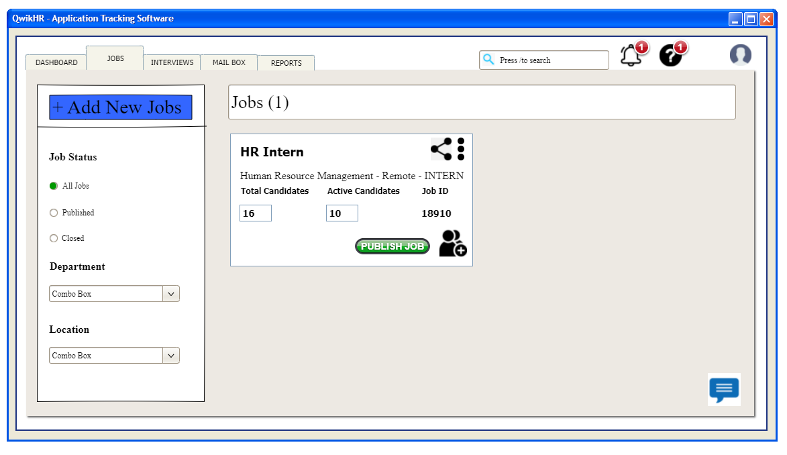

|  |
| --- |
| **Title**  Publish Jobs |
| **User Story:**  **As a** Hr Manager or HR Team  **I want** to publish jobs in various boards  **So that** I can hire the candidates to my company. |
| **Acceptance Criteria:**   1. Go to Jobs Panel 2. Click on Publish button to publish jobs 3. To Edit or schedule job posting time click on the three dote button and select the option required to be done. 4. After publish the jobs will be posted in various fields and boards for the candidate reference. |

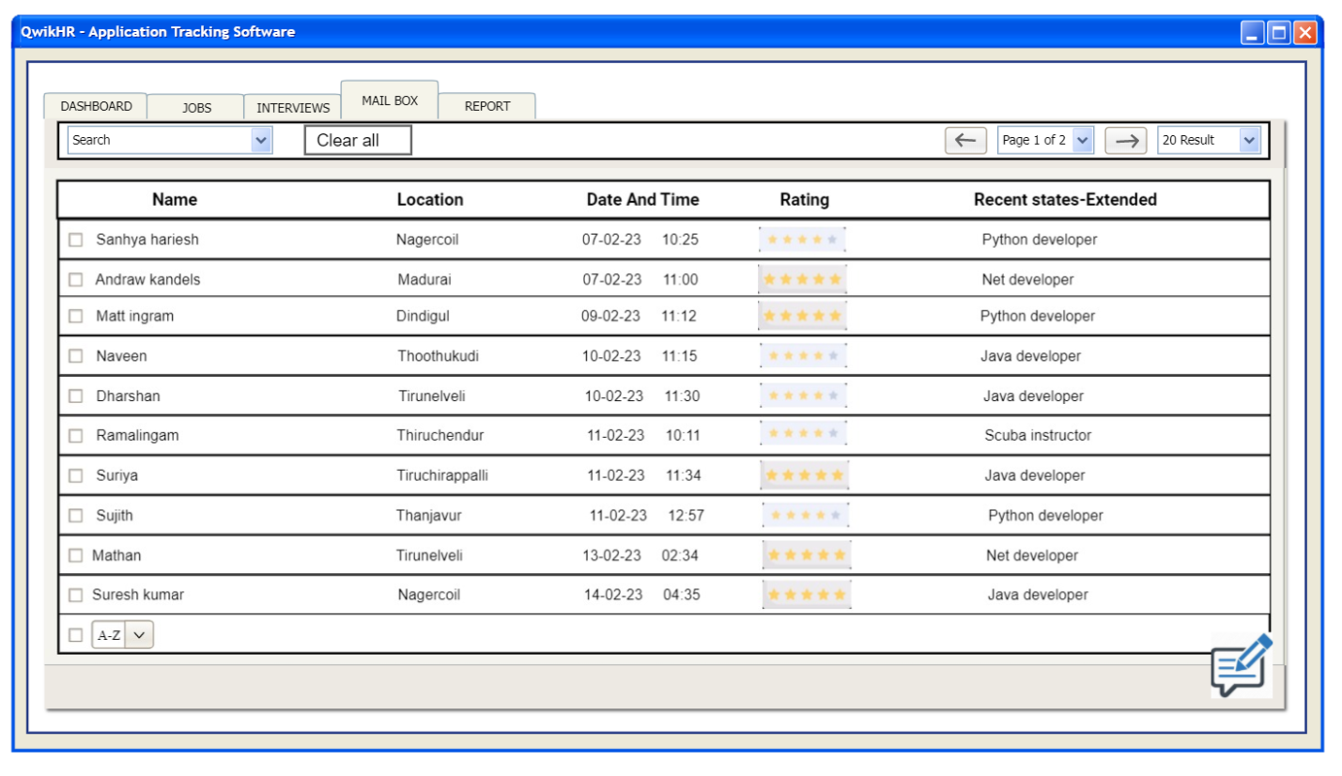

|  |
| --- |
| **Title**  Receive Applications |
| **User Story:**  **As a** Hr Manager or HR Team  **I want** to receive applications from the mailbox  **So that** I can select and shortlist candidates to hire in my company. |
| **Acceptance Criteria:**   1. The candidates who apply for jobs will be received in the Mailbox panel. 2. In the Mailbox the Name of the candidate, Location, Date and time received and the rating of the applicant by other companies and their skills will be displayed in the Mailbox panel. 3. In this mailbox, the pages can be scrolled to view the all over applicant details etc.,. |



|  |
| --- |
| **Title**  Review Applications |
| **User Story:**  **As a** Hr Manager or HR Team  **I want** to review applications from the mailbox  **So that** I can select and shortlist candidates to hire in my company.. |
| **Acceptance Criteria:**   1. The applicants Request letter with CV will be received in the mailbox panel. 2. Those CV can be viewed from mailbox panel by clicking the applicant name from the mailbox panel. 3. The candidates are been selected from the mailbox which is been shortlisted depending upon the requirement using the search bar. |

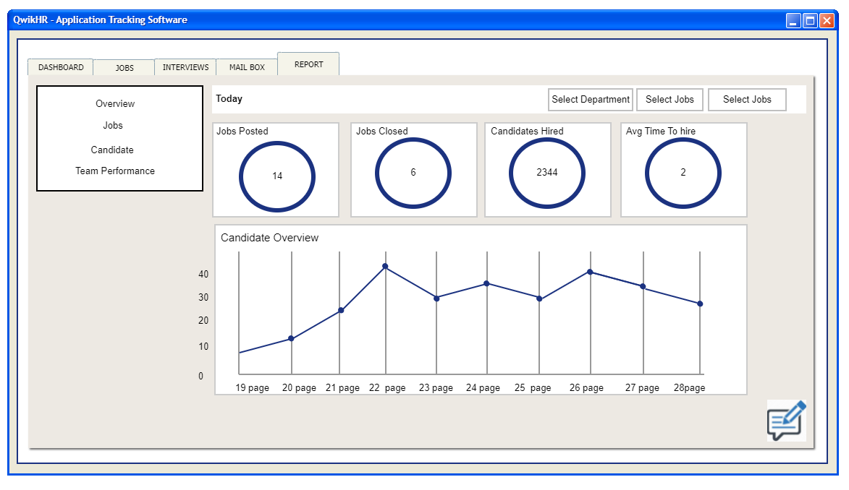

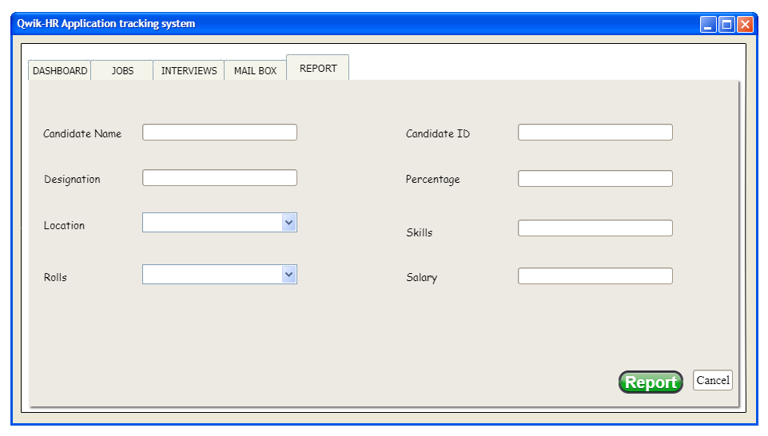

|  |
| --- |
| **Title**  Screening and Reports |
| **User Story:**  **As a** Hr Manager or HR Team  **I want** to screen the selected candidates  **So that** I can select and shortlist candidates to hire in my company. |
| **Acceptance Criteria:**   1. The shortlisted applicants are undergone a screening process online mode. 2. After screening process the reports of the candidate will be displayed in the report panel. 3. In the report panel candidates performance, jobs posted and candidates hired and a lot of additional informations are been displayed in the report panel. 4. According to the report of the candidate the next step is taken. 5. The candidate is been selected according to the reports if the report is poor they are been rejected. |

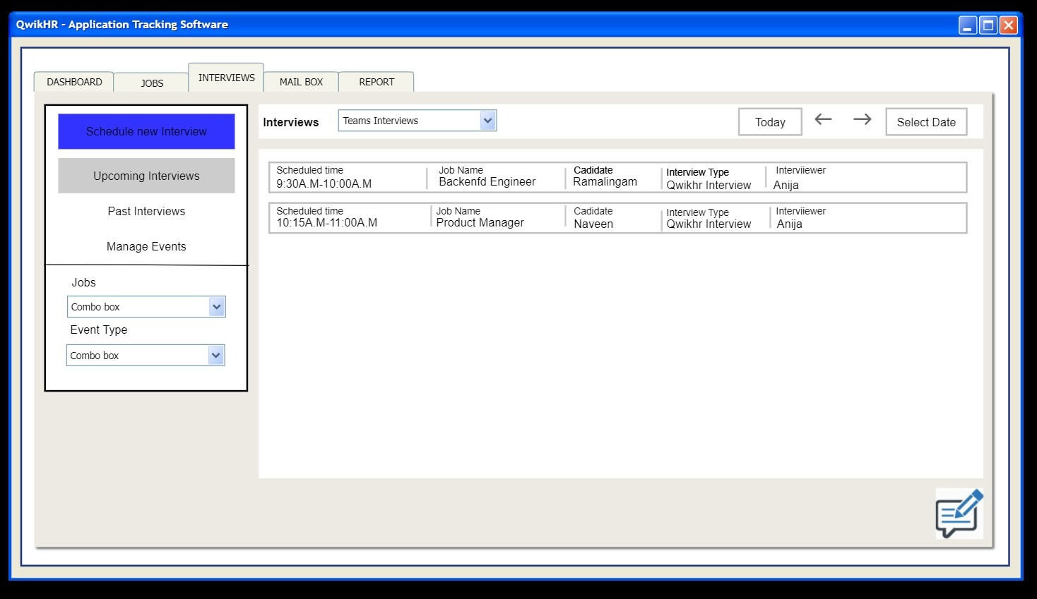

|  |
| --- |
| **Title**  Interview |
| **User Story:**  **As a** Hr Manager or HR Team  **I want** to interview the candidates  **So that** I can to hire in my company according to their performance. |
| **Acceptance Criteria:**   1. The candidates are asked to attend the offline interview according to their report. 2. Based on the interview the candidates performance feedback will be displayed in the report panel. 3. Depending upon the no of candidates the Interview round extends. 4. If there is less number of people within one or two round the interview will be completed. So till the interview completes and the candidates get shortlisted the process from step 1-2 goes in a loop. 5. After the Interview gets overed the people CV and their details are been collected. |



|  |
| --- |
| **Title**  Schedule Interviews |
| **User Story:**  **As a** Hr Manager or HR Team  **I want** to schedule interviews according to the candidates requirement  **So that** I can hire the candidates to my company. |
| **Acceptance Criteria:**   1. It is able to schedule Interview as per candidate options. 2. If the time is scheduled for another employee then, the recruiter may ask the candidate to choose another time and date from the calender available in the interview panel which is interlinked for both candidate and other officials. |

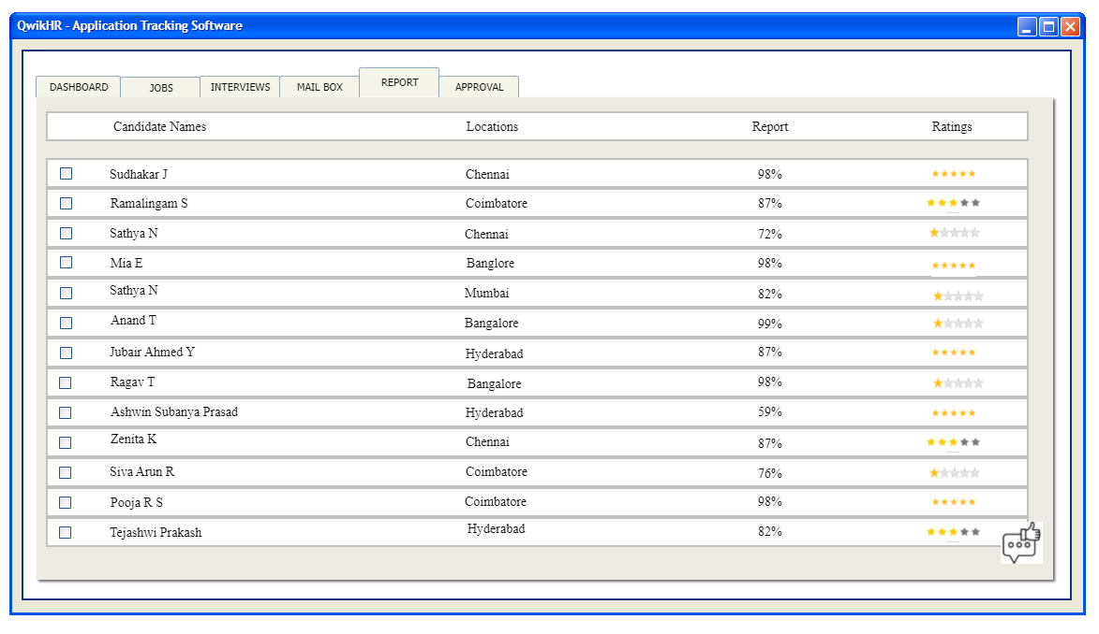

|  |
| --- |
| **Title**  Reports |
| **User Story:**  **As a** Hiring Manager  **I want** view the reports provided by the Recruiter  **So that** I can to hire in my company if they have best knowledge and skills |
| **Acceptance Criteria:**   1. Click on the report panel. 2. Reports/Feedback given by the recruiter will be displayed with the information of the candidate to approve them in the company. |

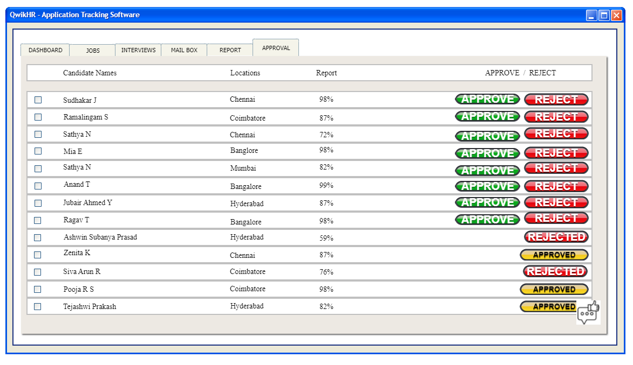

|  |
| --- |
| **Title**  Hiring Manager Approval |
| **User Story:**  **As a** Hiring Manager  **I want** to approve the candidates  **So that** I can to hire in my company if they have best knowledge and skills |
| **Acceptance Criteria:**   1. After the interview is been completed, the selected candidates details are been collected and forwarded to the hiring Manager for Approval. 2. If the hiring manager approves the selected candidates the candidates documents are collected. 3. Else the candidate is been rejected is not approved. |

|  |
| --- |
| **Title**  Document Collection |
| **User Story:**  **As a** HR Team  **I want** to verify the documents  **So that** I can to hire in my company if they have best knowledge and skills |
| **Acceptance Criteria:**   1. After the approval of the hiring manager for the selected candidates the documents are been collected for verification. 2. After the verification job offer is sent to the candidates.. |

|  |
| --- |
| **Title**  Document Verification |
| **User Story:**  **As a** Hiring Manager  **I want** to verify documents  **So that** I can to hire in my company |
| **Acceptance Criteria:**   1. After documents has been collected will be received through mail. 2. After collection from the candidate it undergoes document verification to verify whether the given details matches or not. 3. If Yes the candidate will be proceeded to give him/her an offer letter. 4. If No, the candidate will not be given a offer letter. |

|  |
| --- |
| **Title**  Job Offer |
| **User Story:**  **As a** Hiring Manager  **I want** to sent the job offer to the candidates  **So that** I can to hire in my company |
| **Acceptance Criteria:**   1. After the approval of the hiring manager the job offer letter is been sent to the selected candidates or applicants. 2. The job offer is received by the candidates or applicants who have been shortlisted. 3. The job offer letter is been extended till a Date to join. |

**CANDIDATE USERSTORIES**



|  |
| --- |
| **Title**  Candidate login |
| **User Story:**  **As a** Candidate  **I want** to get job notifications  **So that** I can get a job and laced in a better company |
| **Acceptance Criteria:**   1. Display keypad when the user clicks inside the mail ID and password textbox 2. The Login button is highlighted when the user starts typing. 3. Login button should be inactive when no input is typed. 4. Choose the option whether login as candidate 5. User can click on button after giving input. 6. Display home page after clicking the Login button if the credentials are correct. 7. Display the message “Invalid username/password” if the credentials are wrong and remove the input in the textboxes. |

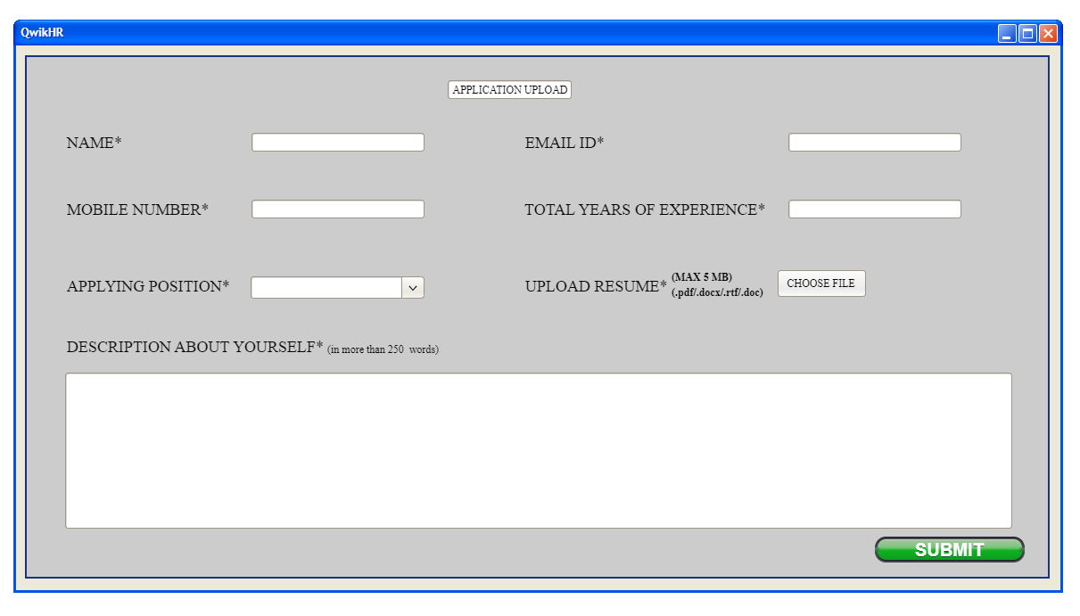

|  |
| --- |
| **Title**  Application Upload |
| **User Story:**  **As a** Candidate  **I want** to upload application  **So that** I don’t want to enter details manually every time whenever I want to apply for the job. |
| **Acceptance Criteria:**   1. After login the page retrieve to Application upload page. 2. In this I have to enter the Name, Designation and other required details. 3. At last I have to upload the resume, with the capability they have instructed by clicking the button Choose option. 4. After entering the details and checking the given details or correct or not, I have to submit the Application. 5. By applying this I don’t want to enter details manually everytime whenever I need to apply for a job. 6. Better to click apply so that the job will be applied and it automatically uploads the application by retrieving the application that have been uploaded. |

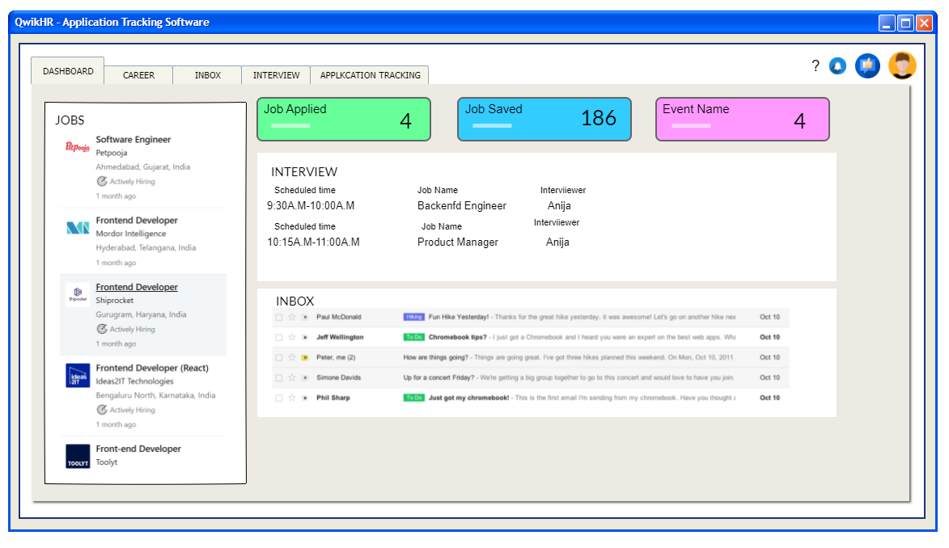

|  |
| --- |
| **Title**  Dashboard |
| **User Story:**  **As a** Candidate  **I want** to view features of QwikHR ATS  **So that** I can get a job and laced in a better company |
| **Acceptance Criteria:**   1. Click the Dashboard 2. It’s able to view All the panels in one window where it is able to click and view the full panel from the given features. |

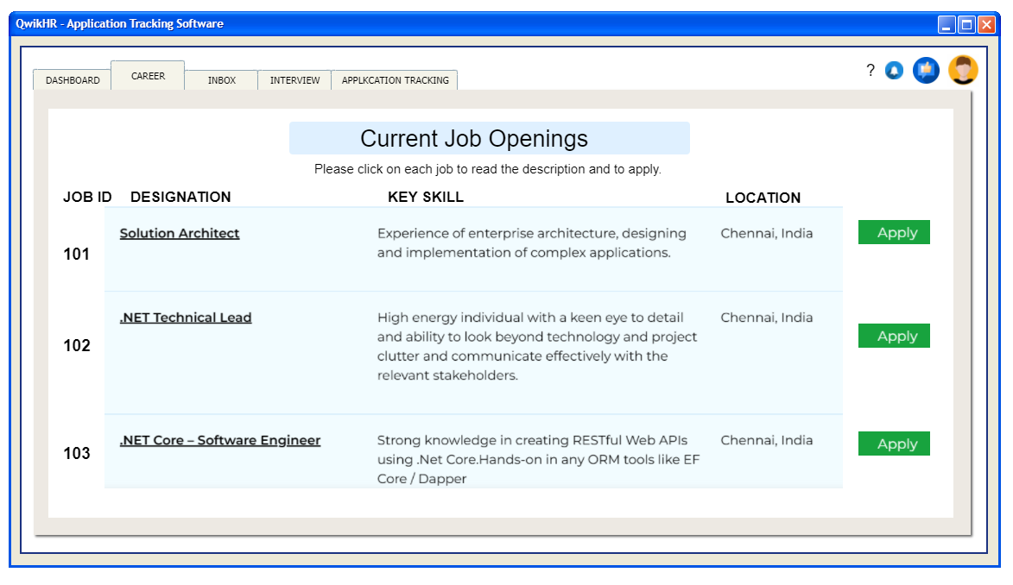

|  |
| --- |
| **Title**  Job Summary |
| **User Story:**  **As a** Candidate  **I want** to view job summary  **So that** I can apply for a job |
| **Acceptance Criteria:**   1. Click the career panel 2. There jobs will be displayed so that I can go through the applications and job summary and apply for the job. 3. To Apply for the job, click the Apply option. So, it directly retrives to the application and upload the application with CV attached to it. |

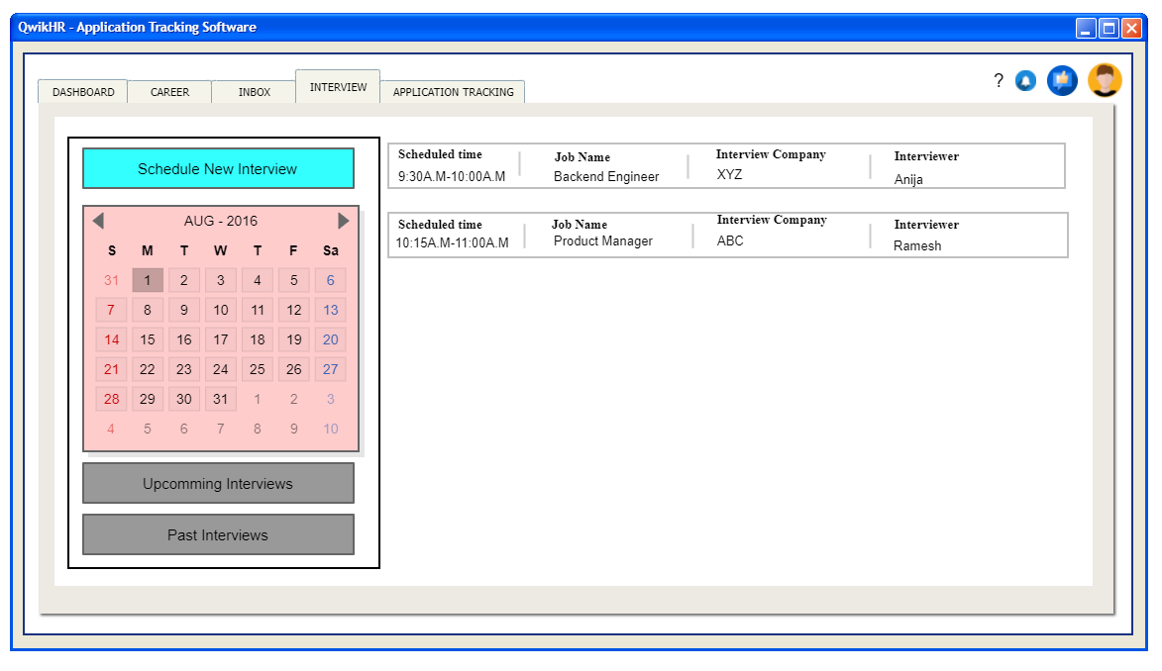

|  |
| --- |
| **Title**  Interview |
| **User Story:**  **As a** Candidate  **I want** to schedule interview for my convinence  **So that** I can get a job and laced in a better company |
| **Acceptance Criteria:**   1. Go to Interview panel. 2. I can view Scheduled Interview in the rightside dialog box. 3. By clicking Schedule New interview button I can schedule new interview. 4. I can also view the upcoming scheduled interview and past interview by clicking the corresponding button. |

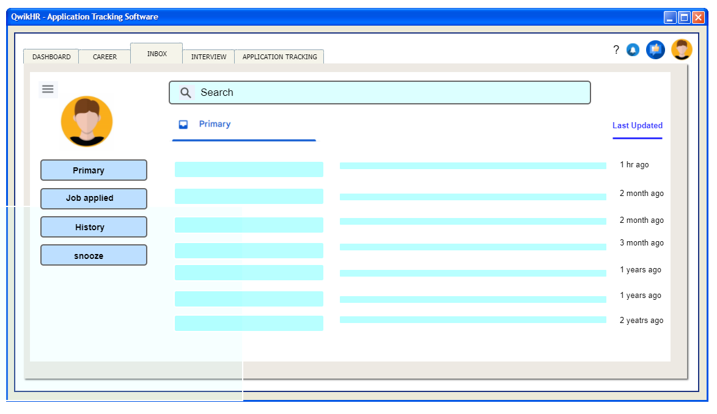

|  |
| --- |
| **Title**  Inbox |
| **User Story:**  **As a** Candidate  **I want** to receive mail  **So that** I can get updates for the jobs I have been applied. |
| **Acceptance Criteria:**   1. Go to Inbox Panel. 2. Click Primary Tab. Mails will be received in Primary Tab. 3. Jobs that have been applied at past will be displayed in the Jobs Applied Panel 4. In the History tab you will be the displayed the job have been applied and their status. 5. Snooze gives remainder if any interviews are been held. 6. Search bar is used to search a particular mail with their requirement which is to be searched. 7. In the User option the candidate can edit their applications and CV |

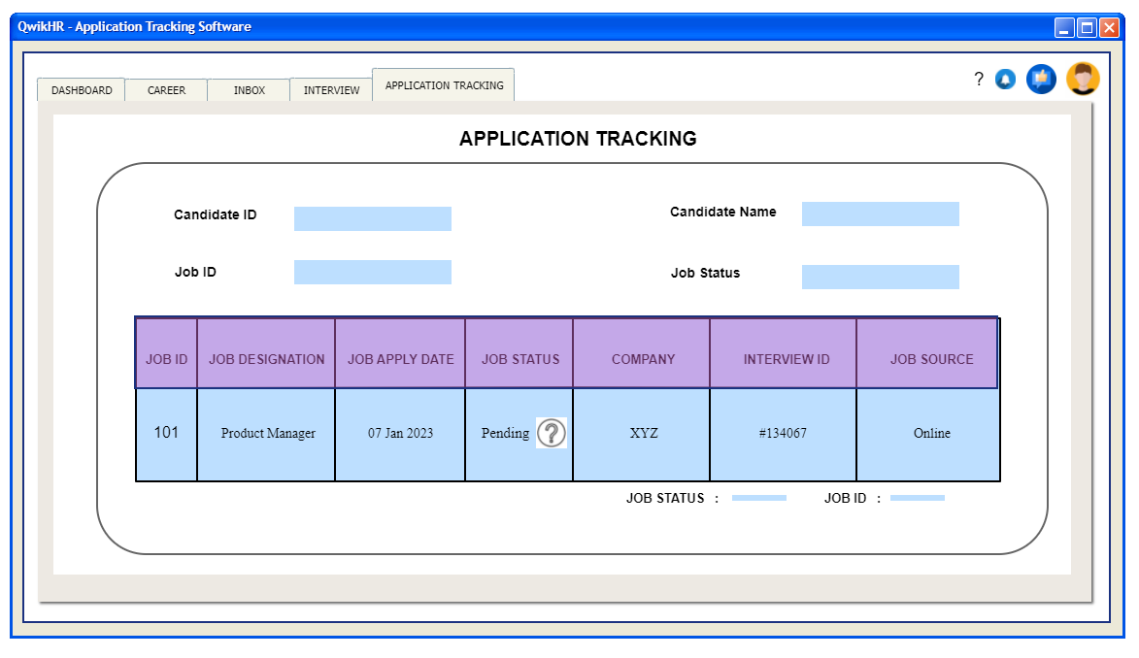

|  |
| --- |
| **Title**  Application Tracking |
| **User Story:**  **As a** Candidate  **I want** track my job status  **So that** I can know the job status. |
| **Acceptance Criteria:**   1. It is able to find the job status in the application tracking panel. 2. Candidate ID, Name, and Job ID, Status will also be displayed. 3. The status of job will be displayed in the job column. |