Introduction:

Estimating business expenses involves forecasting the costs associated with running a company. These expenses encompass a wide range of categories, including fixed and variable costs, direct and indirect costs, and both operational and non-operational expenditures. Accurate estimation is vital for financial planning, securing funding, and setting realistic pricing strategies.

**Methods of Estimating Business Expenses:**

1. Historical Data Analysis: Businesses can use past financial records to identify patterns and trends in expenses. This method is effective for estimating recurring costs. b. Industry Benchmarks: Comparing expenses to industry averages helps businesses gauge their competitiveness and efficiency. c. Vendor Quotes: Obtaining quotes from suppliers and service providers helps estimate costs for specific goods and services. d. Budgeting: Creating a comprehensive budget that outlines all anticipated expenses is a proactive approach to estimation. e. Cost Accounting: Using cost accounting methods to allocate expenses to products or services aids in accurate estimation.

**Key Expense Categories:**

1. Fixed Expenses: These costs remain relatively stable over time, such as rent, salaries, and insurance. b. Variable Expenses: Costs that fluctuate with business activity, like utilities, raw materials, and marketing. c. Direct Expenses: Expenses directly tied to the production of goods or services, e.g., materials and labor. d. Indirect Expenses: General overhead costs that are essential but not directly tied to production, including office supplies and administrative salaries.

**Factors Influencing Expense Estimation:**

1. Economic Conditions: Economic fluctuations can impact expenses, such as changes in interest rates or inflation. b. Market Trends: Shifting consumer preferences and market dynamics can affect marketing and product development costs. c. Regulatory Changes: Changes in regulations can lead to compliance-related expenses. d. Technological Advancements: Investments in technology can result in both cost savings and new expenses. e. Competition: Competitive pressures may influence marketing and promotional expenses

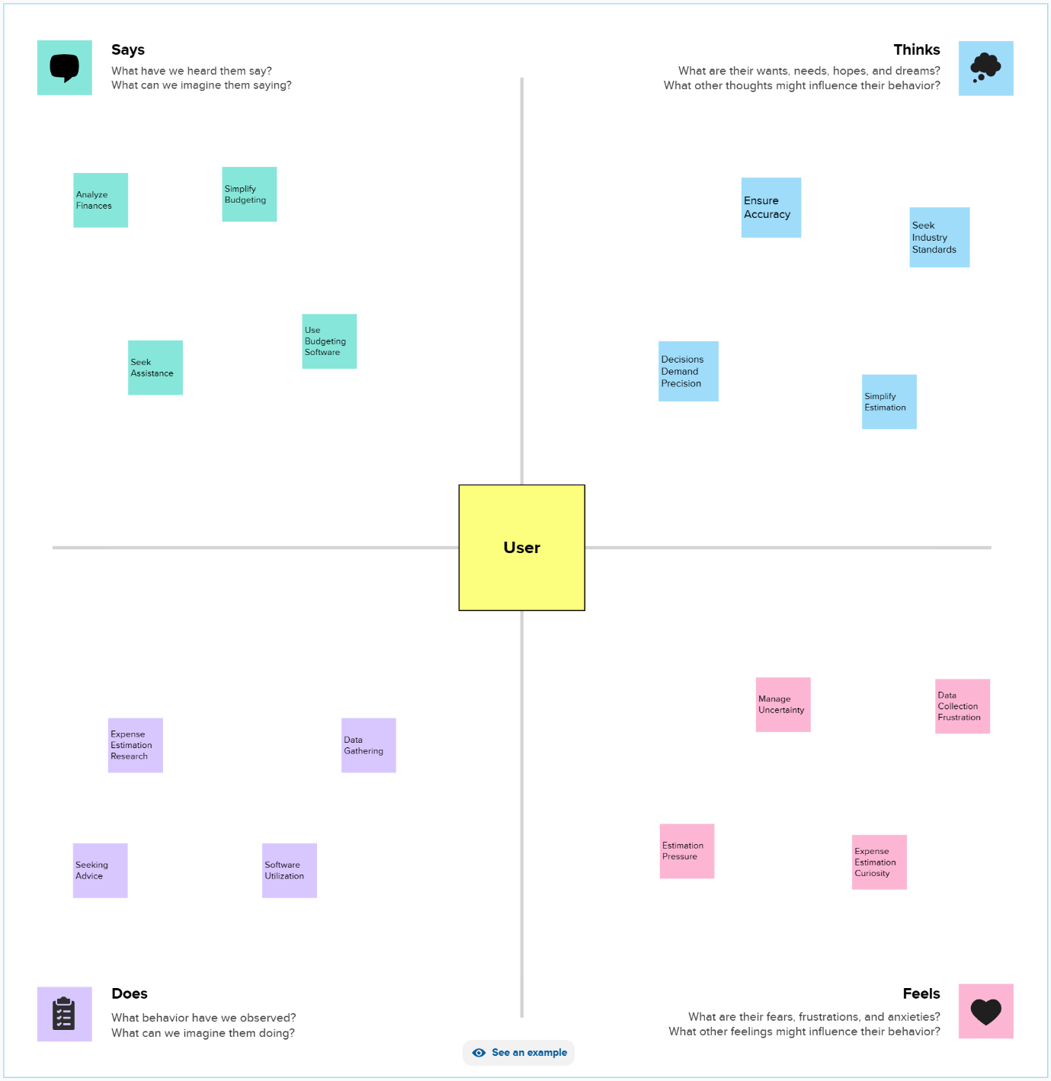

**BRAIN STORM**

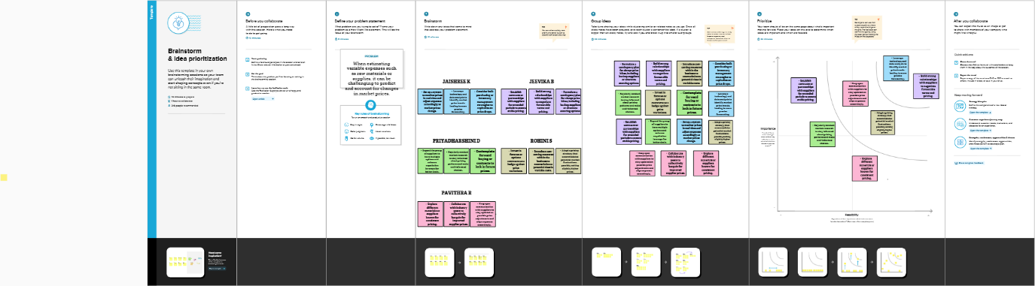

**Conclusion:**

Estimating business expenses is a crucial part of financial planning and management. Accurate estimation enables businesses to make informed decisions, allocate resources effectively, and ensure long-term financial stability. By utilizing various estimation methods and staying attuned to changing factors, businesses can enhance their financial preparedness and competitiveness

Recommendations:

* Regularly review and update expense estimates to account for changing conditions.
* Consider using expense management software to streamline tracking and forecasting.
* Collaborate with financial experts or consultants for more accurate estimations in complex industries.
* Maintain a contingency fund to mitigate the impact of unexpected expenses.