**WordNet Project Report**

1. Problem statement
2. Related concepts
3. Code
4. Test-cases
5. Complexities

Problem statement:

In this project WordNet, We’ve 3 class files WordNet.java, SAP.java, Outcast.java. We need to implement these 3 class files methods and pass the code by submitting in the courser. In this WordNet project, first we need to build digraph for Hypernyms.txt file to add edges between the two vertices i.e., ids’ of two words which present in the synsets.txt file.

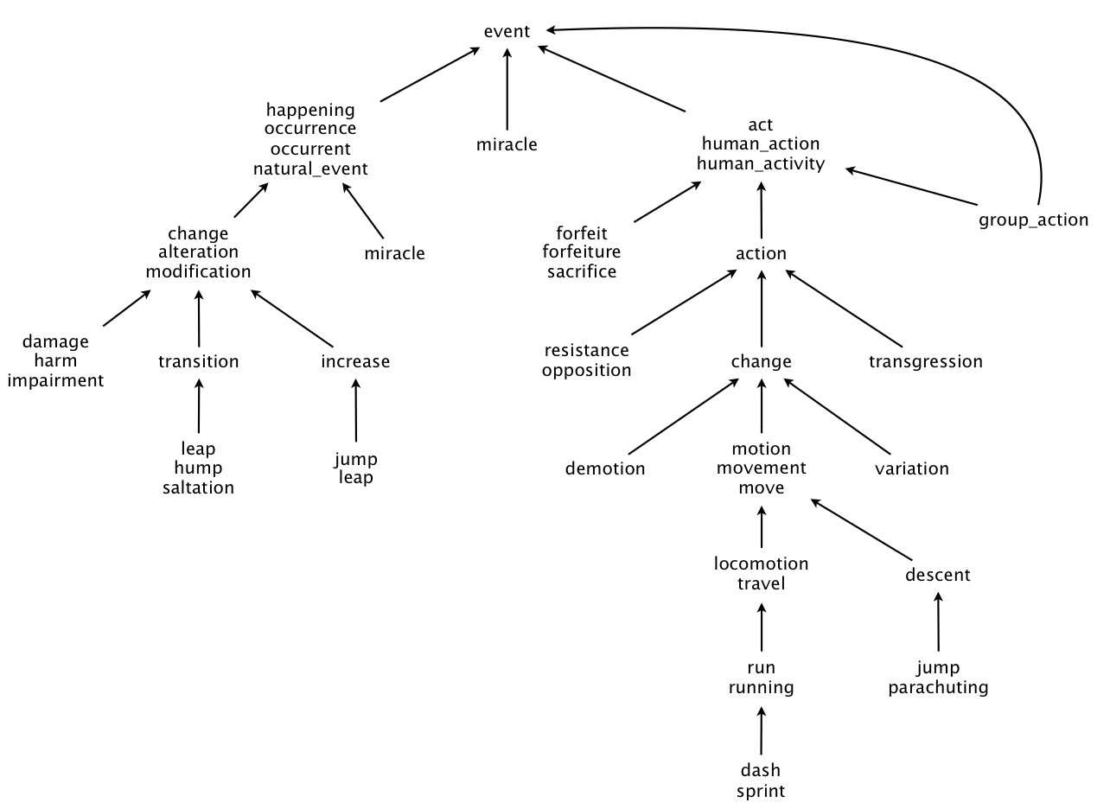

A WordNet digraph is a directed graph which traverse from child to its’ ancestors. This WordNet is used in some applications like chatbots, word suggestions in applications, dictionary applications, etc., This digraph can be built with the help of synsets.txt file and hypernyms.txt files.

Sysnsets:

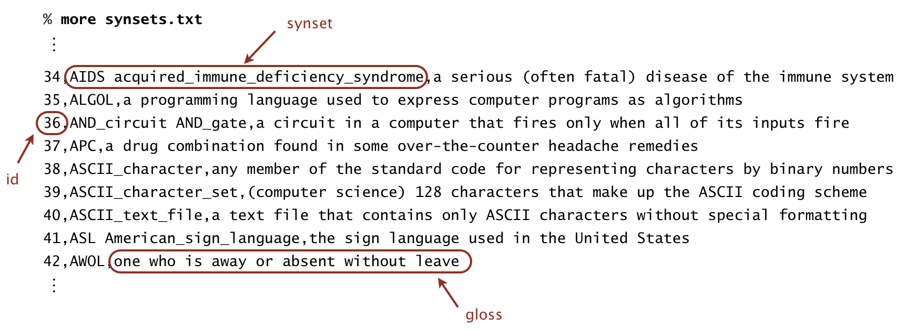

Hypernyms:

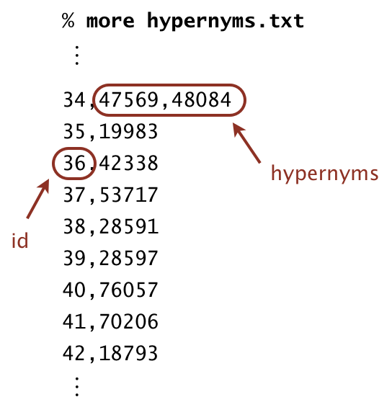

Related concepts:

Some of the concepts and data structures that we need to use in building the WordNet are:

* Digraph
* Bag
* LinearProbingHashTable
* BreathFirstDirectedPaths
* ArrayList
* SAP class – used to find the shortest distance and shortest ancestor path between two synsets ids’.
* WordNet class – used to find length and shortest ancestor path between two input nouns.
* Outcast class – used to find the odd word in the given words array.

Code:

1. WordNet:

* WordNet (String synsets, String hypernyms) –
  + Constructor that takes filenames filenames of synsets, hypernyms.
* nouns() –
  + returns an iterable which is the set of nouns.
* isNoun() –
  + checks whether the given word is noun.
* distance (String nounA, String nounB) –
  + finds the distance between the two nouns.
* sap (String nounA, String nounB) –
  + finds the common ancestor between the two nouns.
* readSynsets (String synsets) –
  + reads the synsets file and store data in the hashtable
* readHypernyms (String hypernyms) –
  + reads the hypernyms file and store data in the ArrayLists.

1. SAP:

* SAP (Digraph dg) - constructor for initializing the digraph.
* length (int v, int w) - It is used to return the shortest length between two vertices v and w.
* ancestor (int v, int w) - it is used to return the common ancestor for v and w vertices and the shortest ancestral path.
* length (Iterable<Integer> v, Iterable<Integer> w) - it is used to find the shortest length between two iterables v and w.
* ancestor (Iterable<Integer> v, Iterable<Integer> w) - it is used to find the shortest ancestor between two iterables v and w.

1. Outcast:

* Outcast (WordNet wordnet) – Constructor for initializing the wordnet.
* Outcast (String [ ] nouns) - it is used to find the outcast noun among the given set of nouns.

Test cases:

First, I got some compilation errors and later cleared them and faced API errors where, some of

the methods and attributes were public. So, I have changed them to private and API is passed.

Some of the spot bugs are there because of scanner class used. So replaced them with In class

Now, the outcast method worked perfectly but as I have used sap in wordnet both classes have

logical errors. So, the ancestor output of the sap methods lead to wrong outputs as the variable

that needs to be returned was returned incorrectly. Now I have changed them to the required

variable and finally passed the code.

Complexities:

WordNet:

● WordNet(String synsets,String hypernyms) - O(N^2)

● nouns() - O(N)

● isNoun(String word) - O(1)

● distance(String nounA,String nounB) - O(N)

● sap(String nounA, String NounB) - O(N)

● parsesynsets(String synsets) - O(N)

● parehypernym(String hypernym) - O(N^2)

SAP:

● SAP(Digraph dg) - O(1)

● length(int v, int w) - O(N)

● ancestor(int v, int w) -O(N)

● length(Iterable<Integer> v, Iterable<Integer> w) -O(N)

● ancestor((Iterable<Integer> v, Iterable<Integer> w) - O(N)

OutCast:

● OutCast(WordNet wordnet) - O(1)

● outcast(String [ ] nouns) - O(N^2)