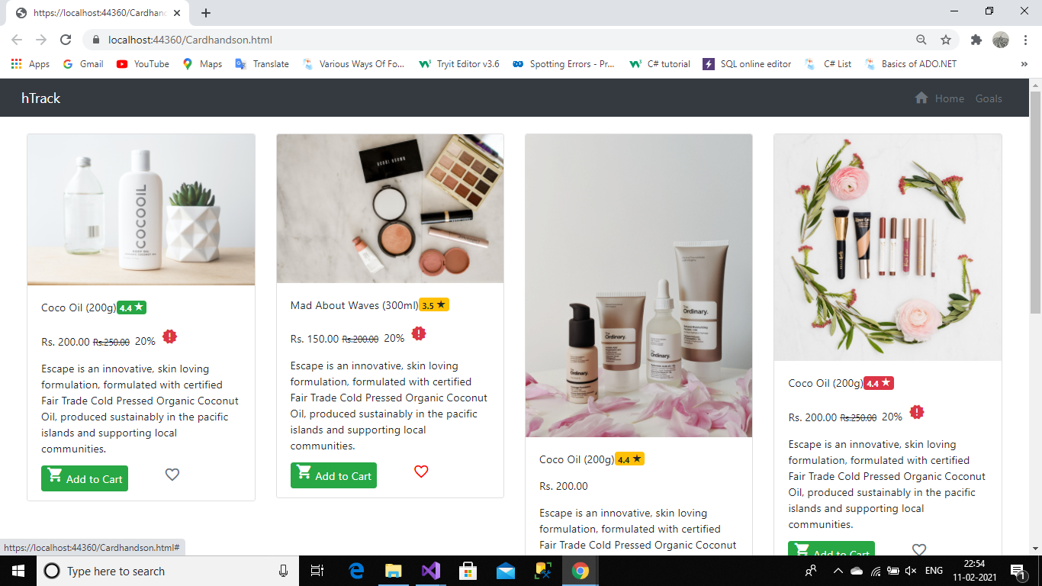

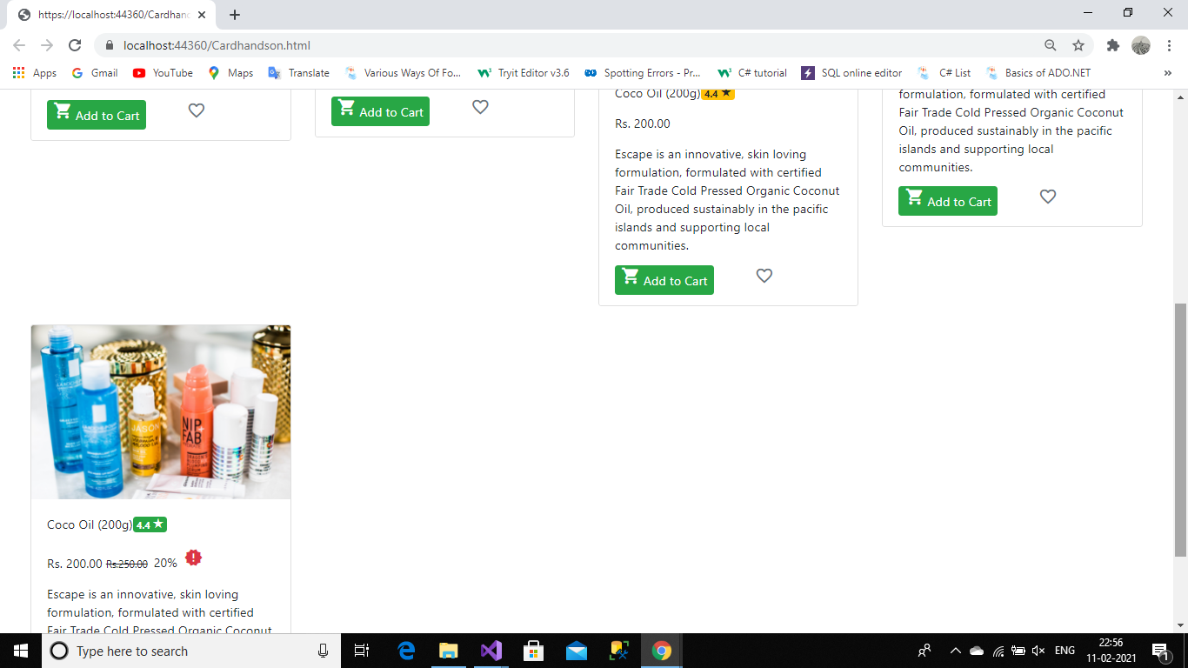

<!DOCTYPE html>

<html>

<head>

<meta charset="utf-8" />

<meta name="viewport" content="width=device-width, initial-scale=1">

<title></title>

<link href="Content/bootstrap.min.css" rel="stylesheet" />

<link href="https://fonts.googleapis.com/icon?family=Material+Icons" rel="stylesheet" />

<style>

.material-icons:hover {

color:red !important;

}

</style>

</head>

<body>

<div class="container-fluid bg-dark ">

<nav class="navbar navbar-expand-sm justify-content-between">

<div>

<span class="navbar-brand text-white">hTrack</span>

</div>

<div>

<nav class=”navbar navbar-inverse navbar-static-top”>

<ul class="navbar-nav">

<li class="text-secondary"><i class="material-icons mt-2">home</i></li>

<li class="nav-item"><a class="nav-link disabled" href="#">Home</a></li>

<li class="nav-item"><a class="nav-link disabled" href="#">Goals</a></li>

</ul>

</nav>

</div>

</nav>

</div>

<div class="row m-4">

<!--card1-->

<div class="col-3">

<div class="card ">

<img src="image/coco oil.jpg" class="card-img-top" />

<div class="card-body">

<p>

Escape is an innovative, skin loving formulation, formulated with certified

Fair Trade Cold Pressed Organic Coconut Oil, produced sustainably in the pacific islands

and supporting local communities.

</p>

<div>

<span class="bg-success rounded text-white p-2"><i class="material-icons ">local_grocery_store</i>&nbsp;Add to Cart</span>

<a class="ml-5 like" href="#"><i class="material-icons text-secondary">favorite_border</i></a>

</div>

</div>

</div>

</div>

<!--Card2-->

<div class="col-3">

<div class="card">

<img src="image/card2.jpg" class="card-img-top" />

<div class="card-body">

<p>

Escape is an innovative, skin loving formulation, formulated with certified

Fair Trade Cold Pressed Organic Coconut Oil, produced sustainably in the pacific islands

and supporting local communities.

</p>

<div>

<span class="bg-success rounded text-white p-2"><i class="material-icons ">local_grocery_store</i>&nbsp;Add to Cart</span>

<a class="ml-5 like" href="#"><i class="material-icons text-secondary">favorite_border</i></a>

</div>

</div>

</div>

</div>

<!--Card3-->

<div class="col-3">

<div class="card ">

<img src="image/card3.jpg" class="card-img-top" />

<div class="card-body">

<p>Rs. 200.00 </p>

<p>

Escape is an innovative, skin loving formulation, formulated with certified

Fair Trade Cold Pressed Organic Coconut Oil, produced sustainably in the pacific islands

and supporting local communities.

</p>

<div>

<span class="bg-success rounded text-white p-2"><i class="material-icons ">local_grocery_store</i>&nbsp;Add to Cart</span>

<a class="ml-5 like" href="#"><i class="material-icons text-secondary">favorite_border</i></a>

</div>

</div>

</div>

</div>

<!--Card4-->

<div class="col-3">

<div class="card ">

<img src="image/card4.jpg" class="card-img-top" />

<div class="card-body">

<p>

Escape is an innovative, skin loving formulation, formulated with certified

Fair Trade Cold Pressed Organic Coconut Oil, produced sustainably in the pacific islands

and supporting local communities.

</p>

<div>

<span class="bg-success rounded text-white p-2"><i class="material-icons ">local_grocery_store</i>&nbsp;Add to Cart</span>

<a class="ml-5 like" href="#"><i class="material-icons text-secondary">favorite_border</i></a>

</div>

</div>

</div>

</div>

</div>

<div class="row m-4">

<!--card1-->

<div class="col-3">

<div class="card ">

<img src="image/card5.jpg" class="card-img-top" />

<div class="card-body">

<p>

Escape is an innovative, skin loving formulation, formulated with certified

Fair Trade Cold Pressed Organic Coconut Oil, produced sustainably in the pacific islands

and supporting local communities.

</p>

<div>

<span class="bg-success rounded text-white p-2"><i class="material-icons ">local_grocery_store</i>&nbsp;Add to Cart</span>

<a class="ml-5 like" href="#"><i class="material-icons text-secondary">favorite_border</i></a>

</div>

</div>

</div>

</div>

</div>

<script src="Scripts/jquery-3.0.0.slim.min.js"></script>

<script src="Scripts/umd/popper.min.js"></script>

<script src="Scripts/bootstrap.min.js"></script>

</body>

</html>