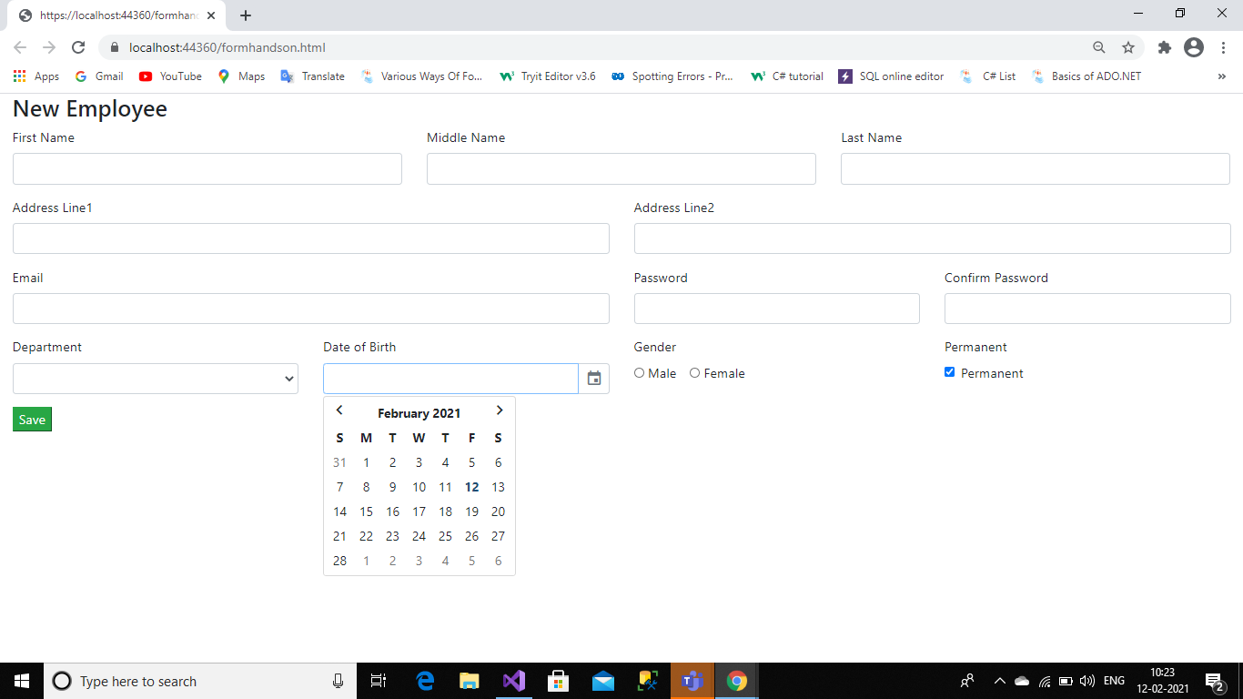

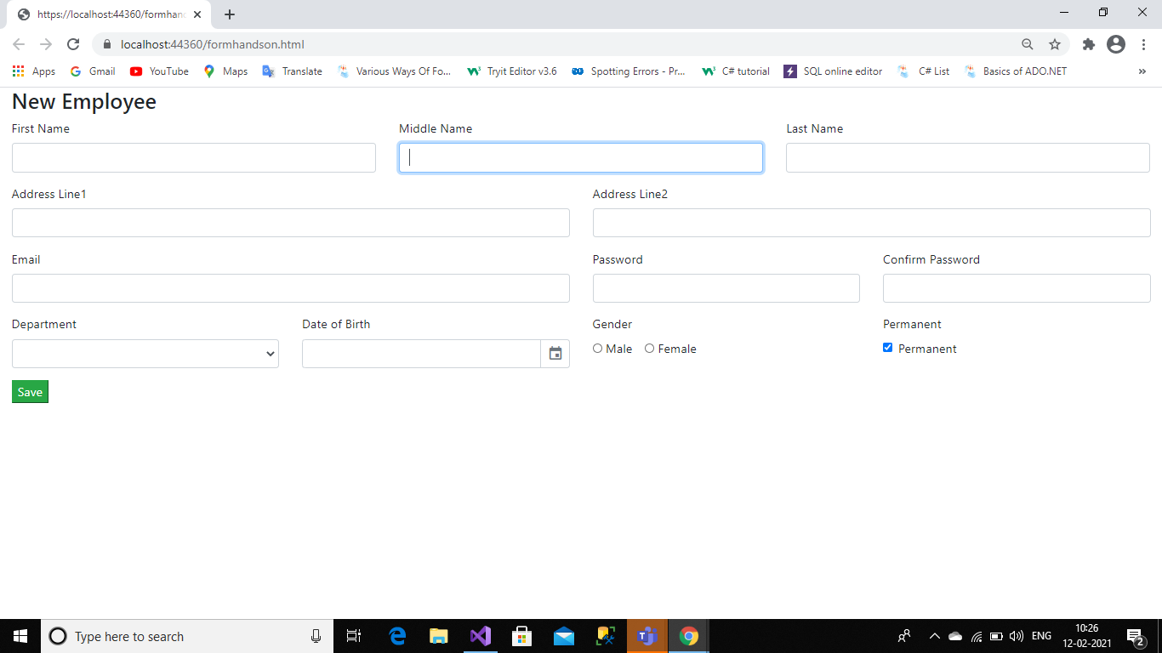

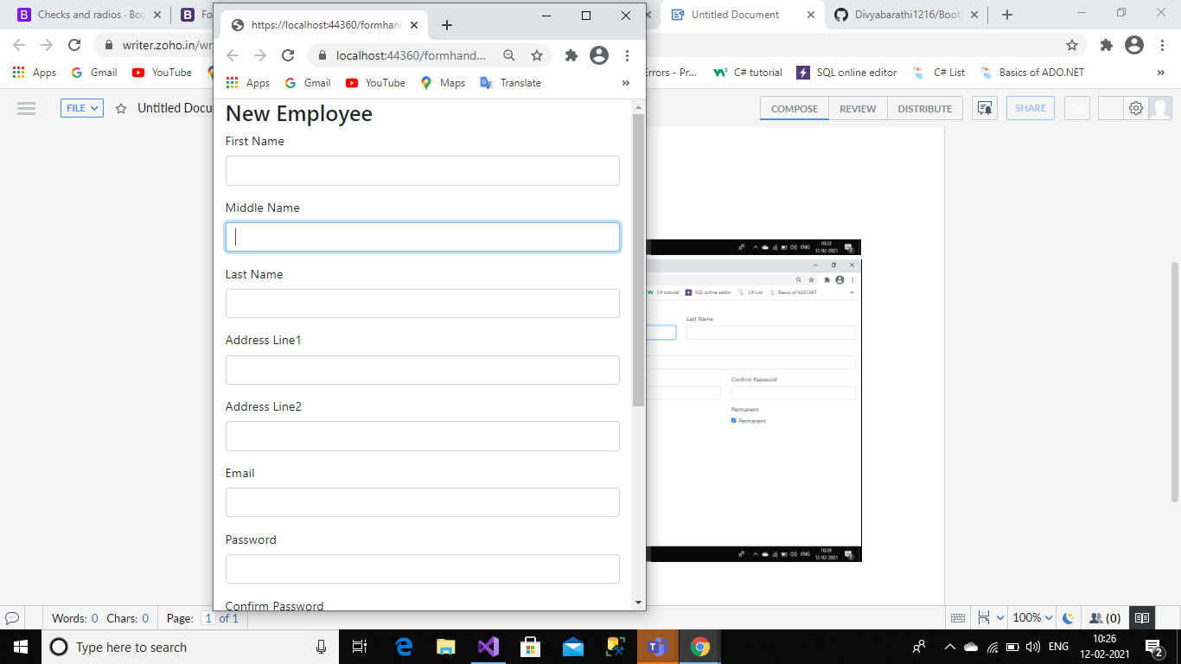

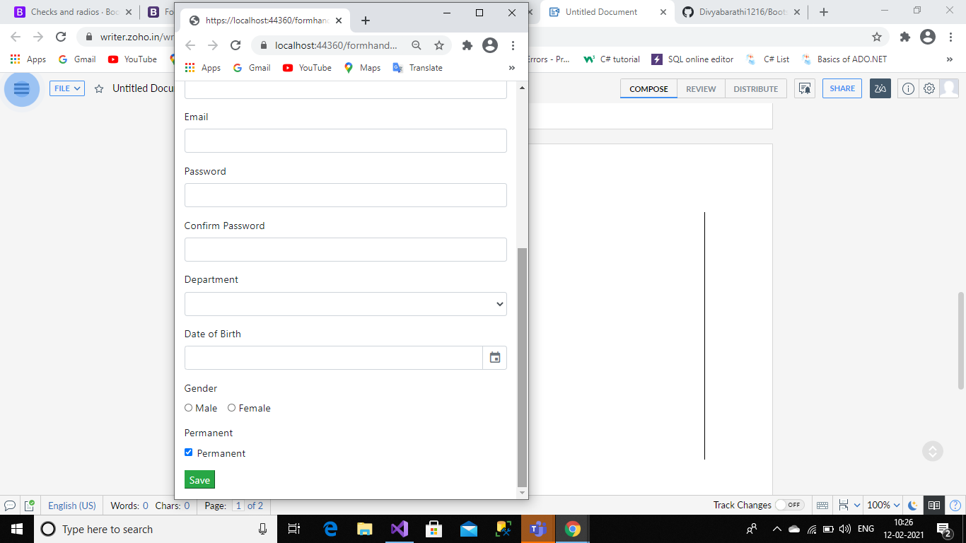

<!DOCTYPE html>

<html>

<head>

<meta charset="utf-8" />

<title></title>

<link href="Content/bootstrap.min.css" rel="stylesheet" />

<link href="https://unpkg.com/gijgo@1.9.13/css/gijgo.min.css" rel="stylesheet" />

</head>

<body>

<div class="container-fluid">

<h3>New Employee</h3>

<div class="row">

<div class="col-md-4 form-group">

<label for="fname">First Name</label>

<input type="text" id="fname" class="form-control" />

</div>

<div class="col-md-4 form-group">

<label for="mname">Middle Name</label>

<input type="text" id="mname" class="form-control" />

</div>

<div class="col-md-4 form-group">

<label for="lname">Last Name</label>

<input type="text" id="lname" class="form-control" />

</div>

</div>

<div class="row">

<div class="col-md-6 form-group">

<label for="add1">Address Line1</label>

<input type="text" id="add1" class="form-control" />

</div>

<div class="col-md-6 form-group">

<label for="add2">Address Line2</label>

<input type="text" id="add2" class="form-control" />

</div>

</div>

<div class="row">

<div class="col-md-6 form-group">

<label for="email">Email</label>

<input type="email" id="email" class="form-control" />

</div>

<div class="col-md-3 form-group">

<label for="pwd">Password</label>

<input type="password" id="pwd" class="form-control" />

</div>

<div class="col-md-3 form-group">

<label for="cpwd">Confirm Password</label>

<input type="password" id="cpwd" class="form-control" />

</div>

</div>

<div class="row">

<div class="col-md-3 form-group">

<label for="dept">Department</label>

<select id="dept" class="form-control">

<option value="select"></option>

<option value="admin">Admin</option>

<option value="hr">HR</option>

</select>

</div>

<div class="col-md-3 form-group">

<label for="dob">Date of Birth</label>

<input type="text" id="dob" class="form-control" />

</div>

<div class="col-md-3 form-group">

<div><label for="gender">Gender</label></div>

<div class="form-check form-check-inline">

<input type="radio" class="form-check-input " />

<label class="form-check-label">Male</label>

</div>

<div class="form-check form-check-inline">

<input type="radio" class="form-check-input " />

<label class="form-check-label">Female</label>

</div>

</div>

<div class="col-md-3 form-group">

<label for="dec">Permanent</label>

<div class="form-check">

<input type="checkbox" class="form-check-input" checked/>

<label class="form-check-label">Permanent</label>

</div>

</div>

</div>

<div class="row">

<div class="col-md-auto form-group">

<button value="Save" class="btn-success">Save</button>

</div>

</div>

</div>

<script src="Scripts/jquery-3.0.0.slim.min.js"></script>

<script src="Scripts/umd/popper.min.js"></script>

<script src="Scripts/bootstrap.min.js"></script>

<script src="https://unpkg.com/gijgo@1.9.13/js/gijgo.min.js" type="text/javascript"></script>

<script>

$('#dob').datepicker({

uiLibrary: 'bootstrap4',

format: 'dd/mm/yyyy'

});

</script>

</body>

</html>