AIM:
SOFTWARE AS A PRODUCT EXPERIMENT – 23

To demonstrate Storage as a Service (SaaS) by creating and configuring a

new VM image in Azure.

PROCEDURE:
- Log in to the Azure Portal.
- Click on Virtual Machines and then click + Create to launch the Create a virtual machine wizard.
- Fill in basic details such as subscription, resource group, VM name, and region.
- Choose an image (e.g., Ubuntu Server or Windows Server) and configure the size according to requirements.
- Set the administrator username and password or SSH key for access.
- In the Disks section, configure the OS disk type and optionally attach additional data disks.
- Under the Networking section, configure the virtual network, subnet, and public IP if needed.
- Click Review + Create and then Create to deploy the VM.
- After deployment, go to the VM’s Settings → Disks to manage and confirm the attached storage.
- Verify that the storage service is active by logging into the VM and checking the mounted volumes.

OUTPUT:

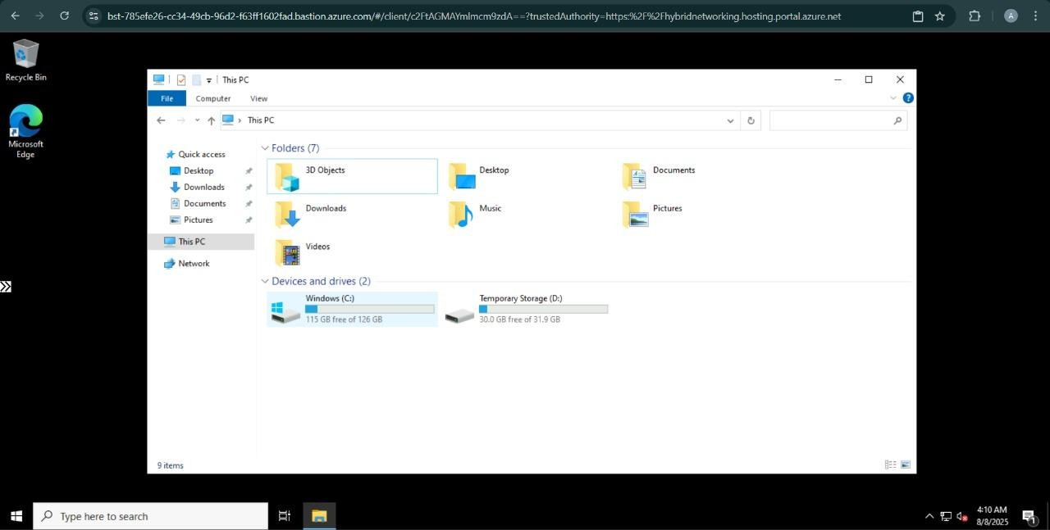

RESULT:
Successfully demonstrated Storage as a Service (SaaS) by configuring a new VM image and verifying attached storage in Azure.

