AIM:
SOFTWARE AS A PRODUCT EXPERIMENT – 24

To create a storage service in Azure and check the public accessibility of

the stored file to demonstrate Storage as a Service.

PROCEDURE:
- Log in to the Azure Portal.
- Go to Storage accounts and click + Create.
- Fill in basic details such as subscription, resource group, and a unique storage account name.
- Choose the region, performance, and redundancy options as required.
- Click Review + Create and then Create.
- Once the storage account is deployed, go to the Containers section under

Data storage.
- Click + Container to create a new container and set the access level to

Blob (anonymous read access).
- Upload a file (e.g., a text file or image) into the container.
- After upload, click on the file and copy the URL provided.
- Paste the URL in a browser to check public access and verify successful storage service configuration.

OUTPUT:

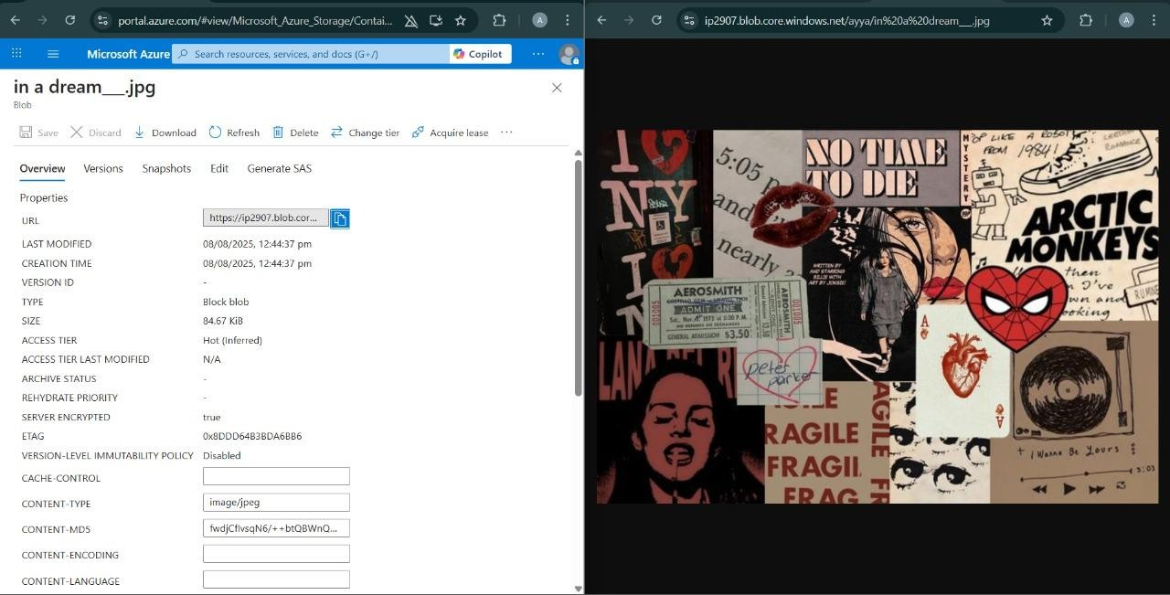

RESULT:
Successfully created a storage service in Azure and verified public accessibility of the stored file to demonstrate Storage as a Service.

