Industry-Oriented Full Stack E-Commerce

Web Application

Objective
To design and develop a full stack e-commerce web application that allows users to browse products, manage a shopping cart, and place orders using MERN/MEAN stack technologies.

Problem Statement
E-commerce platforms must manage product listings, user carts, and order processing efficiently. Poor integration between frontend and backend can lead to slow performance and failed transactions. This project aims to build a scalable and efficient system.

Technologies Used
- Frontend: React.js / Angular
- Backend: Node.js, Express.js
- Database: MongoDB
- API: REST APIs
- Tools: Git, Postman

System Architecture
The system follows a client-server architecture:
- Frontend sends requests to backend APIs
- Backend processes logic
- Data is stored/retrieved from database
- Response is sent back to frontend

Features Implemented

User Features
- User registration and login
- Product browsing
- Add to cart
- Place order
- View order history
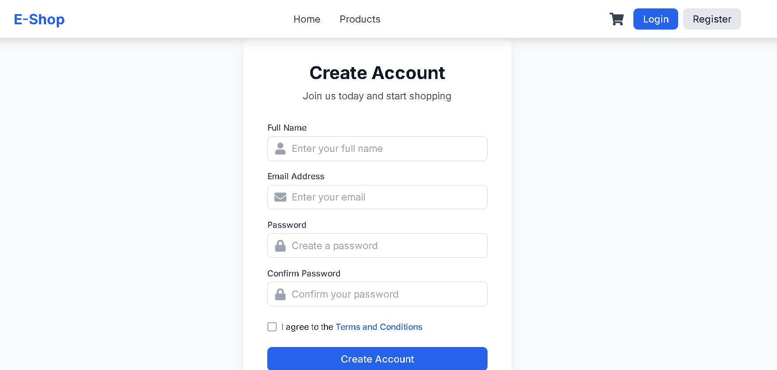
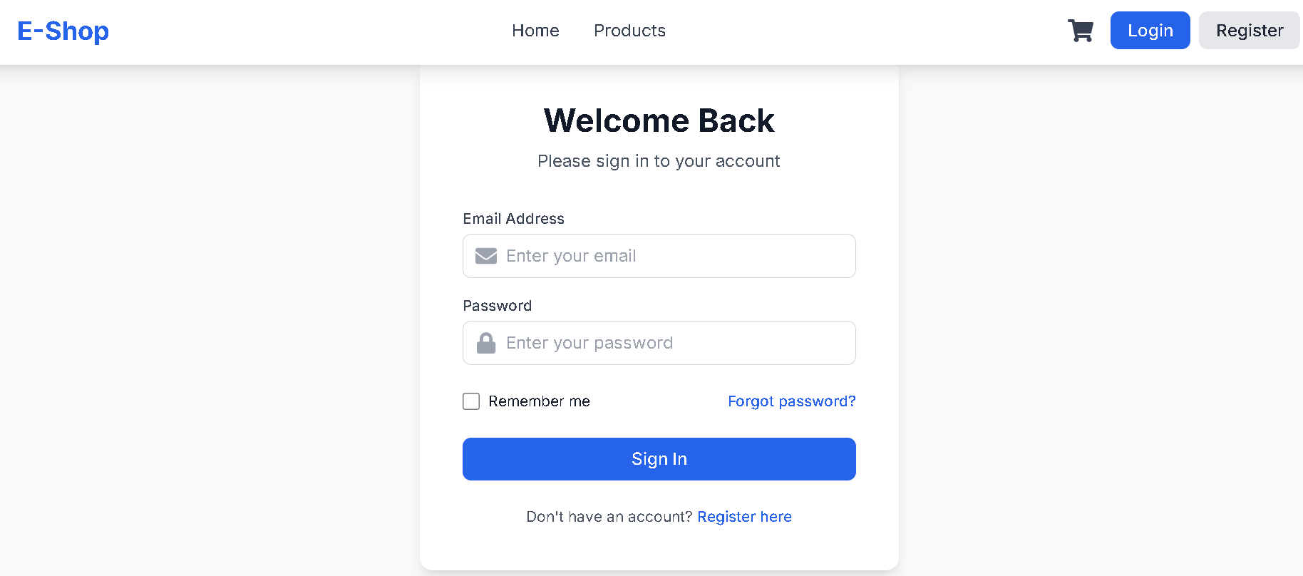

Product Features
- Product listing
- Category management

Order Features
- Order placement
- Order tracking

API Endpoints
- POST /register
- POST /login
- GET /products
- POST /cart
- POST /order
- GET /orders

Database Design
Collections:

Users
- name
- email
- password

Products
- name
- price
- category

Orders
- userId
- products
- totalAmount
- status

Security Features
- Password encryption
- Authentication system
- Protected routes

Testing
Testing was done using Postman to verify:
- API responses
- Authentication
- Order processing

Deployment
- Frontend: Netlify / Vercel
- Backend: Render / Railway

Output
- Home page
- Product page
- Cart page
- Order page
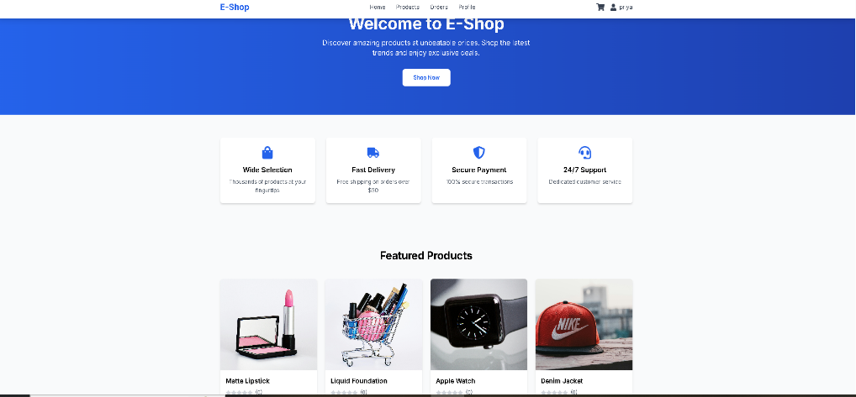


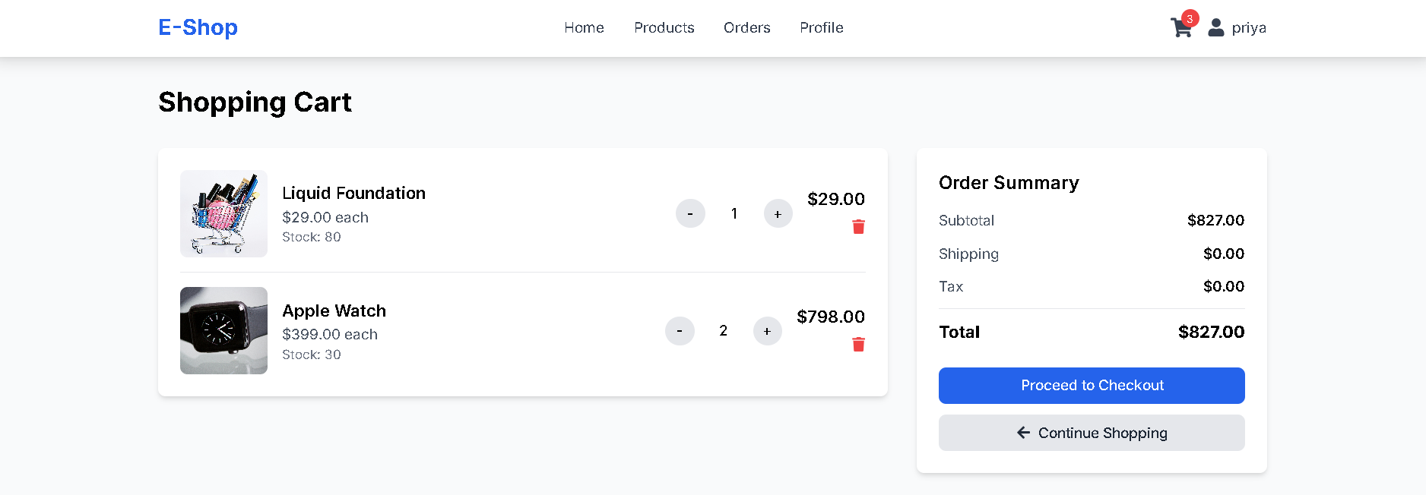

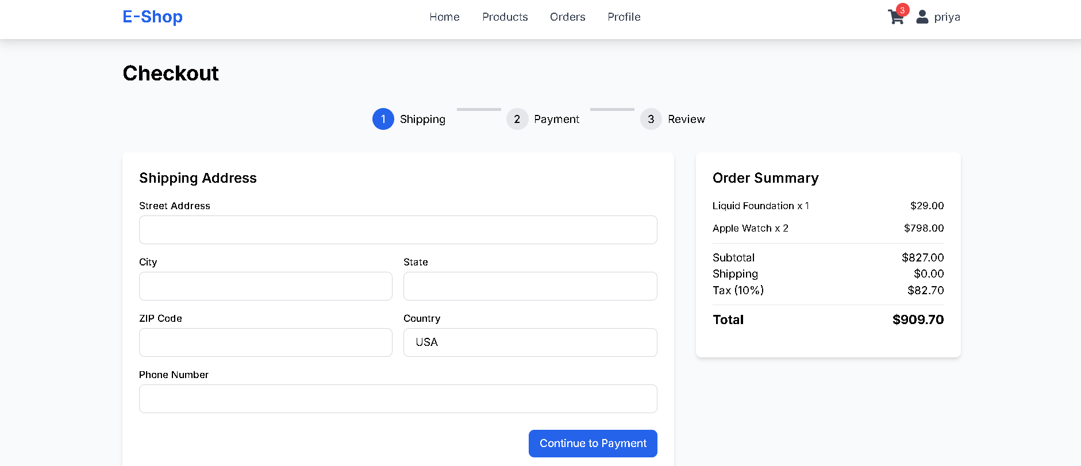

Conclusion
The project successfully demonstrates a full stack e-commerce system with product management, cart functionality, and order processing. It provides hands-on experience in building real-world applications.

