SUPERMARKET SALES ANALYSIS
Data Analytics Project
AICTE | IBM SkillsBuild Data Analytics with AI Internship 2026 | BharatCares
Prepared for Internship Project Submission
Student Name: Sakthivel Dharshana

1. Abstract
This project analyzes 500 supermarket sales transactions using Python-based data analytics. The analysis covers products, branches, categories, payment methods, customer types, gender, ratings, and sales trends over time. The dataset contains no missing values or duplicate rows, and the existing Sales values match Quantity × Unit Price within floating-point precision. The total recorded sales are ₹244,411.08, with an average transaction value of ₹488.82. The results are translated into practical recommendations for inventory, branch performance, customer strategy, payments, and service improvement.

2. Problem Statement
The aim is to analyze supermarket sales data and find useful information about products, branches, categories, customers, payments, ratings, and sales so that the business can make better data-driven decisions.

3. Objectives
- Load and validate the supermarket CSV dataset.
- Check missing values, duplicates, and data types.
- Verify Sales using Quantity × Unit Price.
- Analyze product, branch, category, customer, payment, gender, rating, and time performance.
- Create clear visualizations.
- Convert findings into business insights and recommendations.

4. Dataset Description
The provided dataset contains 500 sales transactions and 14 columns: Invoice ID, Date, Branch, City, Customer Type, Gender, Product, Category, Quantity, Unit Price, Payment, Rating, Sales, Calculated_Sales.
The original CSV was retained without changing its source values.

5. Tools and Technologies
Python, Pandas, NumPy, Matplotlib, Seaborn, and Jupyter Notebook.

6. Methodology
The workflow was: data loading → data inspection → data validation → sales verification → grouping and aggregation → visualization → business interpretation → recommendations.

7. Data Validation and Cleaning
The dataset contains 0 missing values and 0 duplicate rows. The Date field was converted to datetime format. Sales was independently checked as Quantity × Unit Price. All 500 records matched the existing Sales field within a ₹0.01 tolerance; the maximum floating-point difference was below 0.01.

8. Key KPIs
KPI | Value
Total Sales | ₹244,411.08
Transactions | 500
Total Quantity | 2,768
Average Transaction | ₹488.82
Average Unit Price | ₹88.66
Average Rating | 3.99/5

9. Product Analysis
Cheese generated the highest total product sales at ₹27,906.30. Potato had the highest quantity sold at 194 units.

Top 10 Products by Sales
Product | Sales
Cheese | ₹27,906.30
Coffee | ₹27,694.87
Shampoo | ₹27,497.48
Cooking Oil | ₹21,525.06
Tea | ₹17,681.59
Apples | ₹17,057.41
Face Wash | ₹11,946.85
Rice | ₹11,754.17
Cold Drink | ₹10,731.78
Eggs | ₹10,429.77

10. Branch and City Analysis
Branch C (Mumbai) performed best with sales of ₹72,469.45.

Sales by Branch
Branch | Sales
C | ₹72,469.45
B | ₹64,116.26
D | ₹55,468.29
A | ₹52,357.08
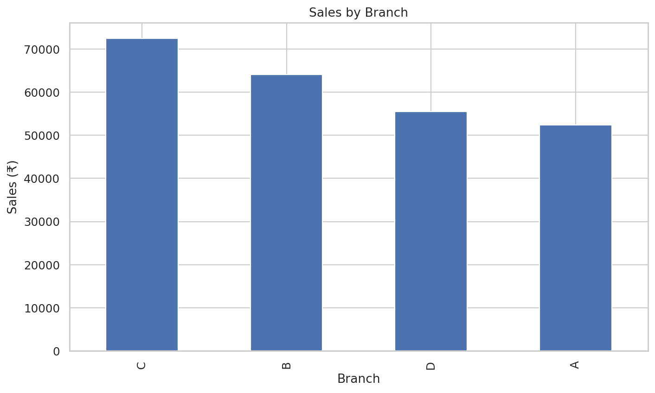

11. Category Analysis
Beverages was the highest-sales category with ₹56,108.24.

Sales by Category
Category | Sales
Beverages | ₹56,108.24
Personal Care | ₹45,943.96
Dairy | ₹43,992.00
Grocery | ₹40,470.47
Fruits | ₹23,263.17
Snacks | ₹16,992.97
Vegetables | ₹11,124.17
Bakery | ₹6,516.10
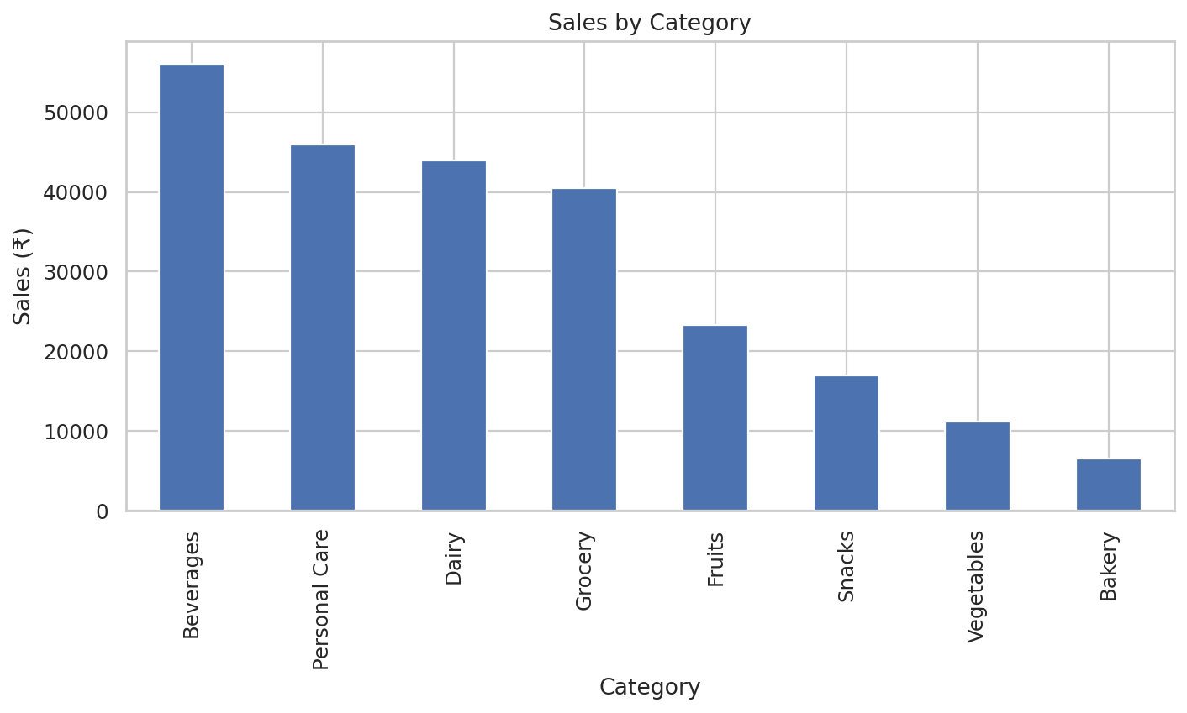

12. Payment Method Analysis
UPI was the most-used payment method with 127 transactions. It also generated the highest total payment-method sales at ₹67,910.33.

Transactions by Payment Method
Payment | Transactions
UPI | ₹127.00
Net Banking | ₹126.00
Card | ₹125.00
Cash | ₹122.00
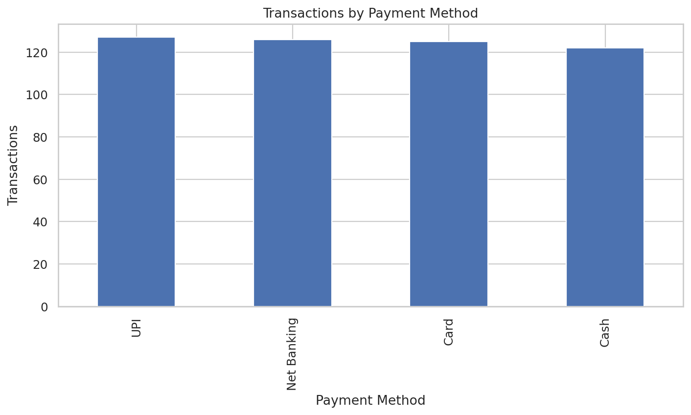

13. Customer Type Analysis
Members averaged ₹483.14 per transaction, while Normal customers averaged ₹497.07. Therefore, Members did not have the higher average transaction value in this dataset.
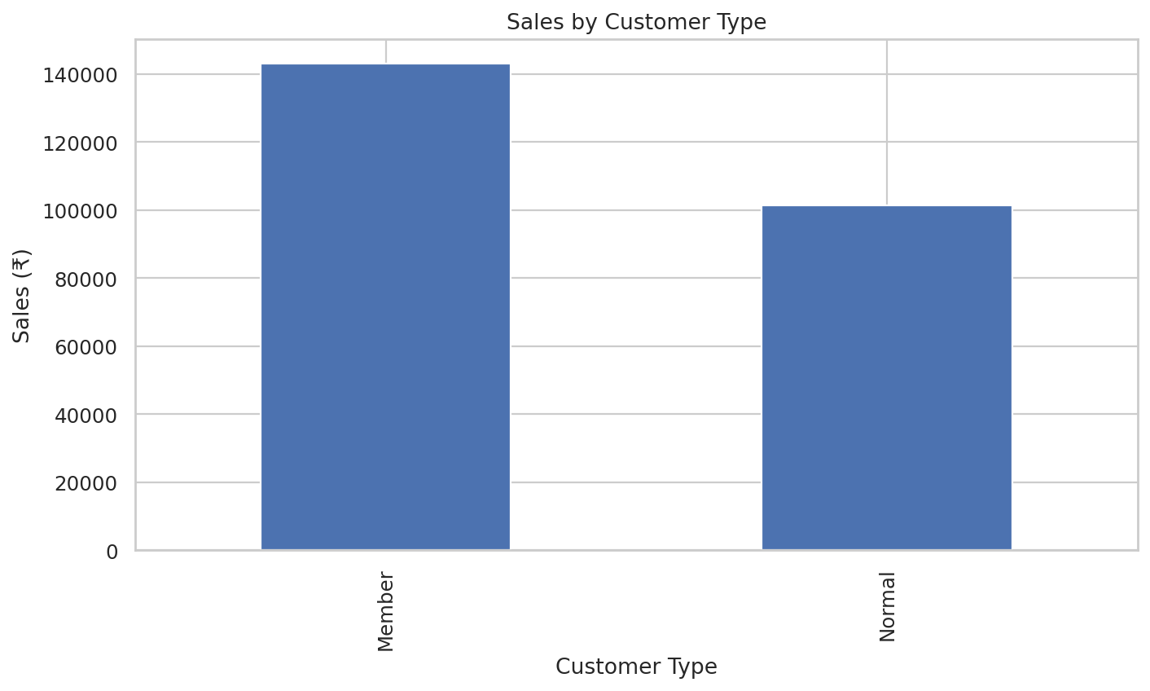

14. Gender Analysis
Female customers generated ₹123,954.12 in sales across 255 transactions; Male customers generated ₹120,456.96 across 245 transactions.
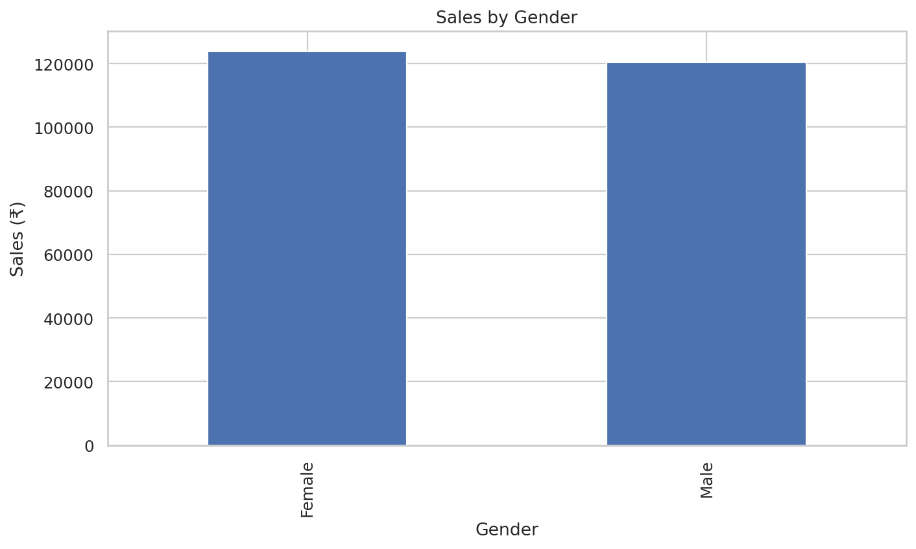

15. Customer Rating Analysis
The average rating was 3.99 out of 5. There were 0 ratings below 3, 500 ratings of 3 or above, and 266 ratings of 4 or above.
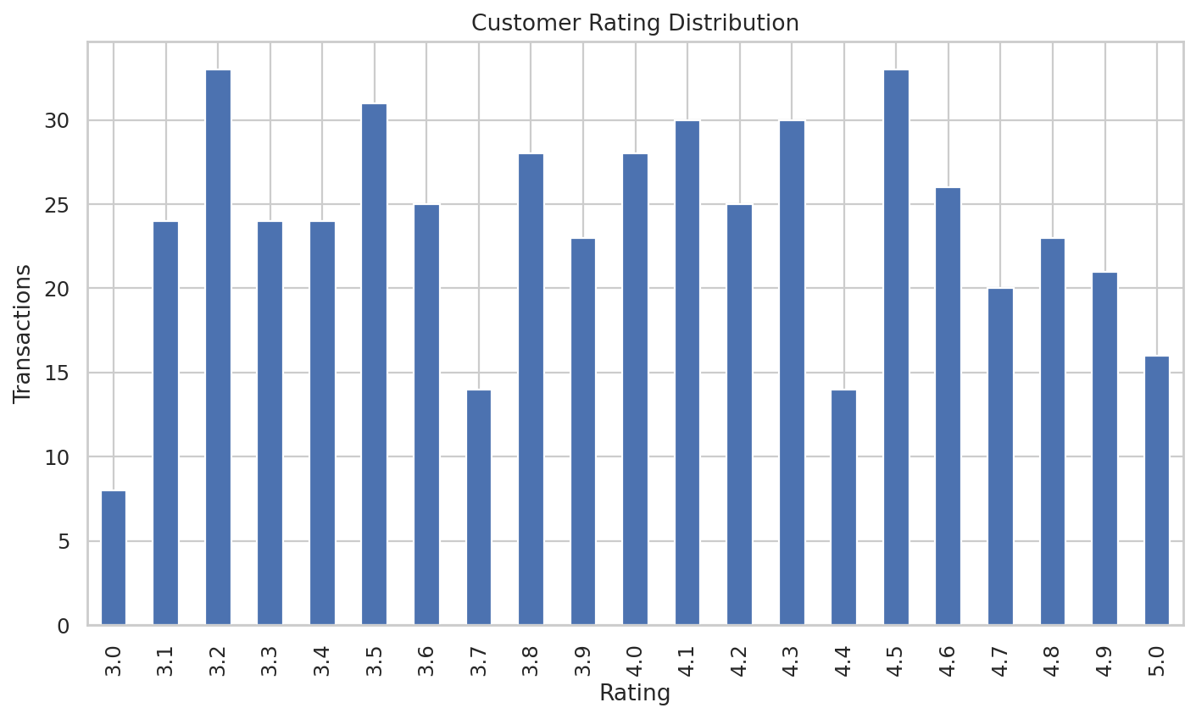

16. Time-Based Analysis
2026-04 had the highest monthly sales at ₹52,569.77. Monday had the highest sales among days of the week at ₹42,602.44. The highest-sales date was 01 January 2026 with ₹2,095.11.
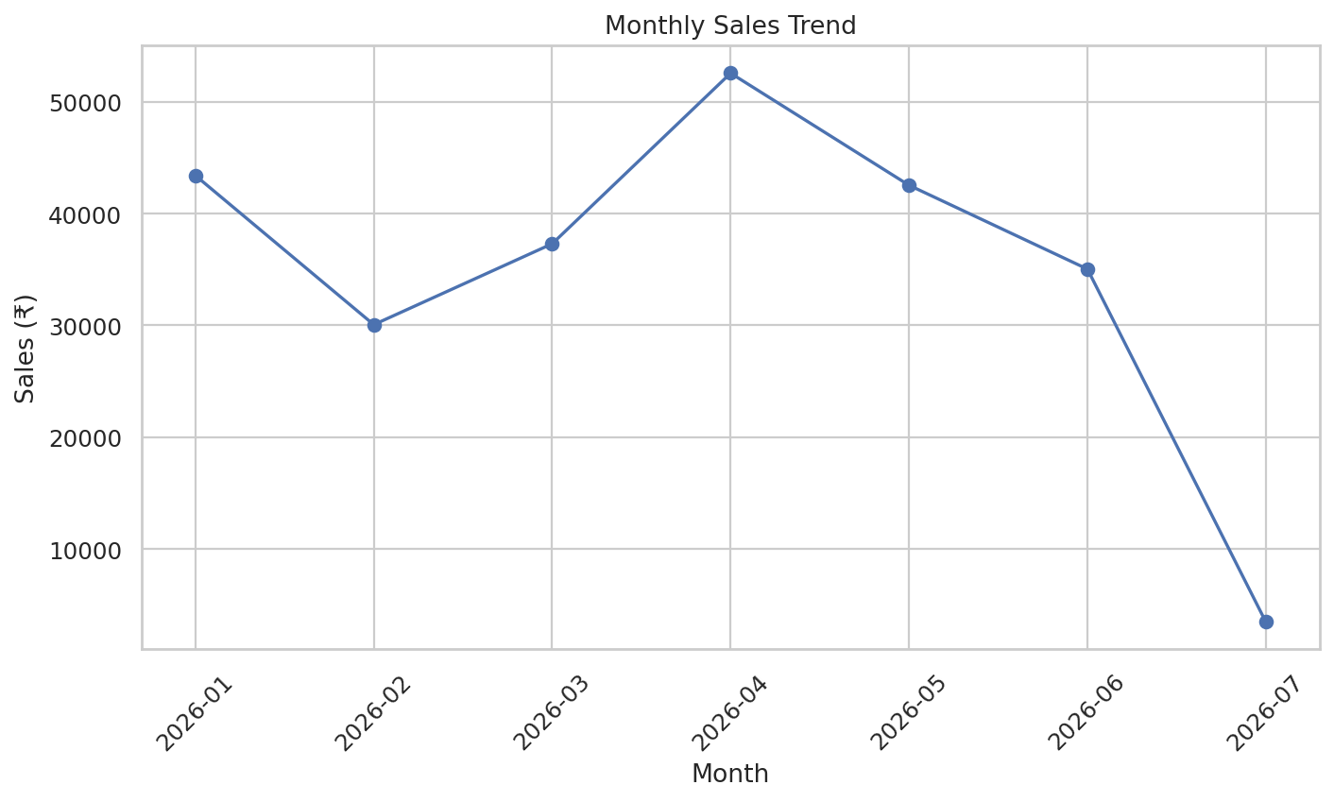
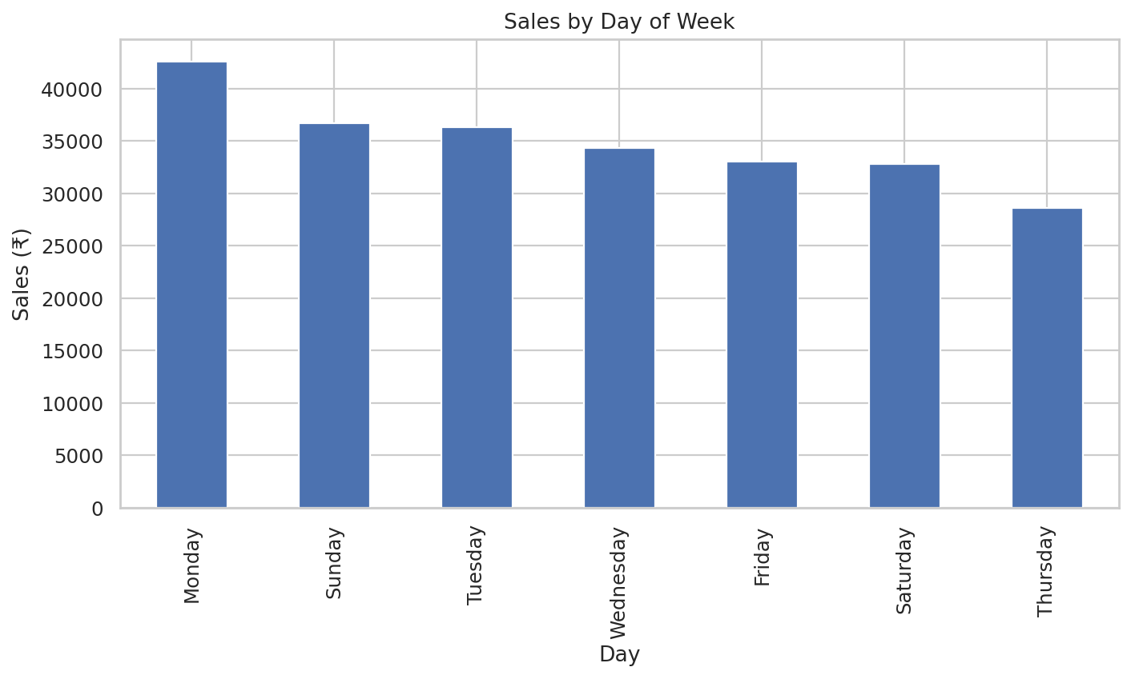

17. Key Business Questions
Which product generates the highest sales? Cheese — ₹27,906.30.
Which branch performs best? Branch C (Mumbai) — ₹72,469.45.
Which category sells the most? Beverages — ₹56,108.24.
What is the most popular payment method? UPI — 127 transactions.
Do Members spend more than Normal customers? No. Members average ₹483.14; Normal customers average ₹497.07.
What is the average customer rating? 3.99 out of 5.
Which product sells the highest quantity? Potato — 194 units.
Which branch has the highest average transaction value? Branch C — ₹506.78.
Which payment method generates the highest total sales? UPI — ₹67,910.33.
Which month has the highest sales? 2026-04 — ₹52,569.77.
Which day of the week performs best? Monday — ₹42,602.44.

18. Business Insights
- Cheese is the highest-sales product, so its availability should be monitored closely.
- Branch C in Mumbai leads branch sales; management can study its product mix and operating practices.
- Beverages is the highest-sales category and can receive focused inventory planning.
- UPI is the most-used payment method, supporting continued reliable digital payment availability.
- Normal customers have the higher average transaction value in this dataset, so membership offers should be designed using actual spending behavior.
- The average rating is close to 4 out of 5, indicating generally positive feedback with room for service improvement.
- 2026-04 and Monday are the strongest observed time periods and can inform planning, while recognizing that this is descriptive evidence rather than proof of causation.

19. Business Recommendations
- Maintain adequate stock of Cheese and other high-sales products.
- Review why Branch C performs strongly and identify practices that may be transferable to other branches.
- Prioritize inventory and promotions for the Beverages category while monitoring lower-performing categories.
- Continue supporting UPI as a major payment channel and maintain alternatives for customers.
- Use customer-type spending patterns to design and evaluate membership benefits rather than assuming membership always increases spending.
- Track ratings regularly and investigate operational areas that could improve customer satisfaction.
- Use observed monthly and weekday sales patterns to support staffing and promotional planning, while validating the pattern with longer-term data.

20. Limitations
The analysis covers 500 transactions over the dates present in the provided file. It is descriptive and does not establish causal relationships. Results may not generalize to other periods or stores. Additional historical data would improve trend analysis and enable stronger forecasting or predictive modelling.

21. Future Scope
Future work could include sales forecasting, customer segmentation, product recommendation, anomaly detection, branch-level benchmarking, and predictive modelling using a larger historical dataset with appropriate validation.

22. Conclusion
This project shows how supermarket transaction data can be converted into actionable information using Python. The dataset recorded ₹244,411.08 in sales across 500 transactions. Product, branch, category, payment, customer, rating, and time analyses identified clear performance patterns. These findings can support inventory planning, branch review, payment-channel support, customer strategy, and service improvement.

23. References
1. Provided Supermarket Sales Analysis project dataset.
2. AICTE | IBM SkillsBuild Data Analytics with AI Internship 2026 | BharatCares project resources.

