Frontend Development with React.js
Project Documentation
1. Introduction
o Project Title : STORE MANAGER : KEEP TRACK INVENTORY
o TEAM ID : NM2025TMID42002
o TEAM LEADER: : DHARSHIKA R
o ROLE : CODING AND DEVELOPMENT
o TEAM MEMBER: DHARSHINI A
o ROLE : CODING AND DEVELOPMENT
o TEAM MEMBER : DHIVYA S
o ROLE : DEMO VIDEO
o TEAM MEMBER : DIVYA V
o ROLE : DOCUMENT CREATER
Inventory Tracking for a Store Manager

PURPOSE
- Meet Customer Demand:
Ensure the right products are available at the right time to meet customer needs and improve satisfaction.
•

Avoid Stock outs:

Prevent lost sales and customer dissatisfaction caused by running out of popular items.

FEATURES
A store manager uses inventory tracking features like real-time stock monitoring, barcode scanning, and automated reordering to maintain optimal stock levels and prevent shortages or overstocking.

Store Manager: Keep Track of Inventory .
Here are some key features and a description of an inventory management system:
- Inventory Management: Inventory Management helps maintain healthy stock levels in a store and acquire them in time.
- Stock Updates: Stock will automatically update on sale of products, and it can be updated on adding new stock.
- Cart: Products can be added to cart for a particular sale and quantity can be added to each product.
- Checkout at Cart: Upon checkout, cart is cleared, inventory is updated, and a sale record is made.
- Adding New Products to Inventory: New products can be added to the inventory by providing product name, image URL, price, stock, tags.
- Alert View for Depleting Stock: Depleting stocks are shown in red background, and alert count can be updated as per requirement.
- Search Functionality for Products: Products in inventory and product catalog can be searched.
Sale Records: All sale records are stored with sale value, products and date time.

Project structure
The image is of the folder structure which shows all the files and folders that have been used in project development.
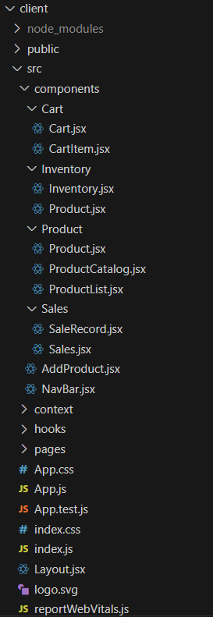
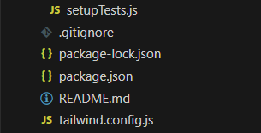

PRE-REQUISITES
Here are the key prerequisites for developing a frontend application using React.js:
- Node.js and npm:
Node.js is a powerful JavaScript runtime environment that allows you to run JavaScript code on the local environment. It provides a scalable and efficient platform for building network applications.

- React.js:
React.js is a popular JavaScript library for building user interfaces. It enables developers to create interactive and reusable UI components, making it easier to build dynamic and responsive web applications.
Install React.js, a JavaScript library for building user interfaces.
- Create a new React app:
npx create-react-app my-react-app
Replace my-react-app with your preferred project name.
- Navigate to the project directory:
cd my-react-app

- HTML, CSS, and JavaScript: Basic knowledge of HTML for creating the structure of your app, CSS for styling, and JavaScript for client-side interactivity is essential.

- Version Control: Use Git for version control, enabling collaboration and tracking changes throughout the development process. Platforms like GitHub or Bitbucket can host your repository.
• Git: Download and installation instructions can be found at: https://git-scm.com/downloads

- Development Environment: Choose a code editor or Integrated Development Environment (IDE) that suits your preferences, such as Visual Studio Code, Sublime Text, or WebStorm.

• Navigate into the cloned repository directory and install libraries:
cd store
npm install
- Start the Development Server:
• To start the development server, execute the following command:
npm start
.
DEMO LINK
https://drive.google.com/file/d/1i_BNxMjY5DM2irPCnzyKCRlwql__Kn7d/view?usp=sharing

