DIABETES PREDICTION SYSTEM
Phase4

In a practical scenario, you would typically choose one of these frameworks (Flask or Django) to build your web application and integrate the chatbot within it. While you can use both frameworks together, it's not a common practice and can lead to added complexity.

Here's a high-level overview of how you could structure the project with Django:

Step 1: Set Up Django Project
Create a new Django project:
django-admin startproject diabetes_chatbot

Create a Django app for the chatbot functionality:
python manage.py startapp chatbot

Define models, views, templates, and URLs for your chatbot functionality within the Django app.

Step 2: Integrate Flask with Django

Within your Django app, create a Flask application using the Flask-Dance library. Flask-Dance allows you to integrate Flask applications into a Django project.

Set up routes and views in your Flask application for the chatbot functionality.

Make sure to use Flask-Dance to handle OAuth, authentication, and other integration requirements between Flask and Django.

Step 3: Implement the Chatbot Logic

Integrate an AI chatbot library into your Flask application. You would typically use a library like ChatterBot or Rasa to handle the chatbot's natural language processing and responses.

Implement the chatbot's logic for diabetes management, including features such as blood sugar tracking, medication reminders, educational content delivery, and more.

Step 4: Frontend and User Interaction

Create Django templates for user interfaces within your Django app to interact with the Flask-integrated chatbot.

Use JavaScript and AJAX for real-time communication between the user interface and the Flask chatbot.

Step 5: Database Integration

Configure your Django project to store relevant data in the database. This might include user profiles, chat histories, and health-related data.

Use Django's database models and migrations to create the necessary data structures.

Step 6: Deployment

Deploy your integrated Django and Flask application to a web server, making sure to set up the necessary configurations and web server options for both frameworks.

Please note that this is a high-level overview, and building a full-featured diabetes chatbot with Django and Flask integration is a complex project that requires significant development effort and expertise in both frameworks. You would also need to focus on security, privacy, and compliance with healthcare regulations when dealing with sensitive health data.

PROGRAMMING:

pip install flask

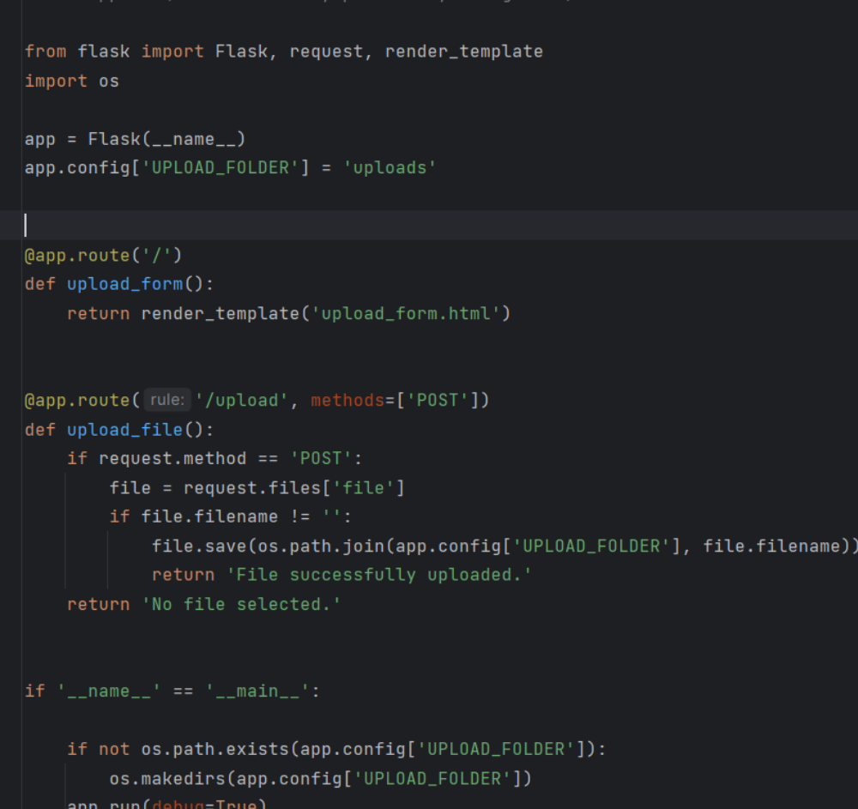

•pip install PyPDF2

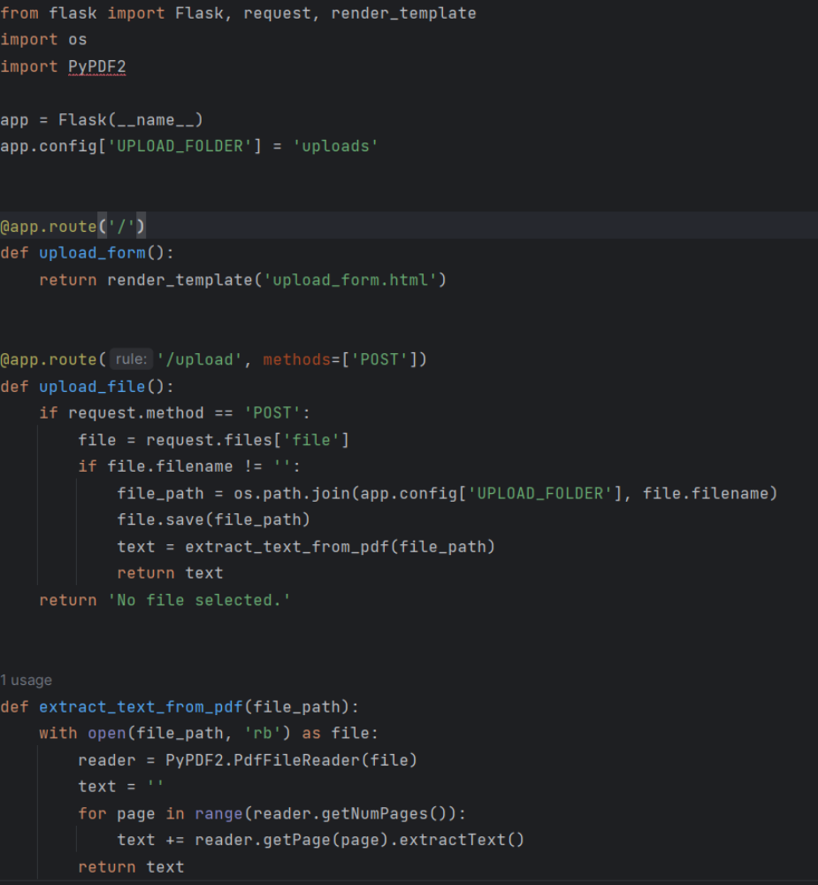

pip install matplotlib

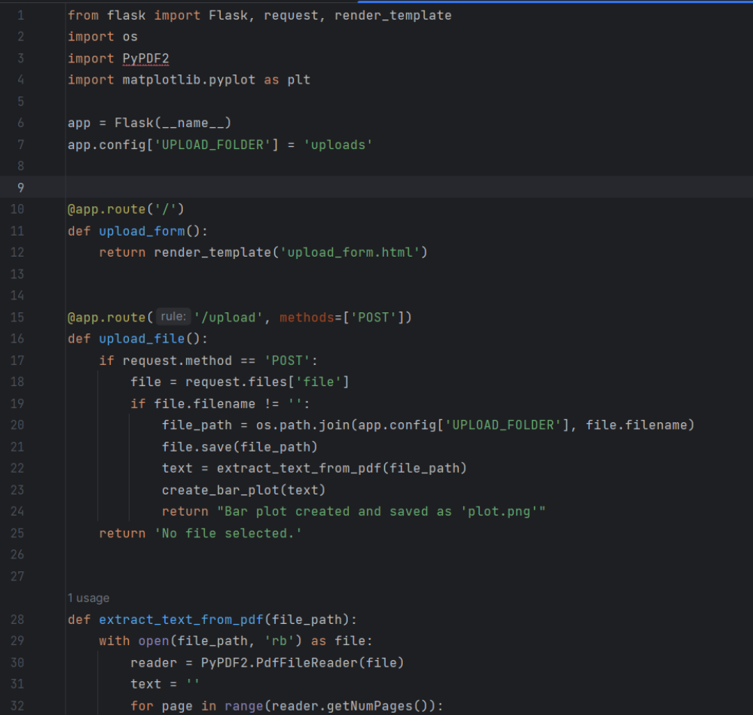

SAMPLE USED , ONLY CREATING THE OUPUT BASED ON BAR GRAPH.
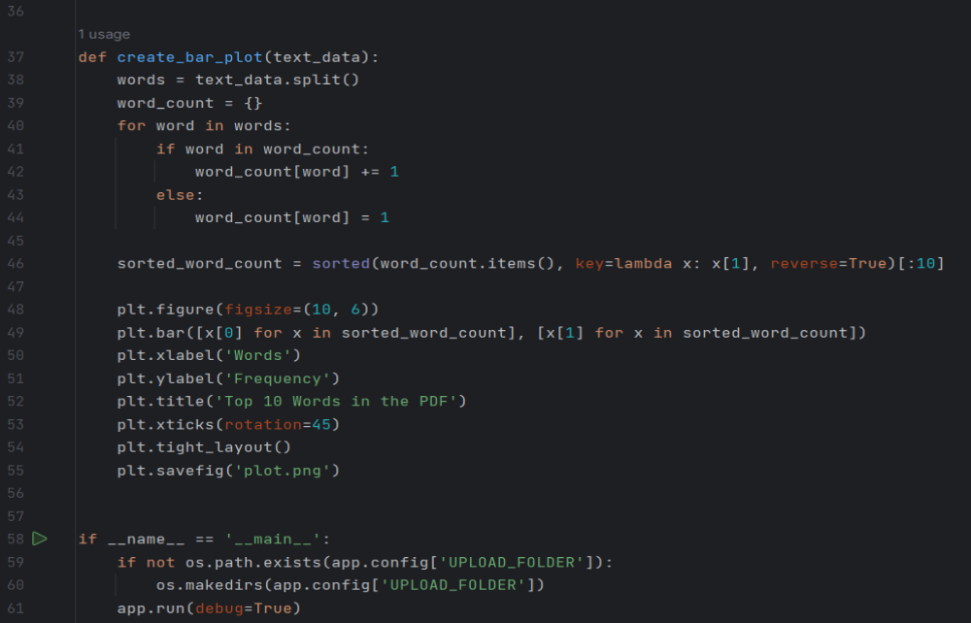

DEPLOYMENT OF THE BOT:
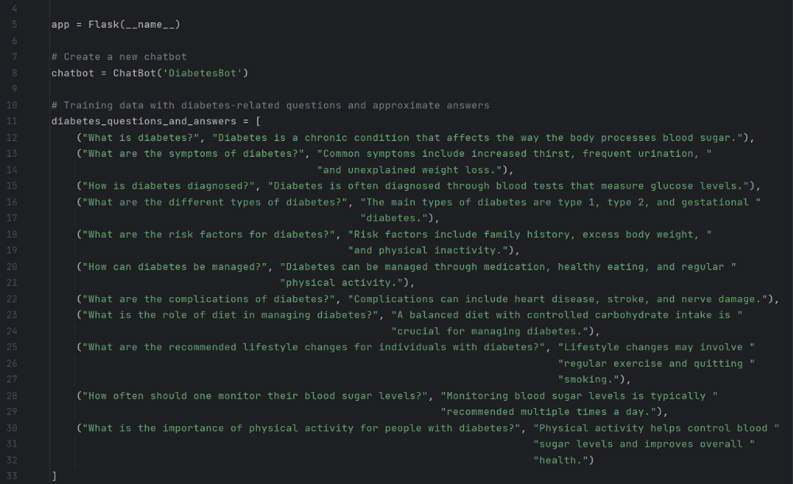
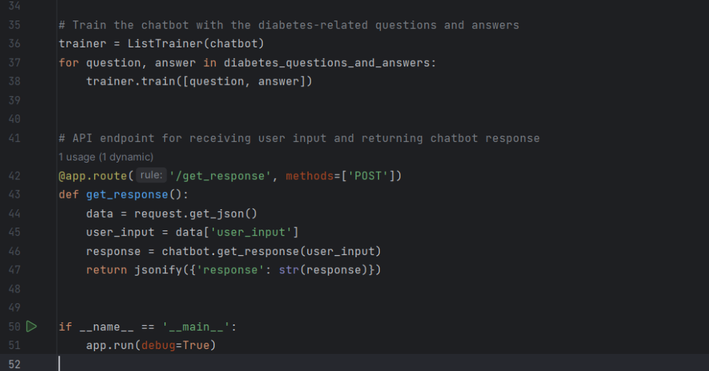

RESULT:
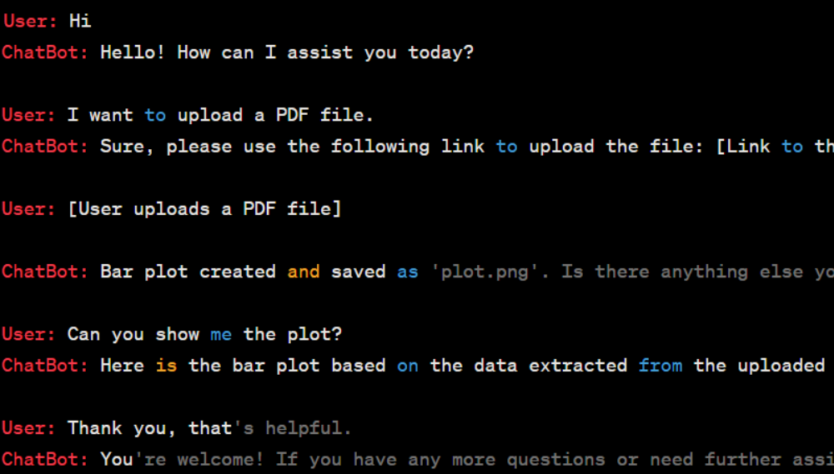

CONCLUSION:
The development of a diabetes prediction system using machine learning techniques represents a significant advancement in proactive healthcare management. By integrating sophisticated algorithms with comprehensive patient data, this system demonstrates the potential to accurately assess the risk of diabetes onset in individuals. Through the analysis of diverse factors such as genetic predisposition, lifestyle patterns, and clinical markers, this tool empowers healthcare professionals to offer personalized interventions and preventive strategies to at-risk populations.

