Assignment 3 : Javascript program to calculate multiplication and division of two numbers

HTML code:
<!DOCTYPE html>

<html>
<head>
<title>Multiplication and Division</title>
<link rel="stylesheet" href="CSS.css">
</head>
<body>
<h2>Assignment 3: JavaScript Program</h2>
<p>Calculate multiplication and division of two numbers</p>
<form>
<label for="num1">1st Number:</label>
<input type="number" id="num1"><br><br>

<label for="num2">2nd Number:</label>
<input type="number" id="num2"><br><br>

<button type="button" onclick="multiply()">Multiply</button>
<button type="button" onclick="divide()">Divide</button>
</form>
<p id="result">The Result Is: </p>

<script src="JS.js"></script>
</body>
</html>

CSS code:
body {
font-family: Arial, sans-serif;
margin: 20px;
}

label {
display: inline-block;
width: 100px;
}

input {
margin-bottom: 10px;
}

button {
margin: 5px;
padding: 5px 10px;
}

#result {
font-weight: bold;
margin-top: 20px;
}

JavaScript code:
function multiply() {
const num1 = parseFloat(document.getElementById("num1").value);
const num2 = parseFloat(document.getElementById("num2").value);
if (!isNaN(num1) && !isNaN(num2)) {
document.getElementById("result").innerText = `The Result Is: ${num1 * num2}`;
} else {
document.getElementById("result").innerText = "Please enter valid numbers.";
}
}

function divide() {
const num1 = parseFloat(document.getElementById("num1").value);
const num2 = parseFloat(document.getElementById("num2").value);
if (!isNaN(num1) && !isNaN(num2)) {
if (num2 !== 0) {
document.getElementById("result").innerText = `The Result Is: ${num1 / num2}`;
} else {
document.getElementById("result").innerText = "Division by zero is not allowed.";
}
} else {
document.getElementById("result").innerText = "Please enter valid numbers.";
}
}

Output(multiply):
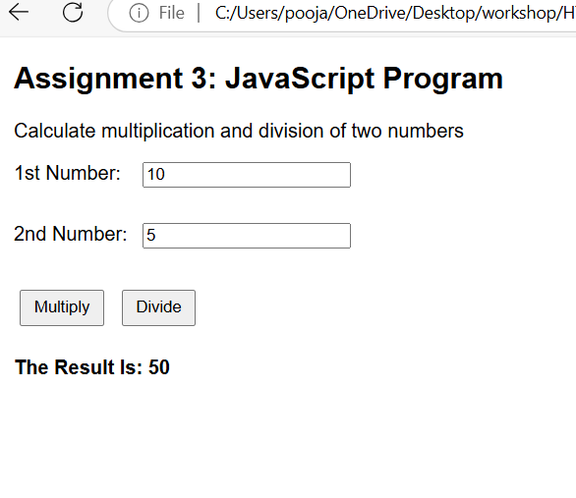
Output(divition):
