Student Lab Manual
Full-Stack Deployment Inside an Ubuntu Docker Container

Done By : Dharshini K

Install Git, .NET SDK/Runtime, Node.js, Angular CLI, Nginx; pull source code from GitHub; deploy ASP.NET Core API and Angular app
Lab Duration: 3 to 5 hours
Target Audience: Beginners learning Linux containers, application deployment, Nginx hosting, and full-stack deployment basics.
Platform Assumption: Docker Desktop running on Windows. Commands are written for Windows PowerShell or Command Prompt on the host, and Bash inside the Ubuntu container.

Lab Overview
In this lab, students will use an Ubuntu Linux Docker container like a small Linux server. Inside the container, they will install required tools, clone two GitHub repositories, run a .NET backend API, build an Angular frontend, and serve the Angular app through Nginx. Nginx will also reverse proxy API calls to the .NET application.
The Angular application will be accessible from the local system browser using http://localhost:8080. The backend API will run inside the same container and will be reached through Nginx using /api routes.
Host Machine / Browser
|
| http://localhost:8080
v
Docker Port Mapping: 8080 -> 80
|
v
Ubuntu Container
|
+-- Nginx on port 80
| +-- Serves Angular static files from /var/www/html/angular
| +-- Reverse proxies /api to ASP.NET Core API
|
+-- ASP.NET Core API running on http://localhost:5000
|
+-- Git, .NET SDK, Node.js, npm, Angular CLI installed
Placeholder | Value to Fill
Backend API GitHub Repository URL | https://github.com/dharshini2022/docker-app-backend
Angular GitHub Repository URL | https://github.com/dharshini2022/docker-app-frontend
Backend project folder name after git clone | docker-app-backend
Angular project folder name after git clone | docker-app-frontend
Backend project .csproj file name | WeatherApi csproj
Angular build output folder under dist | frontend

Important Notes for Students
- This lab intentionally installs software manually inside the Ubuntu container. This is useful for learning Linux server administration inside containers.
- For production, we normally write a Dockerfile instead of manually installing tools and committing containers.
- Do not close the terminal running the container unless instructed.
- If a command asks for confirmation, use -y where shown or type y and press Enter.
- Replace placeholder values like <DOTNET_API_REPO_URL> and <ANGULAR_REPO_URL> with your actual GitHub repository URLs.

Step 1: Pull Ubuntu Linux Image
Objective: Download the Ubuntu Linux image to your local Docker environment.
Commands:
docker pull ubuntu:24.04
docker images
Command Explanation:
- docker pull downloads an image from Docker Hub.
- ubuntu:24.04 means Ubuntu version 24.04.
- docker images lists all images available locally.
Expected Output / Result:
You should see ubuntu with tag 24.04 in the image list.
Verification:
Confirm that the ubuntu:24.04 image appears in the output of docker images.
Screenshot Placeholder
Paste screenshot here
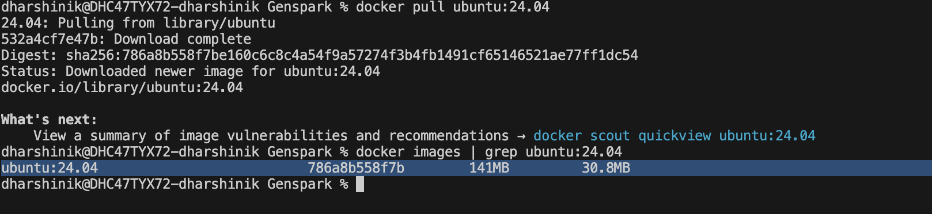
Student Notes: Used docker pull command to pull image from Docker Hub. Used grep command to list image with keyword.

Step 2: Start Ubuntu Container with Port Mapping
Objective: Create an Ubuntu container and expose ports so the host browser can access the app later.
Commands:
docker run -it --name fullstack-ubuntu -p 8080:80 -p 5000:5000 ubuntu:24.04 bash
Command Explanation:
- -it starts the container in interactive mode.
- --name fullstack-ubuntu assigns a readable container name.
- -p 8080:80 maps host port 8080 to container port 80 for Nginx.
- -p 5000:5000 maps host port 5000 to container port 5000 for direct API testing.
- bash opens a Linux shell inside the container.
Expected Output / Result:
You should see a Linux prompt similar to root@container-id:/#.
Verification:
Run pwd and whoami. Expected current user is root.
Screenshot Placeholder
Paste screenshot here
Student Notes:
- Created a container fullstack-ubuntu in of the ubuntu image in interactive mode with 2 ports.
- Port 8080:80 refers to the Nginx
- Port 5000:5000 refers to the backend WebAPI application
______________________________________________________________________________

Step 3: Update Ubuntu Package Repository
Objective: Refresh package information before installing software.
Commands:
apt update
Command Explanation:
- apt is Ubuntu package manager.
- apt update downloads the latest package index.
- This does not install software; it updates package metadata.
Expected Output / Result:
Expected output includes Reading package lists... Done.
Verification:
No error should appear at the end of the command.
Screenshot Placeholder
Paste screenshot here
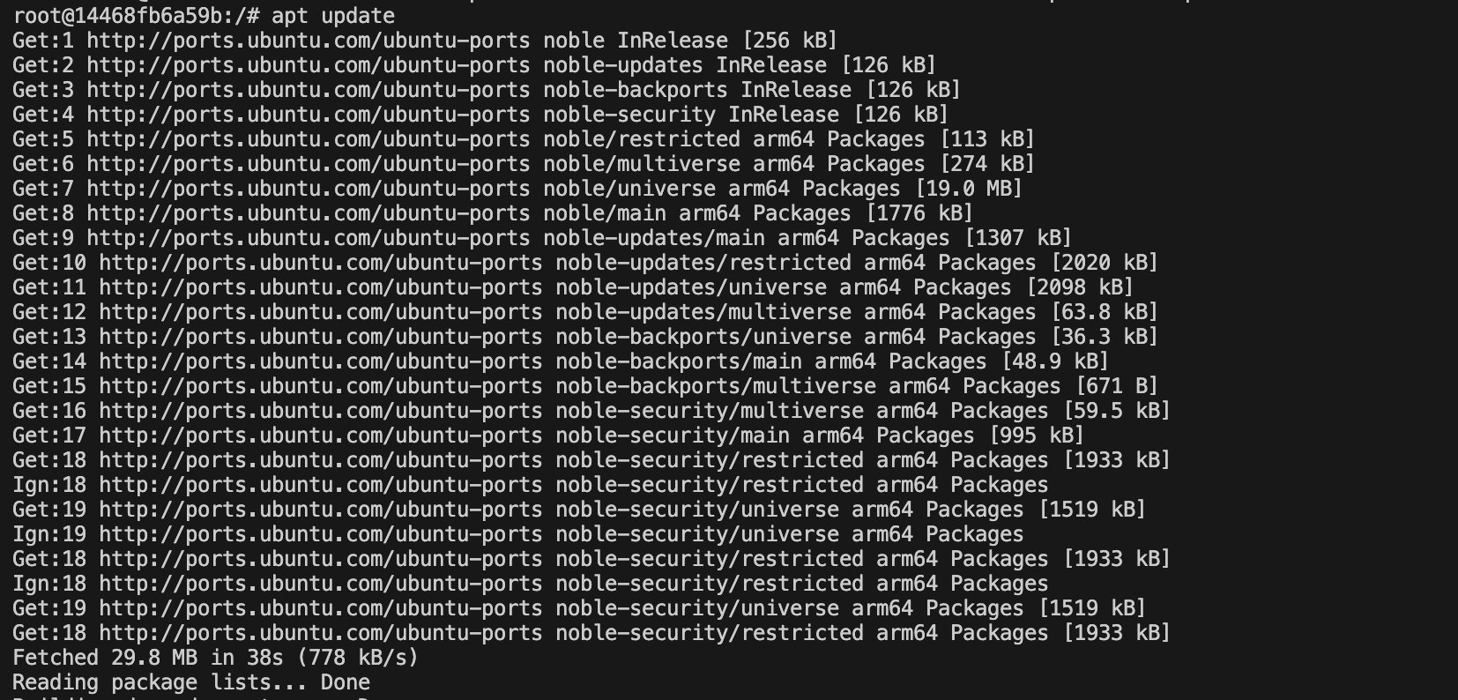
Student Notes: updated the package list meta data with the latest available package (does not update the actual package)

Step 4: Install Basic Utilities and Git
Objective: Install tools required for downloading packages and cloning GitHub repositories.
Commands:
apt install -y git curl wget nano ca-certificates gnupg lsb-release software-properties-common
Command Explanation:
- git is used to clone source code from GitHub.
- curl and wget are used to download files from the internet.
- nano is a beginner-friendly terminal editor.
- ca-certificates and gnupg help with secure package repositories.
- -y automatically confirms installation.
Expected Output / Result:
Packages should be installed without errors.
Verification:
Run git --version and curl --version.
Screenshot Placeholder
Paste screenshot here
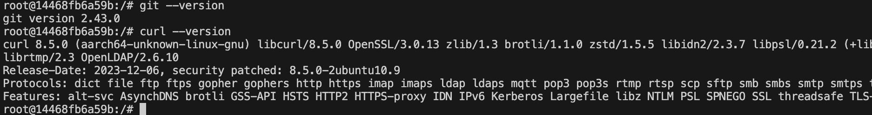
Student Notes:
Install the required packages through apt (Advanced Package Tool) with -y (yes for all download prompts)
Package | Purpose
git | Version control system used for cloning and managing repositories
curl | Command-line tool for transferring data from URLs
wget | Utility for downloading files from the internet
nano | Simple text editor
ca-certificates | SSL certificates used to verify HTTPS connections
gnupg | GNU Privacy Guard; used for verifying package signatures and managing GPG keys
lsb-release | Provides information about the Linux distribution
software-properties-common | Adds utilities like add-apt-repository for managing repositories

Step 5: Verify Git Installation
Objective: Confirm Git is available inside the Ubuntu container.
Commands:
git --version
Command Explanation:
- git --version displays the installed Git version.
- This proves the container can use Git commands.
Expected Output / Result:
Expected output: git version x.xx.x
Verification:
Paste the git version screenshot.
Screenshot Placeholder
Paste screenshot here
Student Notes: Check the installed git version

Step 6: Install .NET 8 SDK and Runtime
Objective: Install .NET SDK so you can restore, build, publish, and run the ASP.NET Core application.
Commands:
wget https://packages.microsoft.com/config/ubuntu/24.04/packages-microsoft-prod.deb -O packages-microsoft-prod.deb
dpkg -i packages-microsoft-prod.deb
apt update
apt install -y dotnet-sdk-8.0 aspnetcore-runtime-8.0
Command Explanation:
- The Microsoft package file adds Microsoft package sources to Ubuntu.
- dpkg -i installs the package source configuration.
- apt update refreshes packages again after adding Microsoft sources.
- dotnet-sdk-8.0 installs build tools and runtime.
- aspnetcore-runtime-8.0 installs the ASP.NET Core runtime used to run Web APIs.
Expected Output / Result:
.NET SDK and ASP.NET Core runtime should install successfully.
Verification:
Run dotnet --info to verify SDK and runtime details.
Screenshot Placeholder
Paste screenshot here
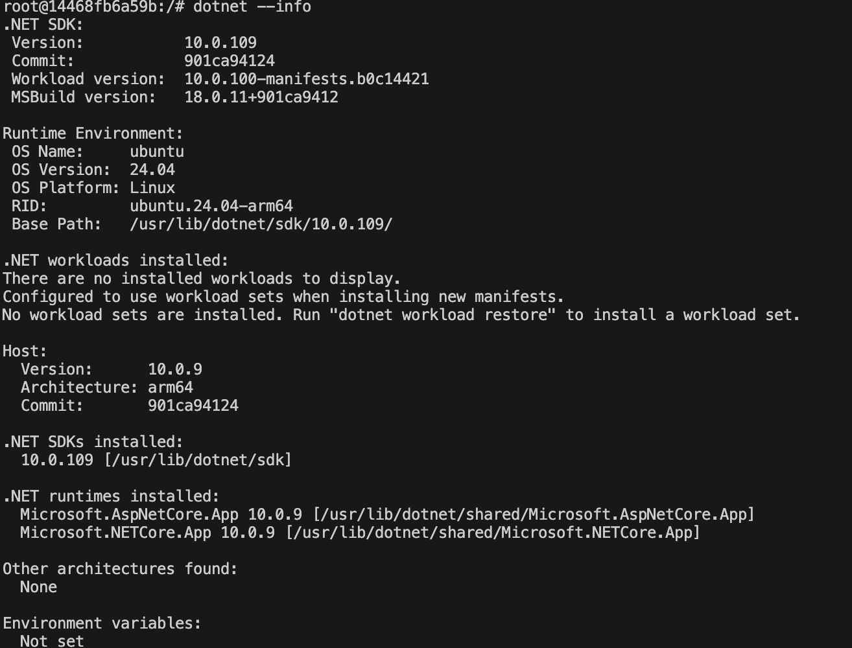
Student Notes:
- Command 1 : Using wget we download Microsoft packages from WebUrl in CLI directly
- -O in wget commands refers to output package name and format
- Command 2: dpkg (Debian package) unzips the .dep package and installs all of it.
- Command 3: adds the updated version of packages to package metadata.
- Command 4: Install dotnet’s sdk and runtime

Step 7: Verify .NET Installation
Objective: Check that .NET is installed correctly.
Commands:
dotnet --version
dotnet --info
Command Explanation:
- dotnet --version shows the installed SDK version.
- dotnet --info shows installed SDKs, runtimes, OS and architecture.
Expected Output / Result:
Expected output should show .NET 8.x SDK and Microsoft.AspNetCore.App 8.x runtime.
Verification:
Capture dotnet --info output.
Screenshot Placeholder
Paste screenshot here

Student Notes:
- Check the package details using dotnet –info
- Check the package version with the version command

Step 8: Install Node.js and npm
Objective: Install Node.js and npm so the Angular project can be built.
Commands:
curl -fsSL https://deb.nodesource.com/setup_20.x | bash -
apt install -y nodejs
Command Explanation:
- NodeSource setup script adds the Node.js package repository.
- Node.js is required to run Angular build tools.
- npm is installed along with Node.js.
Expected Output / Result:
Node.js and npm should be installed.
Verification:
Run node -v and npm -v.
Screenshot Placeholder
Paste screenshot here
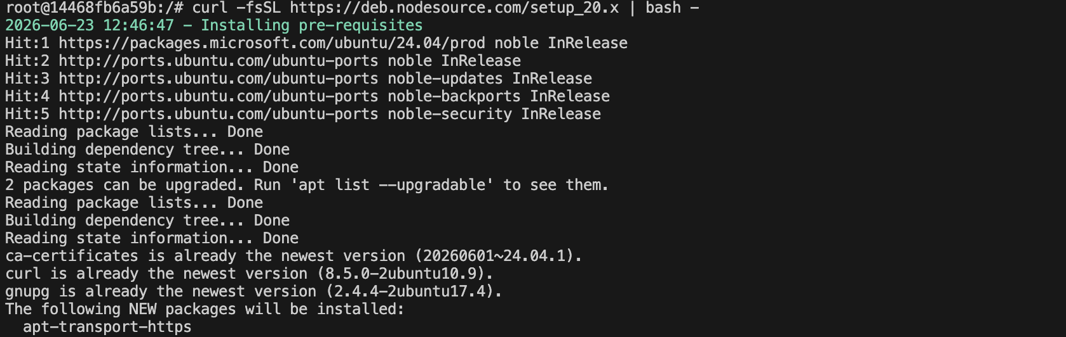
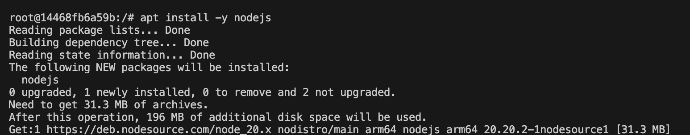
Student Notes:
- Command 1: curl command has 2 parts: curl download scripts | bash execute scripts
- Downloads package from the given link in fsSL => fs = fail in silent mode, SL => s to show error and L to redirect

Step 9: Verify Node.js and npm
Objective: Confirm Node.js and npm versions.
Commands:
node -v
npm -v
Command Explanation:
- node -v displays Node.js version.
- npm -v displays npm version.
Expected Output / Result:
Expected Node.js version should be v20.x or compatible with your Angular project.
Verification:
Capture both command outputs.
Screenshot Placeholder
Paste screenshot here
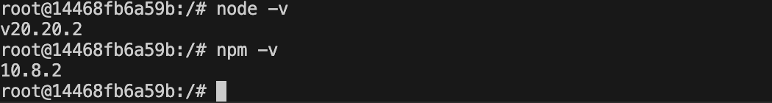
Student Notes: displays the versions of node and npm

Step 10: Install Angular CLI
Objective: Install Angular command line tool globally.
Commands:
npm install -g @angular/cli
ng version
Command Explanation:
- npm install -g installs a package globally inside the container.
- @angular/cli provides the ng command.
- ng version verifies Angular CLI installation.
Expected Output / Result:
Expected output shows Angular CLI version.
Verification:
Capture ng version output.
Screenshot Placeholder
Paste screenshot here
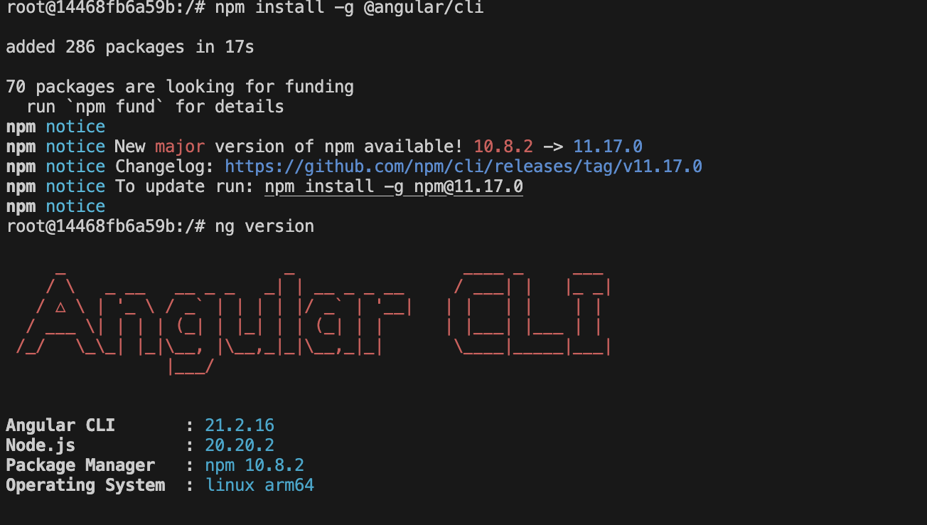
Student Notes:
- Installs Angular’s Command Line Interface and checks its version
- First, we are installing node. Then, we are installing angular through npm

Step 11: Install Nginx
Objective: Install Nginx web server inside Ubuntu container.
Commands:
apt install -y nginx
nginx -v
Command Explanation:
- Nginx will serve the Angular static files.
- Nginx will also forward API requests to the .NET backend.
- nginx -v displays the Nginx version.
Expected Output / Result:
Expected output: nginx version: nginx/x.x.x
Verification:
Capture nginx -v output.
Screenshot Placeholder
Paste screenshot here
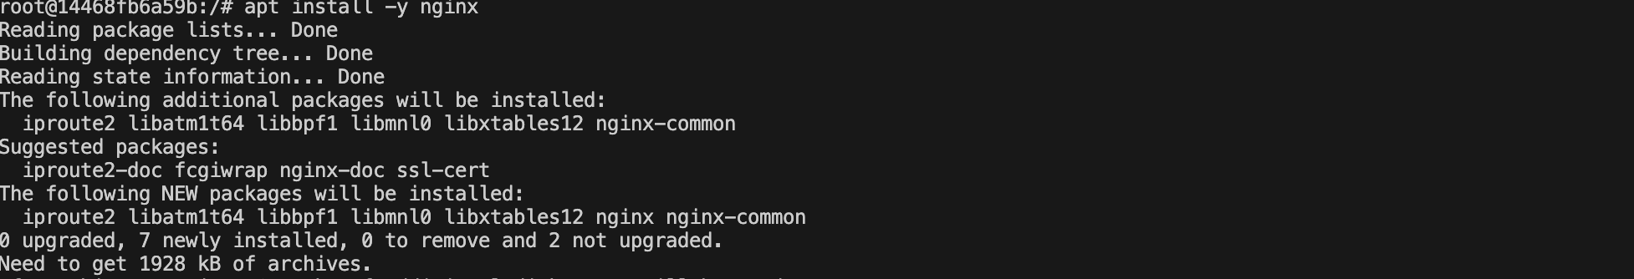
Student Notes:
Install NginX for server hosting and check its version

Step 12: Create Workspace Folder
Objective: Create a clean folder where both projects will be cloned.
Commands:
mkdir -p /workspace
cd /workspace
pwd
Command Explanation:
- mkdir -p creates the folder if it does not already exist.
- cd /workspace moves into the working folder.
- pwd confirms the current folder.
Expected Output / Result:
Expected output: /workspace
Verification:
Capture pwd output showing /workspace.
Screenshot Placeholder
Paste screenshot here
Student Notes:
Create a working directory using mkdir, move to the directory using cd. Verify it using pwd (print working directory)

Step 13: Clone .NET API Repository
Objective: Pull the backend source code from GitHub.
Commands:
cd /workspace
git clone <DOTNET_API_REPO_URL>
ls
Command Explanation:
- Replace <DOTNET_API_REPO_URL> with the real GitHub URL.
- git clone downloads the repository into a local folder.
- ls lists the cloned folder.
Expected Output / Result:
You should see the backend repository folder.
Verification:
Capture git clone success output and ls output.
Screenshot Placeholder
Paste screenshot here
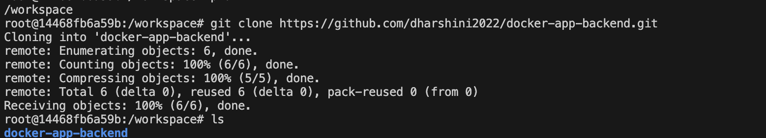
Student Notes: Cloned backend repo to container

Step 14: Restore and Build .NET API
Objective: Download NuGet packages and build the backend application.
Commands:
cd /workspace/<DOTNET_API_FOLDER_NAME>
dotnet restore
dotnet build
Command Explanation:
- dotnet restore downloads NuGet dependencies.
- dotnet build compiles the application.
- Replace <DOTNET_API_FOLDER_NAME> with the actual cloned folder name.
Expected Output / Result:
Expected output: Build succeeded.
Verification:
Capture Build succeeded output.
Screenshot Placeholder
Paste screenshot here
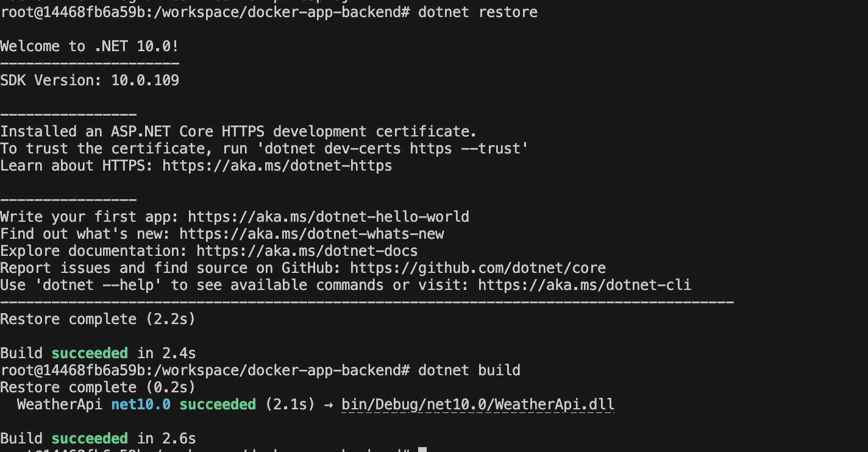
Student Notes: restore package dependencies of the project, and build it for execution

Step 15: Run .NET API for Initial Test
Objective: Start the backend API inside the container.
Commands:
cd /workspace/<DOTNET_API_FOLDER_NAME>
ASPNETCORE_URLS=http://0.0.0.0:5000 dotnet run
Command Explanation:
- ASPNETCORE_URLS tells the API to listen on all network interfaces.
- http://0.0.0.0:5000 makes it accessible through Docker port mapping.
- dotnet run starts the application from source code.
Expected Output / Result:
Expected output includes Now listening on: http://0.0.0.0:5000.
Verification:
From the host browser, try http://localhost:5000 or http://localhost:5000/swagger if Swagger exists. Stop the API with Ctrl+C after testing.
Screenshot Placeholder
Paste screenshot here
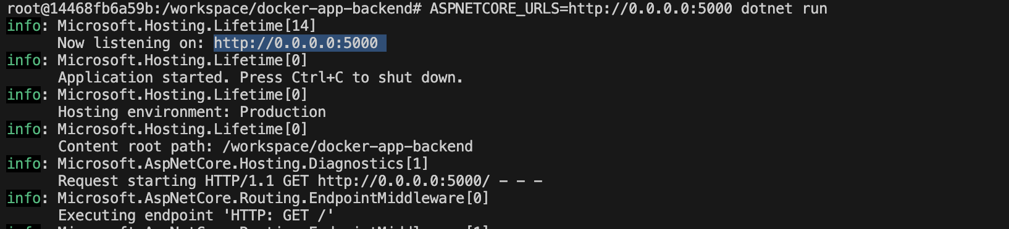
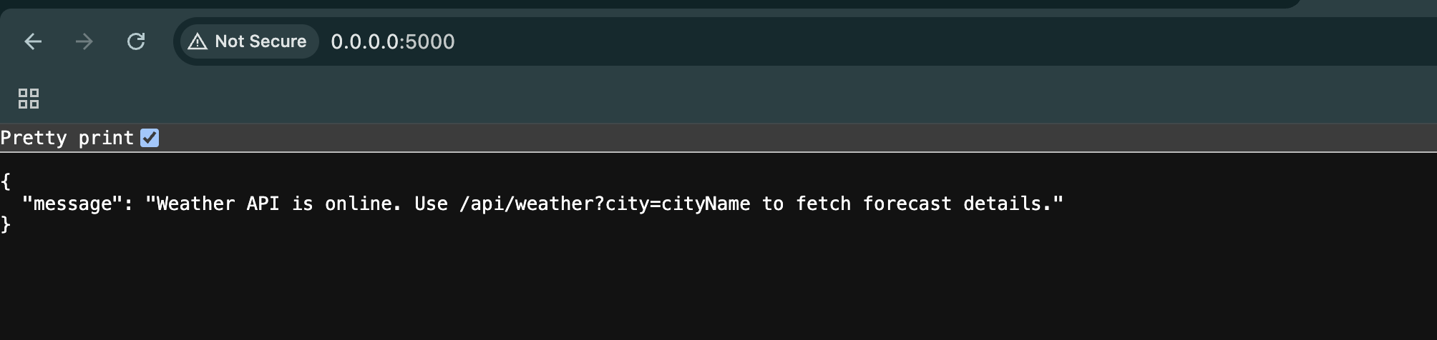
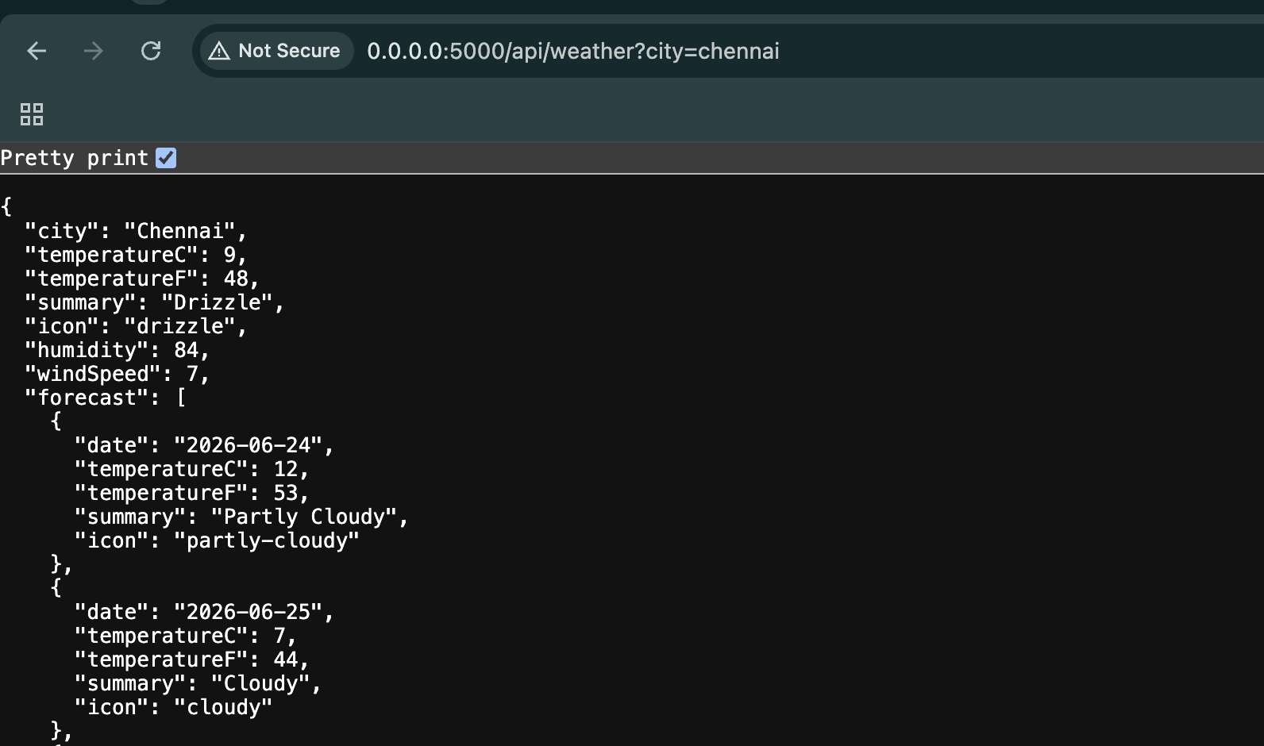
Student Notes:
- This command created a temporary variable ASPNETCORE_URLS with value http://0.0.0.0:500
- 0.0.0 instructs kestrel to allow any network (within docker or localhost). 5000 is the backend port

Step 16: Publish .NET API
Objective: Create a production-ready published output folder.
Commands:
cd /workspace/<DOTNET_API_FOLDER_NAME>
dotnet publish -c Release -o /app/api
Command Explanation:
- dotnet publish prepares compiled files for deployment.
- -c Release creates a release build.
- -o /app/api places the published output in /app/api.
Expected Output / Result:
Expected output says the project was published to /app/api.
Verification:
Run ls /app/api and capture the files.
Screenshot Placeholder
Paste screenshot here
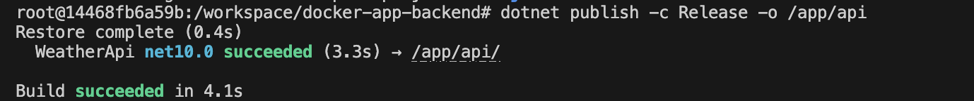
Student Notes:
- Publish : copies all the dependencies and build the project
- -c Debug/Release . -c => configuration. Debug => Development. Release => Deployment
- -o output directory to copy the project files there.
BEFORE:
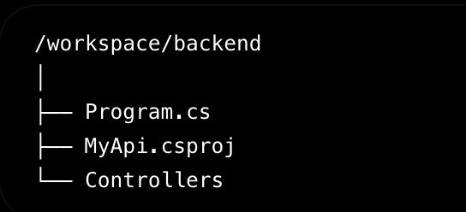
AFTER:
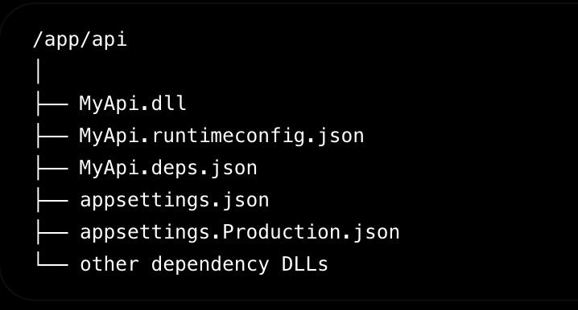

Step 17: Run Published API in Background
Objective: Run the published API as a background process so Nginx can proxy to it.
Commands:
cd /app/api
ASPNETCORE_URLS=http://127.0.0.1:5000 nohup dotnet <DOTNET_PROJECT_FILE_NAME>.dll > /var/log/dotnet-api.log 2>&1 &
ps -ef | grep dotnet
cat /var/log/dotnet-api.log
Command Explanation:
- nohup allows the process to continue running after the shell returns.
- & starts the process in the background.
- 127.0.0.1:5000 means the API listens locally inside the container.
- <DOTNET_PROJECT_FILE_NAME>.dll must be replaced with your actual DLL name.
- The log file helps troubleshoot startup errors.
Expected Output / Result:
Expected: ps output should show a dotnet process. The log should show the API started successfully.
Verification:
Capture ps -ef and log output.
Screenshot Placeholder
Paste screenshot here
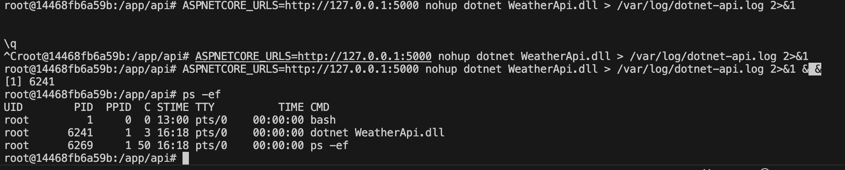
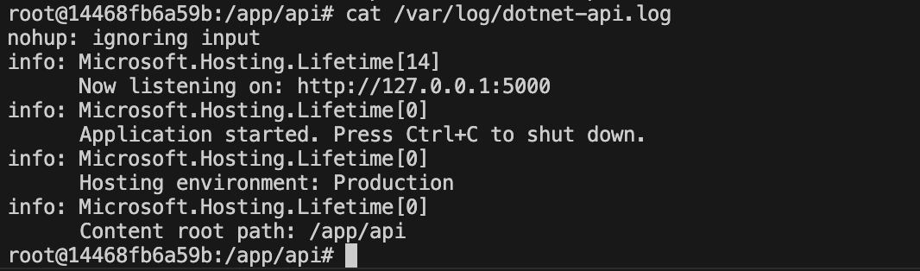
Student Notes:
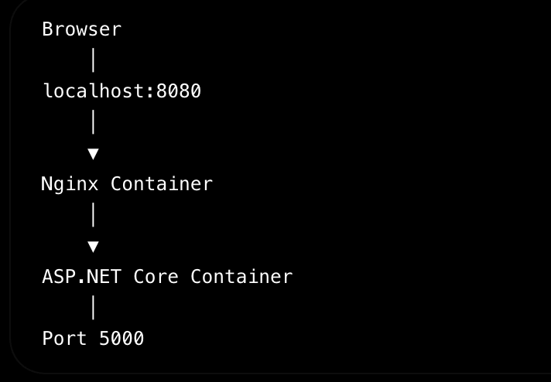
NginX performs reverse proxy. Present in between frontend and backend, also performs load balancing for the backend.
Command Explanations:
- Command 1: ASPNETCORE_URLS=http://127.0.0.1:5000 (sets temp variable with URL definition)
- nohup : no hang up, even if terminal closes, don’t hang up the backend terminal
- <DOTNET_PROJECT_FILE_NAME>.dll : project dll to execute
- > : write to (file navigation
- /var/log/dotnet-api.log : path of logs file
- 2>&1 : store errors and output in the same log file
- & : run in background
- Command 2: to find running process with name dotnet
- Command 3: to verify the content within the logs file

Step 18: Clone Angular Repository
Objective: Pull the Angular frontend source code from GitHub.
Commands:
cd /workspace
git clone <ANGULAR_REPO_URL>
ls
Command Explanation:
- Replace <ANGULAR_REPO_URL> with your real Angular GitHub repository URL.
- The repository will be downloaded into /workspace.
- ls confirms the folder exists.
Expected Output / Result:
You should see the Angular project folder.
Verification:
Capture git clone success output.
Screenshot Placeholder
Paste screenshot here
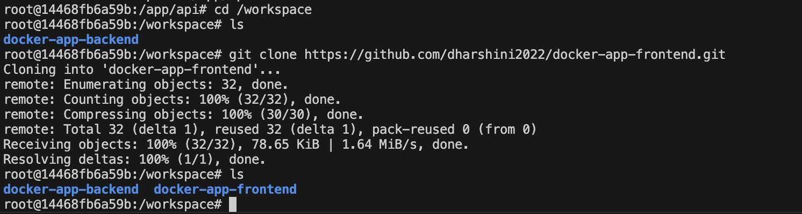
Student Notes: clone frontend repo into workspace

Step 19: Install Angular Dependencies
Objective: Install packages required by the Angular project.
Commands:
cd /workspace/<ANGULAR_FOLDER_NAME>
npm install
Command Explanation:
- npm install reads package.json.
- It downloads project dependencies into node_modules.
- This may take a few minutes.
Expected Output / Result:
Expected output should complete without fatal errors.
Verification:
Capture the final npm install success output.
Screenshot Placeholder
Paste screenshot here
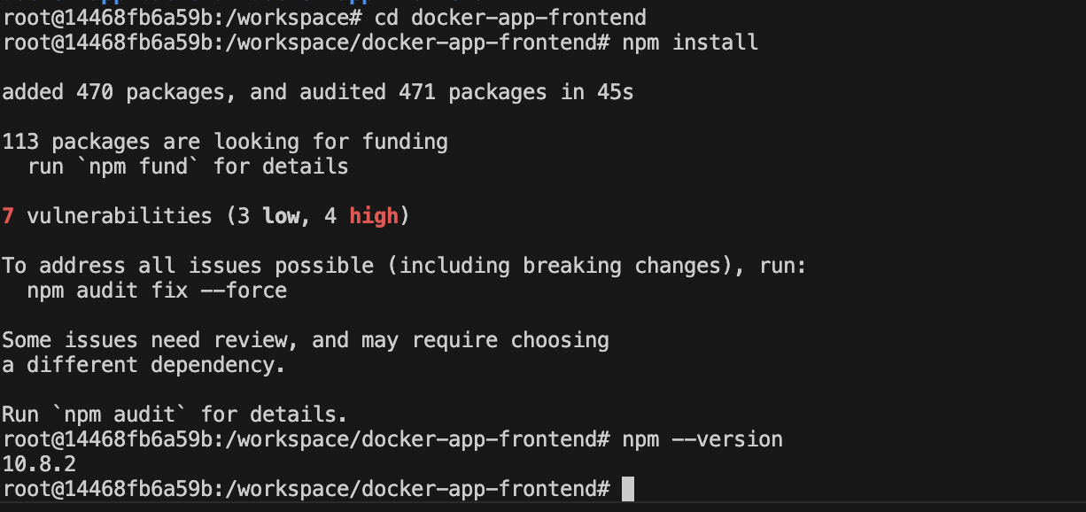
Student Notes: Install node package manager to restore the dependencies of the frontend project

Step 20: Configure Angular API URL Placeholder
Objective: Update Angular configuration so API calls go through Nginx /api path.
Commands:
# Open your Angular environment file if your project uses one
nano src/environments/environment.ts
# Example value to use inside Angular
# apiBaseUrl: "/api"
Command Explanation:
- This step depends on your Angular project structure.
- The recommended browser-facing API URL is /api.
- Using /api allows Nginx to forward calls to the backend API running on port 5000 inside the container.
- If your app uses a different config file, update that file instead.
Expected Output / Result:
Angular source should point API calls to /api or relative API paths.
Verification:
Capture the updated environment/configuration file.
Screenshot Placeholder
Paste screenshot here
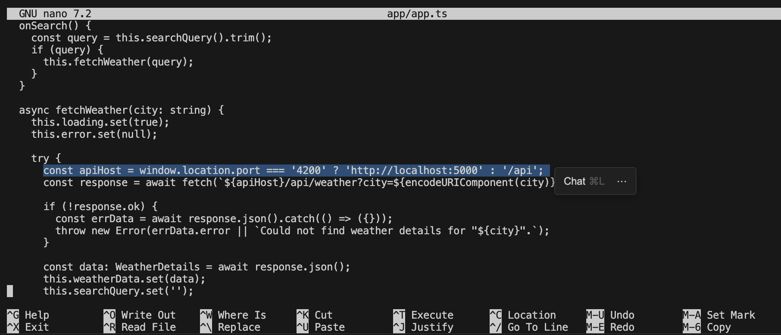
Student Notes:
Changed url endpoint to /api using nano editor

Step 21: Build Angular Application
Objective: Build Angular static files for production.
Commands:
cd /workspace/<ANGULAR_FOLDER_NAME>
ng build --configuration production
Command Explanation:
- ng build compiles the Angular app.
- --configuration production creates optimized static files.
- The output usually goes into dist/<project-name>.
Expected Output / Result:
Expected output: build completed successfully and dist folder created.
Verification:
Run ls dist and capture the output.
Screenshot Placeholder
Paste screenshot here
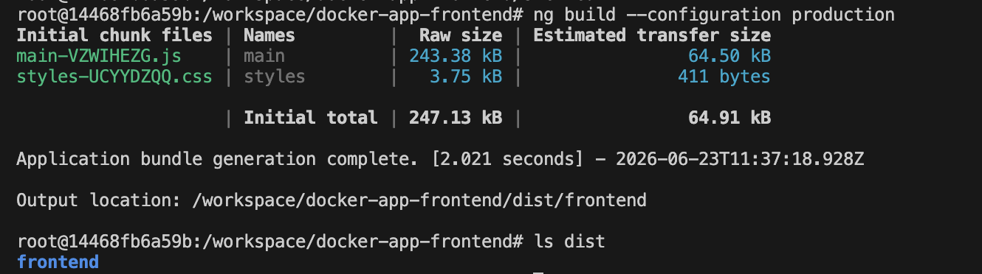
Student Notes:
Builds angular application for production deployment

Step 22: Deploy Angular Build to Nginx Web Root
Objective: Copy the Angular build output into the Nginx hosting folder.
Commands:
rm -rf /var/www/html/*
mkdir -p /var/www/html/angular
cp -r /workspace/<ANGULAR_FOLDER_NAME>/dist/<ANGULAR_DIST_FOLDER_NAME>/* /var/www/html/angular/
ls -la /var/www/html/angular
Command Explanation:
- rm -rf clears default Nginx files.
- mkdir creates the folder that will host Angular files.
- cp copies built Angular files into Nginx web root.
- <ANGULAR_DIST_FOLDER_NAME> must match the actual folder inside dist.
Expected Output / Result:
Expected output should include index.html and static JavaScript/CSS files.
Verification:
Capture ls -la /var/www/html/angular output.
Screenshot Placeholder
Paste screenshot here
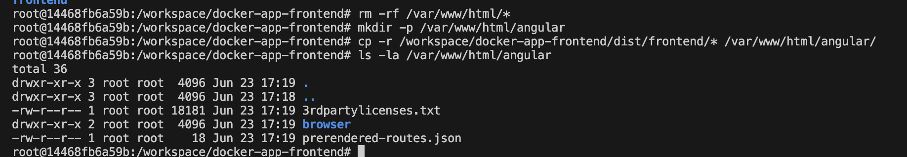
Student Notes:
Clear existing Nginx files and copy the newly built files to the mentioned location.

Step 23: Create Nginx Configuration for Angular and API Reverse Proxy
Objective: Configure Nginx to serve Angular and forward API requests to the .NET backend.
Commands:
cat > /etc/nginx/sites-available/default <<'EOF'
server {
listen 80;
server_name _;
root /var/www/html/angular;
index index.html;
location / {
try_files $uri $uri/ /index.html;
}
location /api/ {
proxy_pass http://127.0.0.1:5000/;
proxy_http_version 1.1;
proxy_set_header Host $host;
proxy_set_header X-Real-IP $remote_addr;
proxy_set_header X-Forwarded-For $proxy_add_x_forwarded_for;
proxy_set_header X-Forwarded-Proto $scheme;
}
}
EOF
nginx -t
Command Explanation:
- listen 80 tells Nginx to listen on port 80 inside the container.
- root points to Angular build files.
- try_files supports Angular client-side routing.
- location /api forwards API requests to the .NET app on port 5000.
- nginx -t validates the configuration syntax.
Expected Output / Result:
Expected output: syntax is ok and test is successful.
Verification:
Capture nginx -t output.
Screenshot Placeholder
Paste screenshot here
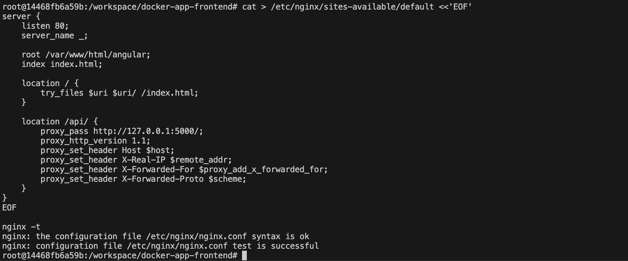
Student Notes:
This is used configure such that Nginx gets the frontend requests and forwards it to the backend api

Step 24: Start or Reload Nginx
Objective: Start Nginx so the Angular app becomes available.
Commands:
nginx
# If Nginx is already running, use this instead:
nginx -s reload
ps -ef | grep nginx
Command Explanation:
- nginx starts the web server.
- nginx -s reload reloads configuration without stopping Nginx.
- ps -ef confirms that Nginx master and worker processes are running.
Expected Output / Result:
Expected output should show nginx master process and worker process.
Verification:
Capture ps -ef | grep nginx output.
Screenshot Placeholder
Paste screenshot here
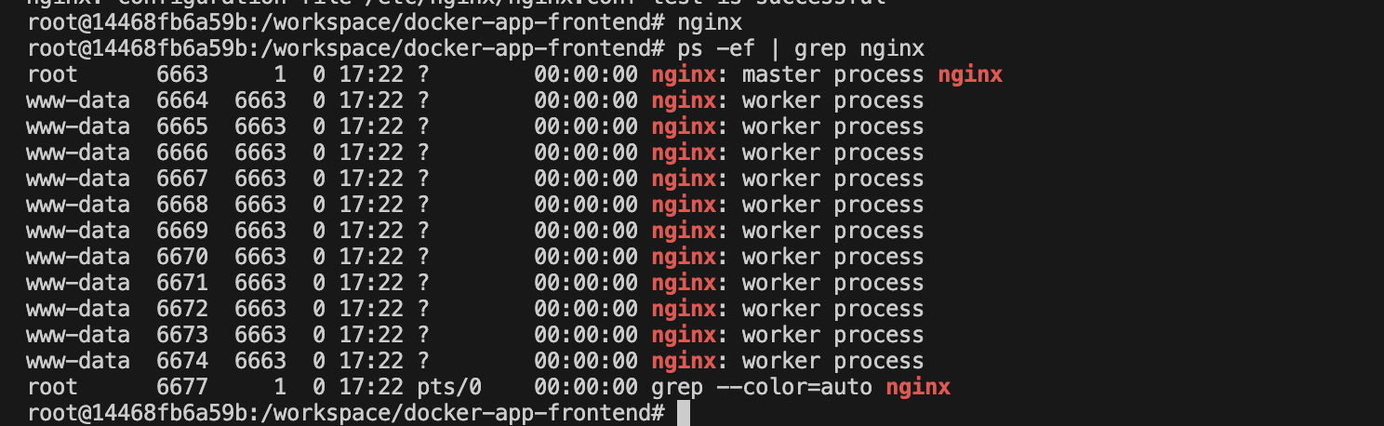
Student Notes:
Start nginx server and verify the process running status

Step 25: Test from Inside the Container
Objective: Verify Angular and API proxy from inside Ubuntu first.
Commands:
curl http://localhost
curl http://localhost/api/health
# If your API does not have /health, test another endpoint:
# curl http://localhost/api/<your-api-endpoint>
Command Explanation:
- curl http://localhost checks Angular/Nginx.
- curl http://localhost/api/health checks whether Nginx can reach the .NET API.
- If your API does not have /health, use an endpoint from your backend project.
Expected Output / Result:
Angular curl may return HTML. API curl should return API response.
Verification:
Capture both curl outputs.
Screenshot Placeholder
Paste screenshot here
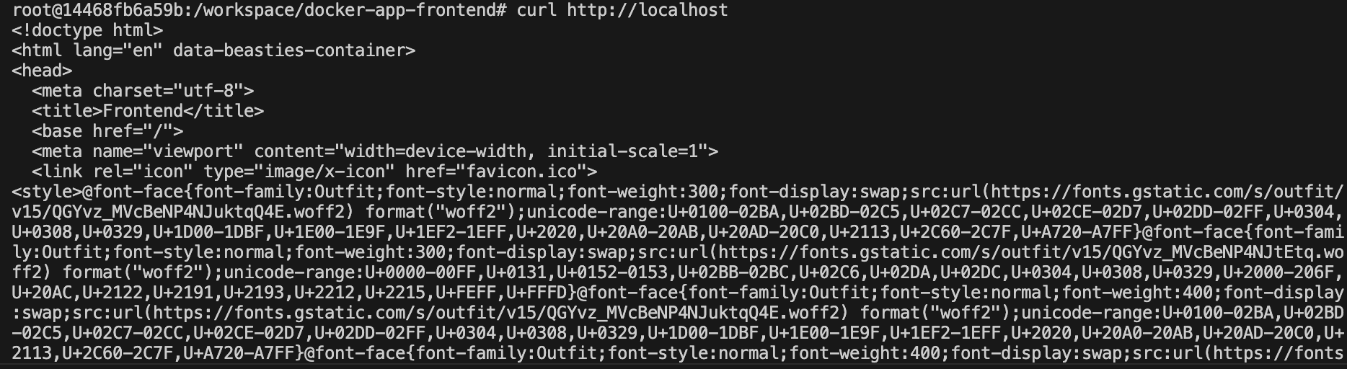
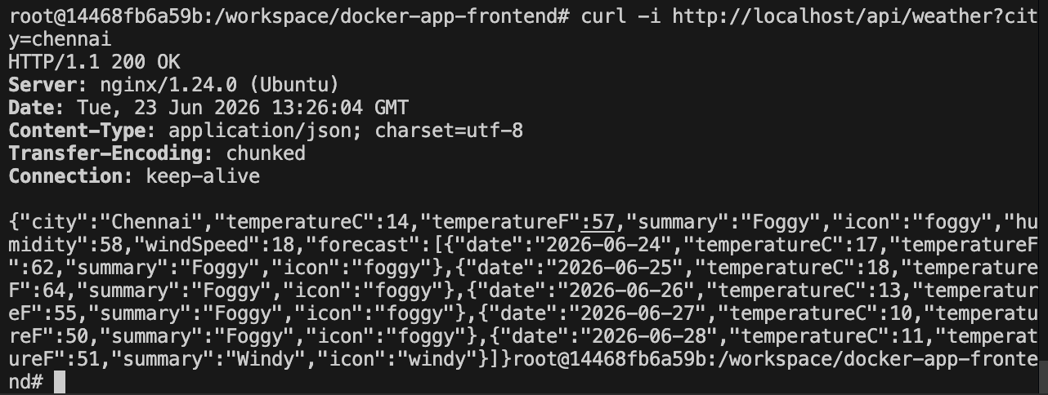
Student Notes: Test the endpoints

Step 26: Test from Local Host Browser
Objective: Access the Angular app from the Windows browser.
Commands:
Open browser on the host machine:
http://localhost:8080
Optional direct API test:
http://localhost:8080/api/health
Command Explanation:
- Docker maps host port 8080 to container port 80.
- The browser talks to Nginx.
- Nginx serves Angular and proxies API calls.
Expected Output / Result:
Expected: Angular app opens in browser. API requests from Angular should reach the .NET backend.
Verification:
Capture browser screenshot showing Angular loaded from localhost:8080.
Screenshot Placeholder
Paste screenshot here
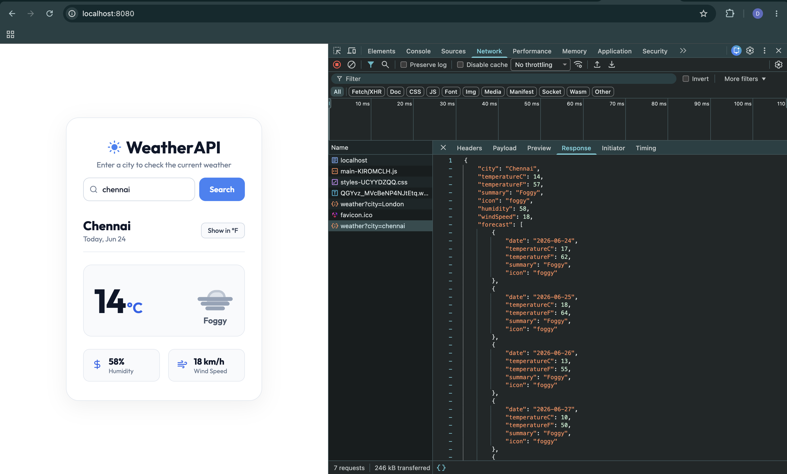
Student Notes:
CONNECTIVITY:
Frontend -> NnginX -> Backend

Step 27: Check Logs for Troubleshooting
Objective: Use logs to diagnose application or Nginx errors.
Commands:
cat /var/log/dotnet-api.log
tail -n 50 /var/log/nginx/access.log
tail -n 50 /var/log/nginx/error.log
Command Explanation:
- dotnet-api.log shows backend startup/runtime logs.
- Nginx access log shows browser/API requests.
- Nginx error log shows configuration and proxy errors.
Expected Output / Result:
Expected: no fatal errors in logs.
Verification:
Capture logs if troubleshooting is required.
Screenshot Placeholder
Paste screenshot here
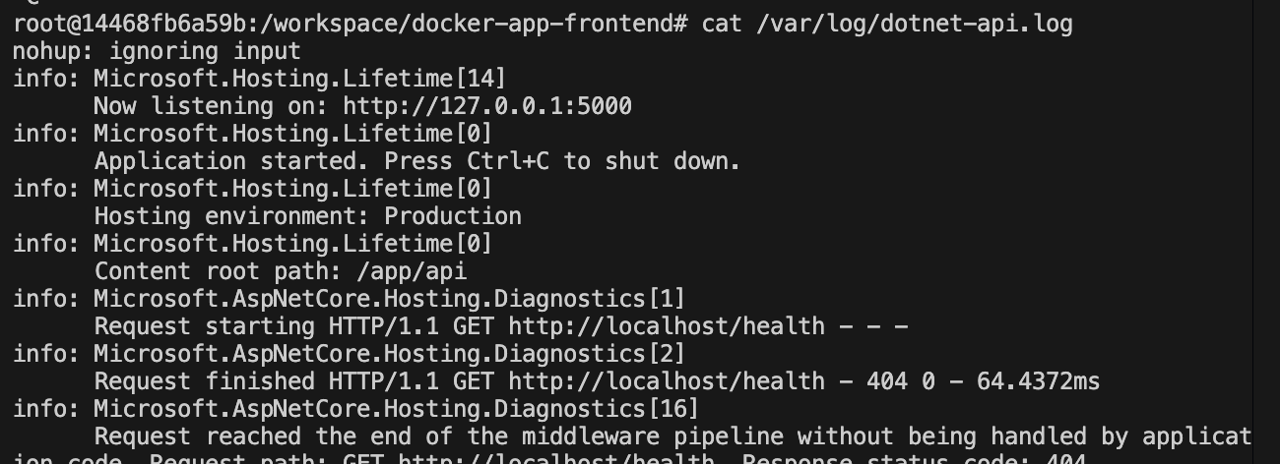
Student Notes:
- cat is used to display the whole logs file
- tail -n 50 to display the last 50 lines

Step 28: Stop and Restart Existing Container
Objective: Learn how to leave and return to the container without losing installed tools.
Commands:
# Inside container
exit
# On host machine
docker ps -a
docker start fullstack-ubuntu
docker exec -it fullstack-ubuntu bash
Command Explanation:
- exit leaves the container shell.
- docker ps -a shows stopped and running containers.
- docker start restarts the existing container.
- docker exec opens a new shell inside the running container.
Expected Output / Result:
You should return to the Ubuntu shell with installed tools still available.
Verification:
Capture docker ps -a and shell prompt after docker exec.
Screenshot Placeholder
Paste screenshot here
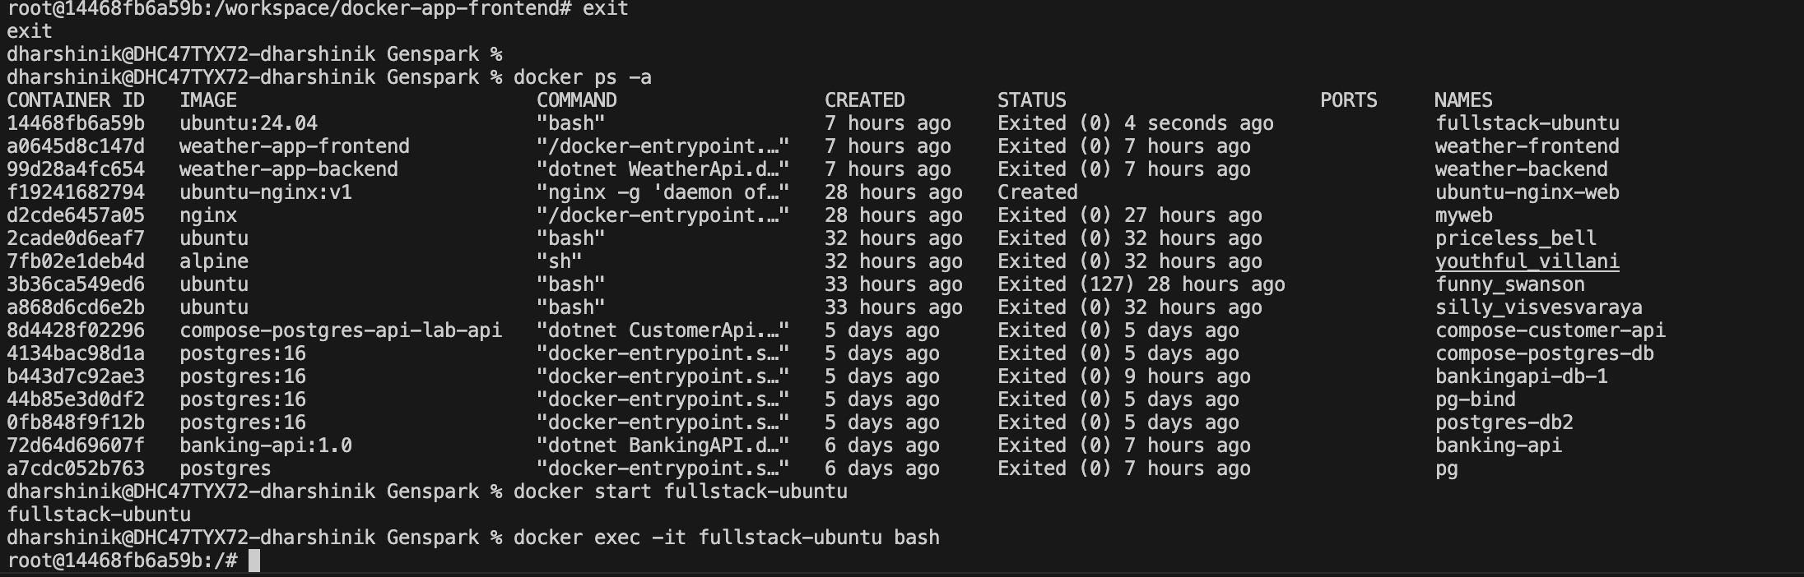
Student Notes:
- To stop and re-execute the container for verification

Step 29: Optional: Save the Configured Container as an Image
Objective: Convert the configured container into a reusable image for later labs.
Commands:
# Run this on host machine after exiting the container if needed
docker commit fullstack-ubuntu fullstack-ubuntu-web:v1
docker images
Command Explanation:
- docker commit saves the current container state as an image.
- This is useful for training demos.
- In production, a Dockerfile is preferred.
Expected Output / Result:
Expected: image fullstack-ubuntu-web:v1 appears in docker images.
Verification:
Capture docker images output.
Screenshot Placeholder
Paste screenshot here
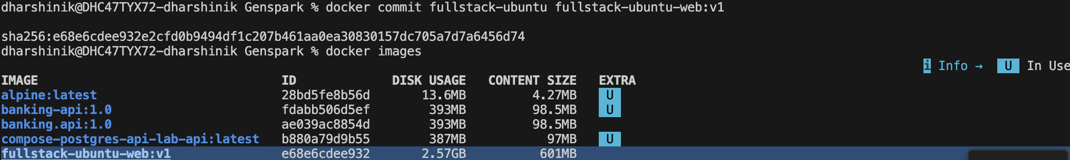
Student Notes:
- Commit changes made in the container to an image

Step 30: Cleanup Lab Resources
Objective: Remove the lab container when finished.
Commands:
docker stop fullstack-ubuntu
docker rm fullstack-ubuntu
# Optional: remove saved image
# docker rmi fullstack-ubuntu-web:v1
Command Explanation:
- docker stop stops the container.
- docker rm removes the container.
- docker rmi removes the saved image if created.
Expected Output / Result:
Container should be removed successfully.
Verification:
Capture docker ps -a output after removal.
Screenshot Placeholder
Paste screenshot here
Student Notes:
- stop and delete the container

Troubleshooting Guide
Problem | Fix
Port 8080 already in use | Use a different host port, for example -p 8090:80, then open http://localhost:8090.
dotnet command not found | Check whether .NET installation completed. Run apt update and reinstall dotnet-sdk-8.0.
ng command not found | Angular CLI may not be installed globally. Run npm install -g @angular/cli.
Angular build fails | Run npm install again. Check Node.js version compatibility. Read the error message carefully.
Nginx configuration test fails | Run nginx -t and fix the exact line mentioned in the error.
API works directly on port 5000 but not through /api | Check proxy_pass configuration and verify the API process is running on 127.0.0.1:5000.
Browser shows Nginx default page | Make sure Angular files are copied to /var/www/html/angular and root points to that folder.
Angular refresh shows 404 | Make sure try_files $uri $uri/ /index.html; is present in the Nginx location / block.

Final Lab Checklist
☑ Ubuntu container started with port mapping 8080:80 and 5000:5000.
☑ Git installed and verified.
☑ .NET SDK/runtime installed and verified.
☑ Node.js and npm installed and verified.
☑ Angular CLI installed and verified.
☑ Nginx installed and verified.
☑ .NET API repository cloned from GitHub.
☑ .NET API restored, built, published, and running.
☑ Angular repository cloned from GitHub.
☑ Angular dependencies installed and production build completed.
☑ Angular files copied to Nginx root folder.
☑ Nginx reverse proxy configured for /api.
☑ Angular app accessible from host browser at http://localhost:8080.
☑ Angular can call backend API through Nginx proxy.

Knowledge Check Questions
- Why do we map host port 8080 to container port 80?
Answer: To allow users to access the web server running on port 80 inside the container through port 8080 on the host machine, avoiding conflicts with services already using port 80.

- What is the purpose of Git in this lab?
Answer: Git is used to clone and manage the frontend and backend source code repositories from GitHub.

- Why do we install .NET SDK instead of only .NET runtime?
Answer: The .NET SDK provides tools required to restore packages, build, compile, and publish applications, whereas the runtime can only execute already-built applications.

- What does npm install do?
Answer: t downloads and installs all project dependencies specified in the package.json file into the node_modules directory.

- What does ng build --configuration production create?
Answer: It generates an optimized production-ready Angular build containing static HTML, CSS, and JavaScript files in the dist/ folder.

- Why does Angular need Nginx after build?
Answer: After building, Angular becomes a collection of static files. Nginx serves these files to browsers efficiently and can also act as a reverse proxy for backend API requests.

- What is the role of proxy_pass in Nginx?
Answer: proxy_pass forwards incoming requests to another server, allowing Nginx to route API requests to the backend application.

- Why do we use /api as the backend path?
Answer: Using /api separates API requests from frontend requests, enabling Nginx to distinguish and forward backend traffic appropriately.
- What is the purpose of nohup when running the .NET API?
Answer: nohup allows the .NET application to continue running in the background even after the terminal session is closed.

- Why is Dockerfile preferred over docker commit in real projects?
Answer: A Dockerfile provides an automated, reproducible, version-controlled way to build images, whereas docker commit creates manual snapshots that are difficult to maintain and reproduce.

Appendix A: Placeholder Replacement Guide
<DOTNET_API_REPO_URL> Example: https://github.com/your-org/your-api.git
<DOTNET_API_FOLDER_NAME> Example: your-api
<DOTNET_PROJECT_FILE_NAME> Example: YourApi
<ANGULAR_REPO_URL> Example: https://github.com/your-org/your-angular-app.git
<ANGULAR_FOLDER_NAME> Example: your-angular-app
<ANGULAR_DIST_FOLDER_NAME> Example: your-angular-app or browser depending on Angular version

Appendix B: Full Command Summary
docker pull ubuntu:24.04
docker run -it --name fullstack-ubuntu -p 8080:80 -p 5000:5000 ubuntu:24.04 bash
apt update
apt install -y git curl wget nano ca-certificates gnupg lsb-release software-properties-common
wget https://packages.microsoft.com/config/ubuntu/24.04/packages-microsoft-prod.deb -O packages-microsoft-prod.deb
dpkg -i packages-microsoft-prod.deb
apt update
apt install -y dotnet-sdk-8.0 aspnetcore-runtime-8.0
curl -fsSL https://deb.nodesource.com/setup_20.x | bash -
apt install -y nodejs
npm install -g @angular/cli
apt install -y nginx
mkdir -p /workspace
cd /workspace
git clone <DOTNET_API_REPO_URL>
cd /workspace/<DOTNET_API_FOLDER_NAME>
dotnet restore
dotnet build
dotnet publish -c Release -o /app/api
cd /app/api
ASPNETCORE_URLS=http://127.0.0.1:5000 nohup dotnet <DOTNET_PROJECT_FILE_NAME>.dll > /var/log/dotnet-api.log 2>&1 &
cd /workspace
git clone <ANGULAR_REPO_URL>
cd /workspace/<ANGULAR_FOLDER_NAME>
npm install
ng build --configuration production
rm -rf /var/www/html/*
mkdir -p /var/www/html/angular
cp -r /workspace/<ANGULAR_FOLDER_NAME>/dist/<ANGULAR_DIST_FOLDER_NAME>/* /var/www/html/angular/
nginx -t
nginx
curl http://localhost
curl http://localhost/api/health
# Host browser
# http://localhost:8080

