Anemia Prediction & Classification from Clinical Images using a Multi-Layer Perceptron (MLP) Neural Network
(Anemia Image Classification using Neural Network)

Problem Statement:
Anemia is a widespread blood disorder in which the number of healthy red blood cells, or the haemoglobin they carry, is too low to supply the body's tissues with enough oxygen. It affects a large share of women, children and low-income populations worldwide, and often goes undiagnosed because early symptoms such as fatigue and pallor are mild and non-specific. The standard diagnostic method, a Complete Blood Count (CBC) laboratory test, is accurate but invasive, needs laboratory infrastructure and trained staff, and is not always available in rural or resource-limited settings.
There is, therefore, a need for a fast, non-invasive and accessible screening system that can analyze a clinical image (palpebral conjunctiva, fingernail bed, or blood smear) and classify it as Non-Anemic (Normal) or Anemic with a measurable confidence score, so that suspected cases can be referred early for a confirmatory CBC test. This project designs and implements a web-based Anemia Image Classification system that performs image preprocessing, handcrafted feature extraction, and classification using a Multi-Layer Perceptron (MLP) neural network, and evaluates the trained model using standard classification metrics (Accuracy, Precision, Recall, F1-Score, Confusion Matrix).

Objectives:
- To collect and preprocess a labelled dataset of Normal (non-anemic) and Anemic clinical images.
- To extract meaningful handcrafted features (colour histograms, spatial gradients, Sobel edge energy) from each image.
- To design, train, and save a Multi-Layer Perceptron (MLP) neural network classifier using the extracted features.
- To build a Flask-based backend and web front-end that lets a user upload a clinical image and view the diagnosis.
- To evaluate the trained model on an unseen test set and report Accuracy, Precision, Recall, F1-score and the Confusion Matrix.
- To persist every prediction (filename, class, confidence, timestamp) in an SQLite database for record-keeping.

Software / Hardware Required:
  - Operating System: Windows / Linux / macOS
  - IDE: Visual Studio Code
  - Language: Python 3.x
  - Backend Framework: Flask (REST API)

  - Machine Learning: scikit-learn (MLPClassifier)
  - Image Processing: OpenCV (cv2), Pillow (PIL), NumPy
  - Database: SQLite3
  - Frontend: HTML5, CSS3, JavaScript
  - Dataset: Kaggle Anemia image dataset (Normal / Anemia classes)
  - Version Control: Git

Project Directory Structure:
The project (“AnemiaClassifier”) is organized as a Flask backend with a separate dataset, trained-model, database, documentation and frontend folder, as shown below.
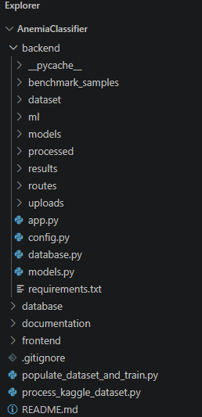
Fig 1: Project directory structure of AnemiaClassifier in Visual Studio Code

Procedure:
- Collect a labelled clinical-image dataset (Normal / Anemia) and organize it into backend/dataset/train and backend/dataset/test folders.
- Run process_kaggle_dataset.py to clean, split and organize the raw dataset into the project's dataset structure.
- Launch the Flask application (app.py) and open the web front-end in the browser.
- Load / upload a clinical image (conjunctiva, fingernail or blood smear), or click an instant benchmark sample, through the interface (Step 1).

- Preprocess the image — resize to 224×224, convert to RGB, apply Gaussian denoising (3×3 kernel) and CLAHE contrast enhancement on the L channel, and normalize pixel values to [0, 1] (Step 2).
- Extract a 128-dimensional handcrafted feature vector from the preprocessed image using colour histograms (96 bins), spatial gradients and Sobel edge energy descriptors (32 bins) (Step 3).
- Train the Multi-Layer Perceptron (MLP) classifier on the extracted features (populate_dataset_and_train.py) using the Adam optimizer with L2 regularization for 15 epochs, and save the trained model to backend/models/anemia_model.pkl (Step 4).
- Feed the extracted feature vector of the uploaded image to the trained model to obtain the predicted class (Normal / Anemia) with a confidence percentage (Step 5).
- Evaluate the trained model on the held-out test set and compute Accuracy, Precision, Recall, F1-score and the Confusion Matrix (Step 6).
- Log every prediction (filename, predicted class, confidence, timestamp) into the SQLite database (database/anemia.db) and display the prediction history (Step 7).

Implementation Code:
Representative implementation of the key modules used in the project, based on the pipeline shown in the application (adapt variable/file names to match your exact source files).

Image Preprocessing (ml/preprocessing.py)
import cv2
import numpy as np
def preprocess_image(image_path, target_size=(224, 224)): img = cv2.imread(image_path)
img = cv2.cvtColor(img, cv2.COLOR_BGR2RGB) # RGB conversion img = cv2.resize(img, target_size) # Resize to 224x224
img = cv2.GaussianBlur(img, (3, 3), 0) # Noise reduction (3x3 kernel) lab = cv2.cvtColor(img, cv2.COLOR_RGB2LAB)
l, a, b = cv2.split(lab)
clahe = cv2.createCLAHE(clipLimit=2.0, tileGridSize=(8, 8))
l = clahe.apply(l) # CLAHE on L channel img = cv2.cvtColor(cv2.merge((l, a, b)), cv2.COLOR_LAB2RGB)
img = img.astype(np.float32) / 255.0 # Normalize to [0, 1]
return img
- Feature Extraction (ml/feature_extraction.py)
import cv2
import numpy as np
def extract_features(img):
# Colour histogram: 32 bins x 3 channels = 96 features hist_feats = []
for ch in range(3):
hist = cv2.calcHist([img], [ch], None, [32], [0, 1]) hist_feats.extend(cv2.normalize(hist, hist).flatten())
# Spatial gradients -> Sobel edge energy
gray = cv2.cvtColor((img * 255).astype('uint8'), cv2.COLOR_RGB2GRAY) gx = cv2.Sobel(gray, cv2.CV_64F, 1, 0, ksize=3)
gy = cv2.Sobel(gray, cv2.CV_64F, 0, 1, ksize=3) edge_energy = np.sqrt(gx**2 + gy**2)

# Sobel edge-energy histogram: 32 features edge_hist, _ = np.histogram(edge_energy, bins=32) edge_hist = edge_hist / (edge_hist.sum() + 1e-8)
features = np.array(hist_feats + list(edge_hist), dtype=np.float32)
return features # 96 + 32 = 128-dimensional feature vector
- Model Training (populate_dataset_and_train.py)
from sklearn.neural_network import MLPClassifier from sklearn.model_selection import train_test_split import joblib, numpy as np
X = np.load('processed/features.npy') # (n_samples, 128)
y = np.load('processed/labels.npy') # 0 = Normal, 1 = Anemia X_train, X_val, y_train, y_val = train_test_split(
X, y, test_size=0.2, stratify=y, random_state=42) model = MLPClassifier(
hidden_layer_sizes=(64, 32), activation='relu', solver='adam',
alpha=0.001, # L2 regularization max_iter=15,
random_state=42) model.fit(X_train, y_train)
print('Validation accuracy:', model.score(X_val, y_val))
joblib.dump(model, 'backend/models/anemia_model.pkl')

Prediction Route (backend/routes/predict.py)
from flask import Blueprint, request, jsonify import joblib
from ml.preprocessing import preprocess_image
from ml.feature_extraction import extract_features predict_bp = Blueprint('predict', name )
model = joblib.load('backend/models/anemia_model.pkl') CLASSES = ['Normal', 'Anemia'] @predict_bp.route('/predict', methods=['POST'])
def predict():
file = request.files['image']
path = f'backend/uploads/{file.filename}' file.save(path)
img = preprocess_image(path)
features = extract_features(img).reshape(1, -1) proba = model.predict_proba(features)[0] pred_idx = proba.argmax()
result = {
'prediction': CLASSES[pred_idx],
'confidence': round(float(proba[pred_idx]) * 100, 1),
'anemia_prob': round(float(proba[1]) * 100, 1),
'normal_prob': round(float(proba[0]) * 100, 1)
}
return jsonify(result)

Saving Prediction History (database.py)
import sqlite3, datetime
def log_prediction(filename, prediction, confidence): conn = sqlite3.connect('database/anemia.db')
cur = conn.cursor()
cur.execute('''CREATE TABLE IF NOT EXISTS history ( id INTEGER PRIMARY KEY AUTOINCREMENT,
filename TEXT, prediction TEXT, confidence REAL, created_at TEXT)''')

cur.execute('INSERT INTO history (filename, prediction, confidence, created_at) ' 'VALUES (?, ?, ?, ?)',
(filename, prediction, confidence, datetime.datetime.now().isoformat()))
conn.commit()
conn.close()

Output (Step-by-Step Screenshots):
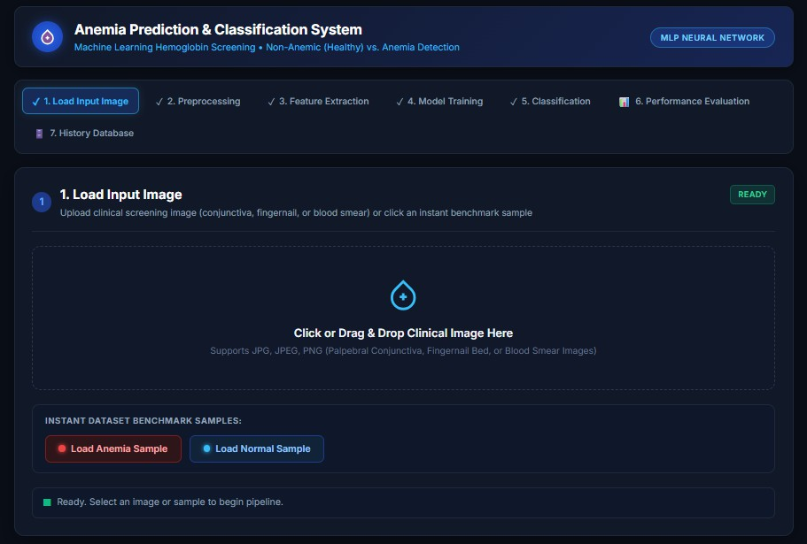
Fig 2: Step 1 — Load Input Image: interface to upload a clinical image or load a benchmark sample (Anemia / Normal)

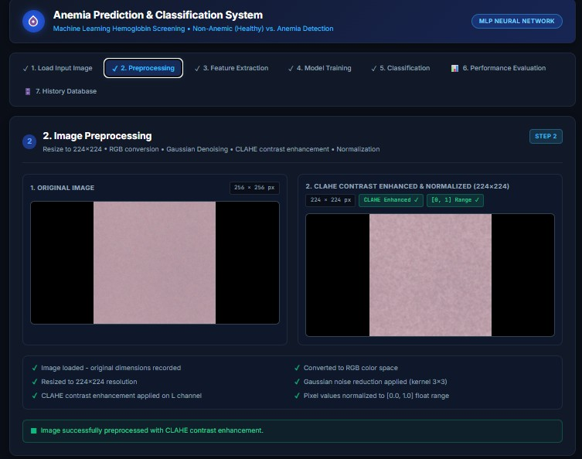
Fig 3: Step 2 — Image preprocessing: original image vs. CLAHE contrast-enhanced & normalized (224×224) image
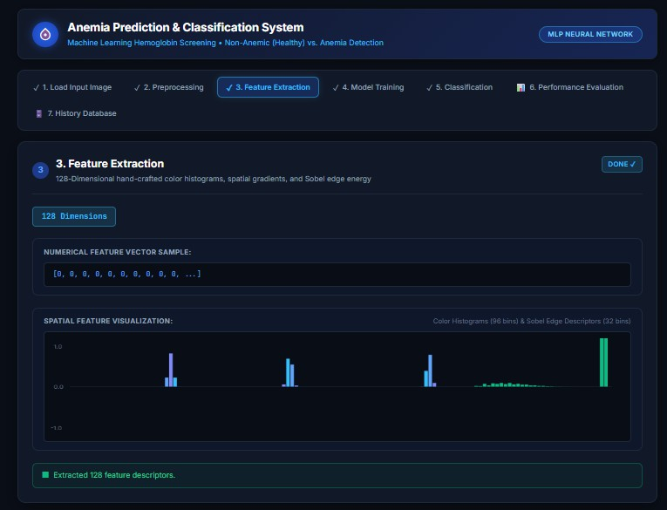
Fig 4: Step 3 — Feature extraction: 128-dimensional feature vector and spatial feature visualization

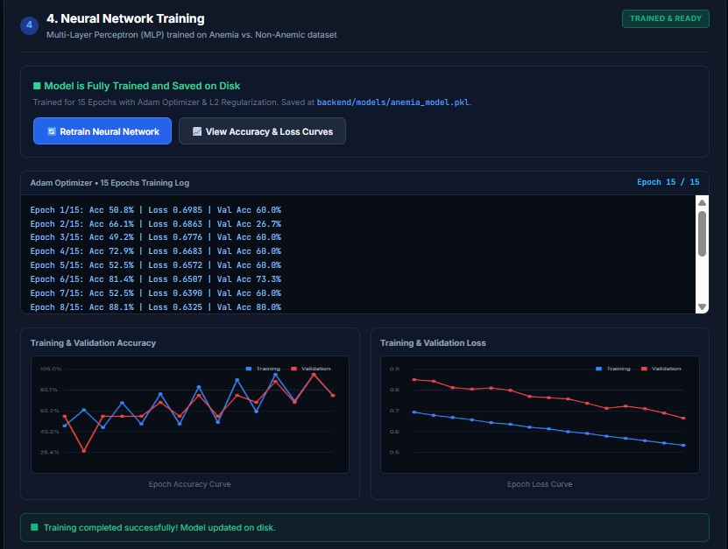
Fig 5: Step 4 — Neural network training completed: epoch-by-epoch log (Adam optimizer, L2 regularization, 15 epochs) with training & validation accuracy and loss curves
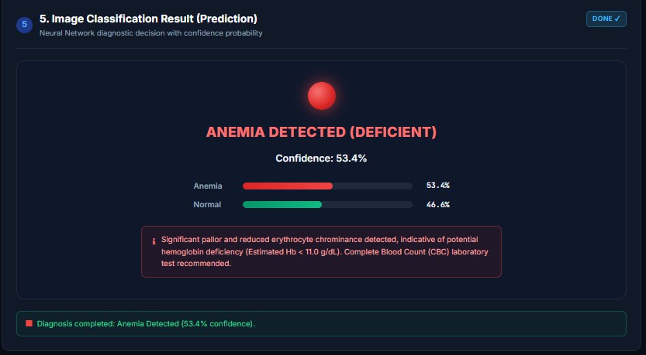
Fig 6: Step 5 — Classification result: Anemia Detected, 53.4% confidence

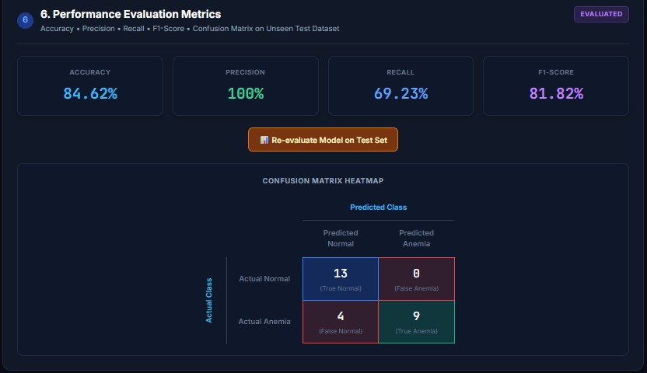
Fig 7: Step 6 — Performance evaluation metrics (Accuracy 84.62%, Precision 100%, Recall 69.23%, F1-Score 81.82%) and confusion matrix
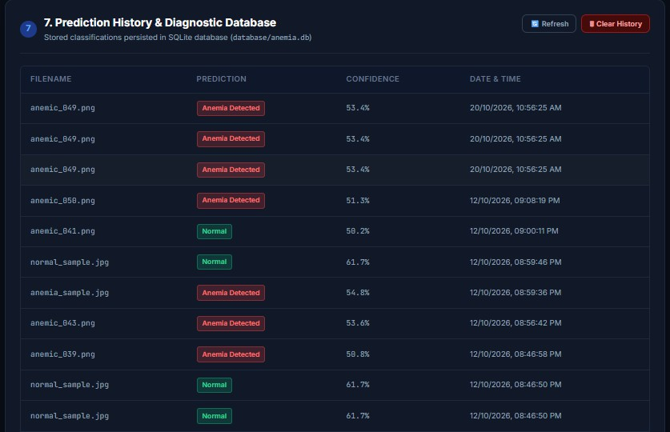
Fig 8: Step 7 — Prediction history log persisted in the SQLite diagnostic database

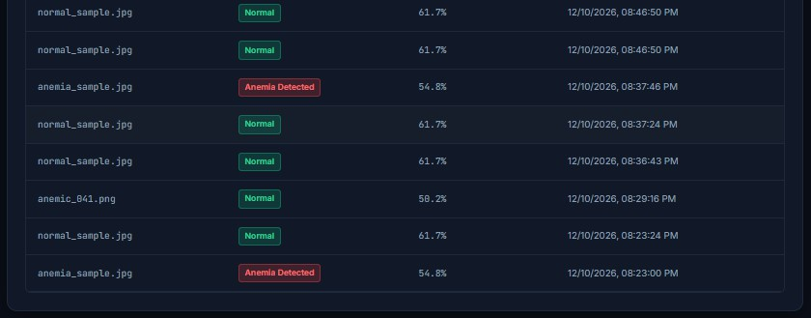
Fig 9: Step 7 — Prediction history log (continued)

Result:
A web-based Anemia Image Classification system was successfully designed and implemented using a Flask backend, an MLP neural network classifier (scikit-learn), and an SQLite database. Clinical images are preprocessed, a 128-dimensional feature vector is extracted, and the trained MLP model classifies the image as Normal or Anemia with a confidence score. On the held-out test set, the model achieved an Accuracy of 84.62%, Precision of 100%, Recall of 69.23%, and an F1-Score of 81.82%, and every prediction is logged to a diagnostic history database.

