PROJECT PHASE DOCUMENTATION
ServiceNow – Client Script & UI Policy Implementation
Evidence prepared from the project demonstration video

Project | Platform | Documentation | Phases
Client Script & UI Policy (Incident) | ServiceNow | Video-based phase report | 8

Purpose: This document divides the project demonstration into eight standard software-project phases. Screenshots are taken directly from the uploaded demonstration video and placed under the phase where the corresponding activity is demonstrated.

1. Brainstorming & Ideation Phase
The project begins by identifying the idea of improving the Incident process using ServiceNow configuration features. The video shows the project environment and the Build Agent/project workspace used to establish the implementation context.

Activities
- Identify the problem and project idea
- Define the intended ServiceNow area of implementation
- Establish the initial project workspace
Phase Output: Initial project concept and implementation direction.
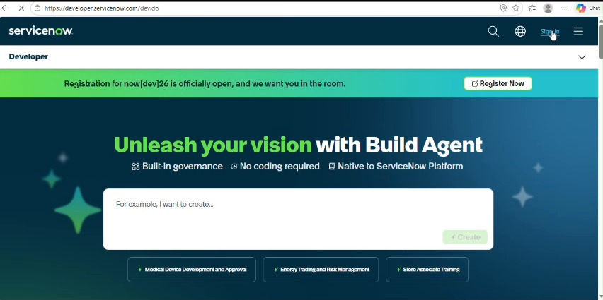
Figure: Evidence from the uploaded project demonstration video

2. Requirement Analysis Phase
The requirements are represented through the project task and its description. The video shows the Incident-related requirements and the expected behaviour to be implemented using Client Script and UI Policy.

Activities
- Study the Incident form requirements
- Identify fields and user-interface behaviour to be controlled
- List the expected validation or visibility behaviour
Phase Output: A clear set of functional requirements for the Incident form.
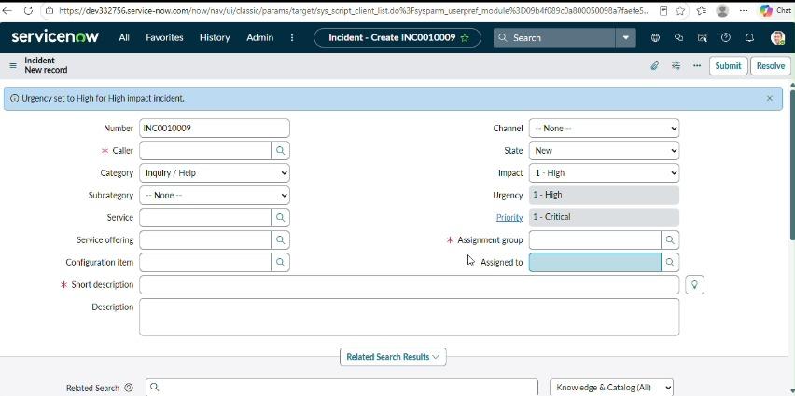
Figure: Evidence from the uploaded project demonstration video

3. Project Design Phase
The design phase converts the requirements into a ServiceNow form-level solution. The video shows the Incident form configuration area, including fields, controls and configuration choices that support the required behaviour.

Activities
- Design the form interaction
- Decide where Client Script and UI Policy are applied
- Define field states and user interaction rules
Phase Output: A technical design for the Incident form behaviour.
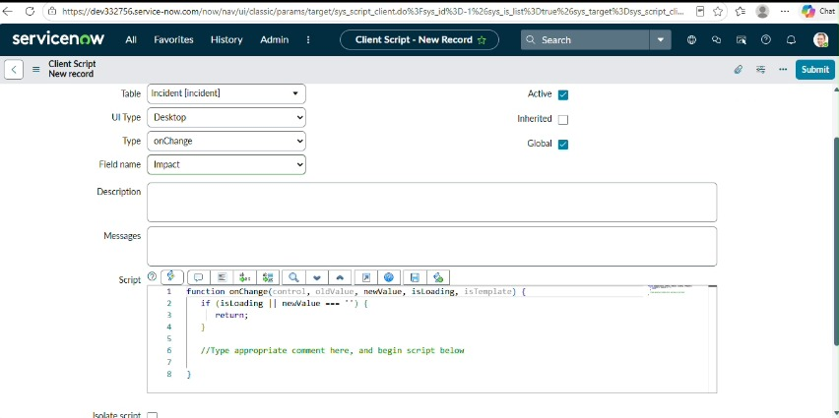
Figure: Evidence from the uploaded project demonstration video

4. Project Planning Phase
The project progress area is used to organize the implementation work. The video shows project activities and progress items that help structure the work before and during development.

Activities
- Break the work into implementation activities
- Arrange activities in a logical order
- Track progress against the project requirements
Phase Output: An organized implementation plan and progress checklist.
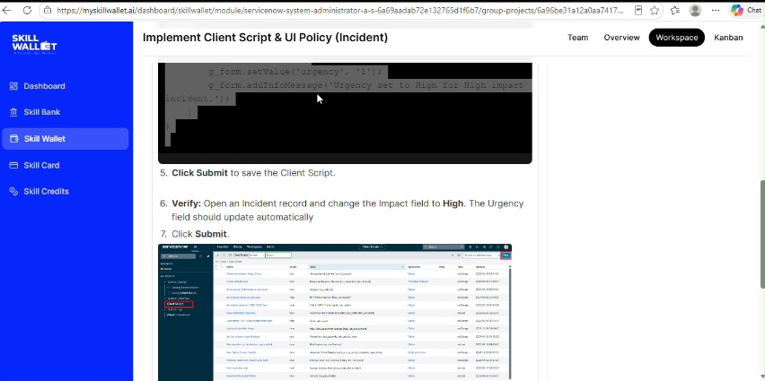
Figure: Evidence from the uploaded project demonstration video

5. Project Development Phase
The development phase is demonstrated by configuring the ServiceNow Incident form and entering the required script/configuration. The video shows the actual development screens used to implement the requested behaviour.

Activities
- Create/configure the required Client Script
- Configure the related UI Policy/form settings
- Save the implementation and review the configuration
Phase Output: Implemented ServiceNow configuration and script logic.
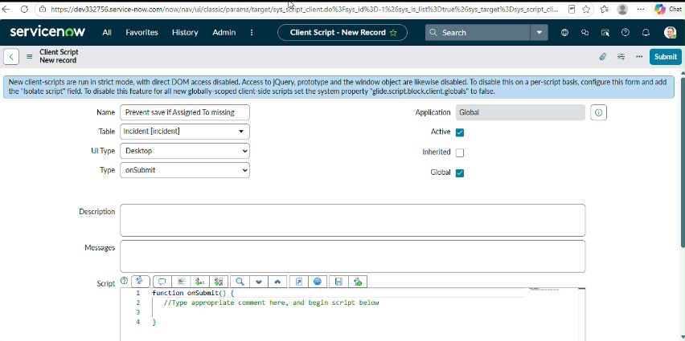
Figure: Evidence from the uploaded project demonstration video

6. Project Testing Phase
Testing is performed by checking the configured Incident form and observing how the fields and validation respond to the implemented rules. The video includes form states and validation feedback that can be used to verify the configuration.

Activities
- Open the configured Incident form
- Enter or change relevant field values
- Verify the expected UI/validation response
- Correct configuration issues if required
Phase Output: Verified form behaviour and validation response.
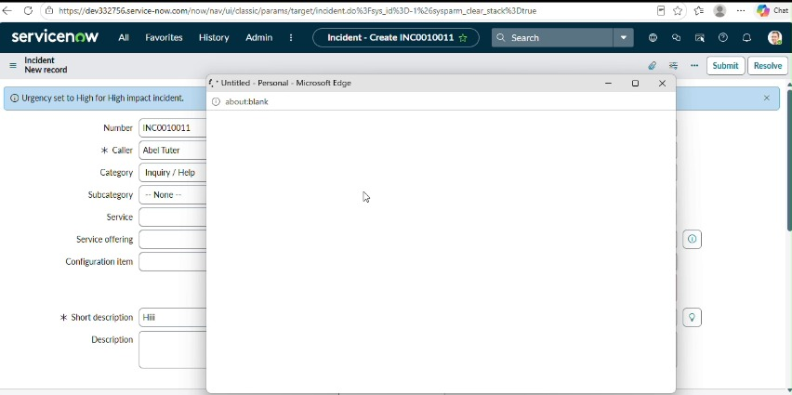
Figure: Evidence from the uploaded project demonstration video

7. Project Documentation Phase
The project information, implementation details and progress are consolidated into a documented project view. The video shows the project description/progress area that records what has been implemented and what remains to be completed.

Activities
- Record the project objective and requirements
- Document implementation activities
- Capture progress and supporting evidence
Phase Output: A documented record of the implementation and project progress.
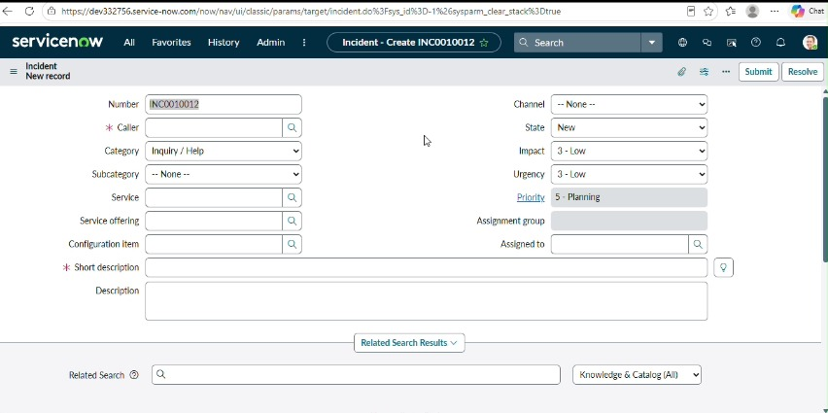
Figure: Evidence from the uploaded project demonstration video

8. Project Demonstration Phase
The final phase presents the completed work. The video returns to the project overview/progress screen and demonstrates the implemented Incident configuration, providing evidence that the project work has been completed and can be presented.

Activities
- Present the implemented solution
- Demonstrate the configured Incident behaviour
- Show project progress and final evidence
Phase Output: Final project demonstration and presentation evidence.
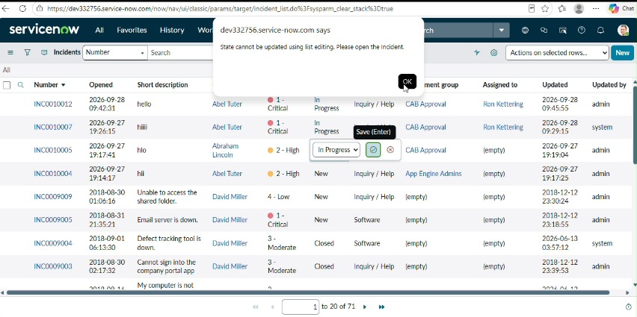
Figure: Evidence from the uploaded project demonstration video

Overall Project Flow
Phase | Main Focus | Evidence in Video
Brainstorming & Ideation Phase | Identify the problem and project idea | Screenshot included
Requirement Analysis Phase | Study the Incident form requirements | Screenshot included
Project Design Phase | Design the form interaction | Screenshot included
Project Planning Phase | Break the work into implementation activities | Screenshot included
Project Development Phase | Create/configure the required Client Script | Screenshot included
Project Testing Phase | Open the configured Incident form | Screenshot included
Project Documentation Phase | Record the project objective and requirements | Screenshot included
Project Demonstration Phase | Present the implemented solution | Screenshot included

Note: The phase descriptions are organized from the visible workflow in the demonstration video. Where a standard project phase is not shown as a separate screen, the closest corresponding project activity/evidence in the video has been placed under that phase.

