2. Requirement Analysis Phase
Project: Implement Client Script & UI Policy (ServiceNow)

Phase Objective
The requirements are identified from the project instructions shown in the video. The required behavior, fields, conditions, and expected form-level changes are reviewed before implementation.

Activities Covered
- Study the given project instructions.
- Identify required fields, conditions and expected behavior.
- Separate functional requirements from the final expected result.

Screenshots from the Project Video
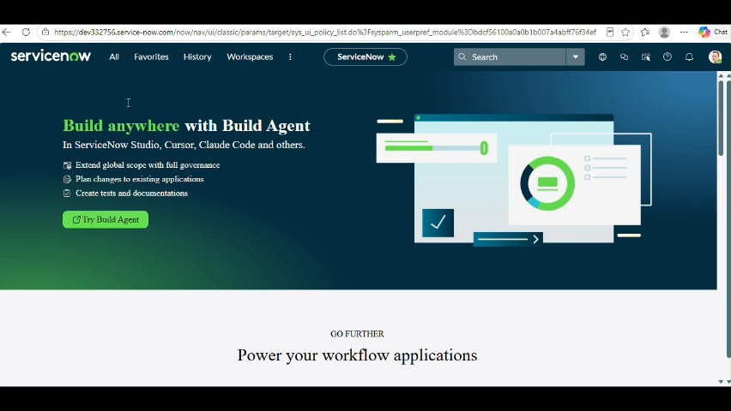
Figure 1: Project video screen at approximately 38 seconds.
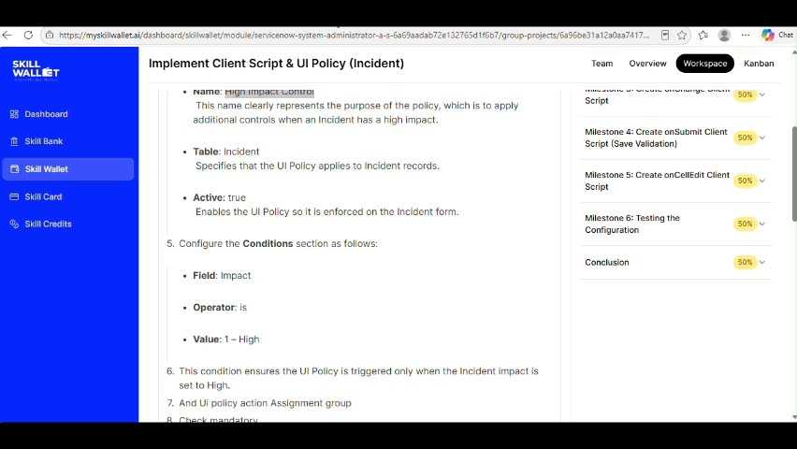
Figure 2: Project video screen at approximately 54 seconds.
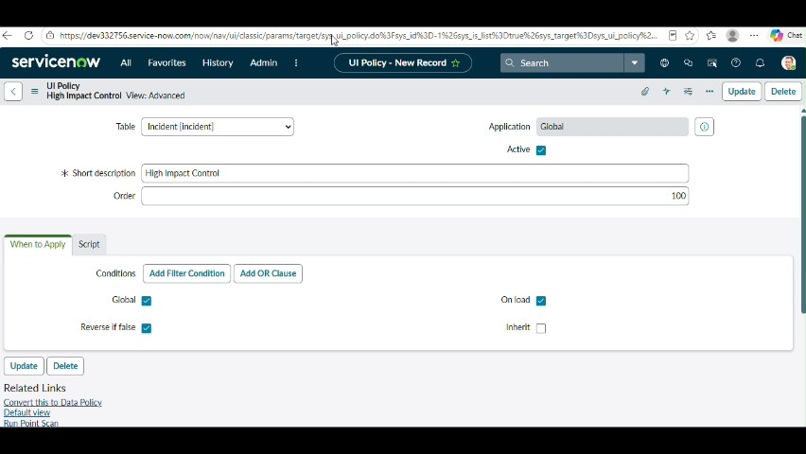
Figure 3: Project video screen at approximately 72 seconds.
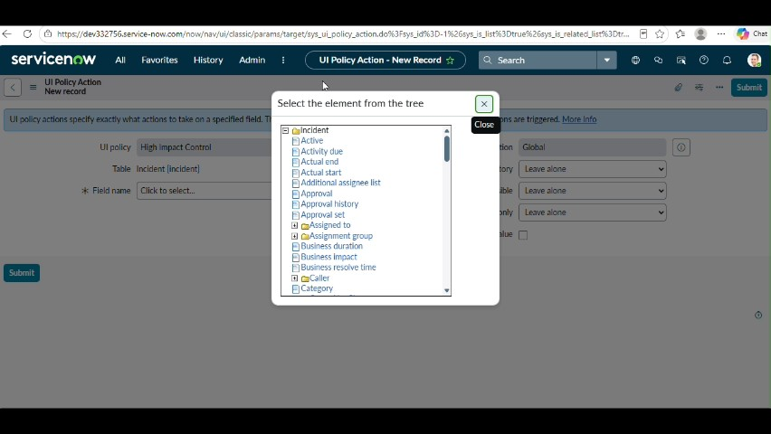
Figure 4: Project video screen at approximately 83 seconds.
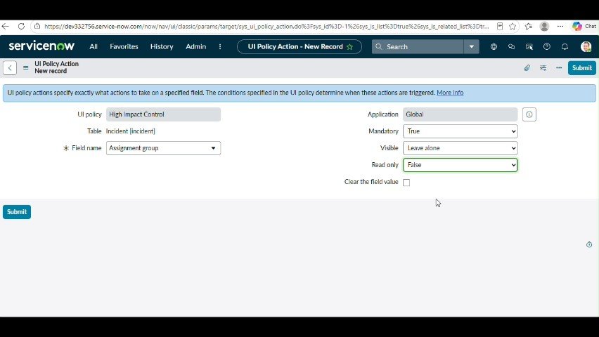
Figure 5: Project video screen at approximately 90 seconds.

Phase Outcome
The required inputs, conditions and expected form behavior are identified before implementation.
Prepared from the supplied project demonstration video

