1. Brainstorming & Ideation Phase
Project: Implement Client Script & UI Policy (ServiceNow)

Phase Objective
This phase presents the initial project idea and the overall ServiceNow task shown in the video. The project focuses on implementing and demonstrating Client Script and UI Policy functionality on a ServiceNow form.

Activities Covered
- Identify the project idea and expected outcome.
- Review the project overview and initial interface.
- Understand the main ServiceNow task to be implemented.

Screenshots from the Project Video
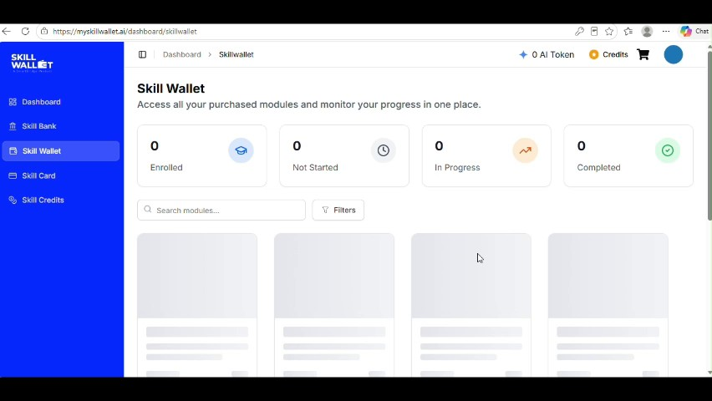
Figure 1: Project video screen at approximately 0 seconds.
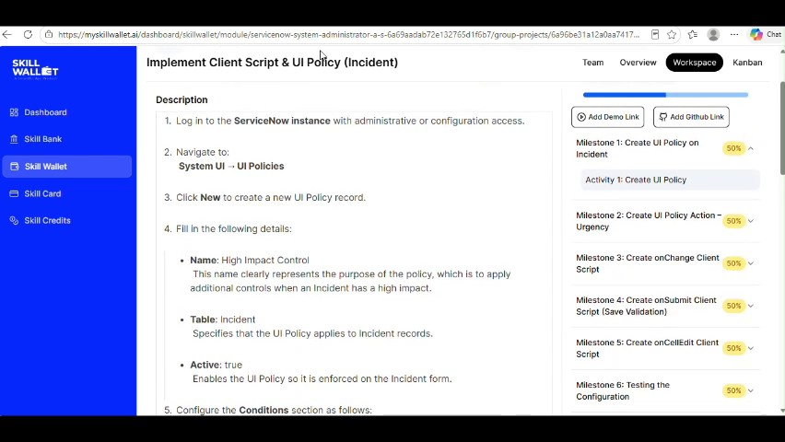
Figure 2: Project video screen at approximately 18 seconds.
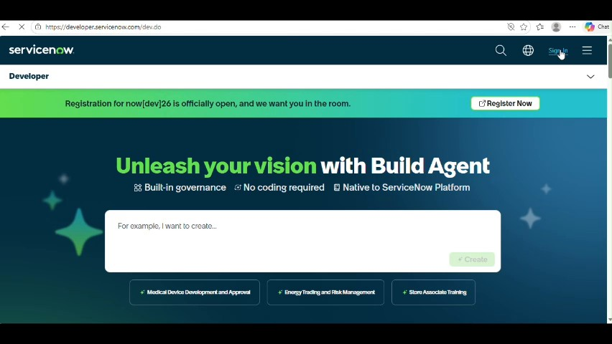
Figure 3: Project video screen at approximately 24 seconds.
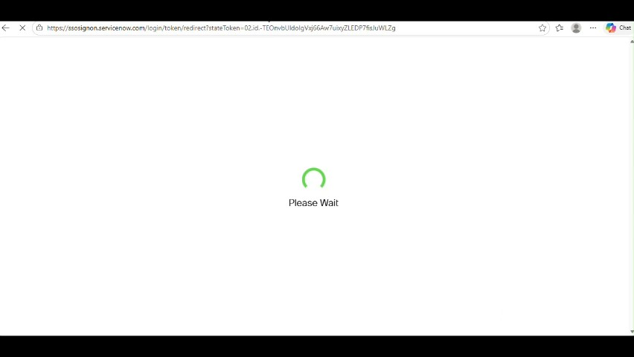
Figure 4: Project video screen at approximately 29 seconds.
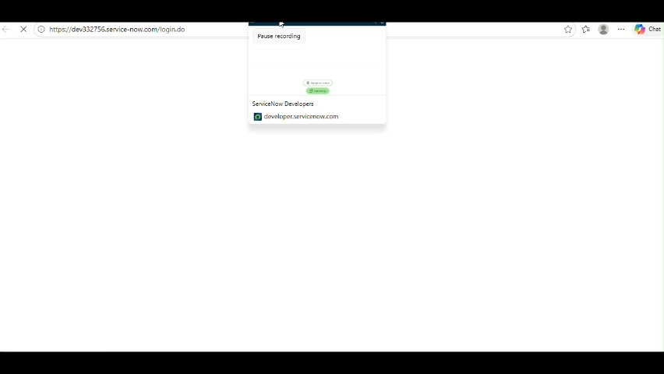
Figure 5: Project video screen at approximately 34 seconds.

Phase Outcome
A clear understanding of the project concept and intended ServiceNow functionality is established.
Prepared from the supplied project demonstration video

