**A SYSTEM FOR RECOMMENDATION OF RESTAURANTS IN BANGALORE**

**Introduction:**

**Problem background:**

Bangalore is the capital city of Karnataka, India. It is one of the most populated cities in India. The diversity of the cuisine available is reflective of its diversity. Bangalore has Thai restaurants, Japanese restaurants, Korean, North Indian, South Indian, and the list wouldn't end. Therefore, the idea of developing a recommender system for restaurants in Bangalore was used as an idea for this project.

**Problem description:**

Expectations from this recommender system is to get answer for the questions, and in such a way that it uncovers all the perspective of managing recommendations. It is sighted to show:

1. What types of restaurants are present in a particular area?

2. Where are the similar restaurant present based on a preference to particular food?

3. How do different restaurants rank with respect to users’ preferences?

**Target Audience and success rate:**

Target audience includes every person residing in Bangalore. People could simply decide to look for a similar restaurant all the time because they are addicted to a specific category of food. So, target for this project is basically everyone who is exploring different places or similar places. With restaurants evolving, new food categories emerge, we need a system that could help us. It is impossible for a person to visit each place and then decide. On the other hand, Computers are good at remembering things, and Machine learning technology can serve us as our personal guide. So, this project would serve as personal assistance and success rate could certainly increase with time.

1. **Data:**

**Data requirements:**

1. Its geographical coordinates (latitude and longitude) to find out where exactly it is located.

2. Population of the neighborhood where the restaurant is located.

3. Average income of neighborhood to know how much the restaurant is worth.

Data requirements in brief:

1. To access location of a restaurant, it’s Latitude and Longitude is to be known so that we can point at its coordinates and create a map displaying all the restaurants with its labels respectively.

2. Population of a neighborhood is very important factor in determining a restaurant's growth and number of customers who turn up to eat. Logically, the more the population of a neighborhood, the more people will be interested to walk openly into a restaurant and less the population, a smaller number of people frequently visit a restaurant. Also, if more people visit, better the restaurant is rated because it is accessed by different people with different taste. Hence is very important factor.

3. Income of a neighborhood is also very important factor as population was. Income is directly proportional to richness of a neighborhood. If people in a neighborhood earns more than an average income, then it is very much possible that they will spend more however not always true with very less probability. So, a restaurant assessment is proportional to income of a neighborhood.

**Data was collected from the following:**

1. https://en.wikipedia.org/wiki/List_of_neighbourhoods_in_Bangalore (geographical coordinates)
2. https://en.wikipedia.org/wiki/List_of_Indian_cities_by_GDP_per_capita (Population by neighborhood)
3. https://indikosh.com/dist/655489/bangalore (per capita income)

**Methodology:**

**Exploratory analysis:**

Scrapping the data from different sources and then combining it to form a single-ton dataset is a difficult task. To do so, we need to explore the current state of dataset and then list up all the features needed to be fetched.

Exploring the dataset is important because it gives you initial insights and may help you to get partial idea of the answers that you are looking to find out from the data.

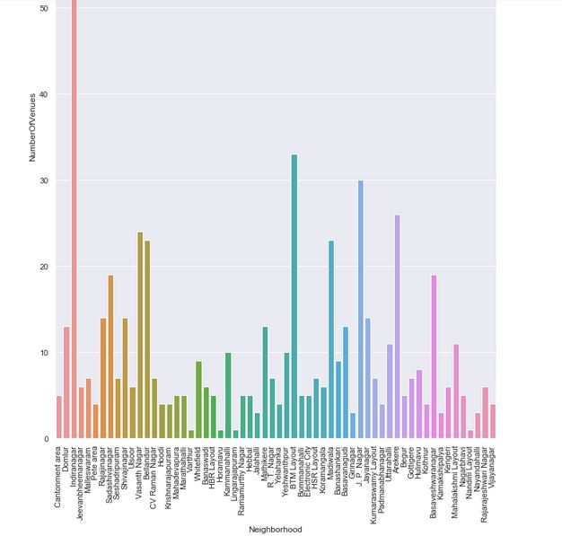

Also, while producing graph for number of cluster, I produced a graph to explore all the values for clusters and then finding the best by exploring the elbow graph.

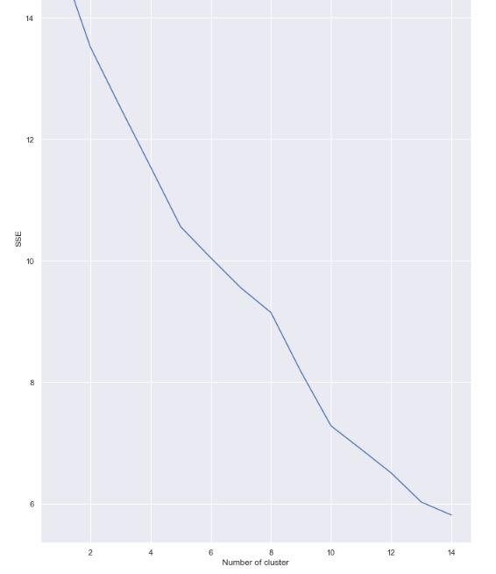

**Inferential analysis:**

Most important factors while building the recommender system were population and income. They are the most import factor because they have a nonlinear relationship according to our dataset.

It needed to make some inferential analysis to understand this nonlinear relationship. As the amount of population increases, it does not necessarily mean that average income of a neighborhood will also increase. It is true to most of the case but also many cases differ to follow this trend. Similarly, a neighborhood with a smaller number of people may not necessarily have less average income. It is possible to have a smaller number of people and more income and vice versa. This can be inferred from the following graph:

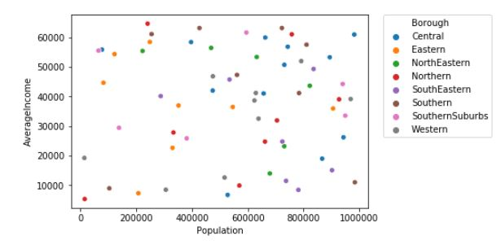

**Result:**

The result of the recommender system is that it produces a list of top restaurants and the most common venue item that the user can enjoy. During the runtime of the model, a simulation was done by taking ‘Whitefield’ as the neighborhood and then processed through our model so that it could recommend neighborhoods with similar characters as that of ‘Whitefield’.

The following image shows the result:

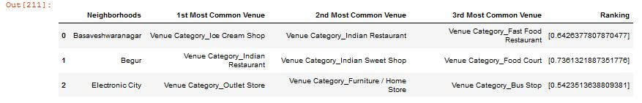

**Discussion:**

Since there was a nonlinear relationship between income and population, it can be concluded that we must always perform inferential approach to find relationship among different set of features. Also during clustering, similar neighborhoods must be dumped into the right cluster.

The following graph shows the clusters:

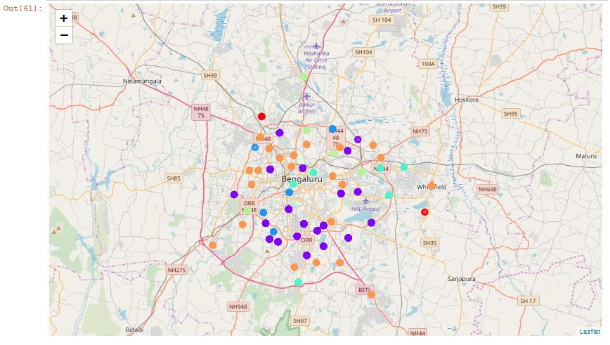

Another observation that we can make is that choosing number of clustering could produce very diverse results. Some may be over fitted, or some may be under fitted. Hence analysis of number of clusters must be done. Ref elbow_graph in the Methodology section.

**Conclusion:**

The recommender system is a system that considers factors such as population, income and makes use of Foursquare API to determine nearby venues. It is a powerful data driven model whose efficiency may decrease with more data, but accuracy will increase. It will help users to finish their hunger by providing the best recommendation to fulfil all their needs.