Detecting Unusual Bank Transactions Using Machine Learning: An Isolation Forest Approach
By Dharshini

Introduction
Every day, banks process thousands or even millions of financial transactions. These transactions include deposits, withdrawals, transfers, payments, and other financial activities. With such a large volume of data, manually monitoring every transaction is difficult and time-consuming.
This is where Data Science and Machine Learning can provide valuable support.
In this project, I developed a Bank Transaction Analytics and Anomaly Detection system using Machine Learning. The goal was to analyze transaction behavior, identify unusual transaction patterns, and generate useful insights that can support financial monitoring.
The project uses Python, Pandas, NumPy, Matplotlib, Seaborn, Scikit-learn, and Streamlit, with the Isolation Forest algorithm as the main anomaly detection technique.

The Problem
Banks need to continuously monitor financial transactions to identify activities that differ significantly from normal transaction behavior.
A transaction may be unusual because of an unusually large transaction amount, an unexpected balance change, unusual transaction timing, abnormal combinations of transaction characteristics, or behavior that differs from historical patterns.
The objective of this project was to build a machine-learning-based workflow capable of identifying statistically unusual transactions for further investigation.

Project Objectives
1. Analyze bank transaction records.
2. Clean and preprocess the transaction data.
3. Perform Exploratory Data Analysis (EDA).
4. Create meaningful transaction features.
5. Select and scale features for machine learning.
6. Detect unusual transactions using Isolation Forest.
7. Evaluate the detected anomalies.
8. Generate business-oriented insights.
9. Deploy the model through a Streamlit application.

Understanding the Dataset
The dataset was based on bank account transaction records. Important fields included Date, Description, Withdrawal (Dr.), Deposit (Cr.), Balance, and Reference Number.
The dataset contained both debit and credit transactions, making it possible to study different transaction behaviors.

Exploratory Data Analysis
Exploratory Data Analysis was performed before building the machine learning model. The analysis examined the distribution of debit and credit transactions, monthly transaction amounts, frequently occurring transaction descriptions, account balance distribution, and transaction amount distribution.
The following figures are taken directly from the project's Jupyter Notebook.
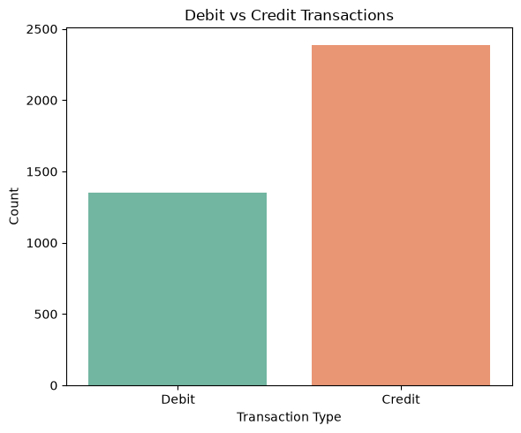
Figure 1: Debit vs Credit Transaction Distribution
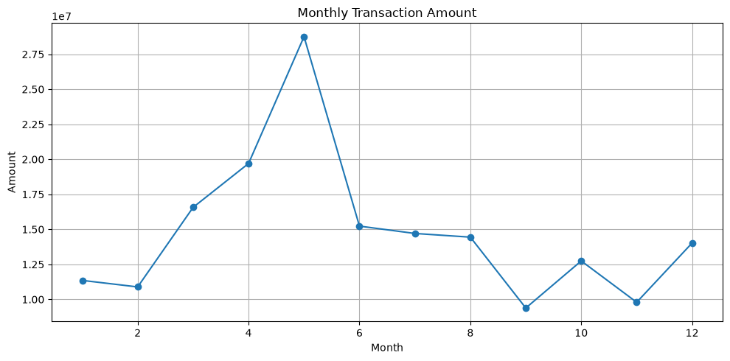
Figure 2: Monthly Transaction Amount

Data Cleaning and Feature Engineering
Before applying machine learning, the transaction data was cleaned and converted into usable numerical and date-based features. Transaction Amount was created from withdrawal and deposit values. Additional features included Transaction Type, Month, Quarter, Is Weekend, High Value Transaction, and Balance Difference.
These engineered variables helped represent transaction behavior more effectively for anomaly detection.

Why Isolation Forest?
For this project, I used the Isolation Forest algorithm for anomaly detection.
Isolation Forest is an unsupervised machine learning algorithm designed to identify observations that are different from the majority of the dataset. Normal observations generally require more splitting operations to isolate, while unusual observations tend to be isolated more easily.
This makes Isolation Forest useful for transaction anomaly detection when reliable fraud labels are not available.

Detecting Anomalies
The processed transaction data was passed to the Isolation Forest model. The model generated an anomaly prediction for each transaction, represented as Normal or Anomaly.
An anomaly does not automatically mean fraud. It means that the transaction has characteristics that differ from the patterns learned from the available data. This distinction is important when applying machine learning to financial systems.
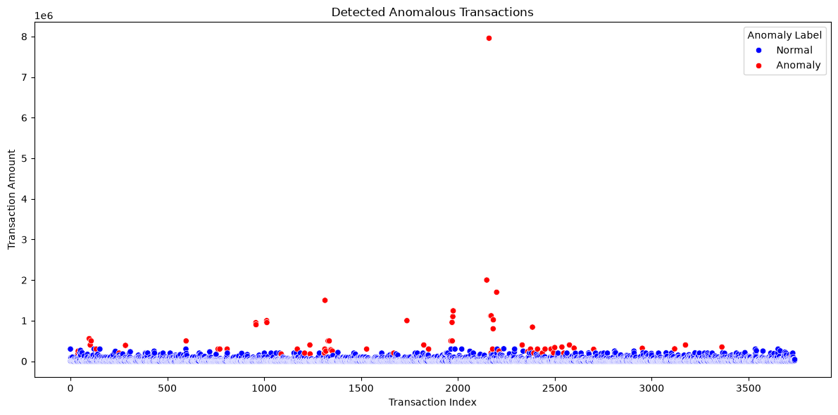
Figure 3: Normal vs Anomalous Transactions

Business Insights
The real value of a machine learning project is not only the model itself. The results should help answer practical questions such as which transactions appear unusual, whether unusually large transactions are being detected, whether anomalies are concentrated in certain periods, and which transactions should receive additional review.
A bank could use these outputs as a decision-support mechanism for analysts, helping them prioritize transactions for investigation.
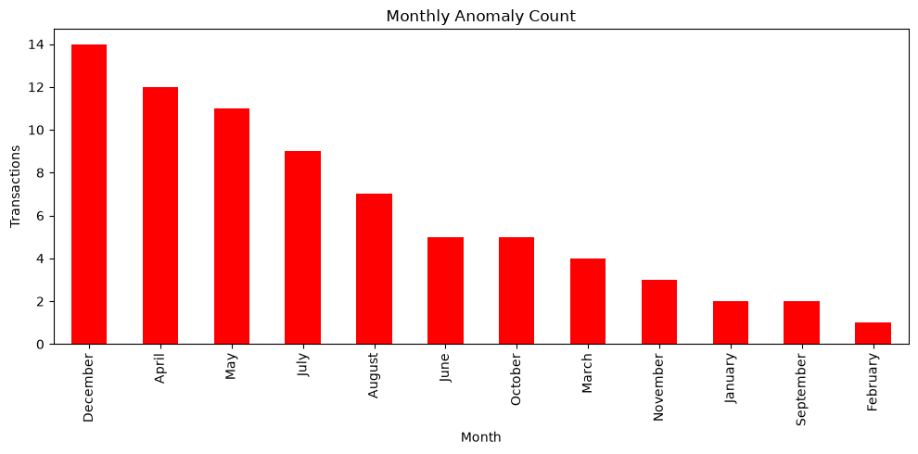
Figure 4: Monthly Anomaly Count

Streamlit Deployment
To make the project more practical, I created a Streamlit web application. The application supports both single-transaction checking and batch CSV analysis.
For a single transaction, users can enter transaction information and receive a Normal or Anomaly result together with an anomaly score. For batch analysis, users can upload a CSV file, process multiple transactions, and download the results.
The Streamlit interface is the final presentation layer of the project and allows the trained model to be used without opening the Jupyter Notebook.
STREAMLIT SCREENSHOT TO ADD: Run the project's app.py with Streamlit, take a screenshot of the working interface, and insert it here. I have not fabricated a screenshot because the uploaded notebook contains the Streamlit source code but not an actual rendered application screenshot.

What I Learned
This project helped me understand that building a machine learning solution involves much more than training an algorithm.
The complete workflow is Data → Cleaning → EDA → Feature Engineering → Scaling → Machine Learning → Evaluation → Business Insights → Deployment.
I also learned that anomaly detection results must be interpreted carefully. A machine learning model should assist human analysts rather than automatically declare a transaction fraudulent.

Future Improvements
Future versions could include Local Outlier Factor, One-Class SVM, Autoencoder-based anomaly detection, customer-level behavioral analysis, merchant category information, transaction location, fraud risk scoring, Power BI or Tableau dashboards, real-time monitoring, and cloud deployment.

Conclusion
The Bank Transaction Analytics and Anomaly Detection Using Machine Learning project demonstrates how Data Science can be applied to financial transaction data.
Starting with raw bank transaction records, the project performed data cleaning, exploratory analysis, feature engineering, feature scaling, and anomaly detection using Isolation Forest. The solution was then extended through Streamlit so users can check individual transactions or analyze multiple transactions through a CSV upload.
The project demonstrates an important principle in Data Science: the goal is not simply to build a machine learning model, but to create a complete workflow that transforms raw data into useful information and practical decision support.
Machine Learning does not replace financial investigation — it helps make the investigation more focused and data-driven.

Technologies Used
Python | Pandas | NumPy | Matplotlib | Seaborn | Scikit-learn | Isolation Forest | StandardScaler | Jupyter Notebook | Streamlit

