**Spring Core And Maven, Spring Data JPA**

**Spring Data JPA - Quick Example**

**Answer:**

OrmLearnApplication.java:

package com.cognizant.ormlearn;

import java.util.List;

import org.slf4j.Logger;

import org.slf4j.LoggerFactory;

import org.springframework.boot.SpringApplication;

import org.springframework.boot.autoconfigure.SpringBootApplication;

import org.springframework.context.ApplicationContext;

import com.cognizant.ormlearn.model.Country;

import com.cognizant.ormlearn.service.CountryService;

@SpringBootApplication

public class OrmLearnApplication {

private static final Logger *LOGGER* = LoggerFactory.*getLogger*(OrmLearnApplication.class);

private static CountryService *countryService*;

public static void main(String[] args) {

ApplicationContext context = SpringApplication.*run*(OrmLearnApplication.class, args);

*countryService* = context.getBean(CountryService.class);

*testGetAllCountries*();

}

private static void testGetAllCountries() {

*LOGGER*.info("Start");

List<Country> countries = *countryService*.getAllCountries();

*LOGGER*.debug("countries={}", countries);

*LOGGER*.info("End");

}

}

Country.java:

**package** com.cognizant.ormlearn.model;

**import** jakarta.persistence.Column;

**import** jakarta.persistence.Entity;

**import** jakarta.persistence.Id;

**import** jakarta.persistence.Table;

@Entity

@Table(name = "country")

**public** **class** Country {

@Id

@Column(name = "co_code")

**private** String code;

@Column(name = "co_name")

**private** String name;

**public** String getCode() { **return** code; }

**public** **void** setCode(String code) { **this**.code = code; }

**public** String getName() { **return** name; }

**public** **void** setName(String name) { **this**.name = name; }

@Override

**public** String toString() {

**return** "Country [code=" + code + ", name=" + name + "]";

}

}

CountryRepository.java:

**package** com.cognizant.ormlearn.repository;

**import** org.springframework.data.jpa.repository.JpaRepository;

**import** org.springframework.stereotype.Repository;

**import** com.cognizant.ormlearn.model.Country;

@Repository

**public** **interface** CountryRepository **extends** JpaRepository<Country, String> {

}

CountryService.java:

**package** com.cognizant.ormlearn.service;

**import** java.util.List;

**import** org.springframework.beans.factory.annotation.Autowired;

**import** org.springframework.stereotype.Service;

**import** org.springframework.transaction.annotation.Transactional;

**import** com.cognizant.ormlearn.model.Country;

**import** com.cognizant.ormlearn.repository.CountryRepository;

@Service

**public** **class** CountryService {

@Autowired

**private** CountryRepository countryRepository;

@Transactional

**public** List<Country> getAllCountries() {

**return** countryRepository.findAll();

}

}

Output:

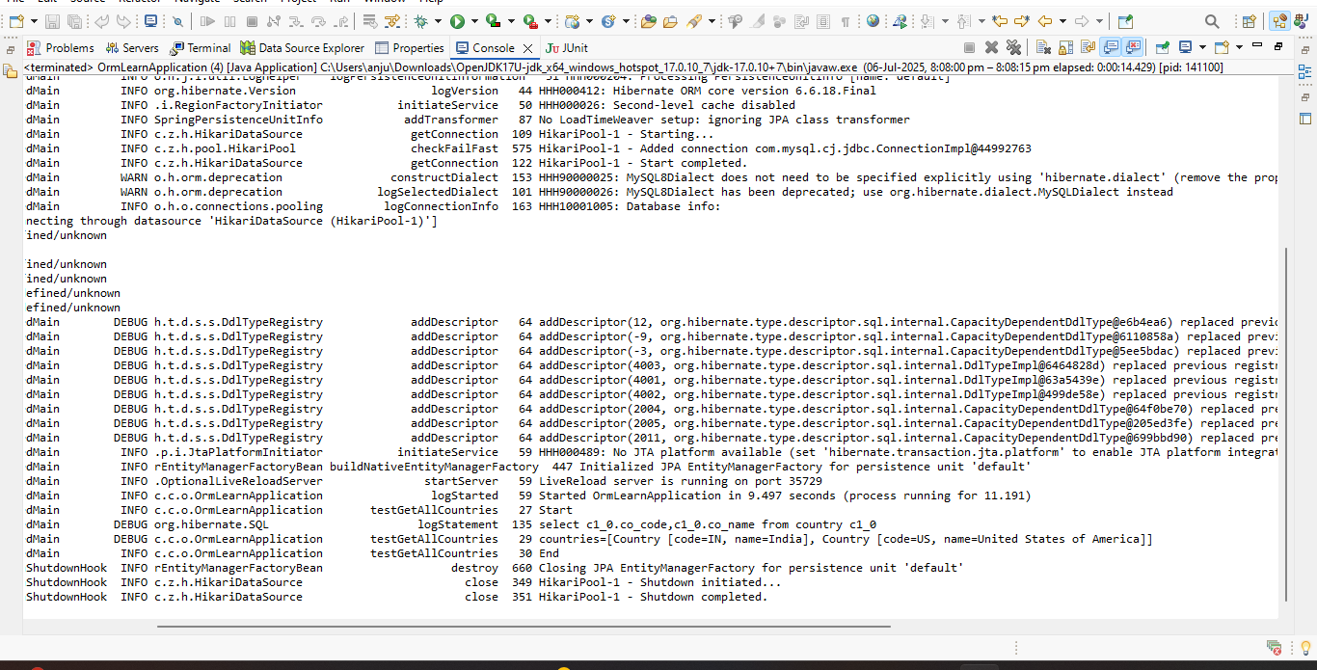

**Difference between JPA, Hibernate and Spring Data JPA**

| **Aspect** | **JPA (Java Persistence API)** | **Hibernate** | **Spring Data JPA** |
| --- | --- | --- | --- |
| **Type** | Specification (JSR 338) | ORM Framework (JPA implementation) | Abstraction layer on top of JPA implementations |
| **Purpose** | Defines standard interfaces and rules for ORM | Implements JPA spec and adds extra features | Simplifies data access by reducing boilerplate |
| **Implementation** | No concrete implementation | Concrete implementation of JPA | Uses existing JPA providers (like Hibernate) |
| **Transaction** | No transaction management | Manages transactions manually | Manages transactions automatically |
| **Boilerplate Code** | N/A (only interfaces and specs) | Requires manual session and transaction code | Minimal code, CRUD methods auto-implemented |
| **Example Use** | Defines EntityManager, Entity, Query, etc. | Use SessionFactory, Session, Transaction | Use Repository interfaces with Spring framework |

**JPA:**

A **standard API** (interface/specification) for managing persistence and ORM in Java.

Specifies how to map Java objects to database tables, query databases, and manage transactions.

**No actual code implementation** — just defines *what* to do, not *how*.

Multiple implementations exist (e.g., Hibernate, EclipseLink).

**Example code:**

public interface EmployeeRepository extends JpaRepository<Employee, Integer> {

}

@Service

public class EmployeeService {

@Autowired

private EmployeeRepository employeeRepository;

@Transactional

public void addEmployee(Employee employee) {

employeeRepository.save(employee);

}

}

Hibernate

An **ORM framework** that implements the JPA specification.

Provides concrete code for JPA interfaces plus **extra features** (e.g., caching, better performance tools).

Requires manual management of sessions and transactions unless you integrate with a container.

**Example code:**

public Integer addEmployee(Employee employee){

Session session = factory.openSession();

Transaction tx = null;

Integer employeeID = null;

try {

tx = session.beginTransaction();

employeeID = (Integer) session.save(employee);

tx.commit();

} catch (HibernateException e) {

if (tx != null) tx.rollback();

e.printStackTrace();

} finally {

session.close();

}

return employeeID;

}

**Exercise 1: Configuring a Basic Spring Application**

**Scenario:**

Your company is developing a web application for managing a library. You need to use the Spring Framework to handle the backend operations.

**Steps:**

1. **Set Up a Spring Project:**
   * Create a Maven project named **LibraryManagement**.
   * Add Spring Core dependencies in the **pom.xml** file.
2. **Configure the Application Context:**
   * Create an XML configuration file named **applicationContext.xml** in the **src/main/resources** directory.
   * Define beans for **BookService** and **BookRepository** in the XML file.
3. **Define Service and Repository Classes:**
   * Create a package **com.library.service** and add a class **BookService**.
   * Create a package **com.library.repository** and add a class **BookRepository**.
4. **Run the Application:**
   * Create a main class to load the Spring context and test the configuration.

**Answer:**

**Pom.xml**

<project xmlns="http://maven.apache.org/POM/4.0.0"

xmlns:xsi="http://www.w3.org/2001/XMLSchema-instance"

xsi:schemaLocation="http://maven.apache.org/POM/4.0.0

https://maven.apache.org/xsd/maven-4.0.0.xsd">

<modelVersion>4.0.0</modelVersion>

<groupId>com.library</groupId>

<artifactId>LibraryManagement</artifactId>

<version>0.0.1-SNAPSHOT</version>

<dependencies>

<!-- Spring Context for ApplicationContext and Beans -->

<dependency>

<groupId>org.springframework</groupId>

<artifactId>spring-context</artifactId>

<version>5.3.32</version>

</dependency>

</dependencies>

</project>

**BookRepository.java**

package com.library.repository;

public class BookRepository {

public void saveBook(String bookName) {

System.out.println("Book saved: " + bookName);

}

}

**BookService.java**

package com.library.service;

import com.library.repository.BookRepository;

public class BookService {

private BookRepository bookRepository;

public void setBookRepository(BookRepository bookRepository) {

this.bookRepository = bookRepository;

}

public void addBook(String bookName) {

System.out.println("Adding book: " + bookName);

bookRepository.saveBook(bookName);

}

}

**applicationContext.xml**

<?xml version="1.0" encoding="UTF-8"?>

<beans xmlns="http://www.springframework.org/schema/beans"

xmlns:xsi="http://www.w3.org/2001/XMLSchema-instance"

xsi:schemaLocation="

http://www.springframework.org/schema/beans

http://www.springframework.org/schema/beans/spring-beans.xsd">

<bean id="bookRepository" class="com.library.repository.BookRepository" />

<bean id="bookService" class="com.library.service.BookService">

<property name="bookRepository" ref="bookRepository" />

</bean>

</beans>

**MainApp.java**

package library;

import org.springframework.context.ApplicationContext;

import org.springframework.context.support.ClassPathXmlApplicationContext;

import com.library.service.BookService;

public class MainApp {

public static void main(String[] args) {

ApplicationContext context =

new ClassPathXmlApplicationContext("applicationContext.xml");

BookService service = (BookService) context.getBean("bookService");

service.addBook("Spring in Action");

}

}

**Output:**

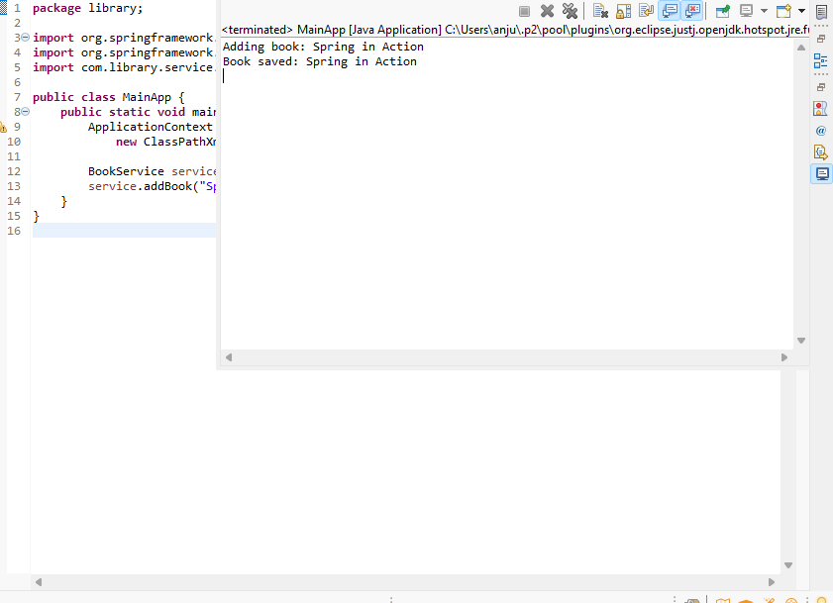

**Exercise 2: Implementing Dependency Injection**

**Scenario:**

In the library management application, you need to manage the dependencies between the BookService and BookRepository classes using Spring's IoC and DI.

**Steps:**

1. **Modify the XML Configuration:**
   * Update **applicationContext.xml** to wire **BookRepository** into **BookService**.
2. **Update the BookService Class:**
   * Ensure that **BookService** class has a setter method for **BookRepository**.
3. **Test the Configuration:**
   * Run the **LibraryManagementApplication** main class to verify the dependency injection.

**Answer:**

**pom.xml**

<project xmlns="http://maven.apache.org/POM/4.0.0"

xmlns:xsi="http://www.w3.org/2001/XMLSchema-instance"

xsi:schemaLocation="http://maven.apache.org/POM/4.0.0

https://maven.apache.org/xsd/maven-4.0.0.xsd">

<modelVersion>4.0.0</modelVersion>

<groupId>com.example</groupId>

<artifactId>LibraryManagementApp</artifactId>

<version>1.0</version>

<dependencies>

<dependency>

<groupId>org.springframework</groupId>

<artifactId>spring-context</artifactId>

<version>5.3.34</version>

</dependency>

<dependency>

<groupId>org.springframework</groupId>

<artifactId>spring-core</artifactId>

<version>5.3.34</version>

</dependency>

<dependency>

<groupId>org.springframework</groupId>

<artifactId>spring-beans</artifactId>

<version>5.3.34</version>

</dependency>

<dependency>

<groupId>org.springframework</groupId>

<artifactId>spring-jcl</artifactId>

<version>5.3.34</version>

</dependency>

</dependencies>

<build>

<sourceDirectory>src/main/java</sourceDirectory>

<resources>

<resource>

<directory>src/main/resources</directory>

</resource>

</resources>

<plugins>

<plugin>

<artifactId>maven-compiler-plugin</artifactId>

<version>3.10.1</version>

<configuration>

<release>17</release>

</configuration>

</plugin>

</plugins>

</build>

</project>

**BookRepository.java**

package com.example.repository;

public class BookRepository {

public void save(String book) {

System.out.println("Saving book: " + book);

}

}

**BookService.java**

package com.example.service;

import com.example.repository.BookRepository;

public class BookService {

private BookRepository bookRepository;

public void setBookRepository(BookRepository bookRepository) {

this.bookRepository = bookRepository;

}

public void addBook(String book) {

System.out.println("Adding book: " + book);

bookRepository.save(book);

}

}

**Library.java**

package com.example;

import com.example.service.BookService;

import org.springframework.context.ApplicationContext;

import org.springframework.context.support.ClassPathXmlApplicationContext;

public class Library {

public static void main(String[] args) {

ApplicationContext context =

new ClassPathXmlApplicationContext("applicationContext.xml");

BookService service = context.getBean("bookService", BookService.class);

service.addBook("Java Programming");

}

}

**Output:**

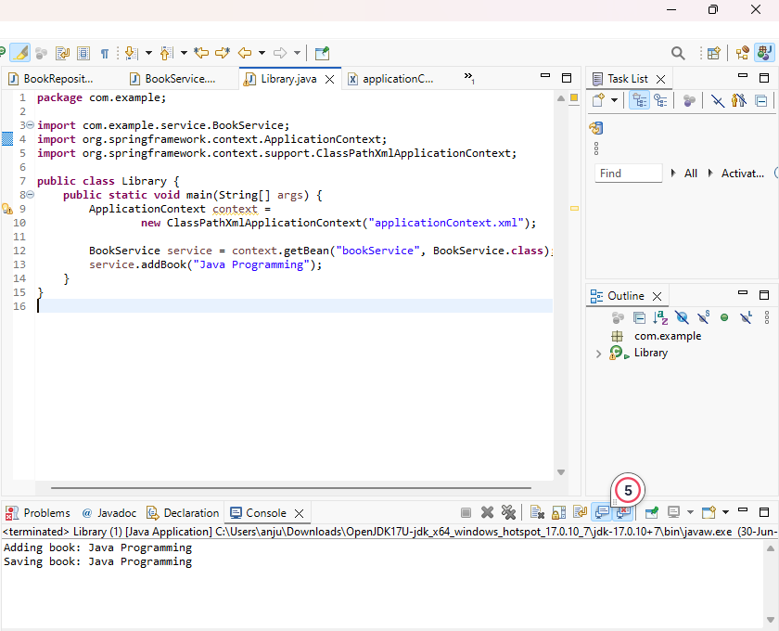

**Exercise 4: Creating and Configuring a Maven Project**

**Scenario:**

You need to set up a new Maven project for the library management application and add Spring dependencies.

**Steps:**

1. **Create a New Maven Project:**
   * Create a new Maven project named **LibraryManagement**.
2. **Add Spring Dependencies in pom.xml:**
   * Include dependencies for Spring Context, Spring AOP, and Spring WebMVC.
3. **Configure Maven Plugins:**
   * Configure the Maven Compiler Plugin for Java version 1.8 in the pom.xml file.

**Answer:**

<project xmlns="http://maven.apache.org/POM/4.0.0"

xmlns:xsi="http://www.w3.org/2001/XMLSchema-instance"

xsi:schemaLocation="http://maven.apache.org/POM/4.0.0

http://maven.apache.org/xsd/maven-4.0.0.xsd">

<modelVersion>4.0.0</modelVersion>

<groupId>com.example</groupId>

<artifactId>LibraryManagement</artifactId>

<version>1.0-SNAPSHOT</version>

<dependencies>

<dependency>

<groupId>org.springframework</groupId>

<artifactId>spring-context</artifactId>

<version>5.3.36</version>

</dependency>

<dependency>

<groupId>org.springframework</groupId>

<artifactId>spring-aop</artifactId>

<version>5.3.36</version>

</dependency>

<dependency>

<groupId>org.springframework</groupId>

<artifactId>spring-webmvc</artifactId>

<version>5.3.36</version>

</dependency>

</dependencies>

<build>

<plugins>

<plugin>

<groupId>org.apache.maven.plugins</groupId>

<artifactId>maven-compiler-plugin</artifactId>

<version>3.11.0</version>

<configuration>

<source>1.8</source>

<target>1.8</target>

</configuration>

</plugin>

</plugins>

</build>

</project>

**Exercise 5: Configuring the Spring IoC Container**

**Scenario:**

The library management application requires a central configuration for beans and dependencies.

**Steps:**

1. **Create Spring Configuration File:**
   * Create an XML configuration file named **applicationContext.xml** in the **src/main/resources** directory.
   * Define beans for **BookService** and **BookRepository** in the XML file.
2. **Update the BookService Class:**
   * Ensure that the **BookService** class has a setter method for **BookRepository**.
3. **Run the Application:**

Create a main class to load the Spring context and test the configuration

**Answer:**

Pom.xml

<project xmlns="http://maven.apache.org/POM/4.0.0"

xmlns:xsi="http://www.w3.org/2001/XMLSchema-instance"

xsi:schemaLocation="http://maven.apache.org/POM/4.0.0

https://maven.apache.org/xsd/maven-4.0.0.xsd">

<modelVersion>4.0.0</modelVersion>

<groupId>com.example</groupId>

<artifactId>LibraryApp</artifactId>

<version>0.0.1-SNAPSHOT</version>

<dependencies>

<dependency>

<groupId>org.springframework</groupId>

<artifactId>spring-context</artifactId>

<version>5.3.30</version>

</dependency>

<dependency>

<groupId>org.slf4j</groupId>

<artifactId>slf4j-api</artifactId>

<version>1.7.36</version>

</dependency>

<dependency>

<groupId>org.slf4j</groupId>

<artifactId>slf4j-simple</artifactId>

<version>1.7.36</version>

</dependency>

</dependencies>

<build>

<plugins>

<plugin>

<groupId>org.apache.maven.plugins</groupId>

<artifactId>maven-compiler-plugin</artifactId>

<version>3.11.0</version>

<configuration>

<source>1.8</source>

<target>1.8</target>

</configuration>

</plugin>

</plugins>

</build>

</project>

BookService.java

**package** com.example.service;

**import** com.example.repository.BookRepository;

**public** **class** BookService {

**private** BookRepository bookRepository;

**public** **void** setBookRepository(BookRepository bookRepository) {

**this**.bookRepository = bookRepository;

}

**public** **void** addBook(String title) {

System.***out***.println("Adding book: " + title);

bookRepository.saveBook(title);

}

}

**BookRepository.java**

**package** com.example.repository;

**public** **class** BookRepository {

**public** **void** saveBook(String title) {

System.***out***.println("Book '" + title + "' saved to the repository.");

}

}

**LibraryApp.java**

**package** com.example;

**import** com.example.service.BookService;

**import** org.springframework.context.ApplicationContext;

**import** org.springframework.context.support.ClassPathXmlApplicationContext;

**public** **class** LibraryApp {

**public** **static** **void** main(String[] args) {

ApplicationContext context = **new** ClassPathXmlApplicationContext("applicationContext.xml");

BookService bookService = (BookService) context.getBean("bookService");

bookService.addBook("Spring Framework Basics");

}

}

**Output:**

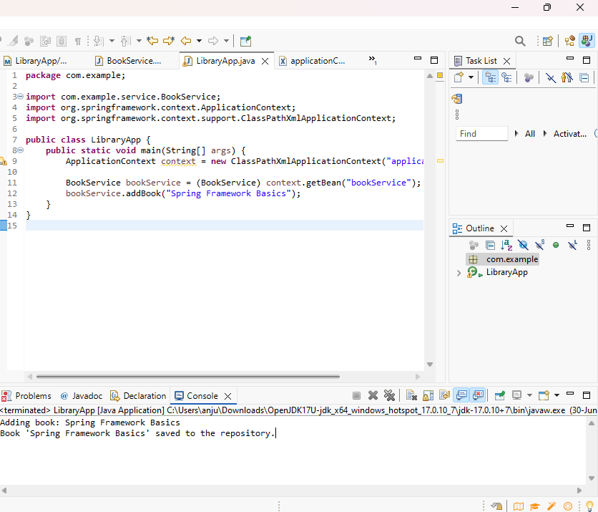

**Exercise 7: Implementing Constructor and Setter Injection**

**Scenario:**

**The library management application requires both constructor and setter injection for better control over bean initialization.**

**Steps:**

1. **Configure Constructor Injection:**
   * **Update applicationContext.xml to configure constructor injection for BookService.**
2. **Configure Setter Injection:**
   * **Ensure that the BookService class has a setter method for BookRepository and configure it in applicationContext.xml.**
3. **Test the Injection:**
   * **Run the LibraryManagementApplication main class to verify both constructor and setter injection.**

**Answer:**

**pom.xml**

<project xmlns="http://maven.apache.org/POM/4.0.0"

xmlns:xsi="http://www.w3.org/2001/XMLSchema-instance"

xsi:schemaLocation="http://maven.apache.org/POM/4.0.0

https://maven.apache.org/xsd/maven-4.0.0.xsd">

<modelVersion>4.0.0</modelVersion>

<groupId>com.example</groupId>

<artifactId>Library</artifactId>

<version>0.0.1-SNAPSHOT</version>

<dependencies>

<dependency>

<groupId>org.springframework</groupId>

<artifactId>spring-context</artifactId>

<version>5.3.34</version>

</dependency>

<dependency>

<groupId>org.springframework</groupId>

<artifactId>spring-beans</artifactId>

<version>5.3.34</version>

</dependency>

</dependencies>

<build>

<plugins>

<plugin>

<groupId>org.apache.maven.plugins</groupId>

<artifactId>maven-compiler-plugin</artifactId>

<version>3.10.1</version>

<configuration>

<source>1.8</source>

<target>1.8</target>

</configuration>

</plugin>

</plugins>

</build>

</project>

**BookService.java**

package com.example;

public class BookService {

private BookRepository bookRepository;

public BookService(BookRepository bookRepository) {

this.bookRepository = bookRepository;

System.*out*.println("Constructor Injection used.");

}

public void setBookRepository(BookRepository bookRepository) {

this.bookRepository = bookRepository;

System.*out*.println("Setter Injection used.");

}

public void showBooks() {

bookRepository.displayBooks();

}

}

**BookRepository.java**

package com.example;

public class BookRepository {

public void displayBooks() {

System.*out*.println("Displaying books from the repository...");

}

}

LibraryManagementApplication.java

**package** com.example;

**import** org.springframework.context.ApplicationContext;

**import** org.springframework.context.support.ClassPathXmlApplicationContext;

**public** **class** LibraryManagementApplication {

**public** **static** **void** main(String[] args) {

ApplicationContext context = **new** ClassPathXmlApplicationContext("applicationContext.xml");

BookService bookService = (BookService) context.getBean("bookService");

bookService.showBooks();

}

}

**Output:**

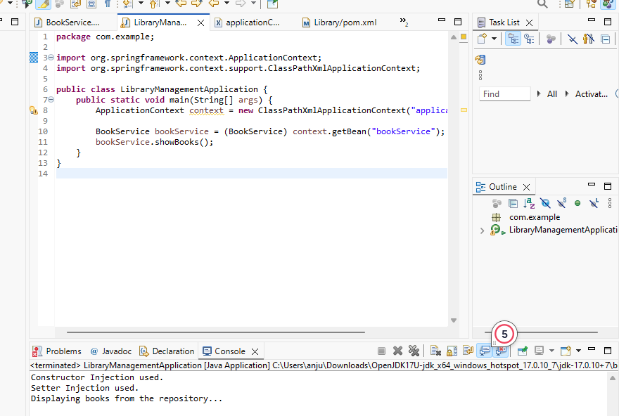

**Exercise 9: Creating a Spring Boot Application**

**Scenario:**

You need to create a Spring Boot application for the library management system to simplify configuration and deployment.

**Steps:**

1. **Create a Spring Boot Project:**
   * Use **Spring Initializr** to create a new Spring Boot project named **LibraryManagement**.
2. **Add Dependencies:**
   * Include dependencies for **Spring Web, Spring Data JPA, and H2 Database**.
3. **Create Application Properties:**
   * Configure database connection properties in **application.properties**.
4. **Define Entities and Repositories:**
   * Create **Book** entity and **BookRepository** interface.
5. **Create a REST Controller:**
   * Create a **BookController** class to handle CRUD operations.
6. **Run the Application:**
   * Run the Spring Boot application and test the REST endpoints.

**Answer:**

Book.java

**package** com.example;

**import** jakarta.persistence.*;

@Entity

**public** **class** Book {

@Id

@GeneratedValue(strategy = GenerationType.***IDENTITY***)

**private** Long id;

**private** String title;

**private** String author;

**private** String isbn;

// Getters and Setters

**public** Long getId() { **return** id; }

**public** **void** setId(Long id) { **this**.id = id; }

**public** String getTitle() { **return** title; }

**public** **void** setTitle(String title) { **this**.title = title; }

**public** String getAuthor() { **return** author; }

**public** **void** setAuthor(String author) { **this**.author = author; }

**public** String getIsbn() { **return** isbn; }

**public** **void** setIsbn(String isbn) { **this**.isbn = isbn; }

}

BookController.java

**package** com.example;

**import** org.springframework.beans.factory.annotation.Autowired;

**import** org.springframework.web.bind.annotation.*;

**import** java.util.List;

**import** java.util.Optional;

@RestController

@RequestMapping("/books")

**public** **class** BookController {

@Autowired

**private** BookRepository bookRepository;

@PostMapping

**public** Book addBook(@RequestBody Book book) {

**return** bookRepository.save(book);

}

@GetMapping

**public** List<Book> getAllBooks() {

**return** bookRepository.findAll();

}

@GetMapping("/{id}")

**public** Optional<Book> getBookById(@PathVariable Long id) {

**return** bookRepository.findById(id);

}

@PutMapping("/{id}")

**public** Book updateBook(@PathVariable Long id, @RequestBody Book bookDetails) {

Book book = bookRepository.findById(id).orElseThrow();

book.setTitle(bookDetails.getTitle());

book.setAuthor(bookDetails.getAuthor());

book.setIsbn(bookDetails.getIsbn());

**return** bookRepository.save(book);

}

@DeleteMapping("/{id}")

**public** **void** deleteBook(@PathVariable Long id) {

bookRepository.deleteById(id);

}

}

BookRepository.java

**package** com.example;

**import** org.springframework.data.jpa.repository.JpaRepository;

**public** **interface** BookRepository **extends** JpaRepository<Book, Long> {

}

LibraryManagementApplication.java

**package** com.example;

**import** org.springframework.boot.SpringApplication;

**import** org.springframework.boot.autoconfigure.SpringBootApplication;

@SpringBootApplication

**public** **class** LibraryManagementApplication {

**public** **static** **void** main(String[] args) {

SpringApplication.*run*(LibraryManagementApplication.**class**, args);

}

}

**Output:**

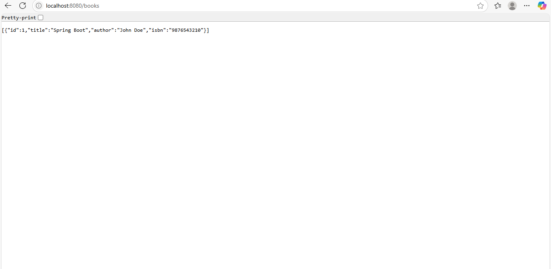

**Exercise 10: Implement services for managing Country**

**CountryServiceApplication.java**

**package com.example.country_service;**

**import org.springframework.boot.SpringApplication;**

**import org.springframework.boot.autoconfigure.SpringBootApplication;**

**@SpringBootApplication**

**public class CountryServiceApplication {**

**public static void main(String[] args) {**

**SpringApplication.*run*(CountryServiceApplication.class, args);**

**}**

**}**

**Country.java**

**import jakarta.persistence.Table;**

**@Entity**

**@Table(name = "country")**

**public class Country {**

**@Id**

**@Column(name = "co_code")**

**private String coCode;**

**@Column(name = "co_name")**

**private String coName;**

**public String getCoCode() {**

**return coCode;**

**}**

**public void setCoCode(String coCode) {**

**this.coCode = coCode;**

**}**

**public String getCoName() {**

**return coName;**

**}**

**public void setCoName(String coName) {**

**this.coName = coName;**

**}**

**}**

**CountryController.java**

**package com.example.countryservice;**

**import org.springframework.beans.factory.annotation.Autowired;**

**import org.springframework.web.bind.annotation.*;**

**import java.util.List;**

**import java.util.Optional;**

**@RestController**

**@RequestMapping("/countries")**

**public class CountryController {**

**@Autowired**

**private CountryService countryService;**

**@GetMapping("/{code}")**

**public Optional<Country> getCountryByCode(@PathVariable String code) {**

**return countryService.findCountryByCode(code);**

**}**

**@PostMapping**

**public Country addCountry(@RequestBody Country country) {**

**return countryService.addCountry(country);**

**}**

**@PutMapping**

**public Country updateCountry(@RequestBody Country country) {**

**return countryService.updateCountry(country);**

**}**

**@DeleteMapping("/{code}")**

**public void deleteCountry(@PathVariable String code) {**

**countryService.deleteCountry(code);**

**}**

**@GetMapping("/search")**

**public List<Country> searchCountries(@RequestParam String name) {**

**return countryService.findCountriesByPartialName(name);**

**}**

**}**

**CountryRepositry.java**

**package com.example.countryservice;**

**import org.springframework.data.jpa.repository.JpaRepository;**

**import java.util.List;**

**public interface CountryRepository extends JpaRepository<Country, String> {**

**List<Country> findByCoNameContainingIgnoreCase(String name);**

**}**

**CountryService.java**

**import org.springframework.beans.factory.annotation.Autowired;**

**import org.springframework.stereotype.Service;**

**import java.util.List;**

**import java.util.Optional;**

**@Service**

**public class CountryService {**

**@Autowired**

**private CountryRepository countryRepository;**

**public Optional<Country> findCountryByCode(String code) {**

**return countryRepository.findById(code);**

**}**

**public Country addCountry(Country country) {**

**return countryRepository.save(country);**

**}**

**public Country updateCountry(Country country) {**

**return countryRepository.save(country);**

**}**

**public void deleteCountry(String code) {**

**countryRepository.deleteById(code);**

**}**

**public List<Country> findCountriesByPartialName(String partialName) {**

**return countryRepository.findByCoNameContainingIgnoreCase(partialName);**

**}**

**}**

**data.sql**

**INSERT INTO country (co_code, co_name) VALUES ('IN', 'India');**

**Output:**

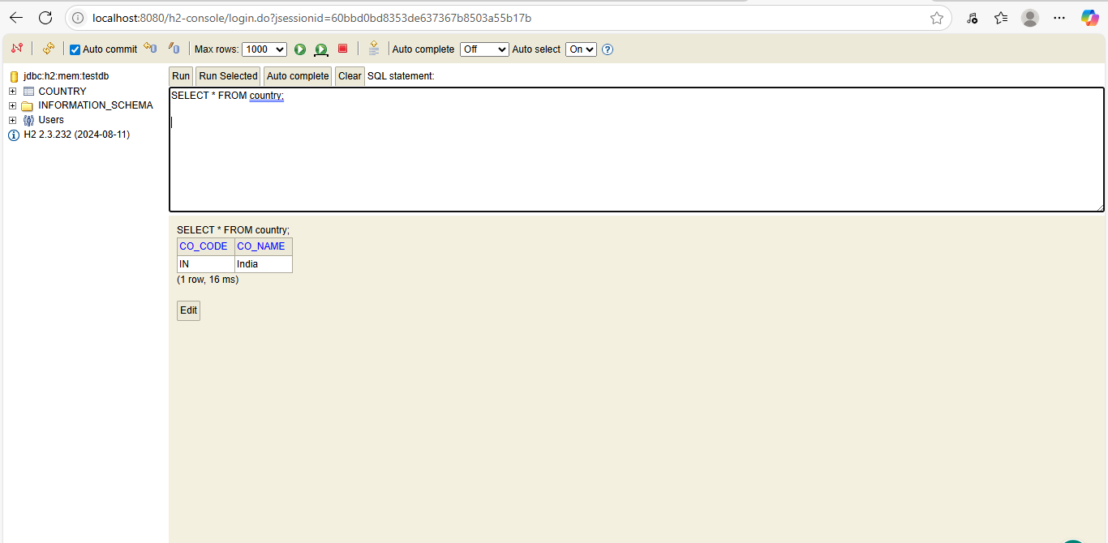

**Find a country based on country code**

OrmLearnApplication.java

package com.cognizant.spring_learn;

import com.cognizant.spring_learn.model.Country;

import com.cognizant.spring_learn.service.CountryService;

import com.cognizant.spring_learn.service.exception.CountryNotFoundException;

import org.slf4j.Logger;

import org.slf4j.LoggerFactory;

import org.springframework.boot.SpringApplication;

import org.springframework.boot.autoconfigure.SpringBootApplication;

import org.springframework.context.ApplicationContext;

@SpringBootApplication

public class OrmLearnApplication {

private static final Logger *LOGGER* = LoggerFactory.*getLogger*(OrmLearnApplication.class);

public static void main(String[] args) {

ApplicationContext context = SpringApplication.*run*(OrmLearnApplication.class, args);

CountryService countryService = context.getBean(CountryService.class);

*testGetCountryByCode*(countryService);

}

private static void testGetCountryByCode(CountryService countryService) {

*LOGGER*.info("Start - testGetCountryByCode");

try {

Country country = countryService.findCountryByCode("IN");

*LOGGER*.info("Country: {}", country);

} catch (CountryNotFoundException e) {

*LOGGER*.error("Country not found: {}", e.getMessage());

}

*LOGGER*.info("End - testGetCountryByCode");

}

}

Country.java

**package** com.cognizant.spring_learn.model;

**import** jakarta.persistence.*;

@Entity

@Table(name = "country")

**public** **class** Country {

@Id

@Column(name = "co_code")

**private** String code;

@Column(name = "co_name")

**private** String name;

// Getters & Setters

**public** String getCode() {

**return** code;

}

**public** **void** setCode(String code) {

**this**.code = code;

}

**public** String getName() {

**return** name;

}

**public** **void** setName(String name) {

**this**.name = name;

}

@Override

**public** String toString() {

**return** "Country [code=" + code + ", name=" + name + "]";

}

}

CountryNotFoundException.java

**package** com.cognizant.spring_learn.service.exception;

**public** **class** CountryNotFoundException **extends** Exception {

**public** CountryNotFoundException() {

**super**();

}

**public** CountryNotFoundException(String message) {

**super**(message);

}

}

CountryRepository.java

**package** com.cognizant.spring_learn.repository;

**import** com.cognizant.spring_learn.model.Country;

**import** org.springframework.data.jpa.repository.JpaRepository;

**public** **interface** CountryRepository **extends** JpaRepository<Country, String> {

}

OrmLearnApplicationTests.java

**package** com.cognizant.spring_learn;

**import** org.junit.jupiter.api.Test;

**import** org.springframework.boot.test.context.SpringBootTest;

@SpringBootTest

**class** OrmLearnApplicationTests {

@Test

**void** contextLoads() {

}

}

**Output:**

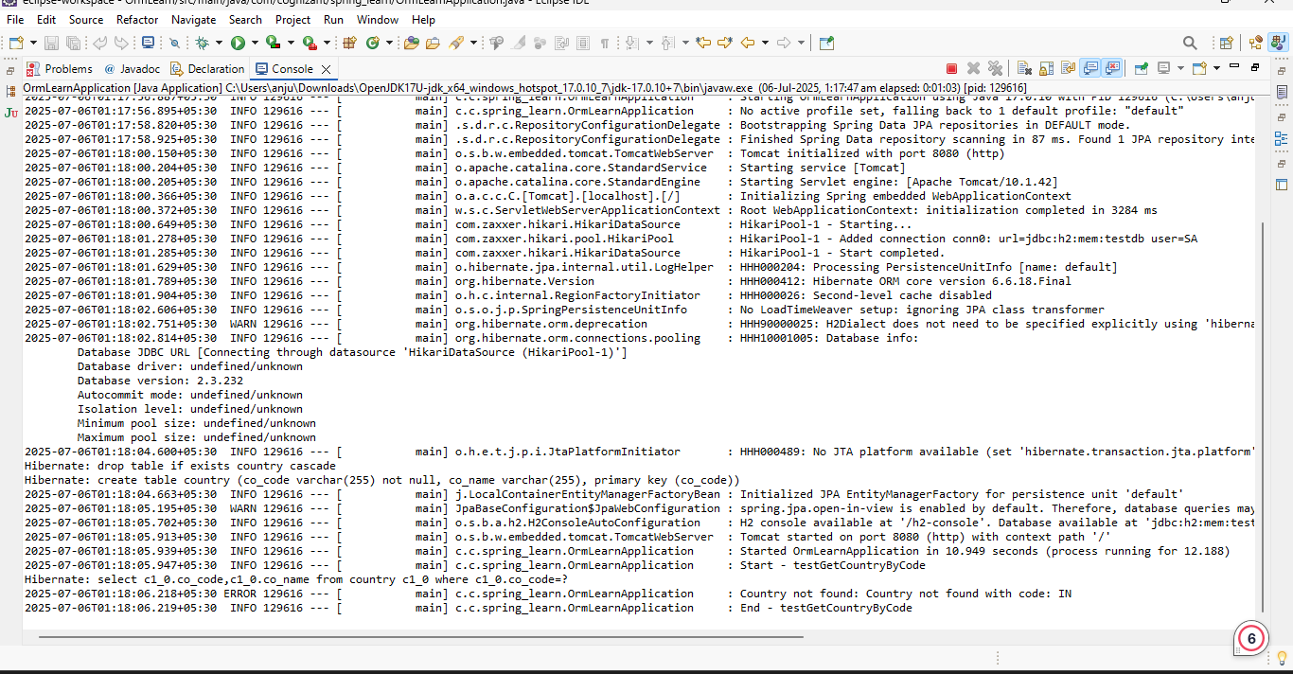

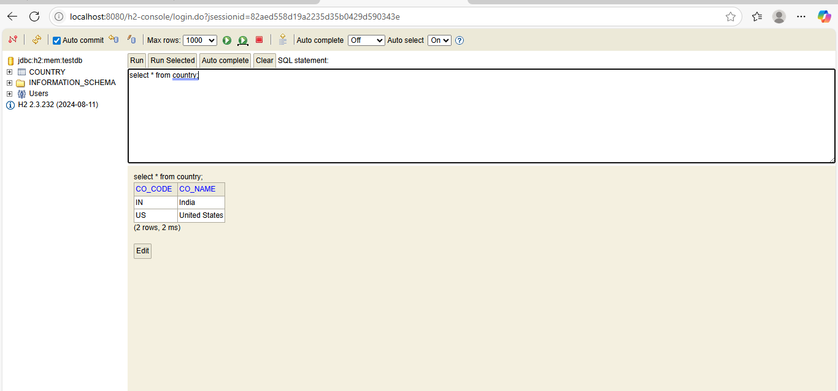

**Exercise: Add a new Country:**

**Answer:**

**package** com.cognizant.spring_learn.service;

**import** com.cognizant.spring_learn.model.Country;

**import** com.cognizant.spring_learn.repository.CountryRepository;

**import** com.cognizant.spring_learn.service.exception.CountryNotFoundException;

**import** org.springframework.beans.factory.annotation.Autowired;

**import** org.springframework.stereotype.Service;

**import** org.springframework.transaction.annotation.Transactional;

**import** java.util.Optional;

@Service

**public** **class** CountryService {

@Autowired

**private** CountryRepository countryRepository;

@Transactional

**public** Country findCountryByCode(String code) **throws** CountryNotFoundException {

Optional<Country> result = countryRepository.findById(code);

**if** (result.isPresent()) {

**return** result.get();

} **else** {

**throw** **new** CountryNotFoundException("Country not found with code: " + code);

}

}

@Transactional

**public** **void** addCountry(Country country) {

countryRepository.save(country);

}

}

**package** com.cognizant.spring_learn.repository;

**import** org.springframework.data.jpa.repository.JpaRepository;

**import** com.cognizant.spring_learn.model.Country;

**public** **interface** CountryRepository **extends** JpaRepository<Country, String> {

}

**package** com.cognizant.spring_learn.model;

**import** jakarta.persistence.*;

@Entity

@Table(name = "country")

**public** **class** Country {

@Id

**private** String code;

**private** String name;

// Getters and Setters

**public** String getCode() {

**return** code;

}

**public** **void** setCode(String code) {

**this**.code = code;

}

**public** String getName() {

**return** name;

}

**public** **void** setName(String name) {

**this**.name = name;

}

// toString

@Override

**public** String toString() {

**return** "Country [code=" + code + ", name=" + name + "]";

}

}

**package** com.cognizant.spring_learn.service.exception;

**public** **class** CountryNotFoundException **extends** Exception {

**public** CountryNotFoundException(String message) {

**super**(message);

}

}

**import** org.springframework.context.ApplicationContext;

@SpringBootApplication

**public** **class** OrmLearnApplication {

**public** **static** **void** main(String[] args) {

ApplicationContext context = SpringApplication.*run*(OrmLearnApplication.**class**, args);

*testAddCountry*(context);

}

**public** **static** **void** testAddCountry(ApplicationContext context) {

CountryService countryService = context.getBean(CountryService.**class**);

Country newCountry = **new** Country();

newCountry.setCode("JP");

newCountry.setName("Japan");

countryService.addCountry(newCountry);

**try** {

Country country = countryService.findCountryByCode("JP");

System.***out***.println("Added Country: " + country);

} **catch** (CountryNotFoundException e) {

System.***out***.println(e.getMessage());

}

}

}

**Output:**

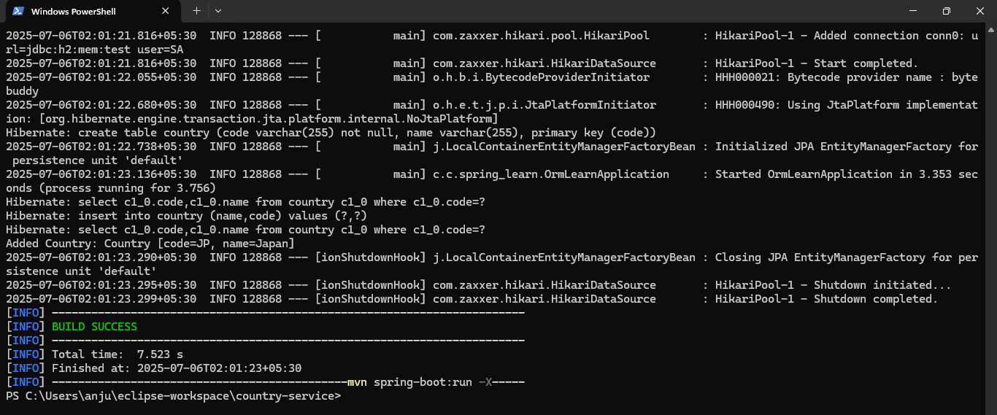

**Exercise: Write queries on country table using Query Methods**

**Answer:**

**package** com.example.ormlearn.model;

**import** jakarta.persistence.*;

@Entity

@Table(name = "country")

**public** **class** Country {

@Id

**private** String code;

**private** String name;

**public** String getCode() {

**return** code;

}

**public** **void** setCode(String code) {

**this**.code = code;

}

**public** String getName() {

**return** name;

}

**public** **void** setName(String name) {

**this**.name = name;

}

@Override

**public** String toString() {

**return** code + " " + name;

}

}

**package** com.example.ormlearn;

**import** com.example.ormlearn.model.Country;

**import** com.example.ormlearn.repository.CountryRepository;

**import** org.springframework.beans.factory.annotation.Autowired;

**import** org.springframework.boot.CommandLineRunner;

**import** org.springframework.boot.SpringApplication;

**import** org.springframework.boot.autoconfigure.SpringBootApplication;

**import** java.util.List;

@SpringBootApplication

**public** **class** OrmLearnApplication **implements** CommandLineRunner {

@Autowired

**private** CountryRepository countryRepository;

**public** **static** **void** main(String[] args) {

SpringApplication.*run*(OrmLearnApplication.**class**, args);

}

@Override

**public** **void** run(String... args) **throws** Exception {

System.***out***.println("Countries containing 'ou':");

List<Country> countries = countryRepository.findByNameContainingIgnoreCase("ou");

countries.forEach(System.***out***::println);

System.***out***.println("\nCountries containing 'ou' (Sorted Ascending):");

List<Country> sortedCountries = countryRepository.findByNameContainingIgnoreCaseOrderByNameAsc("ou");

sortedCountries.forEach(System.***out***::println);

System.***out***.println("\nCountries starting with 'Z':");

List<Country> zCountries = countryRepository.findByNameStartingWithIgnoreCase("Z");

zCountries.forEach(System.***out***::println);

}

}

**package** com.example.ormlearn.repository;

**import** com.example.ormlearn.model.Country;

**import** org.springframework.data.jpa.repository.JpaRepository;

**import** org.springframework.stereotype.Repository;

**import** java.util.List;

@Repository

**public** **interface** CountryRepository **extends** JpaRepository<Country, String> {

List<Country> findByNameContainingIgnoreCase(String name);

List<Country> findByNameContainingIgnoreCaseOrderByNameAsc(String name);

List<Country> findByNameStartingWithIgnoreCase(String prefix);

}

**INSERT** **INTO** country (code, name) **VALUES**

('BV', 'Bouvet Island'),

('DJ', 'Djibouti'),

('GP', 'Guadeloupe'),

('GS', 'South Georgia and the South Sandwich Islands'),

('LU', 'Luxembourg'),

('SS', 'South Sudan'),

('TF', 'French Southern Territories'),

('UM', 'United States Minor Outlying Islands'),

('ZA', 'South Africa'),

('ZM', 'Zambia'),

('ZW', 'Zimbabwe');

**Output:**

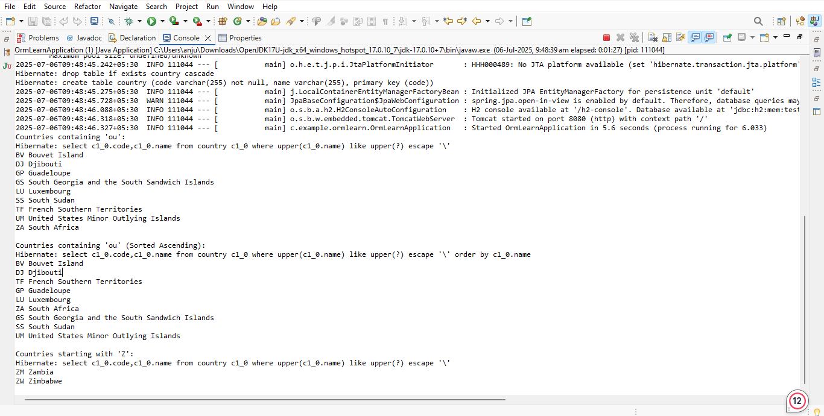

**Exercise: Write queries on stock table using Query Methods**

**Answer:**

**package** com.example.ormlearn;

**import** com.example.ormlearn.model.Stock;

**import** com.example.ormlearn.repository.StockRepository;

**import** org.springframework.beans.factory.annotation.Autowired;

**import** org.springframework.boot.CommandLineRunner;

**import** org.springframework.boot.SpringApplication;

**import** org.springframework.boot.autoconfigure.SpringBootApplication;

**import** java.math.BigDecimal;

**import** java.time.LocalDate;

**import** java.util.List;

@SpringBootApplication

**public** **class** OrmLearnApplication **implements** CommandLineRunner {

@Autowired

**private** StockRepository stockRepository;

**public** **static** **void** main(String[] args) {

SpringApplication.*run*(OrmLearnApplication.**class**, args);

}

@Override

**public** **void** run(String... args) {

System.***out***.println("Query 1 - Facebook stocks in Sep 2019:");

List<Stock> fbStocks = stockRepository.findByCodeAndDateBetween(

"FB", LocalDate.*of*(2019, 9, 1), LocalDate.*of*(2019, 9, 30));

fbStocks.forEach(System.***out***::println);

System.***out***.println("\nQuery 2 - Google stocks with price > 1250:");

List<Stock> googlStocks = stockRepository.findByCodeAndCloseGreaterThan(

"GOOGL", **new** BigDecimal("1250"));

googlStocks.forEach(System.***out***::println);

System.***out***.println("\nQuery 3 - Top 3 Highest Volume:");

List<Stock> topVolumeStocks = stockRepository.findTop3ByOrderByVolumeDesc();

topVolumeStocks.forEach(System.***out***::println);

System.***out***.println("\nQuery 4 - Lowest 3 Netflix closing prices:");

List<Stock> lowNetflixStocks = stockRepository.findTop3ByCodeOrderByCloseAsc("NFLX");

lowNetflixStocks.forEach(System.***out***::println);

}

}

**package** com.example.ormlearn.model;

**import** javax.persistence.*;

**import** java.math.BigDecimal;

**import** java.time.LocalDate;

@Entity

@Table(name = "stock")

**public** **class** Stock {

@Id

@GeneratedValue(strategy = GenerationType.IDENTITY)

@Column(name = "st_id")

**private** Integer id;

@Column(name = "st_code")

**private** String code;

@Column(name = "st_date")

**private** LocalDate date;

@Column(name = "st_open")

**private** BigDecimal open;

@Column(name = "st_close")

**private** BigDecimal close;

@Column(name = "st_volume")

**private** BigDecimal volume;

// Getters and Setters

**public** Integer getId() {

**return** id;

}

**public** **void** setId(Integer id) {

**this**.id = id;

}

**public** String getCode() {

**return** code;

}

**public** **void** setCode(String code) {

**this**.code = code;

}

**public** LocalDate getDate() {

**return** date;

}

**public** **void** setDate(LocalDate date) {

**this**.date = date;

}

**public** BigDecimal getOpen() {

**return** open;

}

**public** **void** setOpen(BigDecimal open) {

**this**.open = open;

}

**public** BigDecimal getClose() {

**return** close;

}

**public** **void** setClose(BigDecimal close) {

**this**.close = close;

}

**public** BigDecimal getVolume() {

**return** volume;

}

**public** **void** setVolume(BigDecimal volume) {

**this**.volume = volume;

}

@Override

**public** String toString() {

**return** "Stock{" +

"code='" + code + '\'' +

", date=" + date +

", open=" + open +

", close=" + close +

", volume=" + volume +

'}';

}

}

**package** com.example.ormlearn.repository;

**import** com.example.ormlearn.model.Stock;

**import** org.springframework.data.jpa.repository.JpaRepository;

**import** java.math.BigDecimal;

**import** java.time.LocalDate;

**import** java.util.List;

**public** **interface** StockRepository **extends** JpaRepository<Stock, Integer> {

List<Stock> findByCodeAndDateBetween(String code, LocalDate startDate, LocalDate endDate);

List<Stock> findByCodeAndCloseGreaterThan(String code, BigDecimal price);

List<Stock> findTop3ByOrderByVolumeDesc();

List<Stock> findTop3ByCodeOrderByCloseAsc(String code);

}

**Output:**

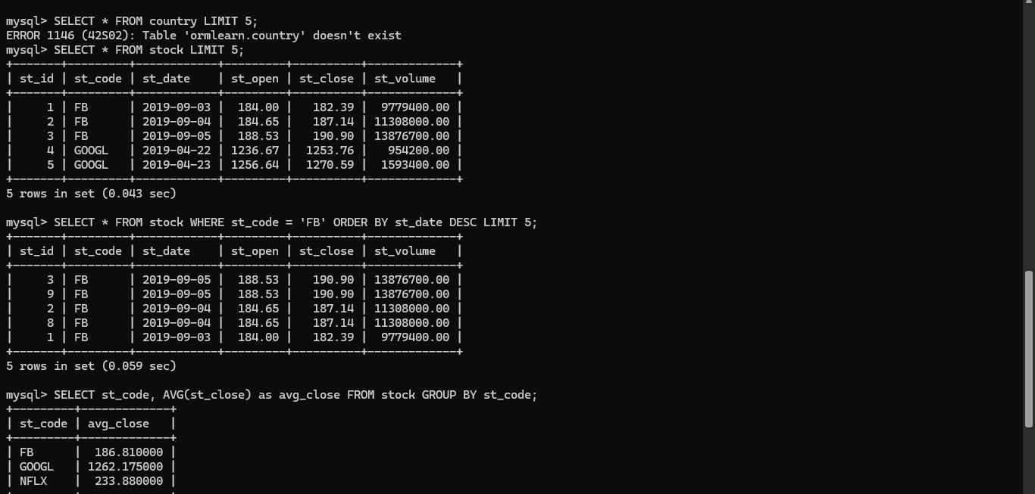

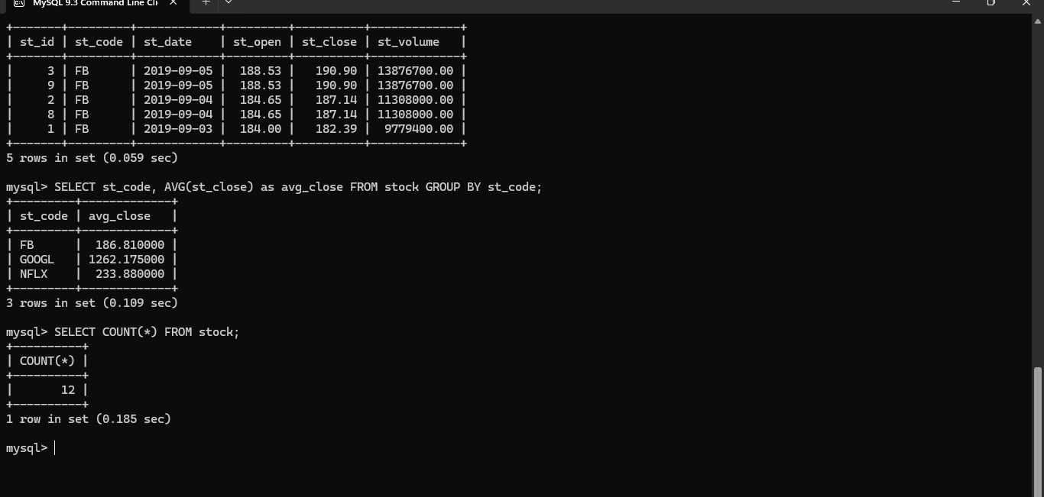

**Create payroll tables and bean mapping**

**Answer:**

package com.cognizant.orm_learn;

import com.cognizant.orm_learn.model.Employee;

import com.cognizant.orm_learn.repository.EmployeeRepository;

import org.springframework.boot.SpringApplication;

import org.springframework.boot.autoconfigure.SpringBootApplication;

import org.springframework.context.ConfigurableApplicationContext;

import java.util.List;

@SpringBootApplication

public class OrmLearnApplication {

public static void main(String[] args) {

ConfigurableApplicationContext context = SpringApplication.run(OrmLearnApplication.class, args);

EmployeeRepository employeeRepository = context.getBean(EmployeeRepository.class);

System.out.println("Fetching Employee Details...");

List<Employee> employees = employeeRepository.findAll();

if (employees.isEmpty()) {

System.out.println("No Employee records found.");

} else {

System.out.println("Employee records:");

for (Employee employee : employees) {

System.out.println(employee);

}

}

context.close();

}

}

**package** com.cognizant.orm_learn.model;

**import** jakarta.persistence.*;

**import** java.util.Set;

@Entity

@Table(name = "department")

**public** **class** Department {

@Id

@GeneratedValue(strategy = GenerationType.***IDENTITY***)

**private** **int** id;

@Column(name = "name")

**private** String name;

@OneToMany(mappedBy = "department")

**private** Set<Employee> employees;

}

**package** com.cognizant.orm_learn.model;

**import** jakarta.persistence.Entity;

**import** jakarta.persistence.Id;

@Entity

**public** **class** Skill {

@Id

**private** **int** id;

**private** String name;

**public** **int** getId() {

**return** id;

}

**public** **void** setId(**int** id) {

**this**.id = id;

}

**public** String getName() {

**return** name;

}

**public** **void** setName(String name) {

**this**.name = name;

}

}

**package** com.cognizant.orm_learn.repository;

**import** com.cognizant.orm_learn.model.Department;

**import** org.springframework.data.jpa.repository.JpaRepository;

**import** org.springframework.stereotype.Repository;

@Repository

**public** **interface** DepartmentRepository **extends** JpaRepository<Department, Integer> {

}

**package** com.cognizant.orm_learn.repository;

**import** com.cognizant.orm_learn.model.Employee;

**import** org.springframework.data.jpa.repository.JpaRepository;

**import** org.springframework.stereotype.Repository;

@Repository

**public** **interface** EmployeeRepository **extends** JpaRepository<Employee, Integer> {

}

**package** com.cognizant.orm_learn.repository;

**import** com.cognizant.orm_learn.model.Skill;

**import** org.springframework.data.jpa.repository.JpaRepository;

**import** org.springframework.stereotype.Repository;

@Repository

**public** **interface** SkillRepository **extends** JpaRepository<Skill, Integer> {

}

CREATE TABLE IF NOT EXISTS department (

id INT AUTO_INCREMENT PRIMARY KEY,

name VARCHAR(50) NOT NULL

);

CREATE TABLE IF NOT EXISTS skill (

id INT AUTO_INCREMENT PRIMARY KEY,

name VARCHAR(50) NOT NULL

);

CREATE TABLE IF NOT EXISTS employee (

id INT AUTO_INCREMENT PRIMARY KEY,

name VARCHAR(100),

salary DOUBLE,

permanent BOOLEAN,

date_of_birth DATE,

department_id INT,

FOREIGN KEY (department_id) REFERENCES department(id)

);

CREATE TABLE IF NOT EXISTS employee_skill (

employee_id INT,

skill_id INT,

PRIMARY KEY (employee_id, skill_id),

FOREIGN KEY (employee_id) REFERENCES employee(id),

FOREIGN KEY (skill_id) REFERENCES skill(id)

);

INSERT INTO department (name) VALUES ('HR'), ('Finance'), ('Engineering');

INSERT INTO skill (name) VALUES ('Java'), ('Python'), ('SQL'), ('Communication');

INSERT INTO employee (name, salary, permanent, date_of_birth, department_id)

VALUES

('Alice Johnson', 75000, TRUE, '1990-03-25', 1),

('Bob Smith', 60000, FALSE, '1992-07-15', 2),

('Charlie Brown', 85000, TRUE, '1985-11-10', 3);

INSERT INTO employee_skill (employee_id, skill_id) VALUES

(1, 1),

(1, 4),

(2, 2),

(2, 4),

(3, 1),

(3, 3);

**Output:**

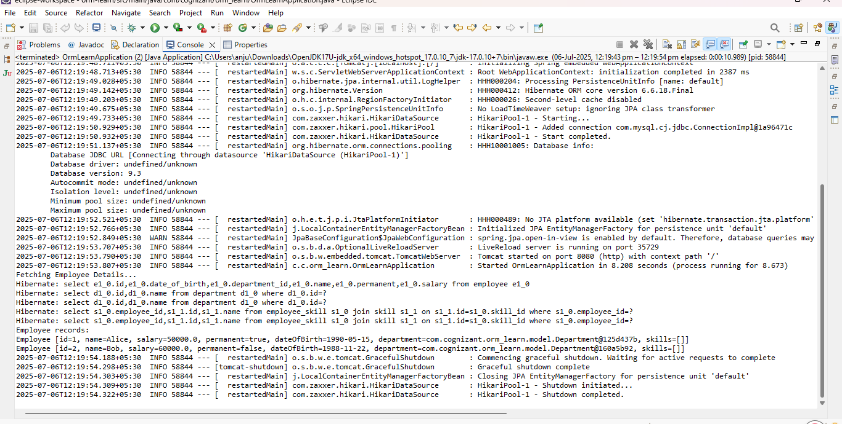

**Implement many to one relationship between Employee and Department**

**package** com.example.ormlearn;

**import** com.example.ormlearn.model.Department;

**import** com.example.ormlearn.model.Employee;

**import** com.example.ormlearn.service.DepartmentService;

**import** org.springframework.beans.factory.annotation.Autowired;

**import** org.springframework.boot.SpringApplication;

**import** org.springframework.boot.autoconfigure.SpringBootApplication;

**import** org.springframework.boot.CommandLineRunner;

@SpringBootApplication

**public** **class** OrmLearnApplication **implements** CommandLineRunner {

@Autowired

**private** DepartmentService departmentService;

**public** **static** **void** main(String[] args) {

SpringApplication.*run*(OrmLearnApplication.**class**, args);

}

@Override

**public** **void** run(String... args) **throws** Exception {

testGetDepartment();

}

**private** **void** testGetDepartment() {

Department department = departmentService.get(1);

**if** (department != **null**) {

System.***out***.println("Department: " + department);

System.***out***.println("Employees in Department:");

**for** (Employee employee : department.getEmployeeList()) {

System.***out***.println(employee);

}

} **else** {

System.***out***.println("Department not found!");

}

}

}

**Answer:**  
**package** com.example.ormlearn;

**import** com.example.ormlearn.model.Department;

**import** com.example.ormlearn.model.Employee;

**import** com.example.ormlearn.repository.DepartmentRepository;

**import** com.example.ormlearn.service.EmployeeService;

**import** org.slf4j.Logger;

**import** org.slf4j.LoggerFactory;

**import** org.springframework.boot.CommandLineRunner;

**import** org.springframework.boot.SpringApplication;

**import** org.springframework.boot.autoconfigure.SpringBootApplication;

@SpringBootApplication

**public** **class** OrmLearnApplication **implements** CommandLineRunner {

**private** **static** **final** Logger ***LOGGER*** = LoggerFactory.*getLogger*(OrmLearnApplication.**class**);

**private** **final** EmployeeService employeeService;

**private** **final** DepartmentRepository departmentRepository;

**public** OrmLearnApplication(EmployeeService employeeService, DepartmentRepository departmentRepository) {

**this**.employeeService = employeeService;

**this**.departmentRepository = departmentRepository;

}

**public** **static** **void** main(String[] args) {

SpringApplication.*run*(OrmLearnApplication.**class**, args);

}

@Override

**public** **void** run(String... args) {

***LOGGER***.info("Start");

Department department = **new** Department();

department.setName("IT");

departmentRepository.save(department);

Employee employee = **new** Employee();

employee.setName("John Doe");

employee.setSalary(60000.0);

employee.setPermanent(**true**);

employee.setDepartment(department);

employeeService.save(employee);

Employee fetchedEmployee = employeeService.get(employee.getId());

***LOGGER***.info("Fetched Employee: {}", fetchedEmployee);

***LOGGER***.info("End");

}

}

**package** com.example.ormlearn.repository;

**import** com.example.ormlearn.model.Employee;

**import** org.springframework.data.jpa.repository.JpaRepository;

**public** **interface** EmployeeRepository **extends** JpaRepository<Employee, Integer> {

}

**package** com.example.ormlearn.repository;

**import** com.example.ormlearn.model.Department;

**import** org.springframework.data.jpa.repository.JpaRepository;

**public** **interface** DepartmentRepository **extends** JpaRepository<Department, Integer> {

}

package com.example.ormlearn;

import com.example.ormlearn.model.Department;

import com.example.ormlearn.model.Employee;

import com.example.ormlearn.repository.DepartmentRepository;

import com.example.ormlearn.service.EmployeeService;

import org.slf4j.Logger;

import org.slf4j.LoggerFactory;

import org.springframework.boot.CommandLineRunner;

import org.springframework.boot.SpringApplication;

import org.springframework.boot.autoconfigure.SpringBootApplication;

@SpringBootApplication

public class OrmLearnApplication implements CommandLineRunner {

private static final Logger LOGGER = LoggerFactory.getLogger(OrmLearnApplication.class);

private final EmployeeService employeeService;

private final DepartmentRepository departmentRepository;

public OrmLearnApplication(EmployeeService employeeService, DepartmentRepository departmentRepository) {

this.employeeService = employeeService;

this.departmentRepository = departmentRepository;

}

public static void main(String[] args) {

SpringApplication.run(OrmLearnApplication.class, args);

}

@Override

public void run(String... args) {

LOGGER.info("Start");

Department department = new Department();

department.setName("IT");

departmentRepository.save(department);

Employee employee = new Employee();

employee.setName("John Doe");

employee.setSalary(60000.0);

employee.setPermanent(true);

employee.setDepartment(department);

employeeService.save(employee);

Employee fetchedEmployee = employeeService.get(employee.getId());

LOGGER.info("Fetched Employee: {}", fetchedEmployee);

LOGGER.info("End");

}

}

**package** com.example.ormlearn.model;

**import** jakarta.persistence.*;

@Entity

@Table(name = "department")

**public** **class** Department {

@Id

@GeneratedValue(strategy = GenerationType.***IDENTITY***)

**private** **int** id;

**private** String name;

**public** **int** getId() {

**return** id;

}

**public** **void** setId(**int** id) {

**this**.id = id;

}

**public** String getName() {

**return** name;

}

**public** **void** setName(String name) {

**this**.name = name;

}

@Override

**public** String toString() {

**return** "Department [id=" + id + ", name=" + name + "]";

}

}

**package** com.example.ormlearn.service;

**import** com.example.ormlearn.model.Employee;

**import** com.example.ormlearn.repository.EmployeeRepository;

**import** org.slf4j.Logger;

**import** org.slf4j.LoggerFactory;

**import** org.springframework.stereotype.Service;

**import** org.springframework.transaction.annotation.Transactional;

@Service

**public** **class** EmployeeService {

**private** **static** **final** Logger ***LOGGER*** = LoggerFactory.*getLogger*(EmployeeService.**class**);

**private** **final** EmployeeRepository employeeRepository;

**public** EmployeeService(EmployeeRepository employeeRepository) {

**this**.employeeRepository = employeeRepository;

}

@Transactional

**public** Employee get(**int** id) {

***LOGGER***.info("Fetching Employee with id: {}", id);

**return** employeeRepository.findById(id).orElse(**null**);

}

@Transactional

**public** **void** save(Employee employee) {

***LOGGER***.info("Saving Employee: {}", employee);

employeeRepository.save(employee);

}

}

**package** com.example.ormlearn.service;

**import** com.example.ormlearn.model.Department;

**import** com.example.ormlearn.repository.DepartmentRepository;

**import** org.springframework.stereotype.Service;

**import** org.springframework.transaction.annotation.Transactional;

@Service

**public** **class** DepartmentService {

**private** **final** DepartmentRepository departmentRepository;

**public** DepartmentService(DepartmentRepository departmentRepository) {

**this**.departmentRepository = departmentRepository;

}

@Transactional

**public** Department get(**int** id) {

**return** departmentRepository.findById(id).orElse(**null**);

}

@Transactional

**public** **void** save(Department department) {

departmentRepository.save(department);

}

}

**Output:**

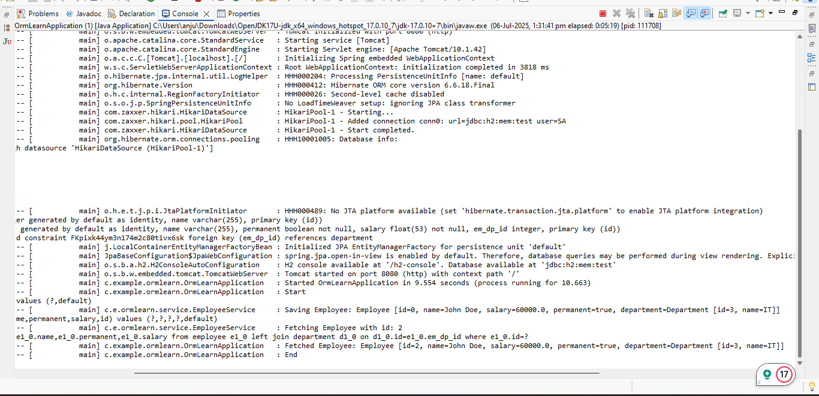

**Implement one to many relationship between Employee and Department**

**Answer:**

**package** com.example.ormlearn.model;

**import** jakarta.persistence.*;

**import** java.util.List;

@Entity

@Table(name = "department")

**public** **class** Department {

@Id

**private** **int** id;

**private** String name;

@OneToMany(mappedBy = "department", cascade = CascadeType.***ALL***, fetch = FetchType.***EAGER***)

**private** List<Employee> employeeList;

**public** **int** getId() {

**return** id;

}

**public** **void** setId(**int** id) {

**this**.id = id;

}

**public** String getName() {

**return** name;

}

**public** **void** setName(String name) {

**this**.name = name;

}

**public** List<Employee> getEmployeeList() {

**return** employeeList;

}

**public** **void** setEmployeeList(List<Employee> employeeList) {

**this**.employeeList = employeeList;

}

@Override

**public** String toString() {

**return** "Department [id=" + id + ", name=" + name + "]";

}

}

package com.example.ormlearn;

import com.example.ormlearn.model.Department;

import com.example.ormlearn.model.Employee;

import com.example.ormlearn.service.DepartmentService;

import org.springframework.beans.factory.annotation.Autowired;

import org.springframework.boot.SpringApplication;

import org.springframework.boot.autoconfigure.SpringBootApplication;

import org.springframework.boot.CommandLineRunner;

@SpringBootApplication

public class OrmLearnApplication implements CommandLineRunner {

@Autowired

private DepartmentService departmentService;

public static void main(String[] args) {

SpringApplication.run(OrmLearnApplication.class, args);

}

@Override

public void run(String... args) throws Exception {

testGetDepartment();

}

private void testGetDepartment() {

Department department = departmentService.get(1);

if (department != null) {

System.out.println("Department: " + department);

System.out.println("Employees in Department:");

for (Employee employee : department.getEmployeeList()) {

System.out.println(employee);

}

} else {

System.out.println("Department not found!");

}

}

}

**package** com.example.ormlearn.repository;

**import** com.example.ormlearn.model.Department;

**import** org.springframework.data.jpa.repository.JpaRepository;

**public** **interface** DepartmentRepository **extends** JpaRepository<Department, Integer> {

}

**package** com.example.ormlearn.service;

**import** com.example.ormlearn.model.Department;

**import** com.example.ormlearn.repository.DepartmentRepository;

**import** org.springframework.beans.factory.annotation.Autowired;

**import** org.springframework.stereotype.Service;

**import** java.util.Optional;

@Service

**public** **class** DepartmentService {

@Autowired

**private** DepartmentRepository departmentRepository;

**public** Department get(**int** id) {

Optional<Department> result = departmentRepository.findById(id);

**return** result.orElse(**null**);

}

}

**package** com.example.ormlearn.model;

**import** jakarta.persistence.*;

@Entity

@Table(name = "employee")

**public** **class** Employee {

@Id

@GeneratedValue(strategy = GenerationType.***IDENTITY***)

**private** **int** id;

**private** String name;

**private** **double** salary;

**private** **boolean** permanent;

@ManyToOne

@JoinColumn(name = "department_id")

**private** Department department;

**public** **int** getId() {

**return** id;

}

**public** **void** setId(**int** id) {

**this**.id = id;

}

**public** String getName() {

**return** name;

}

**public** **void** setName(String name) {

**this**.name = name;

}

**public** **double** getSalary() {

**return** salary;

}

**public** **void** setSalary(**double** salary) {

**this**.salary = salary;

}

**public** **boolean** isPermanent() {

**return** permanent;

}

**public** **void** setPermanent(**boolean** permanent) {

**this**.permanent = permanent;

}

**public** Department getDepartment() {

**return** department;

}

**public** **void** setDepartment(Department department) {

**this**.department = department;

}

@Override

**public** String toString() {

**return** "Employee [id=" + id + ", name=" + name + "]";

}

}

**Output:**

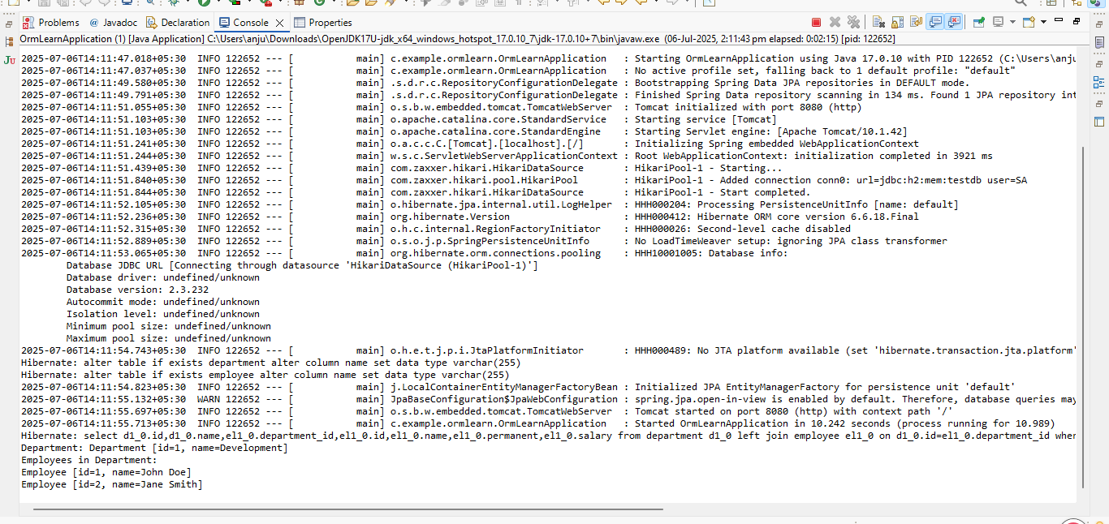

**Implement many to many relationship between Employee and Skill** 

**package** com.example.ormlearn;

**import** com.example.ormlearn.model.Employee;

**import** com.example.ormlearn.model.Skill;

**import** com.example.ormlearn.service.EmployeeService;

**import** com.example.ormlearn.service.SkillService;

**import** org.springframework.beans.factory.annotation.Autowired;

**import** org.springframework.boot.CommandLineRunner;

**import** org.springframework.boot.SpringApplication;

**import** org.springframework.boot.autoconfigure.SpringBootApplication;

**import** org.slf4j.Logger;

**import** org.slf4j.LoggerFactory;

@SpringBootApplication

**public** **class** OrmLearnApplication **implements** CommandLineRunner {

@Autowired

**private** EmployeeService employeeService;

@Autowired

**private** SkillService skillService;

**private** **static** **final** Logger ***LOGGER*** = LoggerFactory.*getLogger*(OrmLearnApplication.**class**);

**public** **static** **void** main(String[] args) {

SpringApplication.*run*(OrmLearnApplication.**class**, args);

}

@Override

**public** **void** run(String... args) **throws** Exception {

testAddSkillToEmployee();

}

**public** **void** testAddSkillToEmployee() {

Employee employee = employeeService.get(1);

Skill skill = skillService.get(2);

**if** (employee != **null** && skill != **null**) {

employee.getSkillList().add(skill);

employeeService.save(employee);

***LOGGER***.debug("Skill added successfully to employee");

System.***out***.println("Skill added successfully to employee");

System.***out***.println("Updated Employee: " + employee);

System.***out***.println("Skills: " + employee.getSkillList());

} **else** {

***LOGGER***.debug("Employee or Skill not found");

System.***out***.println("Employee or Skill not found");

}

}

}

package com.example.ormlearn.model;

import jakarta.persistence.*;

import java.util.HashSet;

import java.util.Set;

@Entity

@Table(name = "employee")

public class Employee {

@Id

private int id;

private String name;

private double salary;

private boolean permanent;

@ManyToOne

@JoinColumn(name = "department_id")

private Department department;

@ManyToMany(fetch = FetchType.EAGER)

@JoinTable(name = "employee_skill",

joinColumns = @JoinColumn(name = "es_em_id"),

inverseJoinColumns = @JoinColumn(name = "es_sk_id"))

private Set<Skill> skillList = new HashSet<>();

public int getId() { return id; }

public void setId(int id) { this.id = id; }

public String getName() { return name; }

public void setName(String name) { this.name = name; }

public double getSalary() { return salary; }

public void setSalary(double salary) { this.salary = salary; }

public boolean isPermanent() { return permanent; }

public void setPermanent(boolean permanent) { this.permanent = permanent; }

public Department getDepartment() { return department; }

public void setDepartment(Department department) { this.department = department; }

public Set<Skill> getSkillList() { return skillList; }

public void setSkillList(Set<Skill> skillList) { this.skillList = skillList; }

@Override

public String toString() {

return "Employee{" +

"id=" + id +

", name='" + name + '\'' +

", salary=" + salary +

", permanent=" + permanent +

", department=" + (department != null ? department.getName() : "null") +

'}';

}

}

package com.example.ormlearn.model;

import jakarta.persistence.*;

import java.util.HashSet;

import java.util.Set;

@Entity

@Table(name = "skill")

public class Skill {

@Id

private int id;

private String name;

@ManyToMany(mappedBy = "skillList")

private Set<Employee> employeeList = new HashSet<>();

public int getId() { return id; }

public void setId(int id) { this.id = id; }

public String getName() { return name; }

public void setName(String name) { this.name = name; }

public Set<Employee> getEmployeeList() { return employeeList; }

public void setEmployeeList(Set<Employee> employeeList) { this.employeeList = employeeList; }

@Override

public String toString() {

return "Skill{" +

"id=" + id +

", name='" + name + '\'' +

'}';

}

}

**package** com.example.ormlearn.repository;

**import** com.example.ormlearn.model.Employee;

**import** org.springframework.data.jpa.repository.JpaRepository;

**public** **interface** EmployeeRepository **extends** JpaRepository<Employee, Integer> {

}

**package** com.example.ormlearn.repository;

**import** com.example.ormlearn.model.Skill;

**import** org.springframework.data.jpa.repository.JpaRepository;

**public** **interface** SkillRepository **extends** JpaRepository<Skill, Integer> {

}

**Output:**

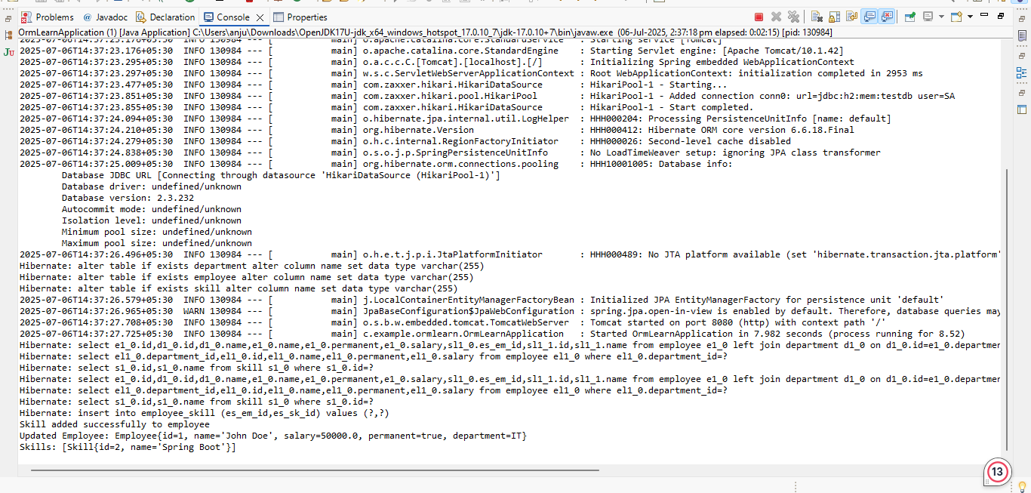

**Get all permanent employees using HQL**

**Answer:**

package com.example.ormlearn.service;

import com.example.ormlearn.model.Employee;

import com.example.ormlearn.model.Skill;

import org.slf4j.Logger;

import org.slf4j.LoggerFactory;

import org.springframework.beans.factory.annotation.Autowired;

import org.springframework.stereotype.Service;

import org.springframework.transaction.annotation.Transactional;

import java.util.List;

@Service

public class TestEmployeeService {

@Autowired

private EmployeeService employeeService;

@Autowired

private SkillService skillService;

private static final Logger LOGGER = LoggerFactory.getLogger(TestEmployeeService.class);

@Transactional

public void addSkillToEmployee() {

Employee employee = employeeService.get(1);

Skill skill = skillService.get(2);

if (employee != null && skill != null) {

if (!employee.getSkillList().contains(skill)) {

employee.getSkillList().add(skill);

employeeService.save(employee);

LOGGER.info("Skill '{}' added successfully to employee '{}'", skill.getName(), employee.getName());

} else {

LOGGER.info("Skill '{}' already exists for employee '{}'", skill.getName(), employee.getName());

}

} else {

LOGGER.warn("Employee or Skill not found for adding skill.");

}

}

@Transactional

public void fetchAllPermanentEmployees() {

LOGGER.info("Fetching all permanent employees...");

List<Employee> employees = employeeService.getAllPermanentEmployees();

for (Employee employee : employees) {

String departmentName = (employee.getDepartment() != null) ? employee.getDepartment().getName() : "No Department";

LOGGER.info("Employee: {}, Department: {}, Skills: {}",

employee.getName(),

departmentName,

employee.getSkillList());

}

LOGGER.info("Completed fetching permanent employees.");

}

}

package com.example.ormlearn.model;

import jakarta.persistence.*;

@Entity

@Table(name = "department")

public class Department {

@Id

@GeneratedValue(strategy = GenerationType.IDENTITY)

private int id;

private String name;

public int getId() {

return id;

}

public void setId(int id) {

this.id = id;

}

public String getName() {

return name;

}

public void setName(String name) {

this.name = name;

}

}

package com.example.ormlearn.model;

import jakarta.persistence.*;

import java.util.HashSet;

import java.util.Set;

@Entity

@Table(name = "employee")

public class Employee {

@Id

@GeneratedValue(strategy = GenerationType.IDENTITY)

private int id;

private String name;

private boolean permanent;

private double salary;

@ManyToOne

@JoinColumn(name = "em_dp_id")

private Department department;

@ManyToMany

@JoinTable(

name = "employee_skill",

joinColumns = @JoinColumn(name = "es_em_id"),

inverseJoinColumns = @JoinColumn(name = "es_sk_id")

)

private Set<Skill> skillList = new HashSet<>();

public int getId() {

return id;

}

public void setId(int id) {

this.id = id;

}

public String getName() {

return name;

}

public void setName(String name) {

this.name = name;

}

public boolean isPermanent() {

return permanent;

}

public void setPermanent(boolean permanent) {

this.permanent = permanent;

}

public double getSalary() {

return salary;

}

public void setSalary(double salary) {

this.salary = salary;

}

public Department getDepartment() {

return department;

}

public void setDepartment(Department department) {

this.department = department;

}

public Set<Skill> getSkillList() {

return skillList;

}

public void setSkillList(Set<Skill> skillList) {

this.skillList = skillList;

}

}

package com.example.ormlearn.model;

import jakarta.persistence.*;

import java.util.Objects;

@Entity

@Table(name = "skill")

public class Skill {

@Id

@GeneratedValue(strategy = GenerationType.IDENTITY)

private int id;

private String name;

public int getId() {

return id;

}

public void setId(int id) {

this.id = id;

}

public String getName() {

return name;

}

public void setName(String name) {

this.name = name;

}

@Override

public String toString() {

return name;

}

@Override

public boolean equals(Object o) {

if (this == o) return true;

if (!(o instanceof Skill)) return false;

Skill skill = (Skill) o;

return id == skill.id;

}

@Override

public int hashCode() {

return Objects.hash(id);

}

}

package com.example.ormlearn.repository;

import com.example.ormlearn.model.Employee;

import org.springframework.data.jpa.repository.JpaRepository;

import org.springframework.data.jpa.repository.Query;

import org.springframework.stereotype.Repository;

import java.util.List;

@Repository

public interface EmployeeRepository extends JpaRepository<Employee, Integer> {

@Query("SELECT e FROM Employee e " +

"LEFT JOIN FETCH e.department d " +

"LEFT JOIN FETCH e.skillList " +

"WHERE e.permanent = true")

List<Employee> getAllPermanentEmployees();

}

package com.example.ormlearn.repository;

import com.example.ormlearn.model.Skill;

import org.springframework.data.jpa.repository.JpaRepository;

import org.springframework.stereotype.Repository;

@Repository

public interface SkillRepository extends JpaRepository<Skill, Integer> {

}

**Output:**

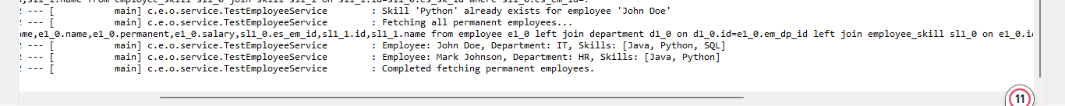

**Fetch Quiz Attempt Details**

**Answer:**

package com.example.ormlearn;

import com.example.ormlearn.model.Attempt;

import com.example.ormlearn.model.AttemptQuestion;

import com.example.ormlearn.repository.AttemptRepository;

import com.example.ormlearn.repository.AttemptQuestionRepository;

import com.example.ormlearn.service.AttemptService;

import org.springframework.beans.factory.annotation.Autowired;

import org.springframework.boot.CommandLineRunner;

import org.springframework.boot.SpringApplication;

import org.springframework.boot.autoconfigure.SpringBootApplication;

import java.sql.Timestamp;

import java.time.LocalDateTime;

import java.util.Arrays;

@SpringBootApplication

public class OrmLearnApplication implements CommandLineRunner {

@Autowired

private AttemptService attemptService;

@Autowired

private AttemptRepository attemptRepository;

@Autowired

private AttemptQuestionRepository attemptQuestionRepository;

public static void main(String[] args) {

SpringApplication.run(OrmLearnApplication.class, args);

}

@Override

public void run(String... args) throws Exception {

Attempt attempt = attemptRepository.findByUserAndId("john_doe", 1);

if (attempt == null) {

attempt = new Attempt();

attempt.setUser("john_doe");

attempt.setDate(Timestamp.valueOf(LocalDateTime.now()));

attempt = attemptRepository.save(attempt);

AttemptQuestion q1 = new AttemptQuestion();

q1.setAttempt(attempt);

q1.setQuestionText("What is Java?");

AttemptQuestion q2 = new AttemptQuestion();

q2.setAttempt(attempt);

q2.setQuestionText("Explain Hibernate.");

attemptQue**stionRepository.saveAll(Arrays.asList(q1, q2));**

System.out.println(" Test data inserted with Attempt ID: " + attempt.getId());

}

System.out.println("\n All Attempts in DB:");

attemptRepository.findAll().forEach(a -> {

System.out.println("Attempt ID: " + a.getId() + ", User: " + a.getUser());

});

Attempt fetchedAttempt = attemptService.getAttempt("john_doe", attempt.getId());

if (fetchedAttempt != null) {

System.out.println("\n Attempt found for user: " + fetchedAttempt.getUser());

System.out.println("Attempt Date: " + fetchedAttempt.getDate());

fetchedAttempt.getQuestions().forEach(q ->

System.out.println("Question: " + q.getQuestionText())

);

} else {

System.out.println("Attempt not found");

}

}

}  
package com.example.ormlearn.model;

import jakarta.persistence.*;

import java.sql.Timestamp;

import java.util.List;

@Entity

@Table(name = "attempt")

public class Attempt {

@Id

@GeneratedValue(strategy = GenerationType.IDENTITY)

private int id;

private String user;

private Timestamp date;

@OneToMany(mappedBy = "attempt", cascade = CascadeType.ALL, fetch = FetchType.LAZY)

private List<AttemptQuestion> questions;

public int getId() {

return id;

}

public void setId(int id) {

this.id = id;

}

public String getUser() {

return user;

}

public void setUser(String user) {

this.user = user;

}

public Timestamp getDate() {

return date;

}

public void setDate(Timestamp date) {

this.date = date;

}

public List<AttemptQuestion> getQuestions() {

return questions;

}

public void setQuestions(List<AttemptQuestion> questions) {

this.questions = questions;

}

}

package com.example.ormlearn.model;

import jakarta.persistence.*;

@Entity

public class AttemptOption {

@Id

@GeneratedValue(strategy = GenerationType.IDENTITY)

private Long id;

@ManyToOne

@JoinColumn(name = "attempt_question_id")

private AttemptQuestion attemptQuestion;

@ManyToOne

@JoinColumn(name = "option_id")

private Option option;

public Long getId() {

return id;

}

public void setId(Long id) {

this.id = id;

}

public AttemptQuestion getAttemptQuestion() {

return attemptQuestion;

}

public void setAttemptQuestion(AttemptQuestion attemptQuestion) {

this.attemptQuestion = attemptQuestion;

}

public Option getOption() {

return option;

}

public void setOption(Option option) {

this.option = option;

}

}

package com.example.ormlearn.model;

import jakarta.persistence.*;

@Entity

@Table(name = "attempt_question")

public class AttemptQuestion {

@Id

@GeneratedValue(strategy = GenerationType.IDENTITY)

private int id;

@ManyToOne

@JoinColumn(name = "attempt_id")

private Attempt attempt;

private String questionText;

public int getId() {

return id;

}

public void setId(int id) {

this.id = id;

}

public Attempt getAttempt() {

return attempt;

}

public void setAttempt(Attempt attempt) {

this.attempt = attempt;

}

public String getQuestionText() {

return questionText;

}

public void setQuestionText(String questionText) {

this.questionText = questionText;

}

}

package com.example.ormlearn.model;

import jakarta.persistence.*;

@Entity

public class Option {

@Id

@GeneratedValue(strategy = GenerationType.IDENTITY)

private Long id;

private String text;

private int score;

@ManyToOne

@JoinColumn(name = "question_id")

private Question question;

public Long getId() {

return id;

}

public void setId(Long id) {

this.id = id;

}

public String getText() {

return text;

}

public void setText(String text) {

this.text = text;

}

public int getScore() {

return score;

}

public void setScore(int score) {

this.score = score;

}

public Question getQuestion() {

return question;

}

public void setQuestion(Question question) {

this.question = question;

}

}

package com.example.ormlearn.model;

import jakarta.persistence.*;

import java.util.Set;

@Entity

public class Question {

@Id

@GeneratedValue(strategy = GenerationType.IDENTITY)

private Long id;

private String text;

@OneToMany(mappedBy = "question", cascade = CascadeType.ALL)

private Set<Option> options;

public Long getId() {

return id;

}

public void setId(Long id) {

this.id = id;

}

public String getText() {

return text;

}

public void setText(String text) {

this.text = text;

}

public Set<Option> getOptions() {

return options;

}

public void setOptions(Set<Option> options) {

this.options = options;

}

}

package com.example.ormlearn.model;

import jakarta.persistence.*;

@Entity

@Table(name = "user")

public class User {

@Id

private int id;

private String name;

public int getId() {

return id;

}

public String getName() {

return name;

}

}

**Output:**

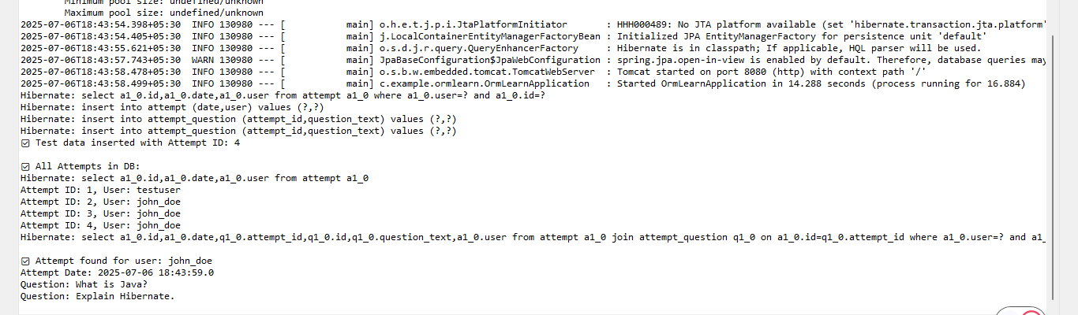

**Get average salary using HQL**

**Answer:**

**package** com.example.ormlearn;

**import** com.example.ormlearn.service.EmployeeService;

**import** org.springframework.beans.factory.annotation.Autowired;

**import** org.springframework.boot.CommandLineRunner;

**import** org.springframework.boot.SpringApplication;

**import** org.springframework.boot.autoconfigure.SpringBootApplication;

@SpringBootApplication

**public** **class** OrmLearnApplication **implements** CommandLineRunner {

@Autowired

**private** EmployeeService employeeService;

**public** **static** **void** main(String[] args) {

SpringApplication.*run*(OrmLearnApplication.**class**, args);

}

@Override

**public** **void** run(String... args) **throws** Exception {

**int** departmentId = 1;

**double** avgSalary = employeeService.getAverageSalary(departmentId);

System.***out***.println("Average salary for Department ID " + departmentId + " is: " + avgSalary);

}

}

**package** com.example.ormlearn.model;

**import** jakarta.persistence.*;

@Entity

@Table(name = "department")

**public** **class** Department {

@Id

@GeneratedValue(strategy = GenerationType.***IDENTITY***)

**private** **int** id;

**private** String name;

**public** **int** getId() {

**return** id;

}

**public** **void** setId(**int** id) {

**this**.id = id;

}

**public** String getName() {

**return** name;

}

**public** **void** setName(String name) {

**this**.name = name;

}

}

**package** com.example.ormlearn.model;

**import** jakarta.persistence.*;

@Entity

@Table(name = "employee")

**public** **class** Employee {

@Id

@GeneratedValue(strategy = GenerationType.***IDENTITY***)

**private** **int** id;

**private** String name;

**private** **double** salary;

@ManyToOne

@JoinColumn(name = "department_id")

**private** Department department;

**public** **int** getId() {

**return** id;

}

**public** **void** setId(**int** id) {

**this**.id = id;

}

**public** String getName() {

**return** name;

}

**public** **void** setName(String name) {

**this**.name = name;

}

**public** **double** getSalary() {

**return** salary;

}

**public** **void** setSalary(**double** salary) {

**this**.salary = salary;

}

**public** Department getDepartment() {

**return** department;

}

**public** **void** setDepartment(Department department) {

**this**.department = department;

}

}

**package** com.example.ormlearn.repository;

**import** com.example.ormlearn.model.Employee;

**import** org.springframework.data.jpa.repository.JpaRepository;

**import** org.springframework.data.jpa.repository.Query;

**import** org.springframework.data.repository.query.Param;

**public** **interface** EmployeeRepository **extends** JpaRepository<Employee, Integer> {

@Query("SELECT AVG(e.salary) FROM Employee e WHERE e.department.id = :id")

**double** getAverageSalary(@Param("id") **int** id);

}

**Output:**

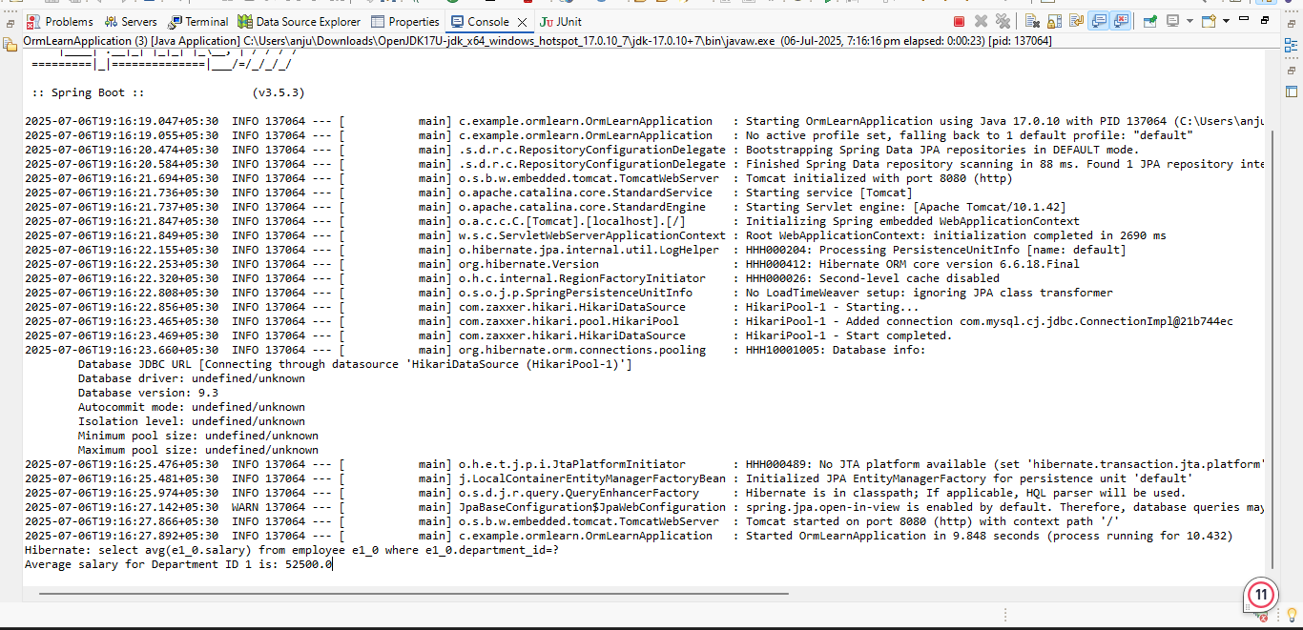

**Get all employees using Native Query**

**Answer:**

**package** com.example.ormlearn;

**import** com.example.ormlearn.model.Employee;

**import** com.example.ormlearn.service.EmployeeService;

**import** org.springframework.beans.factory.annotation.Autowired;

**import** org.springframework.boot.CommandLineRunner;

**import** org.springframework.boot.SpringApplication;

**import** org.springframework.boot.autoconfigure.SpringBootApplication;

**import** java.util.List;

@SpringBootApplication

**public** **class** OrmLearnApplication **implements** CommandLineRunner {

@Autowired

**private** EmployeeService employeeService;

**public** **static** **void** main(String[] args) {

SpringApplication.*run*(OrmLearnApplication.**class**, args);

}

@Override

**public** **void** run(String... args) **throws** Exception {

System.***out***.println("All Employees (Using Native Query):");

List<Employee> employees = employeeService.getAllEmployeesNative();

employees.forEach(System.***out***::println);

}

}

**package** com.example.ormlearn.repository;

**import** com.example.ormlearn.model.Employee;

**import** org.springframework.data.jpa.repository.JpaRepository;

**import** org.springframework.data.jpa.repository.Query;

**import** java.util.List;

**public** **interface** EmployeeRepository **extends** JpaRepository<Employee, Integer> {

@Query(value = "SELECT * FROM employee", nativeQuery = **true**)

List<Employee> getAllEmployeesNative();

}

**package** com.example.ormlearn.service;

**import** com.example.ormlearn.model.Employee;

**import** com.example.ormlearn.repository.EmployeeRepository;

**import** org.springframework.beans.factory.annotation.Autowired;

**import** org.springframework.stereotype.Service;

**import** java.util.List;

@Service

**public** **class** EmployeeService {

@Autowired

**private** EmployeeRepository employeeRepository;

**public** List<Employee> getAllEmployeesNative() {

**return** employeeRepository.getAllEmployeesNative();

}

}

**Output:**

