**1.Creating Microservices for account and loan**

**Answer:**

**AccountApplication.java:**

package com.cognizant.account;

import org.springframework.boot.SpringApplication;

import org.springframework.boot.autoconfigure.SpringBootApplication;

@SpringBootApplication

public class AccountApplication {

public static void main(String[] args) {

SpringApplication.*run*(AccountApplication.class, args);

}

}

**AccountController.java:**

**package** com.cognizant.account.controller;

**import** org.springframework.web.bind.annotation.GetMapping;

**import** org.springframework.web.bind.annotation.PathVariable;

**import** org.springframework.web.bind.annotation.RestController;

**import** java.util.Map;

@RestController

**public** **class** AccountController {

@GetMapping("/accounts/{number}")

**public** Map<String, Object> getAccountDetails(@PathVariable String number) {

**return** Map.*of*(

"number", number,

"type", "savings",

"balance", 234343

);

}

}

**LoanApplication.java:**

package com.cognizant.loan;

import org.springframework.boot.SpringApplication;

import org.springframework.boot.autoconfigure.SpringBootApplication;

@SpringBootApplication

public class LoanApplication {

public static void main(String[] args) {

SpringApplication.*run*(LoanApplication.class, args);

}

}

**LoanController.java:**

package com.cognizant.loan.controller;

import org.springframework.web.bind.annotation.GetMapping;

import org.springframework.web.bind.annotation.PathVariable;

import org.springframework.web.bind.annotation.RestController;

import java.util.Map;

@RestController

public class LoanController {

@GetMapping("/loans/{number}")

public Map<String, Object> getLoanDetails(@PathVariable String number) {

return Map.*of*(

"number", "H00987987972342",

"type", "car",

"loan", 400000,

"emi", 3258,

"tenure", 18

);

}

}

**Output:**

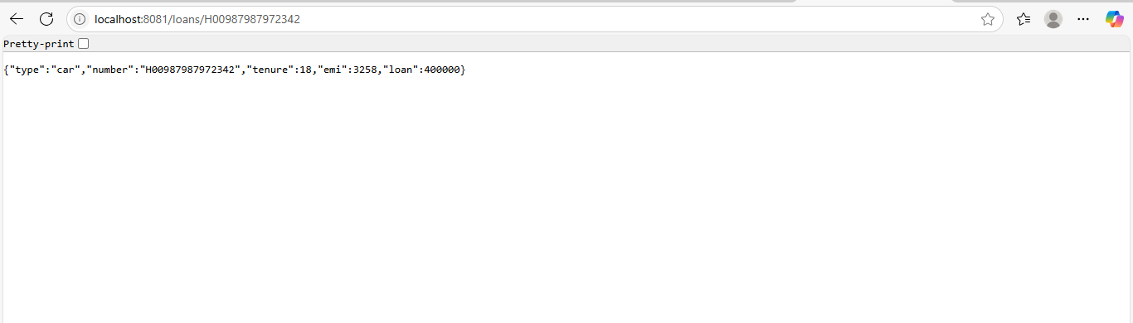

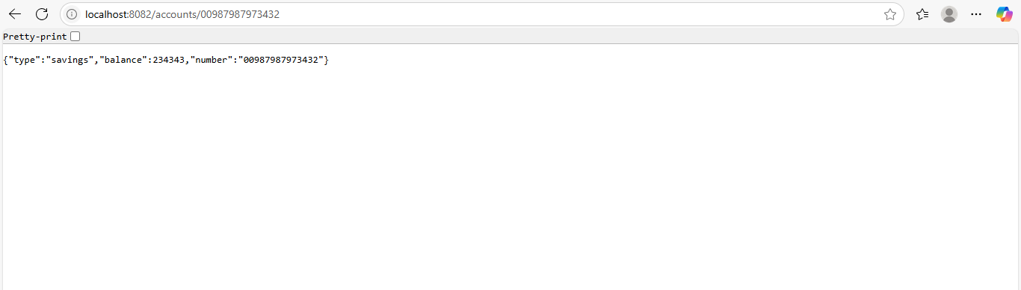

**2.Create Eureka Discovery Server and register microservices**

**Answer:**

**EurekaServerApplication.java:**

package com.example.eurekaserver;

import org.springframework.boot.SpringApplication;

import org.springframework.boot.autoconfigure.SpringBootApplication;

import org.springframework.cloud.netflix.eureka.server.EnableEurekaServer;

@SpringBootApplication

@EnableEurekaServer

public class EurekaServerApplication {

public static void main(String[] args) {

SpringApplication.*run*(EurekaServerApplication.class, args);

}

}

**Application.yml:**

server:

port: 8761

spring:

application:

name: eureka-server

eureka:

client:

register-with-eureka: false

fetch-registry: false

server:

wait-time-in-ms-when-sync-empty: 0

**AccountServiceApplication.java:**

package com.example.accountservice;

import org.springframework.boot.SpringApplication;

import org.springframework.boot.autoconfigure.SpringBootApplication;

import org.springframework.cloud.client.discovery.EnableDiscoveryClient;

@SpringBootApplication

@EnableDiscoveryClient

public class AccountServiceApplication {

public static void main(String[] args) {

SpringApplication.*run*(AccountServiceApplication.class, args);

}

}

**AccountController.java:**

**package** com.example.accountservice.controller;

**import** org.springframework.web.bind.annotation.GetMapping;

**import** org.springframework.web.bind.annotation.RestController;

@RestController

**public** **class** AccountController {

@GetMapping("/hello")

**public** String sayHello() {

**return** "Hello from Account Service!";

}

}

**Application.yml:**

server:

port: 8082

spring:

application:

name: account-service

eureka:

client:

service-url:

defaultZone: http://localhost:8761/eureka

instance:

prefer-ip-address: true

**ApiGatewayApplication.java:**

**package** com.example.apigateway;

**import** org.springframework.boot.SpringApplication;

**import** org.springframework.boot.autoconfigure.SpringBootApplication;

**import** org.springframework.cloud.client.discovery.EnableDiscoveryClient;

@SpringBootApplication

@EnableDiscoveryClient

**public** **class** ApiGatewayApplication {

**public** **static** **void** main(String[] args) {

SpringApplication.*run*(ApiGatewayApplication.**class**, args);

}

}

**LogFilter.java:**

**package** com.example.apigateway;

**import** org.springframework.cloud.gateway.filter.GlobalFilter;

**import** org.springframework.core.Ordered;

**import** org.springframework.stereotype.Component;

**import** org.springframework.web.server.ServerWebExchange;

**import** reactor.core.publisher.Mono;

**import** org.slf4j.Logger;

**import** org.slf4j.LoggerFactory;

@Component

**public** **class** LogFilter **implements** GlobalFilter, Ordered {

**private** **static** **final** Logger ***logger*** = LoggerFactory.*getLogger*(LogFilter.**class**);

@Override

**public** Mono<Void> filter(ServerWebExchange exchange, org.springframework.cloud.gateway.filter.GatewayFilterChain chain) {

***logger***.info("Request path: {}", exchange.getRequest().getPath());

**return** chain.filter(exchange);

}

@Override

**public** **int** getOrder() {

**return** -1; // Highest priority

}

}

**Application.yml:**

server:

port: 9090

spring:

application:

name: api-gateway

cloud:

gateway:

routes:

- id: greet-service

uri: lb://greet-service

predicates:

- Path=/greet-service/**

filters:

- StripPrefix=1

discovery:

locator:

enabled: true

lower-case-service-id: true

eureka:

client:

service-url:

defaultZone: http://localhost:8761/eureka

**GreetingController.java:**

**package** com.example.greetservice;

**import** org.springframework.web.bind.annotation.GetMapping;

**import** org.springframework.web.bind.annotation.RestController;

@RestController

**public** **class** GreetingController {

@GetMapping("/hello")

**public** String sayHello() {

**return** "Hello World";

}

}

**GreetServiceApplication.java:**

**package** com.example.greetservice;

**import** org.springframework.boot.SpringApplication;

**import** org.springframework.boot.autoconfigure.SpringBootApplication;

**import** org.springframework.cloud.client.discovery.EnableDiscoveryClient;

@SpringBootApplication

@EnableDiscoveryClient

**public** **class** GreetServiceApplication {

**public** **static** **void** main(String[] args) {

SpringApplication.*run*(GreetServiceApplication.**class**, args);

}

}

**Application.yml:**

server:

port: 8081

spring:

application:

name: greet-service

eureka:

client:

service-url:

defaultZone: http://localhost:8761/eureka

instance:

prefer-ip-address: true

**Output:**

