**Instructions to setup tomcat server**

* Download tomcat server(version 7.0.70), jdk(1.6.0) from online and install it. Set the environment variables as below:

**Note:** Drive location changes as per individual.

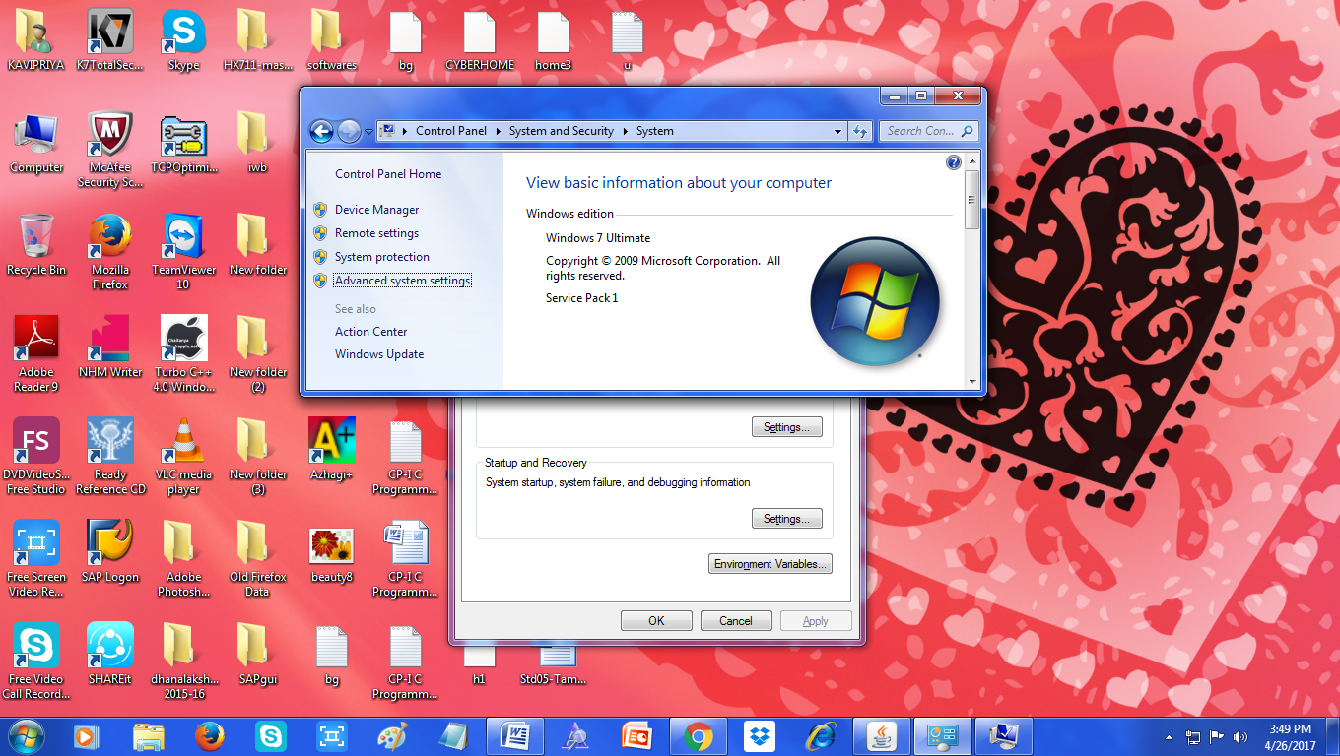

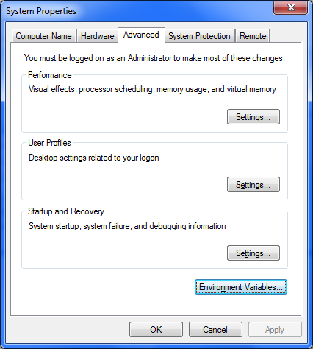

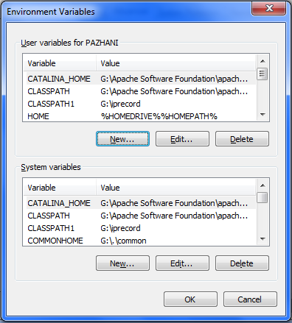

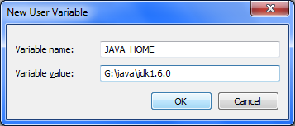

* CATALINA_HOME G:\Apache Software Foundation\apache-tomcat-7.0.70
* CLASSPATH G:\Apache Software Foundation\apache-tomcat-7.0.70\lib\servlet-api.jar
* JAVA_HOME G:\java\jdk1.6.0
* PATH G:\java\jdk1.6.0\bin
* Since MS Access database is used it is necessary to create DSN for each MS Access file as shown below:

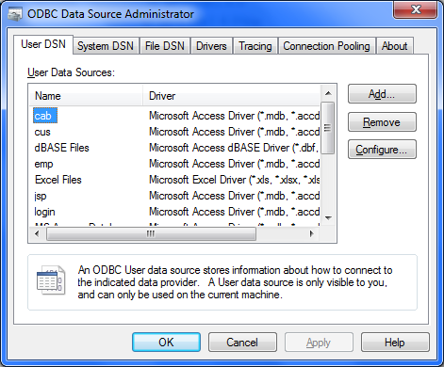

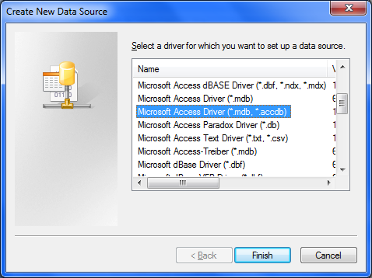

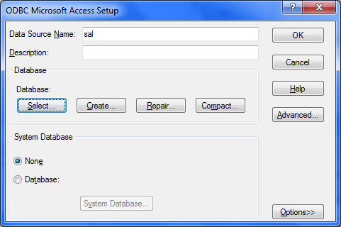

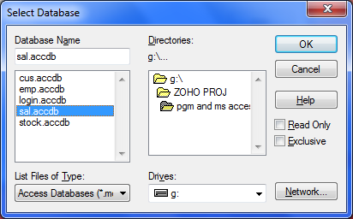

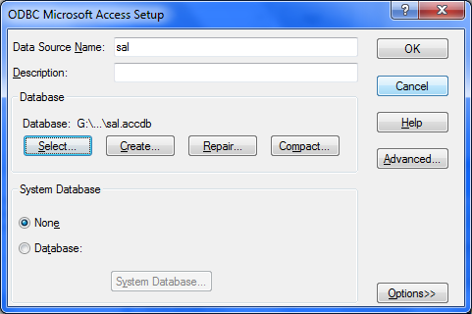

* Java servlets are compiled at command prompt.
* Create a folder inside webapps. place the .jsp and .html files inside this folder.

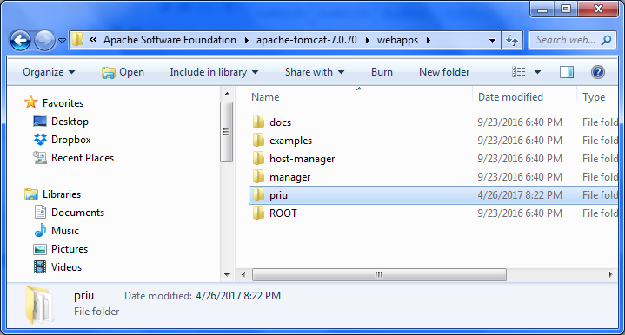

* Create a folder named WEB_INF inside your folder. Place the web.xml file inside this folder for servlet mapping.

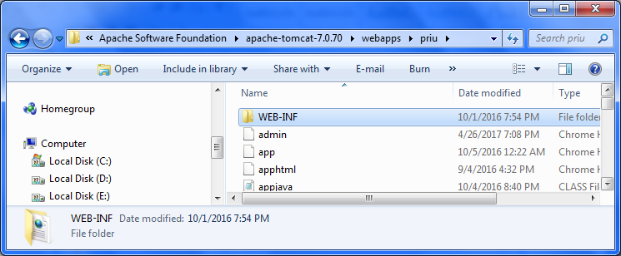

* Create a folder named classes inside WEB_INF. place .java and .class files in this folder.

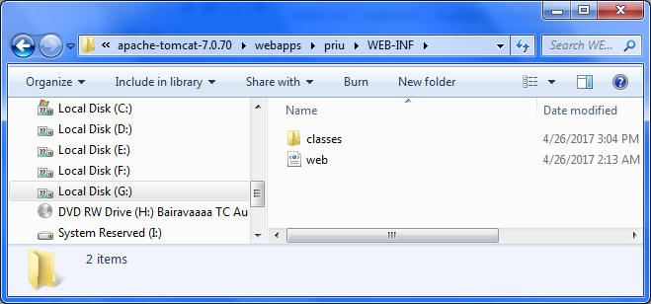

* Start up tomcat server.

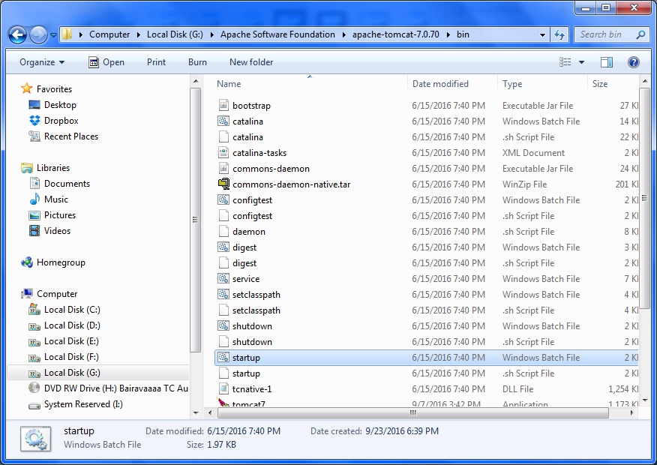

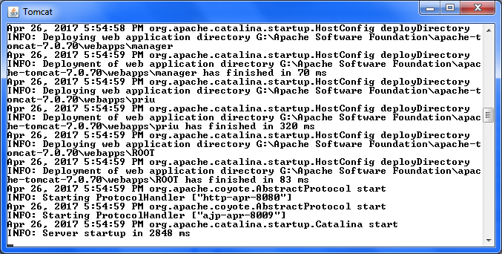

* Execute java servlets and jsp from web browser.(use java 1.6.0 and tomcat 7.0.70)