**13.ReactJS – HOL**

**1. Explain various ways of conditional rendering**

* **Using if-else statements:** Create different elements inside the function and return based on conditions.
* **Using ternary operator:** Inline conditional rendering – condition ? <ComponentA /> : <ComponentB />.
* **Using logical AND (&&):** Render something only when the condition is true – condition && <Component />.

**2. Explain how to render multiple components**

* **Wrap with Fragment (<> </>):** Use React Fragments to return multiple elements without extra HTML tags.
* **Array of components:** Use an array to render components like [<Comp1 />, <Comp2 />].
* **Map through a list:** Dynamically render multiple components using map() function over data arrays.

**3.Define list component**

* A **List Component** displays a collection of similar items, such as names, tasks, or posts.
* It uses **map() function** to loop through array data and return JSX for each item.
* Typically, **keys** are added to each list item for efficient rendering and tracking.

**4.Explain about keys in React applications**

* **Keys are unique identifiers** given to list elements to help React identify which items have changed.
* They improve performance and prevent unnecessary re-renders during updates.
* Keys should be **unique and stable** – often use IDs or indexes (but avoid indexes when items can be reordered).

**5.Explain how to extract components with keys**

* Break complex list rendering into **smaller child components** for readability and reuse.
* Pass the **key prop** from the parent where map() is used – not inside the child component.
* Helps React track individual components correctly in a list for updates and removals.

**6.Explain React Map, map() function**

* **map() is a JavaScript array function** used to transform array items into JSX elements.
* In React, map() is commonly used to **dynamically render components** from an array.
* Syntax: array.map(item => <Component key={item.id} data={item} />) – includes **keys** for each element.

**React Application – bloggerapp**

Create a React App named “bloggerapp” in with 3 components.

1. Book Details
2. Blog Details
3. Course Details

Implement this with as many ways possible of Conditional Rendering.

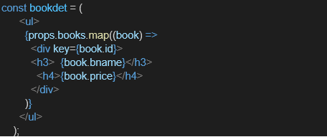

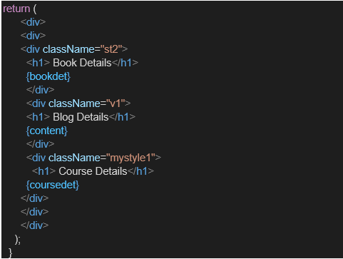

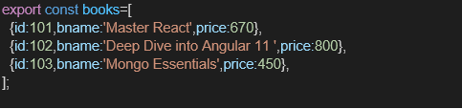

**Output:**

