**9. ReactJs – HOL**

**1**.**List the features of ES6**

* Introduced let, const, arrow functions, template literals, and classes.
* Added new data structures like Set and Map.
* Supports modules, default parameters, promises, and enhanced object literals.

**2.Explain JavaScript let**

* Declares block-scoped variables, meaning it is limited to { }.
* Prevents redeclaration of the same variable in the same scope.
* Hoisted but not initialized, so accessing it before declaration throws an error.

**3. Identify the differences between var and let**

* var is function-scoped; let is block-scoped.
* var allows redeclaration; let does not in the same scope.
* var is hoisted and initialized as undefined; let is hoisted but not initialized.

**4. Explain JavaScript const**

* Used to declare variables with constant values that cannot be reassigned.
* Must be initialized at the time of declaration.
* It is block-scoped like let and not hoisted with initialization.

**5. Explain ES6 class fundamentals**

* ES6 classes provide a cleaner syntax for creating constructor functions.
* Methods are defined inside the class body, without the function keyword.
* Classes are not hoisted and must be declared before use.

**6. Explain ES6 class inheritance**

* Inheritance is done using the extends keyword.
* The super() function is used to call the parent class constructor.
* Subclasses can override or add new methods to the inherited class.

**7. Define ES6 arrow functions**

* Arrow functions use a concise syntax: (args) => expression.
* Do not have their own this, making them useful in callbacks.
* Cannot be used as constructors and don't have a prototype.

**8. Identify set(), map()**

* Set stores only unique values; duplicates are automatically removed.
* Map holds key-value pairs and allows keys of any type.
* Both are iterable and support methods like add(), delete(), get(), and has().

**React Application – cricketapp**

Create a React Application named “cricketapp” with the following components:

1. ListofPlayers

* Declare an array with 11 players and store details of their names and scores using the map feature of ES6

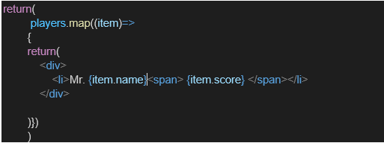

* Filter the players with scores below 70 using arrow functions of ES6.

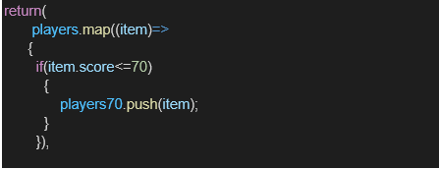

1. IndianPlayers
   1. Display the Odd Team Player and Even Team players using the Destructuring features of ES6

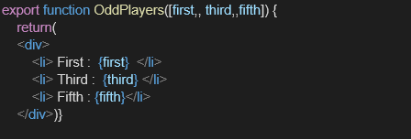

* 1. Declare two arrays T20players and RanjiTrophy players and merge the two arrays and display them using the Merge feature of ES6

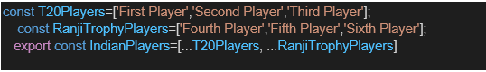

Display these two components in the same home page using a simple if else in the flag variable.

**Output:**

When Flag=true

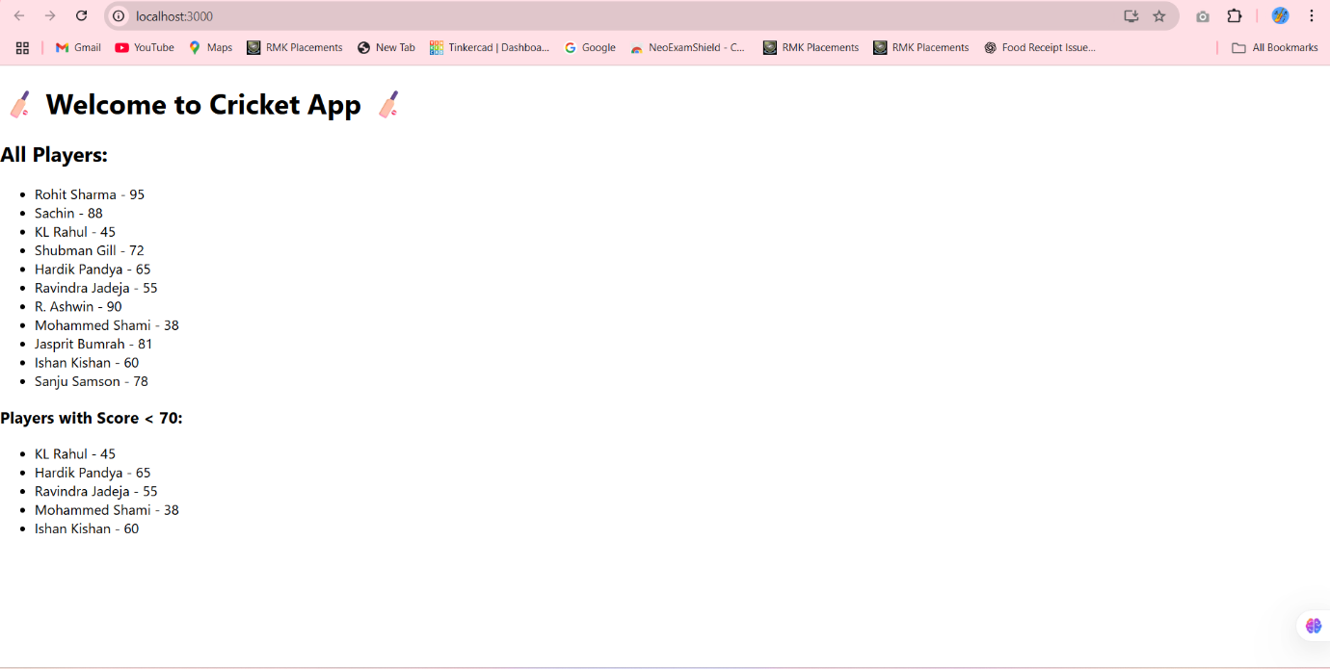

When Flag=false

