**3.Git – HOL**

**1. Explain branching and merging**

**Branching**

1. Branching means creating a separate line of development from the main code (master/main) without affecting it.
2. Each branch can have its own changes, commits, and experiments.
3. Helps in working on features or fixes independently before merging back.

**Merging**

1. Merging means combining the changes from one branch into another.
2. Git compares the commits and applies differences into the target branch.
3. Used to bring feature branch changes into the main branch after completion.

**2.Explain about creating a branch request in GitLab**

1. Go to your project → Repository → Branches.
2. Click New branch, give a branch name, and choose the source branch.
3. Click Create branch to start working on it.

**3.Explain about creating a merge request in GitLab**

1. Go to Merge Requests → Click New merge request.

2. Select the source branch (feature) and target branch (main/master).

3. Add title/description and click Submit merge request for review.

**Please follow the instruction to complete the hands-on. Each instruction expects a command for the Git Bash.**

**Branching:**

1. Create a new branch “GitNewBranch”.
2. List all the local and remote branches available in the current trunk. Observe the “*” mark which denote the current pointing branch.
3. Switch to the newly created branch. Add some files to it with some contents.
4. Commit the changes to the branch.
5. Check the status with “git status” command.

**Output:**

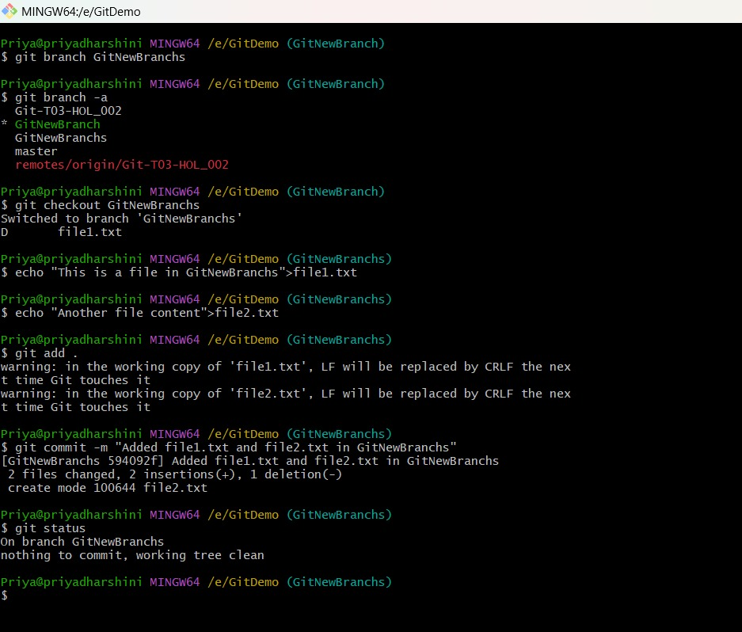

**Merging:**

1. Switch to the master
2. List out all the differences between trunk and branch. These provide the differences in command line interface.
3. List out all the visual differences between master and branch using P4Merge tool.
4. Merge the source branch to the trunk.
5. Observe the logging after merging using “git log –oneline –graph –decorate”
6. Delete the branch after merging with the trunk and observe the git status.

**Output:**

