Dharshini R

727721euai017

Question 1:

**import** org.openqa.selenium.By;

**import** org.openqa.selenium.WebDriver;

**import** org.openqa.selenium.WebElement;

**import** org.openqa.selenium.edge.EdgeDriver;

**import** org.openqa.selenium.firefox.FirefoxDriver;

**import** org.testng.Assert;

**import** org.testng.annotations.AfterTest;

**import** org.testng.annotations.BeforeTest;

**import** org.testng.annotations.Test;

**import** io.github.bonigarcia.wdm.WebDriverManager;

**public** **class** cc2 {

WebDriver driver;

@Test

**public** **void** Test1() **throws** InterruptedException {

driver=**new** FirefoxDriver();

String url="https://www.saucedemo.com/";

driver.get(url);

driver.manage().window().maximize();

driver.findElement(By.*xpath*("//*[@id=\"user-name\"]")).sendKeys("standard_user");

driver.findElement(By.*xpath*("//*[@id=\"password\"]")).sendKeys("secret_sauce");

driver.findElement(By.*xpath*("//*[@id=\"login-button\"]")).click();

driver.findElement(By.*xpath*("//*[@id=\"add-to-cart-sauce-labs-backpack\"]")).click();

driver.findElement(By.*xpath*("//*[@id=\"shopping_cart_container\"]/a")).click();

WebElement txt=driver.findElement(By.*xpath*("//*[@id=\"item_4_title_link\"]/div"));

String txt1=txt.getText();

WebElement price=driver.findElement(By.*xpath*("//*[@id=\"cart_contents_container\"]/div/div[1]/div[3]/div[2]/div[2]/div"));

String pr1=price.getText();

System.***out***.println(pr1);

driver.findElement(By.*xpath*("//*[@id=\"checkout\"]")).click();

String p1=driver.getCurrentUrl();

String ap1="https://www.saucedemo.com/checkout-step-one.html";

Assert.*assertEquals*(p1, ap1);

driver.findElement(By.*xpath*("//*[@id=\"first-name\"]")).sendKeys("Dharshini");

driver.findElement(By.*xpath*("//*[@id=\"last-name\"]")).sendKeys("Ramaswamy");

driver.findElement(By.*xpath*("//*[@id=\"postal-code\"]")).sendKeys("629302");

driver.findElement(By.*xpath*("//*[@id=\"continue\"]")).click();

String p2=driver.getCurrentUrl();

String ap2="https://www.saucedemo.com/checkout-step-two.html";

Assert.*assertEquals*(p2, ap2);

String title=driver.getTitle();

String atitle="Swag Labs";

Assert.*assertEquals*(title,atitle);

driver.findElement(By.*xpath*("//*[@id=\"finish\"]")).click();

}

}

}

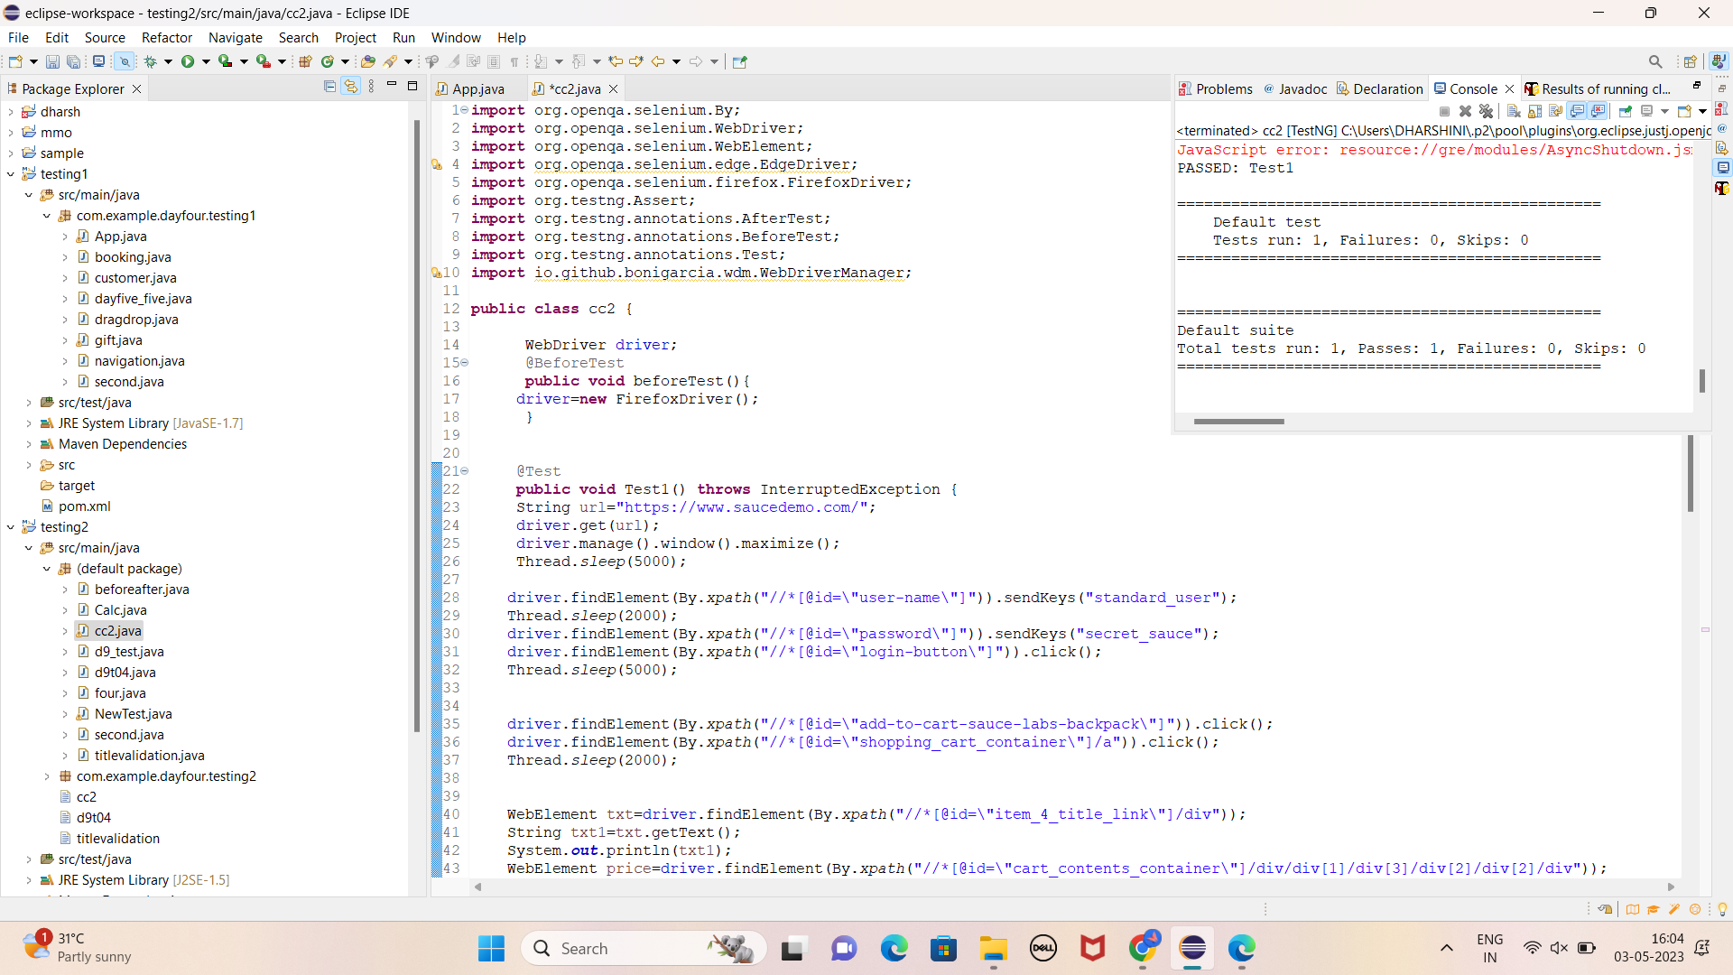

Question 2:

**import** org.openqa.selenium.By;

**import** org.openqa.selenium.WebDriver;

**import** org.openqa.selenium.WebElement;

**import** org.openqa.selenium.firefox.FirefoxDriver;

**import** org.testng.annotations.AfterTest;

**import** org.testng.annotations.BeforeTest;

**import** org.testng.annotations.Test;

**public** **class** cc_q2 {

WebDriver driver;

@BeforeTest

**public** **void** beforeTest() {

driver=**new** FirefoxDriver();

}

@Test

**public** **void** Test1() **throws** InterruptedException {

String url="https://www.saucedemo.com/";

driver.get(url);

driver.manage().window().maximize();

Thread.*sleep*(5000);

driver.findElement(By.*xpath*("//*[@id=\"user-name\"]")).sendKeys("standard_user");

driver.findElement(By.*xpath*("//*[@id=\"password\"]")).sendKeys("secret_sauce");

driver.findElement(By.*xpath*("//*[@id=\"login-button\"]")).click();

driver.findElement(By.*xpath*("//*[@id=\"header_container\"]/div[2]/div/span/select")).click();

driver.findElement(By.*xpath*("//*[@id=\"header_container\"]/div[2]/div/span/select/option[1]")).click();

WebElement az1=driver.findElement(By.*xpath*("//*[@id=\"item_4_title_link\"]/div"));

String text1=az1.getText();

System.***out***.println(text1);

driver.findElement(By.*xpath*("//*[@id=\"header_container\"]/div[2]/div/span/select")).click();

driver.findElement(By.*xpath*("//*[@id=\"header_container\"]/div[2]/div/span/select/option[2]")).click();

WebElement az2=driver.findElement(By.*xpath*("//*[@id=\"item_3_title_link\"]/div"));

String text2=az2.getText();

System.***out***.println(text2);

driver.findElement(By.*xpath*("//*[@id=\"header_container\"]/div[2]/div/span/select")).click();

driver.findElement(By.*xpath*("//*[@id=\"header_container\"]/div[2]/div/span/select/option[3]")).click();

WebElement az3=driver.findElement(By.*xpath*("//*[@id=\"inventory_container\"]/div/div[1]/div[2]/div[2]/div"));

String text3=az3.getText();

System.***out***.println(text3);

driver.findElement(By.*xpath*("//*[@id=\"header_container\"]/div[2]/div/span/select")).click();

driver.findElement(By.*xpath*("//*[@id=\"header_container\"]/div[2]/div/span/select/option[4]")).click();

WebElement az4=driver.findElement(By.*xpath*("//*[@id=\"inventory_container\"]/div/div[1]/div[2]/div[2]/div"));

String text4=az4.getText();

System.***out***.println(text4);

}

@AfterTest

**public** **void** afterTest() **throws** InterruptedException {

driver.quit();

}

}