Dharshini R

727721euai017

Question:1

**import** org.openqa.selenium.By;

**import** org.openqa.selenium.Keys;

**import** org.openqa.selenium.WebDriver;

**import** org.openqa.selenium.WebElement;

**import** org.openqa.selenium.edge.EdgeDriver;

**import** org.openqa.selenium.firefox.FirefoxDriver;

**import** org.testng.annotations.AfterTest;

**import** org.testng.annotations.BeforeTest;

**import** org.testng.annotations.Test;

**import** io.github.bonigarcia.wdm.WebDriverManager;

**public** **class** ca_q1 {

WebDriver driver;

@BeforeTest

**public** **void** beforeTest() {

driver=**new** FirefoxDriver();

}

@Test

**public** **void** Test() **throws** InterruptedException {

String url="https://www.amazon.in/";

driver.get(url);

driver.manage().window().maximize();

Thread.*sleep*(5000);

driver.findElement(By.*xpath*("//*[@id=\"twotabsearchtextbox\"]")).sendKeys("Phones",Keys.***ENTER***);

driver.findElement(By.*xpath*("/html/body/div[1]/div[2]/div[1]/div[1]/div/span[1]/div[1]/div[1]/div/div/div[1]/div[2]/div[2]/div[1]/div/a[2]/div/div[1]/img")).click();

Thread.*sleep*(700);

driver.findElement(By.*xpath*("//*[@id=\"add-to-cart-button\"]")).click();

driver.findElement(By.*xpath*("/html/body/div[1]/div[2]/div/div[1]/div[2]/div/div[3]/div/div[1]/span/span/a")).click();

driver.findElement(By.*xpath*("//*[@id=\"a-autoid-0-announce\"]")).click();

driver.findElement(By.*xpath*("//*[@id=\"quantity_2\"]")).click();

driver.findElement(By.*xpath*("/html/body/div[1]/div[2]/div[3]/div[5]/div/div[2]/div[1]/div/form/div[2]/div[3]/div[4]/div/div[2]/div[1]/span[2]/span/input")).click();

driver.navigate().to("https://www.amazon.in/dp/B09LM98LRT/ref=redir_mobile_desktop?_encoding=UTF8&aaxitk=b64f891a4fd6ae0703bbcb946aabe933&content-id=amzn1.sym.df4bf09f-d6a1-4ca3-98bc-ee2a82b34bf9%3Aamzn1.sym.df4bf09f-d6a1-4ca3-98bc-ee2a82b34bf9&hsa_cr_id=5574300390202&pd_rd_plhdr=t&pd_rd_r=5bafbc7a-2309-413e-b634-b7425bde9fa0&pd_rd_w=j7zzL&pd_rd_wg=KH7Ag&qid=1683189619&ref_=sbx_be_s_sparkle_lsi4d_asin_0_img&sr=1-1-e0fa1fdd-d857-4087-adda-5bd576b25987");

Thread.*sleep*(5000);

driver.findElement(By.*xpath*("//*[@id=\"add-to-cart-button\"]")).click();

Thread.*sleep*(4000);

driver.findElement(By.*xpath*("/html/body/div[1]/div[2]/div/div[1]/div[2]/div/div[3]/div/div[1]/form/span/span/span/input")).click();

Thread.*sleep*(4000);

driver.findElement(By.*xpath*("//*[@id=\"ap_email\"]")).sendKeys("9363161145",Keys.***ENTER***);

Thread.*sleep*(2000);

driver.findElement(By.*xpath*("//*[@id=\"ap_password\"]")).sendKeys("Dharsh@2003",Keys.***ENTER***);

Thread.*sleep*(2000);

WebElement total=driver.findElement(By.*xpath*("/html/body/div[5]/div[1]/div/div[2]/div/div/div[2]/div/div[1]/div/div[2]/div/div[1]/div/table/tbody/tr[4]/td[2]"));

}

@AfterTest

**public** **void** afterTest() {

driver.quit();

}

}

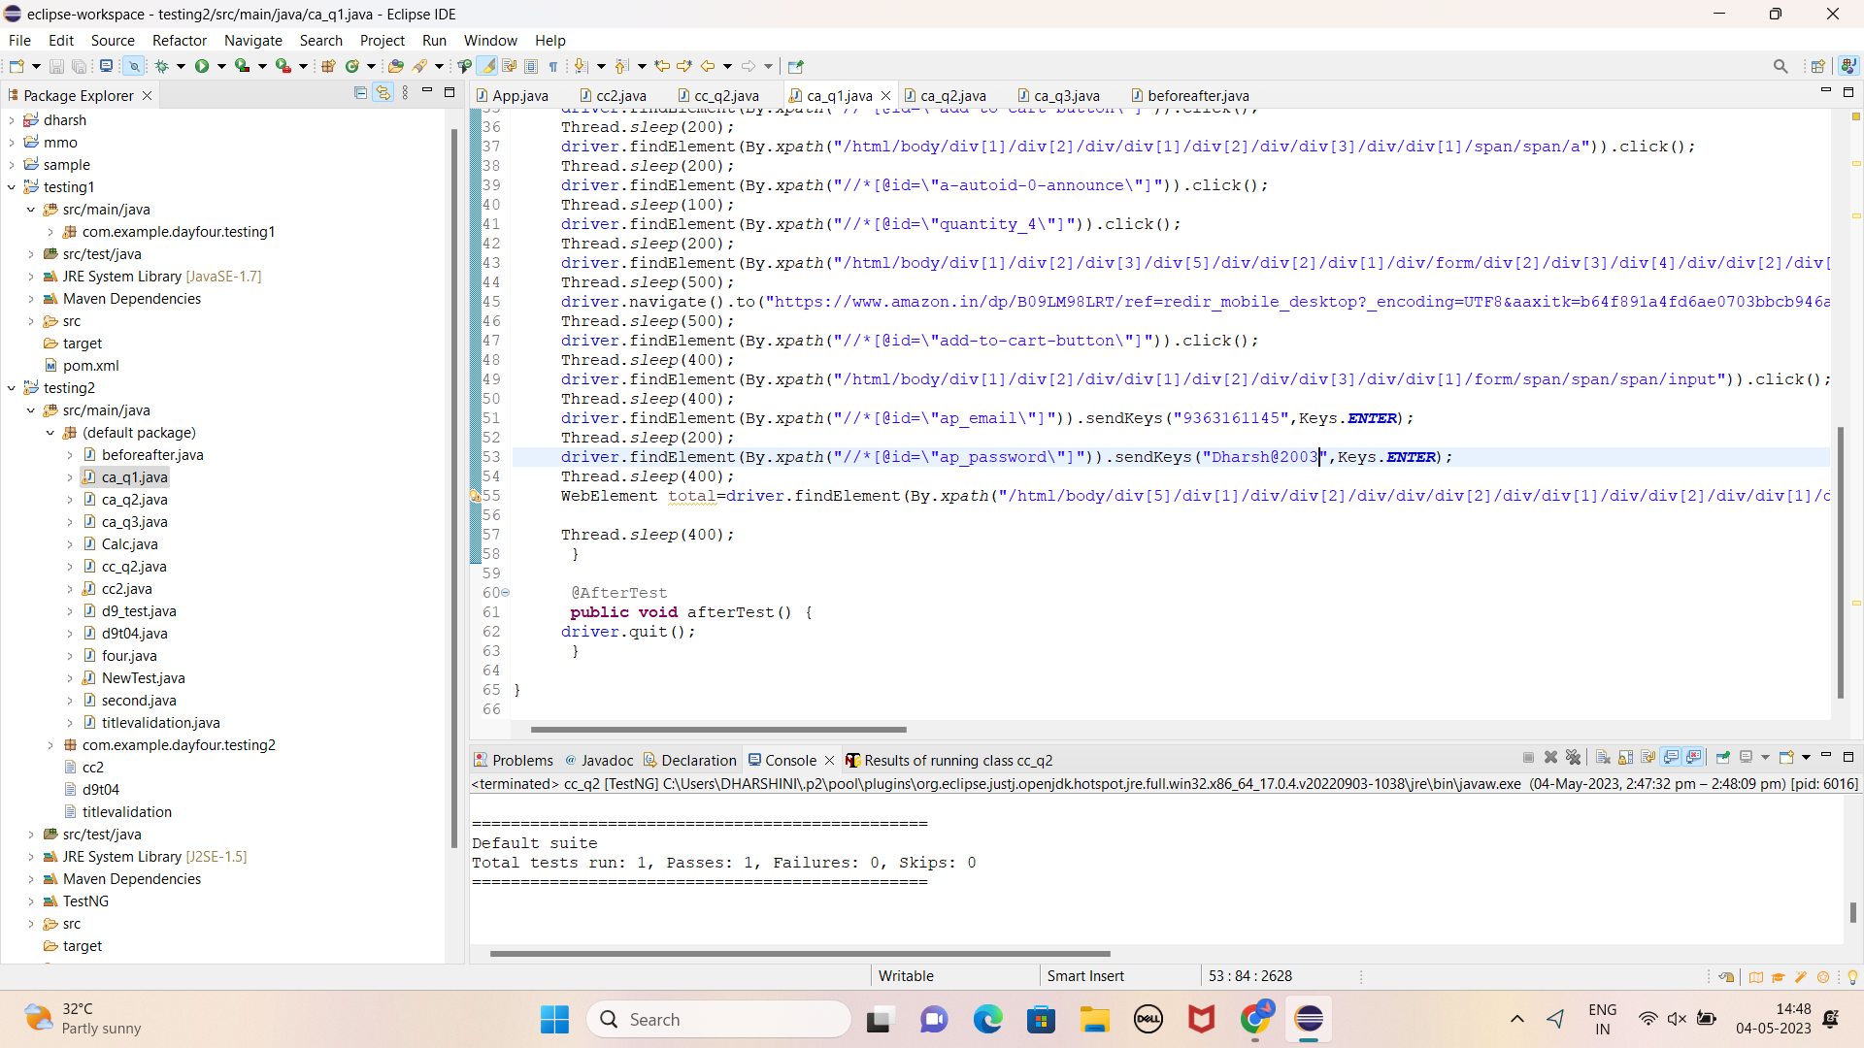

Question 2:

**import** org.openqa.selenium.By;

**import** org.openqa.selenium.WebDriver;

**import** org.openqa.selenium.WebElement;

**import** org.openqa.selenium.chrome.ChromeDriver;

**import** org.openqa.selenium.chrome.ChromeOptions;

**import** org.testng.annotations.Test;

**import** io.github.bonigarcia.wdm.WebDriverManager;

**public** **class** ca_q2 {

**public** **static** **void** main(String[] args) {

ChromeOptions co=**new** ChromeOptions();

co.addArguments ("--remote-allow-origins=*");

WebDriverManager.*chromedriver*().setup ();

WebDriver driver=**new** ChromeDriver(co);

driver.get ("https://www.amazon.in/");

driver.manage().window().maximize() ;

String currentTitle=driver.getTitle();

System.***out***.println(currentTitle);

String expectedTitle="Online Shopping site in India: Shop Online for Mobiles, Books, Watches, Shoes and More - Amazon.in";

**if**(currentTitle.equals(expectedTitle)) {

System.***out***.println("Title Matched");

}

**else** {

System.***out***.println("Title not Matched");

}

WebElement txtBoxl=driver.findElement(By.*xpath*("//*[@id=\"twotabsearchtextbox\"]"));

txtBoxl.sendKeys("iphone");

driver.findElement(By.*xpath*("//*[@id=\"nav-search-submit-button\"]")).click();

String txt1=driver.findElement(By.*xpath*("//*[@id=\"search\"]/div[1]/div[1]/div/span[1]/div[1]/div[3]/div/div/div/div/div/div/div/div[2]/div/div/div[1]/h2/a/span")).getText();

System.***out***.println(txt1);

String txt2=driver.findElement(By.*xpath*("//*[@id=\"search\"]/div[1]/div[1]/div/span[1]/div[1]/div[4]/div/div/div/div/div/div/div/div[2]/div/div/div[1]/h2/a/span")).getText();

System.***out***.println(txt2);

String txt3=driver.findElement(By.*xpath*("//*[@id=\"search\"]/div[1]/div[1]/div/span[1]/div[1]/div[5]/div/div/div/div/div/div[2]/div/div/div[1]/h2/a/span")).getText();

System.***out***.println(txt3);

String txt4=driver.findElement(By.*xpath*("//*[@id=\"search\"]/div[1]/div[1]/div/span[1]/div[1]/div[6]/div/div/div/div/div/div[2]/div/div/div[1]/h2/a/span")).getText();

System.***out***.println(txt4);

String txt5=driver.findElement(By.*xpath*("//*[@id=\"search\"]/div[1]/div[1]/div/span[1]/div[1]/div[7]/div/div/div/div/div/div[2]/div/div/div[1]/h2/a/span")).getText();

System.***out***.println(txt5);

//filter

driver.findElement(By.*xpath*("//*[@id=\"p_36/7252032031\"]/span/a/span")).click();

driver.findElement(By.*xpath*("//*[@id=\"p_n_pattern_browse-bin/1464446031\"]/span/a/span")).click();

}

}

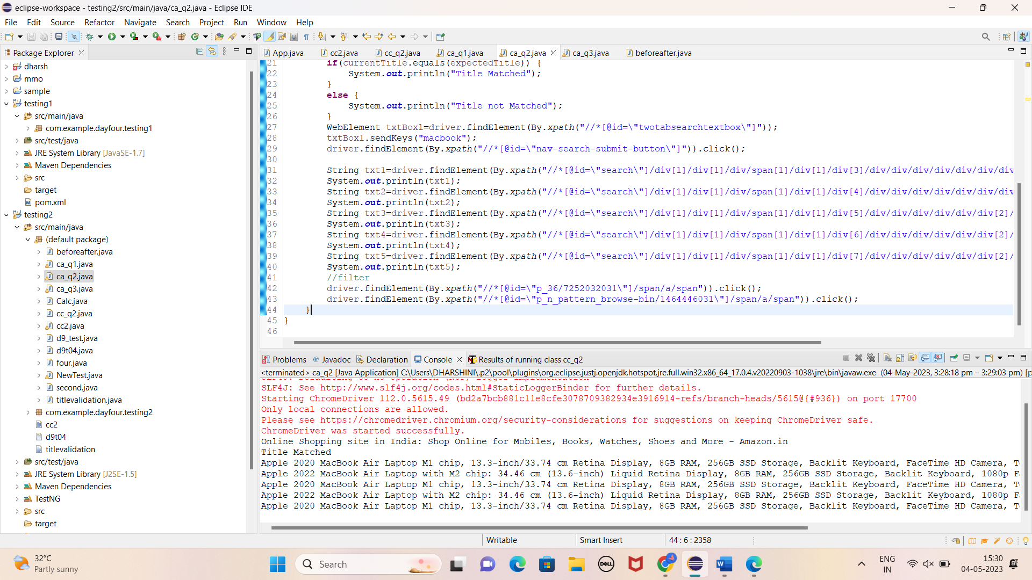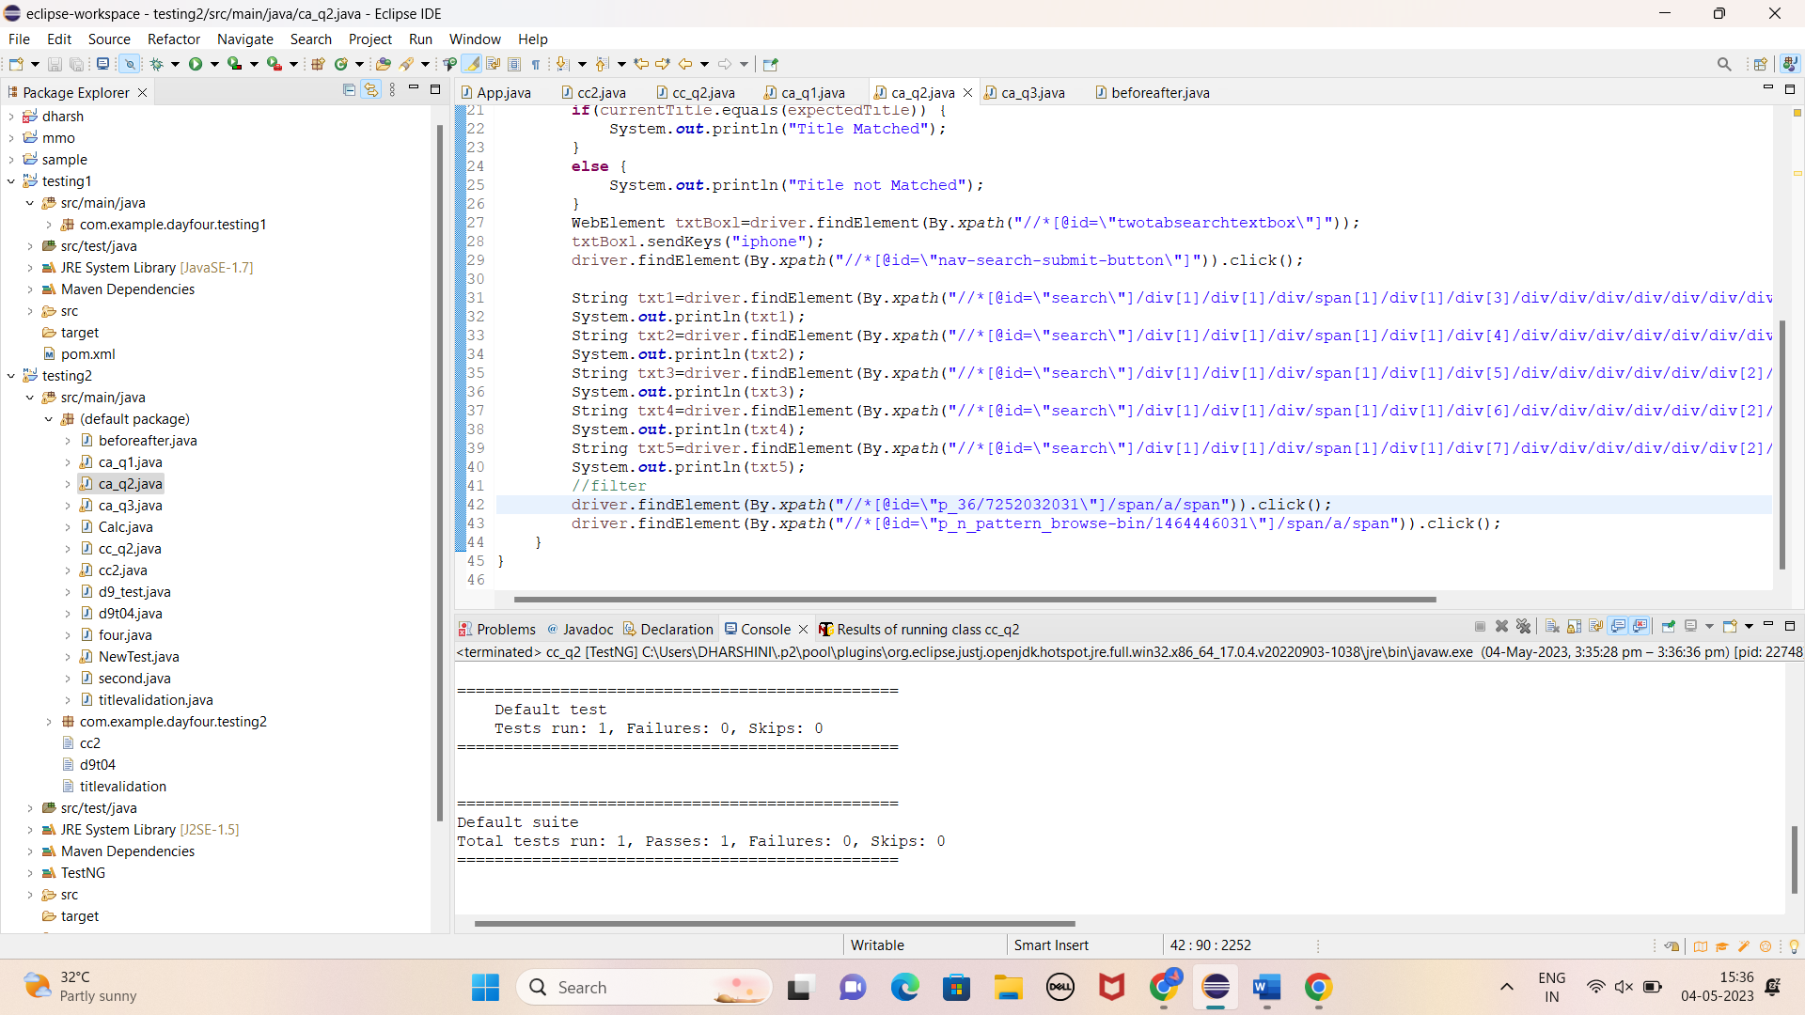

Question 3:

**import** org.openqa.selenium.By;

**import** org.openqa.selenium.WebDriver;

**import** org.openqa.selenium.edge.EdgeDriver;

**import** org.testng.annotations.Test;

**import** io.github.bonigarcia.wdm.WebDriverManager;

**public** **class** ca_q3 {

@Test

**void** Tc_001() **throws** InterruptedException {

WebDriverManager.*edgedriver*().setup();

EdgeDriver driver = **new** EdgeDriver();

driver.get("https://www.amazon.in/");

driver.manage().window().maximize();

driver.findElement(By.*xpath*("//*[@id=\"nav-link-accountList\"]")).click();

driver.findElement(By.*xpath*("//*[@id=\"ap_email\"]")).sendKeys("9363161145");

driver.findElement(By.*xpath*("//*[@id=\"continue\"]")).click();

Thread.*sleep*(2000);

driver.findElement(By.*xpath*("//*[@id=\"ap_password\"]")).sendKeys("Dharsh@2003");

driver.findElement(By.*xpath*("//*[@id=\"signInSubmit\"]")).click();

Thread.*sleep*(2000);

driver.findElement(By.*xpath*("//*[@id=\"nav-link-yourAccount\"]/span[2]/span[1]")).click();

driver.findElement(By.*xpath*("//*[@id=\"link-view\"]/div[1]/div[1]/a")).click();

String ur=driver.getCurrentUrl();

**if**(ur.equals("https://www.amazon.in/gp/your-account/order-history?ref_=ya_d_c_yo")) {

System.***out***.println("Orders page");

}

**else** {

System.***out***.println(**false**);

}

// driver.navigate().back();

driver.findElement(By.*xpath*("//*[@id=\"orderTypeMenuContainer\"]/ul/li[4]/span/a")).click();

String ur2=driver.getCurrentUrl();

**if**(ur2.equals("https://www.amazon.in/gp/your-account/order-history/ref=ppx_yo_dt_b_oo_view_all?ie=UTF8&orderFilter=open")) {

System.***out***.println("Shipment");

}

**else** {

System.***out***.println(**false**);

}

// driver.navigate().back();

driver.findElement(By.*xpath*("//*[@id=\"orderTypeMenuContainer\"]/ul/li[5]/span/a")).click();

String ur21=driver.getCurrentUrl();

**if**(ur21.equals("https://www.amazon.in/gp/your-account/order-history/ref=ppx_yo_dt_b_cancelled_orders?ie=UTF8&orderFilter=cancelled")) {

System.***out***.println("Cancelled orders");

}

**else** {

System.***out***.println(**false**);

}

Thread.*sleep*(1000);

driver.close();

}

}

