EXECUTIVE SUMMARY

18+ years of experience in HR & Internal lead Auditor ISO 9001-2015. He has worked with Hella India Automotive Pvt Ltd. Automotive products solutions and Engineering service sector in different vertical.

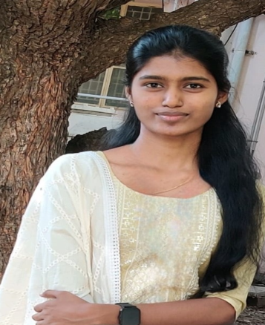He is responsible for our projects as Business development account manager, Mainly into Business Procurement and allocation, Internal Team review meeting , TISAX internal auditor has exposure more than 8 years for OEM business market and mentor and monitoring the team members to achieve the target in specific timeline. He has exposure to Health & Safety of employee, Scheduling, Interaction with client, Data Analysis, Supervise the project teams.

Qualification: MBA HR & MA-LLB

# Mahaashri CV

Manager Security & Compliance

[mahaashrichandran@gmail.com](mailto:mahaashrichandran@gmail.com)

# Responsibilities

* Business Procurement
* Training Health and Safety
* VAPT Analysis
* Data Protection and Security
* ISO 27001 – 2013
* ISO 9001-2015
* Client meetings
* Regular Team Meetings
* Legal Compliance