MicroGoals – Secure Goal Management Backend API

Project Overview
MicroGoals is a backend RESTful API designed to securely manage personal goals. It is developed using Node.js, Express.js, and MongoDB. The system allows users to register, log in, and maintain their goals through CRUD operations. JWT authentication and middleware are used to ensure secure access and protect user data.
Main components of the system include:
- User registration and login
- JWT based authentication
- CRUD operations for goal management
- Protected API routes
- Centralized error handling
The main aim of this project is to create a secure and scalable backend system that allows users to manage their goals digitally.

Project Guidelines
- The project follows REST API design principles.
- JWT is used for authentication and authorization.
- MongoDB serves as the primary database.
- API testing is performed using Thunder Client.
- The system follows MVC (Model-View-Controller) architecture.

Pre-requisites
- Node.js (version 18 or above)
- Express.js framework
- MongoDB (local installation or MongoDB Atlas)
- Visual Studio Code
- Thunder Client extension
- Basic knowledge of JavaScript and REST APIs

Technical Architecture
- Runtime Environment: Node.js
- Framework: Express.js
- Database: MongoDB
- Authentication Method: JWT
- Architecture Pattern: MVC

Entity Relationship Overview
Entities involved in the system:
User Entity:
- _id
- name
- email
- password
Goal Entity:
- _id
- title
- completed
- userId (reference to User)
Relationship: One user can have multiple goals.

System Features
- User account registration
- Secure login using JWT
- Create new goals
- Update existing goals
- Delete goals
- View goals related to a specific user
- Protected routes for security
- Centralized error management

Roles and Responsibilities
User: Register, log in, and manage personal goals.
Developer: Develop APIs and perform testing.

User Workflow
- User registers an account
- User logs into the system
- A JWT token is generated
- The token is sent in request headers
- User accesses protected API routes
- User performs CRUD operations on goals

Project Setup
- Initialize the project using npm init -y
- Install required dependencies such as express, mongoose, jsonwebtoken, bcryptjs, and dotenv
- Start the server using node server.js

Backend Development
An Express server was created to handle API requests, manage routes, and process JSON data for backend operations.
MongoDB was connected using mongoose to store user and goal data securely.
Authentication APIs were implemented for user registration and login. Passwords are hashed and JWT tokens are generated for secure authentication.
Goal CRUD APIs allow authenticated users to create, read, update, and delete their personal goals while ensuring that users can only access their own data.
Authentication middleware verifies JWT tokens before allowing access to protected routes. If the token is missing or invalid, the system returns a 401 Unauthorized response.
Error handling middleware captures runtime errors and sends structured JSON responses with appropriate HTTP status codes such as 200, 201, 400, 401, and 404.

Database Development
MongoDB can be configured either locally or using MongoDB Atlas.
The database connection string is stored in the .env file.
Schemas and models are created using mongoose:
User Schema defines the structure for user information including name, email, and password.
Goal Schema stores goal details and includes a userId reference to link each goal to a specific user.

Project Execution
- Start the MongoDB service
- Run the backend server
- Test APIs using Thunder Client
- Register a user account
- Log in to receive a JWT token
- Use the token to perform CRUD operations on goals

Project Output
The system demonstrates successful user registration and login, JWT token generation, goal creation, secure access to protected routes, and proper error handling
1.user registration .
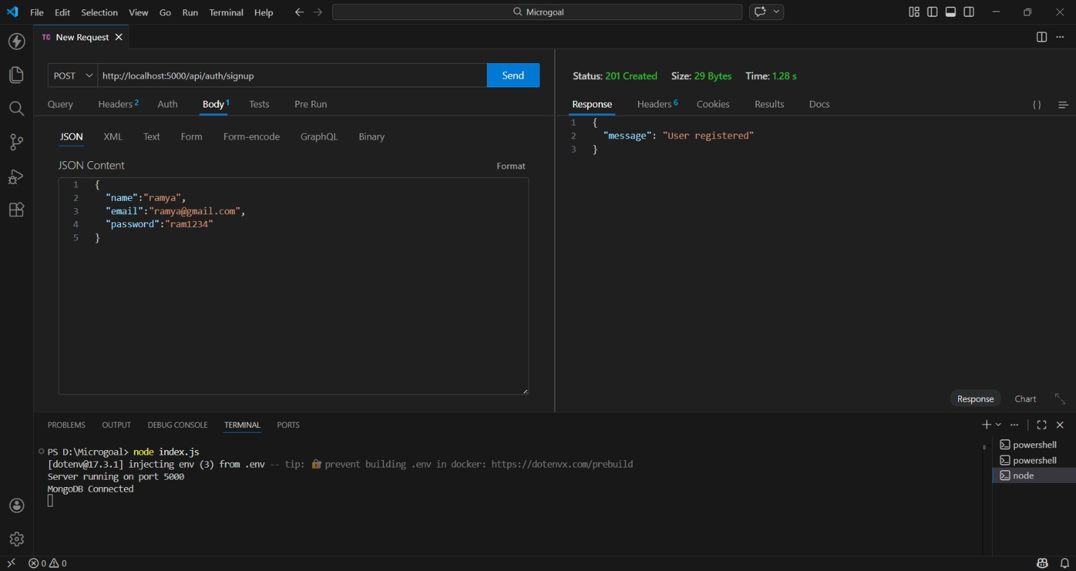
2.user login

2.user login
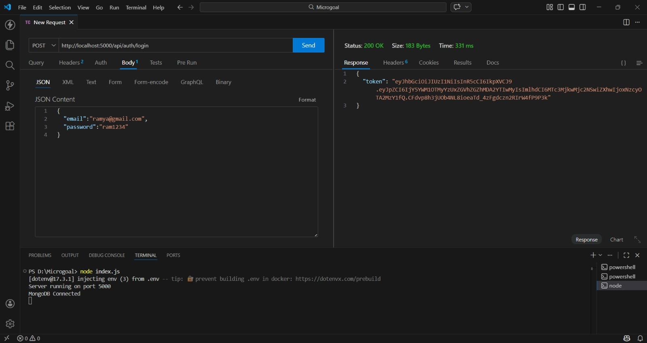
3.Goal creation
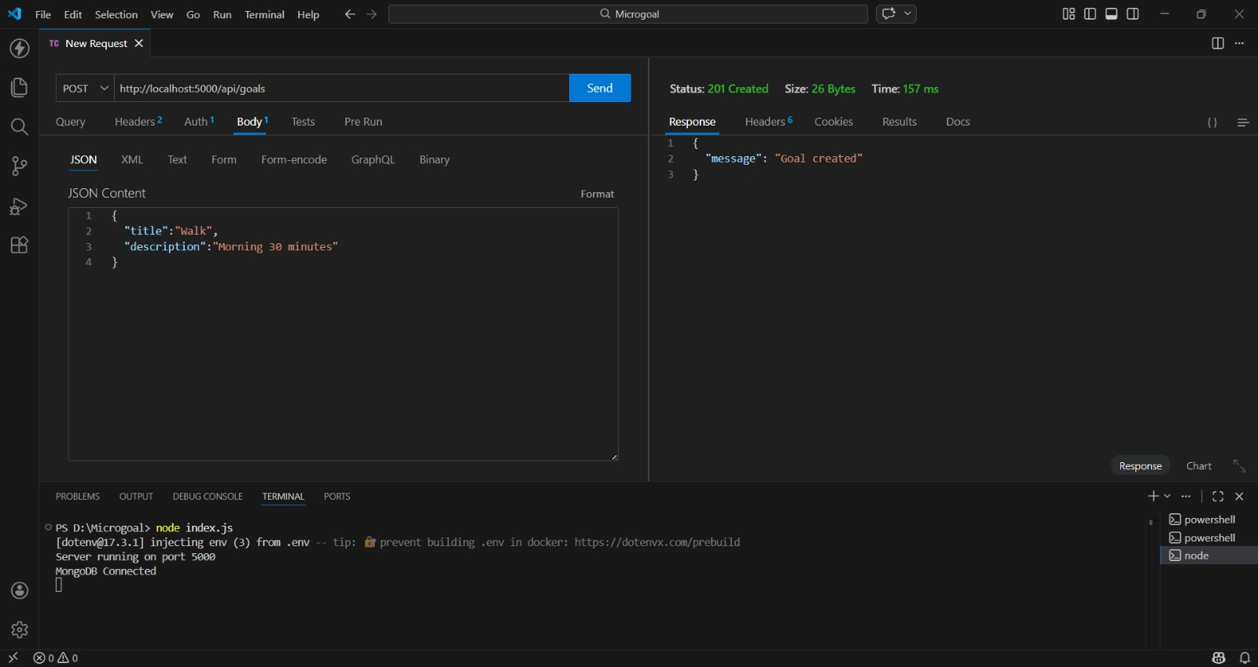

4 view goal
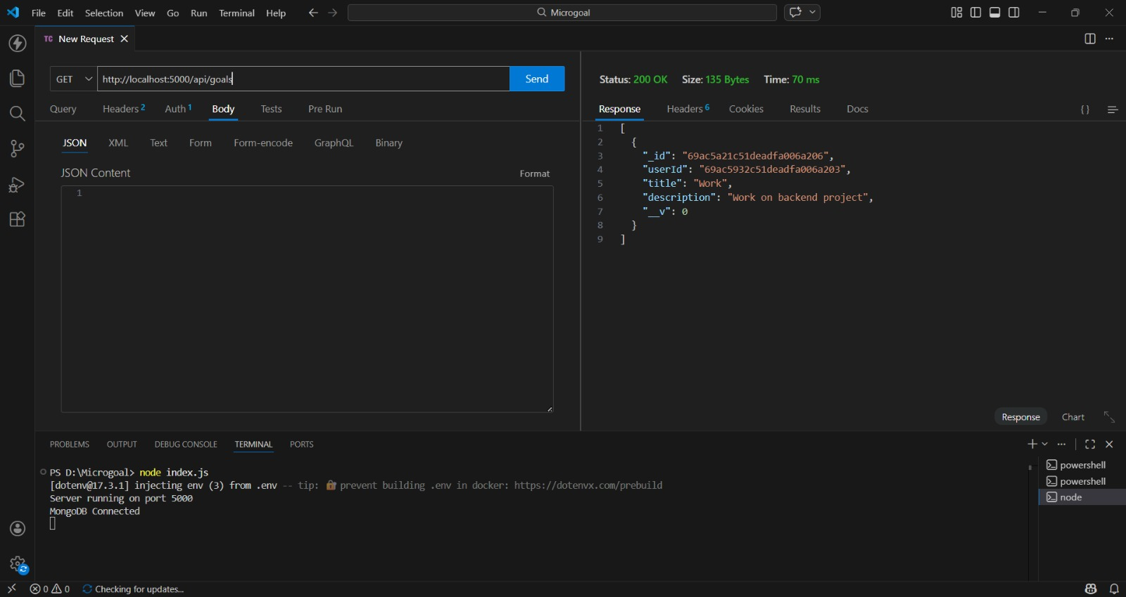
5.Delete goal
