Table 1.1 Benchmark Circuit Descriptions:
Circuits
27-Channel Interrupt Controller (C432)
8-Bit Arithmetic Logic Unit (C880)
16-Bit Error Detector and Corrector (C1908)
FSM Based Controller (S1238)
Sequential Control Circuit(S1488)

Table 1.2 Test Circuit Specifications:
Circuit | Inputs | Outputs | Faults | Patterns
C432 | 36 | 7 | 524 | 8950
C880 | 60 | 26 | 942 | 15357
C1908 | 33 | 25 | 1879 | 34216
S1238 | 32 | 32 | 1158 | 16777
S1488 | 14 | 25 | 1385 | 8636

1.1 Summary of Test Pattern Generation Results:
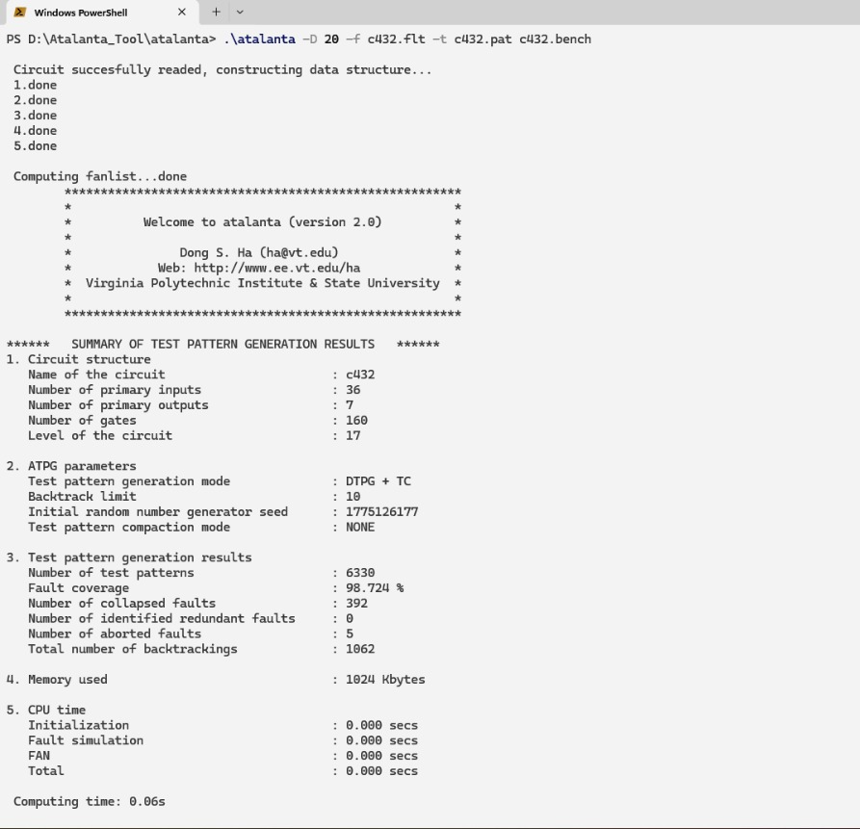
Fig. 1.1 Circuit c432

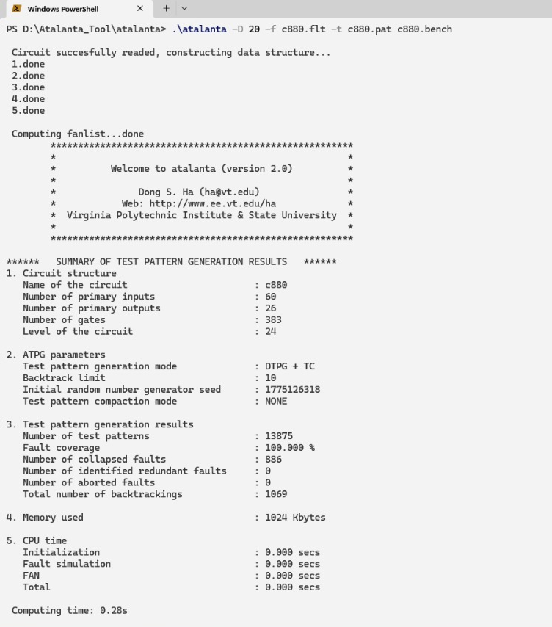
Fig.1.2 Circuit c880
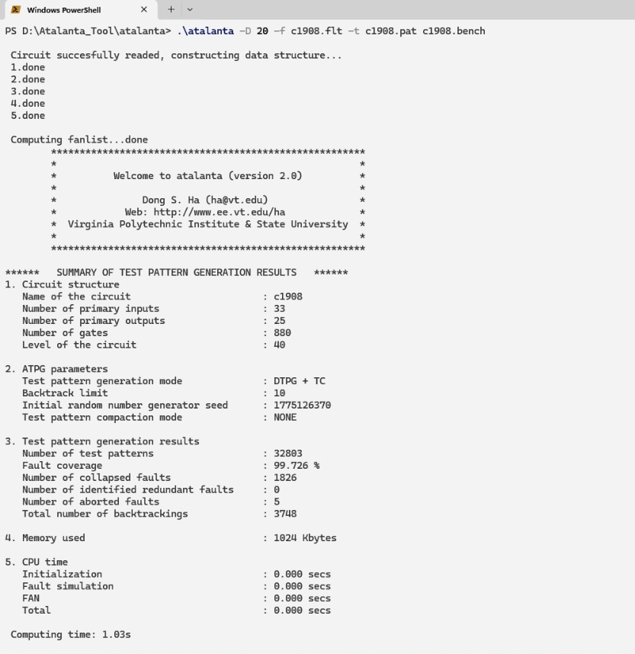
Fig.1.3 Circuit c1908

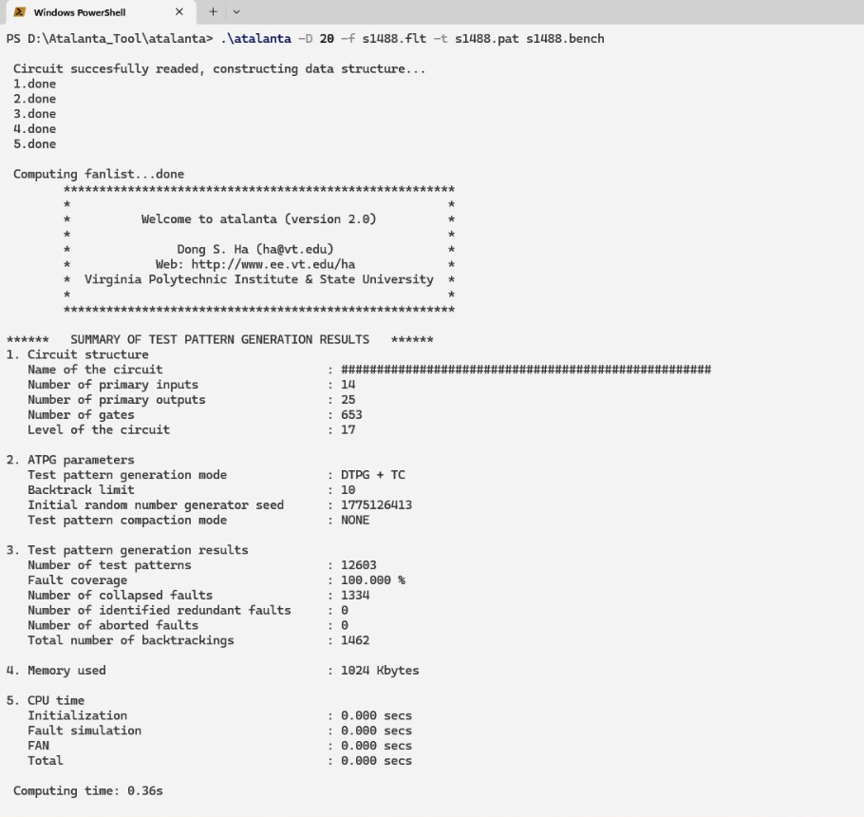
Fig.1.4 Circuit s1238

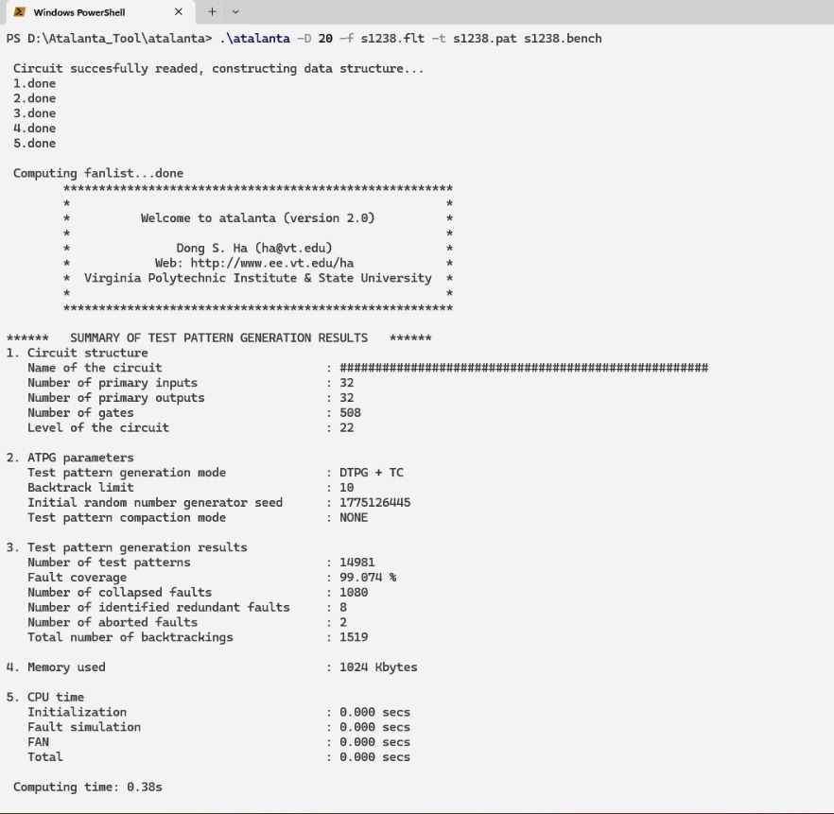
Fig.1.5 Circuit S 1488

Table 1.3 Classification Results for Benchmark Circuits:
Circuit | Accuracy(%) | Recall(%) | Precision(%) | F1 Score | ROC-AUC | MCC | Hamming loss | Fault Coverage  (%)
C432 | 99.95 | 99.42 | 95.88 | 0.9762 | 0.992 | 0.9761 | 0.0005 | 85.86
C880 | 99.99 | 99.86 | 98.5 | 0.9917 | 0.9995 | 0.9917 | 0.0001 | 89.91
C1908 | 99.99 | 99.89 | 97.43 | 0.9865 | 0.9995 | 0.9865 | 0.0001 | 97.98
S1238 | 99.92 | 98.65 | 85.73 | 0.9174 | 0.9996 | 0.9192 | 0.0008 | 92.73
S1488 | 99.89 | 99.59 | 94.03 | 0.9673 | 0.9991 | 0.9671 | 0.0011 | 97.01

1.2Circuit-Wise Model Evaluation
C432:
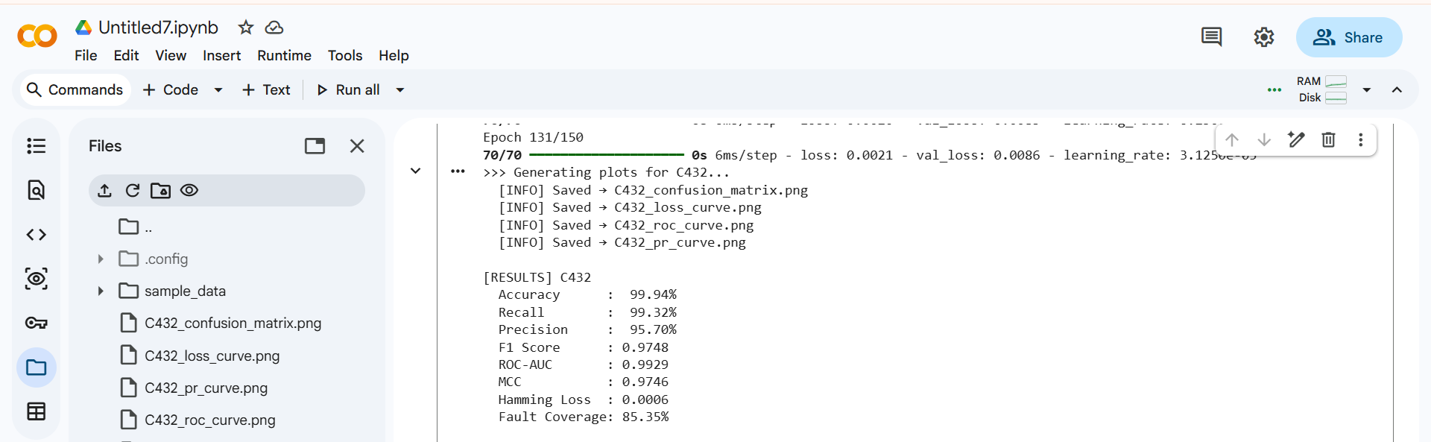
Fig.1.6 Model Training Results for C432 Dataset
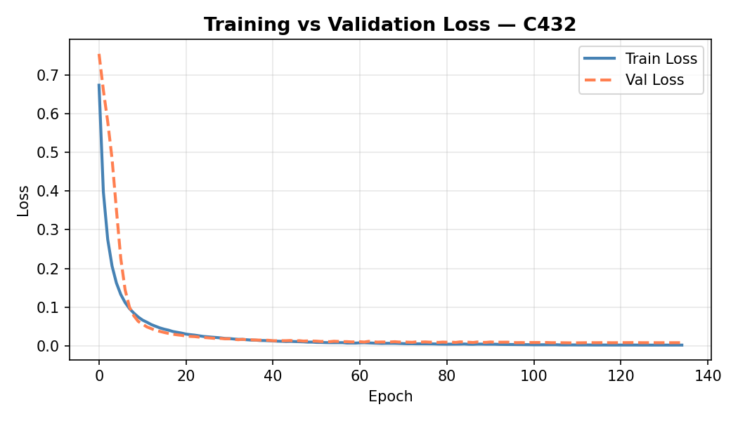Fig.1.7 Training Vs validation Loss
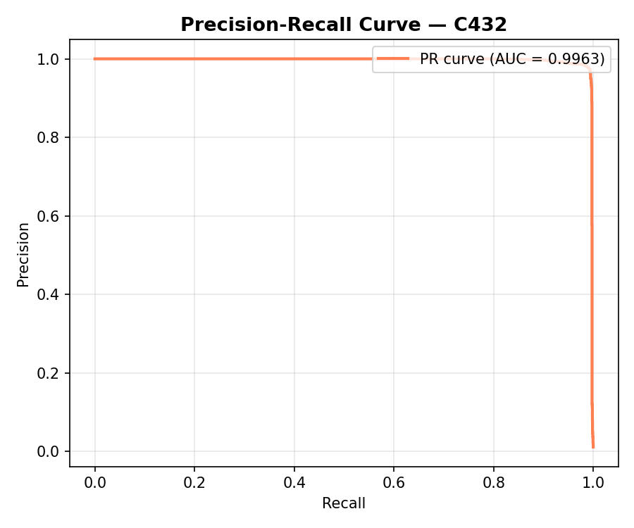
Fig.1.8 Precision-Recall Curve
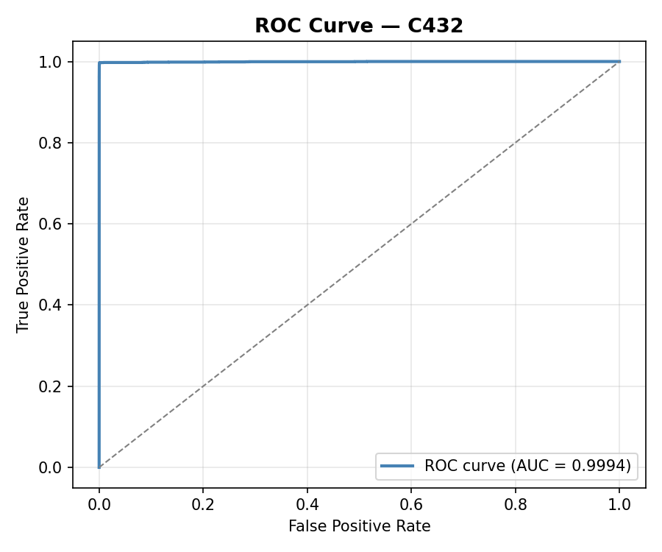
Fig.1.9 ROC Curve

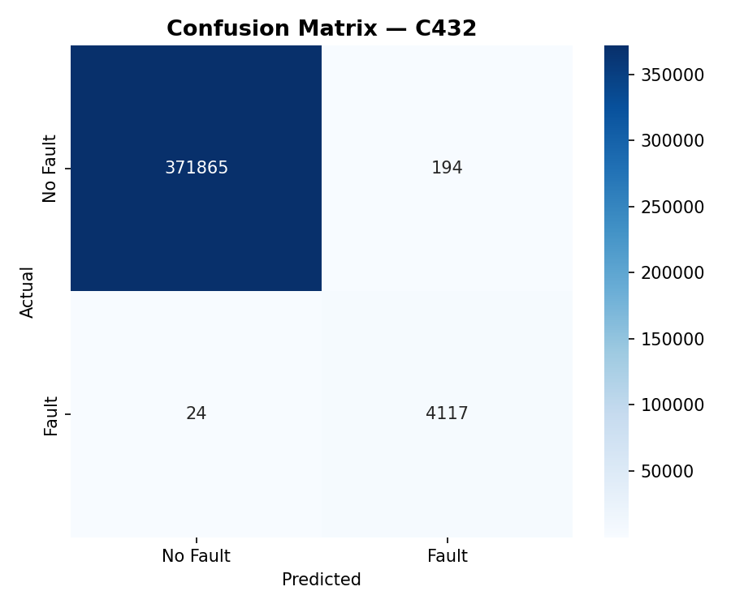
Fig.1.10 Confusion Matrix

C880:
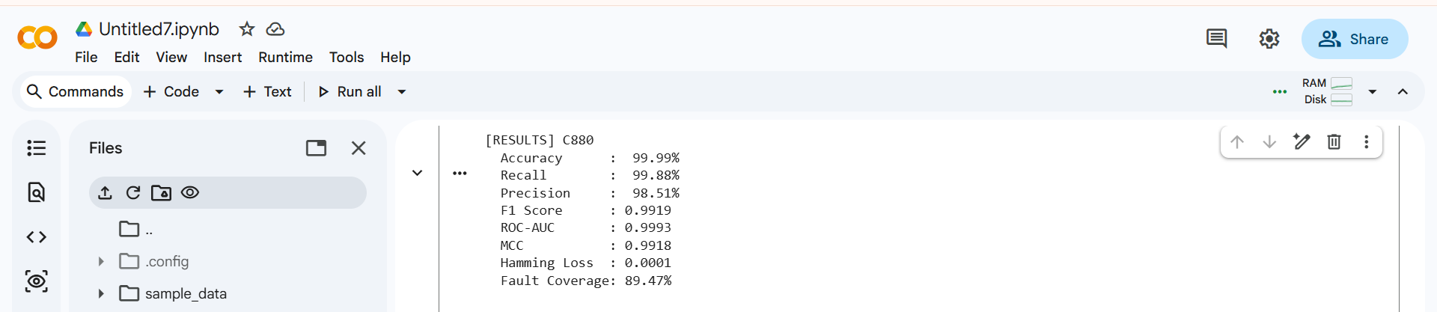
Fig.1.11 Model Training Results for C880 Dataset

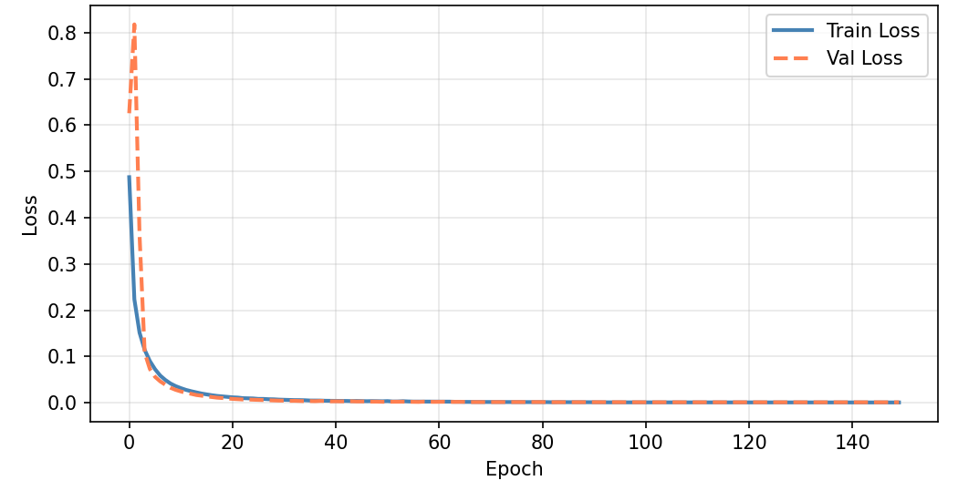
Fig.1.12 Training Vs validation Loss

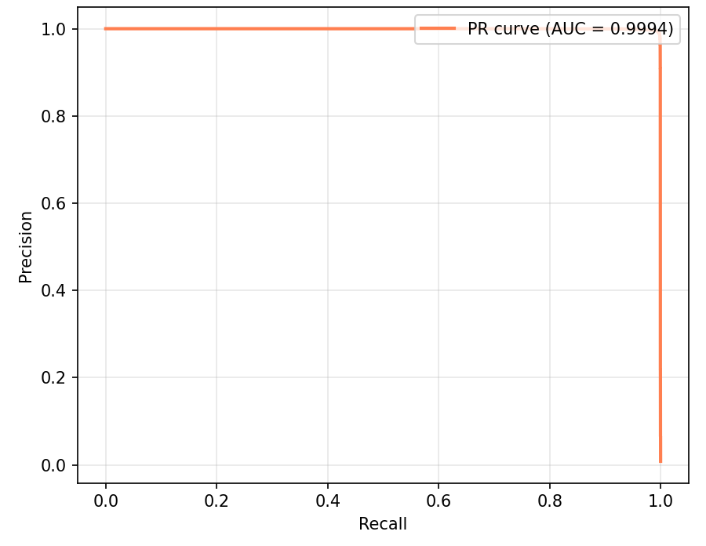
Fig.1.13 Precision-Recall Curve
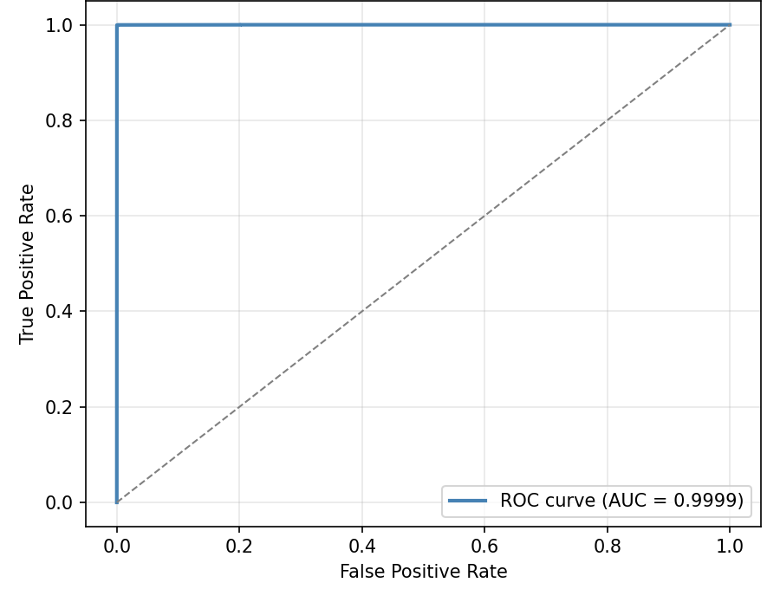
Fig.1.14 ROC Curve
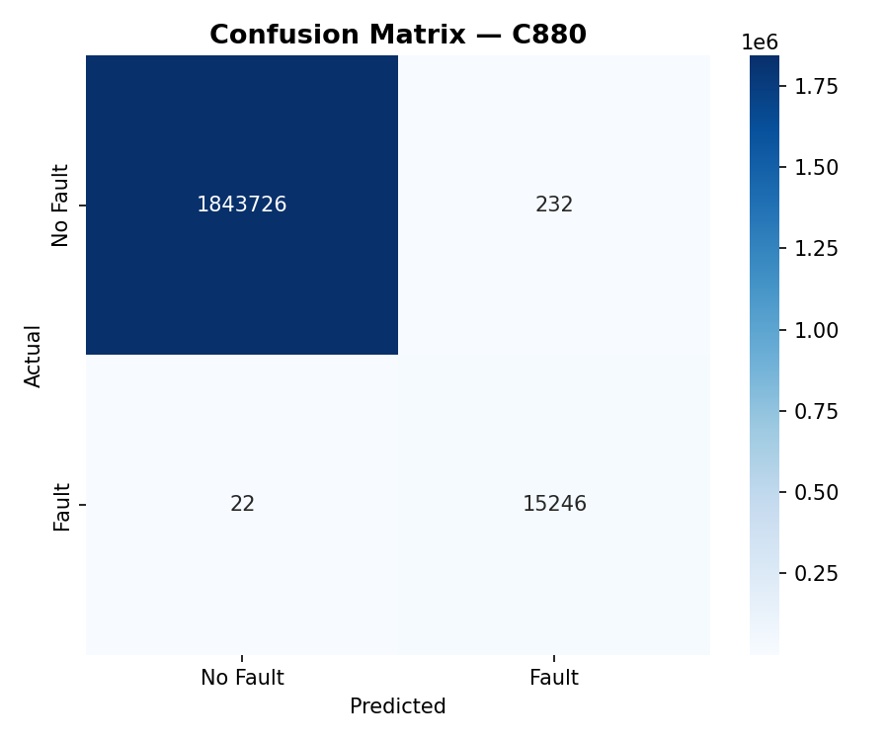

Fig.1.15 Confusion Matrix

C1908:
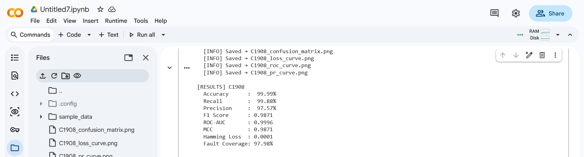
Fig.1.16 Model Training Results for C1908 Dataset

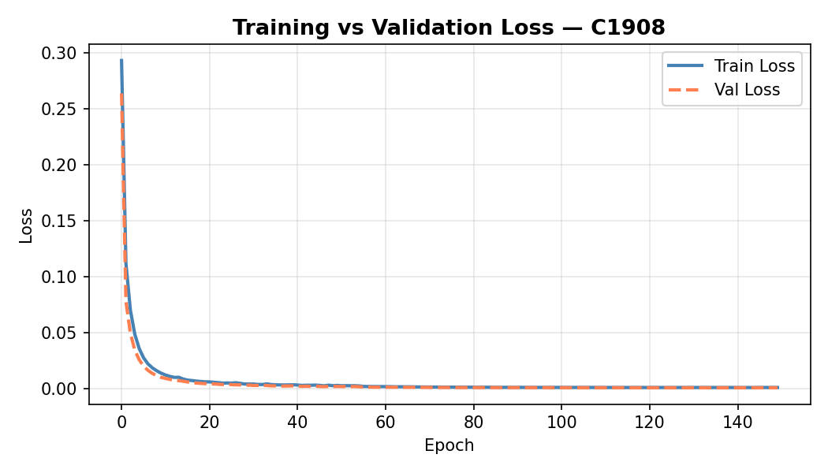
Fig.1.17 Training Vs validation Loss
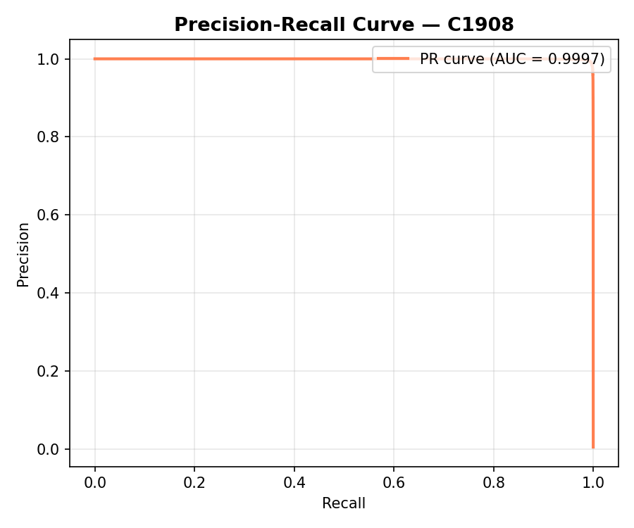
Fig.1.18 Precision-Recall Curve

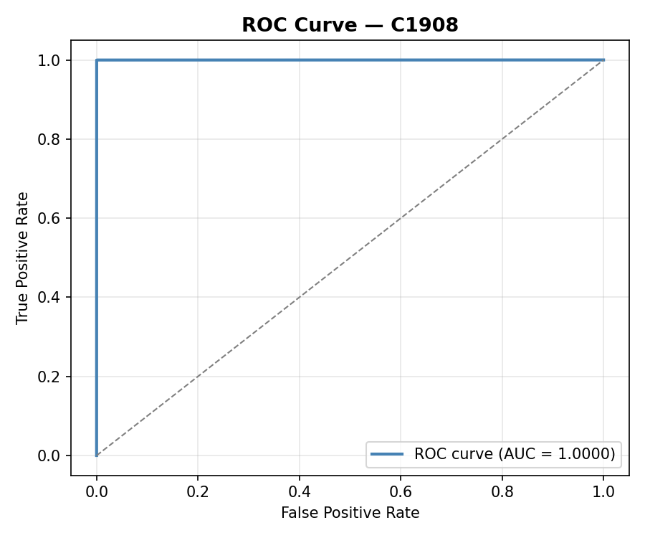
Fig.1.19 ROC Curve

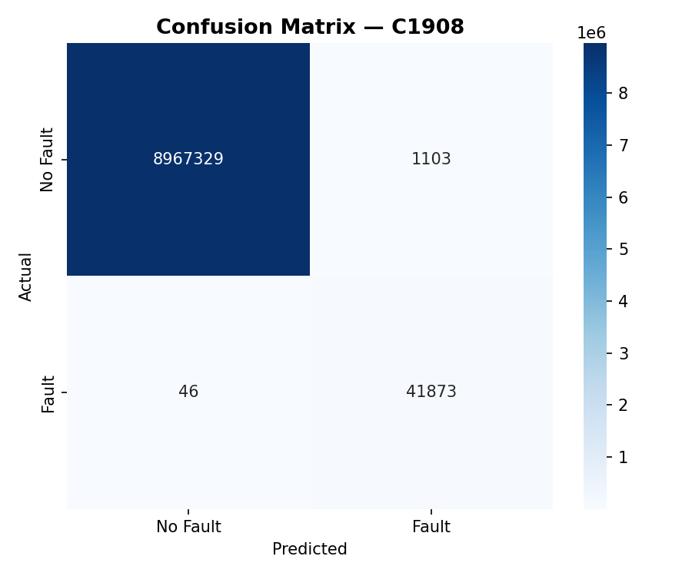
Fig.1.20 Confusion Matrix

S1238:
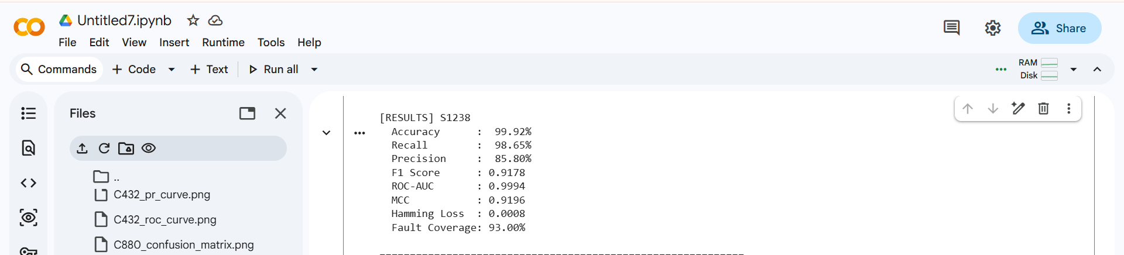
Fig.1.21 Model Training Results for S1238 Dataset

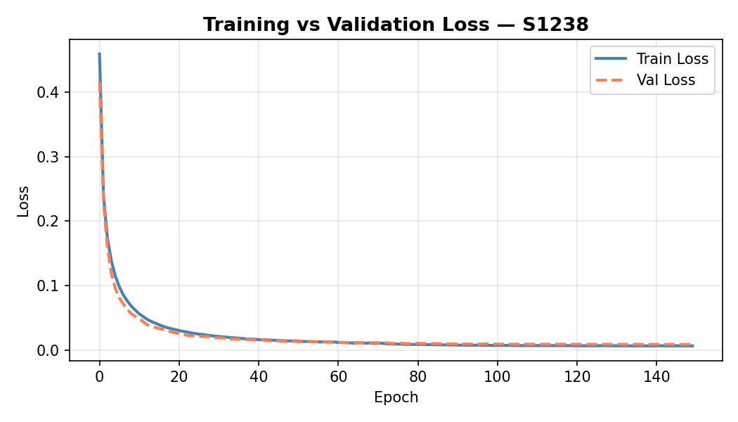
Fig.1.22 Training Vs validation Loss
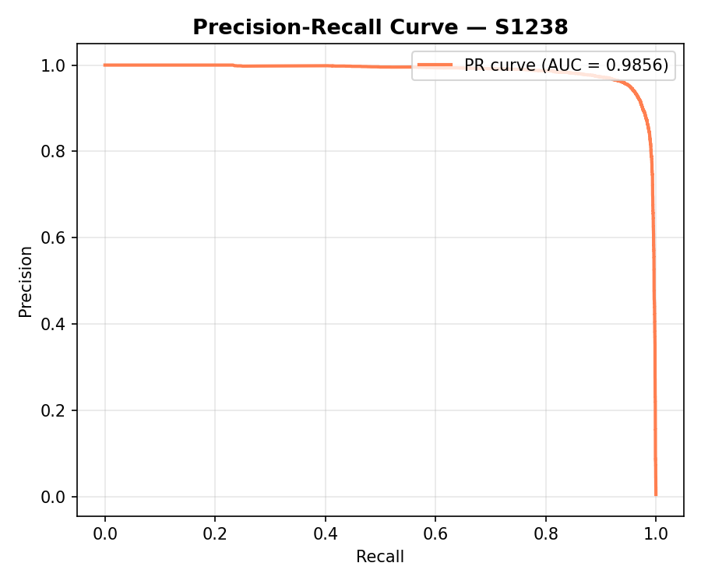
Fig.1.23 Precision-Recall Curve

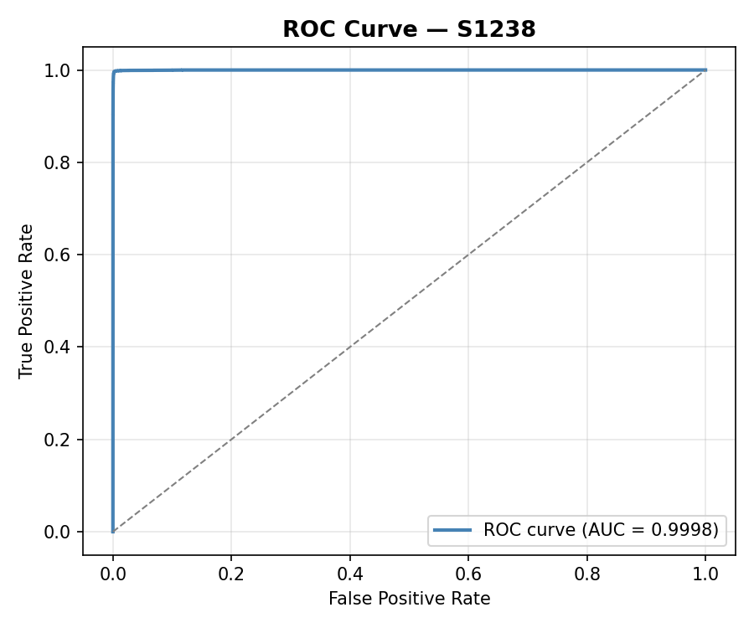
Fig.1.24 ROC Curve

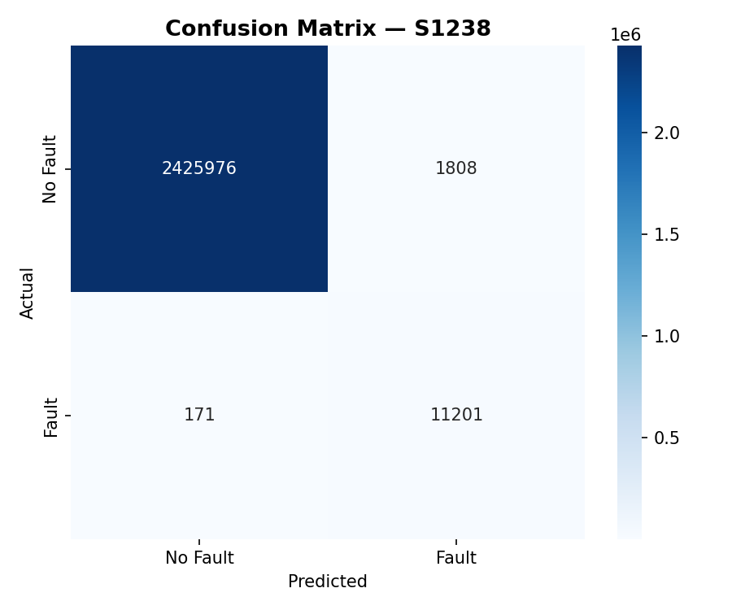
Fig.1.25 Confusion Matrix

S1488:
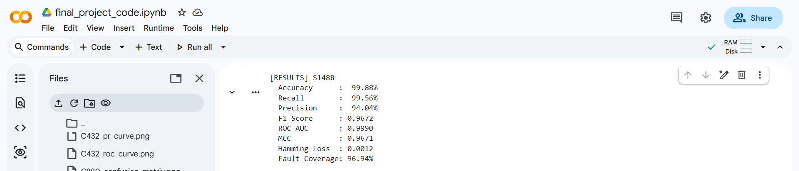
Fig.1.26 Model Training Results for S1488 Dataset

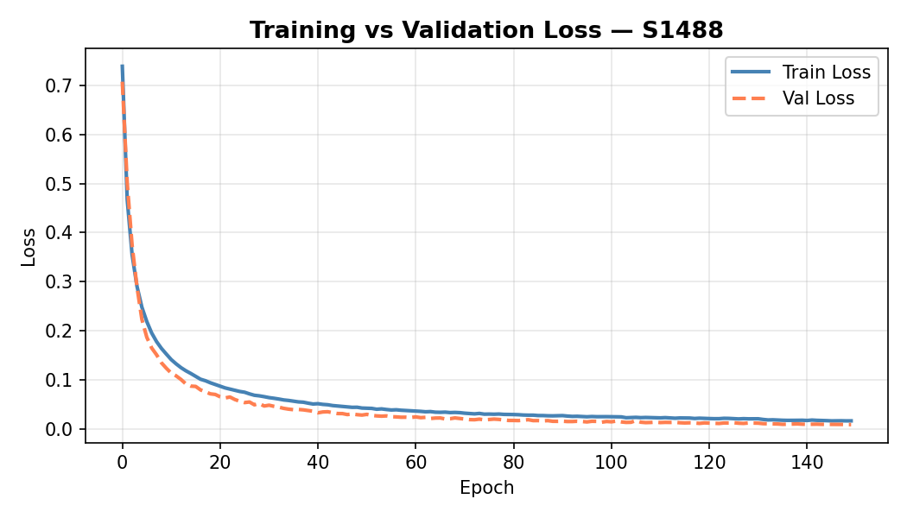
Fig.1.27 Training Vs validation Loss

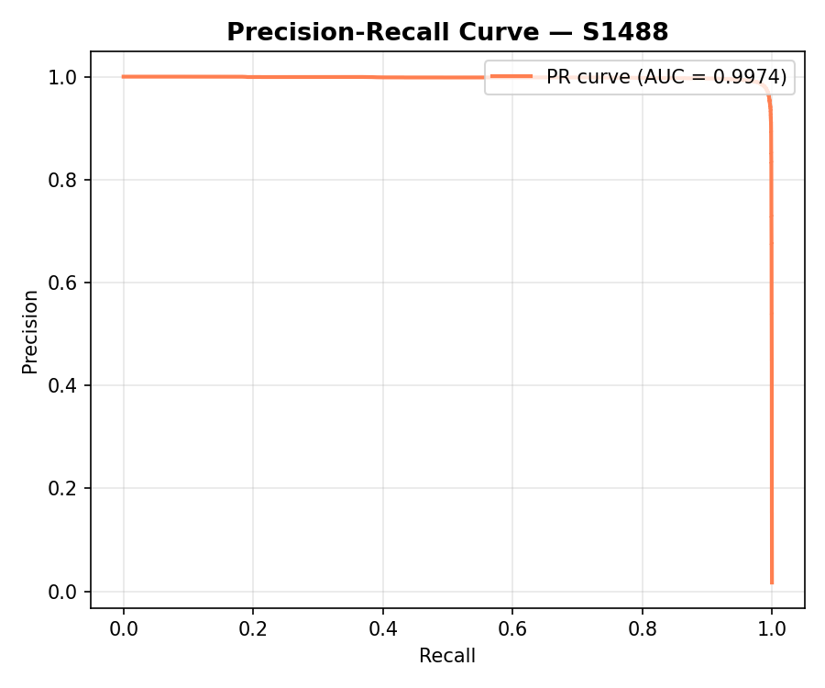
Fig.1.28 Precision-Recall Curve

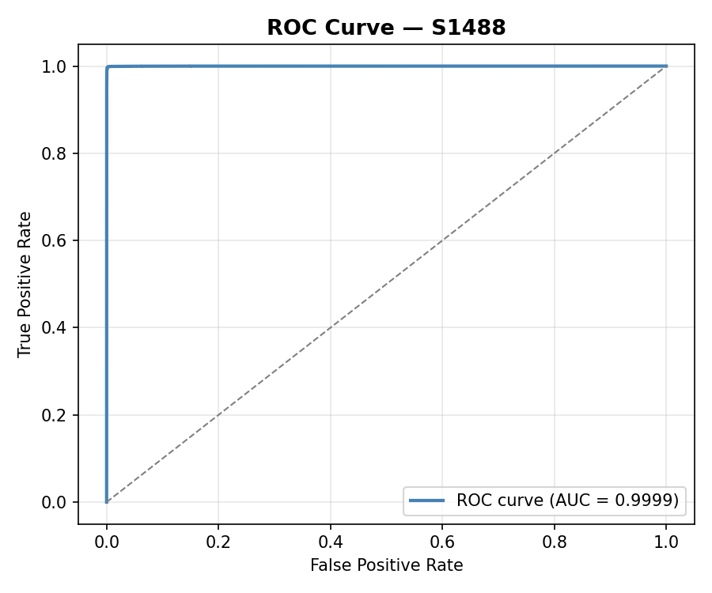
Fig.1.29 ROC Curve

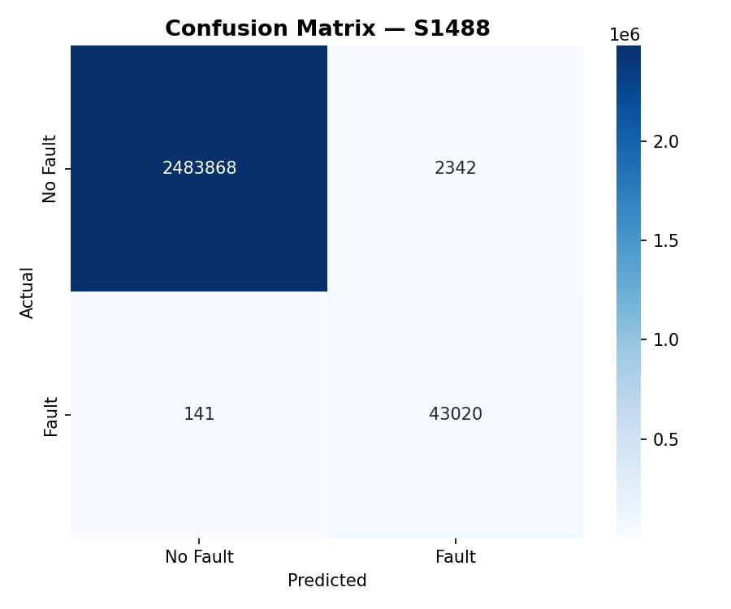
Fig.1.30 Confusion Matrix

Performance Comparison Across Benchmark Circuits:
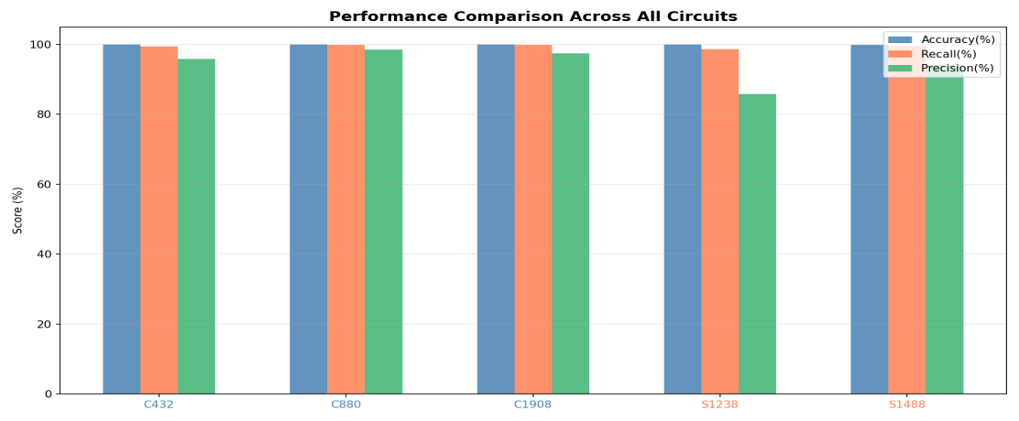
Fig.1.31 Comparative analysis of Accuracy, Recall, and Precision for different benchmark circuits (C432, C880, C1908, S1238, S1488)
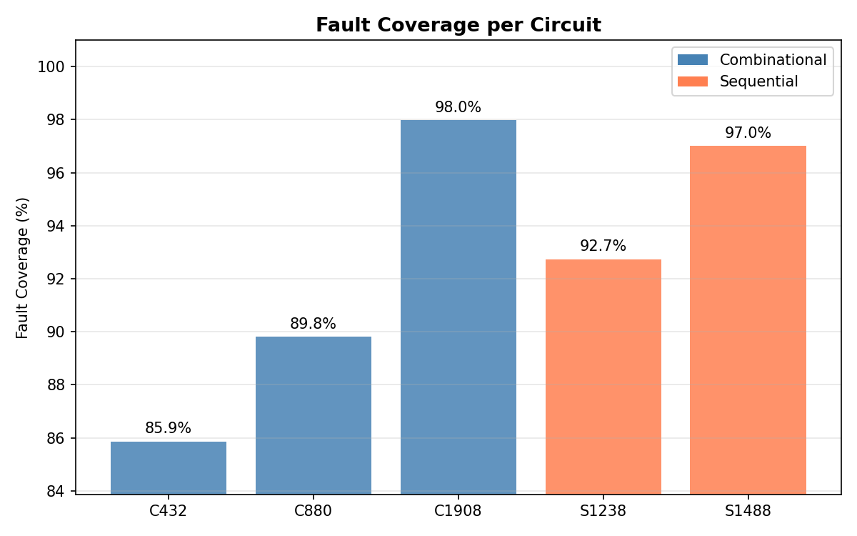
Fig.1.32 Fault Coverage
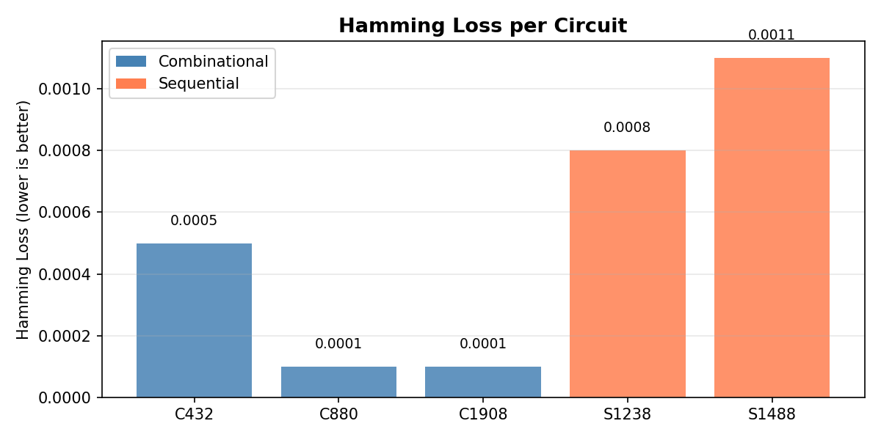
Fig.1.33 Hamming Loss

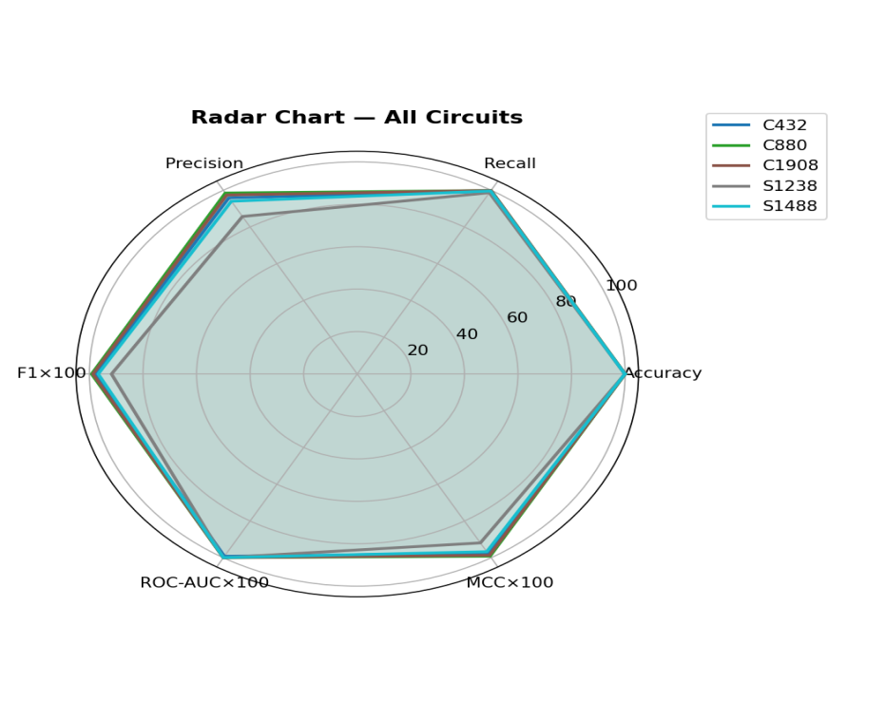
Fig.1.34 Multi-metric comparison of benchmark circuits.

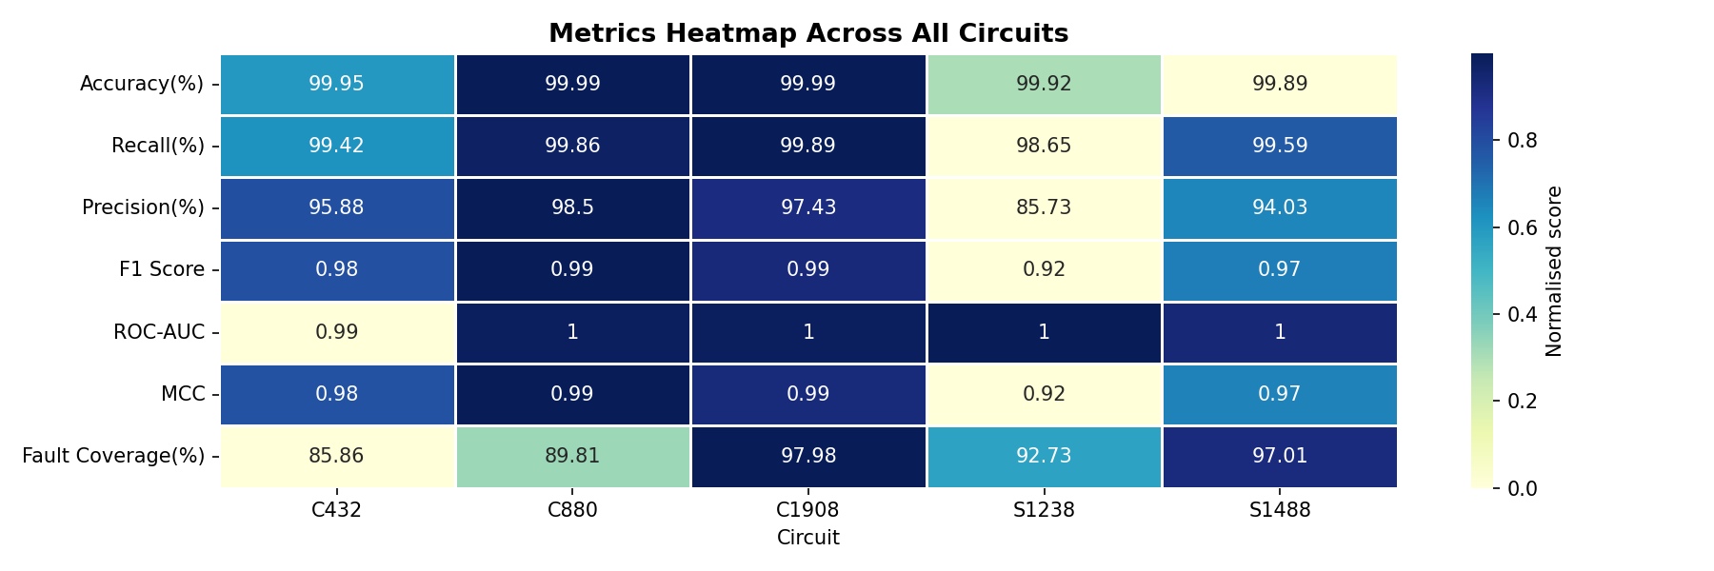
Fig.1.35 Heatmap representation of evaluation metrics.

