AI-BASED WATER QUALITY PREDICTION AND CONTAMINATION CLASSIFICATION USING MACHINE LEARNING

GEA 1401 - PROJECT REPORT

Submitted by
ABINISHASRI B (927624BAD002)
DHARSHINI K (927624BAD023)
GOPIKASRI T (927623BAD037)

In partial fulfilment for the award of the degree

of

BACHELOR OF TECHNOLOGY
in

ARTIFICIAL INTELLIGENCE AND DATA SCIENCE


M.KUMARASAMY COLLEGE OF ENGINEERING
(An Autonomous Institution Affiliated to Anna University, Chennai) KARUR-639113

AI-BASED WATER QUALITY PREDICTION AND CONTAMINATION CLASSIFICATION USING MACHINE LEARNING

GEA 1401 - PROJECT REPORT
Submitted by

ABINISHASRI B (927624BAD002)
DHARSHINI K (927624BAD023)
GOPIKASRI T (927623BAD037)

In partial fulfilment for the award of the degree

of

BACHELOR OF TECHNOLOGY
in

ARTIFICIAL INTELLIGENCE AND DATA SCIENCE

M.KUMARASAMY COLLEGE OF ENGINEERING
(An Autonomous Institution Affiliated to Anna University, Chennai) KARUR-639113

M. KUMARASAMY COLLEGE OF ENGINEERING
(Autonomous Institution affiliated to Anna University, Chennai) KARUR – 639 113

BONAFIDE CERTIFICATE

This is to certify that this project report on “AI-BASED WATER QUALITY PREDICTION AND CONTAMINATION CLASSIFICATION USING MACHINE LEARNING” is the bonafide work of ABINISHASRI B (927624BAD002), DHARSHINI K (927624BAD023), GOPIKASRI
T(927623BAD037) who carried out the project work during the academic year 2026 - 2027 under my supervision.

Signature Signature

Dr. P. MANIKANDAN, M.E., Ph.D., Dr. A.SELVI, M.E.,Ph.D., ASSISTANT PROFESSOR, ASSOCIATE PROFESSOR,
SUPERVISOR HEAD OF THE DEPARTMENT,
Department of Mechanical Engineering, Department of Artificial Intelligence, M.Kumarasamy College of Engineering, M.Kumarasamy College of Engineering, Thalavapalayam, Karur- 639 113. Thalavapalayam, Karur-639 113.

Submitted for GEA1401 - PROJECT Viva Voce examination held on

INTERNAL EXAMINER EXTERNAL EXAMINER

DECLARATION

We affirm that the project work titled “AI-BASED WATER QUALITY PREDICTION AND CONTAMINATION CLASSIFICATION USING MACHINE
LEARNING” being submitted in partial fulfilment for the award of the degree of Bachelor

of Technology in Artificial Intelligence and Data Science is the record of original work done by us under the guidance of Dr. P. Manikandan,M.E., Ph.D.,Department of Mechanical Engineering. It has not formed a part of any other project work submitted for the award of degree in the Anna University.

ABINISHA SRI B | DHARSHINI K | GOPIKASRI T
(927623BAD002) | (927623BAD023) | (927623BAD037)

I certify that the declaration made above by the candidates is true.

Dr. P. MANIKANDAN,M.E., Ph.D.,

ACKNOWLEDGEMENT

We gratefully remember our beloved Founder Chairman, (Late) Thiru. M. Kumarasamy, whose vision and legacy laid the foundation for our education and inspired us to complete this project.
We extend our sincere thanks to Dr. K. Ramakrishnan, Chairman, and Mr.K. R. Charun Kumar, Joint Secretary, for providing excellent infrastructure and continuous support throughout our academic journey.

We are privileged to extend our heartfelt thanks to our respected Principal, Dr. B. S. Murugan, M.Tech., Ph.D., for providing us with a conducive environment and constant encouragement to pursue this project work.

We sincerely thank Dr A. Selvi, M.Tech., Ph.D., Associate Professor and Head, Department of Artificial Intelligence, for her continuous support, valuable guidance, and motivation throughout the course of this project.

Our special thanks and deep sense of appreciation go to our Project Supervisor, Dr. P. Manikandan, M.E., Ph.D., Assistant Professor, for her exceptional guidance, continuous supervision, constructive suggestions, and unwavering support, all of which have been instrumental in the successful execution of this project.

We gratefully thank all faculty members in the Department of Artificial Intelligence and Data Science for their timely assistance, valuable insights, and constant support throughout various phases of the project.

Finally, we extend our profound gratitude to our parents and friends for their encouragement, moral support, and motivation, without which the successful completion of this project would not have been possible.



M.KUMARASAMY COLLEGE OF ENGINEERING DEPARTMENT OF ARTIFICIAL INTELLIGENCE AND DATA SCIENCE

Vision of the Institution
To emerge as a leader among the top institutions in the field of technical education, fostering an environment of innovation, research, and entrepreneurial spirit.

Mission of the Institution
- Produce skilled technocrats capable of addressing global challenges.
- Foster a diverse, learner-centric campus environment.
- Cultivate partnerships with alumni, industry, and professionals.

Vision of the Department
To excel in education, innovation, and research in Artificial Intelligence and Data Science to fulfil industrial demands and societal expectations.

Mission of the Department

M1: To educate future engineers with solid fundamentals, continually improving teaching methods using modern tools.
M2: To collaborate with industry and offer top-notch facilities in a conducive learning environment.
M3: To foster skilled engineers and ethical innovation in AI and Data Science for global recognition and impactful research.
M4: To tackle the societal challenge of producing capable professionals by instilling employability skills and human values.

Program Educational Objectives (PEOs)

PEO 1: Compete on a global scale for a professional career in Artificial Intelligence and Data Science.
PEO 2: Provide industry-specific solutions for the society with effective communication and ethics.
PEO 3: Hone their professional skills through research and lifelong learning initiatives.

Mapping of Programme Educational Objectives with Mission of the Department:

PEOs / Department  Mission Statements | M1 | M2 | M3 | M4
PEO1 | 3 | 3 | 2 | 3
PEO2 | 3 | 3 | 2 | 2
PEO3 | 3 | 2 | 3 | 2
1: Slight (Low) 2: Moderate (Medium) 3: Substantial (High)

Program Outcomes (POs)

PO1: Engineering Knowledge: Apply the knowledge of mathematics, science, engineering fundamentals, and an engineering specialization to the solution of complex engineering problems.
PO2: Problem Analysis: Identify, formulate, review research literature, and analyze complex engineering problems reaching substantiated conclusions with consideration for sustainable development.
PO3: Design/Development of Solutions: Design creative solutions for complex engineering problems and design system components or processes to meet the identified needs with consideration for the public health and safety, whole-life cost, net zero carbon. Society, and environment as required.
PO4: Conduct Investigations of Complex Problems: Conduct investigations of complex engineering problems using research-based knowledge including design of experiments, modelling, analysis and interpretation of data to provide valid conclusions.
PO5: Modern Tool Usage: Create, select, and apply appropriate techniques, resources, and modern engineering and IT tools, including prediction and modelling recognizing their limitations to solve complex engineering problems.
PO6: The Engineer and The world: Analyze and evaluate societal and environmental aspects while solving complex engineering problem for its impact on sustainability with reference to economy, health, safety, legal framework, culture and environment.
PO7: Ethics: Apply ethical principles and commit to professional ethics, human values, diversity and inclusion; adhere to national & international laws
PO8: Individual and Collaborative Team Work: Function effectively as an individual, and as a member or leader in diverse teams, and in multidisciplinary settings.

PO9: Communication: Communicate effectively and inclusively within the engineering community and society at large, such as, being able to comprehend and write effective reports and design documentation, make effective presentations, considering culture, language and learning differences.
PO10: Project Management and Finance: Apply knowledge and understanding of engineering management principles and economic decision-making and apply these to one’s own work, as a member and leader in a team, and to manage projects and in multidisciplinary environments.
PO11: Life-Long Learning: Recognize the need for, and have the preparation and ability for i) independent and life-long learning ii) adaptability to new and emerging technologies and iii) critical thinking in the broad context of technological change.

Program Specific Outcomes (PSOs)

PSO1: Capable of finding the important factors in large datasets, simplify the data, and improve predictive model accuracy.
PSO2: Capable of analyzing and providing a solution to a given real-world problem by designing an effective program.
Mapping of Programme Educational Objectives with Programme Outcomes and Programme Specific Outcomes:

PEOs  / POs &  PSOs | PO 1 | PO 2 | PO 3 | PO 4 | PO 5 | PO 6 | PO 7 | PO 8 | PO 9 | PO1 0 | PO1 1 | PO1 2 | PSO 1 | PSO 2
PEO 1 | 3 | 2 | 2 | 2 | 3 | 2 | 3 | 3 | 1 | 2 | 3 | 1 | 3 | 1
PEO 2 | 2 | 2 | 3 | 2 | 3 | 3 | 3 | 2 | 2 | 3 | 2 | 3 | 3 | 2
PEO 3 | 3 | 3 | 2 | 3 | 3 | 2 | 3 | 3 | 3 | 2 | 3 | 3 | 2 | 3

1: Slight (Low) 2: Moderate (Medium) 3: Substantial (High)

ABSTRACT

Groundwater depletion is a major environmental concern caused by excessive extraction, inadequate recharge, and changing rainfall patterns. It affects agricultural activities, drinking water availability, and sustainable water resource management. This project proposes an AI-based groundwater depletion early-warning system using historical groundwater-level and rainfall data. Machine learning models, including XGBoost and time-series forecasting techniques, are considered to predict future groundwater levels. Data preprocessing is used to handle missing values and improve data quality. Kriging-based spatial interpolation is applied to estimate groundwater conditions in unmonitored areas. The system classifies districts into Safe, Semi-Critical, Critical, and Over-Exploited categories based on Central Ground Water Board (CGWB) standards. A dashboard is designed to display groundwater trends, predicted levels, risk maps, and early-warning alerts. Model performance is evaluated using Mean Absolute Error (MAE) and Root Mean Square Error (RMSE). The proposed system aims to identify potential groundwater depletion risks early and support sustainable groundwater management. Further testing is required to evaluate prediction accuracy and reliability.

Keywords: Groundwater Depletion, Groundwater-Level Prediction, Machine Learning, XGBoost, Rainfall Analysis, Kriging, Risk Classification, Central Ground Water Board (CGWB)

viii

ABSTRACT WITH POs AND PSOs MAPPING

ABSTRACT | POs  MAPPED | PSOs  MAPPED
Groundwater depletion is a major environmental concern that affects agriculture, drinking water availability, and sustainable water management. This project proposes an AI-based groundwater depletion early-warning system using historical groundwater-level and rainfall data. Machine learning models such as XGBoost and time-series forecasting techniques are used to predict future groundwater levels. Kriging-based spatial interpolation estimates groundwater conditions in unmonitored areas. The system classifies districts into Safe, Semi-Critical, Critical, and Over-Exploited categories based on CGWB standards. A dashboard displays groundwater trends, predicted levels, risk maps, and early-warning alerts. Model performance is evaluated using MAE and RMSE. This system aims to identify groundwater depletion risks early and  support sustainable groundwater resource management. | PO1 PO2 PO3 PO5 PO6 PO8 PO9 PO10 PO11 | PSO1 PSO2 PSO3

Note: 1- Low, 2-Medium, 3- High
SDG GOAL | REMARKS
SDG 9 | Promotes industrial innovation by integrating wearable sensors, an ESP32 microcontroller, IoT, and machine learning to monitor workers' health conditions and predict workplace safety risks.
SDG 12 | Supports responsible industrial practices through continuous monitoring of workers' health and environmental conditions.

SUPERVISOR HEAD OF THE DEPARTMENT

TABLE OF CONTENTS

CHAPTER
No.
TITLE PAGE
No.
ABSTRACT vi

- INTRODUCTION 1
  - PROBLEM STATEMENT 1
- LITERATURE SURVEY 2
  - MACHINE LEARNING FOR GROUNDWATER-LEVEL 2
PREDICTION
  - RAINFALL ANALYSIS AND GROUNDWATER RECHARGE 3
  - SPATIAL INTERPOLATION FOR GROUNDWATER MAPPING 4
  - GROUNDWATER RISK CLASSIFICATION USING CGWB 5
STANDARDS
- METHODOLOGY 6
  - PROPOSED SYSTEM 6
  - SYSTEM ARCHITECTURE 8
  - PROJECT WORKFLOW 10
- RESULTS AND DISCUSSION 13
  - DATA SOURCE AND DATASET DESCRIPTION 13
  - DATA PREPROCESSING 14
  - MODEL/ALGORITHM SELECTION 16
  - MODEL IMPLEMENTATION 18
  - MODEL EVALUATION AND PRELIMINARY RESULTS 19
  - DISCUSSION 20
  - OUTPUT AND SNAPSHOTS 21
- CONCLUSION 24
FUTURE WORK 25
REFERENCES 26
APPENDICES 27

LIST OF TABLES

Table No.
TITLE PAGE
No.

TABLE NO : 4.1 GROUNDWATER DATASET FEATURES 14
TABLE NO : 4.2 DATA PREPROCESSING STEPS 16

LIST OF FIGURES

FIGURE NO.
TITLE PAGE
No.
FIGURE NO : 3.1 | SYSTEM ARCHITECTURE | 9
FIGURE NO : 3.2 | PROJECT WORKFLOW | 13
FIGURE NO : 7.1 | HOME PAGE | 21
FIGURE NO : 7.2 | WATER QUALITY INDEX | 21
FIGURE NO : 7.3 | SHAP BASED EXPLANATION | 22
FIGURE NO : 7.4 | WHAT-IF PARAMETER SIMULATION INTERFACE | 22
FIGURE NO : 7.5 | PERFORMANCE EVALUATION | 23
FIGURE NO : 7.6 | OVERVIEW | 23

LIST OF ABBREVIATIONS

- AI – Artificial Intelligence

- ML – Machine Learning

- CGWB – Central Ground Water Board

- DWLR – Digital Water Level Recorder

- RF – Random Forest

- XGBoost – Extreme Gradient Boosting

- MAE – Mean Absolute Error

- RMSE – Root Mean Squared Error

- API – Application Programming Interface

- IoT – Internet of Things

- IDW – Inverse Distance Weighting

- GIS – Geographic Information System

- HTML – HyperText Markup Language

- CSS – Cascading Style Sheets

- HTTP – Hypertext Transfer Protocol

- CSV – Comma-Separated Values

- DB – Database

- UI – User Interface

CHAPTER 1 INTRODUCTION

PROBLEM STATEMENT
Groundwater depletion is a major environmental concern caused by excessive extraction, insufficient groundwater recharge, and changing rainfall patterns. It affects agricultural activities, drinking water availability, and sustainable water resource management. Traditional groundwater monitoring methods mainly depend on periodic measurements and manual analysis, which may limit the early identification of depletion risks.Groundwater levels and rainfall patterns provide important information for understanding groundwater availability and predicting future changes. However, analyzing these parameters individually may not be sufficient to identify high-risk areas or estimate groundwater conditions in unmonitored locations.
The proposed system addresses these challenges by using historical groundwater-level and rainfall data with machine learning models, including XGBoost and time-series forecasting techniques. Kriging-based spatial interpolation is used to estimate groundwater conditions in unmonitored areas, while districts are classified into Safe, Semi-Critical, Critical, and Over-Exploited categories based on Central Ground Water Board (CGWB) standards. A dashboard is designed to display groundwater trends, predicted levels, risk maps, and early-warning alerts. The system aims to support early identification of groundwater depletion risks, but its effectiveness requires validation using appropriate historical data and model evaluation metrics
such as Mean Absolute Error (MAE) and Root Mean Square Error (RMSE).

1

CHAPTER 2 LITERATURE SURVEY
Groundwater depletion is a major environmental concern caused by excessive extraction, insufficient recharge, and changing rainfall patterns. Groundwater availability plays an important role in agriculture, drinking water supply, and environmental sustainability. Traditional groundwater monitoring methods mainly depend on periodic measurements and manual analysis. Recent developments in machine learning, time-series forecasting, and spatial interpolation have created opportunities for predicting groundwater-level changes and identifying depletion risks. This literature survey reviews existing research on groundwater-level prediction, rainfall analysis, and spatial mapping to identify the limitations of current approaches and the need for an AI-based groundwater depletion early-warning system.

MACHINE LEARNING FOR GROUNDWATER-LEVEL PREDICTION
Kumar and Vidhya (2020) investigated an ensemble-based approach for groundwater-level prediction using neural network pattern fitting. Their study explored the use of computational models to analyze groundwater-level variations and improve forecasting. The research highlighted the potential of data-driven techniques for understanding groundwater behaviour and supporting water resource management. However, prediction performance depends on the availability of reliable historical data and the selection of suitable input parameters. These findings support the use of machine learning models for forecasting groundwater-level changes and identifying potential depletion risks.

Nistor et al. (2020) investigated groundwater-table distribution using borehole piezometer data interpolation, with a case study in Singapore. Their research examined spatial interpolation techniques to estimate groundwater levels in areas with limited monitoring data. The study highlighted the importance of spatial analysis in understanding groundwater distribution and identifying variations across different locations. However, the accuracy of interpolation depends on the availability and distribution of monitoring stations and the quality of the collected data. These findings support the use of spatial interpolation techniques, such as Kriging, to estimate groundwater conditions in unmonitored areas and identify regions that may be at risk of groundwater depletion.

RAINFALL ANALYSIS AND GROUNDWATER RECHARGE

Rainfall plays an important role in groundwater recharge and influences the availability of groundwater resources. Rainwater infiltrates into the soil and gradually moves through soil layers to replenish underground aquifers. The amount of groundwater recharge depends on factors such as rainfall intensity, duration, soil characteristics, land use, and surface runoff.

Rainfall analysis helps identify seasonal variations and understand the relationship between precipitation and groundwater-level changes. During periods of sufficient rainfall, groundwater levels may increase due to natural recharge. However, low rainfall and prolonged dry periods can reduce groundwater recharge and contribute to groundwater depletion. Excessive groundwater extraction can further worsen this problem, even in areas receiving moderate rainfall.

In the proposed AI-Based Groundwater Depletion Early-Warning System, historical rainfall data are analyzed along with groundwater-level measurements to identify patterns and predict future groundwater conditions. Rainfall information is used as an input feature for machine learning models to improve forecasting performance. Comparing rainfall trends with groundwater-level variations helps identify areas that may experience declining groundwater availability.

This analysis supports the early identification of groundwater depletion risks and helps authorities plan suitable groundwater conservation and rainwater harvesting measures. However, rainfall alone cannot determine groundwater availability, as recharge also depends on geological conditions, soil properties, land use, and groundwater extraction rates.

SPATIAL INTERPOLATION FOR GROUNDWATER MAPPING

Spatial interpolation is a technique used to estimate groundwater levels at locations where direct monitoring data are unavailable. It uses measurements collected from nearby monitoring stations to predict groundwater conditions in unmonitored areas. This technique helps understand the spatial distribution of groundwater resources and identify regions experiencing groundwater depletion.

Several spatial interpolation techniques are available, including Inverse Distance Weighting (IDW), Kriging, and Spline interpolation. Among these techniques, Kriging considers the spatial relationship between observed data points to estimate values at unknown locations. It can provide useful estimates of groundwater levels and help generate spatial groundwater distribution maps.

In the proposed AI-Based Groundwater Depletion Early-Warning System, spatial interpolation using Kriging is applied to estimate groundwater levels in areas without monitoring stations. The estimated values are used to visualize groundwater conditions across different geographical locations. These results can help identify areas with declining groundwater levels and support the preparation of groundwater risk maps.

However, the accuracy of spatial interpolation depends on the number of monitoring stations, their geographical distribution, and the quality of the available measurements. Therefore, reliable groundwater data and appropriate interpolation methods are essential for producing meaningful groundwater maps and supporting sustainable groundwater management.

GROUNDWATER RISK CLASSIFICATION USING CGWB STANDARDS

Groundwater risk classification is an important process for assessing groundwater availability and identifying areas facing excessive groundwater extraction. In India, the Central Ground Water Board (CGWB) evaluates groundwater resources to determine the level of groundwater development and support sustainable water management. This assessment helps identify regions where groundwater extraction may exceed the available recharge.

Based on CGWB assessment criteria, groundwater assessment units are classified into four categories: Safe, Semi-Critical, Critical, and Over-Exploited. These categories are determined using factors such as the stage of groundwater extraction and the availability of groundwater resources. Safe areas generally have relatively sustainable groundwater extraction levels, whereas Semi-Critical and Critical areas require increasing attention to groundwater management. Over-Exploited areas indicate that groundwater extraction exceeds the annual extractable groundwater resource.

In the proposed AI-Based Groundwater Depletion Early-Warning System, groundwater-level predictions and historical groundwater data are used to support the identification of potential groundwater depletion risks. The system presents groundwater conditions through a dashboard and classifies assessment areas according to the relevant CGWB categories when the required assessment data are available. This helps users understand groundwater conditions and identify areas that may require conservation measures.

The classification results can support early-warning alerts and assist authorities in planning suitable groundwater management strategies. However, groundwater-level decline alone is not sufficient to determine the official CGWB category. Accurate classification requires the relevant groundwater resource assessment data and the application of the appropriate CGWB assessment methodology

PROPOSED SYSTEM
CHAPTER 3 METHODOLOGY

The proposed AI-Based Groundwater Depletion Early-Warning System is designed to predict future groundwater levels and identify areas that may be at risk of groundwater depletion. The system uses historical groundwater-level measurements and rainfall data to analyze groundwater variations and forecast future conditions using machine learning techniques.

Initially, groundwater-level and rainfall datasets are collected from reliable sources and preprocessed to handle missing values, inconsistent records, and data quality issues. The processed data are used to train machine learning models, such as Random Forest and XGBoost, to predict future groundwater levels. Model performance is evaluated using Mean Absolute Error (MAE) and Root Mean Squared Error (RMSE).

To identify groundwater conditions in areas without monitoring stations, the system applies Kriging spatial interpolation. The estimated groundwater levels are used to generate spatial groundwater maps and visualize variations across different geographical locations. The system also supports groundwater risk classification based on the Central Ground Water Board (CGWB) assessment categories: Safe, Semi-Critical, Critical, and Over-Exploited. Official classification requires the relevant groundwater
resource assessment data.

Finally, the system presents groundwater trends, predicted values, spatial maps, and potential depletion warnings through a dashboard developed using a Spring Boot API and Python-based forecasting and interpolation models. The dashboard helps users understand groundwater conditions and identify areas that may require early intervention.

The proposed system aims to support groundwater conservation, improve water resource planning, and promote sustainable groundwater management. However, the reliability of predictions depends on the quality of the available data, model performance, and the distribution of groundwater monitoring station.In the preprocessing stage, the collected datasets are examined to identify missing values, duplicate records, inconsistent measurements, and incorrect data entries. Appropriate data-cleaning techniques are applied to handle missing values and improve data consistency. The datasets are then organized based on geographical locations and time periods. Feature selection and feature engineering techniques are also performed to identify important parameters that influence groundwater-level variations, such as rainfall amount, previous groundwater levels, seasonal patterns, and geographical characteristics. The cleaned and processed datasets are divided into training and testing sets for model development and evaluation.
After preprocessing, machine learning algorithms such as Random Forest and XGBoost are implemented to predict future groundwater levels. Random Forest combines multiple decision trees to improve prediction accuracy and reduce overfitting, while XGBoost uses an optimized boosting technique to improve model performance by learning from previous prediction errors. These models analyze historical groundwater-level patterns and rainfall variations to estimate future groundwater conditions. The predicted results are compared with actual groundwater-level measurements to evaluate the reliability of the models. Model performance is assessed using evaluation metrics such as Mean Absolute Error (MAE) and Root Mean Squared Error (RMSE). Based on these evaluation results, the most suitable model is selected for groundwater-level prediction.

SYSTEM ARCHITECTURE

The system architecture of the AI-Based Groundwater Depletion Early-Warning System describes the major components and their interactions in predicting groundwater levels and identifying potential depletion risks. The system consists of data collection, data preprocessing, machine learning-based forecasting, spatial interpolation, groundwater risk classification, backend processing, and dashboard visualization.

Data Collection
Groundwater-level measurements and historical rainfall data are collected from reliable data sources. These datasets provide the basic information required to analyze groundwater variations and predict future groundwater conditions.

Data Preprocessing
The collected datasets are cleaned and prepared for analysis. Missing values, duplicate records, and inconsistent data are handled to improve data quality. Relevant features are selected for model training and prediction.

Machine Learning Model
The preprocessed data are processed using machine learning algorithms such as Random Forest and XGBoost. These models analyze historical groundwater-level patterns and rainfall variations to predict future groundwater levels.

Spatial Interpolation
Kriging spatial interpolation is applied to estimate groundwater levels in areas without monitoring stations. The estimated values are used to generate spatial groundwater maps and identify areas with potentially declining groundwater levels.

Groundwater Risk Classification
Groundwater conditions are assessed using the relevant Central Ground Water Board (CGWB) assessment criteria. Assessment units are classified into Safe, Semi-Critical, Critical, and Over-Exploited categories when the required groundwater resource data are available.

Backend Processing
A Spring Boot API manages communication between the forecasting models, processed results, and dashboard.

Dashboard Visualization
The dashboard displays predicted groundwater levels, historical trends, spatial groundwater maps, risk classifications, and early-warning alerts. These visualizations help users understand groundwater conditions and support informed water resource management decisions.

Early-Warning Alert Generation
The system analyzes predicted groundwater levels and identifies areas that may experience a significant decline in groundwater availability. When the predicted groundwater level indicates a potential depletion risk, the system generates an early-warning alert through the dashboard. These alerts help users identify vulnerable areas and take preventive measures, such as rainwater harvesting and controlled groundwater extraction. The warning mechanism supports timely decision-making and promotes sustainable groundwater resource management.
The reliability of alerts depends on prediction accuracy and the availability of sufficient historical data.The proposed architecture integrates machine learning, spatial analysis, and web technologies to support groundwater-level forecasting and early identification of potential depletion risks. The reliability of the results depends on the quality of the input data, model performance, and availability of sufficient monitoring observations.
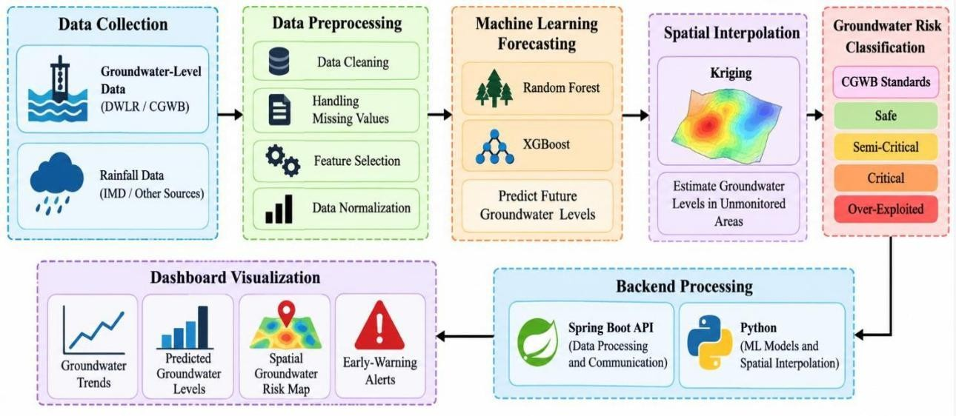
.
Figure 3.1 System Architecture

PROJECT WORKFLOW

Step 1: Data Collection

Groundwater-level measurements and historical rainfall data are collected from reliable sources, such as the Central Ground Water Board (CGWB) and relevant rainfall data providers. These datasets are used to understand groundwater variations and predict future groundwater conditions.

Step 2: Data Preprocessing

The collected datasets are checked for missing values, duplicate records, and inconsistent entries. Data cleaning techniques are applied to improve data quality and prepare the dataset for machine learning.

Step 3: Feature Selection

Relevant features, such as historical groundwater levels and rainfall measurements, are selected from the processed dataset. These features help the machine learning models identify patterns and relationships affecting groundwater levels.

Step 4: Model Training and Prediction

Machine learning algorithms, such as Random Forest and XGBoost, are trained using the prepared dataset. The models learn from historical data and predict future groundwater levels based on the selected input features.

Step 5: Model Evaluation

The performance of the trained models is evaluated by comparing predicted groundwater levels with actual measurements. Mean Absolute Error (MAE) and Root Mean Squared Error (RMSE) are used to measure prediction errors and assess model performance.

Step 6: Spatial Interpolation

Kriging spatial interpolation is used to estimate groundwater levels in areas where monitoring data are unavailable. The estimated values help generate spatial groundwater maps and understand groundwater variations across different locations.

Step 7: Groundwater Risk Classification

Groundwater assessment data are analyzed using the relevant CGWB assessment criteria. The assessment units are classified as Safe, Semi-Critical, Critical, or Over-Exploited based on the required groundwater resource information.

Step 8: Backend Integration

The Python-based machine learning models and spatial analysis components are integrated with the Spring Boot API. The backend processes requests and provides prediction results and groundwater assessment information to the dashboard.

Step 9: Dashboard Visualization

The dashboard displays groundwater-level trends, predicted groundwater levels, spatial risk maps, and groundwater risk classifications. The visual representation helps users understand groundwater conditions easily.

Step 10: Early-Warning Alerts

The system identifies potential groundwater depletion risks based on prediction results and groundwater assessment information. Early-warning alerts help users recognize vulnerable areas and take preventive measures to support sustainable groundwater management.

Step 11: Data Visualization and Analysis

The processed groundwater data and prediction results are represented using graphs, charts, and geographical maps. These visualizations help users compare historical and predicted

groundwater levels and understand changes in groundwater availability over time. The graphical representation makes the analysis easier to interpret and supports effective decision-making.

Step 12: Groundwater Conservation Recommendations

Based on the identified groundwater depletion risks, suitable conservation measures can be suggested. These measures may include rainwater harvesting, artificial groundwater recharge, controlled groundwater extraction, and efficient water usage. Such recommendations help users understand the importance of groundwater conservation and encourage sustainable water resource management.

Step 13: System Testing and Validation

The developed system is tested to verify the accuracy of predictions, proper functioning of the dashboard, and integration between the backend and machine learning components. The prediction results are compared with actual groundwater measurements using evaluation metrics such as MAE and RMSE. Testing helps identify errors and improve the reliability of the system.
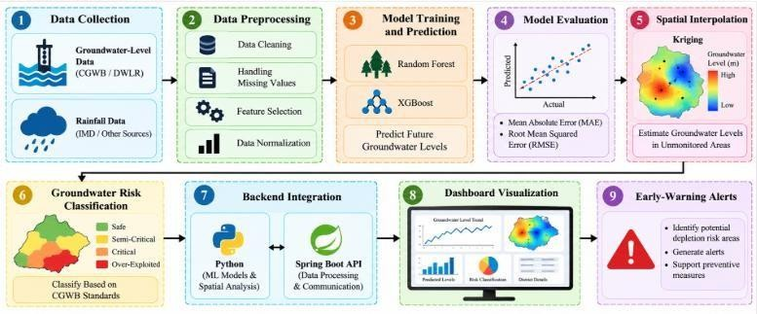

Figure 3.2 Project Workflow

CHAPTER 4 RESULTS AND DISCUSSION

DATA SOURCE AND DATASET DESCRIPTION

The AI-Based Groundwater Depletion Early-Warning System uses groundwater-level measurements and rainfall data to predict future groundwater conditions and identify potential depletion risks. The data required for this project are collected from reliable sources, such as the Central Ground Water Board (CGWB) and relevant rainfall data providers. Historical data are used to understand groundwater-level variations and analyze the relationship between rainfall and groundwater availability.

The dataset contains important parameters such as groundwater level, rainfall measurements, observation date, and geographical location. These parameters help machine learning algorithms identify patterns in groundwater variations and forecast future groundwater levels. The collected data are examined to ensure consistency and suitability for analysis before being used for model training and prediction.

The dataset is preprocessed to handle missing values, duplicate records, and inconsistent entries. Relevant features are selected to improve the quality of the analysis.

S.NO | FEATURE NAME | DESCRIPTION
1 | Groundwater Level | Measures groundwater depth below ground level.
2 | Rainfall | Records rainfall measurements to analyze groundwater recharge.
3 | Geographical Location | Identifies monitoring locations for groundwater mapping and spatial analysis.

Table 4.1: Groundwater Dataset Features

DATA PREPROCESSING

Data preprocessing is an important step in the AI-Based Groundwater Depletion Early-Warning System. It involves preparing the collected groundwater-level and rainfall datasets for machine learning analysis. The quality of the input data directly affects the accuracy and reliability of groundwater-level predictions. Therefore, the collected data must be cleaned and organized before model development.

Data Cleaning

The collected dataset is examined to identify missing values, duplicate records, and inconsistent entries. Appropriate data-cleaning techniques are applied to improve data quality and ensure that the dataset is suitable for further analysis.

Handling Missing Values

Missing groundwater-level or rainfall values may affect prediction performance. These missing values are handled using suitable techniques based on the dataset characteristics. This helps maintain data consistency during model training.

Data Integration

Groundwater-level measurements and rainfall records are combined using common parameters, such as observation dates and geographical locations. This integration helps analyze the relationship between rainfall variations and groundwater-level changes.

Feature Selection

Relevant features, including historical groundwater levels, rainfall measurements, and geographical coordinates, are selected for analysis. These features help machine learning models identify patterns and predict future groundwater conditions.

Data Transformation

The dataset is converted into a consistent format suitable for machine learning algorithms. Date values are formatted correctly, numerical features are checked for valid ranges, and categorical variables are encoded when required.

Training and Testing Data Splitting

The prepared dataset is divided into training and testing sets to evaluate model performance. For time-dependent groundwater forecasting, chronological splitting is preferred to ensure that future observations are not used to predict earlier values.

S.  No. | Preprocessing Step | Description
1 | Data Cleaning | Removes duplicate records and corrects inconsistent data.
2 | Missing Value Handling | Handles missing groundwater-level and rainfall values using suitable techniques.
3 | Data Integration | Combines groundwater-level and rainfall datasets.
4 | Feature Selection | Selects relevant features for groundwater-level prediction.
5 | Data Transformation | Converts data into a suitable format for machine learning.
6 | Data Splitting | Divides the dataset into training and testing sets for model evaluation.

Table 4.2 : Data Preprocessing Steps

MODEL/ALGORITHM SELECTION

Model selection is an important step in the AI-Based Groundwater Depletion Early-Warning System. Suitable machine learning algorithms are selected to predict future groundwater levels by analyzing historical groundwater measurements and rainfall data. The selected models should identify patterns in the dataset and provide reliable predictions to support early identification of groundwater depletion risks.

Random Forest

Random Forest is a supervised machine learning algorithm that combines multiple decision trees to generate predictions. It can analyze relationships between groundwater levels, rainfall measurements, and other relevant input features. It is suitable for groundwater-level prediction because it can capture complex relationships in the data and reduce the risk of overfitting compared with a single decision tree.

XGBoost

XGBoost (Extreme Gradient Boosting) is an ensemble learning algorithm that builds decision trees sequentially to reduce prediction errors. It can handle complex relationships between input variables and groundwater levels. In this project, XGBoost can be used to forecast future groundwater levels based on historical groundwater measurements and rainfall patterns.

Kriging Spatial Interpolation

Kriging is a geostatistical interpolation technique used to estimate groundwater levels at locations where direct measurements are unavailable. It considers the spatial relationships between known monitoring locations to estimate groundwater conditions in unmonitored areas. The estimated values can be used to generate groundwater distribution maps and support spatial risk analysis.

Model Evaluation

The selected forecasting models are evaluated using Mean Absolute Error (MAE) and Root Mean Squared Error (RMSE). These metrics measure the differences between actual and predicted groundwater levels. Comparing the evaluation results helps determine which model performs better on the available test data.The combination of Random Forest, XGBoost, and Kriging supports groundwater-level forecasting and spatial analysis. The final model should be selected based on its measured performance, data availability, and suitability for the project's objectives.

MODEL IMPLEMENTATION

The model implementation phase involves developing and applying machine learning algorithms to predict groundwater levels and identify potential groundwater depletion risks. The preprocessed groundwater-level and rainfall datasets are used as input for training and testing the selected models. Python provides the programming environment for implementing the machine learning algorithms and analyzing the prediction results.

Dataset Loading

The preprocessed dataset is loaded into the Python environment using libraries such as Pandas and NumPy. The dataset contains relevant information, including historical groundwater levels, rainfall measurements, and other available features required for prediction.

Model Training

Random Forest and XGBoost algorithms are trained using historical groundwater data and rainfall information. During training, the models learn relationships between the input features and groundwater levels. The trained models are then used to estimate future groundwater conditions.

Groundwater-Level Prediction

The trained models generate groundwater-level predictions based on the selected input features. These predictions help identify possible increases or decreases in groundwater levels over a specified period. The prediction results can be compared with actual measurements to evaluate model performance.

Spatial Interpolation Implementation

Kriging interpolation is applied to geographical observation to estimate groundwater levels at locations without monitoring stations. The estimated values are used to prepare spatial groundwater distribution maps and identify areas that may require further investigation.

Groundwater Risk Assessment

The prediction results and available groundwater assessment data are analyzed to identify potential depletion risks. Where the required groundwater resource assessment data are available, assessment units can be classified using the relevant Central Ground Water Board (CGWB) categories: Safe, Semi-Critical, Critical, and Over-Exploited.

Model Integration

The machine learning models and spatial analysis components are integrated with the application backend. The Spring Boot API can communicate with the Python-based prediction components and provide the processed results to the dashboard for visualization.

Output Generation

The final outputs include predicted groundwater levels, groundwater trend graphs, spatial distribution maps, and risk assessment information. These outputs help users understand groundwater conditions and support early identification of potential groundwater depletion.

MODEL EVALUATION AND PRELIMINARY RESULTS

Model evaluation is an important phase of the AI-Based Groundwater Depletion Early-Warning System. Random Forest and XGBoost algorithms are evaluated using testing data to measure their performance in predicting groundwater levels.Lower MAE and RMSE values generally indicate better prediction performance. The preliminary results focus on analyzing groundwater-level trends, understanding the relationship between rainfall and groundwater variations, and identifying potential depletion risks. Kriging spatial interpolation is used to estimate groundwater levels in unmonitored areas and support the generation of groundwater distribution maps. The evaluation results help determine the suitability of the selected machine learning models for groundwater forecasting. Actual prediction accuracy and model performance will be confirmed after completing model training, testing, and validation using the project dataset.

DISCUSSION

The AI-Based Groundwater Depletion Early-Warning System aims to improve groundwater monitoring and forecasting by combining machine learning techniques with rainfall analysis and spatial interpolation. Random Forest and XGBoost models are used to analyze historical groundwater-level measurements and rainfall data to predict future groundwater conditions. The prediction results help identify possible groundwater-level declines and understand variations over time.

Kriging spatial interpolation supports the estimation of groundwater levels in areas without monitoring stations and helps visualize groundwater distribution across different locations. The system also supports groundwater risk assessment using the relevant Central Ground Water Board (CGWB) criteria to identify areas that may require conservation measures.

The dashboard presents predicted groundwater levels, historical trends, spatial maps, and early-warning alerts in an understandable format. However, the effectiveness of the system depends on the quality and availability of historical data, the accuracy of the selected models, and the distribution of monitoring stations. Overall, the proposed system has the potential to support early identification of groundwater depletion risks and promote sustainable groundwater resource management.

OUTPUT AND SNAPSHOTS

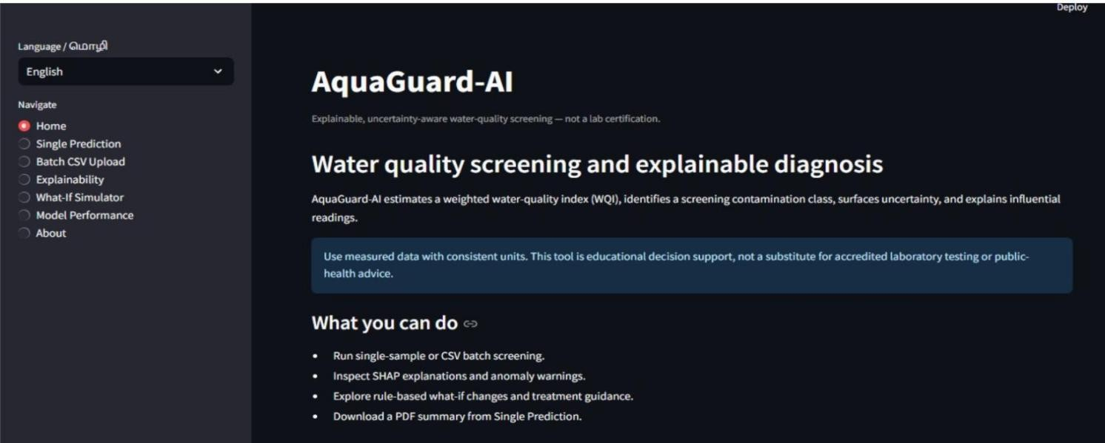

Figure 7.1 Homepage
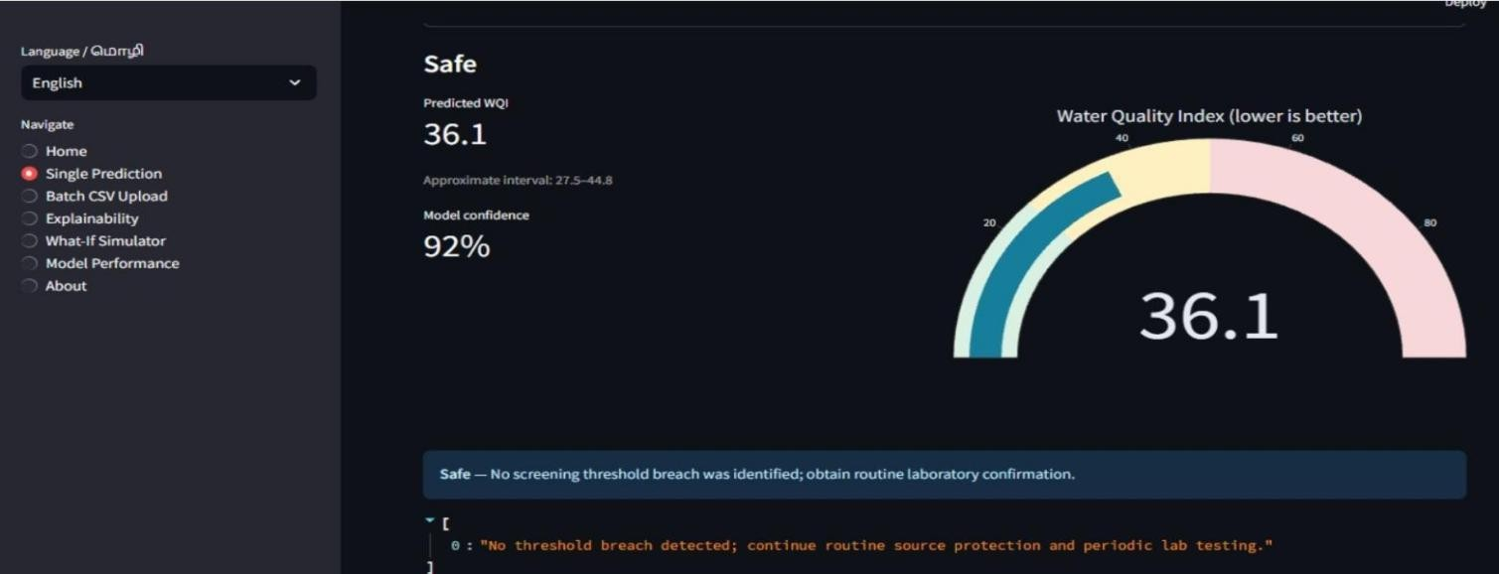

Figure 7.2 Water Quality Index

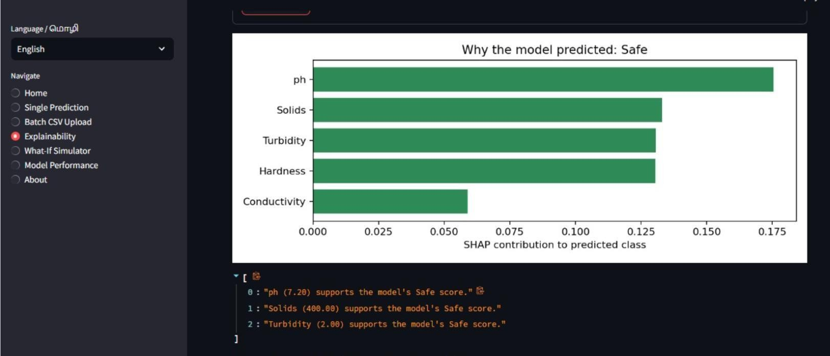

Figure 7.3 SHAP Based Explanation

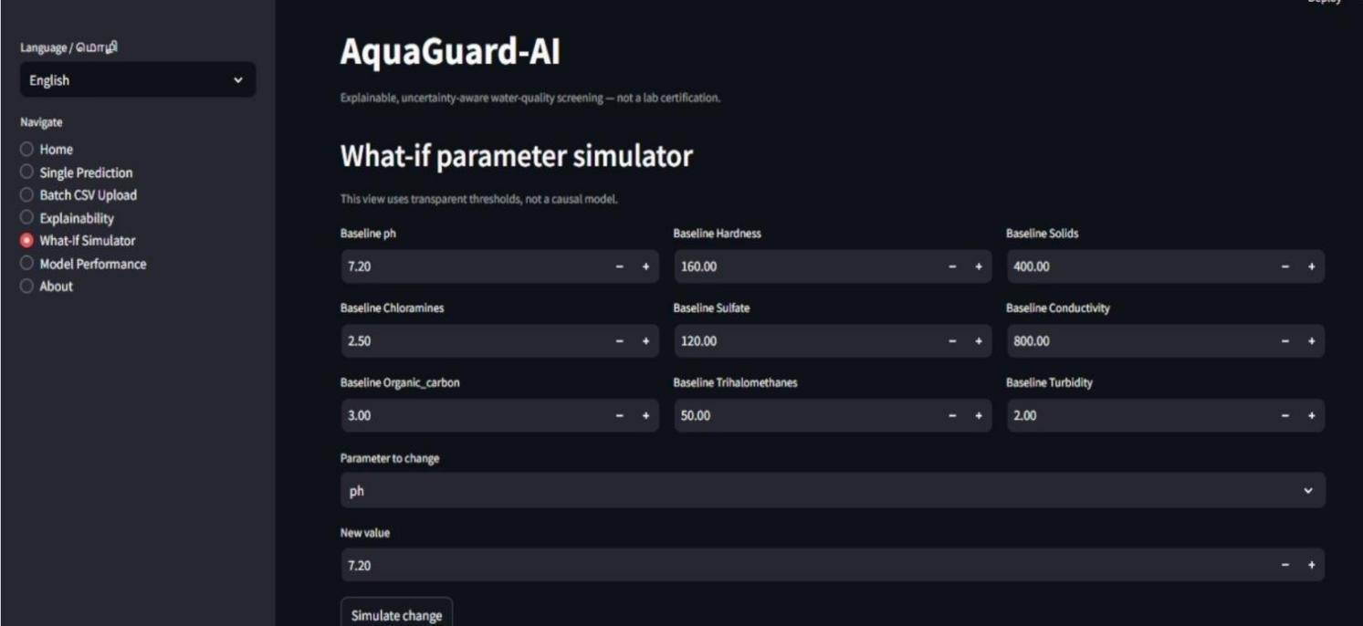

Figure 7.4 What-If Parameter Simulation Interface

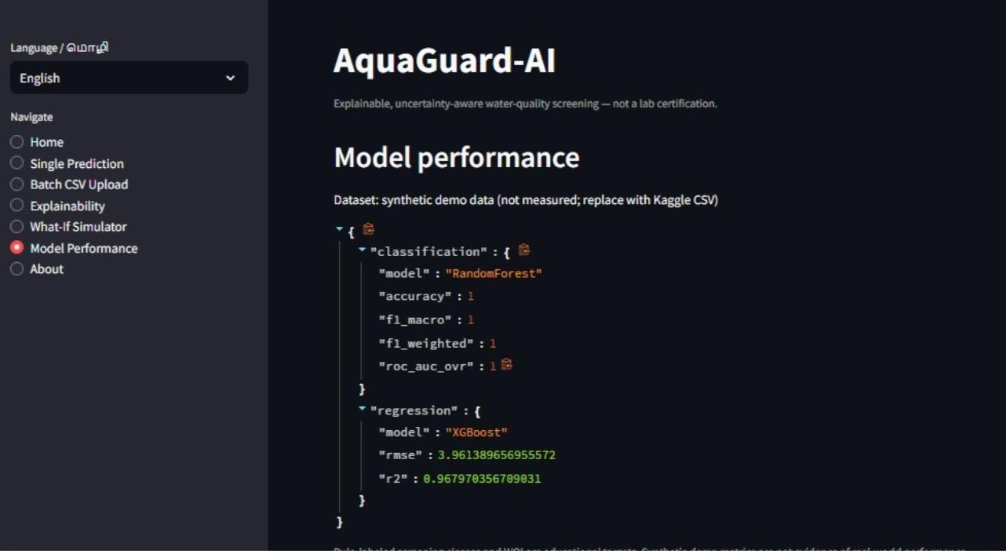

Figure 7.5 Performance Evaluation

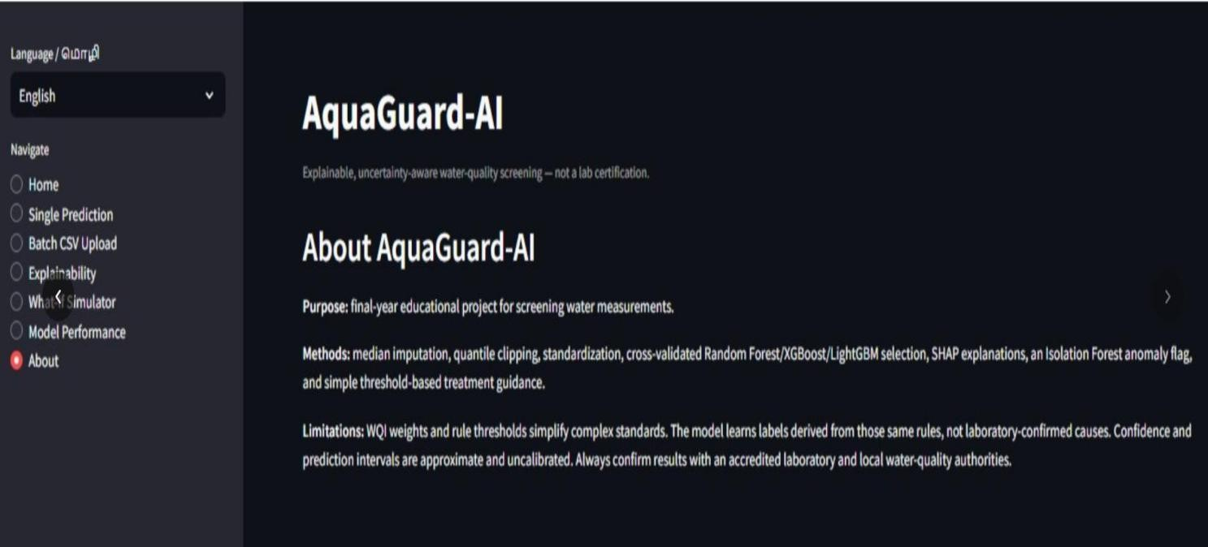

Figure 7.6 Overview

CHAPTER 5 CONCLUSION
The AI-Based Groundwater Depletion Early-Warning System is proposed to predict future groundwater levels and identify areas that may face groundwater depletion. The system uses historical groundwater-level measurements and rainfall data to analyze groundwater variations and forecast future conditions. Machine learning algorithms such as Random Forest and XGBoost are used for groundwater-level prediction, while Kriging spatial interpolation helps estimate groundwater levels in areas without monitoring stations.
The system also supports groundwater risk assessment using relevant Central Ground Water Board (CGWB) criteria. The dashboard presents groundwater trends, predicted levels, spatial distribution maps, and early-warning alerts in an understandable format. These features can help users identify potential groundwater risks and take preventive measures, such as rainwater harvesting, artificial recharge, and controlled groundwater extraction.
The proposed system combines machine learning, spatial analysis, and web technologies to support groundwater monitoring and management. Its effectiveness depends on the quality of the collected data, model performance, and the availability of monitoring stations. After completing model training and validation, the prediction results can be used to assess the system's reliability. Overall, the system aims to support early identification of groundwater depletion risks and encourage sustainable groundwater resource management.

FUTURE WORK

In the future, the AI-Based Groundwater Depletion Early-Warning System can be improved by collecting real-time groundwater data using sensors. Advanced machine learning algorithms can be used to improve prediction accuracy. The system can provide automatic alerts when groundwater levels decrease. A mobile application can also be developed to help users access groundwater information easily. Additional environmental data can be included to improve predictions. The system can also suggest simple solutions, such as rainwater harvesting and controlled groundwater usage, to help conserve water and support sustainable groundwater management.
Another important enhancement is the integration of a recommendation system that suggests suitable groundwater conservation measures based on the identified risk level of each region. For example, areas experiencing declining groundwater levels can receive recommendations such as rainwater harvesting, artificial groundwater recharge, construction of recharge pits, restoration of ponds, and controlled groundwater extraction. The system can also provide region-specific suggestions to help farmers adopt efficient irrigation methods, such as drip irrigation and sprinkler irrigation, to reduce unnecessary water consumption.

The spatial interpolation component can also be improved by incorporating additional monitoring stations and advanced geostatistical techniques. This can help generate more detailed groundwater distribution maps and improve estimation accuracy in areas with limited monitoring facilities. Similarly, the groundwater risk classification module can be updated periodically using the latest official CGWB assessment data to provide more reliable information about groundwater resource conditions.

REFERENCES

    - A. S. Kumar and R. Vidhya, “Ensemble Based Groundwater Level Prediction Using Neural Network Pattern Fitting,” Indian Journal of Geo-Marine Sciences, vol. 49, no. 1, pp. 44–50, 2020.
    - R. K. Sahu, J. Müller, J. Park, C. Varadharajan, B. Arora, and B. Faybishenko, “Impact of Input Feature Selection on Groundwater Level Prediction From a Multi-Layer Perceptron Neural Network,” Frontiers in Water, vol. 2, 2020. DOI: 10.3389/frwa.2020.573034.
    - Y. Li et al., “Improving the Resolution and Accuracy of Groundwater Level Anomalies Using the Machine Learning-Based Fusion Model in the North China Plain,” Sensors, vol. 21, no. 1, article 46, 2021. DOI: 10.3390/s21010046.
    - P. Malakar et al., “Deep Learning-Based Forecasting of Groundwater Level Trends in India: Implications for Crop Production and Drinking Water Supply,” ACS ES&T Engineering, vol. 1, no. 6,
pp. 965–977, 2021.

    - M. Iqbal, U. A. Naeem, A. Ahmad, H. Rehman, U. Ghani, and T. Farid, “Relating Groundwater Levels with Meteorological Parameters Using ANN Technique,” Measurement, vol. 166, article 108163, 2020. DOI: 10.1016/j.measurement.2020.108163.
    - I. Kim and J. Lee, “Performance Analysis of ANN Prediction for Groundwater Level Considering Regional-Specific Influence Components,” Groundwater, vol. 60, no. 3, pp. 344–361, 2022. DOI: 10.1111/gwat.13156.
    - C. M. Shakya, R. K. Bhattacharyya, and S. Dadhich, “Groundwater Level Prediction with Machine Learning for the Vidisha District, a Semi-Arid Region of Central India,” Groundwater for Sustainable Development, vol. 19, article 100825, 2022. DOI: 10.1016/j.gsd.2022.100825.
    - “Groundwater Level Prediction Using Machine Learning Models: A Comprehensive Review,” Neurocomputing, vol. 489, pp. 271–308, 2022. DOI: 10.1016/j.neucom.2022.03.014.
    - “Extreme Gradient Boosting (XGBoost) Model to Predict the Groundwater Levels in Selangor, Malaysia,” Ain Shams Engineering Journal, vol. 12, no. 2, 2021. DOI: 10.1016/j.asej.2020.11.011.

APPENDICES PROGRAM

//"""FastAPI endpoints for single, batch, explainability, and what-if inference.""" from typing import Dict, List, Optional
import pandas as pd

from fastapi import FastAPI, HTTPException

from pydantic import BaseModel, ConfigDict, Field, model_validator from src.config import FEATURES, INPUT_RANGES, MODEL_DIR from src.explain import explain_sample
from src.prediction import load_artifacts, predict_samples from src.whatif import simulate_changes
app = FastAPI( title="AquaGuard-AI",
description="Explainable, uncertainty-aware water-quality screening API.",

version="1.0.0",

)

def _bounded_field(name: str):

low, high = INPUT_RANGES[name]

return Field(default=None, ge=low, le=high, description=f"Expected range: {low:g} to {high:g}") class WaterSample(BaseModel):
"""Validated water sample; missing sensor values are median-imputed."""

ph: Optional[float] = _bounded_field("ph")

Hardness: Optional[float] = _bounded_field("Hardness") Solids: Optional[float] = _bounded_field("Solids") Chloramines: Optional[float] = _bounded_field("Chloramines") Sulfate: Optional[float] = _bounded_field("Sulfate") Conductivity: Optional[float] = _bounded_field("Conductivity")
Organic_carbon: Optional[float] = _bounded_field("Organic_carbon") Trihalomethanes: Optional[float] = _bounded_field("Trihalomethanes") Turbidity: Optional[float] = _bounded_field("Turbidity") @model_validator(mode="after")
def require_one_measurement(self):

if all(getattr(self, name) is None for name in FEATURES):

raise ValueError("At least one measurement must be supplied.") return self
class BatchRequest(BaseModel):

"""Bounded batch request for protecting API resources."""

rows: List[WaterSample] = Field(min_length=1, max_length=500) class WhatIfRequest(BaseModel):
"""A complete baseline sample and a sparse set of parameter changes.""" sample: WaterSample
changes: Dict[str, float] @model_validator(mode="after") def require_changes(self):

if not self.changes:

raise ValueError("At least one changed parameter is required.") return self
def _get_artifacts(): try:
return load_artifacts()

except FileNotFoundError as error:

raise HTTPException(status_code=503, detail=str(error)) from error def _sample_frame(sample: WaterSample) -> pd.DataFrame:
return pd.DataFrame([sample.model_dump()]) @app.get("/health")
def health():

"""Report service status without loading the model files.""" needed = [
MODEL_DIR / "classifier.joblib", MODEL_DIR / "wqi_regressor.joblib", MODEL_DIR / "preprocessor.joblib", MODEL_DIR / "anomaly_detector.joblib",
]

ready = all(path.is_file() for path in needed) return {
"status": "ready" if ready else "models_not_trained", "artifacts_ready": ready,
"message": "Run `python run_all.py` to prepare models." if not ready else "API is ready.",

}

@app.post("/predict")

def predict(sample: WaterSample):

"""Return diagnosis, WQI, confidence, anomaly flag, and recommendations.""" artifacts = _get_artifacts()
return predict_samples(_sample_frame(sample), artifacts)[0] @app.post("/batch-predict")
def batch_predict(request: BatchRequest): """Predict up to 500 samples in one request.""" artifacts = _get_artifacts()
frame = pd.DataFrame([row.model_dump() for row in request.rows]) return {"results": predict_samples(frame, artifacts), "count": len(frame)}
@app.post("/explain")
def explain(sample: WaterSample):

"""Return a SHAP explanation and a plot saved under reports/figures.""" artifacts = _get_artifacts()
raw = _sample_frame(sample)

transformed = artifacts["preprocessor"].transform(raw) prediction = predict_samples(raw, artifacts)[0]
explanation = explain_sample(artifacts["classifier"], transformed, raw) return {"prediction": prediction, "explanation": explanation}
@app.post("/whatif")

def whatif(request: WhatIfRequest):

"""Simulate a validated full sample and a set of changed measurements."""

sample = request.sample.model_dump()

if any(value is None for value in sample.values()): raise HTTPException(
status_code=422,

detail="What-if simulation requires all nine baseline measurements.",

)

try:

return simulate_changes(sample, request.changes) except ValueError as error:
raise HTTPException(status_code=422, detail=str(error)) from error

