Experiment-24:
%{
#include<stdio.h>
%}

%%

"<"[^>]*">" { printf("%s\n", yytext); }

.|\n ;

%%

int yywrap()
{
return 1;
}

int main()
{
yyin = fopen("input.html", "r");

if(yyin == NULL)
{
printf("Cannot open input file\n");
return 0;
}

yylex();

fclose(yyin);

return 0;
}
Input code:
<html>
<head>
<title>My Page</title>
</head>
<body>
<h1>Welcome</h1>
<p>This is a paragraph.</p>
<br>
</body>
</html>

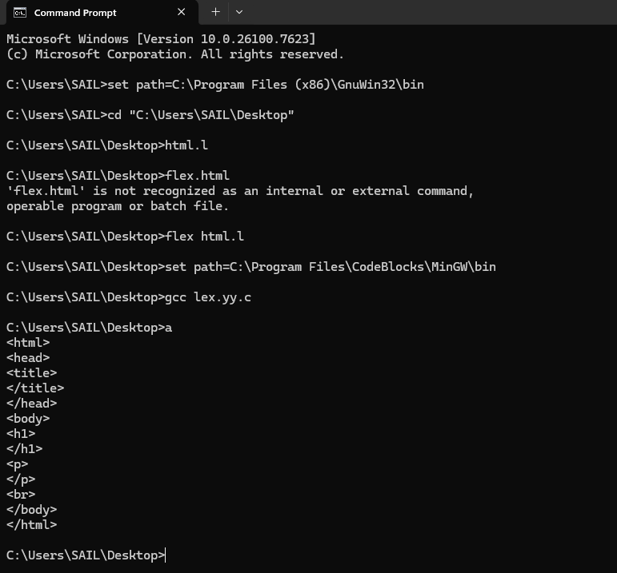Output:

