Mini Project Report

Topic: Future of IoT in Smart Cities

Abstract
The Internet of Things (IoT) connects physical devices through the internet so they can collect, exchange, and act on data in real time. In smart cities, IoT is reshaping how core services are delivered — improving transportation, healthcare, energy, waste management, and public safety by making infrastructure more responsive, efficient, and data-driven. As urban populations grow, IoT is increasingly viewed as the backbone technology for building cities that are not just “smart” but also sustainable and livable.

Introduction
IoT integrates sensors, communication networks, cloud computing, and analytics to automate services and improve urban living. Sensors embedded across city infrastructure — in roads, streetlights, water pipes, and public buildings — continuously collect data, which is transmitted over wired or wireless networks to centralized or cloud-based systems for processing.
- Real-time monitoring allows city administrators to detect problems (e.g. traffic congestion, water leaks, pollution spikes) as they happen rather than after the fact.
- Data-driven decision-making replaces guesswork with evidence, helping city planners allocate resources more effectively.
- Citizen-centric services such as mobile apps and dashboards give residents direct visibility into services like transit schedules and air quality.

Objectives
- Study IoT architecture and how its layers work together.
- Explore real-world smart city applications of IoT.
- Understand the benefits and challenges of IoT adoption in urban settings.
- Review a real-world case study of a functioning smart city.
- Evaluate the role of emerging technologies (AI, 5G, edge computing) in extending IoT capability.

IoT Architecture
IoT systems are typically organized into six functional layers, each handling a distinct stage of the data journey from physical sensing to user-facing insight:
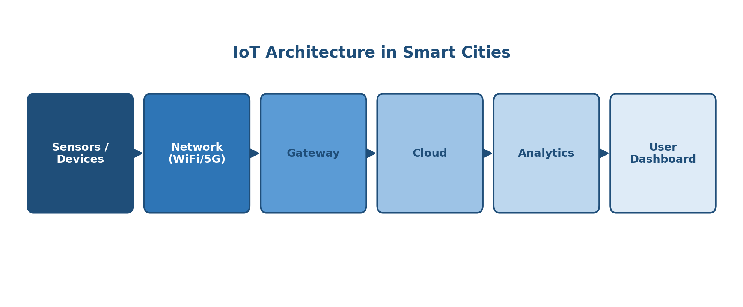
Figure 1: Layers of IoT architecture in a smart city system
- Sensors / Devices — collect raw data such as temperature, motion, traffic flow, or water levels.
- Network — transmits sensor data using WiFi, 5G, LoRaWAN, or other connectivity protocols.
- Gateway — aggregates and pre-processes data from multiple devices before forwarding it onward.
- Cloud — stores and manages large volumes of incoming data at scale.
- Analytics — applies algorithms and machine learning to extract patterns and actionable insights.
- User Dashboard — presents insights to city officials or citizens through visual interfaces.

Applications
IoT powers a wide range of smart city services, each targeting a specific aspect of urban life:
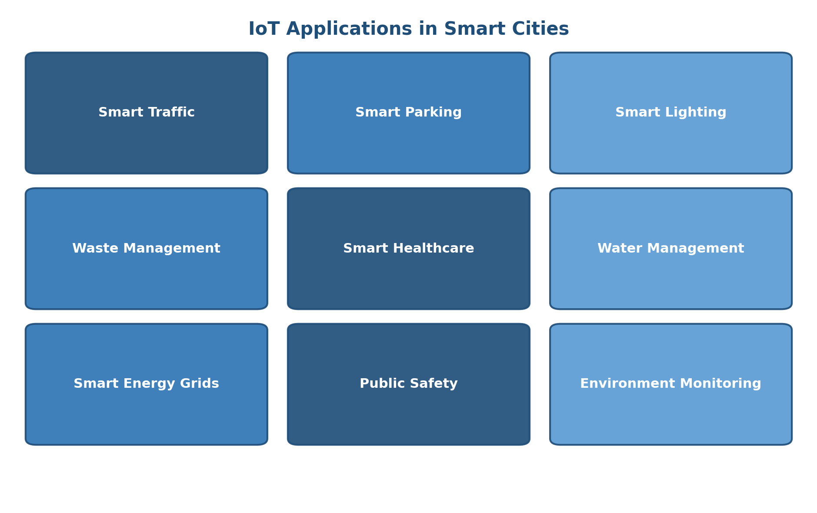
Figure 2: Key IoT application areas in smart cities
- Smart traffic — adaptive signals and congestion sensors that reduce travel time.
- Smart parking — real-time sensors that guide drivers to available spots.
- Smart street lighting — lights that dim or brighten automatically based on activity, saving energy.
- Waste management — fill-level sensors in bins that optimize collection routes.
- Healthcare — remote patient monitoring and connected emergency response systems.
- Water management — leak detection and quality monitoring across the supply network.
- Energy grids — smart meters and grid sensors that balance load and reduce waste.
- Public safety — connected surveillance and emergency alert systems.
- Environmental monitoring — air and noise quality sensors feeding public dashboards.

Sample Arduino Code
The snippet below demonstrates a basic IoT sensing unit: a light-dependent resistor (LDR) is used to automatically switch an LED on when ambient light falls below a threshold — a simplified model of how smart street lighting nodes operate at the edge of an IoT network.
int ldr = A0;
int led = 13;

void setup() {
pinMode(led, OUTPUT);
}

void loop() {
int v = analogRead(ldr);
if (v < 500) {
digitalWrite(led, HIGH);
} else {
digitalWrite(led, LOW);
}
delay(500);
}
- The LDR continuously reads ambient light level on analog pin A0.
- When the reading drops below the threshold (500), the LED — representing a streetlight — switches on automatically.
- This logic can be extended with IoT connectivity (e.g. an ESP8266/ESP32 module) to report status to a cloud dashboard.

Case Study: Singapore's Smart Nation
Singapore's Smart Nation initiative is one of the most cited real-world examples of city-scale IoT deployment. It uses a dense network of IoT sensors for traffic control, environmental monitoring, smart lighting, and a broad range of digital public services.
- Traffic control — sensors and cameras feed a centralized system that adjusts signal timing and predicts congestion.
- Environmental monitoring — city-wide sensors track air quality, rainfall, and temperature in real time.
- Digital public services — residents access government services, payments, and city data through unified digital platforms.
- Smart lighting — motion-based and scheduled lighting reduces energy consumption across public spaces.

Advantages
- Energy saving — automated systems reduce unnecessary power and resource consumption.
- Automation — routine city operations run with minimal manual intervention.
- Improved safety — real-time monitoring enables faster emergency response.
- Efficient resource management — data-driven allocation reduces waste of water, energy, and labor.
- Reduced operational cost — predictive maintenance and automation lower long-term municipal spending.
- Better quality of life — cleaner air, smoother traffic, and faster services for residents.

Challenges
- Cybersecurity — large sensor networks expand the attack surface for hackers.
- Privacy — continuous data collection raises concerns about citizen surveillance.
- Deployment cost — initial infrastructure investment can be substantial for cities.
- Interoperability — devices from different vendors often use incompatible standards.
- Maintenance — thousands of distributed sensors require ongoing upkeep and replacement.
- Digital divide — unequal access to smart services can widen gaps between communities.

Future Scope
- AI — machine learning will enable predictive insights rather than just reactive monitoring.
- Edge Computing — processing data closer to the source will reduce latency and bandwidth load.
- 5G — higher bandwidth and lower latency will support far denser sensor networks.
- Digital Twins — virtual replicas of city infrastructure will allow simulation before real-world changes.
- Autonomous Vehicles — IoT-connected vehicles will integrate directly with traffic infrastructure.
- Sustainable infrastructure — IoT will increasingly support climate goals through smarter resource use.
- Blockchain integration — emerging use cases explore blockchain for secure, tamper-proof IoT data sharing.

Conclusion
IoT is transforming cities into smarter, safer, and more sustainable environments. By connecting physical infrastructure to data and analytics, smart cities can respond to challenges in real time, use resources more efficiently, and improve the everyday experience of residents. While cybersecurity, cost, and interoperability remain real obstacles, continued advances in AI, 5G, and edge computing are likely to accelerate adoption and expand what IoT-enabled cities can achieve.

References
- IBM IoT
- Cisco Networking Academy
- AWS IoT
- IEEE Smart Cities papers

