# DESIGN PATTERNS AND PRINCIPLES:HANDS-ON SOLUTION

**Exercise 1: Implementing the Singleton Pattern**

**Scenario:**

You need to ensure that a logging utility class in your application has only one instance throughout the application lifecycle to ensure consistent logging.

Logger.java:

**public** **class** Logger {

**private** **static** Logger *instance*;

**private** Logger() {

System.***out***.println("Logger instance created.");

}

**public** **static** Logger getInstance() {

**if** (*instance* == **null**) {

*instance* = **new** Logger();

}

**return** *instance*;

}

**public** **void** log(String message) {

System.***out***.println("Log: " + message);

}

}

LoggerTest.java:

**public** **class** LoggerTest {

**public** **static** **void** main(String[] args) {

Logger logger1 = Logger.*getInstance*();

logger1.log("This is the first log message.");

Logger logger2 = Logger.*getInstance*();

logger2.log("This is the second log message.");

**if** (logger1 == logger2) {

System.***out***.println("Both logger instances are the same (Singleton verified).");

} **else** {

System.***out***.println("Different logger instances (Singleton failed).");

}

}

}

OUTPUT:

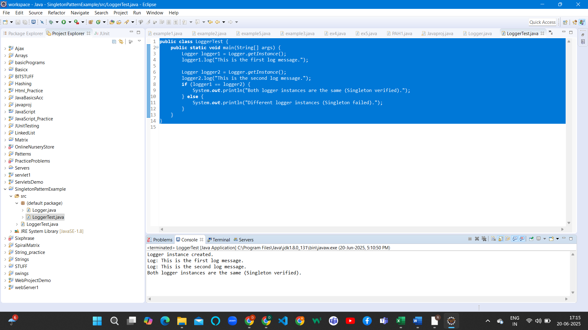

**Exercise 2: Implementing the Factory Method Pattern**

**Scenario:**

You are developing a document management system that needs to create different types of documents (e.g., Word, PDF, Excel). Use the Factory Method Pattern to achieve this.

DocumentFactory.java:

public abstract class DocumentFactory {

public abstract Document createDocument();

}

WordDocumentFactory.java:

public class WordDocumentFactory extends DocumentFactory {

@Override

public Document createDocument() {

return new WordDocument();

}

}

PdfDocumentFactory.java:

public class PdfDocumentFactory extends DocumentFactory {

@Override

public Document createDocument() {

return new PdfDocument();

}

}

ExcelDocumentFactory.java:

public class ExcelDocumentFactory extends DocumentFactory {

@Override

public Document createDocument() {

return new ExcelDocument();

}

}

DocumentFactorytTest.java:

public class DocumentFactoryTest {

public static void main(String[] args) {

DocumentFactory wordFactory = new WordDocumentFactory();

Document wordDoc = wordFactory.createDocument();

wordDoc.open();

DocumentFactory pdfFactory = new PdfDocumentFactory();

Document pdfDoc = pdfFactory.createDocument();

pdfDoc.open();

DocumentFactory excelFactory = new ExcelDocumentFactory();

Document excelDoc = excelFactory.createDocument();

excelDoc.open();

}

}

OUTPUT:

