**Name : Abisha V**

**WEEK – 7**

**1)** 9. ReactJS-HOL

**ListofPlayers.js**

import React from 'react'; const ListofPlayers = () => { const players = [

{ name: 'Rohit', score: 80 },

{ name: 'Virat', score: 65 },

{ name: 'Gill', score: 50 },

{ name: 'Rahul', score: 90 },

{ name: 'Jadeja', score: 70 },

{ name: 'Hardik', score: 40 },

{ name: 'Shami', score: 85 },

{ name: 'Bumrah', score: 60 },

{ name: 'Pant', score: 95 },

{ name: 'Ashwin', score: 55 },

{ name: 'Surya', score: 72 },

];

const filteredPlayers = players.filter(player => player.score < 70); return (

<div>

<h2>All Players</h2>

<ul>

{players.map((p, index) => (

<li key={index}>{p.name} - {p.score}</li>

))}

</ul>

<h3>Players with score below 70</h3>

<ul>

{filteredPlayers.map((p, index) => (

<li key={index}>{p.name} - {p.score}</li>

))}

</ul>

</div>

);

};

export default ListofPlayers;

**IndianPlayers.js** import React from 'react'; const IndianPlayers = () => {

const oddPlayers = ['Rohit', 'Gill', 'Jadeja', 'Shami', 'Pant']; const evenPlayers = ['Virat', 'Rahul', 'Hardik', 'Bumrah', 'Ashwin', 'Surya']; const [p1, p2, p3, ...restOdd] = oddPlayers; const [e1, e2, e3, ...restEven] = evenPlayers; const T20players = ['Rohit', 'Virat', 'Hardik']; const RanjiTrophyPlayers = ['Jaiswal', 'Sarfaraz', 'Iyer'];

const allPlayers = [...T20players, ...RanjiTrophyPlayers]; // ES6 Merge feature return (

<div>

<h2>Odd Team Players (Destructured)</h2>

<ul>

<li>{p1}</li>

<li>{p2}</li>

<li>{p3}</li>

</ul>

<h2>Even Team Players (Destructured)</h2>

<ul>

<li>{e1}</li>

<li>{e2}</li>

<li>{e3}</li>

</ul>

<h2>Merged List (T20 + Ranji Players)</h2>

<ul>

{allPlayers.map((p, i) => <li key={i}>{p}</li>)}

</ul>

</div>

);

}; export default IndianPlayers; **App.js**

import React from 'react'; import ListofPlayers from './ListofPlayers'; import IndianPlayers from './IndianPlayers'; function App() {

const flag = true; // Toggle this to false to see the other component return (

<div className="App">

<h1> Cricket App</h1>

{flag ? <ListofPlayers /> : <IndianPlayers />}

</div>

);

}

export default App;

**OUTPUT :**

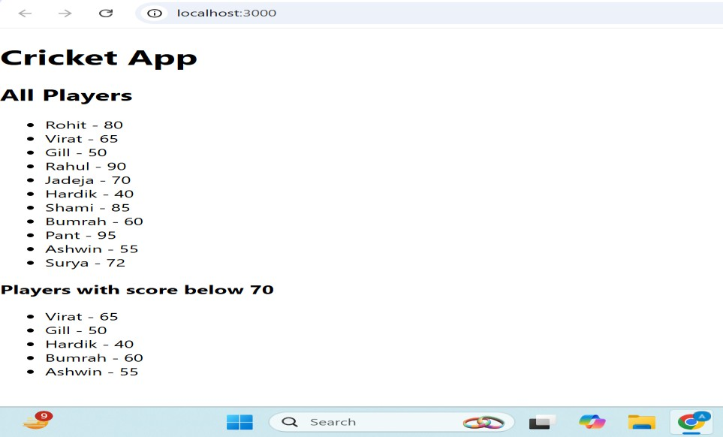

**2) 10. ReactJS-HOL**

# App. js

import React from 'react';

function App() {

const heading = <h1 style={{ textAlign: 'center' }}>Office Space Rental App</h1>;

const imageURL = "https://synergyestates.in/wp-content/uploads/2025/03/office-space- fore-rent.jpg"; const office = { name: "CyberTech Park", rent: 55000,

address: "Sector 21, Bengaluru"

};

const offices = [

{ name: "InnovateHub", rent: 45000, address: "Indiranagar" }, { name: "TechSpace", rent: 65000, address: "Koramangala" },

{ name: "WorkNest", rent: 55000, address: "HSR Layout" },

{ name: "StartX", rent: 75000, address: "MG Road" },

];

return (

<div style={{ fontFamily: 'Arial', padding: '20px' }}>

{heading}

<img src={imageURL} alt="Office Space" style={{ display: 'block', margin: '20px auto', borderRadius: '10px' }} /> <h2>Featured Office</h2>

<p><strong>Name:</strong> {office.name}</p>

<p><strong>Rent:</strong> ₹{office.rent}</p>

<p><strong>Address:</strong> {office.address}</p>

<hr />

<h2>Other Office Listings</h2>

<ul>

{offices.map((item, index) => {

const rentColor = item.rent < 60000 ? 'red' : 'green'; // 👉 7. Conditional inline CSS return (

<li key={index} style={{ marginBottom: '15px' }}>

<p><strong>Name:</strong> {item.name}</p>

<p><strong>Rent:</strong> <span style={{ color: rentColor }}>₹{item.rent}</span></p>

<p><strong>Address:</strong> {item.address}</p>

</li>

);

})}

</ul>

</div>

);

}

export default App;

**OUTPUT :**

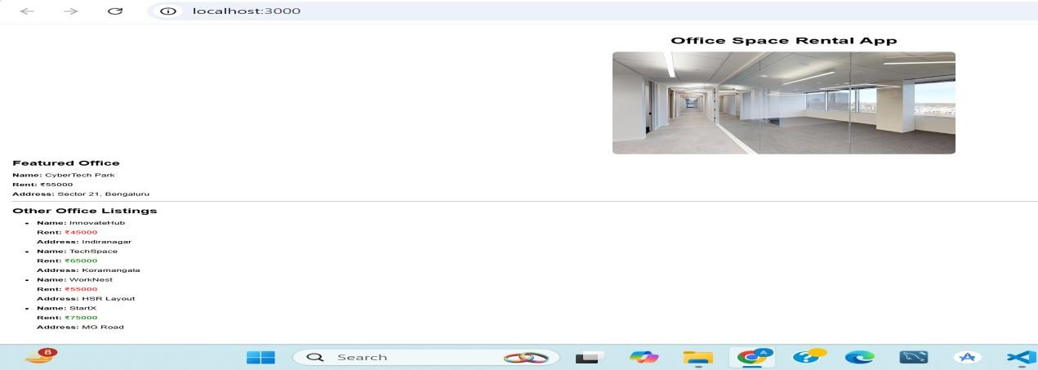

3) 11. ReactJS-HOL

# Counter.js

import React, { Component } from 'react';

class Counter extends Component { constructor() { super(); this.state = {

count: 0

};

this.increment = this.increment.bind(this); this.sayHello = this.sayHello.bind(this); this.handleIncrement = this.handleIncrement.bind(this); this.decrement = this.decrement.bind(this); this.sayWelcome = this.sayWelcome.bind(this);

this.handleSyntheticClick = this.handleSyntheticClick.bind(this);

}

increment() {

this.setState({ count: this.state.count + 1 });

}

decrement() {

this.setState({ count: this.state.count - 1 });

}

sayHello() {

console.log('Hello! This is a static message.');

}

handleIncrement() { this.increment();

this.sayHello(); // Multiple methods

}

sayWelcome(message) {

alert(message);

}

handleSyntheticClick(event) { alert("I was clicked");

console.log(event); // Synthetic Event

}

render() { return (

<div style={{ padding: '20px', borderBottom: '2px solid #ccc' }}>

<h2>Counter: {this.state.count}</h2>

<button onClick={this.handleIncrement}>Increment</button>&nbsp;

<button onClick={this.decrement}>Decrement</button>

<hr />

<button onClick={() => this.sayWelcome("Welcome!")}>Say Welcome</button>

<hr />

<button onClick={this.handleSyntheticClick}>Synthetic Event Button</button>

</div>

);

}

}

export default Counter;

# CurrencyConverter.js

import React, { useState } from 'react'; const CurrencyConverter = () => { const [inr, setInr] = useState(''); const [euro, setEuro] = useState(''); const handleSubmit = (e) => { e.preventDefault();

const euroValue = (parseFloat(inr) / 90).toFixed(2); setEuro(euroValue);

};

return (

<div style={{ padding: '20px' }}>

<h2>Currency Converter (INR to Euro)</h2>

<form onSubmit={handleSubmit}>

<label>INR Amount:</label><br />

<input type="number"

value={inr}

onChange={(e) => setInr(e.target.value)}

/><br /><br />

<button type="submit">Convert</button>

</form>

{euro && <p><strong>Converted Euro:</strong> €{euro}</p>}

</div>

);

};

export default CurrencyConverter;

# App.js

import React from 'react'; import Counter from './Counter'; import CurrencyConverter from './CurrencyConverter'; function App() { return (

<div style={{ textAlign: 'center', fontFamily: 'Arial' }}>

<h1>React Event Handling Examples</h1>

<Counter />

<CurrencyConverter />

</div>

);

}

export default App;

**OUTPUT :**

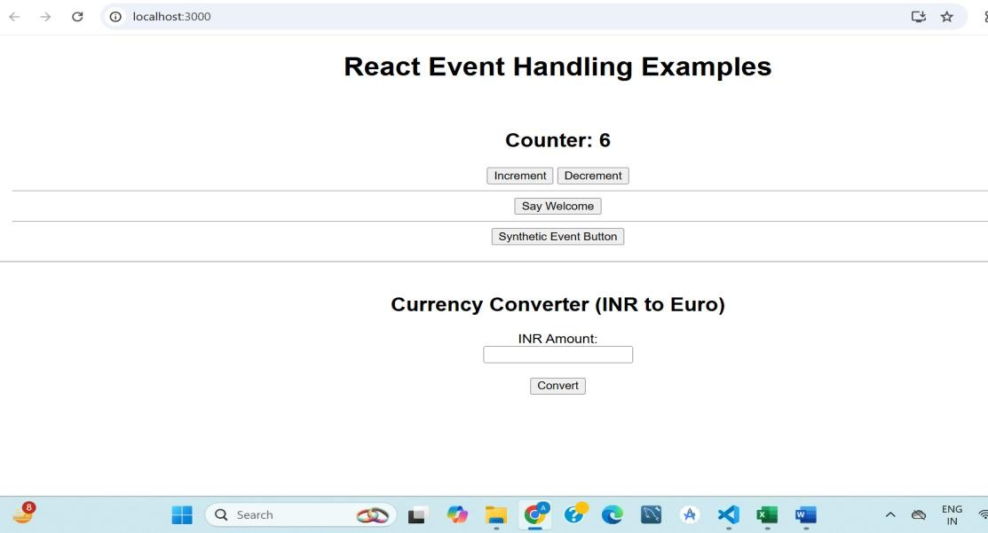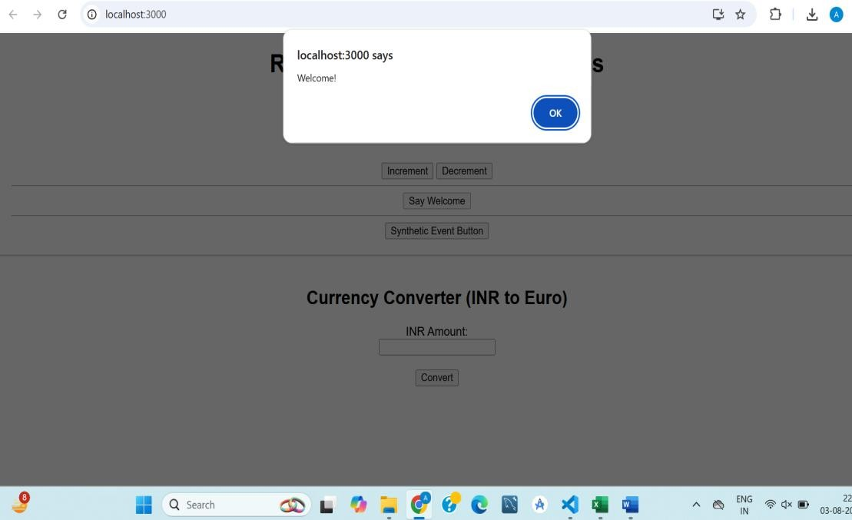

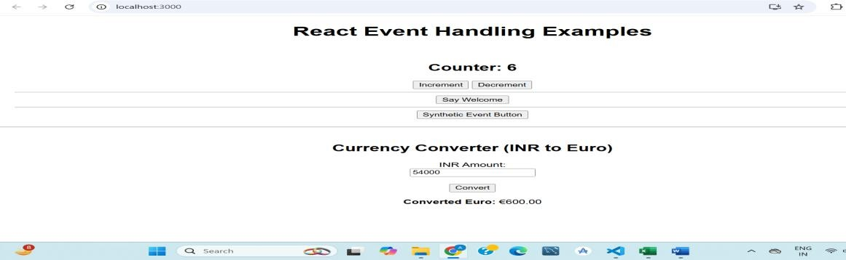

4) 12. ReactJS-HOL

## GuestPage.js

import React from 'react';

function GuestPage() { return (

<div>

<h2>Welcome Guest!</h2>

<p>You can view flight details but cannot book tickets.</p>

<ul>

<li>Flight: AI 202 | From: Delhi → Mumbai | Time: 10:00 AM</li>

<li>Flight: Indigo 501 | From: Chennai → Bangalore | Time: 1:00 PM</li>

</ul>

</div>

);

}

export default GuestPage;

## UserPage.js

import React from 'react';

function UserPage() { return (

<div>

<h2>Welcome Back, User!</h2>

<p>You can book tickets below:</p>

<button>Book AI 202</button>&nbsp;

<button>Book Indigo 501</button>

</div>

);

}

export default UserPage;

## App.js

import React, { useState } from 'react'; import GuestPage from './GuestPage'; import UserPage from './UserPage'; function App() {

const [isLoggedIn, setIsLoggedIn] = useState(false); let content; if (isLoggedIn) { content = <UserPage />;

} else {

content = <GuestPage />;

}

return (

<div style={{ textAlign: 'center', fontFamily: 'Arial', padding: '20px' }}>

<h1>✈️ Ticket Booking App</h1>

{content}

<br /><br />

{/* Toggle login/logout button */}

{isLoggedIn ? (

<button onClick={() => setIsLoggedIn(false)}>Logout</button>

) : (

<button onClick={() => setIsLoggedIn(true)}>Login</button>

)}

</div>

);

}

export default App;

**OUTPUT :**

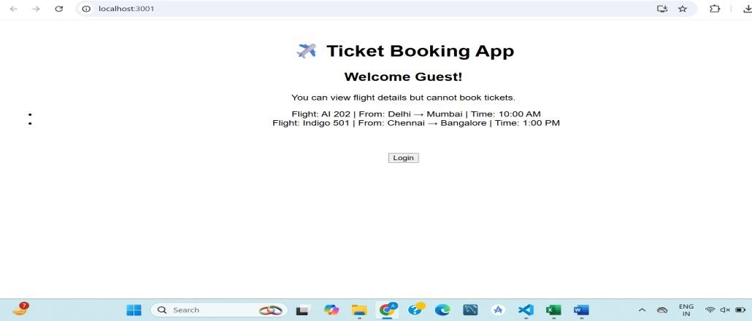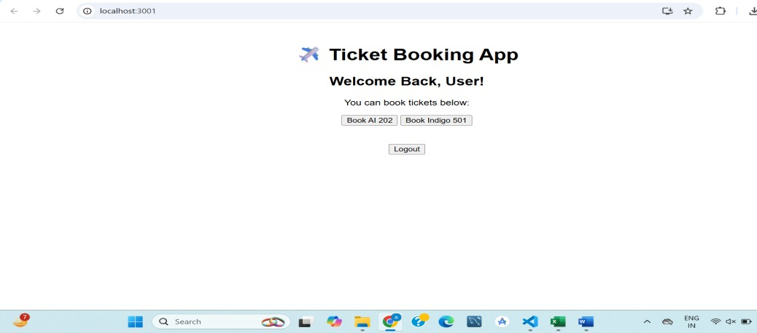

5) 13. ReactJS-HOL

## BlogDetails.js

import React from 'react';

function BlogDetails() {

return (

<div>

<h2>📝 Blog Highlights</h2>

<p>1. How to Learn React</p>

<p>2. State vs Props Explained</p>

</div>

);

}

export default BlogDetails;

## CourseDetails.js

import React from 'react';

function CourseDetails() { return (

<div>

<h2>🎓 Available Courses</h2>

<ul>

<li>React Fundamentals</li>

<li>Advanced JavaScript</li>

<li>Web Accessibility</li>

</ul>

</div>

);

}

export default CourseDetails;

## BookDetails.js

import React from 'react'; function BookDetails({ books }) {

return (

<div>

<h2>📚 Book List</h2>

<ul>

{books.map((book, index) => (

<li key={book.id}>

<strong>{book.title}</strong> by {book.author}

</li>

))}

</ul>

</div>

);

}

export default BookDetails;

## App.js

import React, { useState } from 'react'; import BookDetails from './BookDetails'; import BlogDetails from './BlogDetails'; import CourseDetails from './CourseDetails'; function App() {

const [view, setView] = useState('books'); // default view const books = [

{ id: 1, title: "React Made Easy", author: "Dan Abramov" },

{ id: 2, title: "JS Deep Dive", author: "Kyle Simpson" },

{ id: 3, title: "Learning Hooks", author: "Sarah Drasner" },

];

let content; if (view === 'books') {

content = <BookDetails books={books} />;

} else if (view === 'blogs') {

content = <BlogDetails />;

} else {

content = <CourseDetails />;

}

return (

<div style={{ textAlign: 'center', fontFamily: 'sans-serif' }}>

<h1>🧑‍💻 Blogger App</h1>

<div style={{ marginBottom: '20px' }}>

<button onClick={() => setView('books')}>Books</button>

<button onClick={() => setView('blogs')}>Blogs</button>

<button onClick={() => setView('courses')}>Courses</button>

</div>

{content}

<div style={{ marginTop: '40px' }}>

<h3>🔍 Bonus Info:</h3>

{books.length > 0 && <p>We have {books.length} books in our library.</p>}

</div>

</div>

);

}

export default App;

**OUTPUT :**

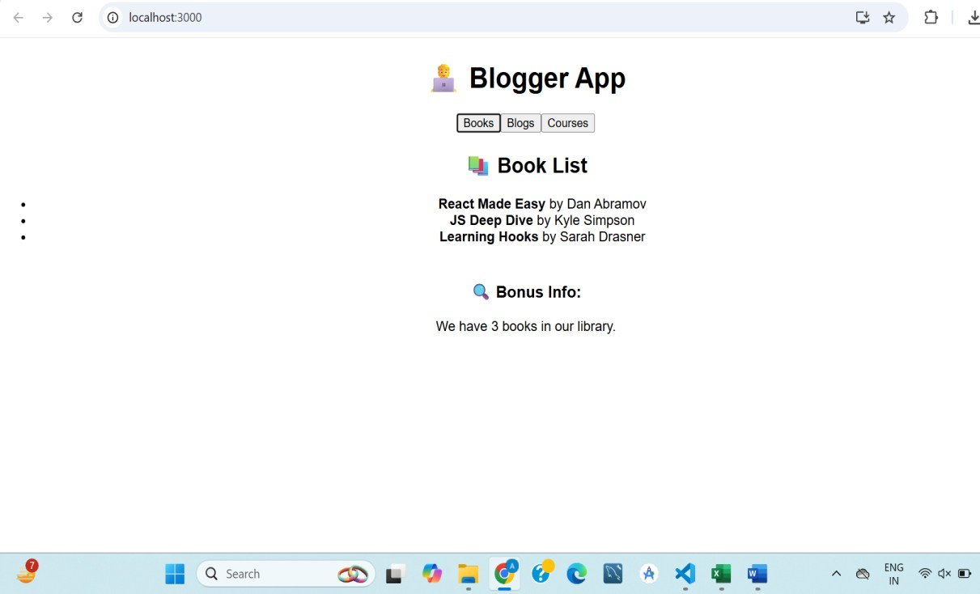

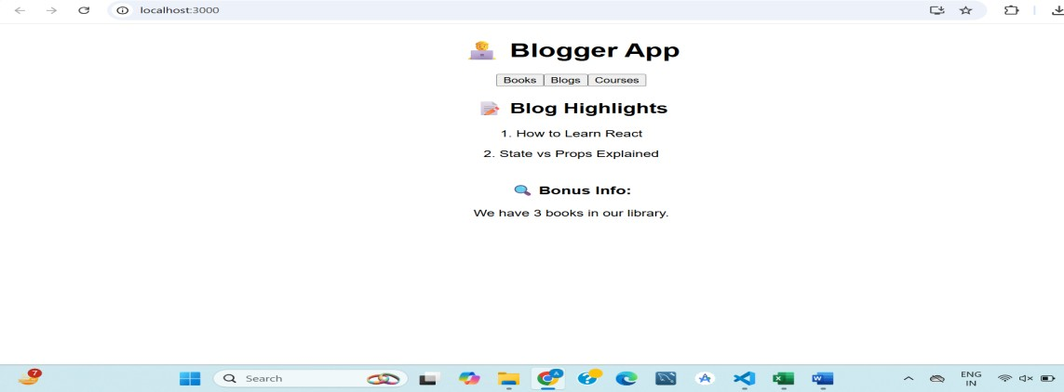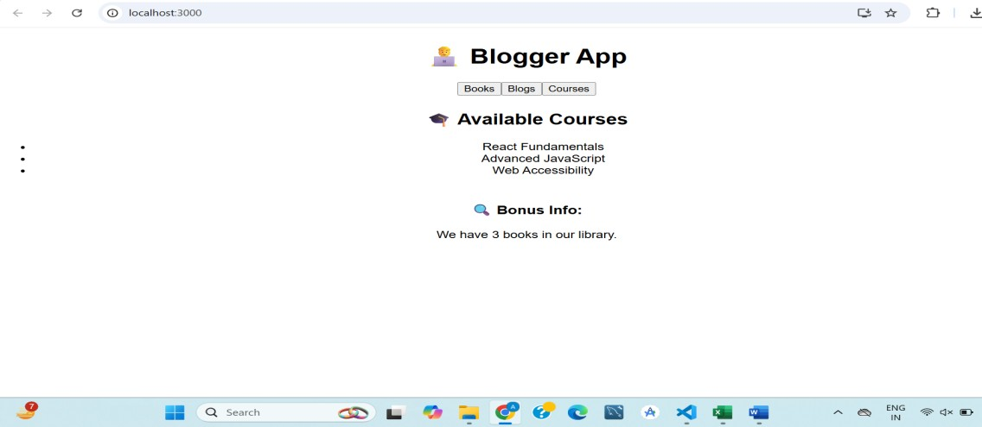

# ADDITIONAL EXERCISES

6) 13. ReactJS-HOL

## BlogDetails.js

import React from 'react';

function BlogDetails() {

return (

<div>

<h2>📝 Blog Highlights</h2>

<p>1. How to Learn React</p>

<p>2. State vs Props Explained</p>

</div>

);

}

export default BlogDetails;

## CourseDetails.js

import React from 'react'; function CourseDetails() { return (

<div>

<h2>🎓 Available Courses</h2>

<ul>

<li>React Fundamentals</li>

<li>Advanced JavaScript</li>

<li>Web Accessibility</li>

</ul>

</div>

);

}

export default CourseDetails;

## BookDetails.js

import React from 'react';

function BookDetails({ books }) {

return (

<div>

<h2>📚 Book List</h2>

<ul>

{books.map((book, index) => (

<li key={book.id}>

<strong>{book.title}</strong> by {book.author}

</li>

))}

</ul>

</div>

);

}

export default BookDetails;

## App.js

import React, { useState } from 'react'; import BookDetails from './BookDetails'; import BlogDetails from './BlogDetails'; import CourseDetails from './CourseDetails'; function App() {

const [view, setView] = useState('books'); // default view const books = [

{ id: 1, title: "React Made Easy", author: "Dan Abramov" },

{ id: 2, title: "JS Deep Dive", author: "Kyle Simpson" },

{ id: 3, title: "Learning Hooks", author: "Sarah Drasner" },

];

let content;

if (view === 'books') {

content = <BookDetails books={books} />;

} else if (view === 'blogs') {

content = <BlogDetails />;

} else {

content = <CourseDetails />;

}

return (

<div style={{ textAlign: 'center', fontFamily: 'sans-serif' }}>

<h1>🧑‍💻 Blogger App</h1>

<div style={{ marginBottom: '20px' }}>

<button onClick={() => setView('books')}>Books</button>

<button onClick={() => setView('blogs')}>Blogs</button>

<button onClick={() => setView('courses')}>Courses</button>

</div>

{content}

<div style={{ marginTop: '40px' }}>

<h3>🔍 Bonus Info:</h3>

{books.length > 0 && <p>We have {books.length} books in our library.</p>}

</div>

</div>

);

}

export default App;

**OUTPUT :**





7) 14. ReactJS-HOL

## EmployeeCard.js

import React, { useContext } from 'react'; import ThemeContext from './ThemeContext'; const EmployeeCard = ({ employee }) => { const theme = useContext(ThemeContext);

const buttonClass = theme === 'dark' ? 'btn-dark' : 'btn-light'; return (

<div className="employee-card">

<h3>{employee.name}</h3>

<p>Role: {employee.role}</p>

<button className={buttonClass}>Message</button>

</div>

);

};

export default EmployeeCard;

## EmployeeList.js

import React from 'react';

import EmployeeCard from './EmployeeCard'; const EmployeesList = () => {

const employees = [

{ id: 1, name: 'Alice', role: 'Developer' },

{ id: 2, name: 'Bob', role: 'Designer' },

{ id: 3, name: 'Charlie', role: 'Tester' },

];

return (

<div>

<h2>Employee List</h2>

{employees.map(emp => (

<EmployeeCard key={emp.id} employee={emp} />

))}

</div>

);

};

export default EmployeesList;

## ThemeContext.js

import { createContext } from 'react';

const ThemeContext = createContext('light'); // default theme = light export default ThemeContext;

## App.js

import React, { useState } from 'react'; import EmployeesList from './EmployeesList'; import ThemeContext from './ThemeContext'; import './App.css'; function App() {

const [theme, setTheme] = useState('light'); const toggleTheme = () =>

setTheme(prev => (prev === 'light' ? 'dark' : 'light')); return (

<ThemeContext.Provider value={theme}>

<div className={`app-container ${theme}`}>

<h1>Employee Management</h1>

<button onClick={toggleTheme}>

Toggle to {theme === 'light' ? 'Dark' : 'Light'} Mode

</button>

<EmployeesList />

</div>

</ThemeContext.Provider>

);

}

export default App;

**OUTPUT :**

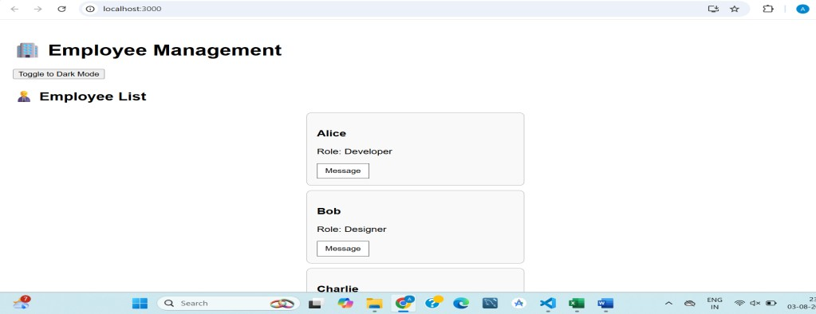

8) 15. ReactJS-HOL

## ComplaintRegister.js

import React, { useState } from 'react'; function ComplaintRegister() {

const [employeeName, setEmployeeName] = useState(''); const [complaint, setComplaint] = useState(''); const handleSubmit = (e) => { e.preventDefault();

const referenceNo = Math.floor(100000 + Math.random() * 900000); // 6-digit ref no alert(`Complaint Submitted Successfully!\n\nEmployee Name: ${employeeName}\nComplaint: ${complaint}\nReference No: ${referenceNo}`);

// Clear form setEmployeeName('');

setComplaint('');

};

return ( <div style={{ maxWidth: '500px', margin: '40px auto', padding: '20px', border: '1px solid #ccc', borderRadius: '8px',

fontFamily: 'Arial'

}}>

<h2>Raise a Complaint 📝</h2>

<form onSubmit={handleSubmit}>

<div>

<label>Employee Name:</label><br />

<input

type="text"

value={employeeName}

onChange={(e) => setEmployeeName(e.target.value)}

required

style={{ width: '100%', padding: '8px', marginBottom: '15px' }}

/>

</div>

<div>

<label>Complaint:</label><br />

<textarea value={complaint}

onChange={(e) => setComplaint(e.target.value)} rows="4" required

style={{ width: '100%', padding: '8px', marginBottom: '15px' }}

/>

</div>

<button type="submit" style={{ padding: '10px 20px', cursor: 'pointer', backgroundColor: '#007bff', color: 'white', border: 'none' }}

>

Submit Complaint

</button>

</form>

</div>

);

}

export default ComplaintRegister;

## App.js

import React from 'react';

import ComplaintRegister from './ComplaintRegister'; function App() { return (

<div className="App">

<ComplaintRegister />

</div>

);

}

export default App;

OUTPUT :

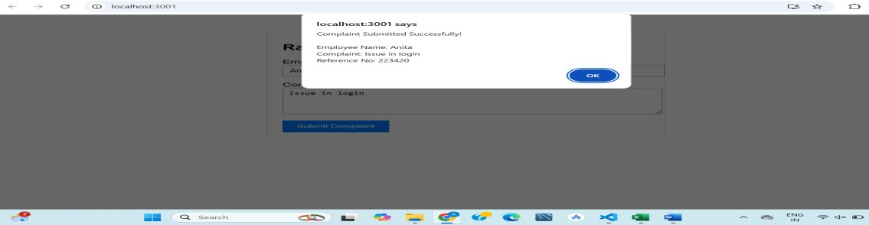

9) 16. ReactJS-HOL

## Register.js

import React, { useState } from 'react'; function Register() {

const [formData, setFormData] = useState({ name: '', email: '',

password: '',

});

const [errors, setErrors] = useState({}); const validate = () => { const newErrors = {};

if (formData.name.trim().length < 5) {

newErrors.name = 'Name should be at least 5 characters.';

}

if (!formData.email.includes('@') || !formData.email.includes('.')) { newErrors.email = 'Enter a valid email (must include @ and .)';

}

if (formData.password.length < 8) {

newErrors.password = 'Password should be at least 8 characters.';

}

setErrors(newErrors);

return Object.keys(newErrors).length === 0;

};

const handleChange = (e) => { const { name, value } = e.target;

setFormData((prev) => ({

...prev,

[name]: value,

}));

setErrors((prevErrors) => ({

...prevErrors,

[name]: '',

}));

};

const handleSubmit = (e) => { e.preventDefault(); if (validate()) {

alert(`Registration Successful!\n\nName: ${formData.name}\nEmail: ${formData.email}`); setFormData({ name: '', email: '', password: '' }); setErrors({});

}

};

return (

<div style={{ maxWidth: '500px', margin: '50px auto', padding: '20px', border: '1px solid #ccc', borderRadius: '8px', fontFamily: 'Arial' }}> <h2>Mail Register Form</h2>

<form onSubmit={handleSubmit}>

<div style={{ marginBottom: '15px' }}>

<label>Name:</label><br />

<input

type="text" name="name" value={formData.name}

onChange={handleChange}

required

style={{ width: '100%', padding: '8px' }}

/>

{errors.name && <p style={{ color: 'red' }}>{errors.name}</p>}

</div>

<div style={{ marginBottom: '15px' }}>

<label>Email:</label><br />

<input type="email" name="email" value={formData.email}

onChange={handleChange}

required

style={{ width: '100%', padding: '8px' }}

/>

{errors.email && <p style={{ color: 'red' }}>{errors.email}</p>}

</div>

<div style={{ marginBottom: '15px' }}>

<label>Password:</label><br />

<input type="password" name="password" value={formData.password}

onChange={handleChange}

required

style={{ width: '100%', padding: '8px' }}

/>

{errors.password && <p style={{ color: 'red' }}>{errors.password}</p>}

</div>

<button type="submit" style={{ padding: '10px 20px', backgroundColor: '#007bff', color: 'white', border: 'none', cursor: 'pointer' }}>

Register

</button>

</form>

</div>

);

}

export default Register;

## App.js

import React from 'react';

import ComplaintRegister from './ComplaintRegister'; function App() {

return (

<div className="App">

<ComplaintRegister />

</div>

);

}

export default App;

OUTPUT :

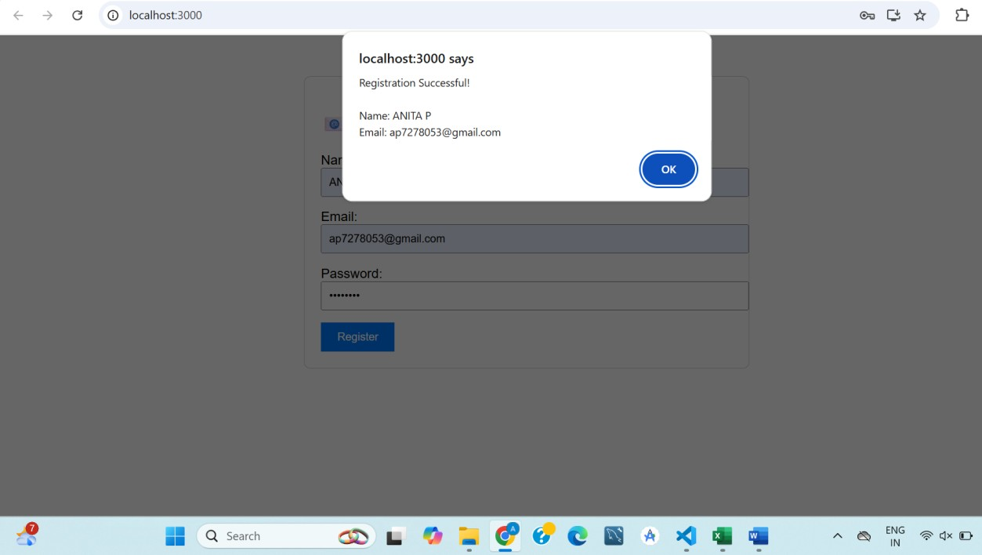

10) 17. ReactJS-HOL

Getuser.js

import React, { Component } from 'react';

class Getuser extends Component { constructor(props) { super(props); this.state = {

user: null

};

}

async componentDidMount() { try {

const response = await fetch('https://api.randomuser.me/'); const data = await response.json(); const fetchedUser = data.results[0]; this.setState({

user: {

title: fetchedUser.name.title, firstName: fetchedUser.name.first,

picture: fetchedUser.picture.large

}

});

} catch (error) {

console.error('Error fetching user:', error);

}

}

render() { const { user } = this.state; return (

<div style={{ textAlign: 'center', marginTop: '50px' }}>

<h2>👤 Random User</h2>

{user ? (

<div> <img src={user.picture}

alt="User"

style={{ borderRadius: '50%', width: '150px', height: '150px' }}

/>

<h3>{user.title} {user.firstName}</h3>

</div>

) : (

<p>Loading user data...</p>

)}

</div>

);

}

}

export default Getuser;

## App.js

import React from 'react';

import Getuser from './Getuser';

function App() {

return (

<div className="App">

<Getuser />

</div>

);

}

export default App;

**OUTPUT :**

