Question 1: Develop an Enterprise Cloud Adoption Strategy using Cloud First / Cloud Smart.
Ms Word
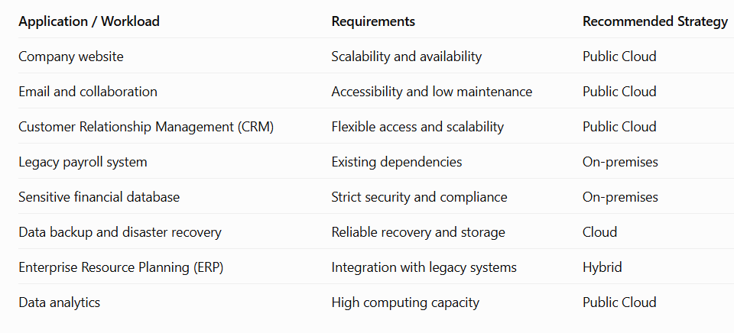
Ms excel
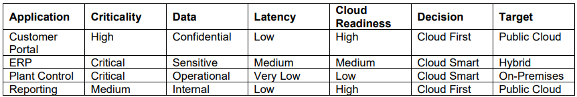
Draw.io
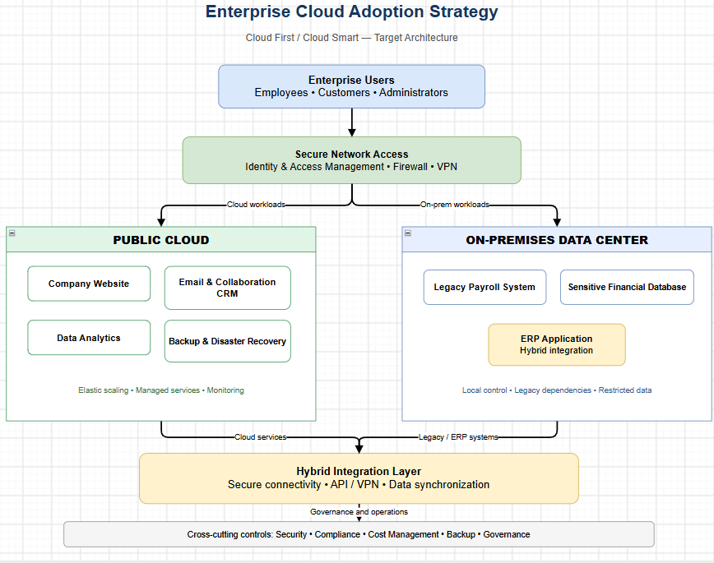
Question 2: Design a Cloud Center of Excellence (CCoE) and Stakeholder Responsibility Model
Ms Word
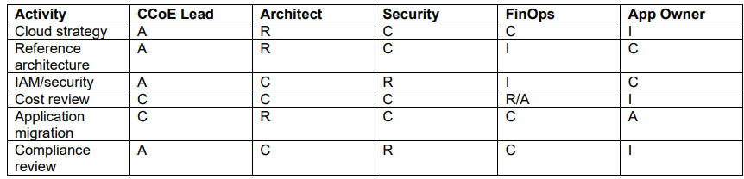
Draw.io
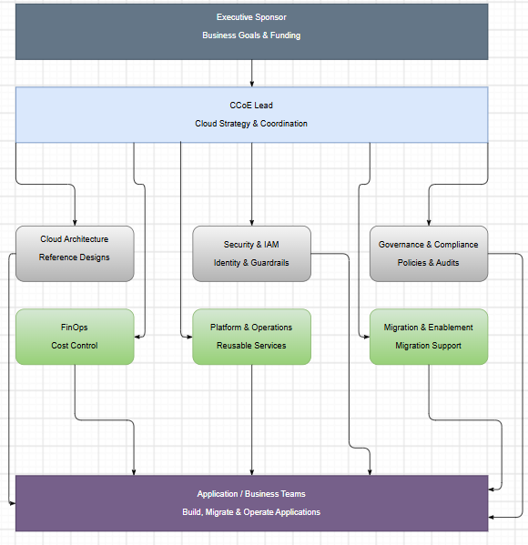

Question 3: Perform Cloud TCO and ROI Analysis for an Enterprise Workload.
Ms Excel
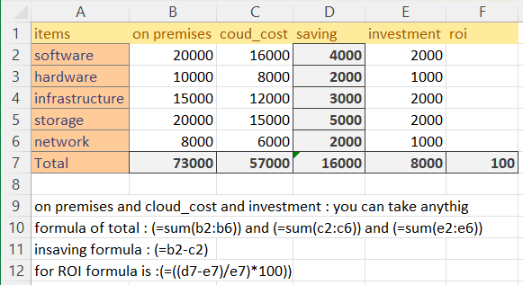

Question: Perform Cloud Cost Analysis and Optimization using FinOps Principles.
Ms Excel
