**Jinja**

**Base**

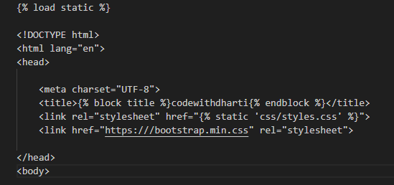

**Navbar**

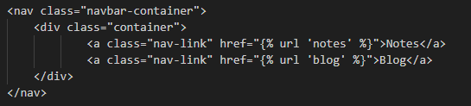

**Main Content**

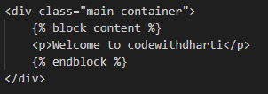

**Expressions**

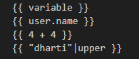

**Statements**

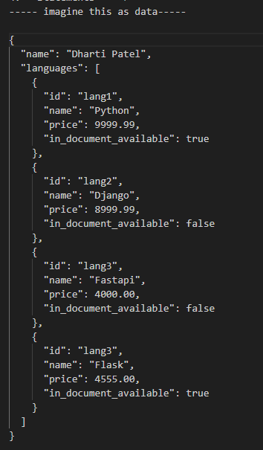

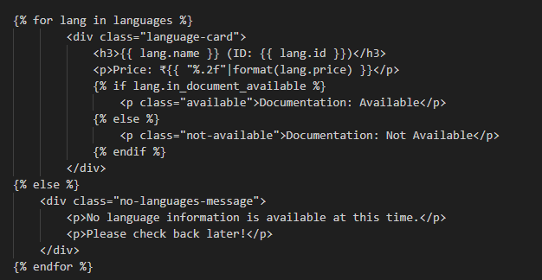

**If/Elif/Else Conditional**

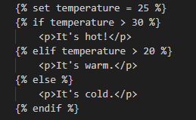

**set statement**



**Comments**



**Filters**

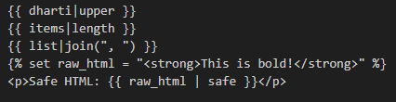

**Tests**

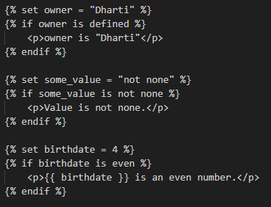

**Macros (like functions)**



**Inheritance**

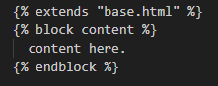

**Imports and Includes**



**Loop Control Variables**

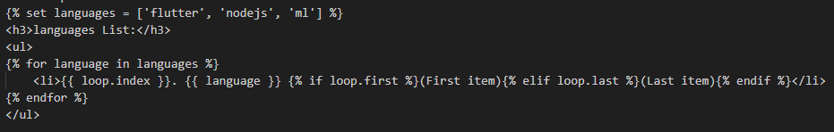

**With Statement**

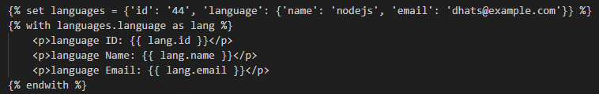

**Whitespace Control**

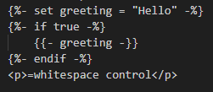

**Footer**

