MONGODB ATLAS

**Mongo can be perform locally but mongo atlas is cloud platform where update and management will be handled by them, we don’t have to do manual setup or efforts needed from our side.**

1. Signup to mongodb atlass or login perform
2. Give answer of basic question where how you will use it
3. Database Access
4. Network Access
5. Clusters
6. Connect mongocompass with mongodb atlass (with a cluster created on it)

**3. Database Access**

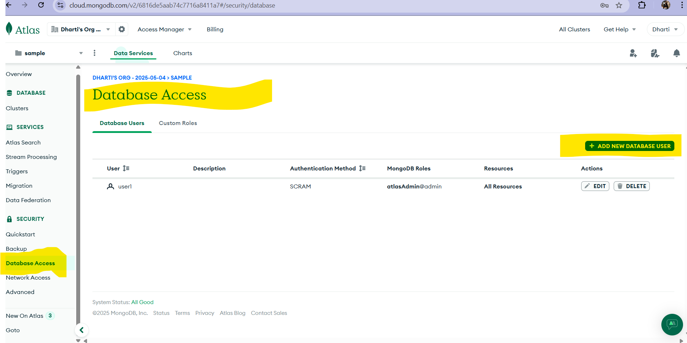

* How to add new user to database so that they can access database. Allow them to access database as per their role.

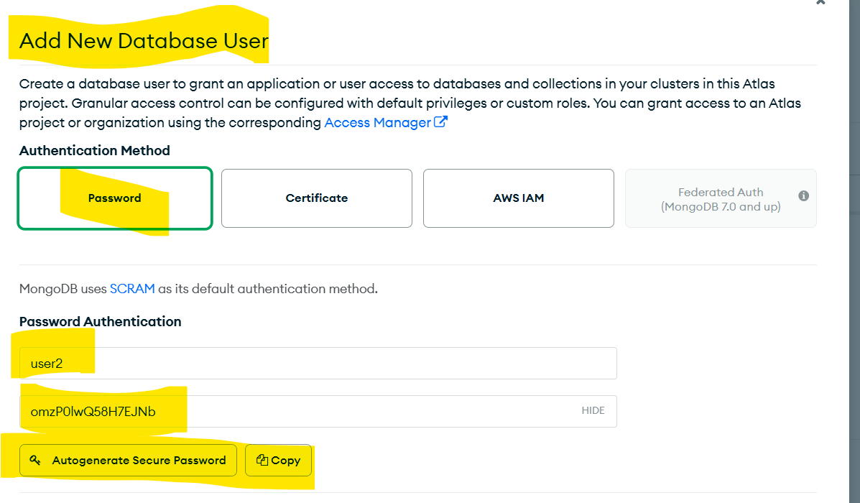

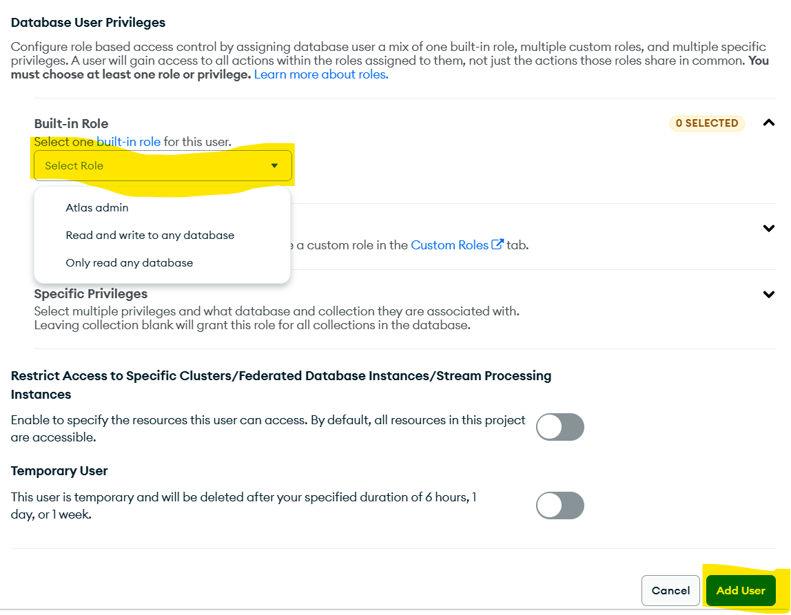

**4. Network Access -** In network access add this to perform api call from each networks.

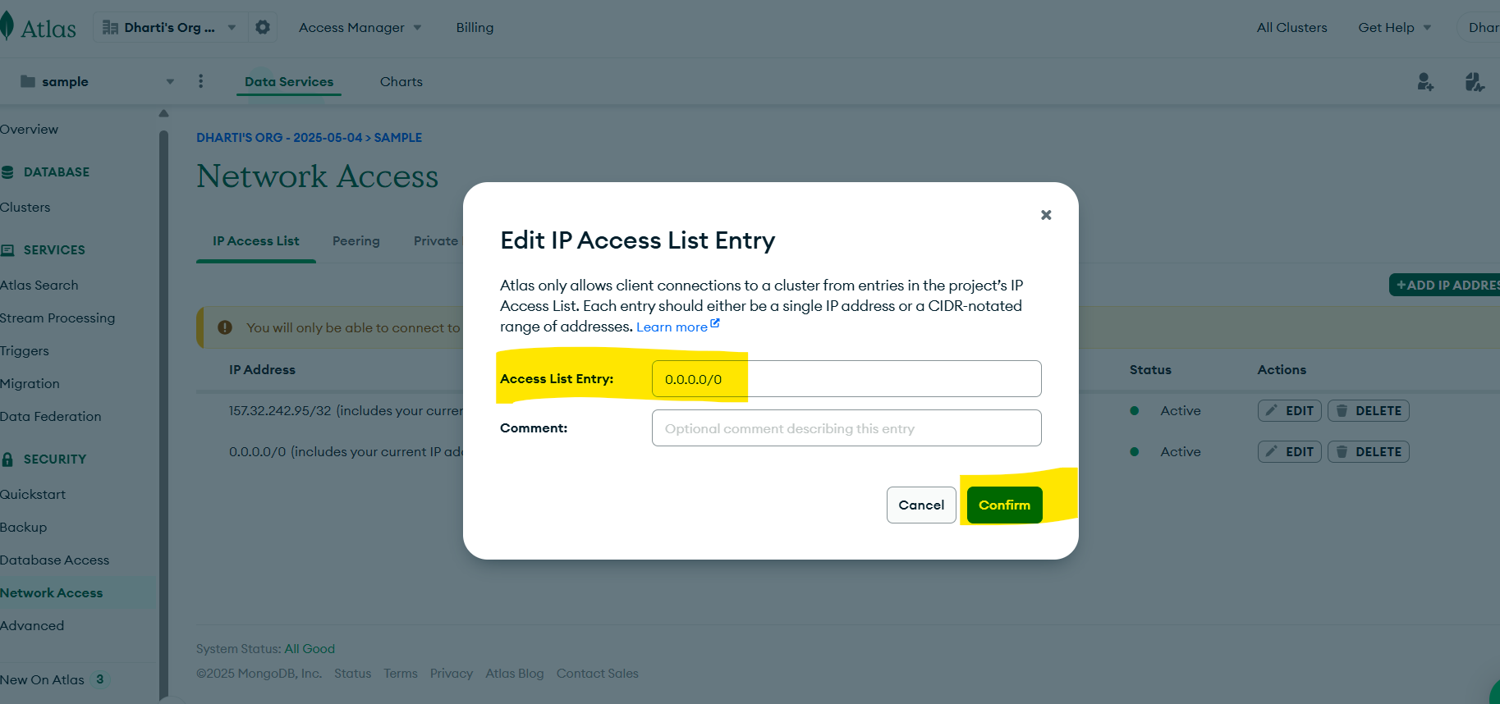

**5. clusters**

1. Create cluster and wait for sometime to get created

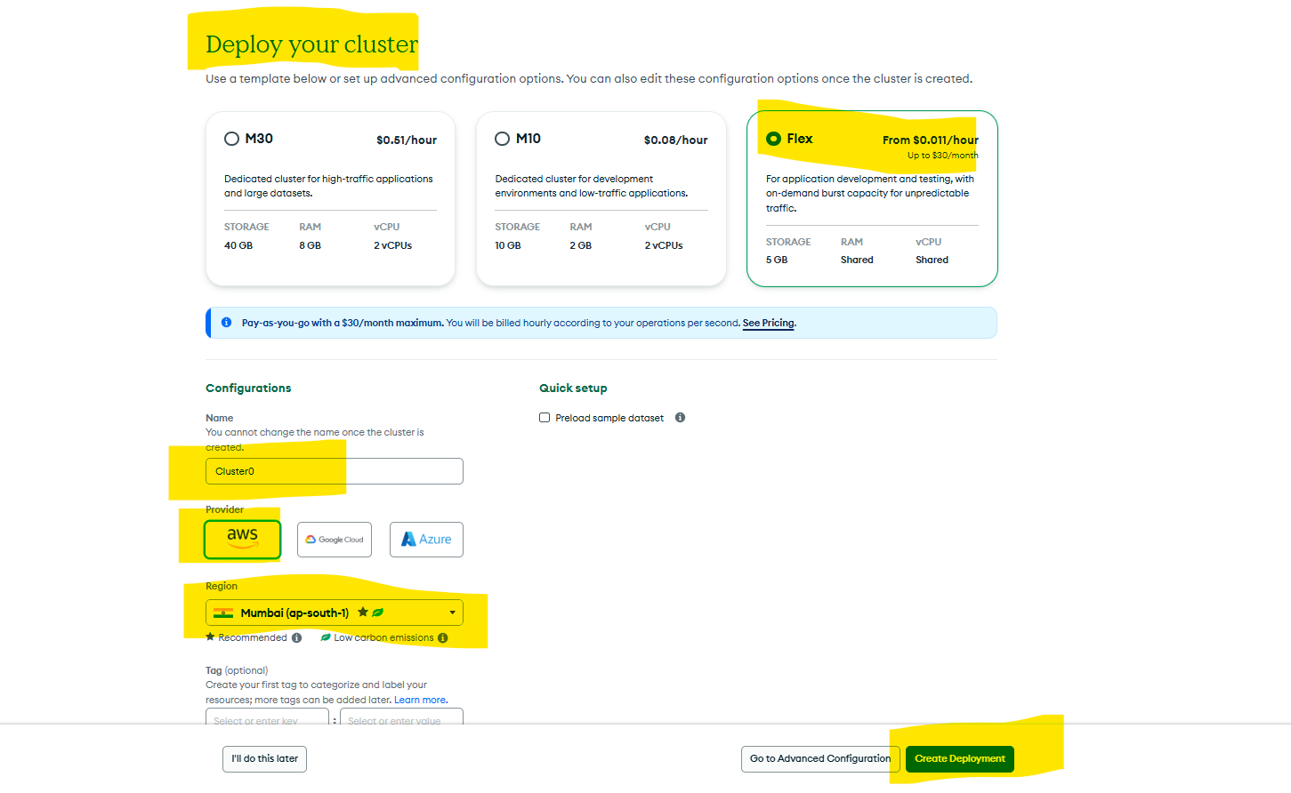

2. Click on connect inside cluster tab and there you can see multiple options to connect like get compass link or shell etc  
3. here im adding compasss for refernce

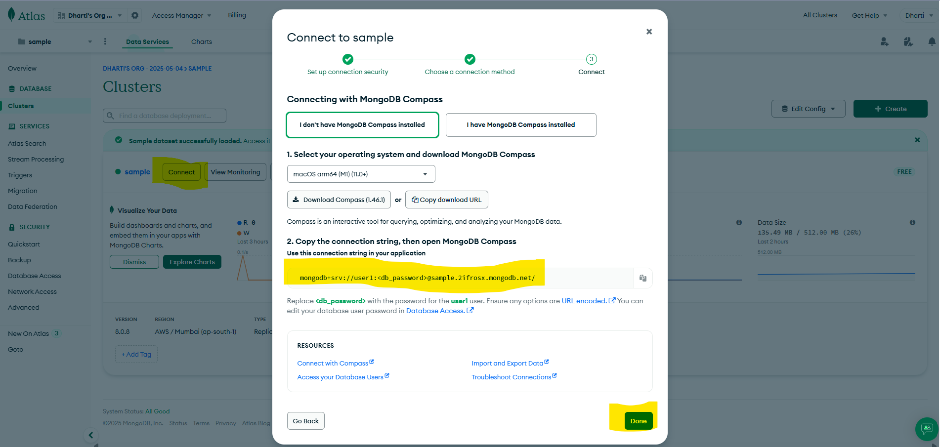

4. Copy link and paste into mongodb compass and you are good to go

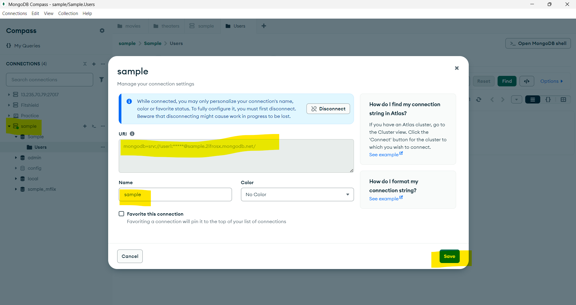

Done!!!!