1.What are the advantages of bootstrap?

Anybody with just basic knowledge of HTML and CSS can start using Bootstrap. Responsive features: Bootstrap's responsive CSS adjusts to phones, tablets, and desktops. Mobile-first approach: In Bootstrap, mobile-first styles are part of the core framework.

2. What is a bootstrap container and how does it work?

In Bootstrap, container is used to set the content's margins dealing with the responsive behaviors of your layout. It contains the row elements and the row elements are the container of columns (known as grid system). The container class is used to create boxed content.

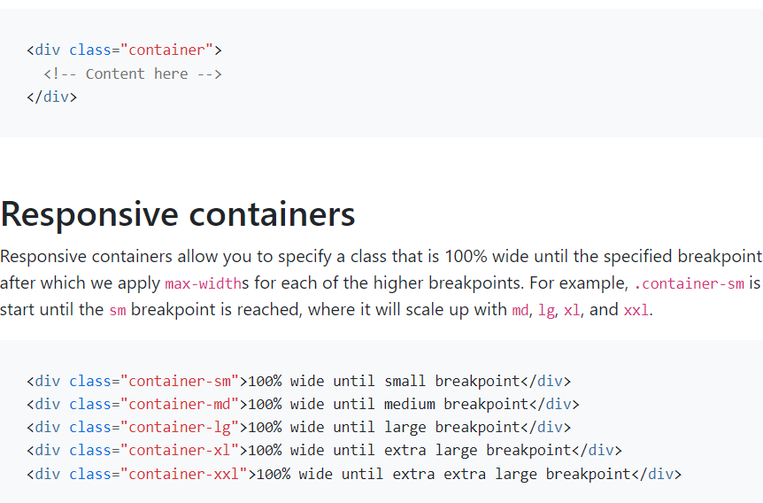

template

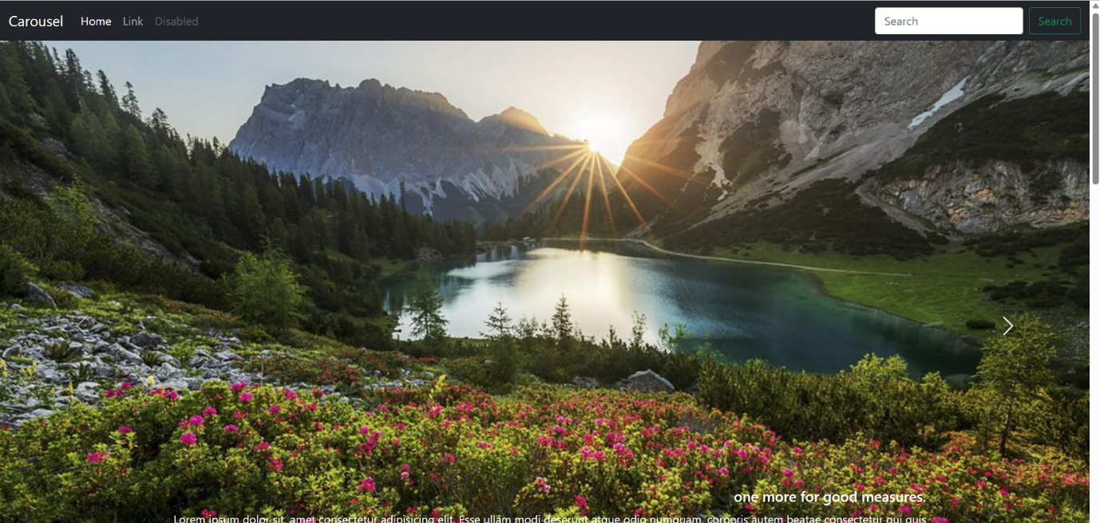

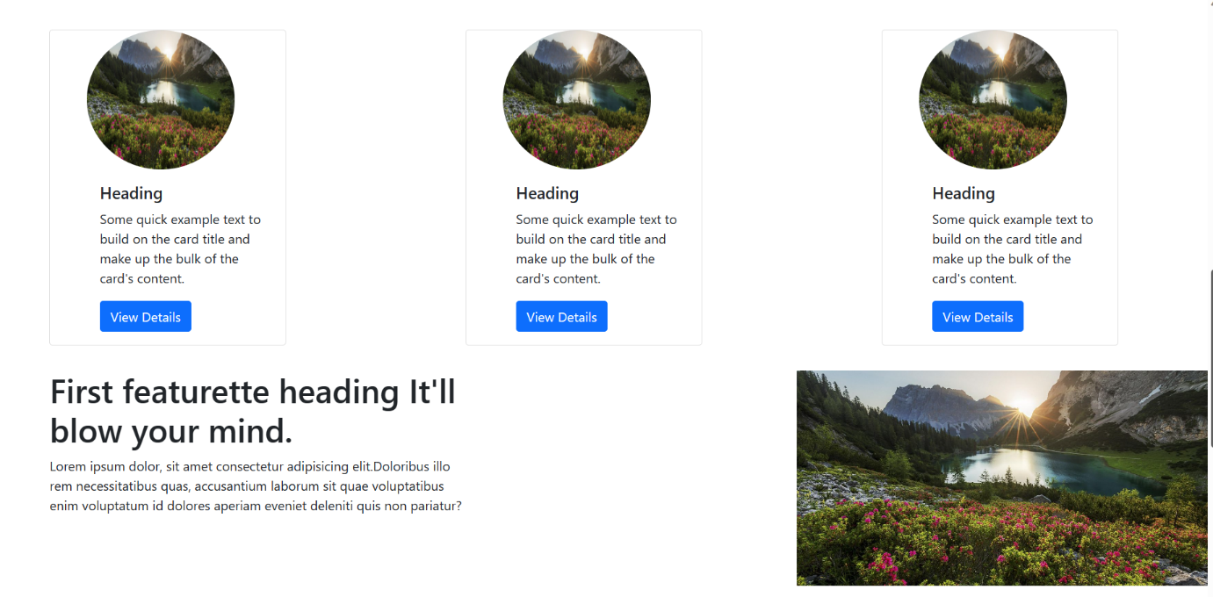

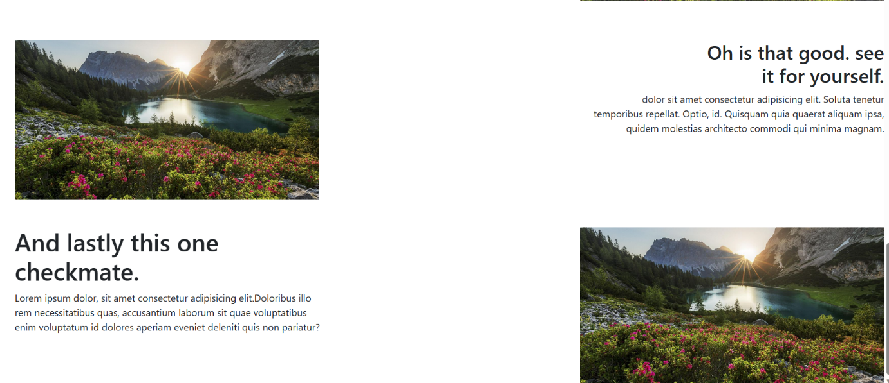

3. What are the default bootstrap text images?

Bootstrap 5 uses a default font-size of 1rem (16px by default), and its line-height is 1.5. In addition, all <p> elements have margin-top: 0 and margin-bottom: 1rem (16px by default).

4. What do you know about the bootstrap grid system?

Bootstrap's grid system uses a series of containers, rows, and columns to layout and align content. It's built with flexbox and is fully responsive.

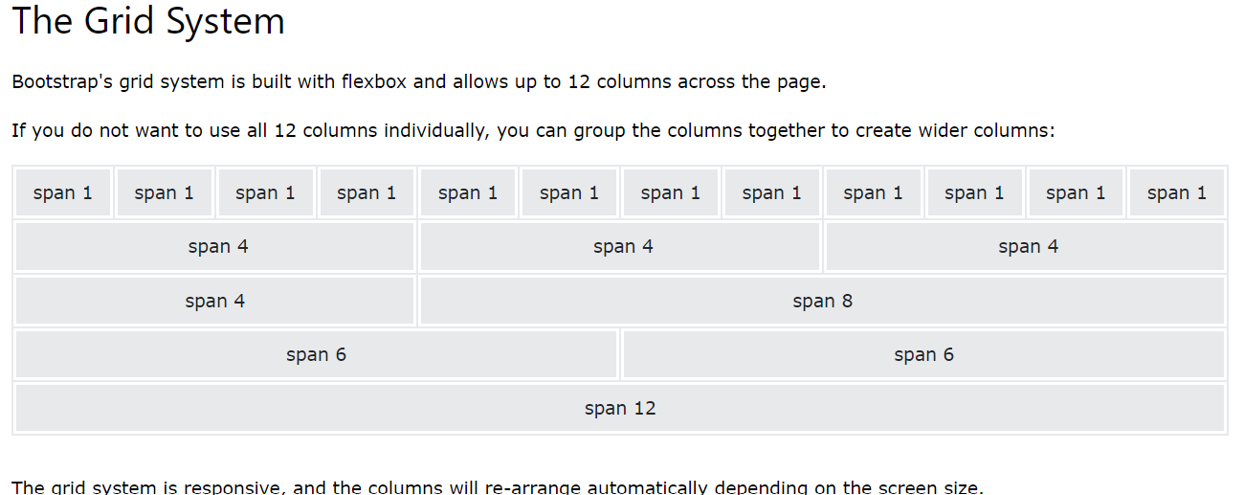

5. What is the difference between bootstrap4 & bootstrap5?

Bootstrap 5 has six levels: xs, sm, md, lg, xl, and xxl. Bootstrap 4 includes jquery and all associated plug-ins. Jquery has been deleted and replaced with vanilla JS and several functional plug-ins in Bootstrap 5. Bootstrap 4 provides a few colors for a web page.

6. What is button group and what is the class of basic button group?

Group a series of buttons together on a single line or stack them in a vertical column. On this page. Basic example. Mixed styles.

This is the basic syntax of the button group class where each button has its own class of Button.

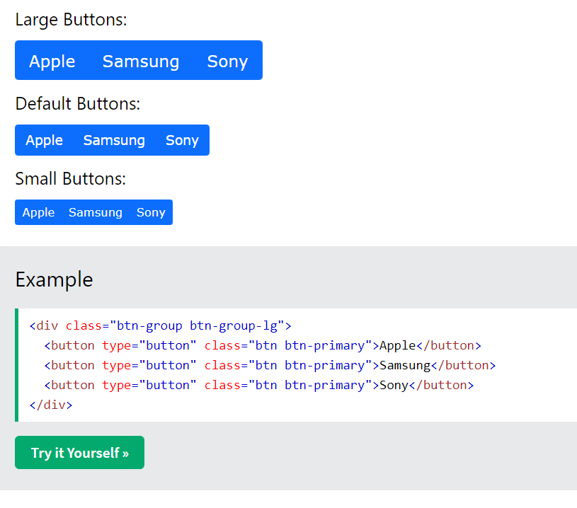

7 . How can you use bootstrap to make thumbnail ?

1. Add an <a> tag with the class of . thumbnail around an image.
2. This adds four pixels of padding and a gray border.
3. On hover, an animated glow outlines the image.

8. In bootstrap4 what is flexbox?

 Bootstrap 4 now uses flexbox, instead of floats, to handle the layout. The Flexible Box Layout Module, makes it easier to design flexible responsive layout structure without using float or positioning.

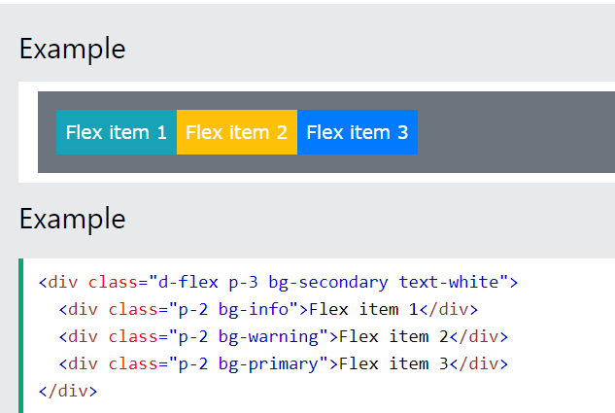

9. How can one create an alert button in

bootstrap?

1. Be sure you've loaded the alert plugin, or the compiled Bootstrap JavaScript.
2. If you're building our JavaScript from source, it requires util.js . ...
3. Add a dismiss button and the .alert-dismissible class, which adds extra padding to the right of the alert and positions the .close button.

10. What is a bootstrap card how would you create one?

Cards are built with as little markup and styles as possible, but still manage to deliver a ton of control and customization. Built with flexbox, they offer easy alignment and mix well with other Bootstrap components.

