

BAZE UNIVERSITY

DATA ANALYTICS CAPSTONE PROJECT

BY Haruna Muhammad

IDEAS/24/7581



**SECTION 1: ANALYSIS OF FEEDBACK THEMES**

In this section, we have examined and categorized the themes extracted from customer feedback provided in the dataset as:

**Categorization of Feedback Themes table**

|  |  |  |  |  |
| --- | --- | --- | --- | --- |
| **Delivery Issues** | **Product Quality** | **Customer Experience** | **Value for Money** | **Repurchase Intentions** |
| * Arrived late * Delays in delivery * Fast delivery * Quick shipping * Very fast service | * Color not as shown * Damaged on arrival * Excellent quality * Great product * I love it * Item as described * Mislabeled * Missing accessories * Not as described * Perfect fit * Poor packaging * Too expensive * Top notch | * Could be better * Exceeds expectations * Fantastic experience * Nice experience * Satisfied with my purchase * Very satisfied * Terrible support | * Good value for money * Not worth the money | * Do not recommend * Not recommended * Returning this item * Will returns * Will shop again * Won't buy again * Would buy again |

**The computed frequencies and percentages of the feedback themes**

**Table 1. The Analysis Feedback Theme Table**

|  |  |  |
| --- | --- | --- |
| Customer Feedback Theme | Frequency | Percentage |
| Quality Product | 479 | 38.47% |
| Customer Experience | 258 | 20.72% |
| Repurchase Intentions | 244 | 19.60% |
| Delivery Issues | 186 | 14.94% |
| Value for Money | 78 | 6.27% |

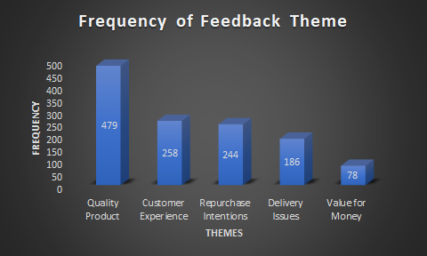

1. ***Bar Chart: Display the frequency of each theme***

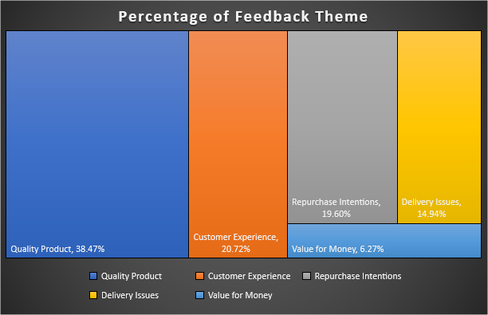

***Hierarchy Chart: Show the proportion of each theme relative to the total feedback***

**INSIGHT FROM THE ANALYSIS**

**Most Frequently Mentioned Themes:**

* Quality Product (38.47%): Emphasizes that product quality is crucial for customer satisfaction, with positive feedback reflecting happiness and negative indicating defects.
* Customer Experience (20.72%): Highlights the significance of overall customer interactions and ease during purchase.
* Repurchase Intentions (19.60%): Reflects customers’ willingness to buy again, with positive signals showing satisfaction and negative indicating discontent.

**Improvement Areas:**

* Delivery Issues (14.94%): Almost 15% of feedback highlights concerns like late deliveries and poor packaging. Enhancing these can greatly improve satisfaction.
* Value for Money (6.27%): Although mentioned less, perceived value is vital. Customers feeling the product is overpriced are less likely to buy again.

**Immediate Attention Needed:**

* Delivery Issues: Given the 15% feedback regarding delivery, this should be prioritized. Improving logistics will address these concerns.
* Value for Money: Competitive pricing and delivering on promises are crucial. A lack of perceived value can lead to decreased repurchase.

**Conclusion**  
Prioritize Quality and Customer Experience: Focus on “Quality Product” and “Customer Experience” to enhance loyalty.  
  
Enhance Delivery Process: Improving logistics and delivery quality is vital due to significant customer feedback.  
  
Ensure Competitive Pricing: Clearly communicate product value and keep prices reflective of quality to enhance brand perception and encourage repeat purchases.

**SECTION 2. SENTIMENT DISTRIBUTION**

This section was focused on analyzing the overall sentiment expressed in the feedback.

1. The Computed frequency and percentages of the sentiments as provided below in the table 2.

**Table 2: Sentiment Distribution**

|  |  |  |
| --- | --- | --- |
| Sentiment | Frequency | Percentage |
| Positive | 618 | 45% |
| Neutral | 370 | 27% |
| Negative | 370 | 27% |
| Total | 1358 | 100% |

1. **The visualization charts of the sentiment Distribution categories**
2. *Pie Chart shows the Visualized the proportion sentiments.*
3. *Bar Chart of the counted of sentiment type.*

The generated Insights from the analysis by assessing overall customer satisfaction and a prevalent sentiment in feedback.

**ANALYSIS INSIGHTS**

**Overall Customer Satisfaction**: The higher proportion of positive feedback (45.5%) indicates that most customers are satisfied with their experience. However, the fact that 27.2% of feedback is negative shows there is still room for improvement.

**Prevalent Sentiment**: The most prevalent sentiment is positive, indicating that a majority of customers have a favorable view.

**Balanced Neutral and Negative Feedback**: The nearly equal distribution of neutral and negative feedback (both at 27.2%) suggests that while some customers are indifferent, an equal number are dissatisfied. This balance may point towards specific areas needing attention.

**SECTION 3. SALES ANALYSIS BY REGION**

The analyzed 0f the sales data based on their geographic regions. This is to gain insight into the regional differences in total purchases and amounts.

|  |  |  |
| --- | --- | --- |
|  | **Table 3a: Analysis of No of Purchases by Region** | |
| **Region** | **Frequency** | **Percentage** |
| Latin America | 275 | 25.23% |
| Middle East & Africa | 259 | 20.50% |
| North America | 234 | 18.88% |
| Asia Pacific | 212 | 15.58% |
| Europe | 209 | 19.80% |

|  |  |  |  |
| --- | --- | --- | --- |
|  | **Table 3b: Analysis of Sales Amount by Region** | |  |
| **Region** | **Total Amount** | **Average Amount** | **Percentage of Total Sales Amount** |
| Latin America | $ 29,278.89 | 109.09% | 25.23% |
| Middle East & Africa | $ 23,793.91 | 94.13% | 20.50% |
| Europe | $ 22,981.23 | 112.67% | 19.80% |
| North America | $ 21,906.23 | 95.92% | 18.88% |
| Asia Pacific | $ 18,081.15 | 87.39% | 15.58% |

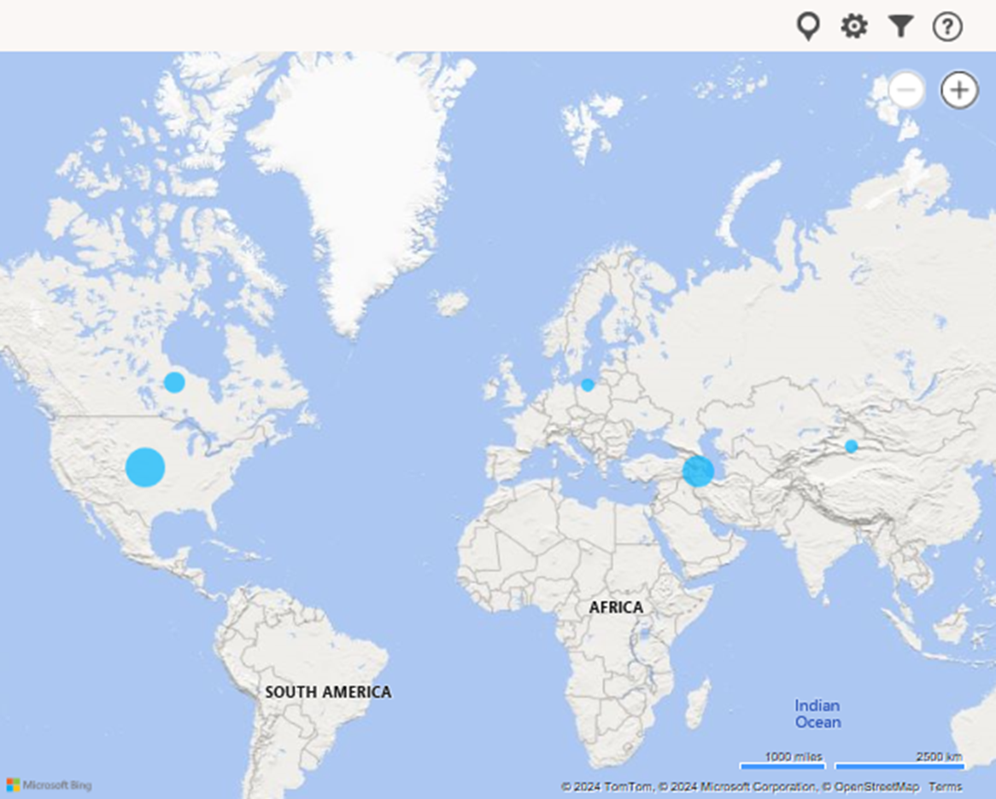

***Bar Chart: Compare the number of feedback entries from each region***

**Generated Insights from the Region Analysis**

**Regions with the Highest and Lowest Purchases**:

* **Highest Purchases**: Latin America (275 purchases) had the highest number of purchases.
* **Lowest Purchases**: Europe (209 purchases) had the lowest number of purchases.

**Regions with the Highest and Lowest Total Sales Amount**:

* **Highest Total Sales Amount**: Latin America also leads with a total sales amount of **$29,278.89**.
* **Lowest Total Sales Amount**: Asia Pacific had the lowest total sales amount of **$18,081.15**.

**Regional Trends and Specific Concerns**:

* **Latin America** is performing well both in terms of the number of purchases and the total sales amount.
* **Europe** shows lower engagement in both metrics, indicating a potential area for targeted marketing or promotional campaigns.
* **Asia Pacific** has a significant difference between its average sales amount and total sales amount, suggesting a need to investigate further into purchase sizes and potential market opportunities.

**Recommendations Based on Insights**:

* **Focus on Europe**: Implement targeted strategies to boost sales in Europe, such as localized promotions or product adjustments to better match consumer preferences.
* **Capitalize on Latin America**: Maintain or increase efforts in Latin America, as it shows strong engagement and sales performance.
* **Explore Opportunities in Asia Pacific**: Assess potential growth areas to enhance sales in Asia Pacific, considering its lower total sales amount despite a substantial number of purchases.

**SECTION 4. ANALYSIS OF CUSTOMER SEGMENTS**

This section examines feedback based on different customer segments with a view to understand how different customers purchased their goods

|  |  |  |
| --- | --- | --- |
| **Table 4: Analysis of by Customer Segment** | | |
| Customer Segment | Frequency | Percentage |
| Retail | 522 | 38.44% |
| Online Direct | 462 | 34.02% |
| Wholesale | 364 | 26.80% |
| Corporate Clients | 6 | 0.44% |
| Institutional Customers | 4 | 0.29% |

***Bar Chart: Compare the number of feedback entries by customer segment.***

*Pie Chart Display the percentage distribution of feedback across segments.*

* 1. **Deduce insights of the Customer Segment:**

**Most Vocal Segments:**

* Retail leads with 38.44% of feedback (522 instances).
* Online Direct follows at 34.02% (462 instances).
* Wholesale contributes 26.80% (364 instances).

**Least Vocal Segments:**

* Corporate Clients and Institutional Customers contribute minimal feedback at 0.44% and 0.29%.
* Segment-Specific Feedback Trends or Issues

**Retail Segment:**

* High feedback levels indicate strong engagement, likely due to diverse purchasing experiences.
* Key Issues: Product availability, pricing, customer service.

**Online Direct Segment:**

* Nearly matching Retail feedback suggests high customer engagement, typical in online platforms.
* Key Issues: Website usability, delivery times, product details.

**Wholesale Segment:**

* Significant feedback but less than Retail and Online Direct, indicating fewer issues or lower engagement.
* Key Issues: Bulk pricing, delivery logistics, stock availability.

**Corporate Clients and Institutional Customers:**

* Minimal feedback suggests low engagement or effective account management.
* Key Issues: Contract negotiations, bulk customization, long-term relations.

**Recommendation:**

* For Retail and Online Direct: Enhance customer experience and address feedback concerns.
* For Wholesale: Monitor feedback and develop mechanisms for latent issues.
* For Corporate and Institutional: Pursue alternative feedback channels to ensure prompt issue resolution and foster strong relationships.

**SECTION 5. DATA ANALYSIS BY SALES REPRESENTATIVE**

This section analyzed the different sales representatives to determine the certainty reps are associated with higher volume purchases.

|  |  |  |
| --- | --- | --- |
| **Table 5a: Analysis of by Sales Representative** | | |
| Sales Rep ID | Frequency | Percentage |
| REP001 | 106 | 7.81% |
| REP002 | 93 | 6.85% |
| REP003 | 105 | 7.73% |
| REP004 | 115 | 8.47% |
| REP005 | 99 | 7.29% |
| REP006 | 142 | 10.46% |
| REP007 | 104 | 7.66% |
| REP008 | 111 | 8.17% |
| REP009 | 135 | 9.94% |
| REP010 | 131 | 9.65% |
| REP011 | 33 | 2.43% |
| REP012 | 33 | 2.43% |
| REP013 | 2 | 0.15% |
| REP014 | 2 | 0.15% |
| REP015 | 2 | 0.15% |
| REP016 | 2 | 0.15% |
| REP017 | 44 | 3.24% |
| REP018 | 33 | 2.43% |
| REP019 | 33 | 2.43% |
| REP020 | 33 | 2.43% |

***Bar chart of purchase sales by Representative***

***Stacked Bar Chart*** *that shows the total representative of each purchases by different sales channels*

**Data Understanding**

**Table 5a: Sales Rep Analysis**Shows frequency and percentage of purchases by Sales Rep (Sales Rep ID).  
  
**Table 5b: Sales Rep & Channel Analysis**Breaks down purchases by Sales Rep across channels (Marketplace, Online Direct, Retail, Wholesale).  
  
**Insights:**  
**Top Performers:**

* REP006 tops with 142 purchases (Table 5a) and 129 in Table 5b.
* Other leaders: REP009 (135), REP010 (131), REP004 (115).

**Channel Insights:**

* REP006 excels in all channels, notably Online Direct and Retail.
* REP009 has balanced performance with a slight edge in Online Direct and Retail.

**Anomalies:**

* Reps like REP013, REP014, REP015, REP016 have very low purchases (2 each in Table 5a), indicating they may be new or errors in data.
* Additional review is necessary.

**Underperformers:**

* REP011, REP012, and REP017 need attention, as they lag behind top reps.  
    
  **Conclusions:**Visuals illustrate sales drivers and preferred channels, with low sales among some reps needing further investigation.

**SECTION 6. ANALYSIS OF BY PRODUCT CATEGORY**

The analysis of the data based on product categories. This should show the determination of which types of products are receiving the most attention and identify any category-specific issues.

|  |  |  |
| --- | --- | --- |
| **Table 6: Analysis of purchases by Product Category** | | |
| Product Category | Frequency | Percentage |
| Automotive | 12 | 0.88% |
| Automotive Parts | 3 | 0.22% |
| Baby Products | 22 | 1.62% |
| Books & Media | 202 | 14.87% |
| Electronics | 272 | 20.03% |
| Fashion | 235 | 17.30% |
| Fitness Equipment | 3 | 0.22% |
| Groceries | 10 | 0.74% |
| Health & Beauty | 205 | 15.10% |
| Home Appliances | 77 | 5.67% |
| Home Décor | 60 | 4.42% |
| Home Security | 3 | 0.22% |
| Jewelry | 3 | 0.22% |
| Musical Instruments | 3 | 0.22% |
| Office Supplies | 10 | 0.74% |
| Sports & Outdoors | 210 | 15.46% |
| Tools & Home Improvement | 10 | 0.74% |
| Wearables | 18 | 1.33% |

***Bar chart of Product category by frequency***

***Pie chart of Product category by percentage***

**Insights**

1. High-Performance Categories:    
   Electronics (20.03%), Books & Media (14.87%), and Health & Beauty (15.10%) show strong consumer interest.  
     
   2. Moderate-Potential Categories:    
   Fashion (17.30%) and Sports & Outdoors (15.46%) have good engagement and marketing opportunities.  
     
   3. Low-Performance Categories:    
   Automotive Parts, Fitness Equipment, Home Security, Jewelry, and Musical Instruments show low purchase frequencies.

**Recommendations**  
1. Increase Marketing:    
Target campaigns for Electronics, Fashion, Sports & Outdoors, and Health & Beauty.  
  
2. Evaluate for Discontinuation:    
Consider discontinuing or revising Automotive Parts, Fitness Equipment, Home Security, Jewelry, and Musical Instruments.  
  
3. Gather Customer Feedback:    
Use surveys to understand preferences.  
  
4. Innovate Products:    
Develop new offerings in low-performance categories based on trends.

**SECTION 7. SALES ANALYSIS BY PRODUCT NAME**

This section is the analysis of purchases related to specific product names. This will help in understanding how individual products are performing.

|  |  |  |
| --- | --- | --- |
| **Table 7a: Sales Analysis by Product Name** | | |
| Products Name | Frequency | Percentage |
| Widget A: (Electronics and Gadgets) | 314 | 23.12% |
| Widget K: (Miscellaneous and General Products) | 203 | 14.95% |
| Widget C: (Fashion and Accessories) | 176 | 12.96% |
| Widget D: (Personal Care) | 159 | 11.71% |
| Widget E:( Outdoor and Sports) | 148 | 10.90% |
| Widget F: (Books and Literature) | 141 | 10.38% |
| Widget B: (Home and Living) | 117 | 8.62% |
| Widget G: (Home Appliances) | 44 | 3.24% |
| Widget H: (Tools and Equipment) | 32 | 2.36% |
| Widget I: (Baby and Child) | 21 | 1.55% |
| Widget J:( Office Supplies) | 3 | 0.22% |

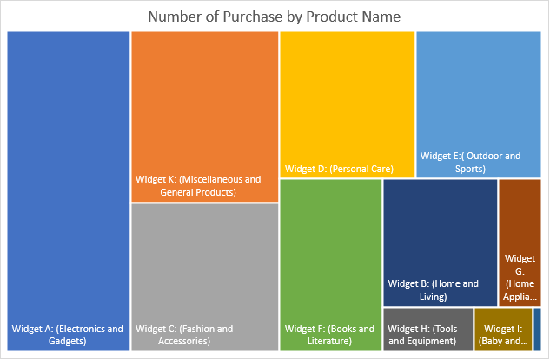

***Number of Purchase by Product Name***

|  |  |  |  |
| --- | --- | --- | --- |
| **Table 7b: Analysis by Sales Channel and Product Name** | | | |
| Sales Channel | Products Name | Frequency | Percentage |
| Marketplace | Widget A: (Electronics and Gadgets) | 314 | 23.12% |
| Marketplace | Widget K: (Miscellaneous and General Products) | 203 | 14.95% |
| Online Direct | Widget C: (Fashion and Accessories) | 176 | 12.96% |
| Retail | Widget D: (Personal Care) | 159 | 11.71% |
| Online Direct | Widget E:( Outdoor and Sports) | 148 | 10.90% |
| Online Direct | Widget F: (Books and Literature) | 141 | 10.38% |
| Marketplace | Widget B: (Home and Living) | 117 | 8.62% |
| Marketplace | Widget G: (Home Appliances) | 44 | 3.24% |
| Wholesale | Widget H: (Tools and Equipment) | 32 | 2.36% |
| None | Widget I: (Baby and Child) | 21 | 1.55% |
| Wholesale | Widget J:( Office Supplies) | 3 | 0.22% |



1. ***Word Cloud: Display frequently mentioned products in analysis***

**INSIGHTS FROM THE TABLE**

1. Top-Selling Products:

* Widget A: Electronics led with 314 units (23.12%).
* Widget K: Miscellaneous followed with 203 units (14.95%).
* Widget C: Fashion sold 176 units (12.96%).

1. Lowest-Selling Products:

* Widget J: Office Supplies had 3 units (0.22%).
* Widget I: Baby Products sold 21 units (1.55%).
* Widget H: Tools totaled 32 units (2.36%).

1. Sales Channel Insights:

* Marketplace excelled with Widgets A and K, showing a preference for diverse products.
* Online Direct did well with Widget C and F.
* Retail had average sales for Widget D but trailed behind.
* Wholesale struggled, especially with Widgets H and J.

**Recommendations:**

Promote to Front Shelves:

* Widget A: High demand in Electronics.
* Widget C: Popular Fashion, consider promotions.
* Widget K: Broad appeal Miscellaneous products.

**Reassess Low Demand Products:**

* Widget J: Low sales, should be less prominent.
* Widget I: Needs better marketing or relocation.
* Widget H: Could benefit from niche marketing.

**Additional Suggestions:**

* Focus Online Sales: Boost visibility for Fashion and Books.
* Enhance Marketing for Low Sellers: Promote Widgets J, I, and H to clear inventory.

**SECTION 8. ANALYSIS OF BY SALES CHANNEL**

This section looks at sales channels to identify how most customers purchase the products available.

|  |  |  |
| --- | --- | --- |
| **Table 8a: Analysis of by Sales Channel** | | |
| Sale Channel | Frequency | Percentage |
| Direct | 342 | 27.47% |
| Online | 313 | 25.14% |
| Offline | 310 | 24.90% |
| Wholesale | 280 | 22.49% |
|  |  |  |

***Bar chart of Sale Channel by frequency***

|  |  |  |  |
| --- | --- | --- | --- |
| **Table 8b: Analysis of customer general feedback across the different channels, identify if the most common feedbacks for sales reps are negative, positive or neutral** | | | |
| **Feedback** | **Sale Channel** | **Frequency of Feedback** | **Percentage of Feedback** |
| Negative | Direct | 88 | 7.07% |
| Online | 89 | 7.15% |
| Offline | 85 | 6.83% |
| Wholesale | 75 | 6.02% |
| Negative Total |  | 337 | 27.07% |
| Neutral | Direct | 93 | 7.47% |
| Online | 88 | 7.07% |
| Offline | 96 | 7.71% |
| Wholesale | 78 | 6.27% |
| Neutral Total |  | 355 | 28.51% |
| Positive | Direct | 161 | 12.93% |
| Online | 136 | 10.92% |
| Offline | 129 | 10.36% |
| Wholesale | 127 | 10.20% |
| Positive Total |  | 553 | 44.42% |

### 

### *****Pie chart of Customer Feedback by Representatives*****

1. **Sales Channel Performance Analysis    
   Insights:**

* Direct Sales leads at 27.47%.
* Online (25.14%) and Offline (24.90%) are nearly tied.
* Wholesale Sales lags at 22.49%.

Direct is best, Wholesale shows minor changes.

1. Customer Feedback Trends    
   **Negative Feedback:**

* Online has the highest negative feedback (7.15%).
* Direct (7.07%) and Offline (6.83%) also show notable levels.
* Wholesale has the least (6.02%).  
    
  **Neutral Feedback:**
* Offline (7.71%) leads, followed by Direct (7.47%).
* Wholesale has the least (6.27%).  
    
  **Positive Feedback:**
* Direct has the highest positive feedback (12.93%).
* Online (10.92%), Offline (10.36%), and Wholesale (10.20%) follow.

1. Overall Channel Insights    
   **Direct Sales:**

* Strengths: Best sales and positive feedback. Low negatives.
* Needs: Address 7.07% negative feedback.  
    
  **Online Sales:**
* Strengths: Strong sales and positive feedback.
* Needs: Reduce high negative feedback.  
    
  **Offline Sales:**
* Strengths: Good positive feedback and steady sales.
* Needs: Minimize neutral feedback.  
    
  **Wholesale Sales:**
* Strengths: Lowest negatives.
* Needs: Boost sales and positive feedback.

4. Improvement Recommendations

**Direct:**

* Investigate negative feedback.
* Online: Enhance website and customer support.
* Offline: Improve engagement.
* Wholesale: Train clients and strengthen ties.

**Strategic Recommendations**:    
Institute customer feedback systems, target marketing for underperforming channels, prioritize staff training, and merge online/offline experiences for better satisfaction.

**SECTION 9. ANALYSIS OF RETURN STATUS**

This section is to assess the impact of returns on overall customer satisfaction and identify any trends.

|  |  |  |  |  |
| --- | --- | --- | --- | --- |
| **Table 9: Analysis of Return Status** | | | | |
| **Return Status** | **sale Rep** | **Frequency** | **Percentage** | **Percentage out of all Feedback** |
| No Return |  | **389** | **31.24%** |  |
| Negative | 112 | 9.00% | 100.00% |
| Neutral | 103 | 8.27% | 91.96% |
| Positive | 174 | 13.98% | 155.36% |
| Pending Return |  | **420** | **33.73%** |  |
| Negative | 109 | 8.76% | 100.00% |
| Neutral | 131 | 10.52% | 120.18% |
| Positive | 180 | 14.46% | 165.14% |
| Returned |  | **436** | **35.02%** |  |
| Negative | 116 | 9.32% | 100.00% |
| Neutral | 121 | 9.72% | 104.31% |
| Positive | 199 | 15.98% | 171.55% |

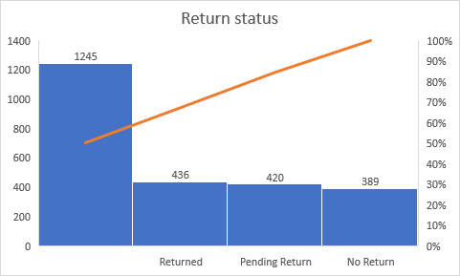

***Bar Chart of return status***

**Insights:**

1. Impact of Return Status on Customer Feedback:

* No Return (31.24% of feedback): Positive feedback (13.98%) exceeds negative (9.00%) and neutral (8.27%). Customers not returning items are significantly more positive (over 55% more) than neutral.
* Pending Return (33.73% of feedback): Positive feedback (14.46%) is highest, but neutral (10.52%) and negative (8.76%) are notable. This implies uncertainty during returns leads to mixed feedback, though positive still prevails.
* Returned (35.02% of feedback): Positive feedback (15.98%) is the highest here, though negative feedback (9.32%) is slightly more common than in other categories. Overall, customers remain generally satisfied despite returns.2. Correlation Between Return Status and Feedback: **Positive Feedback**: Each return status shows positive feedback leading, especially in the "Returned" group (15.98%). **Negative Feedback:** This is low overall, highest in the "Returned" category (9.32%), likely due to dissatisfaction with returned items.Neutral Feedback: Notably high in "Pending Return" (10.52%), indicating customer uncertainty during this phase. **General Trends:**Positive feedback increases across all return statuses, with "Returned" group surpassing "No Return." The highest negative feedback is in "Returned," possibly due to product quality or return processes. **Recommendations to Improve Sales Channels:**Improve the Return Process: Streamlining returns can boost customer satisfaction and minimize negative feedback since returners still provide considerable positive feedback.Enhance Communication During Pending Returns: Clear updates during returns can reduce uncertainty, shifting neutral feedback to positive.Focus on Customer Retention Post-Return: Targeting returning customers with personalized offers can enhance loyalty and lessen the impact of returns.Address Negative Feedback in Returned Category: Understanding and improving the reasons behind returns can further decrease negative feedback.

**Conclusion:**

Return status affects feedback, with positive ratings generally higher across categories. However, increased negative feedback in pending and returned categories indicates areas needing better communication and processes.

**SECTION 10. PRICE ANALYSIS**

In this section, we are analyzing product prices to understand their impact on customer feedback. This is to evaluate how pricing affects the frequency and nature of feedback.

|  |  |  |  |
| --- | --- | --- | --- |
| **Table 10: Price Analysis** | | |  |
| **Product** | **Average Price** | **Highest Price** | **Lowest Price** |
| Widget H: (Tools and Equipment) | $ 312.03 | $ 400.00 | $ 10.00 |
| Widget A: (Electronics and Gadgets) | $ 153.62 | $ 1,500.00 | $ 1.84 |
| Widget I: (Baby and Child) | $ 140.95 | $ 325.00 | $ 20.00 |
| Widget J: (Office Supplies) | $ 115.00 | $ 195.00 | $ 20.00 |
| Widget E: (Outdoor and Sports) | $ 106.72 | $ 400.00 | $ 9.95 |
| Widget B: Home and Living | $ 93.79 | $ 780.00 | $ 15.00 |
| Widget G: (Home Appliances) | $ 92.00 | $ 130.00 | $ 20.00 |
| Widget C: (Fashion and Accessories) | $ 72.50 | $ 400.00 | $ 8.00 |
| Widget K: (Miscellaneous and General Products) | $ 71.24 | $ 650.00 | $ 7.00 |
| Widget D: (Personal Care) | $ 30.77 | $ 400.00 | $ 2.72 |
| Widget F: (Books and Literature) | $ 26.66 | $ 120.00 | $ 5.00 |

***Bar Chart average price by products***

***Line chart between price, feefback and feedback frequency***

**Insights on Product Pricing and Customer Feedback:**  
**1. Price Effects on Feedback Themes:**

* Quality Product (38.47%): Higher-priced items like Widget A ($153.62 avg.) attract strong quality feedback, while lower-priced ones like Widget F ($26.66) receive quality comments with lower expectations.
* Customer Experience (20.72%): Higher-priced products, like Widget B ($780), often provide better shopping experiences, while lower-priced items focus on functionality.
* Repurchase Intentions (19.60%): Affordable products like Widget C ($72.50) encourage repeat purchases when customers are satisfied; high-priced items need to demonstrate value to encourage repurchases.
* Delivery Issues (14.94%): All price ranges can face delivery complaints, but higher-priced products face more scrutiny if delivery falls short.
* Value for Money (6.27%): Lower-priced goods are viewed as good value; higher-priced items must justify their cost to avoid negative feedback.

1. Does Price Influence Positive Feedback? Higher-priced goods prioritize quality and require excellent performance for positive reviews, while lower-priced items often gain favor for affordability and satisfaction.

**Summary:**

High-priced products generate quality feedback but risk dissatisfaction if expectations aren't met; lower-priced products are often seen as valuable, encouraging positive reviews and repurchase.

**SECTION 11. DISCOUNT ANALYSIS**

This section focuses on analyzing discount rates and identify trends related to discount rates.

|  |  |
| --- | --- |
| **Table 11: Discount Analysis** |  |
| Product | Discount Rate |
| **Widget K: (Miscellaneous and General Products)** | **3%** |
| **Widget B: Home and Living** | **2%** |
| **Widget C: (Fashion and Accessories)** | **3%** |
| **Widget D: (Personal Care)** | **3%** |
| **Widget E: (Outdoor and Sports)** | **2%** |
| **Widget F: (Books and Literature)** | **4%** |
| **Widget A: (Electronics and Gadgets)** | **3%** |
| **Widget G: (Home Appliances)** | **3%** |
| **Widget H: (Tools and Equipment)** | **5%** |
| **Widget I: (Baby and Child)** | **3%** |
| **Widget J: (Office Supplies)** | **3%** |

***Bar chart of Discount Rate***

***Chart of discount rate by widget***

### Insights from the visualizations:

**Insights from the visualizations:**1. Impact of Discount Rates on Sales:    
The bar chart indicates that Widget H (Tools and Equipment) has the highest discount at 5%, followed by Widget F (Books and Literature) at 4%. These higher discounts may signal promotional efforts to boost sales. Widgets K, C, and J, with moderate 3% discounts, maintain a steady discount strategy, while lower discount products like Widget B (Home and Living) and Widget E (Outdoor and Sports) have 2% discounts, possibly due to premium pricing.    
  
2. Effect of Discounts on Sales Rep Feedback:    
Higher discounts can enhance positive feedback if perceived as good value. Widget H's larger discount may drive sales and feedback on value and quality. Conversely, lower-discount products need strong quality or branding to maintain positive feedback. Discount tracking shows fluctuations, particularly for Widget F and H, indicating alignment with promotions.    
  
3. Customer Feedback Relation:    
Widgets with higher discounts, like H, may gain better "Value for Money" feedback, while lower-discount items like E may depend more on quality for satisfaction.    
  
4. Potential Trends:    
Consistent discounts for Widgets C, A, and J suggest stable sales strategies, balancing profitability and competitiveness.

**SECTION 12. PROFIT MARGIN ANALYSIS**

This section is to determine if there is a correlation between profit margins and feedback sentiment or frequency.

|  |  |  |  |
| --- | --- | --- | --- |
| **Table 12: Profit Margin Analysis** | | | |
| Product | Cost Price | Selling Price | Margin Price |
| Widget K: (Miscellaneous and General Products) | 14818.7 | 11157 | 3661.703 |
| Widget B: Home and Living | 10597.81 | 7702 | 2895.807 |
| Widget C: (Fashion and Accessories) | 12759.51 | 8225 | 4534.51 |
| Widget D: (Personal Care) | 4891.68 | 3046 | 1845.68 |
| Widget E: (Outdoor and Sports) | 15795.01 | 10720 | 5075.013 |
| Widget F: (Books and Literature) | 3759.531 | 2462 | 1297.531 |
| Widget A: (Electronics and Gadgets) | 48084.18 | 35159 | 12925.18 |
| Widget G: (Home Appliances) | 4047.979 | 2740 | 1307.979 |
| Widget H: (Tools and Equipment) | 9985 | 6275 | 3710 |
| Widget I: (Baby and Child) | 2960 | 2265 | 695 |
| Widget J: (Office Supplies) | 345 | 265 | 80 |

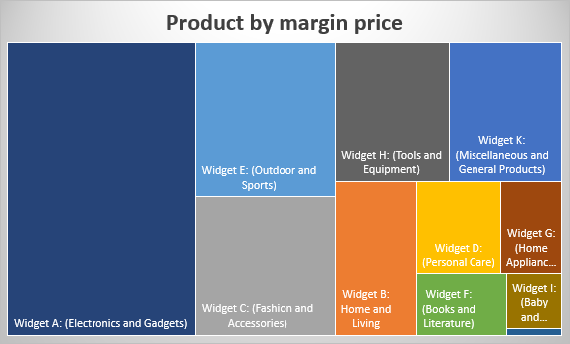

***Chart of product by margin price***

***Relationship between margin and customer feedback***

### Insights on Profit Margins and Customer Feedback:

**Higher-Margin Products:**These products tend to generate feedback centered on quality and experience, with negative feedback arising if perceived value does not match the cost.  
  
Lower-Margin Products:  
Conversely, they may receive positive feedback for value, especially if functionality meets expectations at a lower price, although they may be critiqued for minimal features.  
  
Conclusion:  
Profit margins affect feedback types; higher-margin products face scrutiny for not meeting high expectations, while lower-margin products often gain praise for affordability and basic functionality.

**SUMMARY**

1. Prioritization for Improvement:

* Focus on enhancing product quality and customer experience to build loyalty.
* Improve delivery logistics in response to customer feedback.
* Maintain competitive pricing, ensuring product value is clear to encourage repeat purchases.

1. Customer Satisfaction:

* A majority (45.5%) of customer feedback is positive, but 27.2% is negative, indicating areas for improvement.
* The distribution of neutral (27.2%) and negative feedback suggests some customers are indifferent while others are dissatisfied.

1. Regional Performance:

* Latin America leads in purchases (275) and total sales ($29,278.89).
* Europe has the lowest purchases (209) and total sales ($18,081.15), indicating a need for targeted marketing.
* The Asia Pacific region shows disparity between average sales and total amount, suggesting further investigation is needed.

1. Feedback by Segments:

* The Retail segment provides the most feedback (38.44%).
* Corporate Clients and Institutional Customers offer very little feedback, indicating potential satisfaction or lack of engagement.
* Key issues identified: product availability, pricing, website usability, and delivery logistics.

1. Sales Insights:

* High-performing categories include Electronics, Books & Media, and Health & Beauty.
* Fashion and Sports & Outdoors show moderate potential, while categories like Automotive Parts and Jewelry perform poorly.

1. Selling Trends:

* Widget A (Electronics) is the best seller, while Widget J (Office Supplies) is the lowest.
* Different sales channels show varying performances, with Direct Sales scoring highest in positive feedback and value perceptions.

1. Feedback Trends:

* Online Sales have the highest negative feedback (7.15%) but are strong in overall sales.
* Wholesale Sales experience the least negative feedback yet need improvement in sales performance.

1. Improvement Recommendations:

* Address negative feedback across all channels.
* Enhance website functionality and customer support for online sales.
* Increase engagement in offline sales.
* Foster relationships in wholesale channels to boost sales and feedback quality.

1. Discount Impact:

* Discounts can enhance perceived value; higher discounts may boost sales but can lead to scrutiny of quality in higher-priced items.
* Stable discount strategies are observed for certain widgets, balancing competitiveness with profitability.

Overall, these insights indicate strengths in customer satisfaction and regional performance in Latin America, while highlighting critical areas for improvement in Europe and the need for targeted strategies across segments and channels to enhance customer loyalty and brand perception.