CC2

QUESTION 1

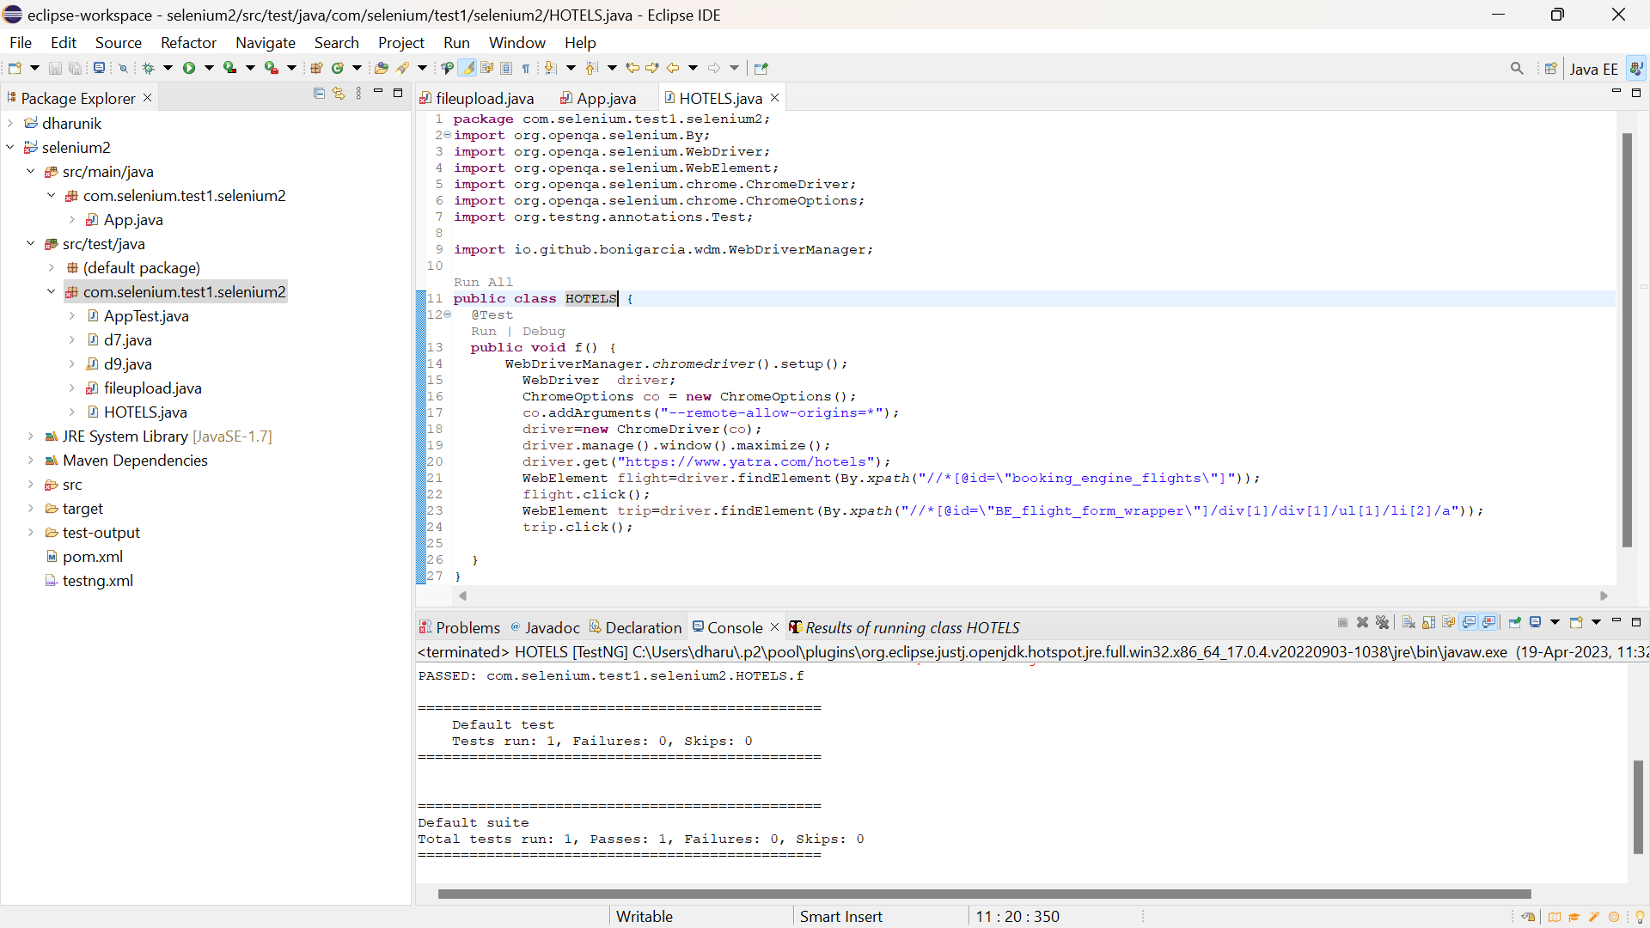

**package** com.selenium.test1.selenium2;

**import** org.openqa.selenium.By;

**import** org.openqa.selenium.WebDriver;

**import** org.openqa.selenium.WebElement;

**import** org.openqa.selenium.chrome.ChromeDriver;

**import** org.openqa.selenium.chrome.ChromeOptions;

**import** org.testng.annotations.Test;

**import** io.github.bonigarcia.wdm.WebDriverManager;

**public** **class** HOTELS {

@Test

**public** **void** f() {

WebDriverManager.*chromedriver*().setup();

WebDriver driver;

ChromeOptions co = **new** ChromeOptions();

co.addArguments("--remote-allow-origins=*");

driver=**new** ChromeDriver(co);

driver.manage().window().maximize();

driver.get("https://www.yatra.com/hotels");

WebElement flight=driver.findElement(By.*xpath*("//*[@id=\"booking_engine_flights\"]"));

flight.click();

WebElement trip=driver.findElement(By.*xpath*("//*[@id=\"BE_flight_form_wrapper\"]/div[1]/div[1]/ul[1]/li[2]/a"));

trip.click();

}

}