IoT-Based Heart Rate And SpO2 Monitoring System
123ec0038
R. Venkata Dharun Reddy
- Introduction
The IoT-based Heart Rate Monitoring System is designed to measure heart rate and SpO₂ levels in real time. The system uses sensors to collect data, which is then processed and transmitted to a cloud-based platform for remote monitoring. Additionally, an alarm system is integrated to alert users when abnormal readings are detected.
2. Objectives
- To develop a real-time heart rate and SpO₂ monitoring system.
- To store and analyze data using ThingSpeak.
- To trigger an alarm when predefined threshold values are exceeded.
3. Components Used
- MAX30102 Pulse Oximeter and Heart Rate Sensor
- Raspberry Pi
- ThingSpeak Cloud Platform
4. Methodology
- The MAX30100 sensor captures heart rate and SpO₂ readings.
- The Raspberry PI processes the data and uploads it to ThingSpeak using a Secure Access System Implemented with JWT.
- The stored data can be accessed via a web dashboard for analysis on Thingspeak which is also plotted using matplotlib to show the real time plot of Pulse Rate and SpO2.
5. Implementation
- Hardware Setup: Components were soldered and assembled for stable connections.
- Software Development: The system was programmed using Raspberry Pi with libraries for sensor data acquisition and Wi-Fi connectivity.
- Cloud Integration: Data was transmitted to ThingSpeak for real-time monitoring and visualization.
- Secure Access: The project uses JWT which helps in blocking unauthorized access to the data using transportation.
- Plots and Analysis: Matplotlib is used to plot the graph on the terminal too for offline access.
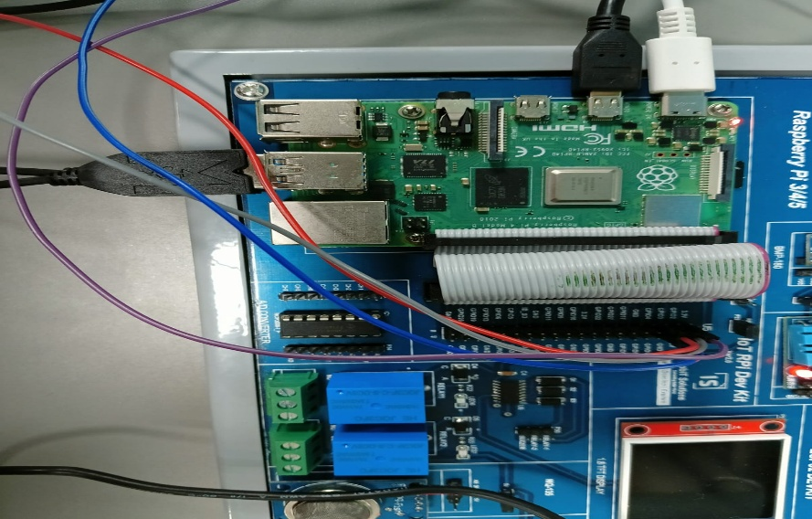
6. Results and Observations
- The system successfully measured heart rate and SpO₂ levels in real time.
- Data was uploaded to ThingSpeak and visualized through live graphs.
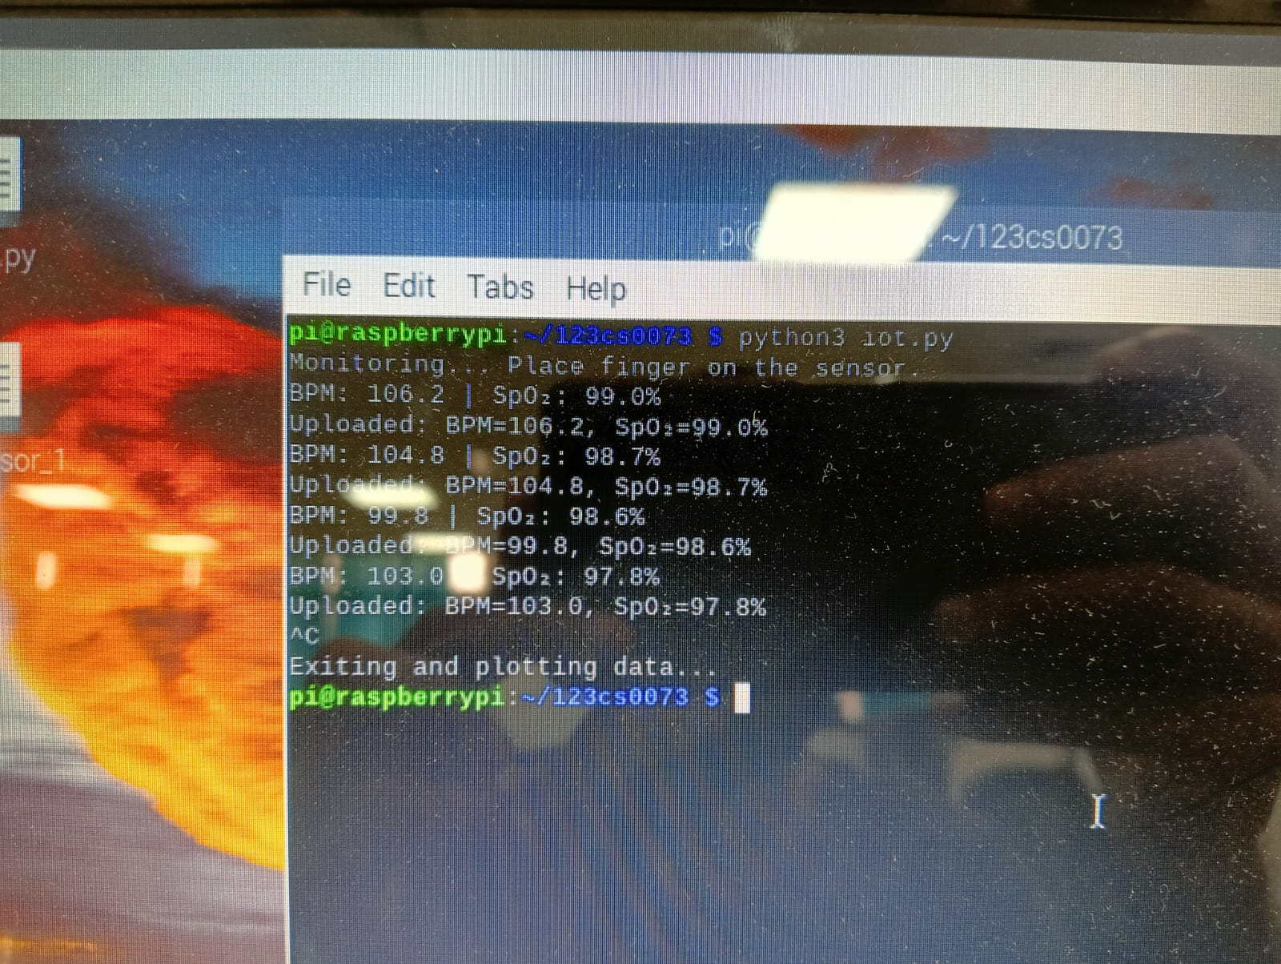
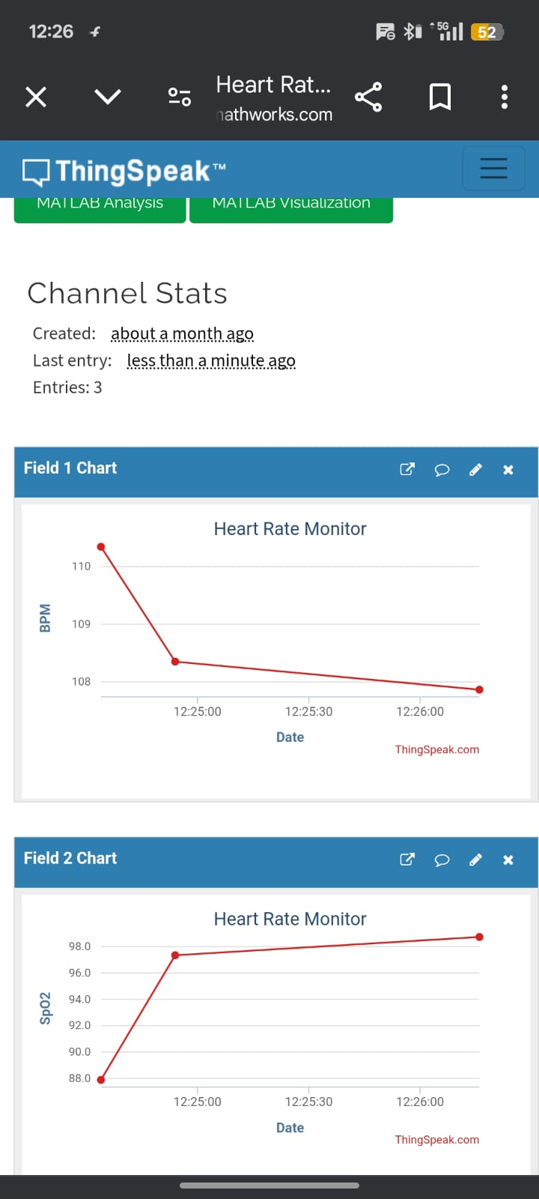
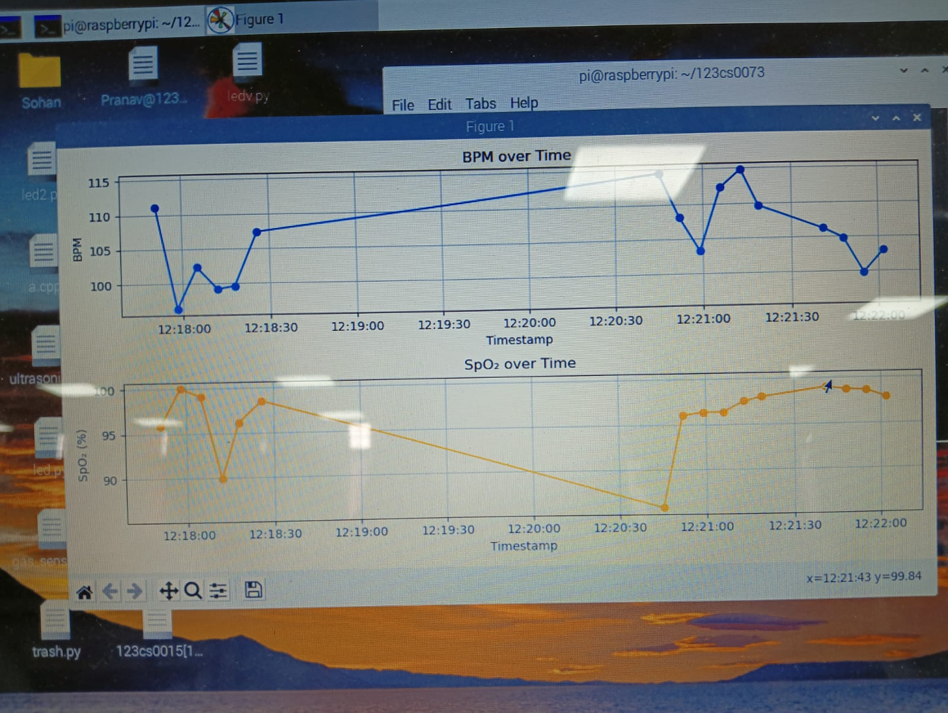

7. Conclusion
The IoT-based Heart Rate Monitoring System provides a cost-effective and efficient solution for real-time health monitoring. With further enhancements, such as mobile app integration and enhanced accuracy, the project has potential applications in healthcare and remote patient monitoring.
8. Future Scope
Integration with a mobile application for user notifications.
Addition of temperature and ECG monitoring.
Improved sensor accuracy and power optimization.

