**DA Assignment**

*- Dharun VS* ***20AD09****, Harish Khumar* ***20AD56***

**Introduction**

**Statistics**

***Statistics*** is the discipline that concerns the collection, organization, analysis, interpretation, and presentation of data. In applying statistics to a scientific, industrial, or social problem, it is conventional to begin with a statistical population or a statistical model to be studied.

**Hypothesis test**

A statistical ***hypothesis test***is a method of statistical inference used to decide whether the data at the hand sufficiently supports a hypothesis. Hypothesis testing allows the researcher to determine whether the data from the sample is statistically significant. Hypothesis testing is one of the most important processes for measuring the validity and reliability of outcomes in any systematic investigation.

The ***null hypothesis*** is a typical statistical theory which suggests that no statistical relationship and significance exists in a set of given single observed variable, between two sets of observed data and measured phenomena.

*The* ***alternative hypothesis*** is one of the proposed proposition in the hypothesis test.

A ***z-test*** is a statistical test to determine whether two population means are different when the variances are known and the sample size is large. A z-test is a hypothesis test in which the z-statistic follows a normal distribution. A z-statistic, or z-score, is a number representing the result from the z-test.

**Data-set study**

**Data will be updated weekly**

The data-set describes Russian and Ukrainian Equipment Losses During The 2022 Russian Invasion Of Ukraine.

The data-set was created based on Oryx by scraping Ukrainian losses and Russian losses pages.

This list only includes destroyed vehicles and equipment of which photo or video-graphic evidence is available. Therefore, the amount of equipment destroyed is significantly higher than recorded. You can find numbers here 2022 Ukraine Russia War Data-set.

Data includes Equipment Losses, Equipment Models, Countries that produce Equipment, the Number of Equipment Losses, and types of Losses (abandoned, damaged, destroyed, captured, etc.).

### Main Columns

equipment

model

sub_model

manufacturer

losses_total

**Now we have to check for inconsistency in the csv if so we have to preprocess the data .**

A csv file is imported and preprocessed in using the pandas.dropna() function of Python’s pandas module and then use the data frame for our analysis.

**Data-set Source**

<https://www.kaggle.com/datasets/piterfm/2022-ukraine-russia-war-equipment-losses-oryx>

**Source Code**

<https://github.com/dharunvs/DA>

**Output:**

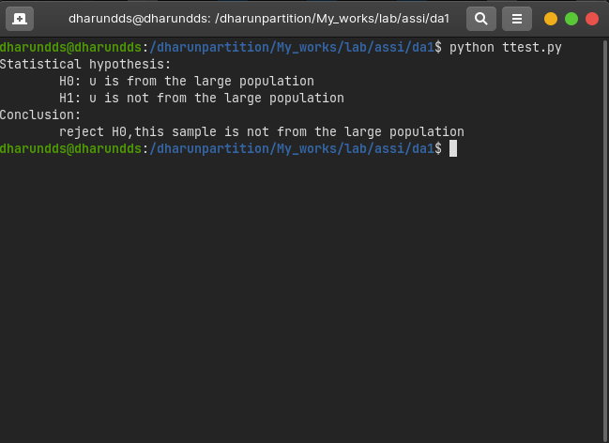

**References:**

Kaggle.com